Supporting Information
Title: Mitochondria-targeted ROS burst synergistically induces pyroptosis and remodels the immune microenvironment to enhance photodynamic efficacy against colorectal cancer
Qiao Tang † 1 2 3, Jianxin Feng † 4, Tianxiang Lei † 5, Liang Tang † 1 2 3, Yongxin Zhang 1, Zhuoyuan Li 1 6, Wenwei Liu 1, Ting Yang 1, Hufei Wang 1 3, Yebohao Zhou 1 3, Yuxin Wu 1 3, Xiaofeng Wang* 1 6, Jianying Shi* 4, Wu Song* 1
1 Department of Gastrointestinal Surgery, The First Affiliated Hospital, Sun Yat-sen University, Guangzhou 510080, China.
2 Department of Pediatric Surgery, Guangzhou Women and Children's Medical Center, Guangzhou Medical University, Guangzhou 510623, China.
3 Laboratory of General Surgery, the First Affiliated Hospital, Sun Yat-sen University, Guangzhou 510080, China.
4 School of Chemistry, Lehn Institute of Functional Materials, Sun Yat-Sen University, Guangzhou 510275, China.
5 Department of Thyroid and Hernia Surgery, Guangdong Provincial People's Hospital, Southern Medical University, Guangzhou 510080, China.
6 Center for precise medicine, First Affiliated Hospital, Sun Yat-sen University, Guangzhou 510080, China.

†Qiao Tang, Jianxin Feng, Tianxiang Lei and Liang Tang contributed equally to this work.
*Corresponding author: Xiaofeng Wang, wangxf77@mail.sysu.edu.cn; Jianying Shi, shijying@mail.sysu.edu.cn; Wu Song, songwu@mail.sysu.edu.cn.

Experimental Section
Characterization
The content of Re and Mn elements in the ZIF-8 composite was determined using inductively coupled plasma - optical emission spectrometry (ICP-OES). Transmission electron microscopy (TEM) and energy-dispersive X-ray spectroscopy (EDS) were performed on electron microscope (JEOL ARM-200F) equipped with a Heidelberg probe corrector and an EDS detector, with samples deposited on ultrathin carbon-film-coated copper grids. Powder X-ray diffraction (XRD) patterns were acquired on a Bruker diffractometer (D8 ADVANCE). Fluorescence spectra were recorded on an Edinburgh FLS980 spectrophotometer equipped with a continuous Xe900 xenon lamp. Samples were dissolved in PBS containing 5% (v/v) dimethyl sulfoxide (DMSO) at a concentration of 0.2 mM for measurement. Fourier-transform infrared (FTIR) spectroscopy was conducted on a PerkinElmer spectrometer (L1280124) in reflectance mode, with data processed by Fourier transformation. UV–visible diffuse reflectance spectra for solid samples and UV–visible absorption spectra for liquid samples were obtained using a Shimadzu UV-2450 spectrophotometer. Liquid samples were prepared in PBS with 1.25% (v/v) DMSO at a concentration of 0.0625 mM. X-ray photoelectron spectroscopy (XPS) analysis was carried out on K-alpha spectrometer (Thermo Fisher Scientific) with an Al Kα monochromatic X-ray source (1486.7 eV), a 400 μm spot size, under room temperature and a vacuum better than 2 × 10⁻⁷ mbar. All binding energies were calibrated relative to the C 1s peak (C–H) at 284.8 eV.

Release of Rhenium(I) at different pH values
The release profile of Re was quantified by ICP-OES (pH 6.0 and 7.4). Samples in dialysis bags were immersed in 100 mL of release medium at 37 °C with shaking at 100 rpm. Aliquots (2 mL) were collected at 0, 2, 4, 8, 12, 24, 48, and 72 h for analysis, with equal volumes of fresh medium replenished after each sampling.

O₂ production
A portable dissolved oxygen meter was used to measure the real-time oxygen concentration with the oxygen electrode probe immersed in the solution after adding ZIF-8^{F127}@Mn₃O₄/Re-TPP into 1 mM H₂O₂.

Photodynamic activity
The photocatalytic performance and ROS generation of ZMRT were assessed using DCFH (5 μM, total ROS), HPF (10 μM, ·OH), and ABDA (50 μM, ¹O₂) fluorescent probes. For each assay, 1 mL of the corresponding probe solution was mixed with 30 μL of the sample. Selected groups were exposed to specific wavelength light irradiation (“+L” groups). Absorbance changes were monitored dynamically at 0, 30, 60, 90, 120, 150, and 180 s after illumination using a UV-vis spectrophotometer (Shimadzu UV-1900i, Japan), allowing quantitative evaluation of ROS generation kinetics.

Cellular uptake ability
CT26 cells were seeded on glass slides placed in 24-well plates at a density of 3×10⁴ cells per well and cultured for 24 h. The cells were then incubated with ICG labeled ZMRT NPs for 1, 2, 4, 6 and 8 h, respectively. Following incubation, the cells were washed three times with PBS. After fixation with 4% paraformaldehyde for 30 min, the nuclei were counterstained with DAPI. Fluorescence imaging was performed using CLSM. Meanwhile, the cellular uptake of CT26 cells was quantitatively assessed using Fc.

In vitro cytotoxicity studies
Cell cytotoxicity against HUVECs and CT26 cells was assessed via CCK-8 assay. Cells were seeded in 96-well plates at 5.0 × 10⁴ cells/mL and treated with PBS, ZMR, or ZMRT, with or without irradiation (425 nm, 20 mW/cm², 10 min). After adding 10 μL CCK-8 reagent per well, plates were incubated for 2 h, and absorbance was measured using a Tecan M200 Pro microplate reader (Switzerland). Under identical conditions, cells in 6-well plates were stained using an AM/PI live/dead assay kit (Solarbio, CA1630). Cells were collected, washed with PBS, and resuspended in Annexin V binding buffer at 1 × 10⁶ cells/mL. Then, 5 μL of Annexin V-PE and 5 μL of 7-AAD were added, followed by incubation in the dark at room temperature for 10–15 min. Apoptotic populations were analyzed by flow cytometry (CytoFLEX, Beckman).

In vitro mitochondrial targeting of ZMRT
CT26 cells were co-cultured with ICG-labeled ZMRT nanoparticles in confocal dishes for 6 hours. After washing three times with PBS to remove extracellular nanoparticles, the cells were stained with the mitochondrial green fluorescent probe MitoTracker Green FM. The mitochondria-targeted accumulation of ICG-labeled ZMRT nanoparticles was subsequently visualized using CLSM.

Detection of mitochondrial function
The mitochondrial transmembrane potential, a key indicator of mitochondrial function, was measured using a JC-1 assay kit (Beyotime, C2003S). Briefly, CT26 cells treated with PBS, ZMR or ZMRT, with or without 425nm laser irradiation, were collected and stained with JC-1. The stained cells were then imaged using a fluorescence microscope. Additionally, cells were harvested and fixed with 2.5% glutaraldehyde, embedded in resin, sectioned, and stained with osmium tetroxide. Ultrastructural morphology was subsequently examined using TEM.

In vitro CLSM images of ox-mtDNA
First, CT26 cells were seeded in CLSM dishes and cultured overnight. Subsequently, PBS, ZMR and ZMRT were added and incubated with the cells for 6 h, followed by treatment with or without 425nm irradiation. After an additional 18 h of incubation, the cells were fixed with 4% paraformaldehyde for 10 min, permeabilized with 0.3% Triton X-100 for 10 min, and blocked with 5% BSA for 1 h. The cells were then incubated with both 8-OH-dG antibody (R&D, 4354-MC-050) to detect oxidized mitochondrial DNA. After 12 h, the samples were incubated with Alexa Fluor® 488-preadsorbed goat anti-rabbit IgG (H&L), followed by DAPI staining. Images were acquired using CLSM.

Escape of mtDNA detection
CT26 cells were seeded in CLSM dishes and cultured for 24 h. Subsequently, ZMRT was added and incubated with the cells for 6 h, followed by 425nm irradiation. After an additional 18 h of incubation, the cells were fixed with 4% paraformaldehyde for 10 min, permeabilized with 0.3% Triton X-100 for 10 min, and blocked with 5% BSA for 1 h. The cells were then incubated with TFAM antibody at 4 °C overnight. After 12 h, the samples were incubated with Alexa Fluor® 488-preadsorbed goat anti-rabbit IgG (H&L). Finally, following DAPI staining, representative images were acquired using a confocal laser scanning microscope. In addition, we quantified the content of 8-OH-dG in the culture supernatants collected from each treatment group using ELISA.

RNA-sequencing
CT26 cells (10.0 × 10⁴ cells mL⁻¹) were cultured in 6-well plates and treated with PBS or ZMRT+L (containing 30 μg/mL of ZMRT) for 6 h. The cells were then irradiated with a 425 nm laser (20 mW/cm², 10 min) and further incubated for 24 h. Total RNA was extracted from both the cells and the culture supernatant. RNA sequencing was performed by Hangzhou Lianchuan Biotechnology Co., Ltd. DEGs were identified with DESeq2 using the criteria |log₂FC| ≥ 1 and FDR < 0.05. KEGG pathway enrichment analysis was conducted using SciPy with a significance threshold of p < 0.05 after Bonferroni correction. The GSEA enrichment analysis displayed the top 30 gene sets with the smallest P-values in the GO terms. Gene sets with an FDR q-value less than 0.05 were selected to generate enrichment score (ES) line plots.

Western blotting assay
CT26 cells were seeded in 6-well plates and cultured until they reached approximately 70% confluency. The cells were then treated for 24 hours with PBS, PBS+L, ZMR, ZMR+L, ZMRT or ZMRT+L. Protein extraction was performed using RIPA lysis buffer (EpiZyme, PC102) supplemented with PMSF (Beyotime, ST505) and Protease and Phosphatase Inhibitor Cocktail (Beyotime, P1049). The extracted proteins were separated by SDS-PAGE (Servicebio, G2018-1L) and transferred onto 0.22 μm PVDF membranes (Millipore, ISEQ00010). The membranes were blocked with 5% non-fat milk in TBST for 1 hour at room temperature and then incubated overnight at 4 °C with the following primary antibodies: β-actin (Proteintech, 66009-1-Ig, 1:20000), GAPDH (Proteintech, 60004-1-Ig, 1: 100000), STING (CST, 13647S, 1:1000), p-STING (CST, 72971S, 1:1000), IRF3 (CST, 4302S, 1:1000), p-IRF3 (CST, 29047S, 1:1000), TBK1 (CST, 3504S, 1:1000), p-TBK1 (affinity, AF8190, 1:2000), CRT (CST, 12238S, 1:1000), HMGB1 (CST, 3935S, 1:1000), HSP70 (CST, 4872T, 1:1000), p-p65 (CST, 3033T, 1:1000), p65 (CST, 6956S, 1:1000), p-IKB-α (Abmart, TP56280, 1:1000), IKB-α (Abmart, T55026, 1:1000), GSDMD (Abcam, ab209845, 1:1000), Cleaved Gasdermin D (CST, 10137S, 1:1000), Caspase-1 (Abcam, ab179515, 1:1000), Cleaved Caspase-1 (CST, 89332S, 1:1000)and NLRP3 (CST, 15101S, 1:1000). After washing three times with TBST for 10 minutes each, the membranes were incubated with HRP-conjugated Goat Anti-Rabbit IgG (H&L) (CST, 7074, 1:2000) or HRP-conjugated Goat Anti-Mouse IgG (H&L) (CST, 7076, 1:2000) at room temperature for 1 hour. Protein bands were visualized using a gel imaging system (Bio-Rad, US).

Immunofluorescence staining
CT26 cells were seeded on glass slides placed in 24-well plates and cultured until they reached approximately 70% confluency. The cells were then treated for 24 hours with PBS, PBS+L, ZMR, ZMR+L, ZMRT or ZMRT+L. Tissue sections were dewaxed, rehydrated, and subjected to antigen retrieval prior to fluorescent staining. Both cell and tissue samples were washed three times with cold PBS and fixed with 4% paraformaldehyde for 10 minutes at room temperature. Permeabilization was performed using 0.5% Triton X-100 in PBS for 10 minutes at room temperature. Subsequently, the samples were blocked with normal goat serum for 60 minutes at room temperature. Primary antibodies were applied and incubated overnight at 4 °C. After washing three times with PBS, secondary antibodies were incubated for 1 hour at room temperature. Finally, nuclei were stained with DAPI (Beyotime, C1005). The following primary and secondary antibodies were used at the indicated dilutions: anti-8-oxo-dG (R&D, 4354-MC-050, 1:250), CRT (CST, 12238S, 1:200), HMGB1 (CST, 3935S, 1:50), mtTFAM (Abcam, ab307302, 1:100), CD8α (Abcam, ab316778, 1:100), iNOS (HUABIO, ER1706-89, 1:100), Alexa Fluor® 488-preadsorbed goat anti-rabbit IgG (H&L) (Abcam, ab150077, 1:1000) and Alexa Fluor® 594-preadsorbed goat anti-rabbit IgG (H&L) (Abcam, ab150080, 1:1000).

ELISA
Cytokine secretion was detected using ELISA. Culture supernatants from differently treated CT26 cell groups were collected, centrifuged (1000×g, 10 min, 4°C), and the supernatant was retained for subsequent analysis. Standard and sample wells were set up by adding 50 μL of serially diluted standards or test samples to each well. Then, 50 μL of biotin-labeled antibody working solution was added to each well, followed by incubation at 37°C for 60 min. After discarding the reaction solution, the plate was washed five times with washing buffer. Next, 100 μL of enzyme conjugate working solution was added to each well, and the plate was sealed with a membrane and incubated at 37°C for 30 min. After a second wash, 90 μL of TMB substrate solution was added to each well, and the plate was covered and incubated at 37°C for 15 min under light-protected conditions. Finally, the reaction was terminated by adding 50 μL of stop solution, and the optical density (O.D.) at 450 nm was measured within 15 min. The following commercial ELISA kits were used: Mouse TNF-α Precoated ELISA Kit (J&L Biological, JL10484), Mouse IFN-γ Precoated ELISA Kit (Elabscience, E-HSEL-M0007), Mouse IL-6 Precoated ELISA Kit (J&L Biological, JL20268), Mouse IL-10 ELISA Kit (J&L Biological, JL20242), Mouse IL-1β ValukineTM ELISA Kit (Novus, VAL601) , Mouse IL-18 ValukineTM ELISA Kit (J&L Biological, JL20253), Mouse 8-OHdG ELISA Kit (J&L Biological, JL12294) and Mouse HMGB1 ELISA Kit (J&L Biological, JL13702).

Quantitative Reverse-Transcription (qRT)-PCR Examination
Total RNA was extracted using a commercial RNA isolation kit (ESscience, RN001) according to the manufacturer's protocol. The purified RNA was then reverse transcribed into cDNA using the Evo M-MLV Reverse Transcription Premix (AG, AG11706). Quantitative real-time PCR (qRT–PCR) was performed on a LightCycle480 II platform (Roche, Switzerland) with SYBR® Green Premix Pro Taq HS qPCR Kit II (AG, AG11702). Gene expression levels were normalized to β-actin and calculated using the 2−ΔΔCT method.

BMDCs activation
Bone marrow-derived dendritic cells (BMDCs) were isolated from the femurs and tibiae of 6–8-week-old female BALB/c mice. The harvested BMDCs were plated in 10 mm cell culture dishes and maintained in complete RPMI 1640 medium supplemented with IL-4 (10 ng/mL) and GM-CSF (20 ng/mL). The medium was replaced every two days. On day 7, BMDCs were collected for subsequent experiments. For co-culture experiments, CT26 cells subjected to different treatments and BMDCs were incubated together in 6-well plates. After 48 hours, mature dendritic cells (characterized by expression of CD11c⁺, CD80⁺, and CD86⁺) were analyzed by flow cytometry.

BMDMs polarization
Bone marrow-derived Macrophages‌ (BMDMs) were isolated from the femurs and tibiae of 6–8-week-old female BALB/c mice. The harvested BMDMs were plated in 10 mm cell culture dishes and maintained in complete RPMI 1640 medium supplemented with M-CSF (20 ng/mL). On day 7, BMDMs were collected for subsequent experiments. To polarize BMDMs toward the M2 phenotype, IL-4 and IL-13 were added to each well at a concentration of 20 ng/mL. For co-culture experiments, CT26 cells subjected to different treatments and BMDMs were incubated together in 6-well plates. After 48 hours, M1 Macrophages (characterized by expression of F4/80⁺ and CD86⁺) and M2 Macrophages (characterized by expression of F4/80⁺ and CD206⁺) were analyzed by flow cytometry.

Lung metastasis
In the CT26 colon tumor rechallenge model, CT26 tumor cells were subcutaneously inoculated into the right dorsal flank of female BALB/c mice to establish primary tumors. Once the tumor volume reached approximately 100 mm³, the mice were treated with PBS and ZMRT+L. On day 8 post-treatment, the primary tumors were surgically removed to permit mouse recovery and the development of an immune memory response. The mice were then rechallenged via intravenous injection of CT26-Luc cells. Lung metastases were monitored by bioluminescence imaging using an In Vivo Imaging System on day 30 after tumor implantation. Finally, the lungs were harvested for hematoxylin and eosin (H&E) staining to assess the efficacy of immune memory in suppressing metastatic growth. In addition, spleens were collected from the mice and processed into single-cell suspensions. The isolated cells were stained with a fluorescent antibody panel including anti-CD45-V500, anti-CD3-FITC, anti-CD8-APC, anti-CD44-PE (Biolegend, 103024), and anti-CD62L-PC5.5 (Biolegend, 104432), and subsequently analyzed by flow cytometry to evaluate the proportion of memory T cells in the peripheral blood.

In vivo safety assessment
To evaluate the in vivo safety profile of ZMRT NPs, a comprehensive toxicological assessment was performed on tumor-bearing mice upon treatment completion. Blood samples were collected for analyses of hematological parameters (WBC, RBC, HGB, and PLT), liver function (AST, ALT), and renal function (CR, UR). Furthermore, major organs (heart, liver, spleen, lung, and kidney) were harvested for histological examination by H&E staining.

Supporting Figures S1-S46

Figure S1. The schematic diagram of the synthesis of Re-TPP complex.

Figure S2. FTIR spectra of Re, Re-TPP complexes and TPP ligand.

Figure S3. Fluorescence spectra of Re and Re-TPP complexes, illustrated as UV-Vis absorption spectra of Re, Re-TPP complexes and TPP ligand.

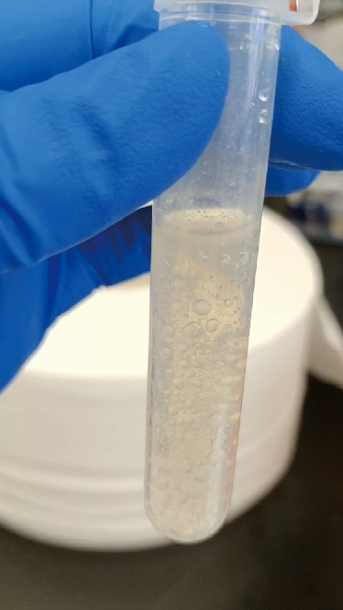
Figure S4. Schematic illustration of oxygen production by ZIF-8@Mn₃O₄ (1 mg/mL) in a 0.5% H₂O₂ aqueous solution.

Figure S5. Fluorescence intensity of DCF at 524 nm as a function of light irradiation time for different treatment groups (n=6).

Figure S6. Fluorescence intensity of HPF at 515 nm as a function of light irradiation time for different treatment groups (n=6).

Figure S7. Plot of ln(Aₜ/A₀) versus laser irradiation time, where A₀ and Aₜ represent the absorbance of ABDA at 402 nm before and after light irradiation, respectively (n=6).

Figure S8. Flow cytometric analysis showing cellular uptake of ICG-ZMRT in CT26 cells for different incubation times.
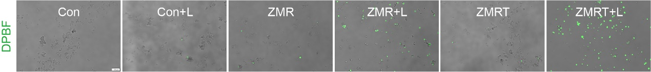
Figure S9. Fluorescence images of Singlet oxygen (¹O₂) generation in CT26 cells after different treatments. Scale bar: 100 µm.

Figure S10. Flow cytometric analysis showing the production of ¹O₂ in CT26 cells after different treatments.

Figure S11. CLSM imaging for evaluating the mtROS generation in CT26 cells treated by different treatments, mitochondria: Mito tracker (green), mtROS: Mito SOX (red). Scale bar, 20 µm.

Figure S12. CLSM images of mtDNA in CT26 cells after different treatments. Scale bar: 20 µm.

Figure S13. CLSM images of CT26 cells stained with TFAM (mtDNA markers) and DAPI after treatment with ZMRT+L, the red arrow indicates the extracellular mtDNA. scale bar: 20 µm.

Figure S14. Flow cytometric quantitative analysis of expression of M1 macrophage influenced by CT26 cells that received different treatments (n = 3).

Figure S15. Flow cytometric quantitative analysis of expression of M2 macrophage influenced by CT26 cells that received different treatments (n = 3).
Figure S16. Quantitative analysis of relative protein expression levels, normalized to the control group at each respective temperature (n = 3).
Figure S17. Morphological changes of CT26 cells under light microscopy after different treatments. scale bar: 50 µm.

Figure S18. Quantitative analysis of NLRP3 mRNA expression levels in CT26 cells after different treatments by RT-qPCR (n=6).

Figure S19. Quantitative analysis of Caspase-1 mRNA expression levels in CT26 cells after different treatments by RT-qPCR (n=6).

Figure S20. Quantitative analysis of GSDMD mRNA expression levels in CT26 cells after different treatments by RT-qPCR (n=6).

Figure S21. Quantitative analysis of Caspase-3 mRNA expression levels in CT26 cells after different treatments by RT-qPCR (n=6).

Figure S22. Quantitative analysis of GADME mRNA expression levels in CT26 cells after different treatments by RT-qPCR (n=6).

Figure S23. Quantitative analysis of IL-1β mRNA expression levels in CT26 cells after different treatments by RT-qPCR (n=6).

Figure S24. Quantitative analysis of IL-18 mRNA expression levels in CT26 cells after different treatments by RT-qPCR (n=6).
Figure S25. Quantitative analysis of relative protein expression levels, normalized to the control group at each respective temperature (n = 3).
Figure S26. Quantitative analysis of relative protein expression levels, normalized to the control group at each respective temperature (n = 3).

Figure S27. Flow cytometric quantification of CRT membrane expression in CT26 cells after different treatments.

Figure S28. Flow cytometric quantification of HMGB1 expression in CT26 cells after different treatments.

Figure S29. CLSM images of HMGB1 expression in CT26 cell after different treatments. Scale bar: 20 µm.

Figure S30. Body weight changes after different treatments (n=6).

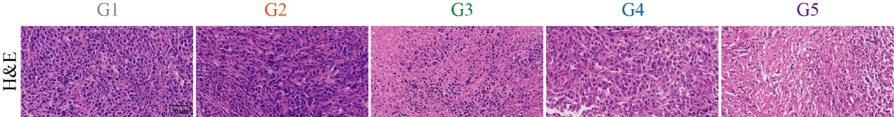
Figure S31. Histological analysis of tumor tissues that were immunohistochemically stained with H&E. Scale bar: 50 µm.
Figure S32. Quantitative analysis of relative protein expression levels, normalized to the control group at each respective temperature (n = 3).

Figure S33. Histological analysis of tumor tissues that were immunohistochemically stained with CRT, CD8, iNOS, and 8-OH-dG. Scale bar: 50 µm.

Figure S34. Flow cytometric analysis of expression of CD86 (M1 macrophage marker) and CD206 (M2 macrophage marker) in tumor tissues.

Figure S35. Flow cytometric analysis of DCs in tumor-draining lymph nodes.

Figure S36. Representative flow cytometry images of CD3⁺CD8⁺ T cells in peripheral blood mononuclear cells after different treatments.

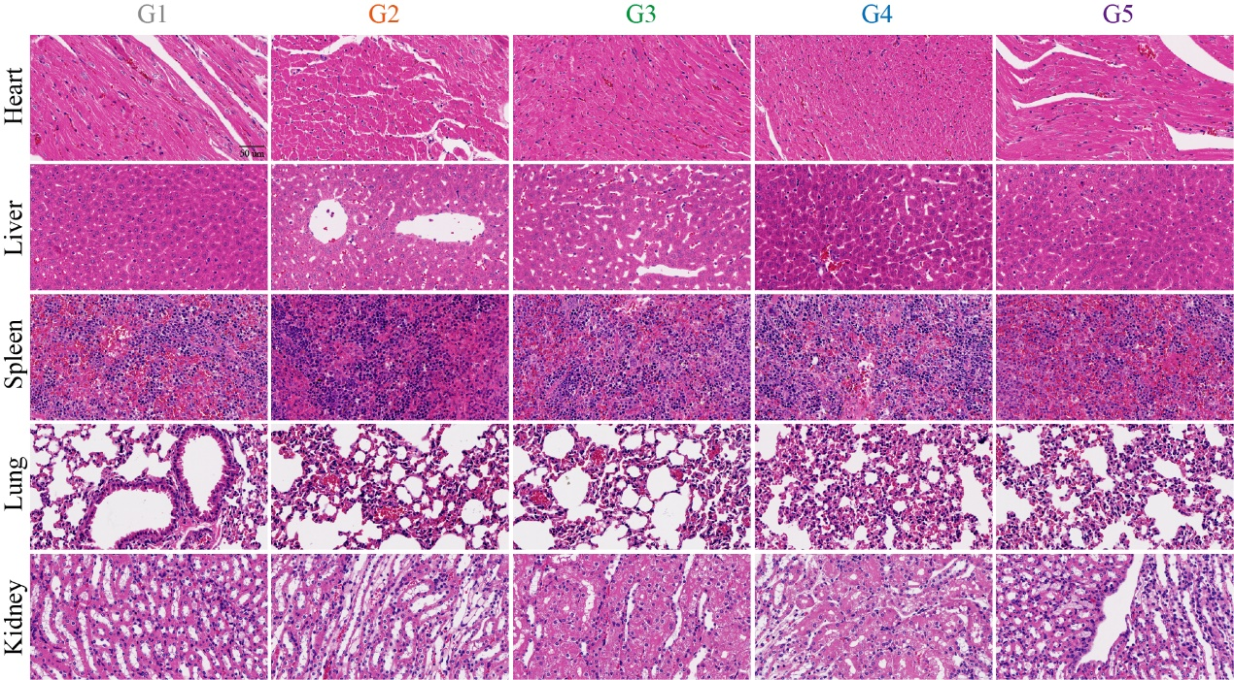
Figure S37. H&E staining images of major organs (hearts, livers, spleens, lungs, and kidneys) of bearing CT26 tumor mice in control and treatment groups. Scale bar: 50 µm.

Figure S38. The detection of WBC, RBC, PLT, HGB, UR, CR, AST and ALT after different treatment (n=6). Data are presented as mean ± SD.

Figure S39. Tumor weight variation of primary tumor after different treatments (n=6).

Figure S40. Tumor weight variation of distant tumor after different treatments (n=6).

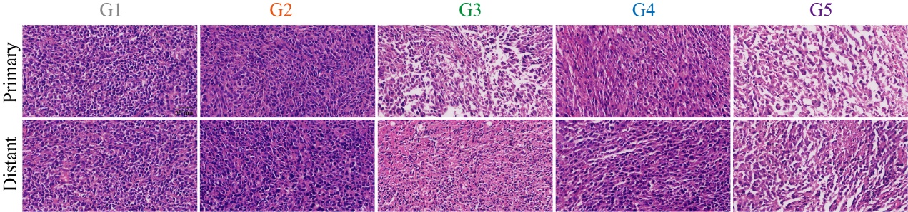
Figure S41. Images of the primary tumor and distant tumor slices after H&E staining collected from mice after various treatments. Scale bar: 50 µm.

Figure S42. Representative flow cytometry images of CD3⁺CD8⁺ T cells in peripheral blood mononuclear cells after different treatments.

Figure S43. Flow cytometry-based quantitative analysis of the proportion of CD3⁺CD8⁺ T cells in the spleen (n=6).

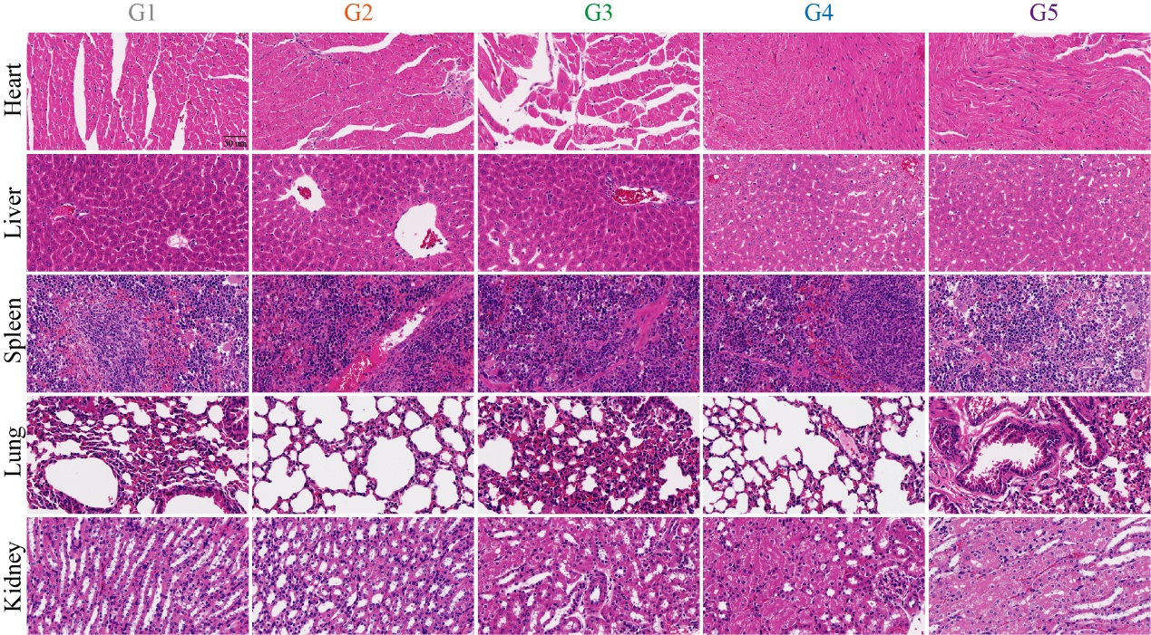
Figure S44. H&E staining images of major organs (hearts, livers, spleens, lungs, and kidneys) of bearing CT26 tumor mice in control and treatment groups. Scale bar: 50 µm.

Figure S45. Statistical proportion of CD8⁺ T cells in peripheral blood mononuclear cells after ZMRT+L treatment (n=3).
Table S2
Table S2. Primer sequences used for qPCR
Gene Symbols | Sequences (5′ to 3′)
β-actin | Forward: CCCCAGGCACCAGGGCGTGAT
 | Reverse: GTCATCTTCTCGCGGTTGGCCTTGGGGT
NLRP3 | Forward: TGGTGACTTTGTATATGCGTG
 | Reverse: CTTAGGTCCACACAGAAAGT
GSDMD | Forward: GATCAAGGAGGTAAGCGGCA
 | Reverse: AACACTCCGGTTCTGGTTCT
Caspase-1 | Forward: AATACAACCACTCGTACACGTC
 | Reverse: AGCTCCAACCCTCGGAGAAA
GSDME | Forward: TCACCACGGACACCAATGTAG
 | Reverse: CCACCATGTTTCCCTTGGAG
Caspase-3 | Forward: CTCGCTCTGGTACGGATGTG
 | Reverse: TCCCATAAATGACCCCTTCATCA
IL-1β | Forward: GAAATGCCACCTTTTGACAGTG
 | Reverse: TGGATGCTCTCATCAGGACAG
IL-18 | Forward: GACTCTTGCGTCAACTTCAAGG
 | Reverse: CAGGCTGTCTTTTGTCAACGA

