Supporting Information

A Vertically Stratified Dual Layer for Stable Micro/Nanoelectrode Operation in Ionic Solutions by Suppressing Electrochemical Degradation
Seok Cheol Kim^{1,2}, Jinyoung Bae¹, Aejin Lee¹, Jong Kwan Park¹, SeHui Oh¹ and Wan Soo Yun^{1,2,*}

¹Department of Chemistry, Sungkyunkwan University, 2066 Seobu-ro, Jangan-gu, Suwon 16419, Gyeonggi-do, Republic of Korea
²Research Institute of Nanobio Convergence, Sungkyunkwan University, 2066 Seobu-ro, Jangan-gu, Suwon 16419, Gyeonggi-do, Republic of Korea

*Correspondence should be addressed to the following author(s):
Wan Soo Yun
Department of Chemistry
Sungkyunkwan University
Suwon, Gyeonggi-do 16419, South Korea
wsyun87@skku.edu

Figure S1. Microfluidic chip and experimental setup
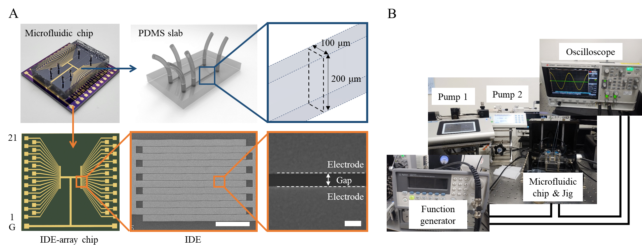

A) Images and schematics of the microfluidic chip used in this study. The microfluidic chip was fabricated by integrating an IDE-array chip with a PDMS slab. The PDMS slab contains two parallel microchannels. Each microchannel has two inlets and one outlet, all 1 mm in diameter, and is 100 μm wide and 200 μm high. A total of 42 interdigitated electrodes (IDEs) were aligned beneath the two microchannels, with 21 IDEs per channel. Each IDE consists of a total of 12 electrode fingers with an interelectrode gap of 400 ± 20 nm. Scale bars: 50 μm and 500 nm. B) Photograph of the experimental setup, comprising two syringe pumps for solution injection, a function generator for voltage application, an oscilloscope for monitoring current changes, and a jig for electrical connection to the chip.
Figure S2. Determination of fluid boundaries RGB intensity analysis
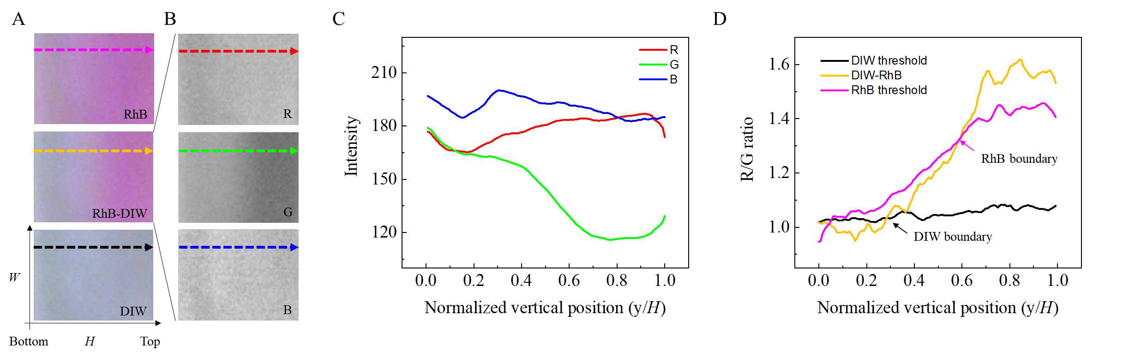
(A) shows cropped optical images obtained during the flow of RhB solution, RhB and DIW at a 1:1 flow-rate ratio, and DIW. To determine the boundaries of the two solutions in the RhB–DIW co-flow image, the images were separated into the R, G, and B color channels, as shown in (B). The corresponding intensity profiles are presented in (C). In the upper region of the channel, where the RhB solution was located, the R intensity was relatively high, whereas it decreased toward the lower region containing DIW. This difference was more pronounced in the G intensity profile. Because green is complementary to red, the G intensity was low in the RhB-rich upper region and increased toward the DIW-rich lower region. To enhance the contrast between the two solutions, the R/G intensity ratio was therefore used for boundary determination. (D) shows the R/G profile obtained from the RhB–DIW co-flow image together with the threshold values derived from the RhB-only and DIW-only images. The yellow line represents the R/G ratio of the RhB–DIW co-flow image, while the magenta and black lines represent the RhB threshold (mean − 3SD) and the DIW threshold (mean + 3SD), respectively, calculated from the R/G ratios of the corresponding reference images. The RhB boundary was defined as the position at which the R/G ratio fell below the RhB threshold, whereas the DIW boundary was defined as the position at which the R/G ratio exceeded the DIW threshold.

Figure S3. Optical visualization of fluid boundaries using a dye at different total flow rates and flow ratios
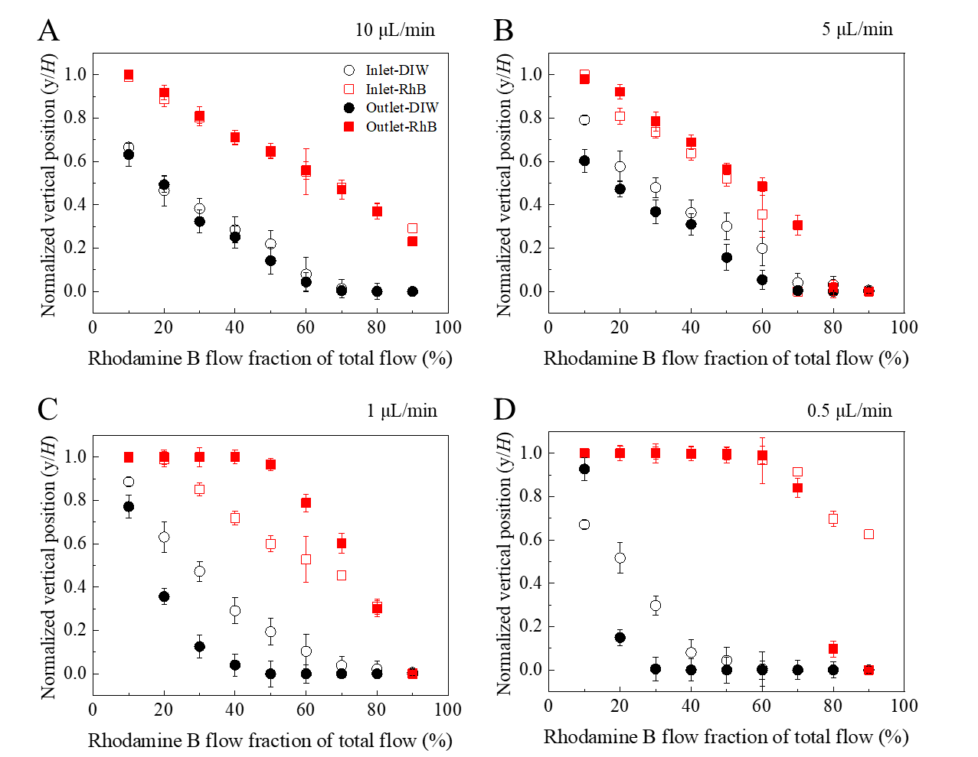
The positions of the DIW and RhB boundaries near the inlet and outlet were plotted as functions of the RhB flow fraction at different total flow rates, including the condition used in Fig. 2D. In all panels, the boundary positions changed systematically with the flow fraction of the two solutions.
In (A) and (B), except for a few deviating data points, the DIW and RhB boundary positions remained nearly unchanged between the two total-flow-rate conditions, both near the inlet and near the outlet. The separation between the two boundaries, corresponding to the thickness of the interdiffusion region, also remained nearly constant at both locations. These results indicate that the two solutions maintained vertically stratified laminar layers throughout the channel without appreciable broadening of the interdiffusion region from the inlet to the outlet.
At the lower total flow rate shown in (C), the boundary distributions changed. Although the boundary positions near the inlet remained similar to those in (A) and (B), the two boundaries near the outlet shifted toward the opposing channel walls, indicating that the interdiffusion region became thicker along the channel. This broadening can be attributed to the longer residence time at the lower flow rate, which allowed greater molecular diffusion across the interface between the two solutions.
In (D), the two boundaries shifted toward the opposing channel walls, and the interdiffusion region occupied most of the channel height. This extensive mixing is thought to arise from the channel geometry. The two solutions did not merge as parallel streams within a channel of constant cross-section; instead, they met vertically at inlet 2 and immediately entered the narrower main channel. The abrupt change in flow direction and channel cross-section is thought to have caused substantial mixing when the two solutions met, resulting in an interdiffusion region that occupied most of the channel.

Figure S4. Vetically stratified laminar flow simulations.
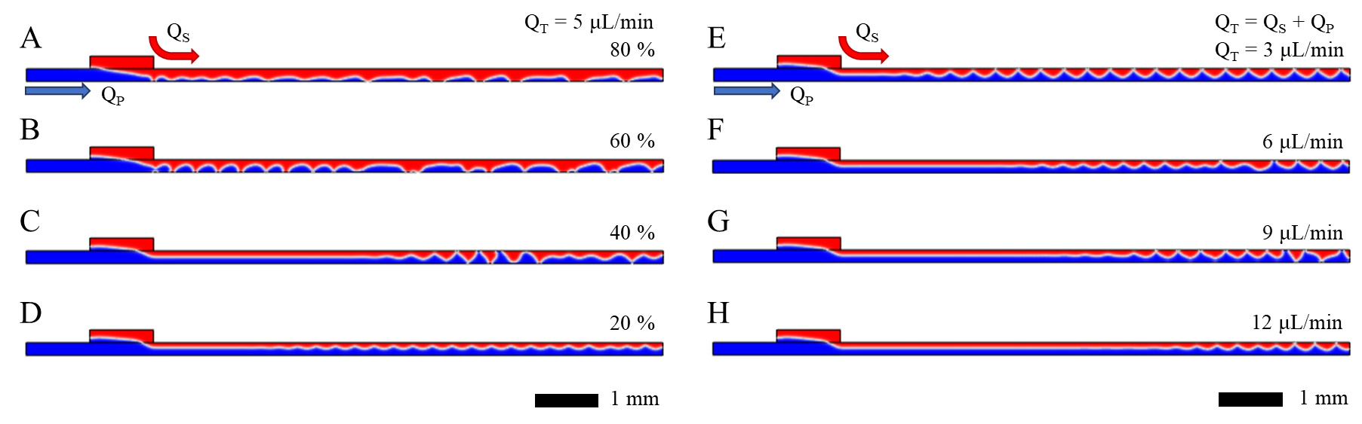
The formation and persistence of vertically stratified laminar flow were simulated using a 2D model consisting of a horizontal flow channel (200 μm × 10 mm) and a vertical inlet branch (200 μm × 1 mm). Fluid 1 (blue) entered through the left inlet of the horizontal flow channel, while Fluid 2 (red) entered through the vertical inlet branch. The two fluids formed vertically stratified layers at the junction and exited through the outlet of the horizontal flow channel. A two-phase flow module was used, with both phases assigned the properties of water.
(A)–(D) show the simulated fluid distributions at a constant total flow rate (Q_{T} = Q_{P} + Q_{S}) of 5 μL/min. The flow rates of Fluid 1 (Q_{P}) and Fluid 2 (Q_{S}) were varied from 1 to 4 μL/min and from 4 to 1 μL/min, respectively. The corresponding flow fractions of Fluid 2 (Q_{S}/Q_{T}) were 80%, 60%, 40%, and 20% for A), B), C), and D), respectively. In (C), the two fluids remained vertically stratified up to approximately the midpoint of the horizontal flow channel. In (D), the stratified flow was maintained to the outlet, and Fluid 2 did not contact the bottom wall.
(E)–(H) show the simulated fluid distributions at Q_{T} values of 3, 6, 9, and 12 μL/min, with the flow-rate ratio fixed at Q_{P}:Q_{S} = 2:1. As Q_{T} increased, the downstream distance over which the vertically stratified flow was maintained increased.

Figure S5. Electrochemical verification of vertically stratified fluid-layer formation
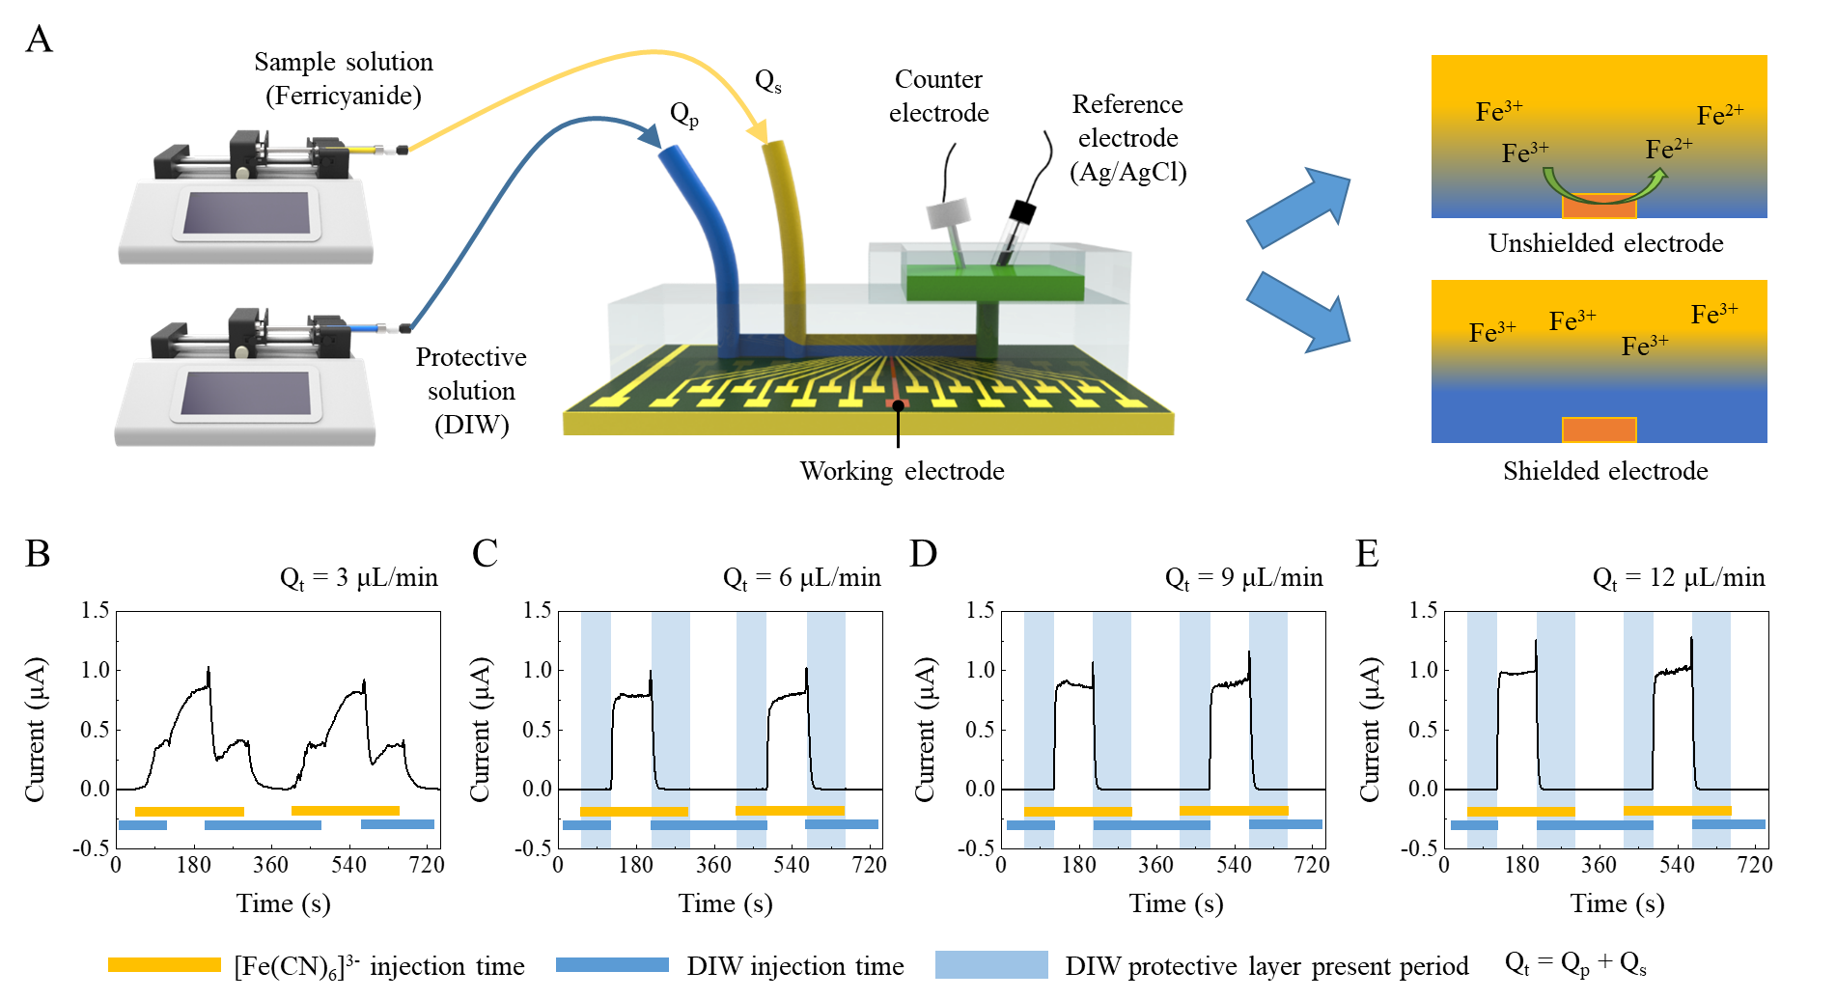
(A) Schematic illustration of the electrochemical approach used to verify the formation of vertically stratified fluid layers. Ferricyanide solution and DIW were introduced independently and co-flowed to form the sample and protection layers, respectively. The outlet was connected to a reservoir containing the reference and counter electrodes, and CA measurements were performed using the IDE as the working electrode. When ferricyanide ions diffused across the DIW layer and reached the electrode surface, they were reduced to ferrocyanide, producing a measurable reduction current. In the presence of a stable DIW layer over the electrode, ferricyanide transport to the electrode surface was restricted, and little or no reduction current was expected.
(B)–(E) CA responses measured at total flow rates (Q_{t}) of 3, 6, 9, and 12 μL/min, respectively, while maintaining a fixed flow-rate ratio of Q_{p}:Q_{s}=2:1. Here, Q_{p} denotes the flow rate of DIW, and Q_{s} denotes that of the ferricyanide solution. Yellow bars indicate the ferricyanide injection periods, blue bars indicate the DIW injection periods, and light-blue shading indicates the co-flow periods during which the DIW layer shielded the electrode. In (B), only a baseline-level signal was observed while DIW, which contained no electroactive species, was supplied. The current gradually increased after the ferricyanide solution was introduced. When the DIW supply was subsequently stopped, the ferricyanide solution was no longer diluted by DIW, resulting in a further increase in current. When the DIW supply was resumed, more ferricyanide ions momentarily reached the electrode, causing the current to increase before subsequently decreasing. In (C)–(E), the current responses were considerably more stable than that in (B). During the co-flow periods indicated by the light-blue shading, the current remained near the baseline measured with DIW alone, whereas a clear current response was observed when only the ferricyanide solution was supplied. Together with the results in Fig. 2, these electrochemical results showed the same trend as the optical observations of vertically stratified flow in Fig. S3.

Figure S6. Identification of VSDL conditions for electrode protection based on gap distance
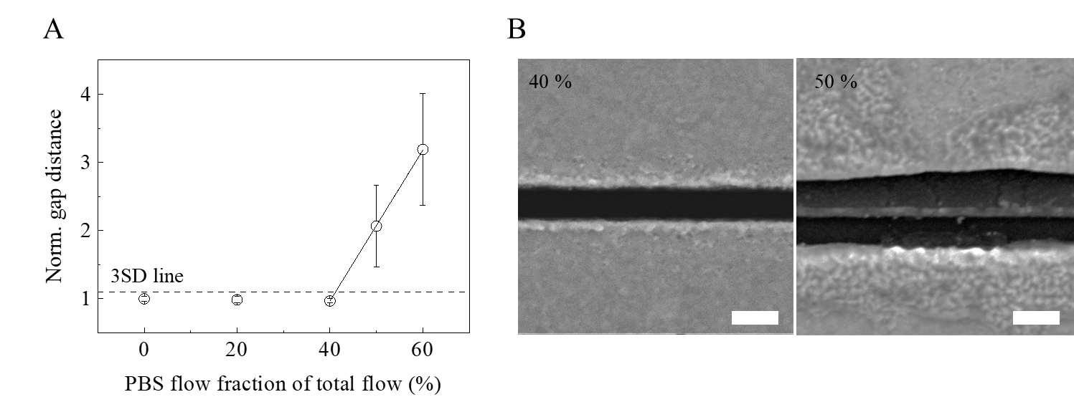
A) Changes in the gap distance as a function of the PBS flow fraction. At a total flow rate of 5 μL/min, an AC voltage of 4 V_{pp} at 100 kHz was applied while the flow-rate ratio of the sample solution (1× PBS) to the protection solution (DIW) was varied. The resulting changes in gap distance were used to identify the flow conditions under which the electrodes remained protected by the VSDL. B) SEM images obtained under conditions that preserved or damaged the electrodes. The left image corresponds to a DIW:PBS flow-rate ratio of 3:2 (40% PBS), at which no apparent change in the gap distance was observed. The right image corresponds to a DIW:PBS flow-rate ratio of 1:1 (50% PBS), at which electrode damage was observed.

Figure S7. DNA modification
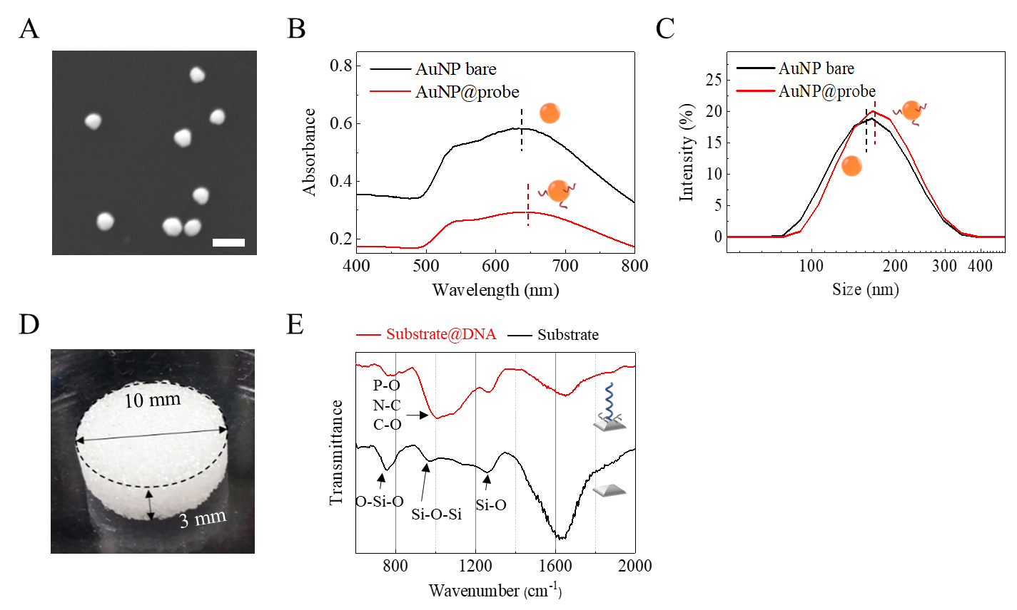
A) SEM image of the AuNPs. B) UV–Vis absorption spectra of bare and DNA-modified AuNPs (AuNP@probe). A red shift in the plasmon peak was observed after DNA attachment. C) DLS size distributions of bare and DNA-modified AuNPs. The increase in hydrodynamic size after DNA attachment supported successful surface modification. D) Photograph of the glass substrate used for DNA immobilization. The substrate was 10 mm in diameter and 3 mm thick. E) IR spectrum of the DNA-modified glass substrate. The appearance of a new absorption peak after DNA immobilization supported successful surface modification.

