Supplementary information
Root-Toughened Molecular Interfaces Unlock Efficient and Air-Stable Blue Perovskite LEDs
Jiandong Wu¹, Lijie Wang³, Xinhao Liu¹, Yimin Bai², Hongtao Bian², Yang Yang¹, Huixin Li¹, Yazhou Shuang¹, Ziyong Kang¹, Omar F. Mohammed³*, Hongyue Wang¹*, and Hongqiang Wang¹*
¹ State Key Laboratory of Solidification Processing, Center for Nano Energy Materials, School of Materials Science and Engineering, Northwestern Polytechnical University and Shaanxi Jo int Laboratory of Graphene, Xi'an, 710072, P. R. China
² Key Laboratory of Applied Surface and Colloid Chemistry, Ministry of Education, School of Chemistry and Chemical Engineering, Shaanxi Normal University Xi’an, 710062, P. R. China
³ Center for Renewable Energy and Storage Technologies (CREST), Division of Physical Science and Engineering, King Abdullah University of Science and Technology (KAUST), Thuwal 23955-6900, Kingdom of Saudi Arabia
* Corresponding authors.
Hongyue Wang, hongyue.wang@nwpu.edu.cn
Omar F. Mohammed, omar.abdelsaboor@kaust.edu.sa
Hongqiang Wang, hongqiang.wang@nwpu.edu.cn

Table of Contents
Supplementary Fig. 1-47
Supplementary Note 1-5
Supplementary Table 1-6
Supplementary References

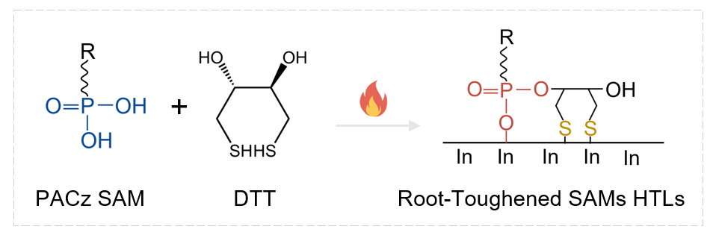
Supplementary Fig. 1 The phosphonate-based covalent linking between PACz SAMs and DTT.

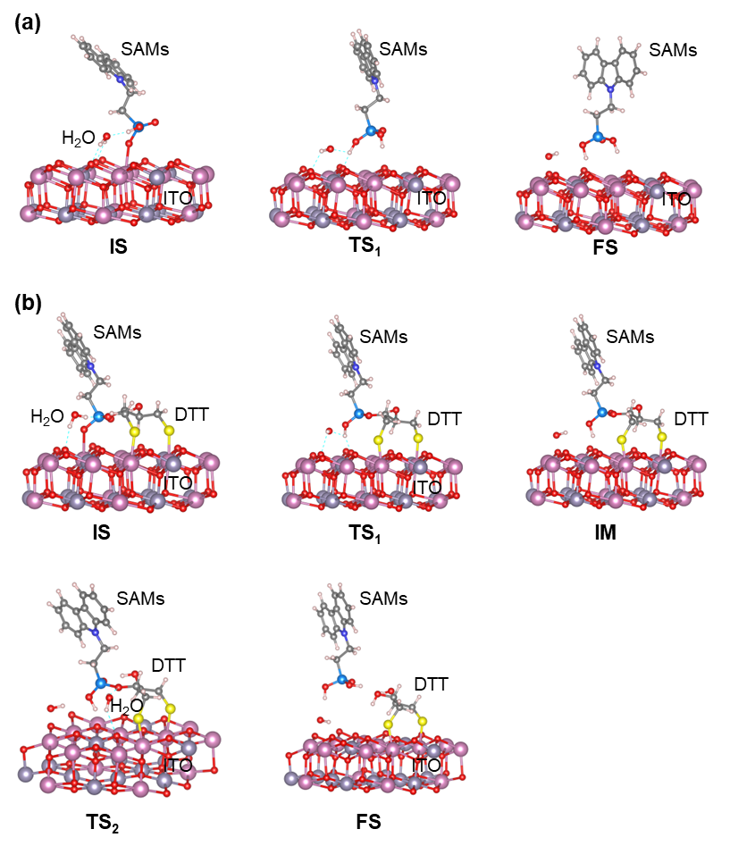
Supplementary Fig. 2 Corresponding DFT trajectory of the desorption reaction mechanism of PACz SAMs from the ITO substrate (a) with and (b) without DTT. The insets show the reaction configurations of the initial state (IS), transition state (TS), intermediate state (IM) and final state (FS).

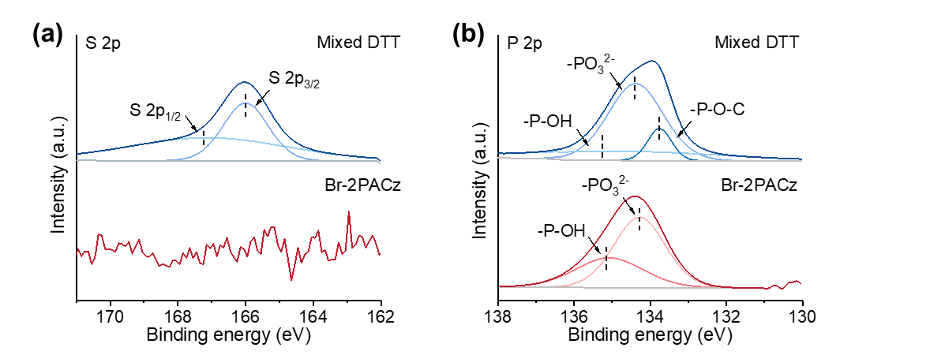
Supplementary Fig. 3 (a) XPS S 2p and (b) P 2p spectrum for the Br-2APCz and mixed DTT films.
Film X-ray photoelectron spectroscopy (XPS) was employed to investigate the film composition and its bonding interaction with ITO substrates. The presence of DTT was evidenced by the newly emerged doublet peaks (166.0 eV and 167.1 eV) in S 2p spectra. In P 2p spectra, DTT involved film exhibits higher binding energy of the -PO₃²⁻ and emerged new peak of P-O-C (133.7 eV),^{[1-3]} indicating successful linked Br-2PACz and DTT molecules, as well its stronger anchoring on ITO substrate. Notably, the pristine Br-2PACz film exhibits a high proportion -P-OH signal, indicating that a substantial fraction of Br-2PACz molecules failed to bond with the underlying ITO substrate.

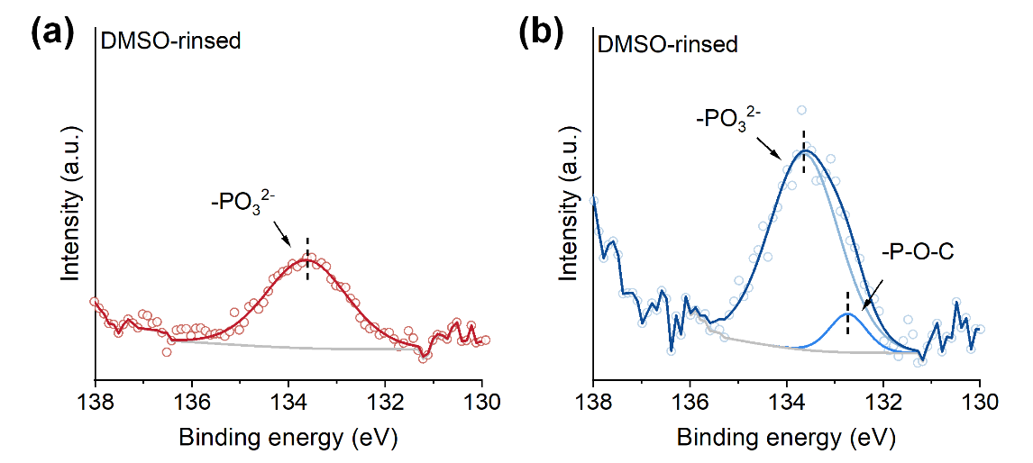
Supplementary Fig. 4 XPS P 2p spectrum for the DMSO rinsed (a) Br-2APCz and (b) mixed DTT films.

Supplementary Table 1. The fitted XPS results of before and after polar solvent treatments Phosphorus (P) elements in prepared Br-2APCz and mixed DTT films.
 | Condition |  | Phosphorus concentration (%)
 |  |  | -P-OH | -PO₃²⁻ | -P-O-C-
 | Br-2PACz film
 | Initial film | Peak area | 2316.7 | 4143.4 | /
 | H₂O rinsed | Peak area | / | 1644.5 | /
 | DMSO rinsed | Peak area | / | 1500.8 | /
Mixed DTT film
Initial film |  | Peak area | 942.0 | 2764.6 | 394.7
 | H₂O rinsed | Peak area | / | 2146.7 | 372.1
 | DMSO rinsed | Peak area | / | 2243.0 | 324.5

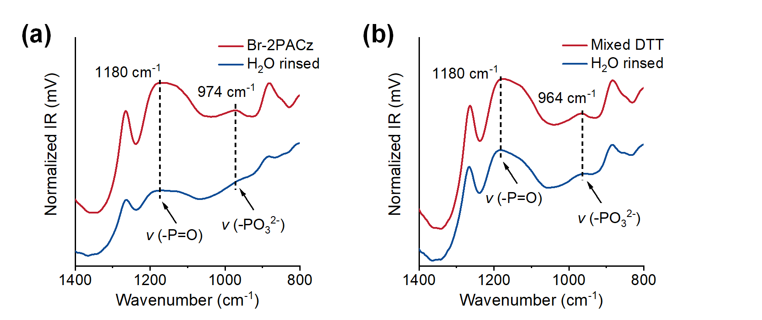
Supplementary Fig. 5 ATR-FTIR spectra for the Br-2PACz (a) and mixed DTT films before and after H₂O rinsed. The FTIR peaks identified at 1180 cm⁻¹ and 974 cm⁻¹ correspond to the vibrations of -P=O group and -PO₃²⁻, respectively.

Supplementary Note 1: Analysis of sum frequency generation (SFG) spectroscopy.
SFG spectroscopy is obtained by overlapping two laser pulses at a surface or interface: one visible pulse and one infrared pulse. If the medium is isotropic, the bulk nonlinear susceptibility in this process is zero; whereas in regions where symmetry is broken, such as at surfaces, the nonlinear susceptibility becomes non-zero. This allows the two waves to mix and generate a third beam with a frequency equal to the sum of the two input frequencies. The SFG intensity is typically modeled using the following Equation 1:^{[4]}
$I_{SFG}∝{\left|χ_{NR}^{\left(2\right)}+χ_{R}^{\left(2\right)}\right|}^{2}={\left|χ_{NR}^{\left(2\right)}+\sum_{R}{\frac{A_{R}}{ω-ω_{R}+iΓ_{R}}}\right|}^{2}$ (1)
Where $χ_{NR}^{\left(2\right)}$ and $χ_{R}^{\left(2\right)}$ represent the effective non-resonant (NR) and resonant (R) second-order nonlinear susceptibilities, respectively. The parameters $A_{R}$, $ω_{R}$, and $Γ_{R}$ denote the resonance amplitude, central frequency, and half-width at half-maximum (HWHM) of the Lorentzian lineshape for the resonant peak R, while ω corresponds to the frequency of the incident infrared beam. The resonance amplitude $A_{R}$ is determined by the product of the infrared transition dipole moment and the Raman polarizability (collectively termed the molecular hyperpolarizability). Generally, a vibrational mode can only be observed in SFG spectroscopy if it exhibits both infrared and Raman activity. Furthermore, the resonance amplitude depends on molecular orientation, implying that specific vibrational modes may not appear in SFG spectra under certain conditions, depending on the structural arrangement of molecules at the surface or interface.
For benzene rings, there are traditionally five normal vibrational modes labeled as ν_{20a}, ν_{7b}, ν_{7a}, ν_{20b} and ν₂. These modes correspond to specific symmetry-related vibrational patterns of the benzene molecule, such as in-plane and out-of-plane bending or stretching motions of the carbon-hydrogen bonds, as show in Supplementary Fig. 5a. And allows for determination of the phenyl-group tilt angle with Equation 2:^{[5]}
$R=\left|\frac{A_{B1}}{A_{A1}}\right|=\left|\left(\frac{β_{caa,B1}}{β_{aac,A1}}\right)\left(\frac{2\left(〈\cos{3θ}〉-〈\cos{θ}〉\right)}{\left(7+2r\right)〈\cos{θ}〉+\left(1-2r\right)〈\cos{3θ}〉}\right)\right|$ (2)
In this equation, $A_{A1}$and $A_{B1}$ represent the amplitudes of peaks corresponding to modes of A₁ and B₁ symmetry, respectively. $β_{aac,A1}$and $β_{caa,B1}$ represent the respective elements of the hyperpolarizability tensor of the same two modes, and r is the ratio of $β_{ccc}$/$β_{acc}$ for the A₁ mode. The tilt angle of the $C_{2υ}$ axis of the phenyl ring relative to the surface normal is indicated by $θ$.
Assuming local $C_{2υ}$ symmetry for the phenyl groups (which we acknowledge is not strictly true, but seems to hold for this case), all vibrational modes are either of A₁ or B₁ symmetry. For the phenyl rings, the ν₂ mode is A₁ symmetry, the ν_{20b} mode is B₁ symmetry, and the IR transition dipole moment vectors for A₁ and B₁ modes are orthogonal. Therefore, the ratio of the intensities of the ν_{20b} peak (B₁ symmetry) and the ν₂ feature (A₁ symmetry) is denoted as R for Equation 2. When the phenyl rings are parallel to the surface normal, we will detect the stronger ν₂ feature, giving an R value of 0. As the phenyl ring tilts toward the surface, the ν_{20b} feature becomes stronger, resulting in an increase in the R value.^{[6]}
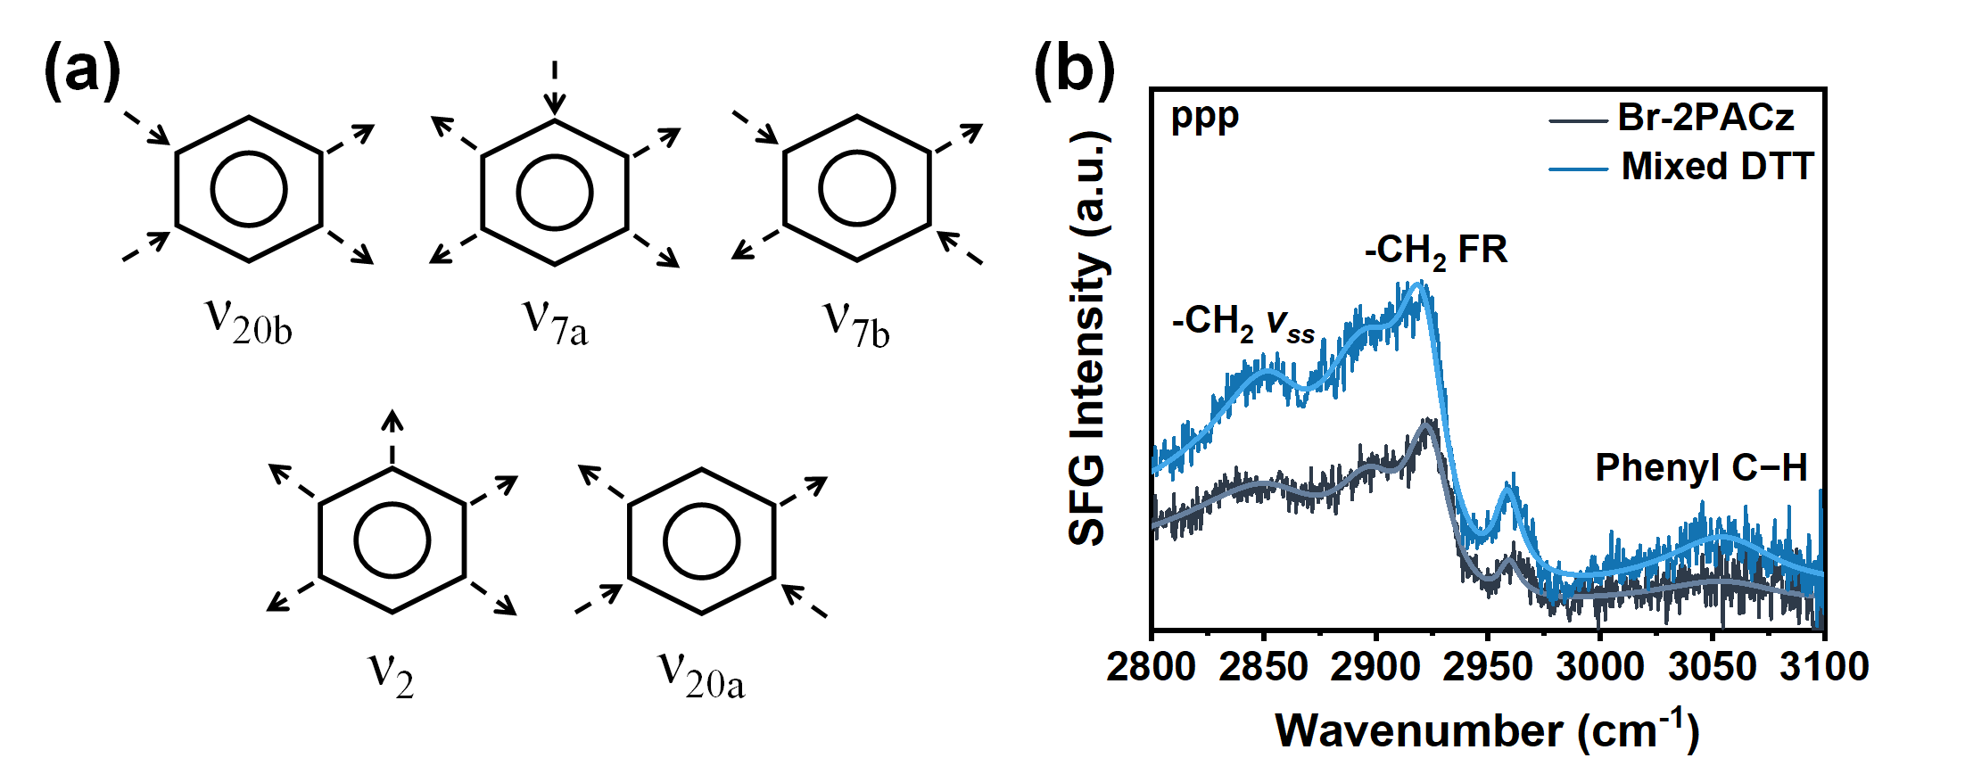
Supplementary Fig. 6 (a) Characteristic motions of the -C-H stretch modes for phenyl ring. (b) The ppp SFG spectra for the Br-2APCz and mixed DTT films.

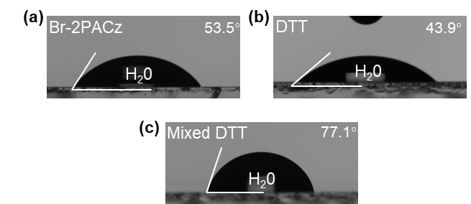
Supplementary Fig. 7 Water contact angle of Br-2PACz, DTT and mixed DTT on ITO surface.

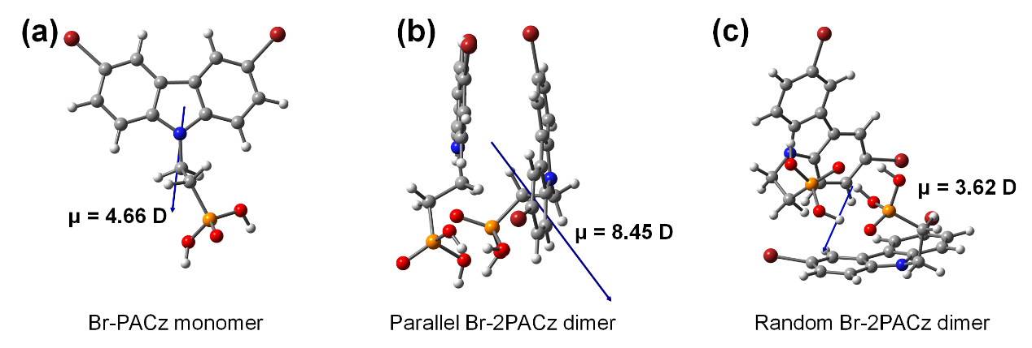
Supplementary Fig. 8 Molecular structures and dipole moments of Br-2PACz dimer with different stacking configurations.

Supplementary Table 2. The dipole moment for self-assembled molecule used in perovskite optoelectronics.
Self-assembled molecule | Dipole moment (D) | HOMO (eV) | Ref.
Parallel Br-2PACz  Br-2PACz  Random Br-2PACz | 8.45 | -5.90 | This work
Parallel Br-2PACz  Br-2PACz  Random Br-2PACz | 4.66 | -6.05 | This work
Parallel Br-2PACz  Br-2PACz  Random Br-2PACz | 3.62 | -5.72 | This work
RS-2  RS-1  MeO-2PACz | 7.94 | -5.07 | Science. 389(6756), 195-199.
RS-2  RS-1  MeO-2PACz | 7.58 | -5.05 | Science. 389(6756), 195-199.
RS-2  RS-1  MeO-2PACz | 2.67 | -5.14 | Science. 389(6756), 195-199.
Br-SPTZ3PA  SPTZ3PA  PTZ3PA | 6.25 | -5.62 | ACS Appl. Electron. Mater. 2025, 7, 10284-10293.
Br-SPTZ3PA  SPTZ3PA  PTZ3PA | 5.26 | -7.09 | ACS Appl. Electron. Mater. 2025, 7, 10284-10293.
Br-SPTZ3PA  SPTZ3PA  PTZ3PA | 2.11 | -7.08 | ACS Appl. Electron. Mater. 2025, 7, 10284-10293.
PAFTB  2PACz | 4.93 | / | Adv. Mater. 2025, 37, e08740.
PAFTB  2PACz | 1.97 | / | Adv. Mater. 2025, 37, e08740.
Cl-4PACz  Br-4PACz  F-4PACz  2PACz  4PACz  Me-4PACz | 4.78 | -5.68 | Energy Environ. Sci. 2025, 18, 874-883.
Cl-4PACz  Br-4PACz  F-4PACz  2PACz  4PACz  Me-4PACz | 4.63 | -5.66 | Energy Environ. Sci. 2025, 18, 874-883.
Cl-4PACz  Br-4PACz  F-4PACz  2PACz  4PACz  Me-4PACz | 3.87 | -5.46 | Energy Environ. Sci. 2025, 18, 874-883.
Cl-4PACz  Br-4PACz  F-4PACz  2PACz  4PACz  Me-4PACz | 1.92 | -5.45 | Energy Environ. Sci. 2025, 18, 874-883.
Cl-4PACz  Br-4PACz  F-4PACz  2PACz  4PACz  Me-4PACz | 1.92 | -5.37 | Energy Environ. Sci. 2025, 18, 874-883.
Cl-4PACz  Br-4PACz  F-4PACz  2PACz  4PACz  Me-4PACz | 1.69 | -5.17 | Energy Environ. Sci. 2025, 18, 874-883.
Br-2PACz  2PACz  MeO-2PACz | 4.50 | -6.26 | Chem. Eng. J. 508 (2025), 160931.
Br-2PACz  2PACz  MeO-2PACz | 1.29 | -5.60 | Chem. Eng. J. 508 (2025), 160931.
Br-2PACz  2PACz  MeO-2PACz | 0.29 | -5.40 | Chem. Eng. J. 508 (2025), 160931.
Br-BACz  BACz | 4.32 | -5.51 | Angew. Chem. Int. Ed. 2024, 63, e202401518.
Br-BACz  BACz | 3.25 | -5.57 | Angew. Chem. Int. Ed. 2024, 63, e202401518.
IDCz-3  IDCz-2  IDCz-1 | 4.27 | -5.26 | Adv. Mater. 2024, 36, 2401537.
IDCz-3  IDCz-2  IDCz-1 | 1.41 | -5.11 | Adv. Mater. 2024, 36, 2401537.
IDCz-3  IDCz-2  IDCz-1 | 0.98 | -4.94 | Adv. Mater. 2024, 36, 2401537.
1Cl-PACz  2-PACz | 4.15 | -5.59 | Chem. Eng. J. 483 (2024), 149035.
1Cl-PACz  2-PACz | 2.07 | -5.43 | Chem. Eng. J. 483 (2024), 149035.
DMPP  2PACz | 4.12 | -5.51 | Nature Photonics. 2025, 1-9.
DMPP  2PACz | 1.92 | -5.48 | Nature Photonics. 2025, 1-9.
Cross-linked co-SAMs  CbzNaph  JJ24 | 4.01 | / | Nature. 646(8083), 95-111.
Cross-linked co-SAMs  CbzNaph  JJ24 | 2.58 | / | Nature. 646(8083), 95-111.
Cross-linked co-SAMs  CbzNaph  JJ24 | 1.11 | / | Nature. 646(8083), 95-111.

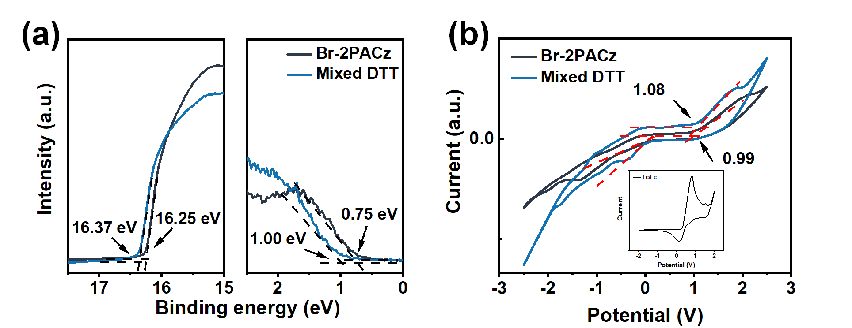
Supplementary Fig. 9 (a) UPS spectra of Br-2APCz and mixed DTT films. (b) Cyclic voltammograms of the Br-PACz and mixed DTT HTLs.

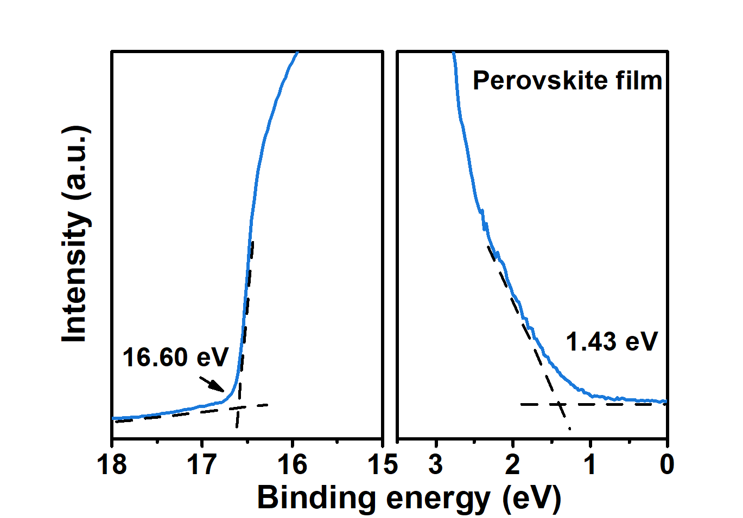
Supplementary Fig. 10 UPS spectra of blue perovskite film (HOMO level is 6.05 eV).

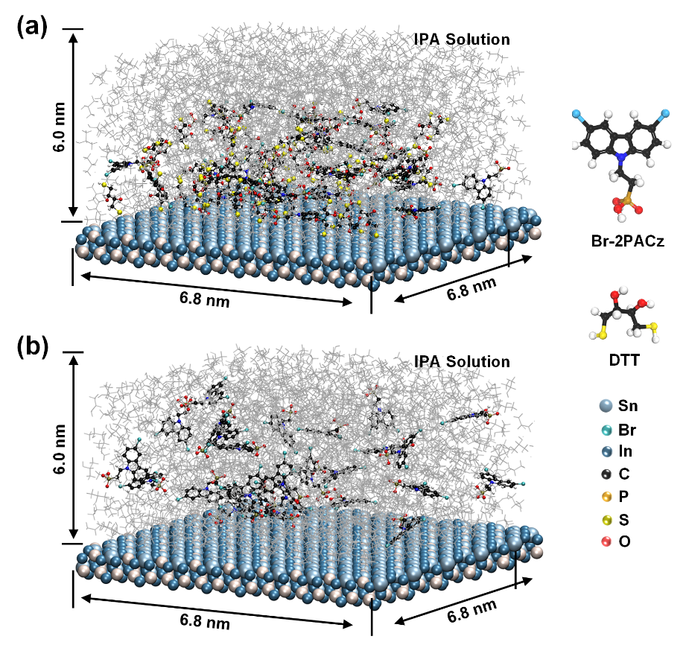
Supplementary Fig. 11 Illustration of the molecular dynamic simulations model for (a) mixed DTT and (b) Br-2PACz.

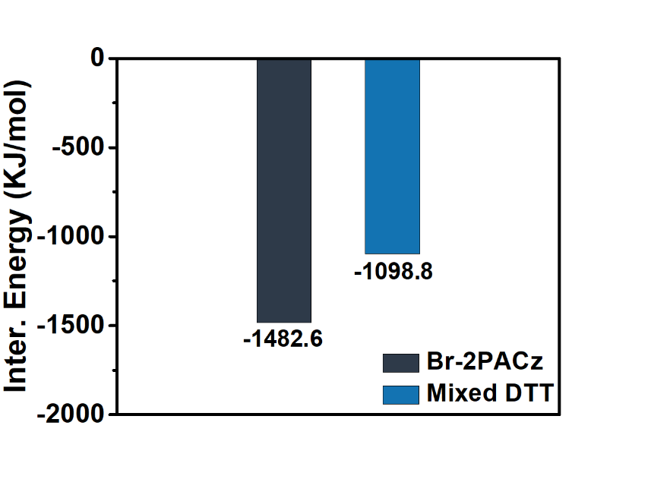
Supplementary Fig. 12 The calculated interaction energy among Br-2PACz molecule in the two MD models.

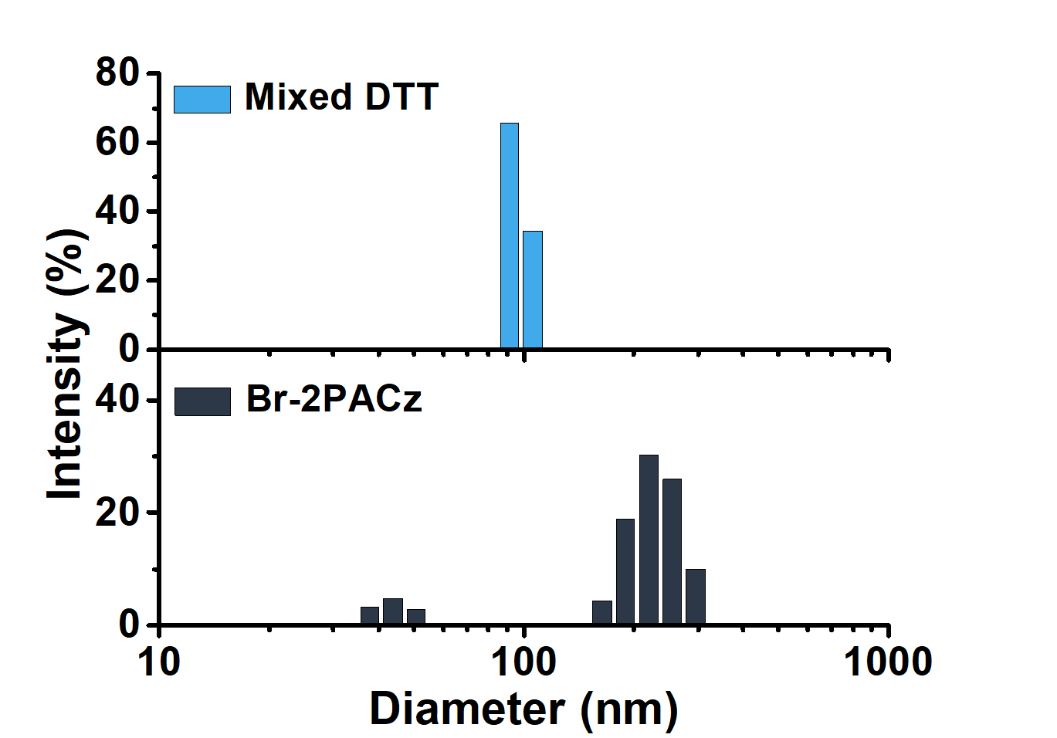
Supplementary Fig. 13 Size distribution of Br-2PACz and mixed DTT in IPA solution.

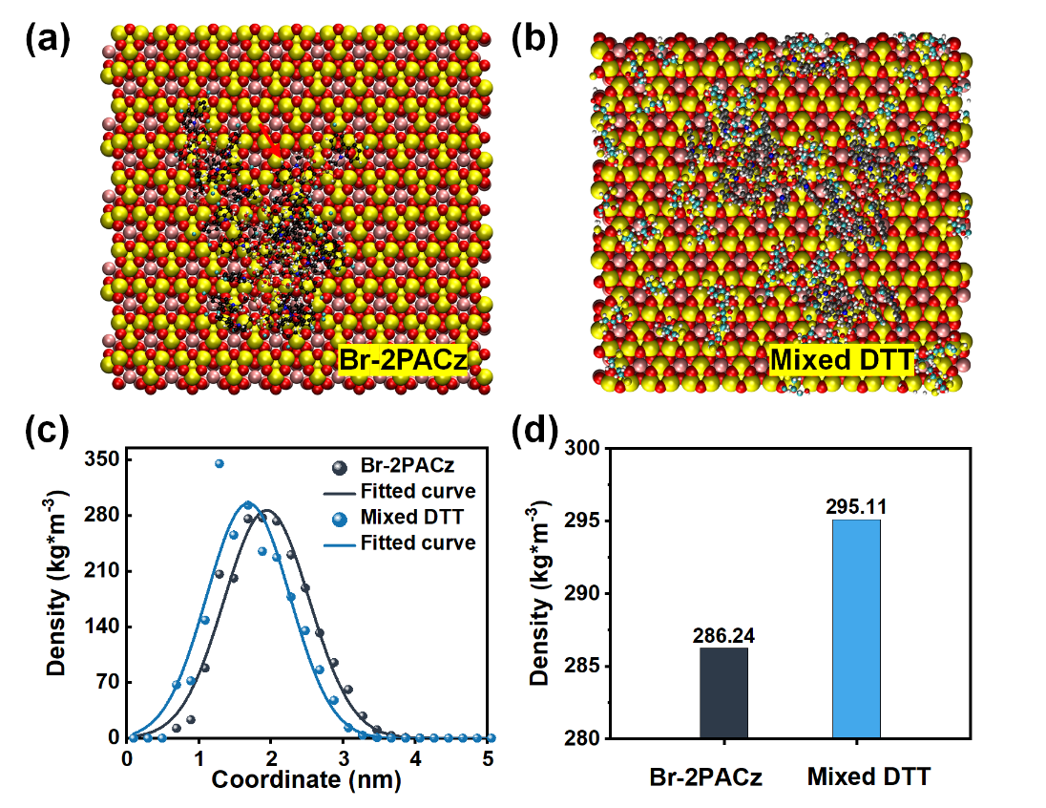
Supplementary Fig. 14 Top views of equilibrated molecular representations on the ITO of (a) Br-2PACz and (b) Br-2PACz mixed DTT. (c) The curve of molecular density distribution and (d) statistical average mass density of Br-2PACz on ITO surface throughout the entire simulation process.

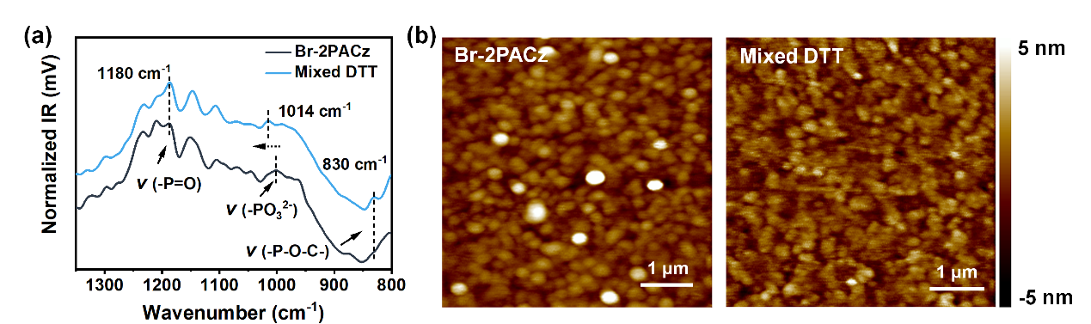
Supplementary Fig. 15 (a) AFM-IR spectra and (b) The surface morphology of samples corresponding to AFM-IR signals.

Supplementary Note 2: The model of Br-2PACz coverage on ITO substrate.
The density of self-assembly molecules on the substrate could be approximately given by the number of molecules in a unit volume on the surface, if all molecules are chemically immobilized on the substrate with maximized density. This ideal model has been used to study the fluorescent properties of the self-assembly film in the community of fluorescent film sensors, which is called “two-dimensional solution model”.^{[7]} Then, the coverage (R) of self-assembly molecules (Br-2PACz in this work) is given by the formula (1):
R = c₂/c₀ (1)
where c₀ is the ideally maximum density of Br-2PACz on ITO substrate, c₂ is the real density of Br-2PACz on ITO substrate. Theoretically, the π-π stacked Br-2PACz with face-to-face aggregation given rise a maximum density on the substrate (Supplementary Fig. 16b), while such conformation requires precise control of self-assembly. Therefore, the ideally maximum density is defined by a face-to-face parallel Br-2PACz molecule per unit volume of itself, due to the steric effect of the molecules, which is given by c₀ = 1/N_{A} H·L·W is ~ 5.71 × 10⁻³ mol/L, where N_{A} is Avogadro constant, H is the height of Br-2PACz ~ 1.047 nm, L is the length of Br-2PACz ~ 0.032 nm and W is width of Br-2PACz ~ 0.868 nm.
Then, the real density c₂ of Br-2PACz on ITO substrate could be approximately calculated from the optical absorbance compassion of Br-2PACz solution according to Lambert-Beer’s law: A = ε·c·l, where A represents the absorbance, ε is molar absorption coefficient, c is concentration of Br-2PACz in solution, and l is the optical path length. By applying the “two-dimensional solution model”, we propose that the immobilized Br-2PACz molecules on ITO surface have same ε molar absorption coefficient with that in solution, that is ε₁ = ε₂, where ε₁ is the molar absorption coefficient of Br-2PACz molecules in solution, and ε₂ is the molar absorption coefficient of Br-2PACz molecules on ITO substrate. Measuring the absorption of Br-2PACz solution with certain concentration and Br-2PACz film on ITO substrate, respectively. Keeping all equipment parameters remained precisely consistent for the two measurements. Then we have,
A₁ = ε₁·c₁·1₁ for solution (2)
A₂ = ε₂·c₂·1₂ for film (3)
Adjusting concentration of Br-2PACz solution, making A₁ as closed to A₂ as possible to reduce the non-linear optical error between the two measurements. Then, we have c₂ =·A₂ c₁·1₁/A₁·1₂, c₁ = 0.360 mg/mL in isopropyl alcohol, and the parameters are summarized in Supplementary Table 3. Finally, the R of Br-2PACz on ITO substrate with and without DTT are 96.14% and 55.86%, respectively.
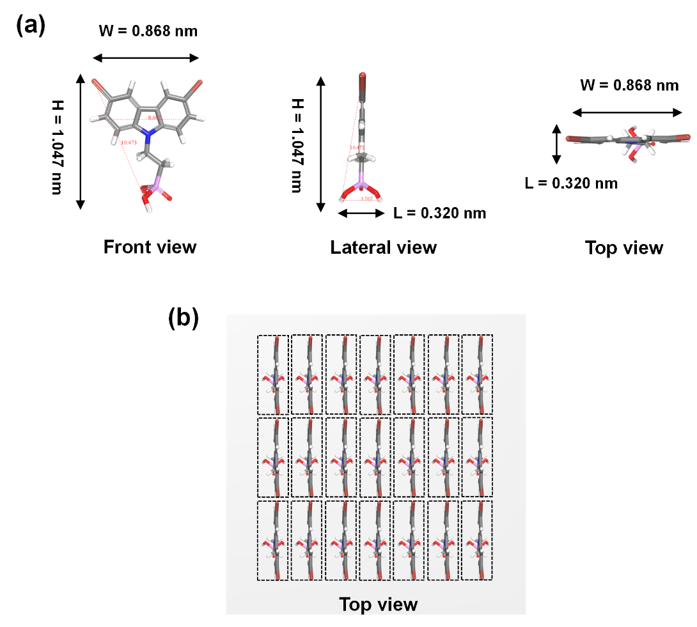
Supplementary Fig. 16 (a) The volume of a single Br-2PACz molecular. (b) arbitrary directional distribution and (c) ideal π-π stacking of the Br-2PACz molecular assembly on ITO substrates.
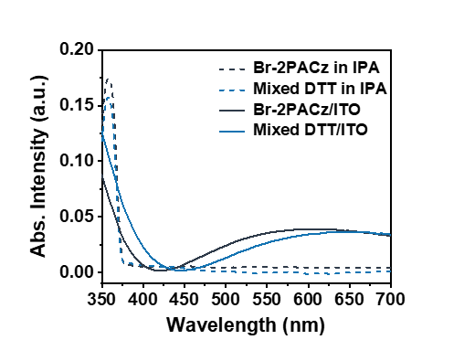
Supplementary Fig. 17 The Uv-vis spectra of Br-2APCz and mixed DTT in precursor solution and spin-coating on ITO substrates.

Supplementary Table 3. The extracted absorbance from the Uv-vis spectrum.
Samples | A (%) | c₂ (mol/L) | l (nm)
Br-2PACz  in IPA | 0.174 | 8.31×10⁻¹⁰ | 1.0×10⁷
Adding DTT  in IPA | 0.156 | 8.31×10⁻¹⁰ | 1.0×10⁷
Br-2PACz  on ITO | 0.070 | 3.19×10⁻³ | 1.047
Adding DTT on ITO | 0.108 | 5.49×10⁻³ | 1.047

Supplementary Note 3: Investigations on a series of PACz molecules with different alkyl spacer lengths and functionalized head substituents.
We extended our investigation to a series of representative PACz molecules featuring varied alkyl spacer lengths and functionalized head substituents (molecular structures shown in Supplementary Fig. 18a). These compounds were thoroughly mixed with DTT via vigorous stirring, followed by filtration, spin-coating onto ITO substrates, and annealing at 100°C for 10 minutes to obtain Co-SAM films (detailed procedures provided in the Experimental Section). Atomic Force Microscope (AFM) and Kelvin probe force microscopy (KPFM) characterization of the fabricated Co-SAM films revealed significantly reduced surface roughness and lowered contact potential difference (CPD) in all DTT involved films (Supplementary Fig. 18-25). These observations indicate enhanced assembly uniformity and improved substrate coverage density of PACz molecules on ITO surfaces. Therefore, DTT incorporation proves to be a universal strategy for optimizing the assembly process of PACz-based SAM, achieving higher packing density and enhanced structural homogeneity in self-assembled films and improving its carrier transport properties.
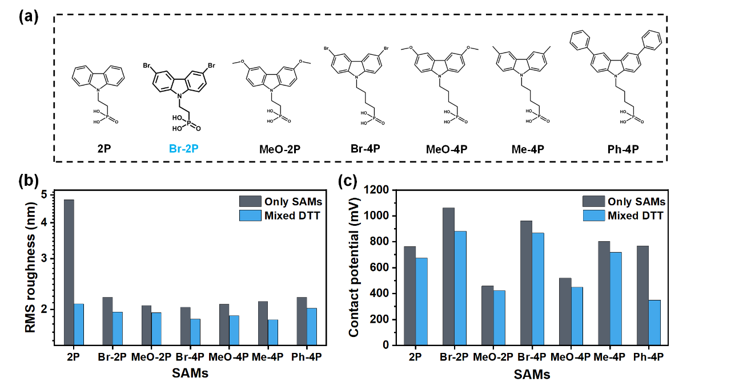
Supplementary Fig. 18 (a) Molecular structures featuring the PACz skeleton beyond Br-2PACz. Statistical graphs of (b) surface roughness and (c) CPD of PACz self-assembled films with and without DTT.
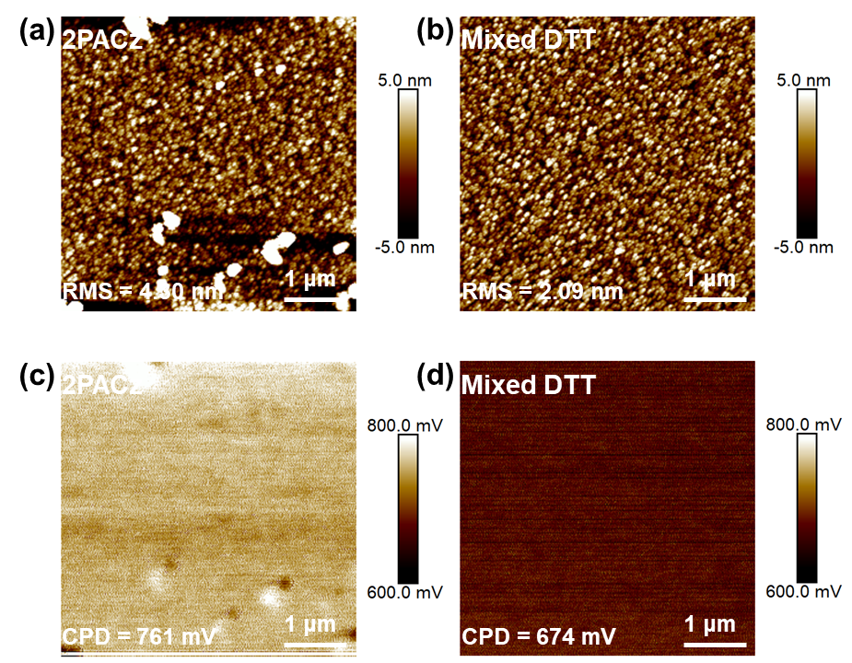
Supplementary Fig. 19 The surface roughness and contact potential difference of (a, c) 2PACz and (b, d) mixed DTT films.

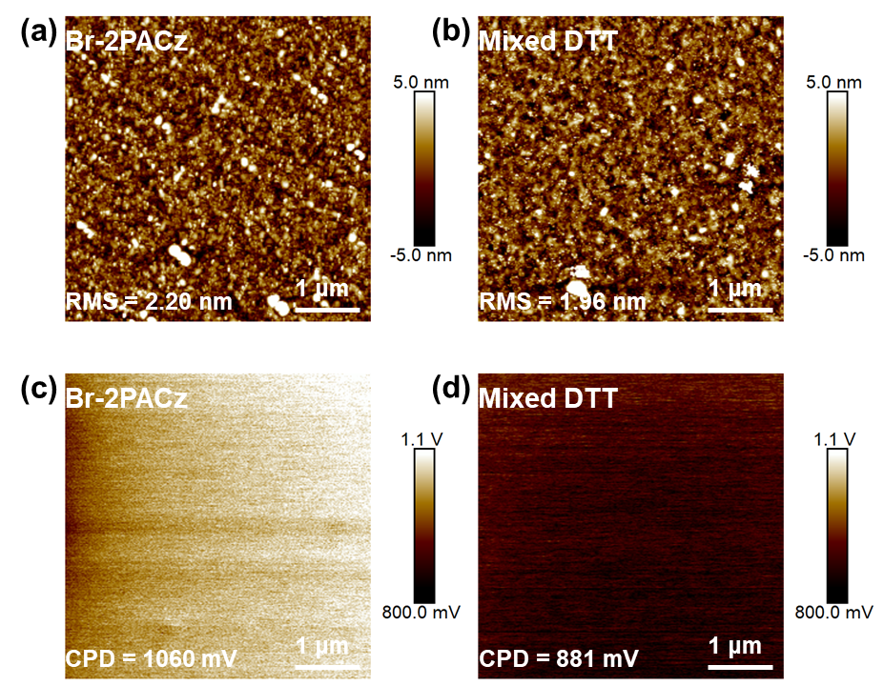
Supplementary Fig. 20 The surface roughness and contact potential difference of (a, c) Br-2PACz and (b, d) mixed DTT films.

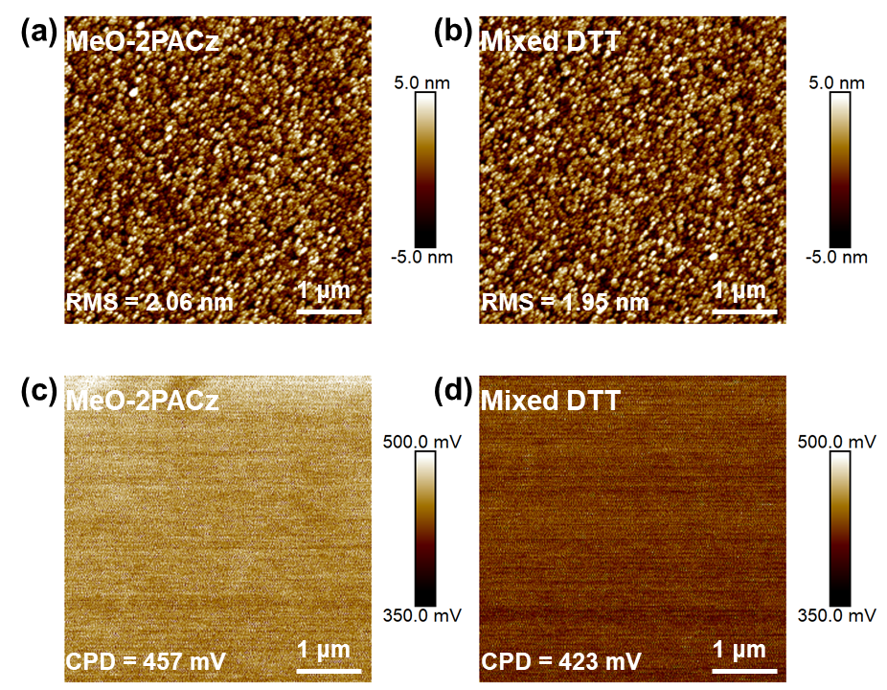
Supplementary Fig. 21 The surface roughness and contact potential difference of (a, c) MeO-2PACz and (b, d) mixed DTT films.

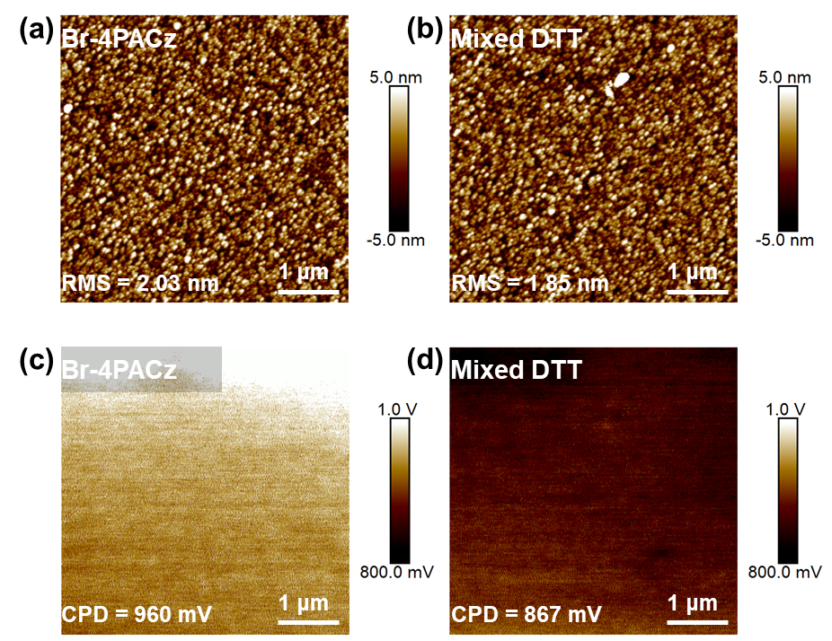
Supplementary Fig. 22 The surface roughness and contact potential difference of (a, c) Br-4PACz and (b, d) mixed DTT films.

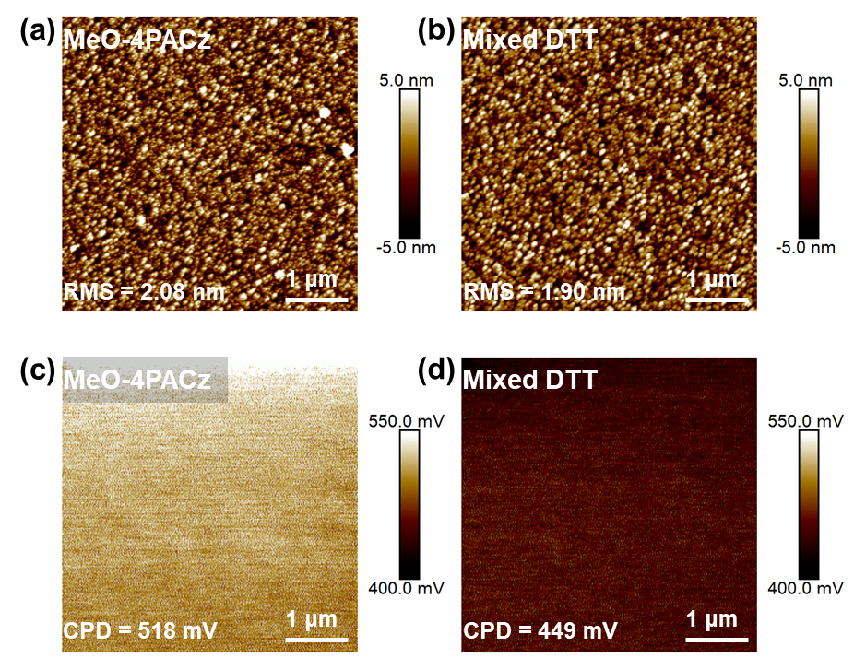
Supplementary Fig. 23 The surface roughness and contact potential difference of (a, c) MeO-4PACz and (b, d) mixed DTT films.

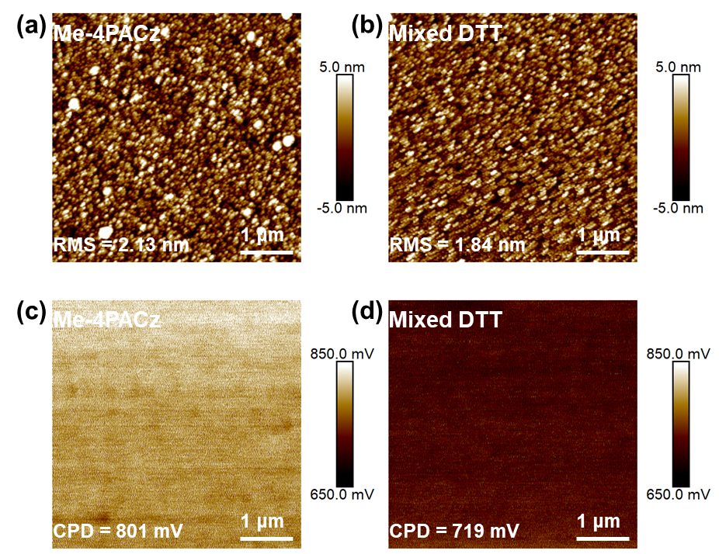
Supplementary Fig. 24 The surface roughness and contact potential difference of (a, c) Me-4PACz and (b, d) mixed DTT films.

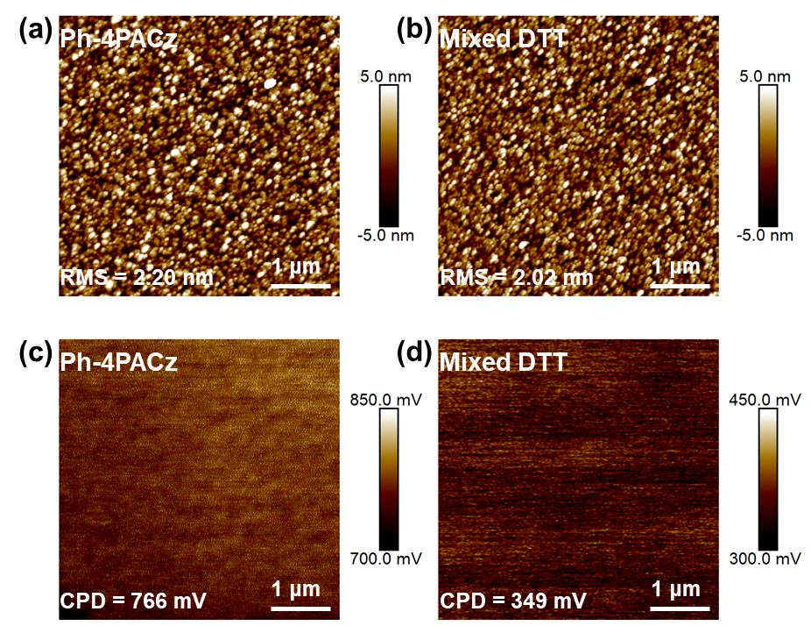
Supplementary Fig. 25 The surface roughness and contact potential difference of (a, c) Ph-4PACz and (b, d) mixed DTT films.

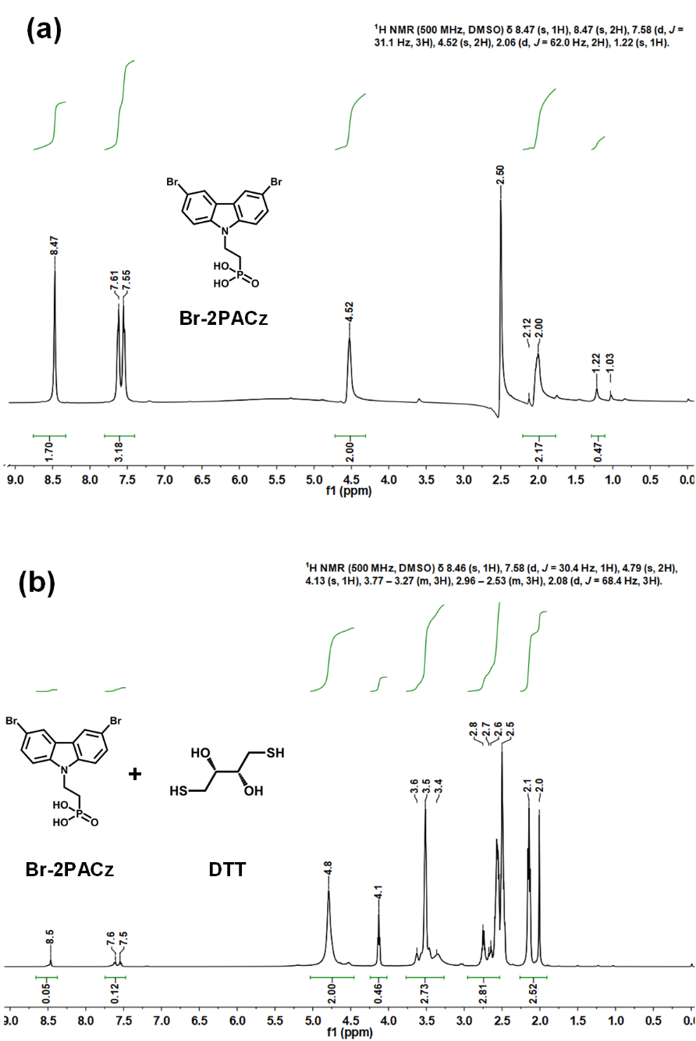
Supplementary Fig. 26 The original ¹H NMR spectra of (a) Br-2PACz and (b) Br-2PACz with DTT in DMSO-d₆.

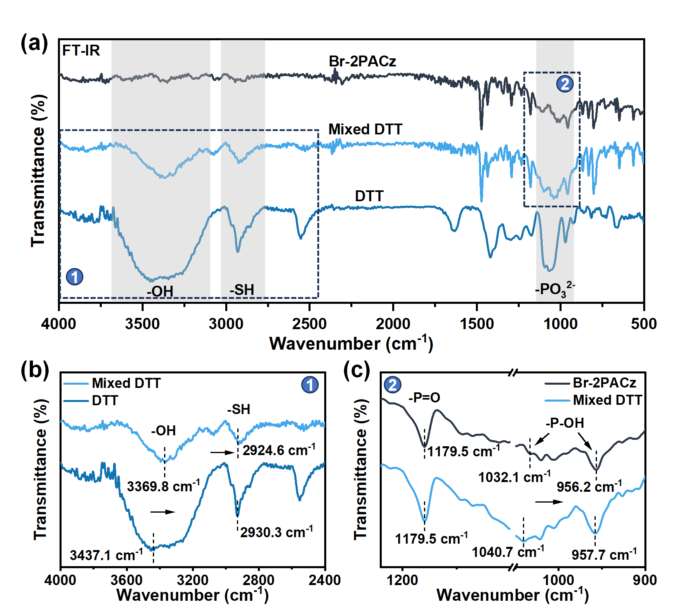
Supplementary Fig. 27 FT-IR spectra of Br-2PACz with and without DTT powder.
In spectra ①, the fingerprint signal at 2930.3 cm⁻¹ and 3437.1 cm⁻¹ could attribute to the -SH and -OH vibrations of DTT, respectively.^{[8]} In spectra ②, the fingerprint signal at 1032.1 cm⁻¹ and 956.2 cm⁻¹ could attribute to the -P-OH vibrations.^{[9]} After with DTT addition, a remarkable redshift exhibited for those vibrations, indicating the formation of hydrogen bonds between the DTT and Br-2PACz precursor solution.

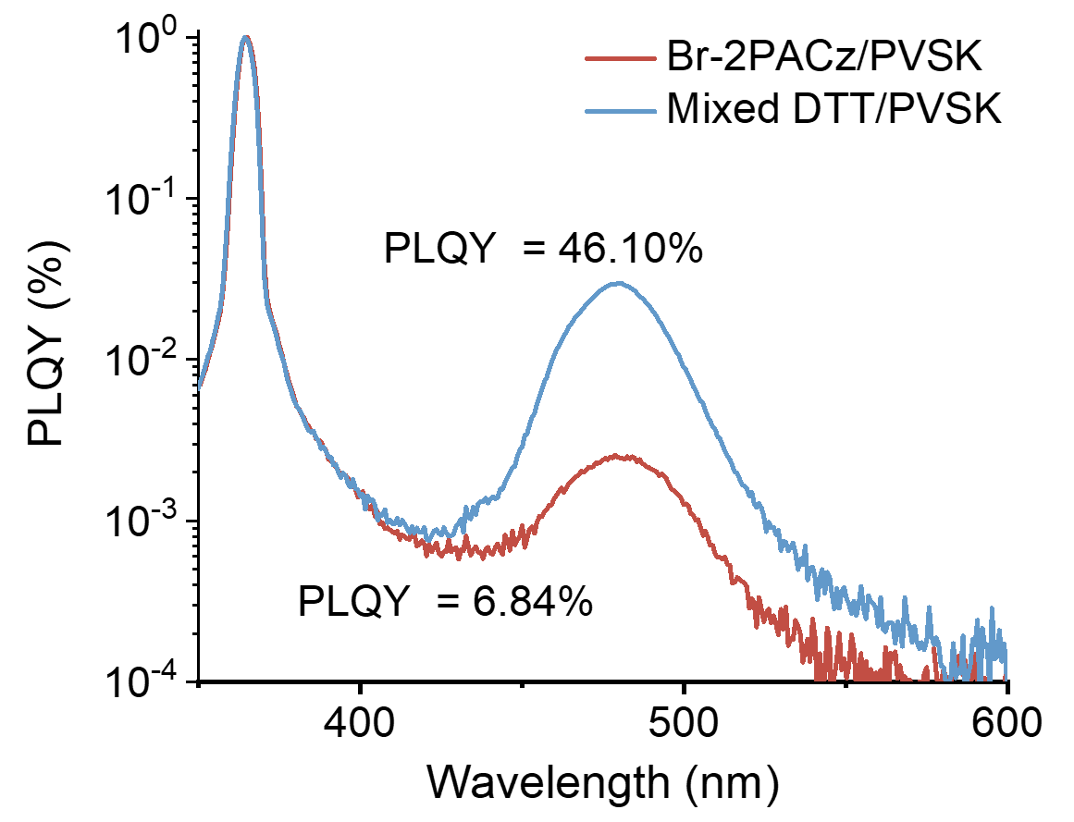
Supplementary Fig. 28 PLQY of air-processed perovskite films.

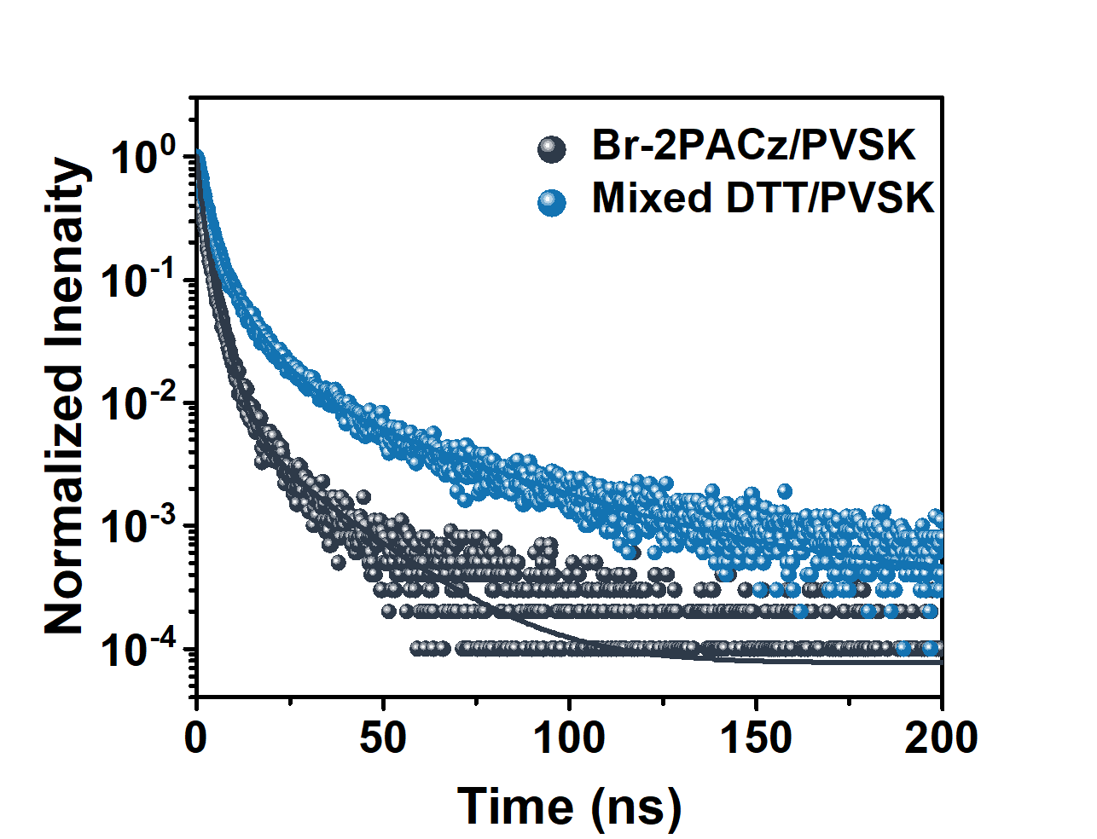
Supplementary Fig. 29 TRPL spectra of air-processed perovskite films on different HTLs.
Supplementary Table 4. The fitted carrier lifetime for TRPL of perovskite on HTLs.
Parameters | Br-2PACz/PVSK | Mixed DTT/PVSK
A₁ (%)  τ₁ (ns) | 0.25 | 0.81
A₁ (%)  τ₁ (ns) | 3.54 | 2.19
A₂ (%)  τ₂ (ns) | 0.75 | 0.21
A₂ (%)  τ₂ (ns) | 1.28 | 7.87
A₃ (%)  τ₃ (ns) | 0.009 | 0.020
A₃ (%)  τ₃ (ns) | 18.956 | 38.039
τ_{avg} (ns) | 3.78 | 10.94
The TRPL curves fitted with tri-exponential function, I (t)= I₀ + A₁ exp(-t/τ₁) + A₂ exp(-t/τ₂) + A₃ exp(-t/τ₃), where A₁, A₂ and A₃ are the amplitudes, τ₁, τ₂ and τ₃ represents the fast decay, middle decay and slow decay time refer to nonradiative recombination and radiative recombination, respectively.

Supplementary Note 4 Carrier dynamics of perovskite on different substrates.
The transient-absorption (TA) measurements were performed to investigate the n phase distribution and energy transfer dynamics in the quasi-2D perovskite films. The two ground-state bleach (GSB) peaks at ~ 432 nm and ~ 460 nm in TA spectra are attributed to the n = 2 and n = 3 phases, respectively.^{[10]} The n = 2 phase dominated distribution is consistent with the absorption spectra of the perovskite films (Supplementary Fig. 30c).^{[11]}
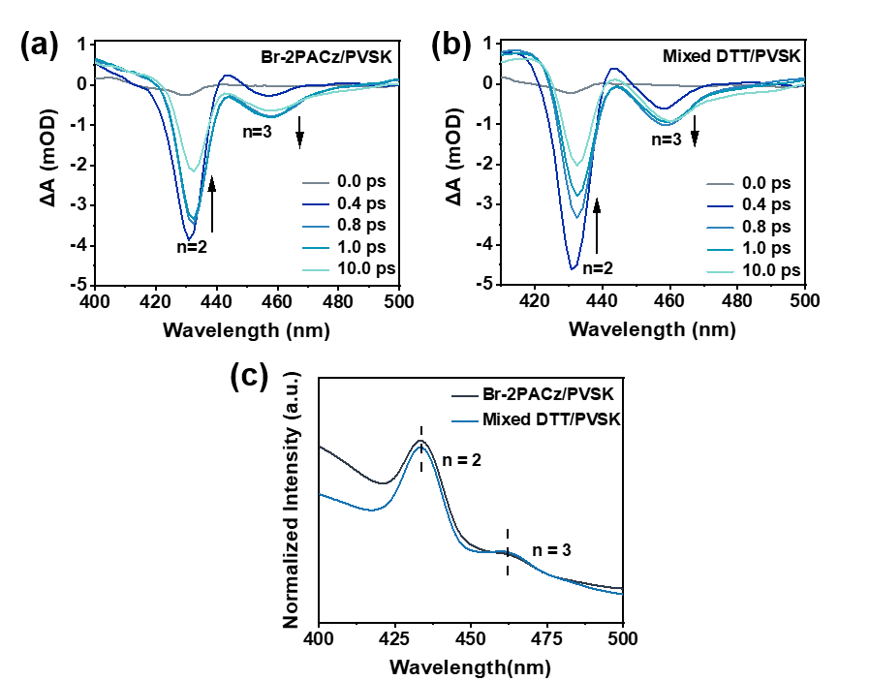
Supplementary Fig. 30 (a, b) TA spectra and (c) UV-vis absorption spectra of the perovskite films on different substrates.

The wavelength- and time-resolved TA datasets were then analyzed using two complementary global approaches: global sequential analysis and lifetime density distribution (LDD) analysis. In both approaches, the complete wavelength-time matrix was fitted simultaneously, with the kinetic parameters shared across all probe wavelengths and the corresponding spectral amplitudes allowed to vary with wavelength.
For the global sequential analysis (Supplementary Fig. 30), the TA data were described using an irreversible three-stage model, S1 → S2 → S3. The temporal evolution of the three components was governed by
$$\frac{dc(t)}{dt}=Kc(t)$$
where $c(t)$ contains the time-dependent populations of the three sequential components and $K$ is the rate matrix containing the fitted rate constants, with k_{i} = 1/τ_{i}. The calculated TA response was expressed as
$$∆A_{fit}\left(λ,t\right)=g(t)⨂\sum_{i=1}^{3}{c_{i}(t){EAS}_{i}(λ)}$$
where ${EAS}_{i}(λ)$ is the evolution-associated spectrum of component $i$, $g(t)$ represents the instrument response function, and $⨂$ denotes convolution. A common set of time constants was applied over the entire probe-wavelength range, while the three evolution-associated spectra were determined globally. The resulting EAS describe successive stages of the photoinduced spectral evolution: EAS1 corresponds to the initial response, EAS2 to the intermediate response after the first kinetic step, and EAS3 to the later response formed after further evolution.
The same datasets were also analyzed using LDD (Supplementary Fig. 31), which represents the wavelength-resolved TA kinetics as a continuous distribution of exponential decays. The TA signal was expressed as:
$$∆A\left(λ,t\right)=\int_{0}^{∞}{Φ(λ,t)exp⁡(-t/τ)dτ}$$
where $λ$ is the probe wavelength and $Φ(λ,t)$ is the wavelength-dependent lifetime distribution function associated with lifetime $τ$. For numerical analysis, the integral was discretized into a quasi-continuous sum of exponential functions. A total of 100 lifetimes were logarithmically distributed between 0.03 and 10000 ps, and the same lifetime grid was applied across the entire probe-wavelength range. The resulting lifetime-dependent amplitudes were displayed as two-dimensional lifetime-wavelength distribution maps. This approach provides an overview of the distributed kinetics without restricting the analysis to a small number of discrete time constants.

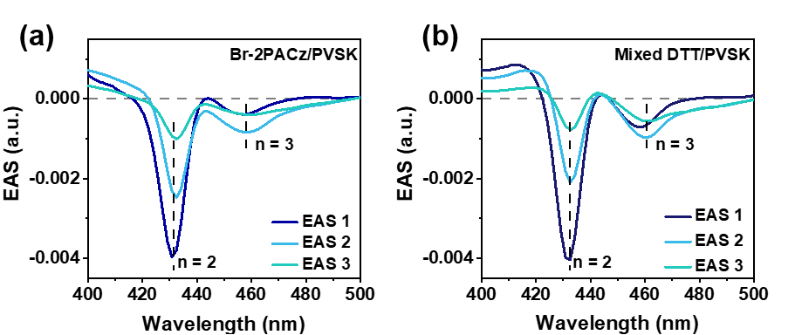
Supplementary Fig. 31 Evolution-associated spectra (EAS) obtained from global sequential analysis of the TA data.

Supplementary Table 5. Evolution of the n = 3/n = 2 bleach-amplitude ratio obtained from the EAS.
EAS stage | Kinetic stage | Br-2PACz/PVSK | Mixed DTT/PVSK
EAS 1 | initial response | 0.10 | 0.18
EAS 2 | intermediate response | 0.35 | 0.46
EAS 3 | later response | 0.40 | 0.71

The data were globally fitted using a sequential model, yielding evolution-associated spectra (EAS) with a common set of time constants across all probe wavelengths. The three EAS represent successive stages of the photoexcited response: S1 describes the initial response, S2 the intermediate response after the first kinetic step, and S3 the later response formed after further evolution. In both films, the n = 2 bleach near 433 nm weakens from S1 to S3, while the relative contribution of the n = 3 bleach near 459 nm increases. In the control film, R_{(n = 3/n = 2)} increases from 0.10 in S1 to 0.35 in S2 and 0.40 in S3, whereas the corresponding values in the target film are 0.18, 0.46, and 0.71. The final-stage ratio is therefore about 1.8 times higher in the target film, showing a stronger shift of the excited-state response toward the lower-energy n = 3 domains.

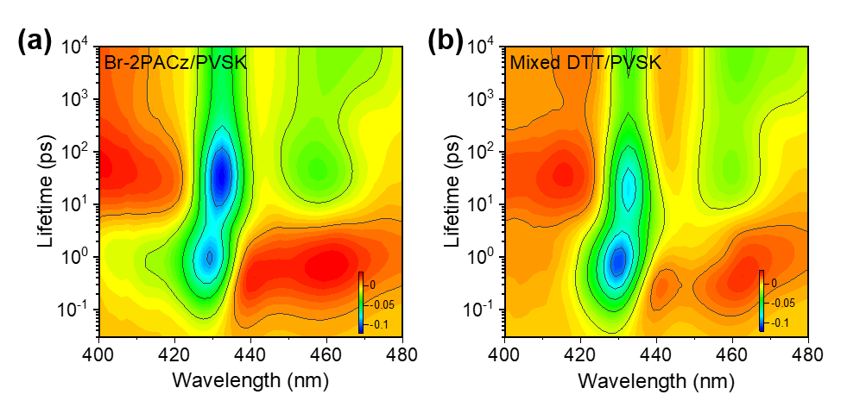
Supplementary Fig. 32 Lifetime-density mapping of those perovskite films on the different substrates.
Lifetime-density analysis decomposes the wavelength-resolved TA response into a quasi-continuous distribution of lifetime-associated amplitudes, such that each feature identifies the spectral location, characteristic timescale, and relative contribution of a kinetic process. For a negative bleach band, a negative feature describes its recovery at the corresponding lifetime, whereas a short-lived positive feature paired with longer-lived negative contributions reflects the buildup of the bleach. For example, the positive sub-ps feature near 459 nm represents the formation of the n = 3 bleach, while the negative contributions at longer lifetimes describe its subsequent persistence and recovery.
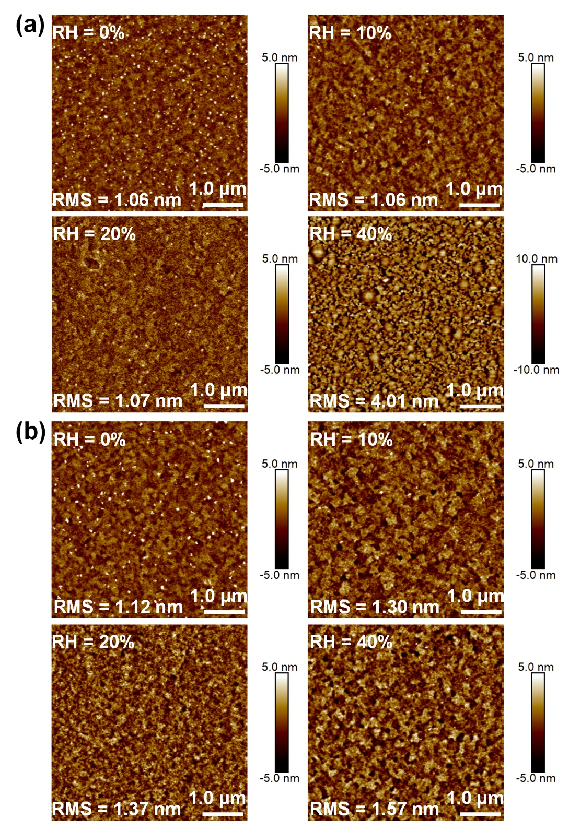
Supplementary Fig. 33 The AFM images of perovskite films prepared under different ambient humidity on (a) Br-PACz and (b) mixed DTT substrates.

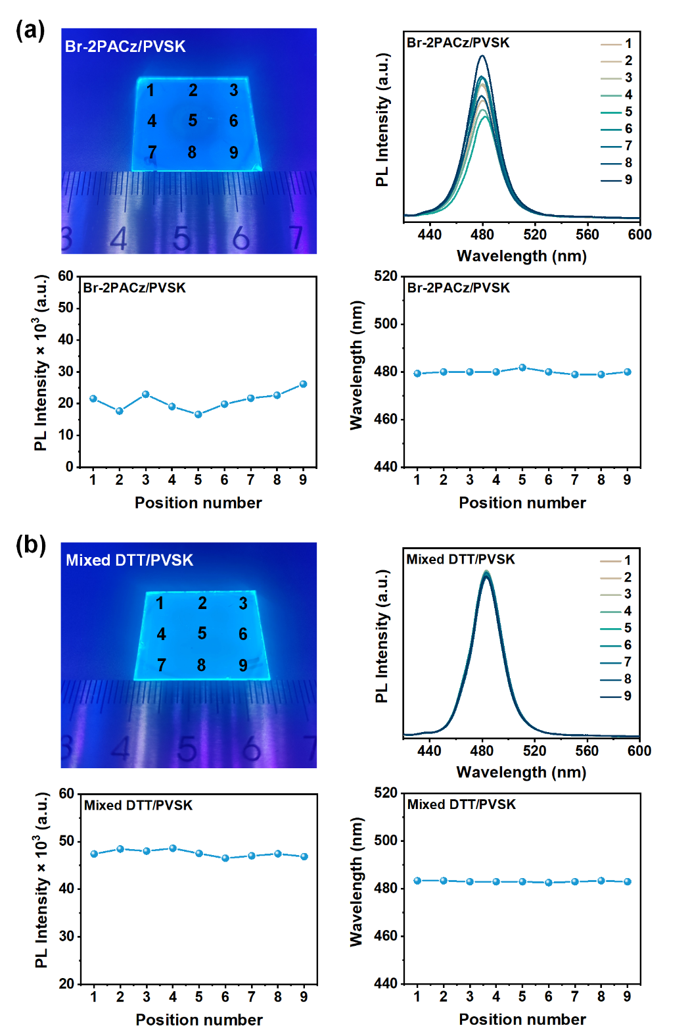
Supplementary Fig. 34 The photoluminescent uniformity of large-area perovskite films with an area of 2.5 cm × 2.5 cm on (a) Br-PACz and (b) mixed DTT substrates.

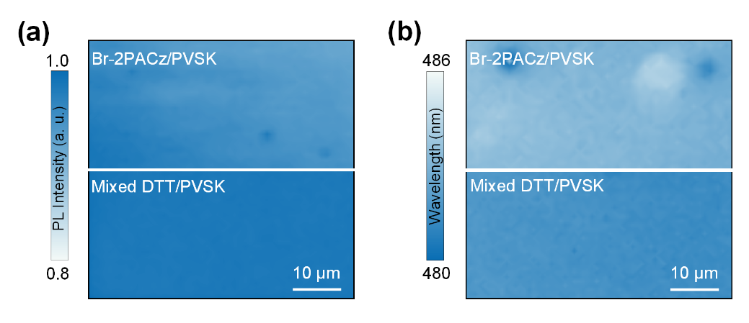
Supplementary Fig. 35 (a) PL mapping and (b) emission wavelength uniformity for air-processed perovskite films on Br-2PACz and mixed DTT substrates.

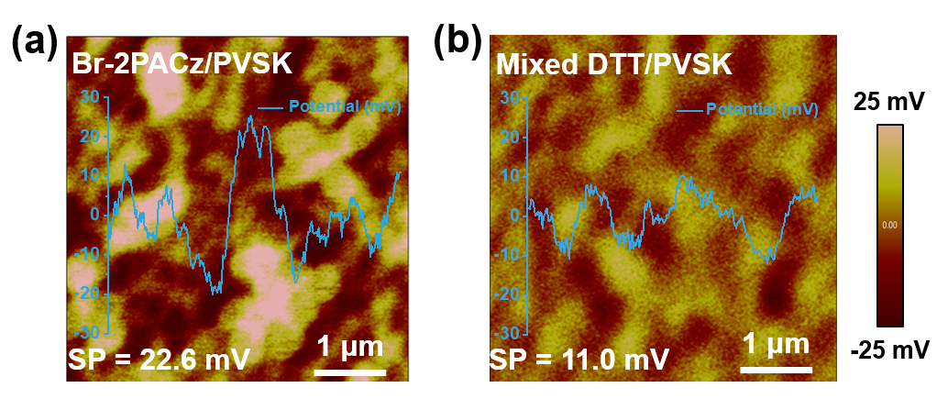
Supplementary Fig. 36 KPFM images of the air-processed perovskite films.

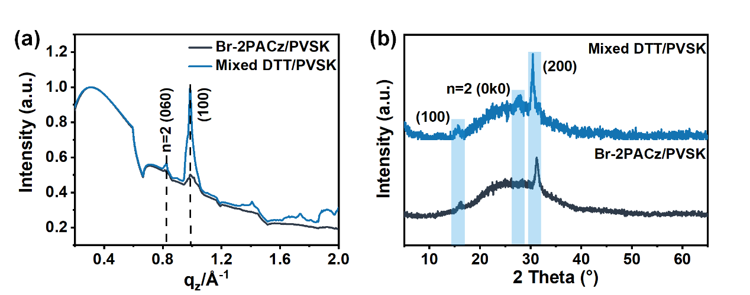
Supplementary Fig. 37 (a) 1D patterns of the perovskite films based on GIWAXS results. (b) XRD patterns.

Supplementary Note 5 Crystallization kinetics of perovskite on different substrates.
We conducted in-situ PL measurements to further study the crystallization kinetic of the perovskite on Br-2PACz with and without DTT substrates. All measurement conditions (e.g., distance between the fiber and perovskite films, excitation power, etc.) are strictly controlled to allow the comparison of PL intensity for different films. As show in Supplementary Fig. 38, during the spin-coating process, the signals at the 435 nm, 465 nm and 478 nm could attribute to the PL emission of n = 2, n = 3 and n ≥ 4 phases in the quasi-2D perovskite, and those PL intensities exhibited a gradual enhancement following the introduction of anti-solvent at 40 seconds. Notably, on the DTT involved substrate film, higher-n phases (n = 3 and n = 4) demonstrated similar growth rates (Supplementary Fig. 39), which effectively promoted the proportion of higher-n phases in the perovskite film and amplified the “energy funneling” effect in the quasi-2D perovskite film.
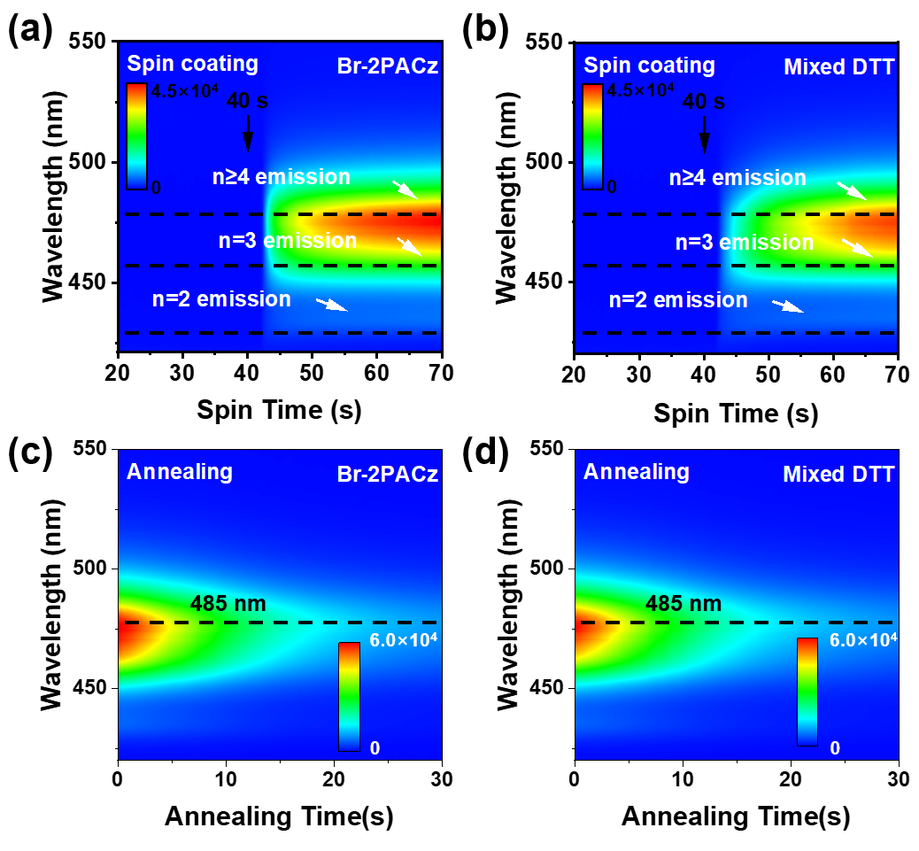
Supplementary Fig. 38 In-situ PL spectra during (a, b) spin coating and (c, d) annealing process for air-processed perovskite (excitation wavelength at 365 nm, T ≈ 21 ℃, RH ≈ 20 %).
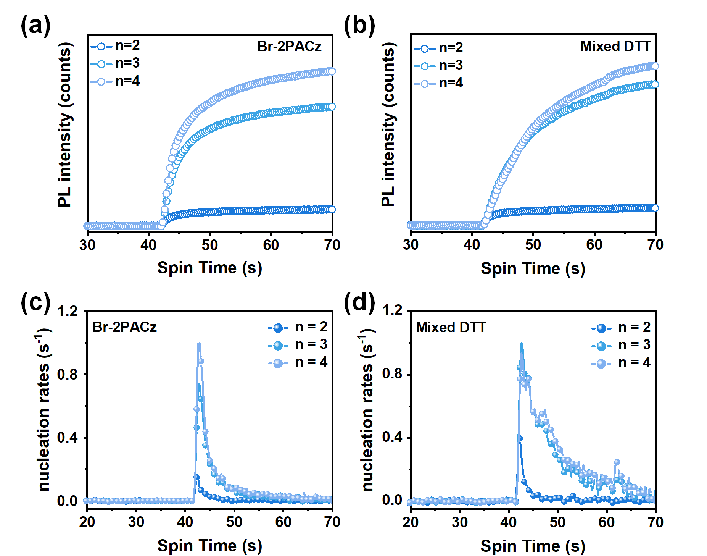
Supplementary Fig. 39 The extracted PL intensity values from the spin-coating in situ PL spectrum (a, b) and their corresponding first-order derivatives (c, d).

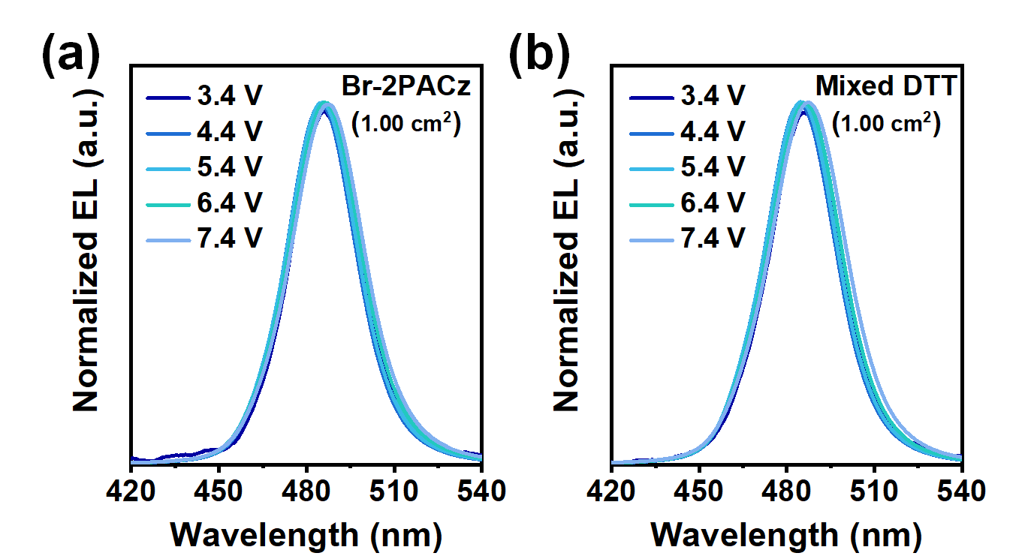
Supplementary Fig. 40 The EL spectra of air-processed blue PeLEDs (1.00 cm²).

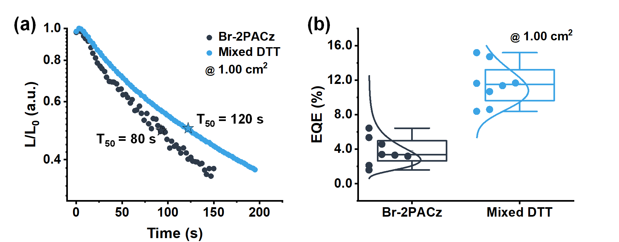
Supplementary Fig. 41 (a) operational stability measurement of T₅₀ (the initial luminance is 100 cd m⁻²) for air-processed large-area blue PeLEDs (1.00 cm²). (b) The statistic of EQE for 8 air-processed large-area blue PeLEDs (1.00 cm²).

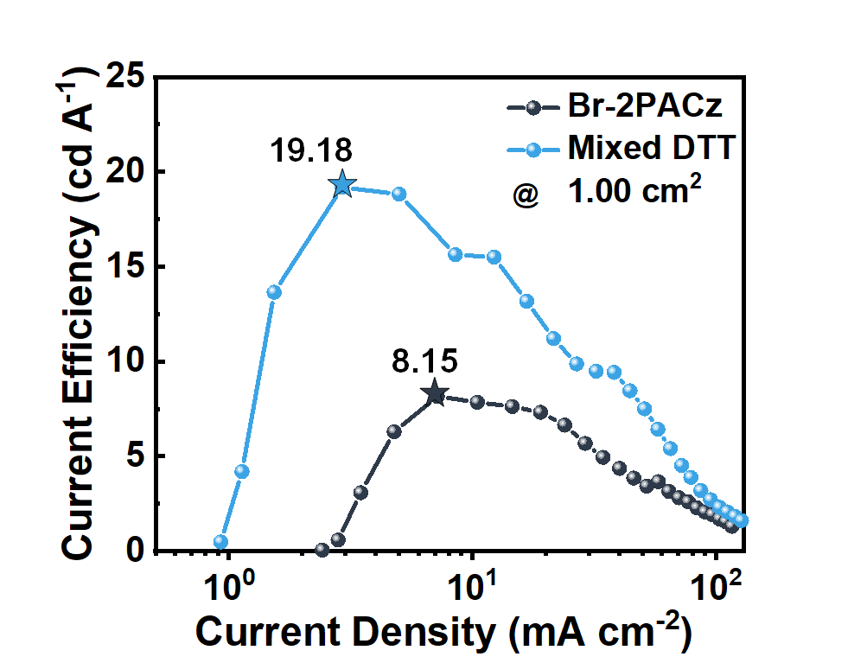
Supplementary Fig.42 The current efficiency-current density (CE-J) curve of air-processed large-area blue PeLEDs (1.00 cm²).

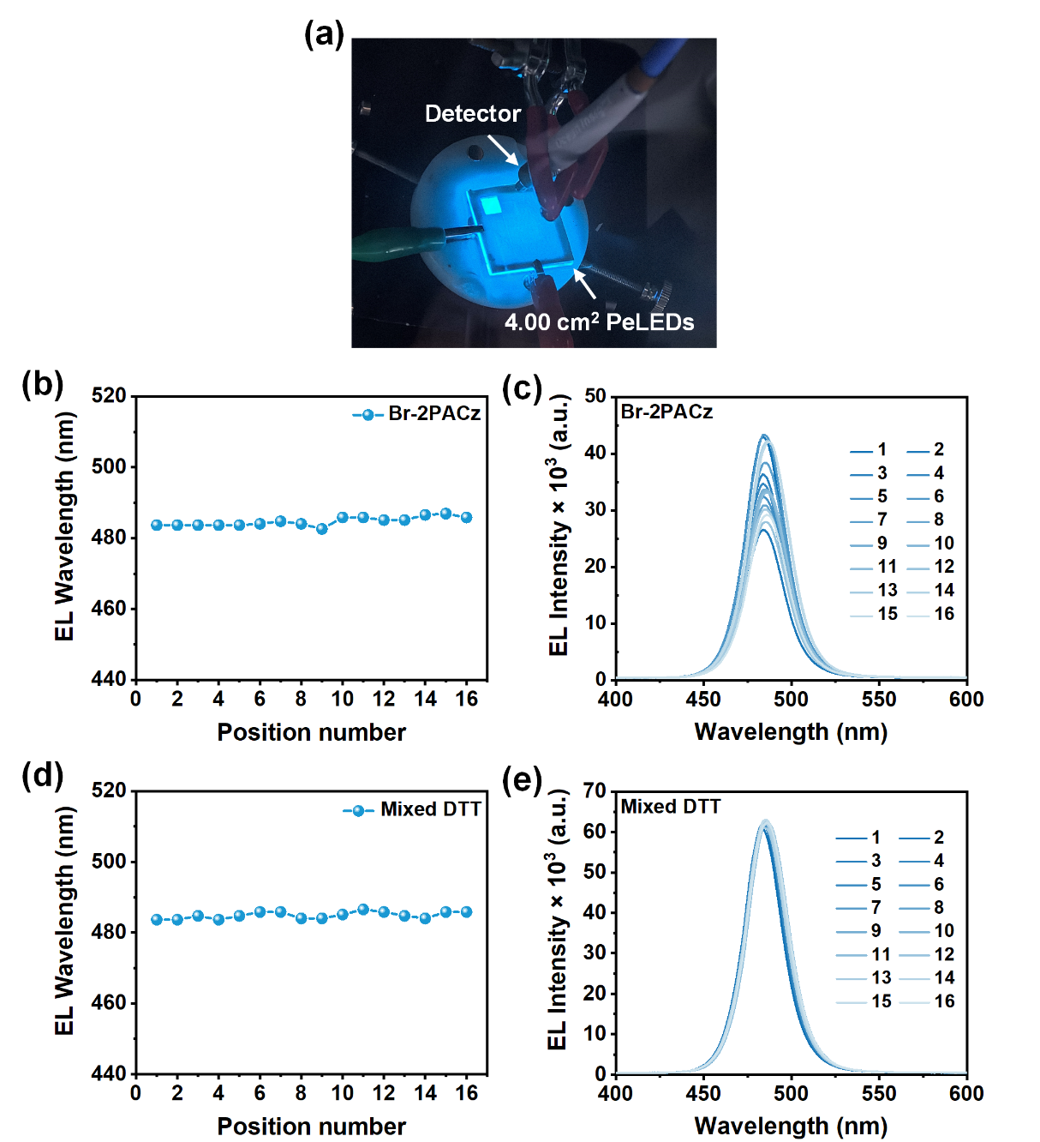
Supplementary Fig. 43 The electroluminescence uniformity testing of air-processed large-area blue PeLEDs. (The mask of EL uniformity test for large-area PeLEDs features square holes with area of 5 × 5 mm²).

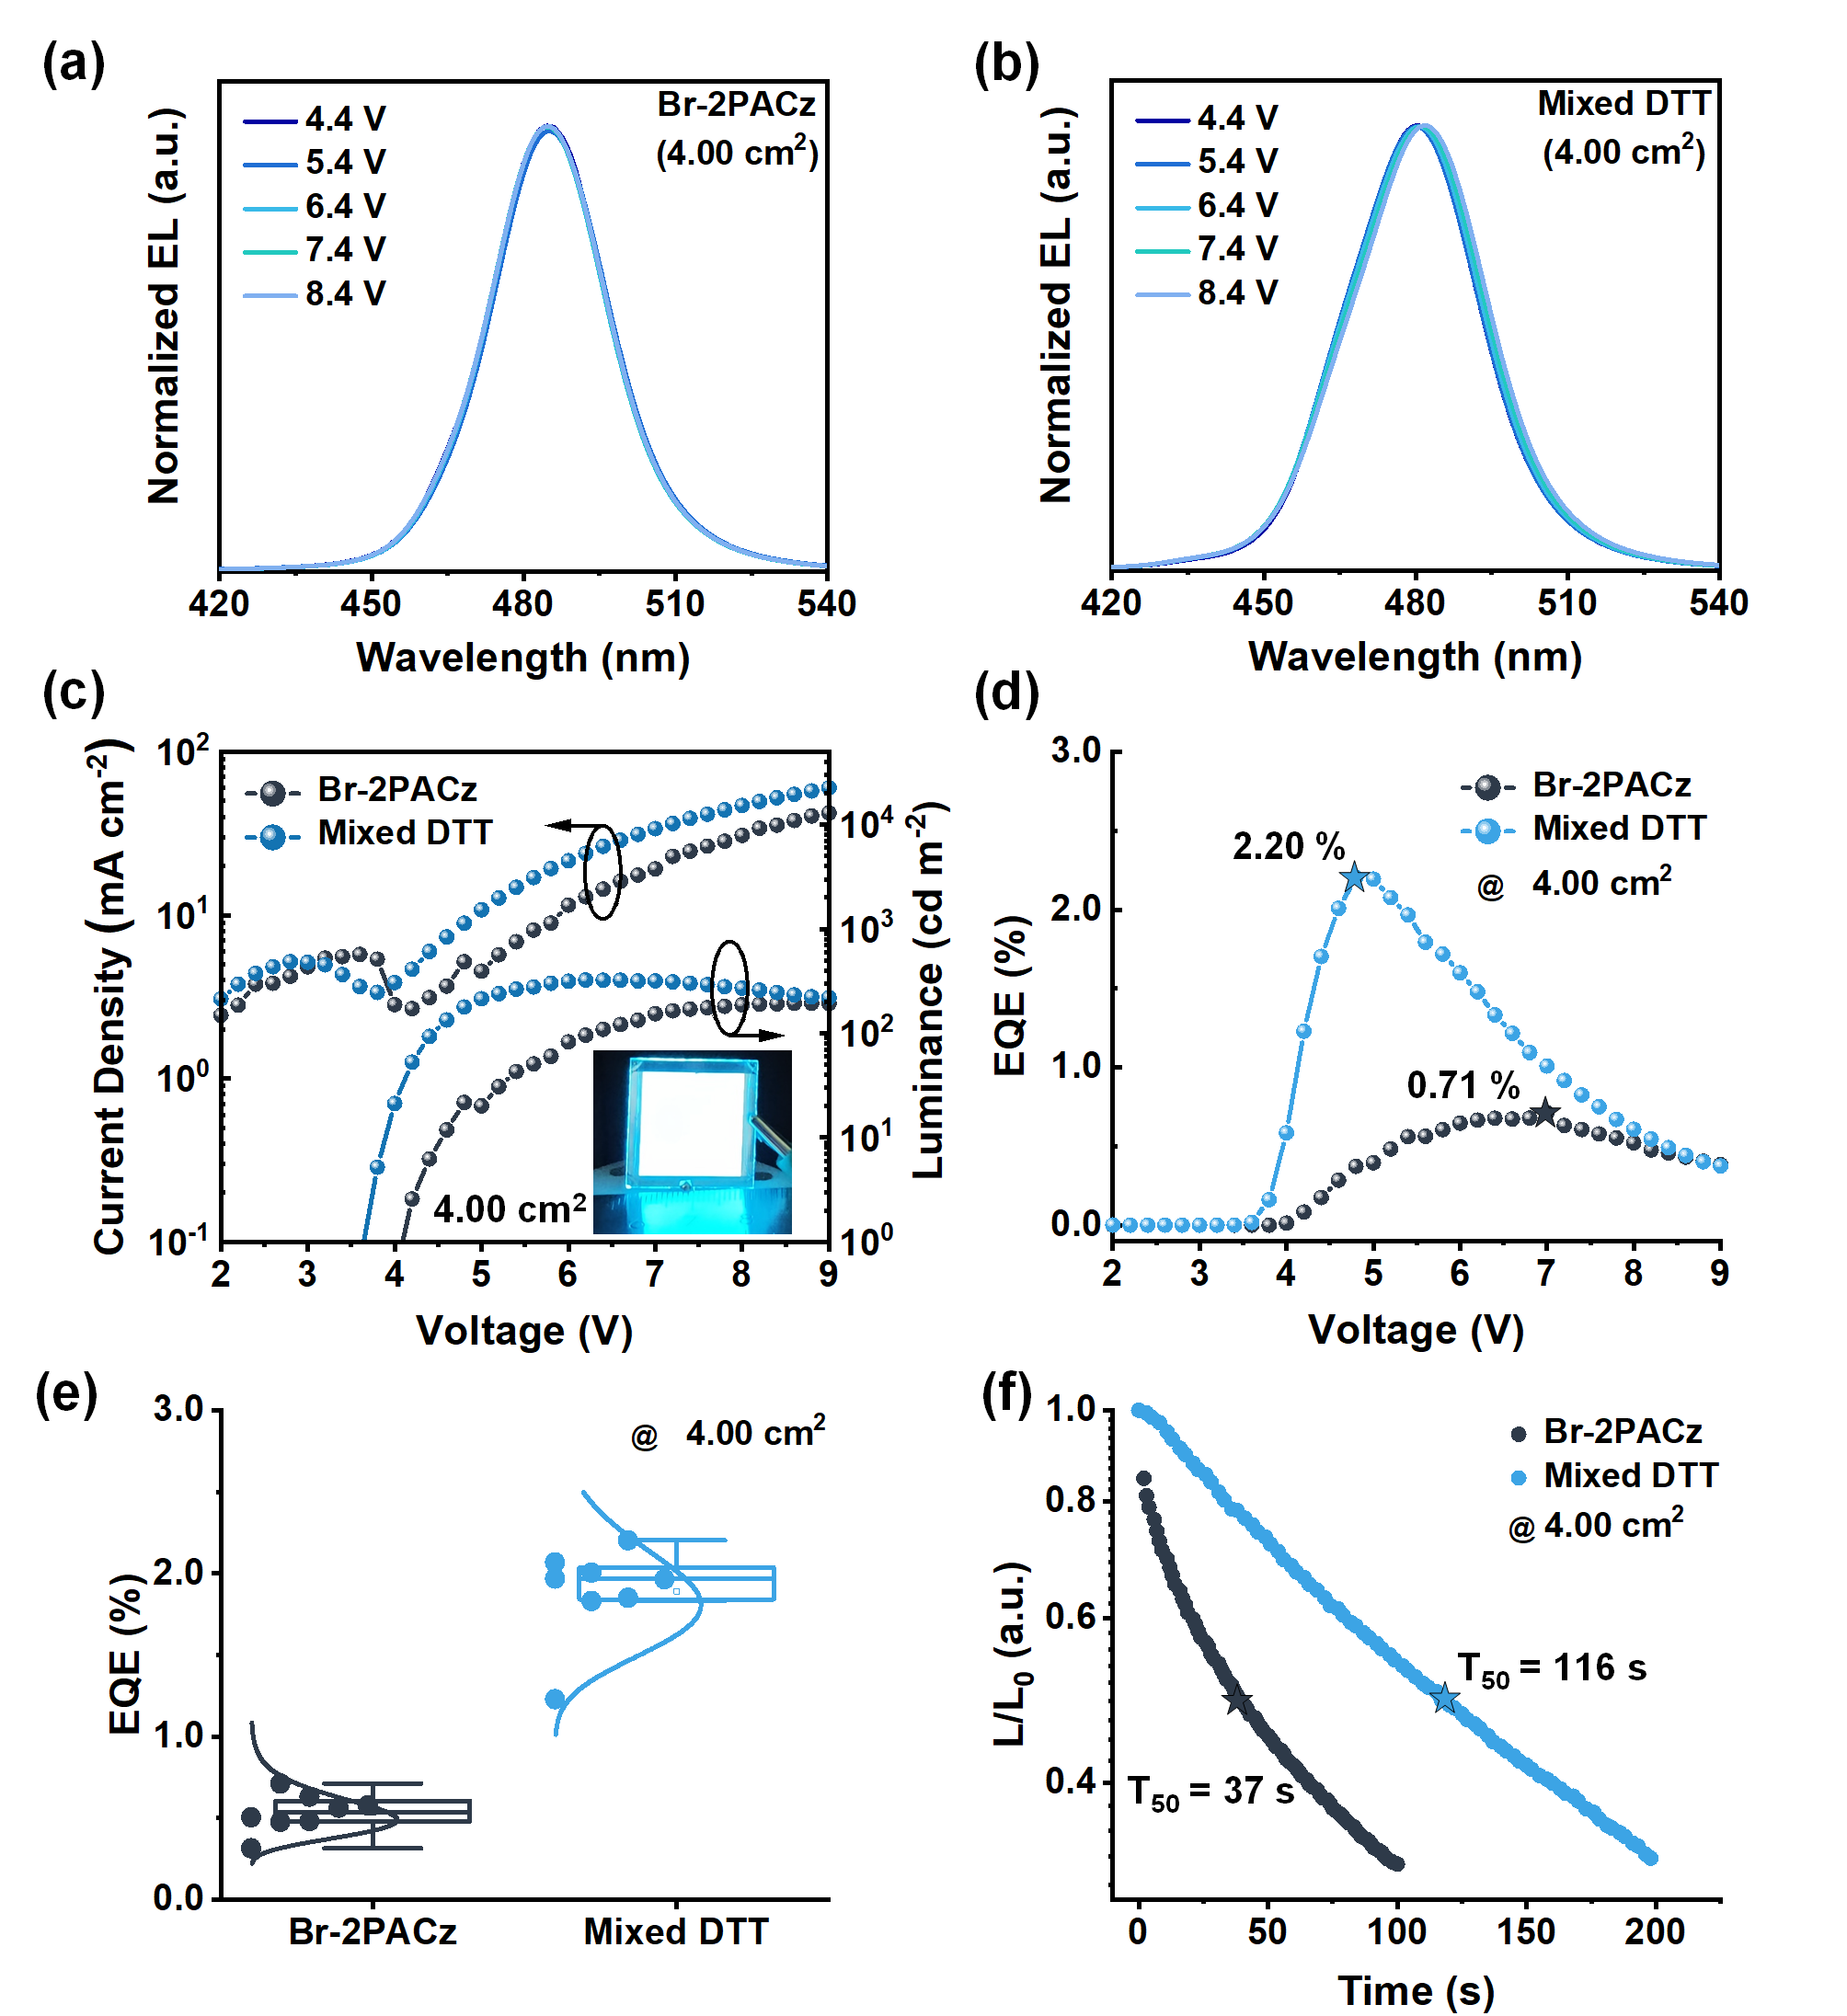
Supplementary Fig. 44 (a, b) The EL spectra of air-processed large-area blue PeLEDs. (c) Current density-voltage-luminance curves, (d) EQE-voltage curves, (e) corresponding EQE statistic and (f) operational stability measurement of T₅₀ (the initial luminance is 100 cd m⁻²) for air-processed large-area blue PeLEDs (4.00 cm²).

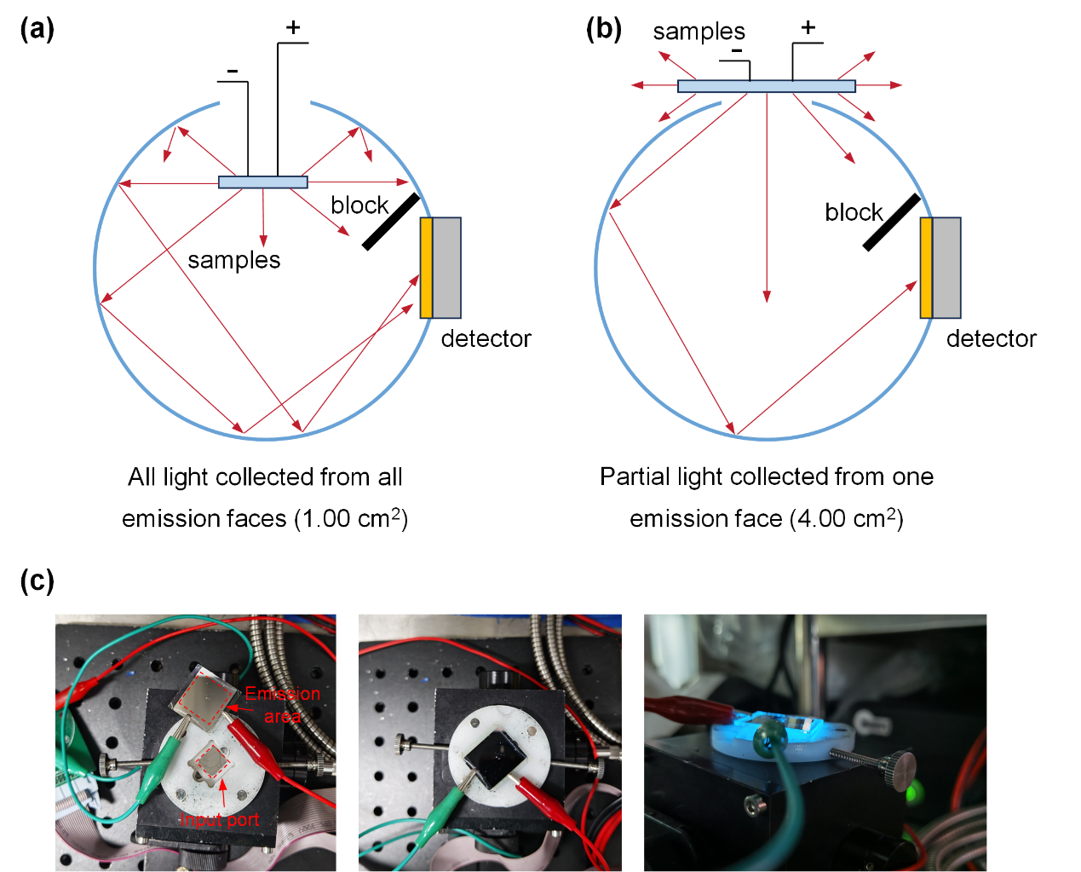
Supplementary Fig. 45 Integrating-sphere photometer measurements from (a) the all sides of device and from (b) one side of device. (c) Top-view and side-view of the large-area blue PeLEDs in direct contact with the window of the integrating sphere (4.00 cm²).

Supplementary Table 6. Performance comparison of large-area blue PeLEDs fabricated in glovebox and ambient air.
Method | Emission Area (cm²) | EL (nm) | Peak EQE (%) | Luminance  (cd m⁻²) | Ref.
Large-area blue PeLEDs prepared in glovebox
Spin-coating | 0.56 | 483 | 9.50 | ~ 700 | [12]
QDs spin-coating | 0.64 | 469 | 3.91 | 184 | [13]
Spin-coating | 1.00 | 490 | 9.20 | 1775 | [14]
Spin-coating | 4.00 | 490 | 6.10 | 1564 | [14]
Spin-coating | 1.00 | 443 | 3.02 | 311.8 | [15]
Spin-coating | 4.00 | 443 | 2.74 | / | [15]
Spin-coating | 12.25 | 443 | 2.53 | / | [15]
Spin-coating | 9.00 | 493 | 11.20 | 838 | [16]
Spin-coating | 9.00 | 463 | 11.20 | / | [17]
Spin-coating | 4.00 | 490 | / | / | [18]
Spin-coating | 4.00 | 483 | / | / | [19]
Spin-coating | 6.00 | 463 | / | / | [20]
Spin-coating | 9.00 | 489 | / | / | [21]
Spin-coating | 10.5 | 490 | / | / | [22]
Inkjet-printing | 28.00 | 489 | / | / | [23]
Blade-coating | 28.00 | 490 | / | / | [24]
Large-area blue PeLEDs prepared in ambient air
Spin-coating | 1.00 | 483 | 2.09 | 624 | [25]
Spin-coating | 4.00 | 483 | 0.80 | 734 | [25]
Spin-coating | 1.00 | 480 | 1.83 | 653 | [26]
Spin-coating | 9.00 | 470 | / | / | [27]
Spin-coating | 1.00 | 485 | 15.18 | 3915 | This work
QDs: Quantum dots

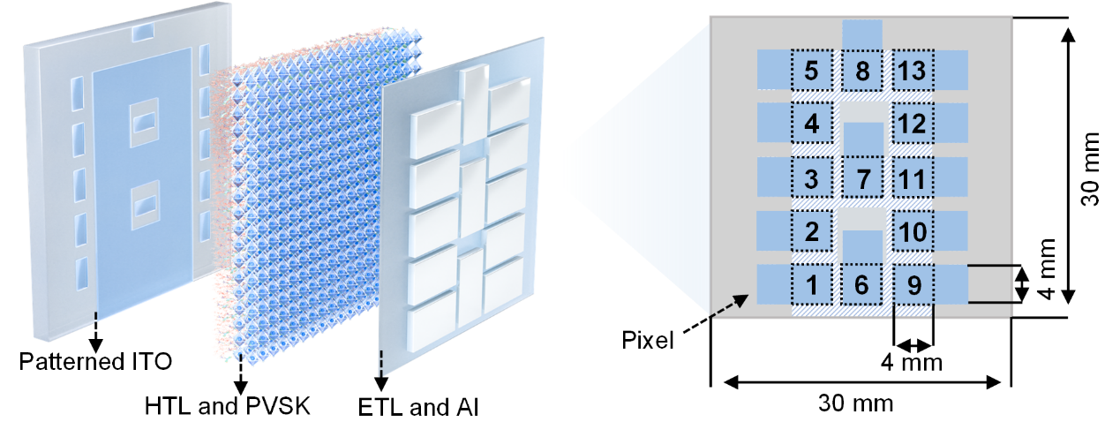
Supplementary Fig. 46 Structure diagram of the air-processed segment PeLEDs display.

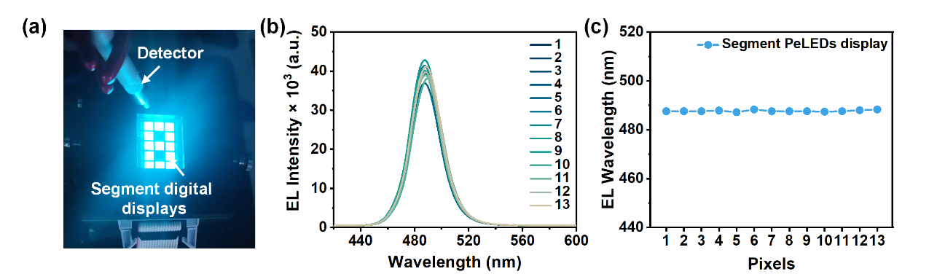
Supplementary Fig. 47 (a) The electroluminescence uniformity testing of air-processed segment digital displays by sequency control the “on and off” states of these pixel PeLEDs. Statistics of the (b) EL spectrum and (c) peak position of each emitting pixels working under same operating voltage.

Supplementary References
1 Alghamdi, A. R. M., Yanagida, M., Shirai, Y., Andersson, G. G. & Miyano, K. Surface Passivation of Sputtered NiOx Using a SAM Interface Layer to Enhance the Performance of Perovskite Solar Cells. ACS Omega 7, 12147-12157, (2022).
2 Xiao, F. et al. Cross-linked binary polymeric binder of β-cyclodextrin-carboxymethyl cellulose for black phosphorus anode in lithium-ion batteries. Electrochim. Acta 535, (2025).
3 Fang, Z. et al. High-performance phosphorus/carbon anodes with P–O–C bonds enabled by oxygen-rich CO2-Derived carbon for sodium-ion batteries. Carbon 243, (2025).
4 Wang, B. et al. Investigation of the double layer structure of 1-butyl-3-methylimidazolium thiocyanate at the air–water interface using sum-frequency generation vibrational spectroscopy. The Journal of Chemical Physics 161, (2024).
5 Hong, Y., Bao, S., Xiang, X. & Wang, X. Concentration-Dominated Orientation of Phenyl Groups at the Polystyrene/Graphene Interface. ACS Macro Letters 9, 889-894, (2020).
6 Curtis, A. D., Calchera, A. R., Asplund, M. C. & Patterson, J. E. Observation of sub-surface phenyl rings in polystyrene with vibrationally resonant sum-frequency generation. Vib. Spectrosc 68, 71-81, (2013).
7 Bain, C. D. et al. Formation of Monolayer Films by the Spontaneous Assembly of Organic Thiols from Solution onto Gold. J. Am. Chem. Soc. 111, 321-335, (1988).
8 Shao, C. et al. Dithiothreitol-capped red emitting copper nanoclusters as highly effective fluorescent nanoprobe for cobalt (II) ions sensing. Microchem. J. 163, (2021).
9 Farag, A. et al. Evaporated Self‐Assembled Monolayer Hole Transport Layers: Lossless Interfaces in p‐i‐n Perovskite Solar Cells. Adv. Energy Mater. 13, (2023).
10 Wu, J. et al. Bilateral Embedded Anchoring via Tailored Polymer Brush for Large‐Area Air‐Processed Blue Light‐Emitting Diodes. Angew. Chem. Int. Ed., e202411361, (2024).
11 Kong, L. et al. Smoothing the energy transfer pathway in quasi-2D perovskite films using methanesulfonate leads to highly efficient light-emitting devices. Nat. Commun. 12, 1246, (2021).
12 Liu, Y. et al. Efficient blue light-emitting diodes based on quantum-confined bromide perovskite nanostructures. Nat. Photonics 13, 760-764, (2019).
13 Chen, F. et al. Bilayer phosphine oxide modification toward efficient and large-area pure-blue perovskite quantum dot light-emitting diodes. Sci. Bull. 68, 2354-2361, (2023).
14 Shen, Y. et al. Interfacial “Anchoring Effect” Enables Efficient Large-Area Sky-Blue Perovskite Light-Emitting Diodes. Adv. Sci. 8, 2102213, (2021).
15 Li, X. et al. Efficient Deep-Blue Light-Emitting Diodes from Highly Luminescent Eu2+-Doped Alkali Metal Halide Nanocrystals via Lattice Field Modulation. Nano Lett. 24, 6601-6609, (2024).
16 Wang, Z. et al. Scalable Fabrication of Efficient Sky-Blue Perovskite Light-Emitting Diodes with Dual Salts. The Journal of Physical Chemistry Letters 16, 5281-5286, (2025).
17 Wei, S. et al. Stable Energy‐Level Regulation of NiOx for Efficient Deep‐Blue Perovskite LEDs. Adv. Mater. 38, (2026).
18 Yu, Y. et al. Efficient Blue Perovskite LEDs via Bottom‐Up Charge Manipulation for Solution‐Processed Active‐Matrix Displays. Adv. Mater. 37, 2503234, (2025).
19 Zhou, W. et al. Manipulating Ionic Behavior with Bifunctional Additives for Efficient Sky‐Blue Perovskite Light‐Emitting Diodes. Adv. Funct. Mater. 33, (2023).
20 Wang, Y. et al. Isomeric multi-hydrogen-bonding enables blue perovskite LEDs. Nature, (2026).
21 Kim, J. S. et al. Kinetically-controlled intermediate-direct-pinning for homogeneous energy landscapes in quasi-two-dimensional perovskites for efficient and narrow blue emission. Nat. Commun. 16, (2025).
22 Cao, Y. B. et al. High-efficiency, flexible and large-area red/green/blue all-inorganic metal halide perovskite quantum wires-based light-emitting diodes. Nat. Commun. 14, (2023).
23 Chu, S. et al. Large-Area and Efficient Sky-Blue Perovskite Light-Emitting Diodes via Blade-Coating. Adv. Mater. 34, 2108939, (2022).
24 Liu, H. et al. Large‐Area Flexible Perovskite Light‐Emitting Diodes Enabled by Inkjet Printing. Adv. Mater. 36, (2023).
25 Wu, J. et al. Bilateral Embedded Anchoring via Tailored Polymer Brush for Large‐Area Air‐Processed Blue Light‐Emitting Diodes. Angew. Chem. Int. Ed., (2024).
26 Wu, J. et al. Self-assembled monolayer modified nickel oxide surface for air-processed blue perovskite light-emitting diodes. RSC Applied Interfaces 3, 687-695, (2026).
27 Guo, Y. et al. Quantum‐Well Encapsulation Enabling Air‐Processed Quasi‐2D Perovskites with Long‐Term Stability for Large‐Area Deep‐Blue Light‐Emitting Diodes. Adv. Funct. Mater., e09277, (2025).

