Supplementary Material
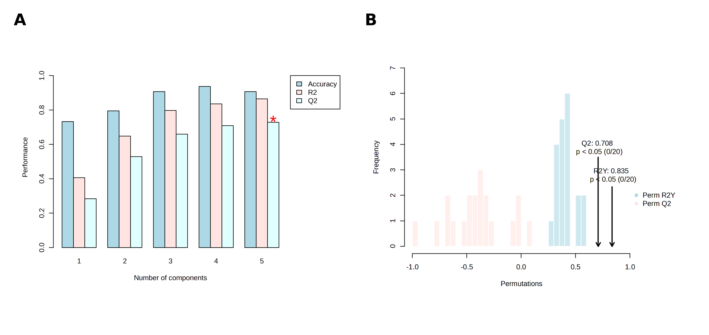
Figure S1. OPLS-DA model validation. (A) Five-fold cross-validation performance (accuracy, R², Q²) across 1–5 components; the red asterisk marks the onset of overfitting at component 5. (B) Permutation test (20 permutations) distribution of R²Y and Q² versus the true model values.
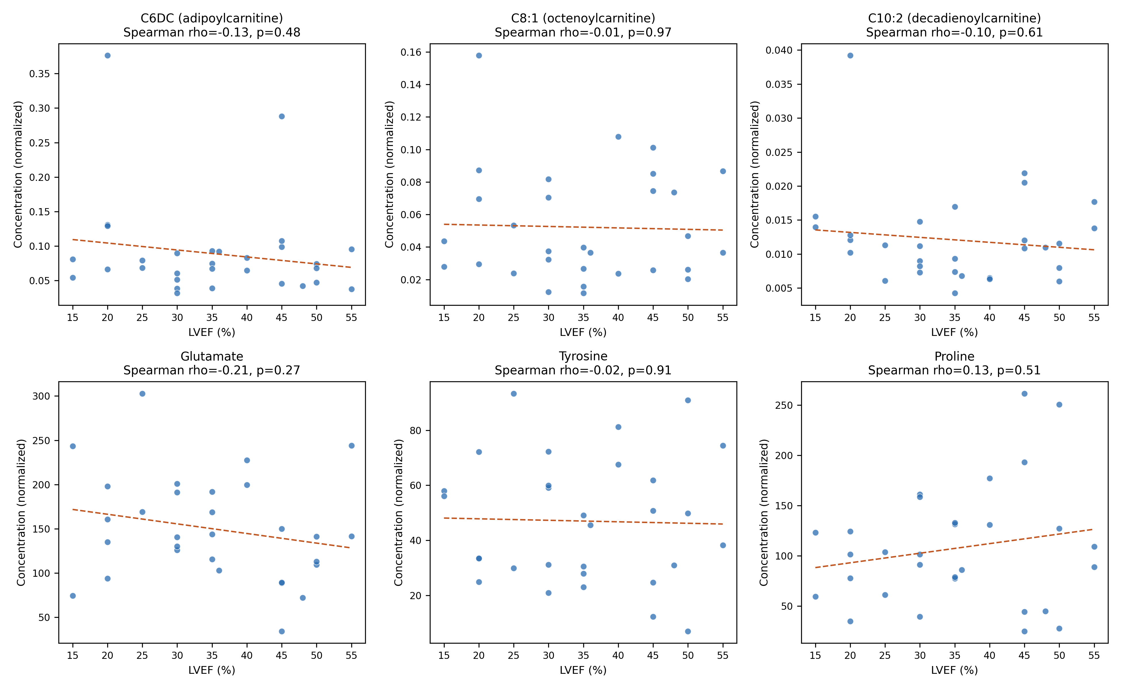
Figure S2. Correlation between the candidate six-metabolite panel and left ventricular ejection fraction (LVEF) among HF patients (n=30). Scatterplots show each panel metabolite (C6DC, C8:1, C10:2, glutamate, tyrosine, proline) plotted against LVEF; dashed line indicates the linear trend (for visualization only). Spearman ρ and p-values are shown per panel; none of the six correlations reached statistical significance (all p>0.05, Benjamini–Hochberg FDR-corrected p≥0.91 for all).
Table S1. Full list of metabolites with OPLS-DA VIP score > 1.
Rank | Metabolite | VIP score
1 | C6DC (adipoylcarnitine) | 2.34
2 | C8:1 (octenoylcarnitine) | 2.21
3 | Tyrosine | 2.16
4 | Glutamate | 1.83
5 | Proline | 1.63
6 | C10:2 (decadienoylcarnitine) | 1.61
7 | C12 (dodecanoylcarnitine) | 1.50
8 | Alanine | 1.48
9 | C14 (tetradecanoylcarnitine) | 1.38
10 | Ornithine | 1.37
11 | C6 (hexanoylcarnitine) | 1.28
12 | Methionine | 1.18
13 | C16 (hexadecanoylcarnitine) | 1.04
14 | Glycine | 1.02
Leucine (VIP=0.937) was the next-ranked metabolite and did not exceed the VIP>1 threshold.
Table S2. Top 15 of 39 metabolite sets identified by MSEA, ranked by enrichment ratio.
Metabolite set | Enrichment ratio | FDR
Catecholamine biosynthesis | 23.67 | 0.0007
Thyroid hormone synthesis | 23.67 | 0.0007
Tyrosine metabolism | 20.12 | 0.0007
Beta-alanine metabolism | 16.58 | 0.0017
Cysteine metabolism | 16.58 | 0.0017
Lysine degradation | 16.58 | 0.0017
Histidine metabolism | 16.58 | 0.0017
Amino sugar metabolism | 16.58 | 0.0017
Nicotinate and nicotinamide metabolism | 16.58 | 0.0017
Folate metabolism | 16.58 | 0.0017
Arachidonic acid metabolism | 16.58 | 0.0017
Malate-aspartate shuttle | 16.58 | 0.0017
Warburg effect | 16.58 | 0.0017
Phenylalanine and tyrosine metabolism | 13.42 | 0.0017
Tryptophan metabolism | 12.85 | 0.0017
Fatty-acid β-oxidation and carnitine-synthesis pathways were not among the significantly enriched sets (FDR range 0.24–0.62; lowest for carnitine synthesis, FDR=0.24).
Table S3. Spearman correlation between candidate panel metabolites and left ventricular ejection fraction (LVEF) among HF patients (n=30).
Metabolite | Spearman ρ | p | FDR-corrected p
Glutamate | -0.21 | 0.27 | 0.91
C6DC (adipoylcarnitine) | -0.13 | 0.48 | 0.91
Proline | 0.13 | 0.51 | 0.91
C10:2 (decadienoylcarnitine) | -0.10 | 0.61 | 0.91
Tyrosine | -0.02 | 0.91 | 0.97
C8:1 (octenoylcarnitine) | -0.01 | 0.97 | 0.97
None of the six correlations reached statistical significance (all p>0.05, Benjamini-Hochberg FDR-corrected).

