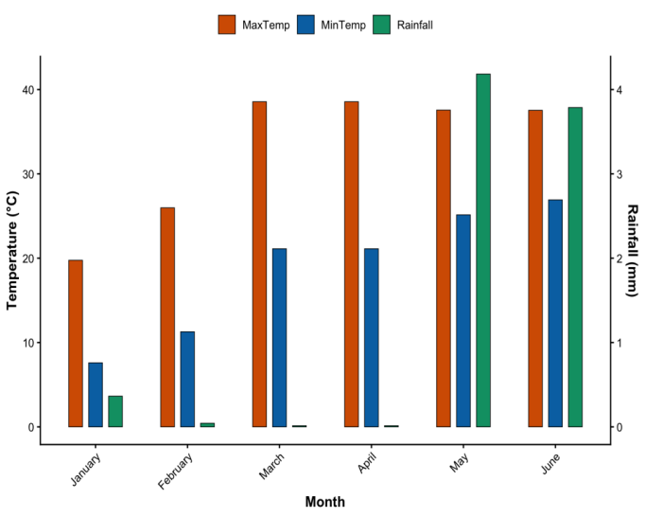
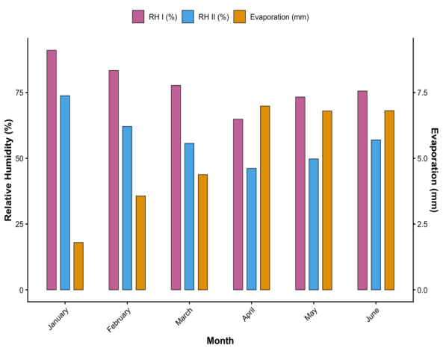
a
b
Supplementary Fig. 1 Meteorological data during the experimental period. a: Temperature and Rainfall, b: Relative humidity and evaporation
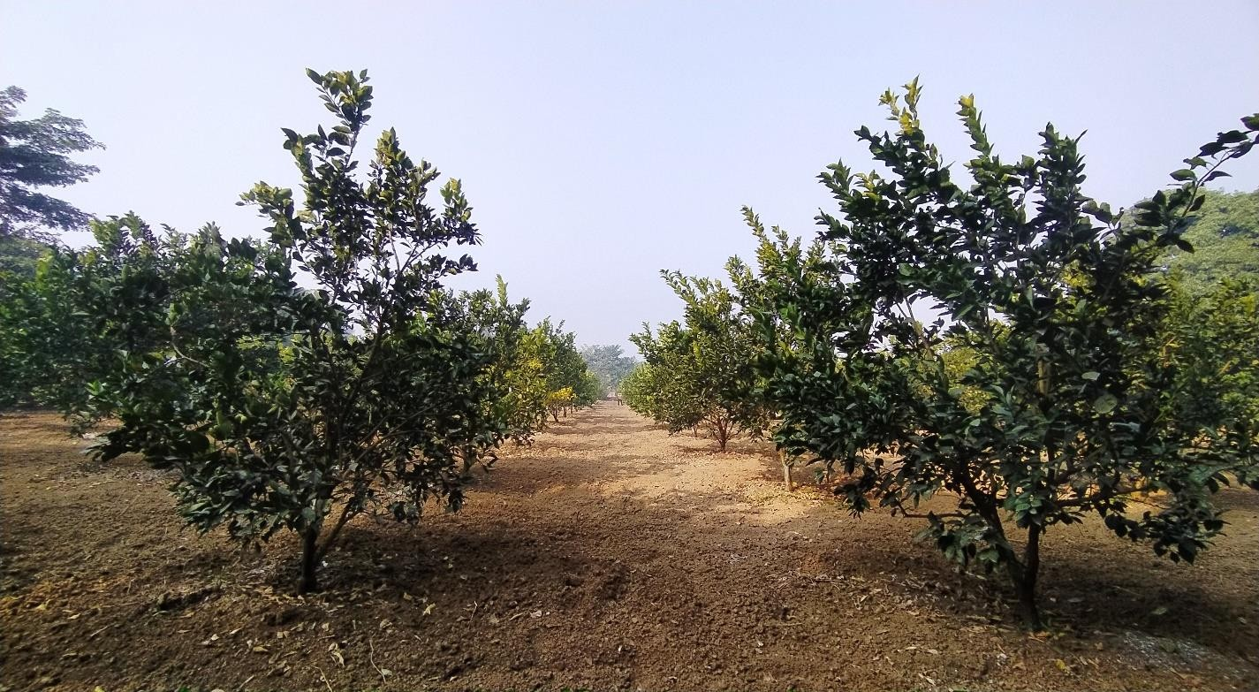

Supplementary Fig. 2 General orchard view after application of FYM.
Sl. No. | Properties | value | Units
1. | Soil type | Clay loam | -
2. | Clay content | 41.80 | %
3. | Organic carbon | 0.58 | %
4. | Bulk density | 1.28 | g/cc
5. | Moisture holding capacity | 48.31 | %
6. | Moisture at wilting | 16.00 | %
7. | pH | 7.80 | -
8. | Electrical conductivity | 0.39 | ds/m
9. | Available Nitrogen | 260.67 | Kg/ha
10. | Available Phosphorous | 45.32 | Kg/ha
11. | Available Potassium | 150.28 | Kg/ha
12. | Available Copper | 1.64 | ppm
13. | Available Manganese | 1.96 | ppm
14. | Available Zinc | 0.61 | ppm
15. | Available Iron | 16.18 | ppm
Supplementary Table 1 Physicochemical properties of the soil of the experimental field.

