Supplementary materials

Natural Deep Eutectic Solvent-Guided Engineering of Herbal Residue-Derived Carbon Dots for Endothelial Oxidative Stress Protection

Kunze Du ^{1,3,4}†, Haixiang Li ^{1,2,3}†, Shujing Chen ^{1,3,4}†, Zhuofan Peng ^{1,2,3}, Ru Cang ^{1,3}, Zhaoyu Jia ^{1,3}, Yidan Jia ^{1,2,3}, Xiaoxia Li ^{1,2,3,4*}, Yanxu Chang ^{1,3,4*}

¹ State Key Laboratory of Chinese Medicine Modernization, Tianjin University of Traditional Chinese Medicine, Tianjin 301617, China
² School of Chinese Materia Medica, Tianjin University of Traditional Chinese Medicine, Tianjin 301617, China
³ Tianjin Key Laboratory of Therapeutic Substance of Traditional Chinese Medicine, Tianjin University of Traditional Chinese Medicine, Tianjin 301617, China
⁴ China-Ghana Belt and Road Joint Laboratory on Traditional Medicine, Tianjin University of Traditional Chinese Medicine, Tianjin 301617, China

* Correspondence:
Xiaoxia Li, School of Chinese Materia Medica, Tianjin University of Traditional Chinese Medicine, Tianjin 301617, China
E-mail: lixx@tjutcm.edu.cn (X. Li)
Yanxu Chang, State Key Laboratory of Chinese Medicine Modernization, Tianjin University of Traditional Chinese Medicine, Tianjin 301617, China
E-mail: Tcmcyx@tjutcm.edu.cn (Y. Chang)

†These authors contributed equally to this paper.
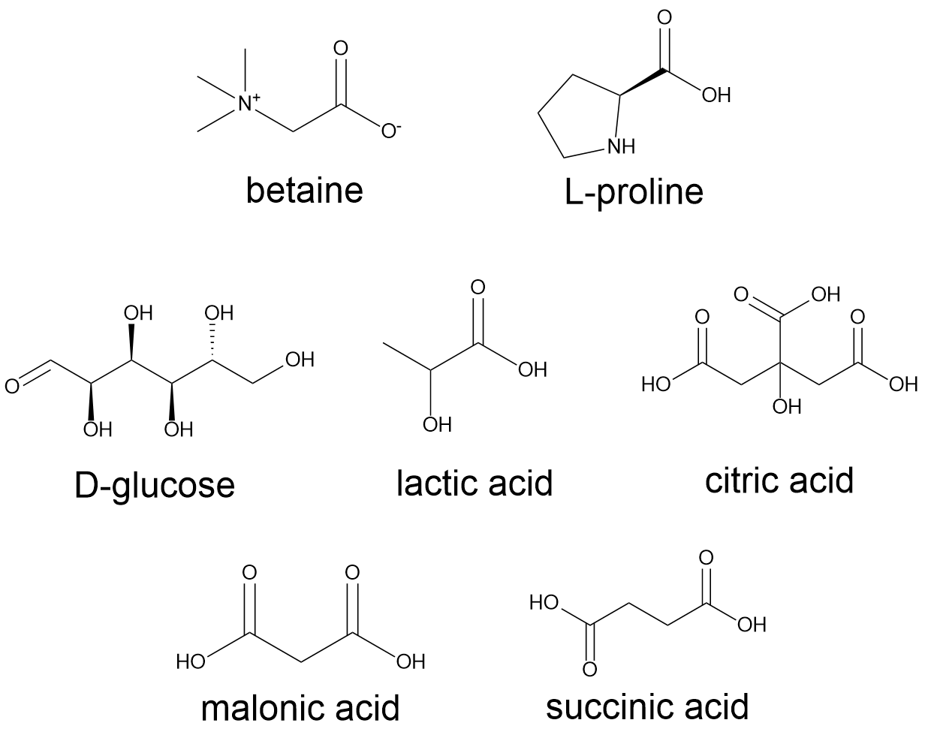

Figure S1. Chemical structure of HBAs and HBDs.

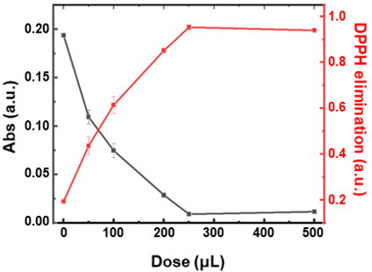

Figure S2. Dose- dependent DPPH• scavenging by SM-PN-CDs.

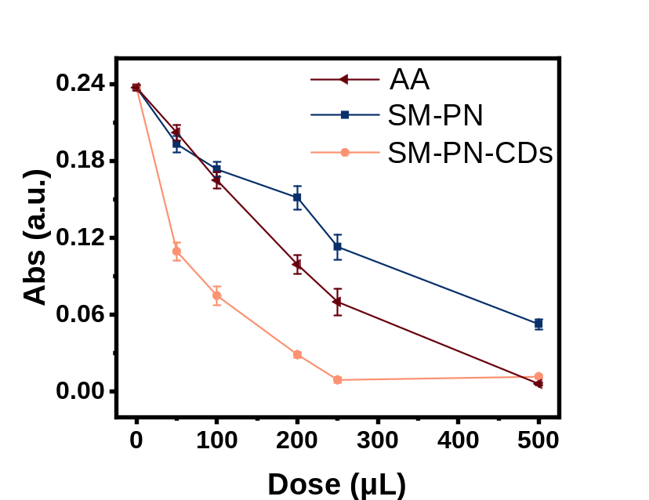

Figure S3. Comparison of DPPH• scavenging by AA, SM-PN, and SM-PN-CDs at different doses.

Table S1. Primary antibodies used for western blot analysis.
Primary antibody | Dilution | Catalog number
Keap1 | 1:1000 | 8047S
Nrf2 | 1:1000 | 12721S
β-actin | 1:80000 | AC026

Table S2. Primer sequences used for RT-qPCR.
Gene | Forward primer (5′–3′) | Reverse primer (5′–3′)
Keap1 | GCTGTCCTCAATCGTCTCCTTTATG | TCATTCGCCACTCGTTCCTCTC
Nrf2 | TTCCTTCAGCAGCATCCTCTCC | AATCTGTGTTGACTGTGGCATCTG
HO-1 | GCCAGTGCCACCAAGTTCAAG | GATGTTGAGCAGGAACGCAGTC

Table S3. Selected enriched Gene Ontology terms in the molecular function, cellular component, and biological process categories.
GO ID | GO term
GO:0001223 | transcription coactivator binding
GO:0020037 | heme binding
GO:0061629 | RNA polymerase II-specific DNA-binding transcription factor binding
GO:0031625 | ubiquitin protein ligase binding
GO:0003700 | DNA-binding transcription factor activity
GO:0016702 | oxidoreductase activity, acting on single donors with incorporation of molecular oxygen, incorporation of two atoms of oxygen
GO:0001228 | DNA-binding transcription activator activity, RNA polymerase II-specific
GO:0016705 | oxidoreductase activity, acting on paired donors, with incorporation or reduction of molecular oxygen
GO:0000978 | RNA polymerase II cis-regulatory region sequence-specific DNA binding
GO:0000981 | DNA-binding transcription factor activity, RNA polymerase II-specific
GO:0030235 | nitric-oxide synthase regulator activity
GO:0004601 | peroxidase activity
GO:0004497 | monooxygenase activity
GO:0019825 | oxygen binding
GO:0016701 | oxidoreductase activity, acting on single donors with incorporation of molecular oxygen
GO:0005737 | cytoplasm
GO:0005829 | cytosol
GO:0005886 | plasma membrane
GO:0000785 | chromatin
GO:0032991 | protein-containing complex
GO:0098802 | signaling receptor complex
GO:0005634 | nucleus
GO:0070062 | extracellular exosome
GO:0005654 | nucleoplasm
GO:0005901 | caveola
GO:0098857 | membrane raft
GO:0090575 | RNA polymerase II transcription regulator complex
GO:0048471 | perinuclear region of cytoplasm
GO:0005783 | endoplasmic reticulum
GO:0009986 | cell surface
GO ID | GO term
GO:0045893 | positive regulation of DNA-templated transcription
GO:0045944 | positive regulation of transcription by RNA polymerase II
GO:0045429 | positive regulation of nitric oxide biosynthetic process
GO:0070301 | cellular response to hydrogen peroxide
GO:1901701 | cellular response to oxygen-containing compound
GO:0006809 | nitric oxide biosynthetic process
GO:0042311 | vasodilation
GO:0031648 | protein destabilization
GO:0071498 | cellular response to fluid shear stress
GO:0034599 | cellular response to oxidative stress
GO:2000379 | positive regulation of reactive oxygen species metabolic process
GO:0032436 | positive regulation of proteasomal ubiquitin-dependent protein catabolic process
GO:0034405 | response to fluid shear stress
GO:0072593 | reactive oxygen species metabolic process

