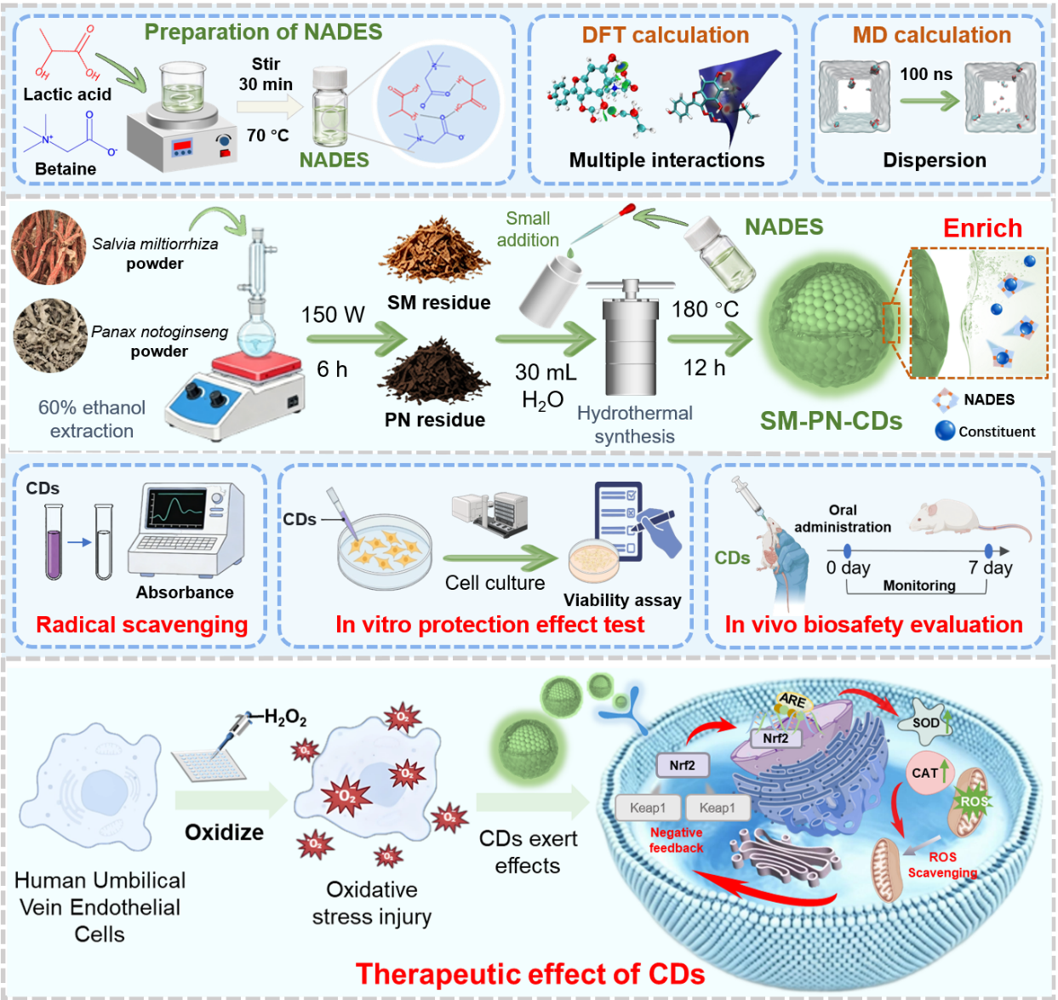

Scheme 1. Low-loading NADES-guided engineering of herbal residue-derived bioactive carbon dots for endothelial oxidative stress protection.

