Depot- and Sex Specific Effects of the PTN/RPTPβ/ζ Axis on White Adipose Tissue Browning and Inflammatory Remodelling in Diet-Induced Obesity

Marta Inmaculada Sanz-Cuadrado¹, Julio Sevillano¹, María Gracia Sánchez-Alonso¹, Teresa Fontán-Baselga², Héctor Cañeque-Rufo¹, María Limones^{1,} José María Zapico¹, Beatriz de Pascual-Teresa¹, Gonzalo Herradón² and María del Pilar Ramos-Álvarez¹*
- Department of Chemistry and Biochemistry, School of Pharmacy, Universidad San Pablo-CEU, CEU Universities, Urbanización Montepríncipe, 28660 Boadilla del Monte, Spain.
- Department of Health and Pharmaceutical Sciences, School of Pharmacy, Universidad San Pablo-CEU, CEU Universities, Urbanización Montepríncipe, 28660 Boadilla del Monte, Spain.

*Corresponding author:
María del Pilar Ramos-Álvarez
pramos@ceu.es
ORCID: 0000-0002-7727-7783

Supplementary Figure S1: Ptn and Ptprz1 mRNA expression in white adipose tissue after HFD feeding and pharmacological modulation with MY10.
Ptn and Ptprz1 mRNA expression was measured by qPCR in white adipose tissue from male and female mice. Panels (a) and (b) show the effect of 3-month STD or HFD feeding in Ptn^{+/+} and Ptn^{-/-} mice. Panels (c) and (d) show the effect of vehicle or MY10 treatment in wild-type mice fed STD or HFD for 3 months. Ptprz1 encodes receptor protein tyrosine phosphatase β/ζ (RPTPβ/ζ), a receptor involved in PTN-dependent signaling. Data are expressed as fold change relative to the corresponding control group. ND, not detected.
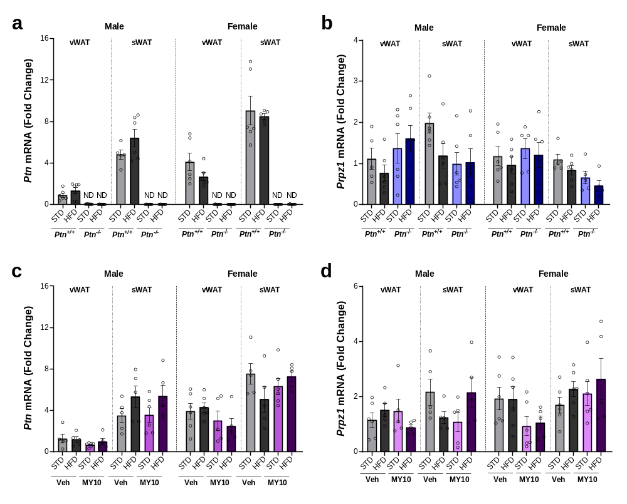

Supplementary Table 1: Three-way ANOVA results of body and AT weight, Ptn deletion study, Fig.1. Model, significance, and effect size

Variable (Fig. 1) | Sex |  |  | Genotype |  |  | Diet |  |  | Interaction
Variable (Fig. 1) | Model | Sig. | Effect size | Model | Sig. | Effect size | Model | Sig. | Effect size | Model | Sig. | Effect size
Body weight gain (a,b) | F = 0.738 | p = 0.395 | η² = 0.015 | F = 91.908 | p < 0.001 | η² = 0.657 | F = 239.481 | p < 0.001 | η² = 0.833 | F= 499.449 | p < 0.001 | η² = 0.912
Perigonadal adipose tissue weight (c,d) | F= 1.939 | p = 0.169 | η² = 0.033 | F = 19.461 | p < 0.001 | η² = 0.236 | F = 27.529 | p < 0.001 | η² = 0.581 | F = 30.646 | p < 0.001 | η² = 0.365
Retroperitoneal  adipose tissue weight (c,d) | F= 0.107 | p = 0.744 | η² = 0.002 | F = 8.814 | p = 0.004 | η² = 0.128 | F = 123.713 | p < 0.001 | η² = 0.673 | F = 33.135 | p < 0.001 | η² = 0.356
Mesenteric  adipose tissue weight (c,d) | F= 1.236 | p = 0.271 | η² = 0.021 | F = 19.332 | p < 0.001 | η² = 0.253 | F = 25.882 | p < 0.001 | η² = 0.312 | F = 18.118 | p < 0.001 | η² = 0.241
Visceral  adipose tissue weight (c,d) | F= 0.004 | p = 0.951 | η² = 0.000 | F = 19.461 | p < 0.001 | η² = 0.236 | F = 87.529 | p < 0.001 | η² = 0.581 | F = 36.179 | p < 0.001 | η² = 0.365
Subcutaneous  adipose tissue weight (e,f) | F= 1.498 | p = 0.226 | η² = 0.028 | F = 36.055 | p < 0.001 | η² = 0.409 | F = 78.412 | p < 0.001 | η² = 0.601 | F = 15.319 | p < 0.001 | η² = 0.228

Supplementary Table 2: Quantitative analysis of adipocyte size across experimental groups (Fig. 2b) Values represent the median with interquartile range (IQR) of adipocyte area for counted adipocytes in vWAT and sWAT. Statistical significance is indicated as follows: *p<0.05; **p<0.01; *** p<0.001 for diet effects (HFD vs. STD within the same genotype), and #p<0.05; ##p<0.01; ###p<0.001 for genotype effects (Ptn^{+/+} vs. Ptn^{-/-} within the same dietary condition).
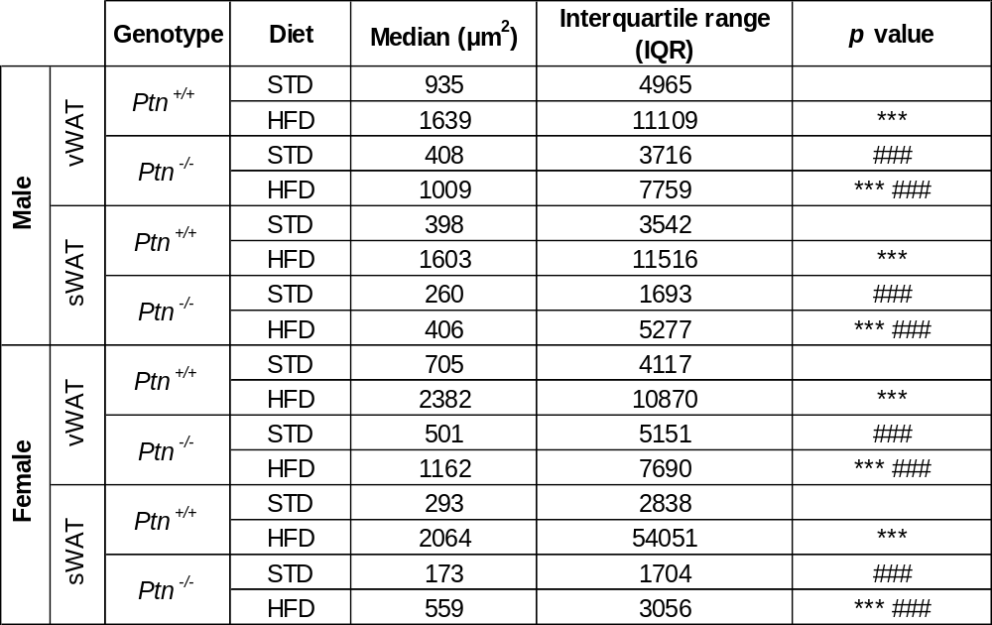

Supplementary Table 3: Four-way ANOVA results of adipocyte size and fibrosis, Ptn deletion study, Fig 2b and Fig.3. Model, significance, and effect size

Supplementary Table 4: Four-way ANOVA Results of Inflammatory markers, Ptn deletion study, Fig. 4. Model, significance, and effect size
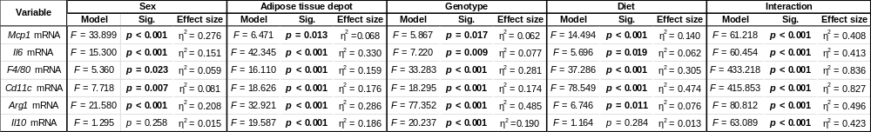
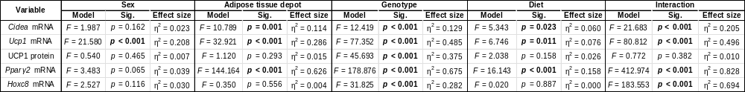
Supplementary Table 5: Four-way ANOVA and three-way ANOVA results of thermogenic markers, Ptn deletion study, Fig. 5. Model, significance, and effect size

Supplementary Table 6: Quantitative analysis of body temperature across experimental groups (Fig. 5f). Values represent mean body temperature and standard deviation (SEM).
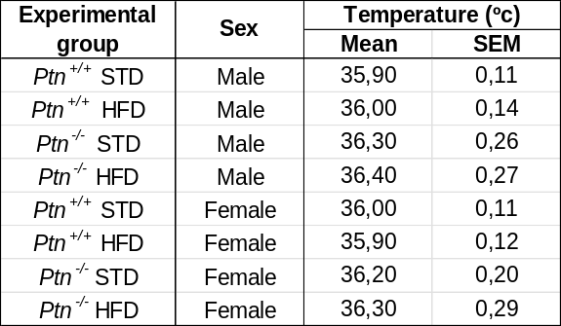

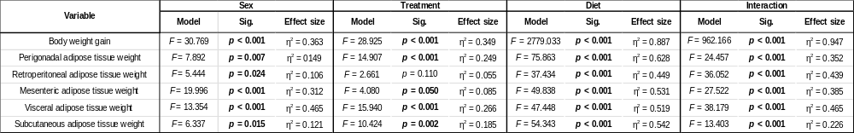
Supplementary Table 7: Three-way ANOVA results of body and AT weight, MY10 study, Fig. 6. Model, significance, and effect size

Supplementary Table 8: Quantitative analysis of adipocyte size across experimental groups (Fig. 7b). Values represent median with interquartile range (IQR) of adipocyte area for counted adipocytes in vWAT and sWAT. Statistical significance is indicated as follows: *p<0.05; **p<0.01; *** p<0.001 for diet effects (HFD vs. STD within the same genotype), and #p<0.05; ##p<0.01; ###p<0.001 indicate significant differences between vehicle- and MY10-treated groups.
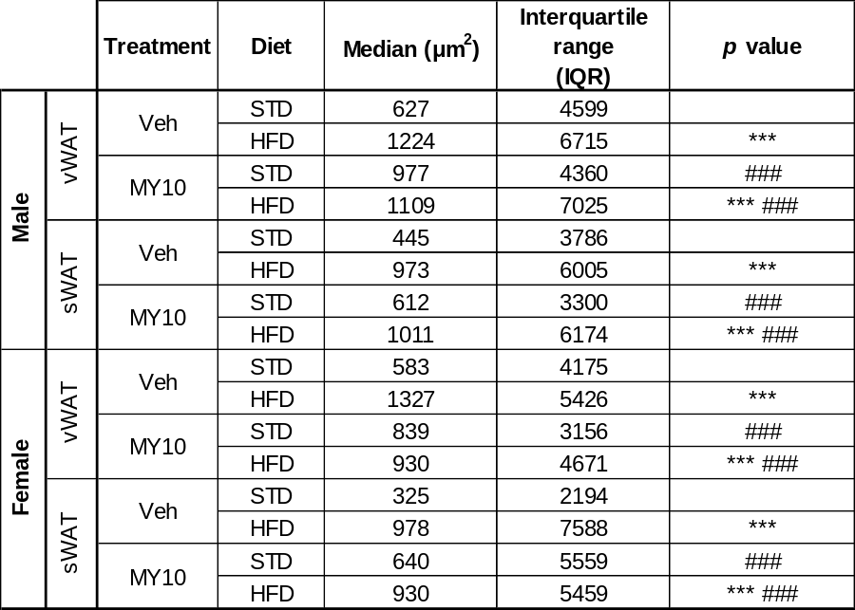

Supplementary Table 9: Four-way ANOVA results of adipocyte size and fibrosis, MY10 study, Fig. 7 and Fig.8. Model, significance, and effect size

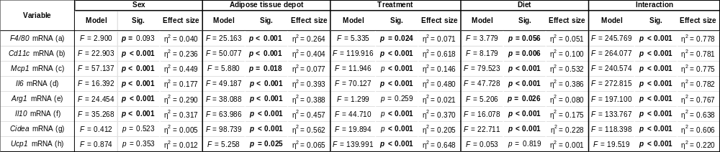
Supplementary Table 10: Four-way ANOVA results of inflammatory and thermogenic markers, MY10 study, Fig. 9. Model, significance, and effect size

