Supplementary Information for
Layer Number Dependent Ferroelasticity in 2D Ruddlesden-Popper Organic-inorganic Hybrid Perovskites
Xun Xiao¹, Jian Zhou², Kepeng Song³, Jingjing Zhao¹, Yu Zhou¹, Peter Neil Rudd¹, Yu Han³, Ju Li^{2,*} and Jinsong Huang^{1,}*
¹ Department of Applied Physical Sciences, University of North Carolina, Chapel Hill, NC 27599, USA.
² Department of Nuclear Science and Engineering and Department of Materials Science and Engineering, Massachusetts Institute of Technology, Cambridge, MA 02139, USA.
³ Advanced Membranes and Porous Materials (AMPM) Center, Physical Sciences and Engineering Division, King Abdullah University of Science and Technology (KAUST), Thuwal, Saudi Arabia

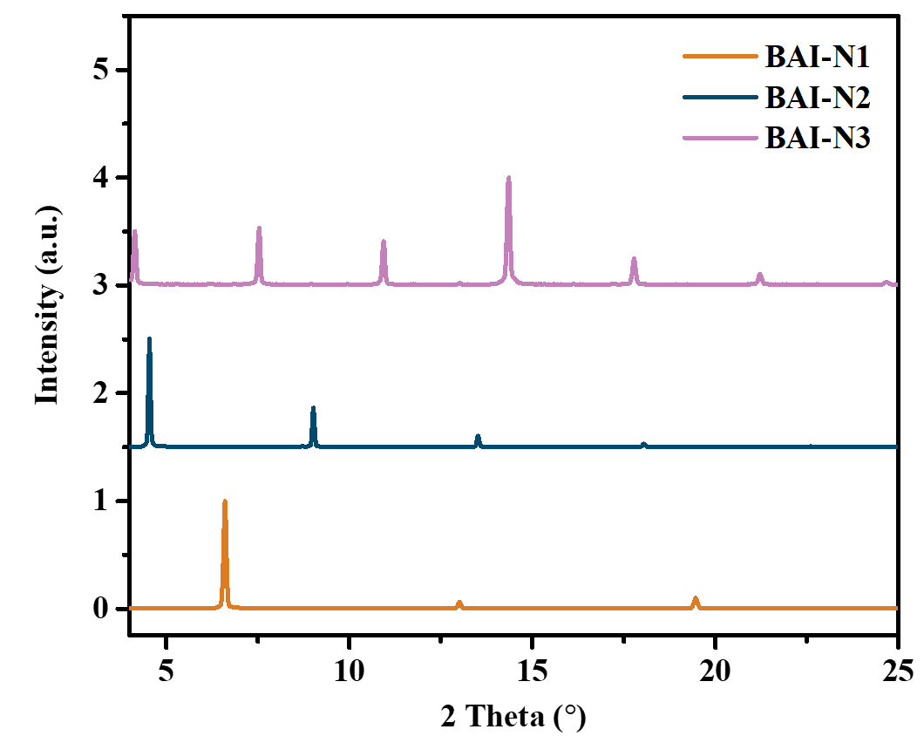
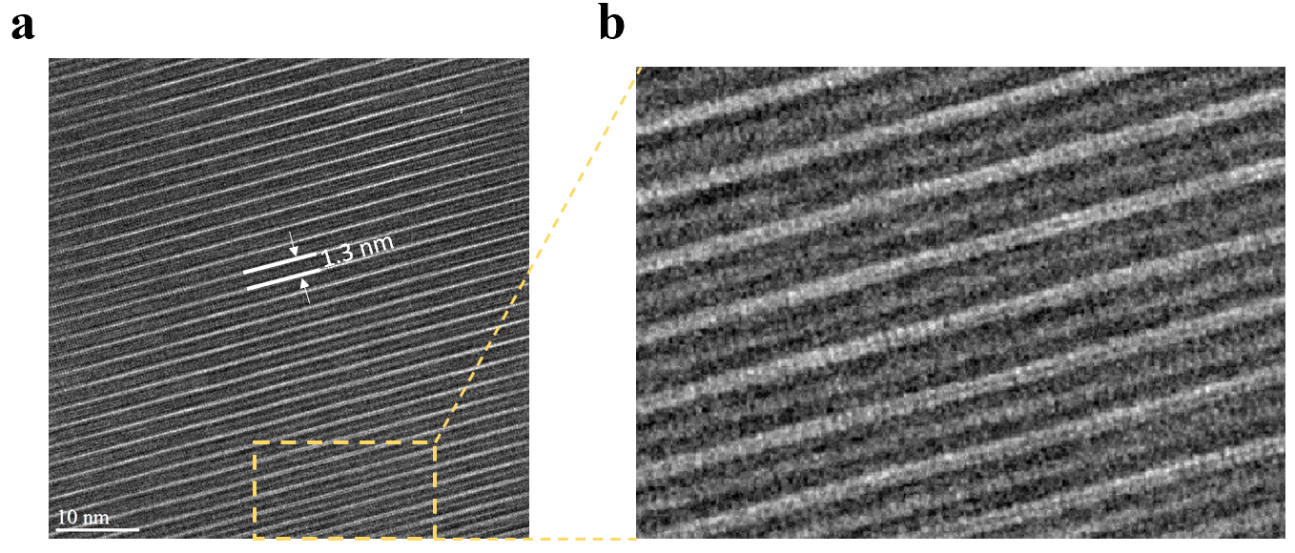
Supplementary Figure 1: XRD patterns for BAI-N1, BAI-N2 and BAI-N3 single crystals, respectively.

Supplementary Figure 2: (a) Cross section TEM for BAI-N2, (b) is the zoom-in image corresponding to golden rectangular mark in (a).

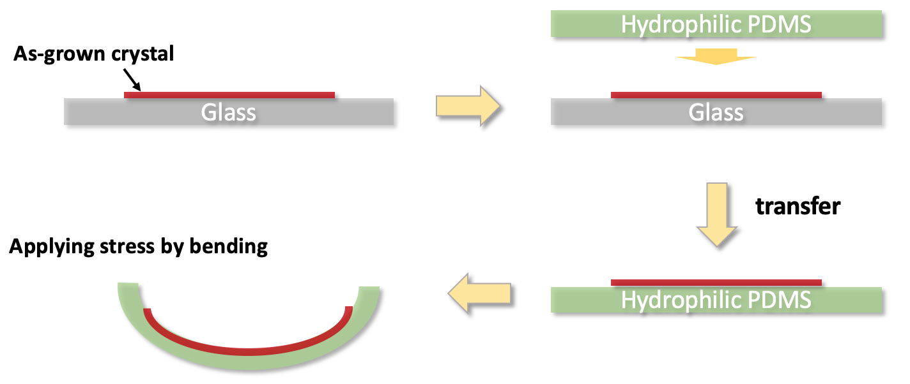

Supplementary Figure 3: scheme of applying external stress on layered perovskite crystals
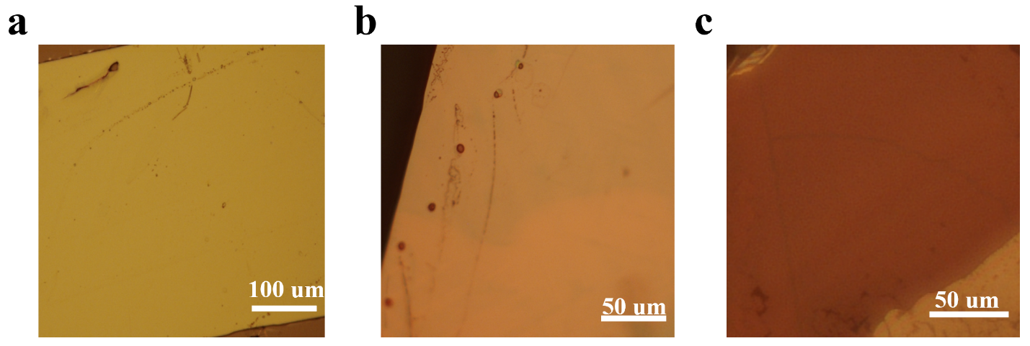

Supplementary Figure 4: (a), (b) and (c) are non-polarized optical microscope images for BAI-N1, BAI-N2 and BAI-N3 single crystals, respectively.

Supplementary Note 1: DFT calculation models for BAI-N1 and BAI-N2.
BAI-N1 (VASP form)
BAI-N1
1.0000000000
8.55045 0.00000 0.000-0
0.00000 8.55045 0.00000
0.00000 0.00000 27.53405
H C N Pb I
96 32 8 4 16
Direct
0.264512 0.434668 0.722538
0.448592 0.219584 0.732024
0.324343 0.318234 0.808609
0.340386 0.959671 0.806062
0.206742 0.058346 0.881770
0.127183 0.291085 0.504313
0.337771 0.088998 0.511514
0.341462 0.293102 0.419305
0.571102 0.118750 0.418764
0.409909 0.119418 0.340055
0.419348 0.785804 0.234368
0.228105 0.569407 0.230342
0.331166 0.650854 0.311553
0.976041 0.598218 0.316671
0.111149 0.652115 0.398157
0.048159 0.767957 0.025720
0.243944 0.559132 0.002678
0.160509 0.814605 0.928055
0.360865 0.630670 0.895265
0.140022 0.714567 0.839713
0.609833 0.695036 0.719338
0.786989 0.919224 0.724617
0.659479 0.808683 0.800467
0.997433 0.920135 0.816562
0.866364 0.812146 0.892932
0.761190 0.572377 0.506677
0.952090 0.780775 0.505935
0.700299 0.829664 0.427189
0.912974 0.039499 0.433045
0.787302 0.979469 0.352820
0.769325 0.053132 0.237126
0.566141 0.246391 0.238012
0.691376 0.185798 0.320194
0.580734 0.520869 0.301025
0.734967 0.517728 0.378039
0.692234 0.081292 0.019149
0.870840 0.264780 0.986111
0.541370 0.339139 0.946510
0.752064 0.523875 0.917452
0.532423 0.450864 0.860344
0.762813 0.569270 0.723503
0.945431 0.786467 0.732416
0.823515 0.685290 0.809048
0.836008 0.044082 0.807266
0.707277 0.940451 0.883264
0.610521 0.701575 0.505419
0.798131 0.920666 0.508319
0.849973 0.687211 0.424635
0.053816 0.892338 0.423570
0.924781 0.830351 0.341787
0.912681 0.190051 0.236724
0.707522 0.396775 0.229671
0.822490 0.342957 0.310869
0.465221 0.362941 0.321003
0.623280 0.359512 0.400348
0.549459 0.214127 0.025669
0.749394 0.422825 0.004542
0.656385 0.178792 0.927400
0.862369 0.362126 0.896686
0.642470 0.287148 0.839823
0.112177 0.308058 0.718915
0.292039 0.084904 0.723852
0.161505 0.193733 0.799464
0.499857 0.085197 0.816528
0.363233 0.189010 0.892620
0.267538 0.430494 0.502144
0.474526 0.242022 0.500846
0.214193 0.134403 0.430924
0.457477 0.960448 0.439571
0.300242 0.960844 0.363145
0.270406 0.917011 0.234129
0.076512 0.711558 0.234524
0.186074 0.797631 0.315859
0.112326 0.447982 0.305744
0.244021 0.499944 0.385478
0.191871 0.900202 0.020173
0.369817 0.716307 0.986520
0.040077 0.655745 0.944990
0.248481 0.468673 0.914666
0.029530 0.549085 0.858577
0.251155 0.309781 0.675787
0.395661 0.984524 0.895879
0.251564 0.314222 0.550735
0.501798 0.935460 0.349846
0.297626 0.796854 0.186889
0.042839 0.456095 0.394353
0.209424 0.752901 0.060562
0.205596 0.524893 0.825273
0.750020 0.692875 0.676546
0.895676 0.017008 0.896717
0.731159 0.695941 0.553240
0.987761 0.028303 0.344854
0.791335 0.171447 0.189405
0.532966 0.544150 0.390512
0.711008 0.225480 0.060526
0.709320 0.478124 0.827698
0.324028 0.198550 0.739693
0.289042 0.203687 0.793805
0.372390 0.073727 0.821801
0.332849 0.076387 0.875783
0.356264 0.199937 0.492130
0.333240 0.179125 0.437811
0.453709 0.065812 0.416598
0.415331 0.018142 0.364624
0.196060 0.682835 0.246305
0.209830 0.679925 0.301283
0.097512 0.561544 0.324018
0.124360 0.541357 0.378341
0.246567 0.679631 0.988659
0.163140 0.691674 0.940190
0.239834 0.590128 0.901295
0.148921 0.594513 0.853716
0.820736 0.805908 0.740338
0.786935 0.799789 0.794509
0.870105 0.929900 0.822488
0.833354 0.924813 0.876625
0.832735 0.806600 0.493347
0.821816 0.805032 0.438298
0.931826 0.925373 0.415446
0.907565 0.941817 0.360875
0.684595 0.284834 0.248002
0.703294 0.301025 0.302661
0.582922 0.414897 0.323740
0.619576 0.461218 0.375943
0.748576 0.303990 0.989194
0.663118 0.300030 0.940919
0.741831 0.403878 0.902958
0.651690 0.405414 0.855206
0.232763 0.320164 0.712924
0.243822 0.315376 0.513121
0.302030 0.802608 0.224500
0.169601 0.780869 0.025884
0.730615 0.683335 0.713644
0.727652 0.686882 0.515659
0.796039 0.168311 0.227043
0.670836 0.200330 0.025663
0.208855 0.238425 0.125609
0.709777 0.737072 0.124658
0.312015 0.751780 0.612859
0.815755 0.253838 0.612876
0.524211 0.053345 0.134787
0.023966 0.921793 0.134976
0.878726 0.406471 0.119273
0.379588 0.567637 0.117064
0.237507 0.192740 0.009316
0.736560 0.786833 0.008461
0.713027 0.761924 0.243246
0.206622 0.204089 0.244574
0.987130 0.580952 0.615417
0.135188 0.074088 0.613030
0.631025 0.935218 0.615055
0.490350 0.428195 0.613812
0.829992 0.291412 0.495869
0.314673 0.717190 0.495699
0.318421 0.720981 0.730304
0.819519 0.281865 0.730435

BAI-N2 (VASP form)
BAI-N2
1.00000000000000
8.51265 0.00000 0.00000
0.00000 8.68462 0.00000
0.00000 0.00000 40.90000
H C N Pb I
120 36 12 8 28
Direct
0.25061 0.43368 0.48401
0.43541 0.22094 0.49147
0.29916 0.32052 0.54169
0.31859 0.96732 0.54068
0.17774 0.06523 0.59089
0.10986 0.28835 0.18262
0.31148 0.08332 0.18376
0.32191 0.29575 0.12333
0.54033 0.10618 0.12198
0.38802 0.14190 0.06850
0.40375 0.78299 0.98786
0.21453 0.56789 0.98748
0.32640 0.65669 0.04107
0.97221 0.59298 0.04668
0.10784 0.66079 0.10071
0.03217 0.77076 0.69521
0.21450 0.55813 0.67907
0.15920 0.81925 0.62924
0.35121 0.62507 0.60830
0.14571 0.72675 0.56886
0.59460 0.69617 0.47962
0.76768 0.91817 0.48510
0.63660 0.80459 0.53531
0.97480 0.91389 0.54790
0.83914 0.80488 0.59854
0.74721 0.57046 0.18127
0.93732 0.77881 0.17941
0.67519 0.81817 0.12801
0.87981 0.03202 0.12949
0.75667 0.95835 0.07570
0.76259 0.05352 0.99215
0.56191 0.24894 0.99369
0.68458 0.17772 0.04817
0.60210 0.51895 0.03870
0.74462 0.48284 0.09187
0.68648 0.08967 0.68872
0.86077 0.27648 0.66614
0.52798 0.32690 0.63810
0.72910 0.52204 0.61910
0.51593 0.43673 0.58006
0.74806 0.57342 0.48348
0.92857 0.78983 0.49067
0.80137 0.68314 0.54122
0.81333 0.03667 0.54134
0.68010 0.93252 0.59191
0.59573 0.69696 0.18219
0.78047 0.91388 0.18184
0.82961 0.68214 0.12559
0.02769 0.89237 0.12402
0.90257 0.81703 0.06950
0.90795 0.18680 0.99035
0.70812 0.39353 0.98848
0.82660 0.32436 0.04262
0.46971 0.37026 0.04868
0.61531 0.33240 0.10292
0.54010 0.21663 0.69296
0.73024 0.42699 0.67731
0.65559 0.17678 0.62607
0.85065 0.37002 0.60551
0.63745 0.28282 0.56653
0.10068 0.30820 0.47901
0.27840 0.08936 0.48458
0.13825 0.19600 0.53438
0.47696 0.09235 0.54845
0.33354 0.19521 0.59874
0.25249 0.42270 0.17916
0.45560 0.22838 0.17704
0.18376 0.14694 0.13027
0.41097 0.95601 0.13272
0.26187 0.98991 0.08026
0.25406 0.91076 0.98844
0.06086 0.70584 0.99077
0.17675 0.79718 0.04452
0.11483 0.44938 0.03995
0.24737 0.51457 0.09313
0.18029 0.89624 0.69104
0.35394 0.70420 0.66970
0.02461 0.67112 0.63892
0.22341 0.47370 0.61949
0.01979 0.57164 0.57973
0.24922 0.31444 0.45184
0.36694 0.99423 0.60133
0.24447 0.30987 0.21228
0.46315 0.95189 0.07232
0.27542 0.78996 0.95670
0.04738 0.46500 0.09970
0.19449 0.75202 0.71852
0.19993 0.53586 0.55923
0.73993 0.69547 0.45174
0.86918 0.00624 0.60163
0.72490 0.69088 0.21310
0.95554 0.01492 0.07026
0.77873 0.16991 0.95969
0.54293 0.52334 0.09878
0.70353 0.23463 0.71604
0.69311 0.47501 0.55865
0.70655 0.37135 0.81672
0.74596 0.09481 0.82126
0.28151 0.88094 0.86468
0.20934 0.61551 0.85510
0.26719 0.91521 0.82147
0.20271 0.64363 0.81469
0.70414 0.38102 0.86059
0.74346 0.10527 0.86209
0.55086 0.28014 0.83923
0.41651 0.78919 0.83721
0.06888 0.72864 0.83898
0.89093 0.18992 0.84087
0.62254 0.70344 0.31064
0.89866 0.77194 0.31145
0.12209 0.30594 0.35335
0.39761 0.23555 0.35313
0.12744 0.30757 0.30943
0.40227 0.23638 0.31227
0.62570 0.70257 0.35456
0.90093 0.77229 0.35230
0.73942 0.56405 0.33210
0.24090 0.44489 0.33223
0.29466 0.10266 0.33205
0.79519 0.90602 0.33209
0.30920 0.20105 0.49551
0.26684 0.20695 0.53162
0.34862 0.08028 0.55126
0.30465 0.08385 0.58741
0.33421 0.19374 0.17148
0.30652 0.18186 0.13484
0.41839 0.06529 0.11911
0.38155 0.03594 0.08316
0.18256 0.68016 0.99799
0.20259 0.68118 0.03493
0.09598 0.56258 0.05148
0.12556 0.55012 0.08817
0.22765 0.67696 0.67014
0.15106 0.69764 0.63689
0.22601 0.59431 0.61095
0.14353 0.60759 0.57796
0.80250 0.80641 0.49547
0.76500 0.79670 0.53177
0.84663 0.92348 0.55140
0.80690 0.91652 0.58774
0.81567 0.80170 0.17175
0.79903 0.79776 0.13476
0.90371 0.91870 0.11843
0.87893 0.92775 0.08156
0.68248 0.28244 0.00023
0.70407 0.29184 0.03706
0.59175 0.40964 0.05221
0.62473 0.43837 0.08834
0.73596 0.30890 0.66765
0.65301 0.29680 0.63488
0.72688 0.40339 0.60940
0.63866 0.39952 0.57696
0.67586 0.31024 0.83924
0.29586 0.83052 0.84035
0.69436 0.68222 0.33236
0.19512 0.32699 0.33180
0.22239 0.32138 0.47661
0.22881 0.31017 0.18707
0.28490 0.79793 0.98196
0.15435 0.77993 0.69515
0.71630 0.68555 0.47659
0.71482 0.68287 0.18784
0.78958 0.16646 0.98497
0.66234 0.20652 0.69277
0.18709 0.69732 0.83717
0.77026 0.16626 0.84095
0.32982 0.21800 0.33234
0.82975 0.79046 0.33204
0.20285 0.24814 0.75810
0.21718 0.24416 0.91849
0.70103 0.75173 0.75911
0.71608 0.74082 0.91857
0.27585 0.75037 0.25231
0.77942 0.24863 0.25210
0.28086 0.75716 0.41099
0.78139 0.25338 0.41089
0.52539 0.06995 0.77015
0.01530 0.94163 0.76785
0.88104 0.43062 0.75023
0.36797 0.58244 0.75832
0.23172 0.18849 0.68102
0.71993 0.79791 0.68156
0.90051 0.42811 0.92319
0.39010 0.56764 0.91265
0.54618 0.06755 0.91338
0.03457 0.92810 0.91619
0.75987 0.73720 0.83952
0.21028 0.19574 0.99673
0.69875 0.77383 0.99735
0.17682 0.27712 0.83844
0.95149 0.57377 0.25985
0.09992 0.06965 0.25140
0.59660 0.93289 0.25129
0.45310 0.42768 0.25945
0.80892 0.29110 0.17413
0.29530 0.70603 0.17412
0.60277 0.93610 0.41261
0.45325 0.42915 0.40512
0.95465 0.57923 0.40527
0.10276 0.07381 0.41233
0.26129 0.80401 0.33175
0.80192 0.29002 0.48928
0.29640 0.71826 0.48940
0.76135 0.20382 0.33164

* Correspondence to J.H. (email: jhuang@unc.edu) or to J.L. (email: liju@mit.edu)

