Table S1 — Structural and Topological Summary of All 18 Candidate Multiheme Cytochromes
Protein ID | Bin | Heme Count (HEC) | ChimeraX Topology & Step Connectivity | Fe–Fe Distance Range (Å) | Edge-to-Edge Range (Å) | SignalP | Notes & Structural Insights
AMOEBI_14320_1 | 16 | 32 | 5 discrete clusters (78–99 Å apart); 27 step pairs | 9.60–14.97 | 2.66–7.07 | Sec/SPI ✓ | Flagship; corrected from assumed continuous wire; multi-cluster architecture with localized bottlenecks up to 7.07 Å
HLJFKF_05120_1 | 1 | 21 | Continuous wire (20 step pairs) | 9.08–14.62 | 2.64–7.17 | Sec/SPI ✓ | Flagship; high-density 21-heme conduit with a localized rate-limiting gap (7.17 Å max)
MOHMIK_01685_1 | 6 | 10 | Continuous wire (9 step pairs) | 9.18–11.86 | 3.17–3.69 | Sec/SPI ✓ | Flagship; true decaheme pathway
AODJJH_08655 | 8 | 25 | Continuous wire (24 step pairs) | 8.86–14.05 | 3.25–3.87 | "Other" (no signal) | Flagship; massive 25-heme construct lacking a canonical signal peptide
GEOFCE_00695_1 | 2 | 19 | Continuous wire (18 step pairs) | 9.26–13.02 | 3.16–4.01 | Not assessed | Cluster member; ultra-tight packing (≤4.01 Å) enabling rapid hopping
GEOFCE_05025_1 | 2 | 18 | Continuous wire (17 step pairs) | 9.05–14.90 | 2.39–4.14 | "Other" | Cluster member; PANTHER hit: dissimilatory sulfite reductase SirA; close direct contact (min 2.39 Å)
GEOFCE_07030_1 | 2 | 16 | Fragmented (13 step pairs; orphan heme J) | 9.23–12.61 | 2.67–3.96 | Not assessed | Cluster member; orphan heme J introduces a 2-step gap despite tight spacing
GEOFCE_08230_1 | 2 | 14 | Fragmented (11 step pairs; orphan heme N) | 9.16–12.01 | 3.26–3.94 | Not assessed | Cluster member; orphan heme N causes step gaps; narrow variance (3.26–3.94 Å)
AODJJH_01940_1 | 8 | 9 | Continuous wire (8 step pairs) | 10.00–13.94 | 3.28–4.13 | Not assessed | Compact non-flagship wire with tight, consistent coupling
MHFOMH_00390_1 | 10 | 19 | Continuous wire (18 step pairs) | 11.21–12.91 | 3.48–7.18 | Not assessed | Extended wire with a prominent rate-limiting bottleneck (7.18 Å)
MHFOMH_05715_1 | 10 | 18 | Fragmented/branched (16 step pairs) | 9.21–11.68 | 2.88–4.11 | Not assessed | Single step gap; uniform, tight packing (≤4.11 Å)
MHFOMH_00385_1 | 10 | 16 | Continuous wire (15 step pairs) | 11.77–14.35 | 3.61–7.07 | Not assessed | Bimodal transfer kinetics due to a 7.07 Å rate-limiting step
MIGFJM_15875_1 | 20 | 17 | Fragmented/branched (15 step pairs) | 9.10–12.12 | 2.58–3.92 | Not assessed | Tight packing (≤3.92 Å) with a single topological disruption
JEAGNG_10235_1 | 15 | 9 | Continuous wire (8 step pairs) | 9.13–12.62 | 3.47–3.95 | Not assessed | Compact pathway, consistent sub-4 Å coupling
GKOGEE_01290_1 | 14 | 6 | Fragmented (4 step pairs; orphan heme F) | 8.78–14.50 | 3.47–4.05 | Not assessed | Shortest overall Fe–Fe distance in the set (8.78 Å)
JHCEJE_03790_1 | 17 | 8 | Continuous wire (7 step pairs) | 9.18–12.62 | 3.12–3.87 | Not assessed | Strict sub-4 Å edge distances across all steps
MOHMIK_08200_1 | 6 | 16 | Continuous wire (15 step pairs) | 11.56–14.29 | 3.66–6.91 | Not assessed | Wide 6.91 Å kinetic bottleneck step
MOHMIK_09535_1 | 6 | 13 | Continuous wire (12 step pairs) | 11.68–14.17 | 2.83–7.11 | Not assessed | Bimodal distance distribution, 7.11 Å bottleneck

Supplementary Materials

Figure S1 — AlphaFold3 structural models of all 18 candidate multiheme cytochromes (Table S1)
Figure 5 in the main text presents the five flagship candidates discussed in detail in Section 3.4. For completeness, structural models for all 18 candidate multiheme cytochromes identified from motif-count screening (Table S1) are provided below, with the five flagship taxa separated at top from the remaining 13 candidates.
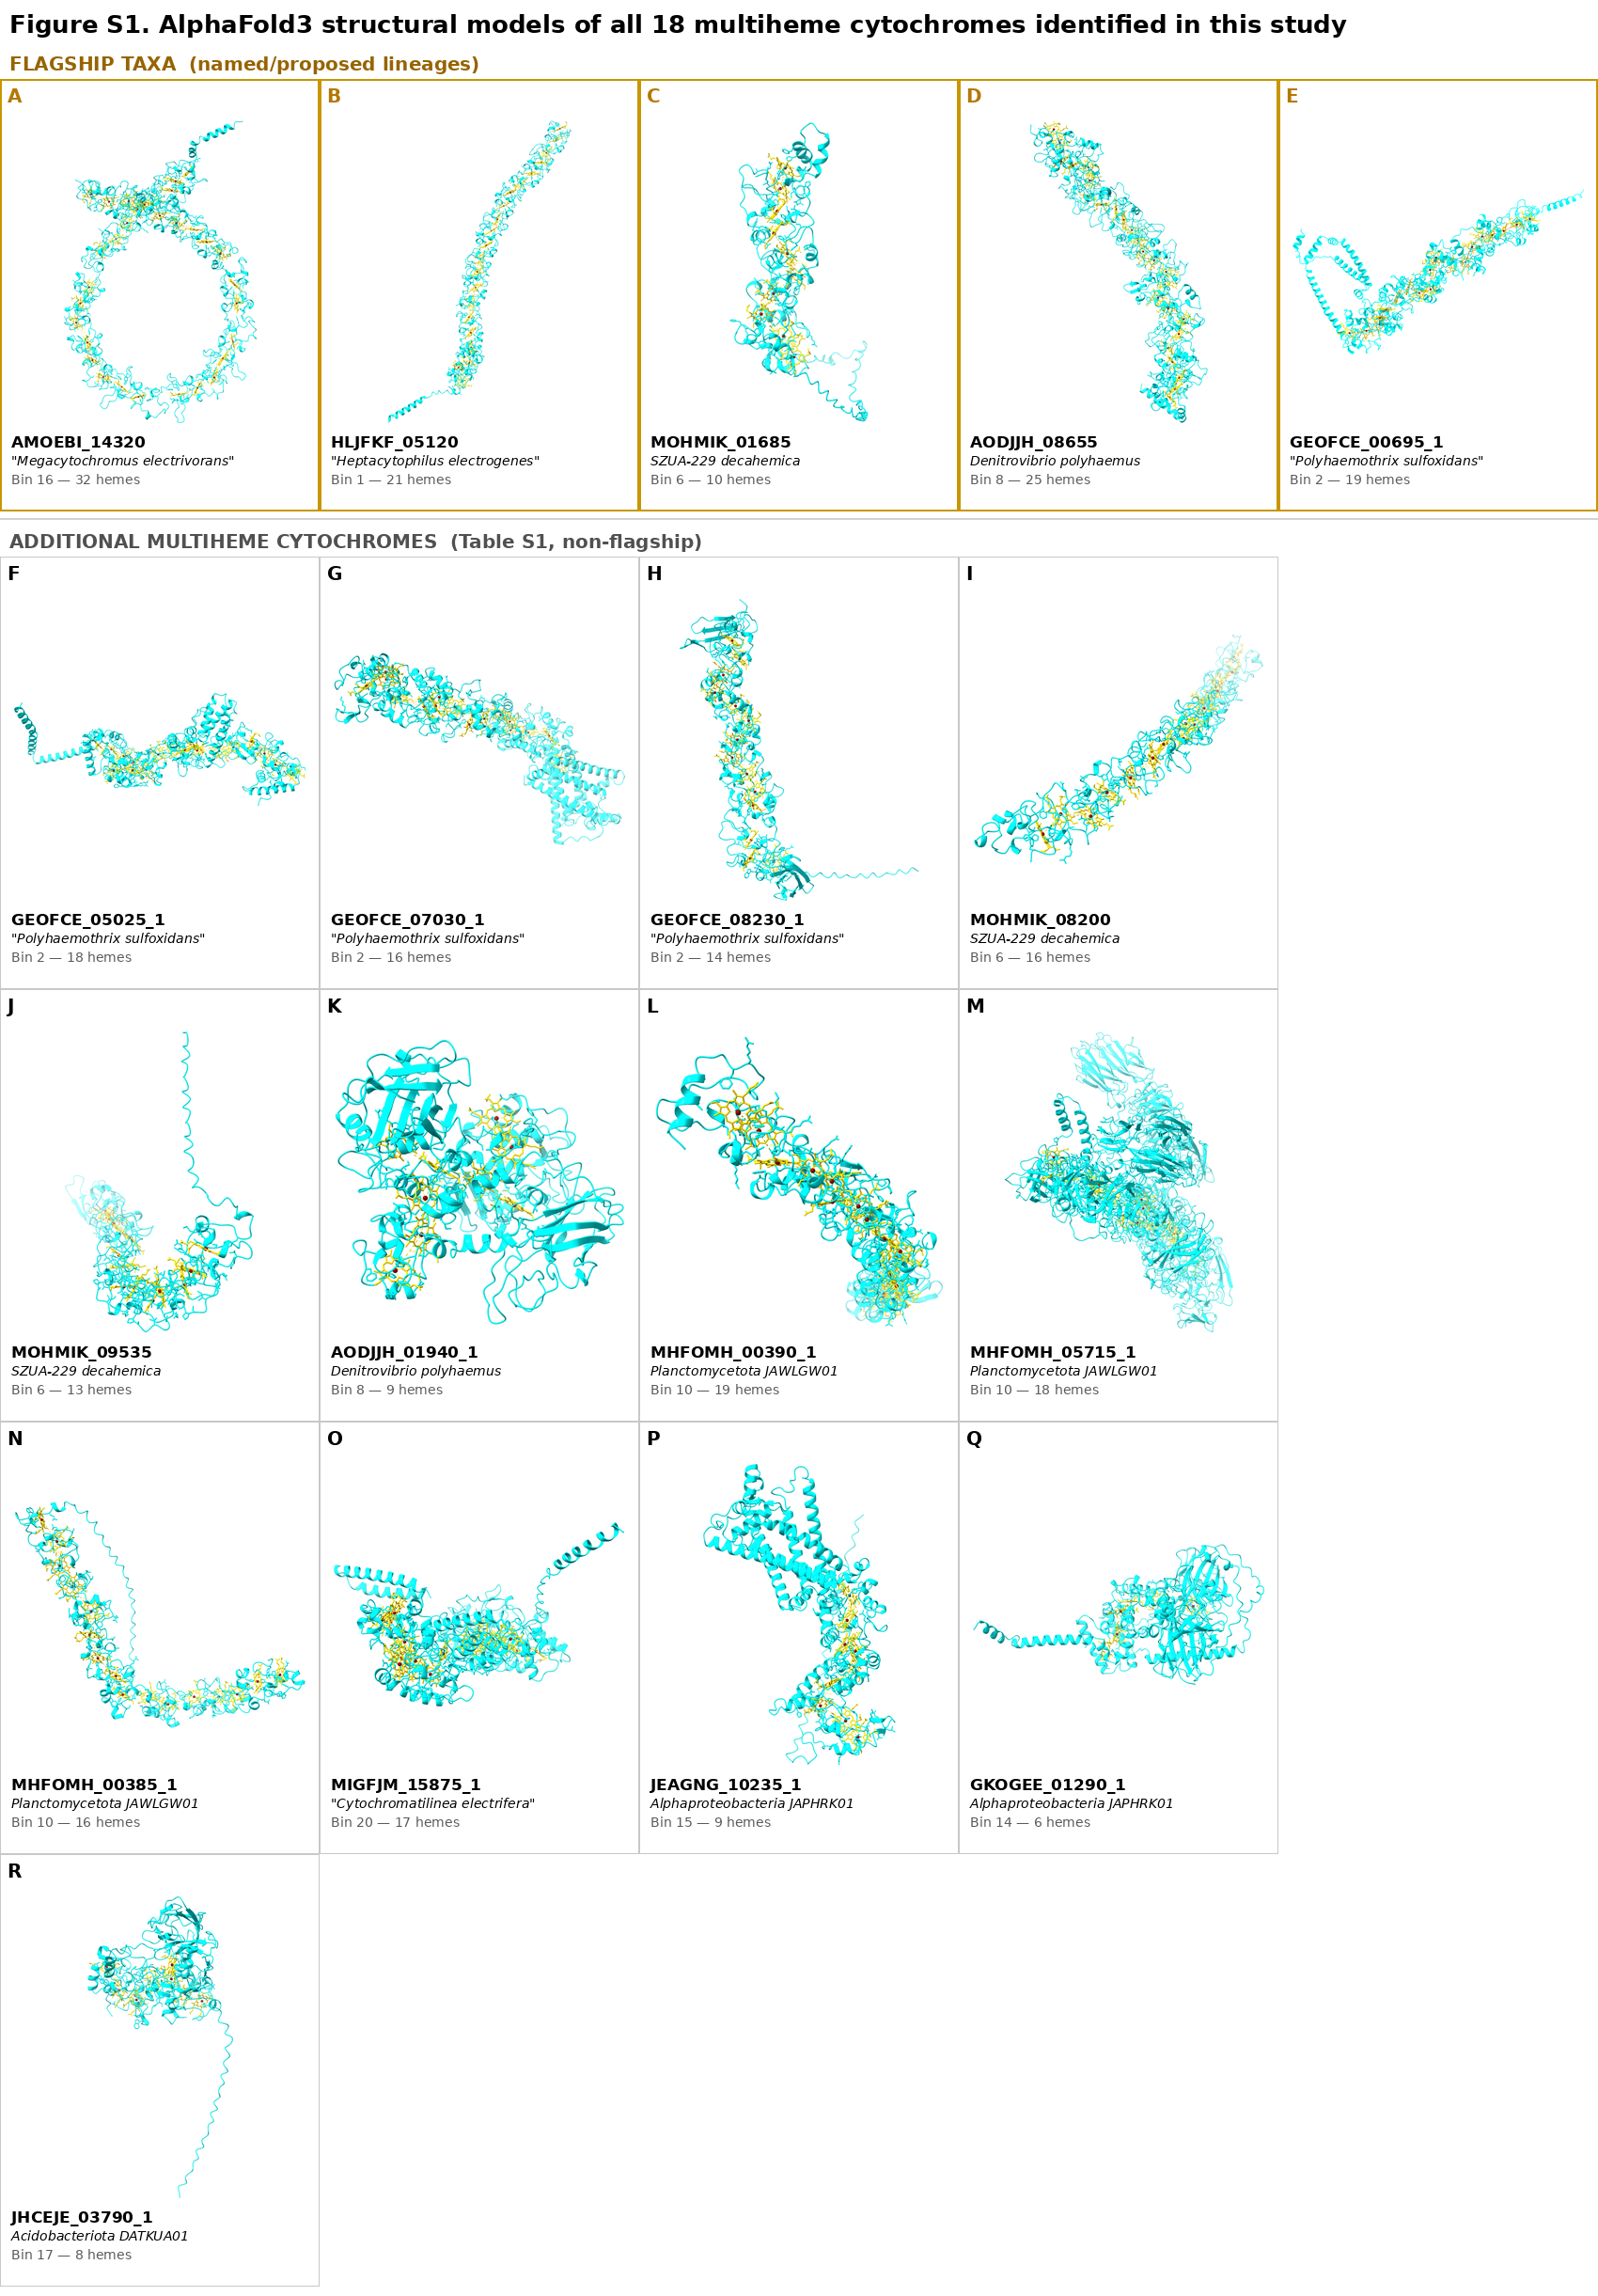
Figure S1. AlphaFold3 structural models of all 18 candidate multiheme cytochromes identified in this study, with heme cofactors (yellow) modeled as explicit HEC ligands. Top row (gold border): the five flagship taxa discussed in Section 3.4 and shown in Figure 5. Remaining panels: the additional 13 candidates from Table S1, grouped by genome bin and labeled with gene ID, organism/bin designation, and heme count.

