Supplementary material
Family-specific structure in infant gut viromes enables closed-set mother-child matching
Anmin Wang¹, Lauren Lai², Colin Patrick Johnson², Xiaoyue Yang³, Chao Ye^{3*}
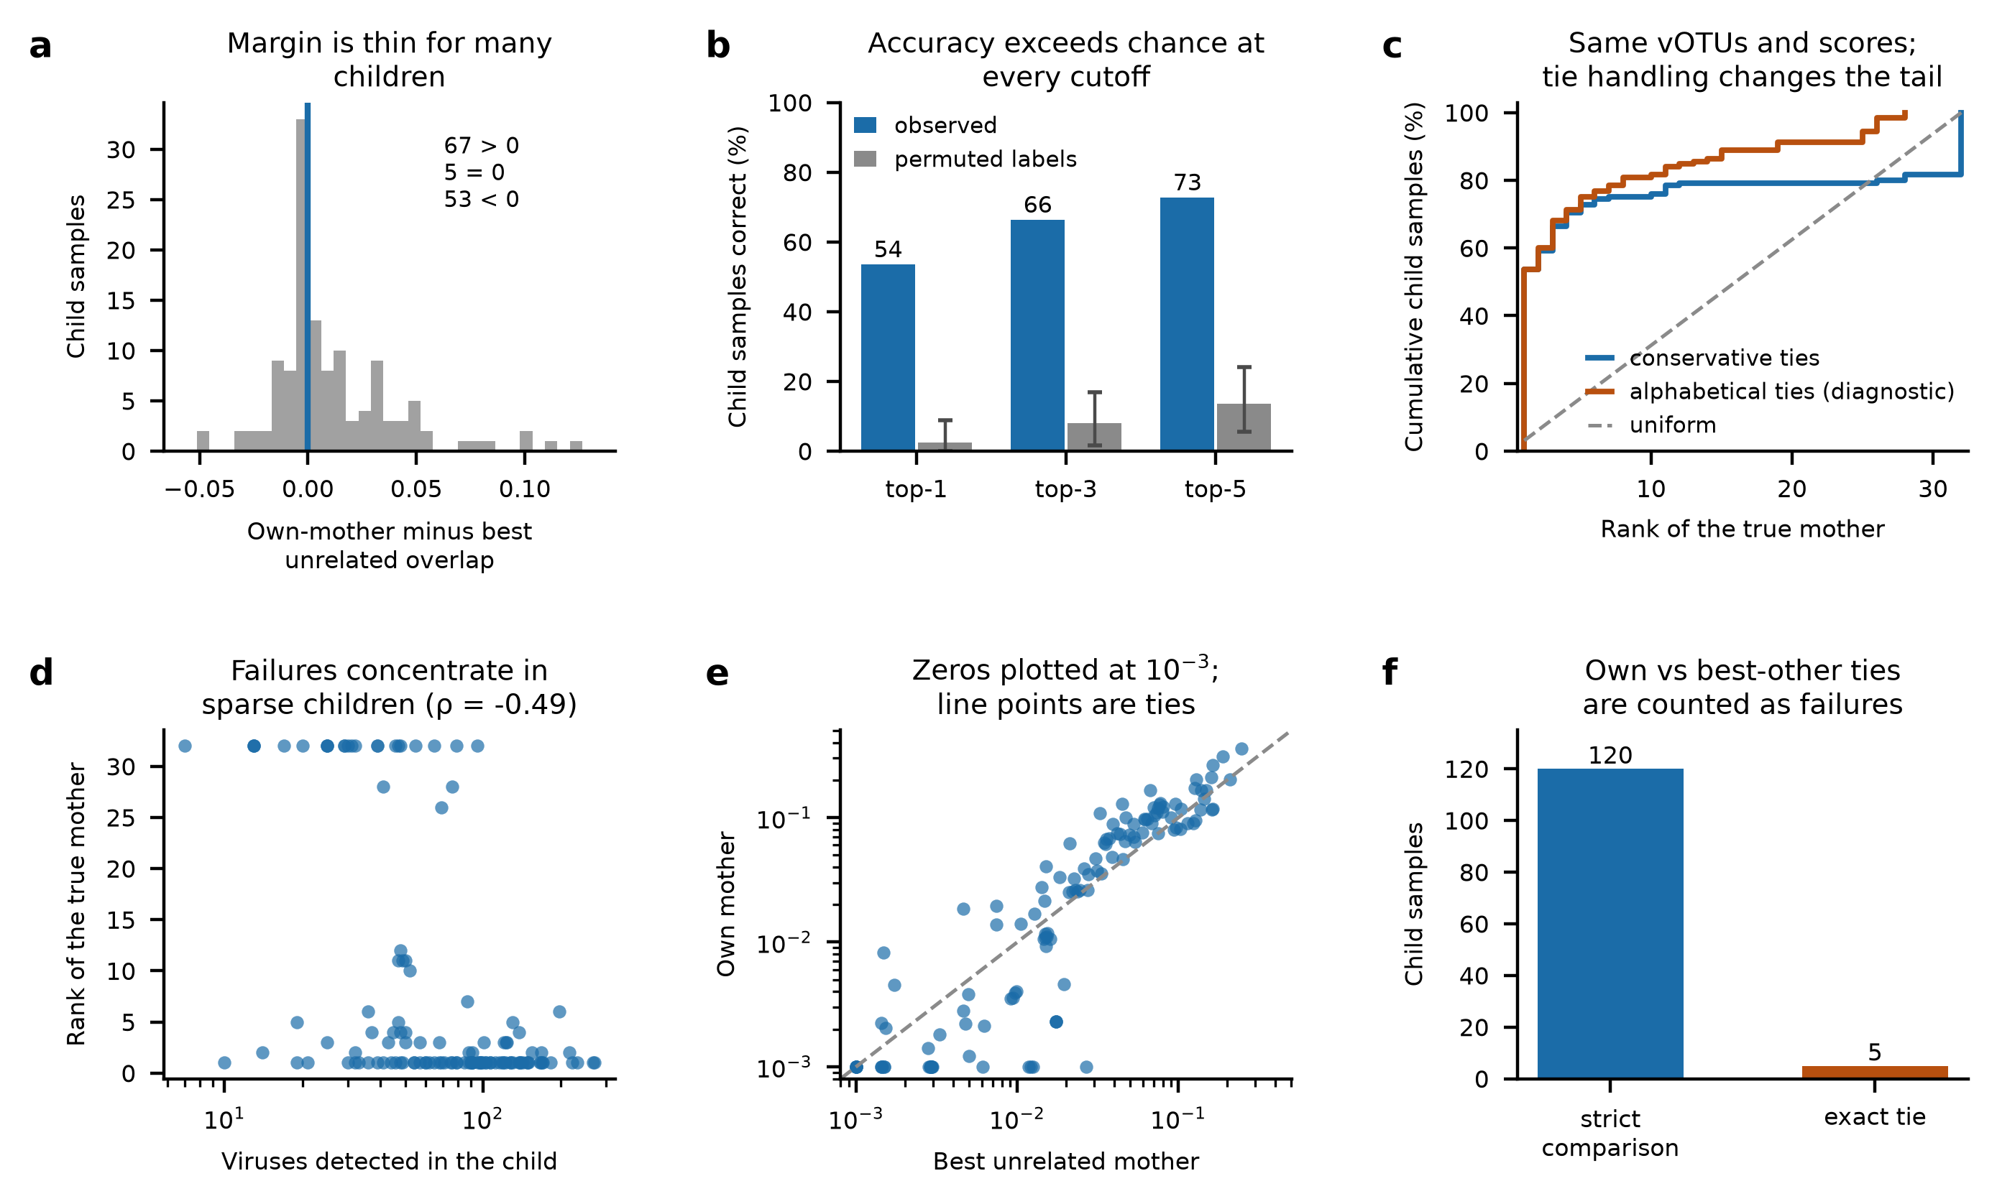

Figure S1. Diagnostics for the identification result. (a) Difference between a child's overlap with their own mother and with the best unrelated mother, one value per child sample; 67 are positive, 5 are exact ties and 53 are negative, and ties are scored as failures throughout. (b) Accuracy at the top-one, top-three and top-five cutoffs against the median and 95% range of the label-permuted null. (c) Cumulative rank distributions for identical full-set Jaccard scores under the primary conservative tie rule and an alphabetical tie-break diagnostic. The diagnostic changes the tail of the rank distribution; it does not evaluate a different prevalence filter and is not used for primary inference. (d) Rank against the number of viruses detected in the child (Spearman ρ = −0.49): failures concentrate in sparsely sampled children. (e) Own-mother against best-unrelated overlap on log axes with zeros drawn at 10⁻³; points on the diagonal are the ties from panel a. (f) Counts of strict own-versus-best-unrelated comparisons and exact ties at that comparison; this is not a count of all tied candidate scores.
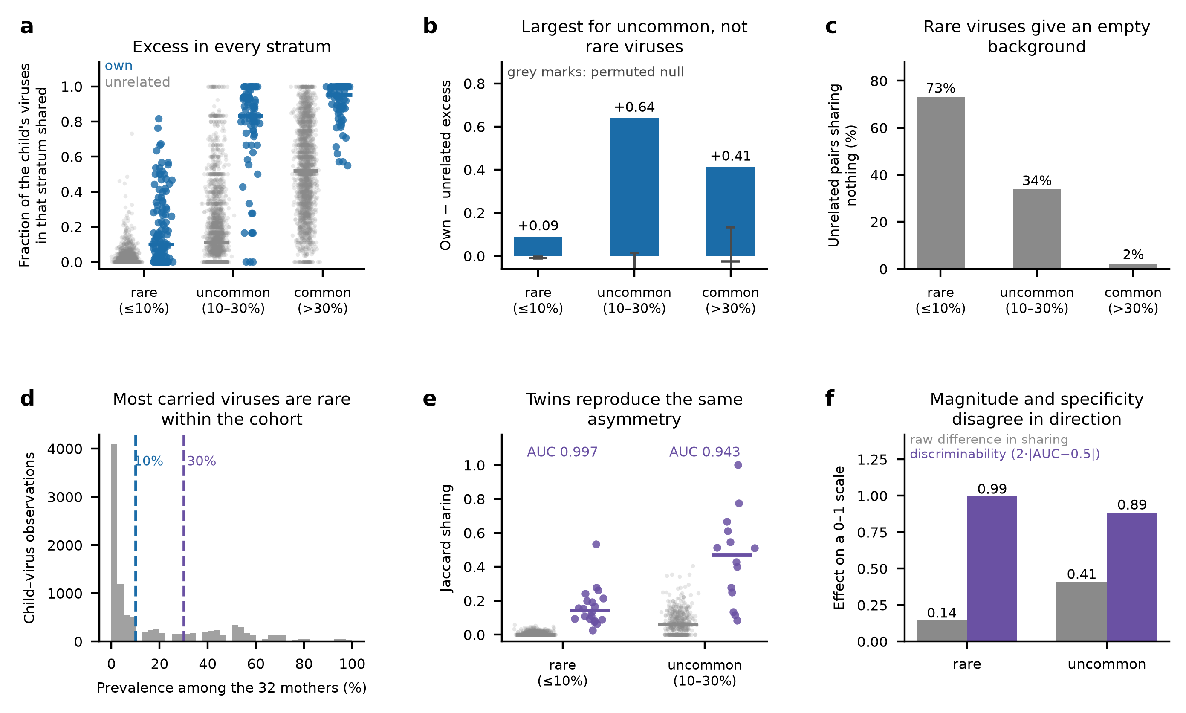
Figure S2. Prevalence decomposition: rare viruses supply specificity, not effect size. (a) Fraction of a child's viruses within a prevalence stratum that a given mother also carries, own-mother and unrelated pairs shown separately for each stratum. (b) The own-minus-unrelated excess in each stratum against its own family-label permutation null; the excess is largest for uncommon viruses (+0.64) and smallest for rare ones (+0.09). (c) Percentage of unrelated pairs sharing nothing at all in each stratum (73%, 34% and 2%): the rare stratum is where an unrelated background is effectively empty, which is what makes a match informative about identity. (d) Prevalence among the 32 cohort mothers of every child-virus observation (10,308 observations), with the stratum boundaries marked. (e) The same decomposition in the independent twin cohort. (f) The dissociation in direction: the raw twin-minus-unrelated difference is larger for uncommon viruses (0.41 against 0.14) while discriminability, expressed as 2·|AUC−0.5|, is higher for rare ones (AUC 0.997 against 0.943). The two quantities are plotted on a common 0-1 axis to show their opposite ordering across strata; their numerical magnitudes are not directly comparable.
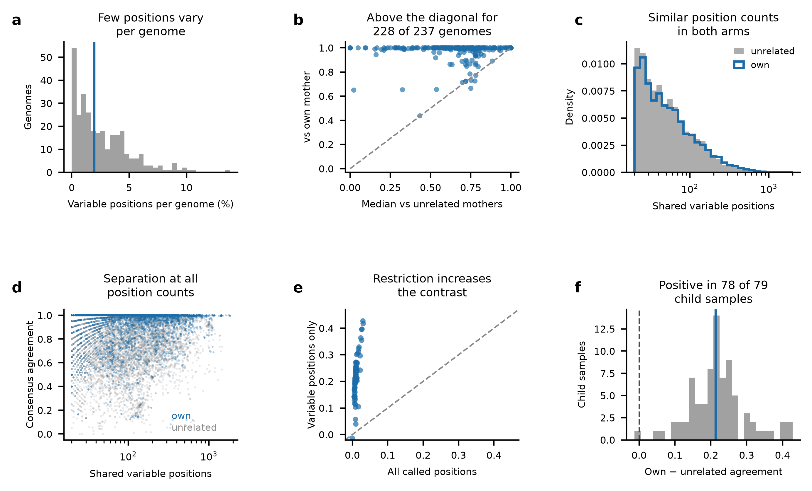
Figure S3. Within-vOTU consensus-sequence concordance is evaluated at a minority of cohort-variable positions. (a) Percentage of called positions that vary across individuals, per genome (median 1.9%). (b) Median agreement with the own mother against the median across unrelated mothers, one point per genome; 228 of 237 genomes lie above the diagonal, so the result is not carried by a few deeply covered genomes. (c) Densities of the number of shared variable positions per comparison for the two arms (medians 105 and 95), plotted as densities because the unrelated arm contains many more comparisons. (d) Agreement against the number of shared variable positions; the separation between arms is present across the whole range rather than only where positions are few. (e) Per-child contrast computed on all called positions against the same contrast on variable positions only; restricting the positions increases the same quantity rather than changing its sign. (f) Distribution of the per-sample contrast on variable positions: 78 of 79 child samples positive, median +0.213; the family-level aggregate is +0.216, positive in all 24 families.
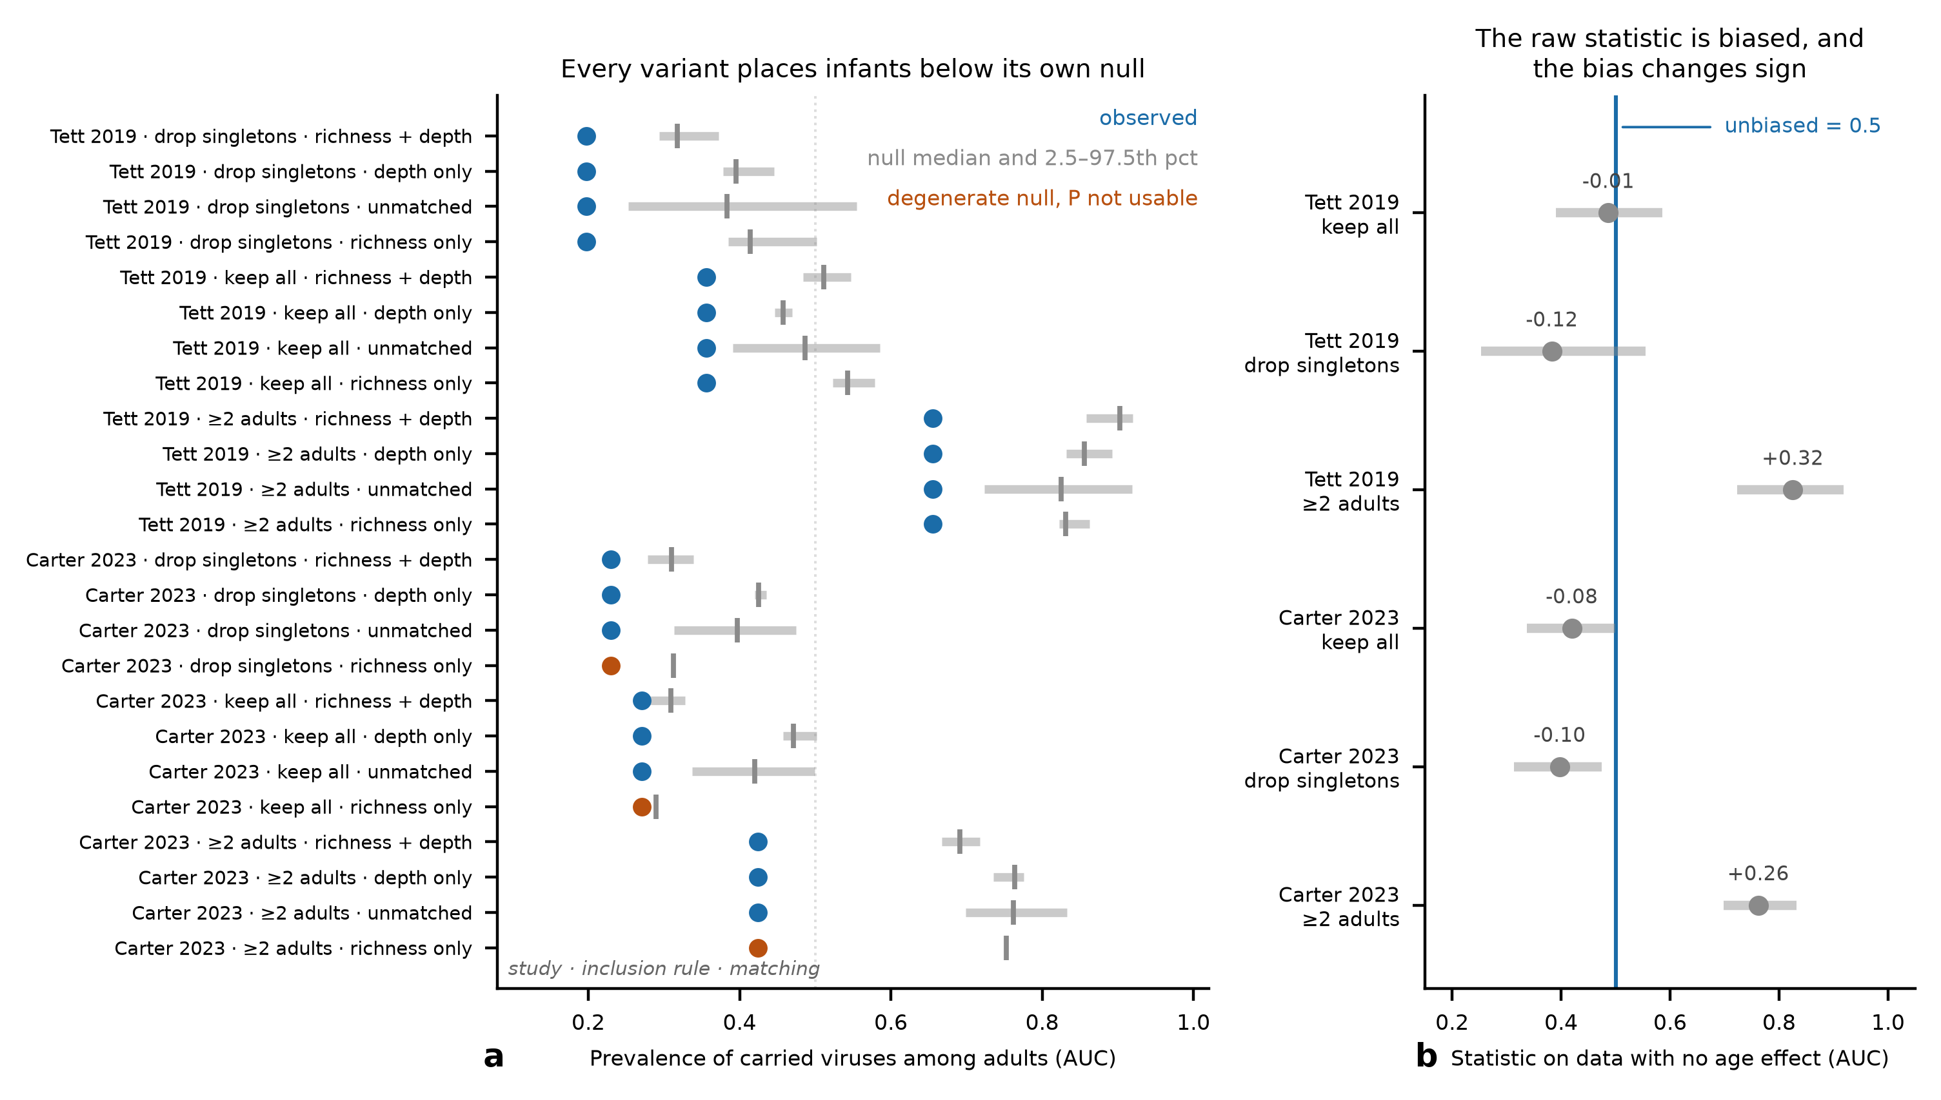
Figure S4. Calibration and variant sweep for the infant prevalence statistic. (a) For each of 24 analysis cells (study × inclusion rule × matching scheme), the observed rank statistic (filled point) against the median and 2.5th-97.5th percentile range of that cell's own null (grey); studies are labelled by first author and year, as in Fig. 4. All 24 observed values lie below their null. Three cells whose null collapsed to a single value are drawn in orange; P values are not interpretable for these cells. (b) The calibration cells alone: pseudo-infants drawn at random from adults, where the correct value is 0.5 by construction. Annotations give the bias, which spans −0.12 to +0.32 and changes sign with the inclusion rule. Full numeric detail, including the covariate match achieved and the number of distinct null values drawn per cell, is in Table S2.
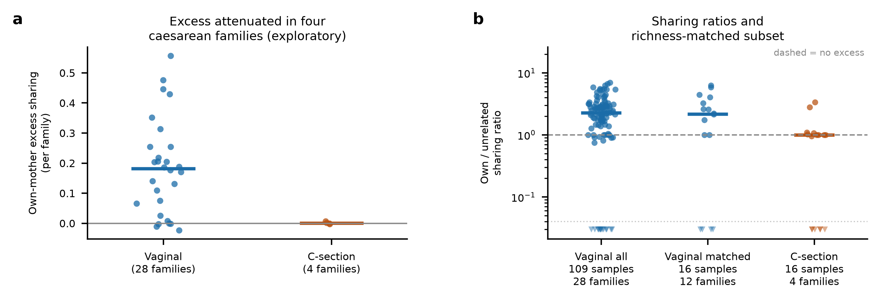
Figure S5. Exploratory delivery-mode contrast and sharing-ratio diagnostics. (a) Own-mother excess sharing aggregated to one value per family and split by delivery mode; bars are medians (n = 28 vaginal, n = 4 caesarean families) and the exact permutation over all 35,960 family assignments gives one-sided P = 0.015 (0.030 when doubled as a sensitivity calculation). This four-family contrast is exploratory. (b) Ratio of own-mother sharing to the mean across unrelated mothers, which is invariant to a strictly multiplicative change in both terms but unstable when either approaches zero, for all vaginal samples (n = 109 samples from 28 families), a vaginal subset matched to caesarean samples on detection richness (n = 16 samples from 12 families), and caesarean samples (n = 16 samples from 4 families). Each point is one child sample; the test in panel a is performed at the family level, so these points are descriptive. A pseudocount of 10⁻⁶ is added to both terms, so no ratio is undefined; ratios below 0.05, which arise when a sample shares almost nothing with any mother, are drawn as downward triangles below the dotted line rather than compressing the log axis over four decades.
Table S1. Primary full-set matching and prevalence-restricted sensitivity results. The first row is the recomputed primary analysis using all detected vOTUs. The remaining rows preserve the archived child-only ≤30% filter results (full 32-mother reference; own-mother exclusion; assigned-and-candidate-mother exclusion); all maternal sets remain unfiltered. Thus, 53.6% and 58.4% refer to different scores. The conservative tie rule is shared, but the archived leave-out nulls retain the true-family exclusion when labels are permuted and must be re-estimated with exclusions following the assigned labels. Verification status and provenance are provided in the table; archived P values are not independently verified sensitivity evidence. Supplied as tableS1_circularity.csv.
Table S2. Full variant sweep for the infant prevalence statistic. Every combination of inclusion rule (keep all vOTUs present in the adult reference; drop those whose leave-one-out prevalence is zero; restrict to those carried by at least two adults) and matching scheme (richness and depth; richness only; depth only; unmatched). Columns give the sample sizes entering the statistic, the observed value, the null median and 95% range, the observed-minus-null gap, the empirical P and the number of permutation draws behind it, the number of distinct null values drawn — a diagnostic for whether the null is a distribution at all — and the median detection richness and log sequencing depth achieved by the match. Supplied as `tableS2_q1_variant_sweep.csv`.
Table S3. Analysis sets, independent units and permutation units. For each reported analysis, the number of child samples, the number of families they come from, the size of the candidate mother set, the primary statistic and the unit that is permuted. Every reported statistic uses the 32 families with both a mother and a child above threshold, except the consensus-concordance analysis, which is restricted to the 24 families in which at least one shared virus reached tenfold coverage in both members. The 43 families with a usable maternal virome are the enrolment set and do not enter any test. Supplied as `tableS3_analysis_sets.csv`.
Table S4. Sample flow for the mother-infant cohort. Successive stages from deposited runs to the analysis set, with samples and families at each stage. One run failed because of a computational resource limit and one produced no quantification output; neither family lost its pairing. The depth filter removes 38 shallow runs, 29 of which are meconium samples, which is why the earliest post-birth window is the interval these data cover least well. The final drop from 131 to 125 child samples applies the requirement of at least five detected viruses, below which a sharing fraction is not meaningfully defined. Supplied as `tableS4_sample_flow.csv`.

