Supplementary Material
Chronic Cerebral Small Vessel Disease Burden and Acute Infarction in Relation to Functional Brain Network Efficiency

Table S1. Sensitivity analyses for acute infarction definition and volume
Model | Predictor | N | B | HC3 95% CI | P value
Model1-volume-N156 | Clinical acute infarction | 156 | -0.0022 | -0.0111 to 0.0066 | 0.620
Model1-volume-N156 | Case-centered acute-infarct log volume | 156 | -0.0006 | -0.0069 to 0.0058 | 0.858
Model1-RSSI-N166 | RSSI positive | 166 | -0.0056 | -0.0137 to 0.0024 | 0.168
Model1-RSSI-N166 | Case-centered RSSI log volume | 166 | 0.0000 | -0.0056 to 0.0056 | 0.995
Both models adjusted for age, sex, hypertension, diabetes mellitus, and meanFD. Clinical acute-infarction volume was not imputed for 10 acute cases without usable RSSI volume; therefore, that sensitivity model used N=156.
Supplementary result. Alternative acute-injury definitions did not change the primary null finding. In the volume-based model (N=156), neither clinical acute-infarction status (B=-0.0022, 95% CI -0.0111 to 0.0066; P=0.620) nor case-centered acute-infarct log volume (B=-0.0006, 95% CI -0.0069 to 0.0058; P=0.858) was associated with global efficiency. In all 166 participants, RSSI positivity was also non-significant (B=-0.0056, 95% CI -0.0137 to 0.0024; P=0.168), as was case-centered RSSI log volume (B=0.0000, 95% CI -0.0056 to 0.0056; P=0.995).

Table S2. Regional-effect robustness analyses
Family | Region | Main B | Huber B | Strict exclusion B (P) | No acute B (P) | +Global mean signal B (P) | Retained time points B (P) | Leave-one-out B range
LA | Frontal lacune | 0.0014 | 0.0002 | 0.0010 (0.826) | 0.0113 (0.277) | 0.0017 (0.735) | 0.0023 (0.654) | 0.0001 to 0.0030
LA | Parietal lacune | -0.0130 | -0.0144 | -0.0140 (0.008) | -0.0147 (0.079) | -0.0138 (0.012) | -0.0139 (0.012) | -0.0147 to -0.0111
LA | Deep lacune | -0.0132 | -0.0117 | -0.0141 (0.003) | -0.0221 (0.017) | -0.0130 (0.009) | -0.0111 (0.033) | -0.0142 to -0.0116
CMB | Frontal CMB | 0.0023 | 0.0053 | 0.0025 (0.687) | -0.0049 (0.641) | 0.0015 (0.821) | 0.0041 (0.523) | 0.0005 to 0.0053
CMB | Parietal CMB | -0.0060 | -0.0045 | -0.0010 (0.878) | -0.0040 (0.665) | -0.0068 (0.399) | -0.0058 (0.480) | -0.0087 to -0.0015
CMB | Temporal CMB | -0.0046 | -0.0070 | -0.0057 (0.274) | -0.0089 (0.350) | -0.0047 (0.400) | -0.0049 (0.368) | -0.0061 to -0.0028
CMB | Deep CMB | -0.0070 | -0.0085 | -0.0070 (0.226) | -0.0043 (0.654) | -0.0071 (0.270) | -0.0069 (0.254) | -0.0098 to -0.0050
CMB | Infratentorial CMB | -0.0034 | -0.0030 | -0.0058 (0.431) | 0.0070 (0.492) | -0.0042 (0.559) | -0.0039 (0.592) | -0.0051 to -0.0001
PVS | Frontal PVS volume | 0.0001 | 0.0008 | 0.0003 (0.941) | 0.0035 (0.529) | 0.0000 (0.995) | 0.0009 (0.812) | -0.0010 to 0.0022
PVS | Parietal PVS volume | 0.0019 | 0.0024 | 0.0025 (0.438) | 0.0017 (0.796) | 0.0022 (0.540) | 0.0014 (0.692) | 0.0011 to 0.0030
PVS | Temporal PVS volume | -0.0009 | -0.0012 | -0.0011 (0.729) | -0.0005 (0.932) | -0.0007 (0.833) | -0.0009 (0.811) | -0.0028 to 0.0002
PVS | Occipital PVS volume | -0.0004 | -0.0017 | -0.0013 (0.535) | -0.0051 (0.092) | -0.0005 (0.835) | -0.0011 (0.691) | -0.0016 to 0.0001
PVS | Deep PVS volume | -0.0018 | -0.0016 | -0.0008 (0.740) | -0.0069 (0.032) | -0.0018 (0.473) | -0.0018 (0.485) | -0.0030 to -0.0009
PVS | Infratentorial PVS volume | 0.0003 | -0.0003 | -0.0009 (0.638) | 0.0017 (0.554) | 0.0000 (0.991) | 0.0005 (0.806) | -0.0003 to 0.0007
WMH | Juxtaventricular WMH volume | 0.0031 | -0.0004 | 0.0005 (0.929) | 0.0021 (0.836) | 0.0023 (0.702) | 0.0031 (0.587) | 0.0011 to 0.0046
WMH | Periventricular WMH volume | -0.0062 | -0.0033 | -0.0030 (0.600) | -0.0084 (0.423) | -0.0055 (0.358) | -0.0058 (0.340) | -0.0082 to -0.0042
WMH | Deep WMH volume | 0.0001 | -0.0001 | -0.0011 (0.717) | 0.0001 (0.989) | -0.0000 (0.997) | 0.0007 (0.831) | -0.0008 to 0.0009
WMH | Juxtacortical WMH volume | -0.0028 | -0.0023 | -0.0032 (0.237) | -0.0016 (0.660) | -0.0028 (0.346) | -0.0036 (0.237) | -0.0039 to -0.0015
Strict exclusion required both Cook D>4/N and |studentized residual|>3 (N=164). The no-acute-infarction subgroup included 86 participants. Remaining time points replaced meanFD and were not entered concurrently. These sensitivity analyses are supportive and do not replace the primary HC3 models.
Supplementary result. Parietal and deep lacune coefficients remained negative with Huber regression and after strict exclusion of two influential observations (N=164; B=-0.0140, P=0.008 and B=-0.0141, P=0.003, respectively). Their negative associations were also retained after additional adjustment for global mean signal (P=0.012 and P=0.009), when retained time points replaced meanFD (P=0.012 and P=0.033), and in all leave-one-out models. In the no-acute-infarction subgroup (N=86), the deep-lacune association persisted (B=-0.0221; P=0.017), whereas the parietal estimate remained negative but was less precise (B=-0.0147; P=0.079).
The lacune block remained significant after adjustment for global mean signal, substitution of retained time points, and inclusion of a quadratic meanFD term (robust block P=0.0014, P=0.0058, and P=0.0015, respectively). CMB and PVS blocks remained non-significant across the principal sensitivity models, whereas the WMH block remained borderline (robust block P=0.057-0.075). An isolated negative association for deep PVS volume in the no-acute-infarction subgroup (P=0.032) was not reproduced in the primary model or other sensitivity analyses.

Table S3. Regional block tests, collinearity, diagnostics, and bootstrap quality
Family | N | R2 | Adjusted R2 | Delta R2 | Block P | Max VIF | BP P | Strict influence n | Bootstrap success/requested | Failed | Singular
LA | 166 | 0.275 | 0.233 | 0.0927 | 0.002 | 1.21 | <0.001 | 2 | 1000/1000 | 0 | 0
CMB | 166 | 0.217 | 0.161 | 0.0344 | 0.392 | 1.33 | 0.003 | 2 | 1000/1000 | 0 | 0
PVS | 166 | 0.188 | 0.124 | 0.0057 | 0.987 | 2.88 | 0.014 | 2 | 1000/1000 | 0 | 0
WMH | 166 | 0.224 | 0.173 | 0.0413 | 0.057 | 8.38 | 0.001 | 2 | 1000/1000 | 0 | 0
Block P values are HC3 robust joint Wald tests. BP denotes the Breusch-Pagan heteroskedasticity test. Bootstrap used participant-level resampling with 1,000 requested samples and seed 20260801. WMH variance inflation factors require cautious interpretation because juxtaventricular and periventricular volumes were highly correlated.
Supplementary result. Breusch-Pagan tests indicated heteroskedasticity for all four regional models (P<0.05), supporting the prespecified use of HC3 robust inference. Maximum variance inflation factors were low for lacunes (1.21) and CMBs (1.33), moderate for PVS (2.88), and high for WMH (8.38). Two participants met the strict influence criterion, but their exclusion did not materially alter the principal lacune estimates. Each lesion-family bootstrap completed 1,000 of 1,000 requested resamples, with no failed or singular fits.

Figure S1. Exploratory correlations between quantitative CSVD markers and network measures
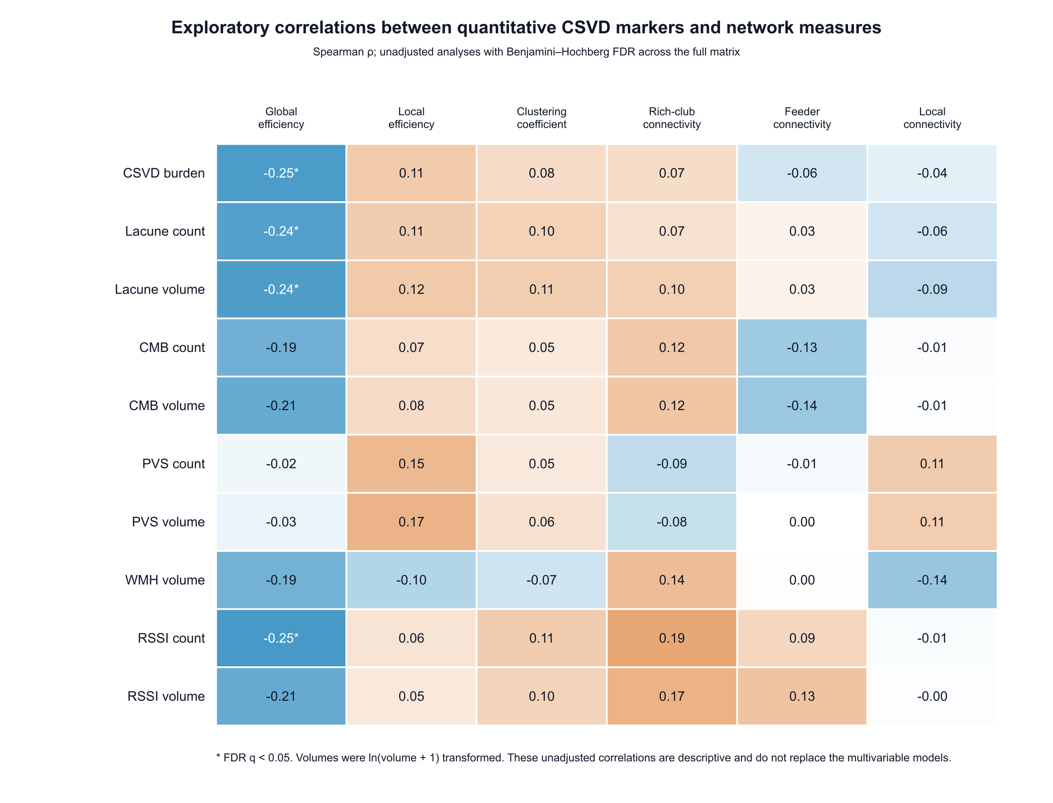
Spearman correlations are unadjusted and descriptive. Benjamini-Hochberg FDR correction was applied across the full displayed matrix. Volumes were ln(volume+1) transformed. These analyses do not replace the multivariable models.

