Salivary microbiome exhibits stage-associated network topological shifts in upper gastrointestinal carcinogenesis
Junling Xiang^{1,2†}, Shuai Zhang^{1,2†}, Nan Zhang³, Jun Zhang^{1,2}, Youhua Lu³*, Tao Zhang^{1,4,5,6}*
1 Department of Biostatistics, School of Public Health, Cheeloo College of Medicine, Shandong University, Jinan, Shandong, 250012, China.
2 National Institute of Health Data Science, Shandong University, Jinan, Shandong, 250002, China.
3 Shandong Cancer Hospital and Institute, Shandong First Medical University and Shandong Academy of Medical Sciences, Jinan, Shandong, 250117, China.
4 Department of Epidemiology and Biostatistics, School of Public Health, Tianjin Medical University, Tianjin, 300070, China.
5 Key Laboratory of Prevention and Control of Major Diseases in the Population, Ministry of Education, Tianjin Medical University, Tianjin 300070, China.
6 Tianjin Key Laboratory of Environment, Nutrition and Public Health, Tianjin 300070, China.

†Junling Xiang and Shuai Zhang have contributed equally to this work.
*To whom correspondence should be addressed.
The authors do not have any conflict of interest.

Running Title: Stage-associated microbiome network shifts in UGIC
Correspondence & Reprints:
Youhua Lu, MD, PhD
Shandong Cancer Hospital and Institute, Shandong First Medical University and Shandong Academy of Medical Sciences, Jinan, Shandong, 250117, China.
E-mail: luyouhua@126.com

Tao Zhang, MD, PhD
Department of Epidemiology and Biostatistics, School of Public Health, Tianjin Medical University, Tianjin, 300070, China.
E-mail: taozhang@tmu.edu.cn

Continent
Supplementary Methods 1
Subject 1
Data collection 2
Supplementary Tables 7
Supplementary Table 1. Distribution of study participants across the 13 multicenter recruitment sites stratified by clinical stage. 7
Supplementary Table 2. Pairwise Kolmogorov-Smirnov (K-S) test results comparing the distributions of degree across clinical stages. 7
Supplementary Table 3. Reconnection edge counts of core high-reconnect taxa 8
Supplementary Figures 9
Supplementary Figure 1 Flow diagram of study participant selection and cohort design. 12
Supplementary Figure 2. Marginal variance partitioning of the salivary microbiome driven by host and environmental metadata. 13
Supplementary Figure 3. Constrained variance partitioning of the salivary microbiome via canonical analysis of principal coordinates (CAP). 13
Supplementary Figure 4. Calibration curve of the combined predictive model. 14
Supplementary Figure 5. Nomogram of the combined predictive model for estimating the risk of UGIC progression. 14
Supplementary Figure 6. Diagnostic performance of the predictive models for distinguishing LGIN from HC. 15
Supplementary Figure 7. Diagnostic performance of the predictive models for distinguishing HGIN from HC. 16
Supplementary Figure 8. Diagnostic performance of the predictive models for distinguishing UGIC from HC. 17

Supplementary Methods

Subject
Study cohort
Participants in this study were enrolled from a multicenter upper digestive tract cancer screening initiative conducted in the general population of Shandong Province, China. Initiated in March 2024 with a planned three-year duration, the recruitment phase remains active (state 2026).
Eligibility criteria, follow-up, ethics
The recruitment followed a standardized workflow as depicted in Fig.S1. Eligible participants were required to meet the following inclusion criteria: (i) local permanent residents aged 40 to 69 years, (ii) voluntary participation with signed informed consent, and (iii) the capacity to complete structured questionnaires. Conversely, we excluded individuals based on the following criteria: (i) a prior history of malignancy, (ii) current intensive treatment for severe medical or surgical conditions, and (iii) major organ dysfunction or psychiatric disorders. Furthermore, we excluded (iv) individuals with clinical contraindications to endoscopic examination.
Upon providing written informed consent, all enrolled participants underwent a standardized study protocol, including a baseline questionnaire survey, physical measurements, biospecimen collection, and comprehensive endoscopic examination.
Consequently, the frequency of longitudinal follow-up was strategically assigned based on these diagnostic findings. Specifically, the progression of upper gastrointestinal conditions was categorized into four distinct groups according to histopathological severity. (i) Healthy Controls (HC): defined by normal mucosa with no evidence of atrophy, intestinal metaplasia, or dysplasia. (ii) Low-grade Intraepithelial Neoplasia (LGIN): characterized by neoplastic transformations with mild-to-moderate cellular atypia. Both the HC and LGIN groups were assigned to a low-intensity surveillance program, requiring endoscopic follow-up at least once every three years. (iii) High-grade Intraepithelial Neoplasia (HGIN): exhibiting marked cellular atypia and complex architectural distortion. Individuals in this high-risk group underwent intensified annual surveillance. (iv) Upper Gastrointestinal Cancer (UGIC): comprising pathologically confirmed cases of squamous cell carcinoma and adenocarcinoma. For these patients, a regular oncological follow-up was implemented in accordance with standardized clinical guidelines.
The study was conducted in accordance with the Declaration of Helsinki. Informed consent was obtained from all participants, who were explicitly informed of their right to withdraw from the study at any stage without providing a justification and without prejudice. Ethical approval for this study was granted by the Institutional Review Boards of Shandong University (LL20240353) and the Cancer Hospital Affiliated to Shandong First Medical University (SDTHEC2024003167). The study protocol was prospectively registered with the Chinese Clinical Trial Registry (ChiCTR2500113249).

Data collection
Questionnaire and measurements
All participants completed a standardized, structured questionnaire covering five primary domains. These included (i) demographics, such as age, sex, body mass index (BMI), and recruitment center; and (ii) lifestyle factors, specifically smoking status and alcohol consumption. Dietary habits (iii) were assessed based on flavor and texture preferences, as well as the intake frequency of tea (black and green), fresh vegetables, fruits, beans, and protein-rich foods (meat, dairy, and eggs). This domain also captured consumption patterns of pickled, fried, hot, or moldy foods. Furthermore, we collected data on (iv) oral health, including brushing frequency, dental problems, and missing teeth. Finally, (v) medical and family history encompassed H. pylori infection status, previous gastroscopies, and family history of upper gastrointestinal cancer, alongside chronic comorbidities including hypertension, hyperlipidemia, coronary heart disease, stroke, diabetes, and hepatitis.
Subsequent to the questionnaire, trained staff performed standardized measurements for all participants, encompassing height, weight, waist and hip circumferences, as well as seated resting blood pressure and heart rate.
Endoscopic and pathological diagnosis
After fasting for at least 8 hours overnight, all participants underwent upper gastrointestinal endoscopy performed by experienced endoscopists, including the esophagus, cardia, stomach, and descending duodenum. To enhance visualization of subtle mucosal changes, a standardized chromoendoscopy protocol was implemented: suspicious lesions were delineated using 1.2% Lugol's iodine solution and 0.2% indigo carmine or narrow-band imaging. Biopsy collection followed a combination of targeted and pre-arranged systematic sampling strategies. In addition to biopsies from any endoscopically suspicious lesions, systematic biopsies were pre-arranged from predefined standard sites to ensure accurate confirmation. All biopsy specimens were fixed in 10% neutral buffered formalin, paraffin-embedded, and stained with hematoxylin and eosin (H&E). Pathological diagnoses were independently determined by two senior gastrointestinal pathologists. When the severity of biopsy pathologies differed at different sampling sites, the higher-level diagnosis was used for the final pathological diagnosis.
Saliva samples collection
Participants were instructed to rinse their oral cavities with pure water 30 minutes prior to sampling. Saliva was harvested by chewing a standardized cotton swab within a sterile swab collection tube (SARSTEDT, Germany) for at least 2 minutes. Following collection, the specimens were subjected to centrifugation at 1,000 times g for 3 minutes at room temperature. To ensure the preservation of microbial profiles and sample stability, the entire duration from initial collection to the completion of centrifugation was strictly controlled to within 4 hours. The processed samples were subsequently cryopreserved at -80 °C for downstream metagenomic sequencing.
Metagenomics process
Total DNA of paired participants was extracted from saliva samples using the QIAamp Fast DNA Mini Kit (Qiagen, Hilden, Germany) following the manufacturer’s instructions. DNA concentration and integrity were rigorously assessed using a NanoDrop2000 spectrophotometer (Thermo Fisher Scientific, USA) and agarose gel electrophoresis. For library preparation, DNA was fragmented using S220 Focused-ultrasonicators (Covaris, USA) and purified with Agencourt AMPure XP beads (Beckman Coulter, USA). Metagenomic libraries were subsequently constructed using the TruSeq Nano DNA LT Sample Preparation Kit (Illumina, San Diego, CA, USA). Sequencing was performed on the DNBSEQ-T7 platform (MGI Tech Co., Ltd., Shenzhen, China) by OE Biotech Co., Ltd. (Shanghai, China), generating raw reads in FASTQ format.
Raw reads were quality-filtered using fastp (v0.20.1) and dehosted via bbmap (v38.93-0) against the host genome. High-quality sequences were assembled into contigs using MEGAHIT (v1.2.9). Open reading frames (ORFs) longer than 500 bp were predicted using Prodigal (v2.6.3) and translated into amino acid sequences. A non-redundant gene catalog was established using MMSeqs2 (v13.45111) (95% identity, 90% coverage), and abundance was quantified using Salmon (v1.8.0). Taxonomic and functional annotations were performed by aligning representative sequences against the Micro-NR and Kyoto Encyclopedia of Genes and Genomes (KEGG) databases using DIAMOND (v2.1.9), hmmscan (v3.1), and blast (v2.6.0) (E-value < 1 times 10^-5). To further elucidate functional potential, identified genes were mapped to KEGG Orthology (KO) identifiers. The abundance of each functional pathway was derived by aggregating the relative abundances of all constituent genes assigned to KEGG Level 2 categories, ensuring comparability across the HC, LGIN, HGIN, and UGIC groups.
Storage of biomaterial and data management
Biomaterials were initially archived in ultra-low temperature freezers (-80°C) at each respective recruitment center. Centralized transport to the Shandong Cancer Hospital was initiated periodically based on accumulated storage volumes. All biomaterials were transferred via a continuous, monitored cold-chain logistics system to ensure sample integrity and are currently housed in the hospital's central biobank for long-term preservation.
All epidemiological data derived from questionnaires, biospecimen-associated metadata, and comprehensive clinical diagnostic records were securely uploaded to the Shandong Province Information System for Cancer Prevention, Early Diagnosis, and Treatment. This system operates on an isolated, firewall-protected internal server. Due to the presence of personally identifiable information, access is strictly governed by a centralized, role-based authentication protocol, actively precluding any unauthorized external access. To maintain absolute participant confidentiality and adhere to ethical guidelines, only fully anonymized and deidentified datasets were exported and utilized for all downstream statistical modeling and reporting.

Supplementary Tables
Supplementary Table 1. Distribution of study participants across the 13 multicenter recruitment sites stratified by clinical stage.
Center, n(%) | HC  n=104 | LGIN  n=104 | HGIN  n=103 | UGIC  n=105
DP | 14 (13.5) | 48 (46.2) | 22 (21.4) | 11 (10.5)
FC | 21 (20.2) | 15 (14.4) | 17 (16.5) | 29 (27.6)
LC | 8 (7.7) | 2 (1.9) | 6 (5.8) | 3 (2.9)
LQ | 0 (0.0) | 0 (0.0) | 7 (6.8) | 13 (12.4)
NY | 25 (24.0) | 4 (3.8) | 14 (13.6) | 9 (8.6)
PY | 17 (16.3) | 19 (18.3) | 8 (7.8) | 5 (4.8)
QF | 1 (1.0) | 5 (4.8) | 3 (2.9) | 6 (5.7)
QR | 0 (0.0) | 0 (0.0) | 2 (1.9) | 7 (6.7)
QZ | 9 (8.7) | 0 (0.0) | 1 (1.0) | 9 (8.6)
TA | 1 (1.0) | 2 (1.9) | 5 (4.9) | 2 (1.9)
WR | 0 (0.0) | 0 (0.0) | 4 (3.9) | 2 (1.9)
XT | 8 (7.7) | 0 (0.0) | 4 (3.9) | 4 (3.8)
YZ | 0 (0.0) | 9 (8.7) | 10 (9.7) | 5 (4.8)
DP, People's Hospital of Dongping; FC, People's Hospital of Feicheng; LC, Liao Cheng Tumor Hospital; LQ, People's Hospital of Linqu; NY, Ningyang County First People's Hospital; PY, Pingyin Hospital of Traditional Chinese Medicine; QF, Qufu Hospital of Traditional Chinese Medicine; QR, People's Hospital of Qufu; QZ, People's Hospital of Qingzhou; TA, Tai'an Tumor Hospital; WR, People's Hospital of Wenshang; XT, People's Hospital of Xintai; YZ, Yanzhou Hospital of Traditional Chinese Medicine.
HC, healthy controls; LGIN, low-grade intraepithelial neoplasia; HGIN, high-grade intraepithelial neoplasia; UGIC, upper gastrointestinal cancer.

Supplementary Table 2. Pairwise Kolmogorov-Smirnov (K-S) test results comparing the distributions of degree across clinical stages.
Group1 | Group2 | D_stat | P_value | P_FDR
HC | LGIN | 0.181 | 0.00118 | 0.00235
HC | HGIN | 0.199 | 0.000257 | 0.000771
HC | UGIC | 0.226 | 0.0000201 | 0.000120
LGIN | HGIN | 0.0796 | 0.470 | 0.470
LGIN | UGIC | 0.173 | 0.00239 | 0.00358
HGIN | UGIC | 0.150 | 0.0120 | 0.0144
D_stat, Kolmogorov-Smirnov test statistic representing the maximum distance between the empirical cumulative distribution functions of the two groups; P_FDR, false discovery rate-adjusted P value.
HC, healthy controls; LGIN, low-grade intraepithelial neoplasia; HGIN, high-grade intraepithelial neoplasia; UGIC, upper gastrointestinal cancer.

Supplementary Table 3. Reconnection edge counts of core high-reconnect species
taxa | LGIN  different edges | HGIN  different edges | UGIC  different edges
Prevotella_baroniae | 42 | 40 | 31
Prevotellaceae_bacterium | 37 | 41 | 30
Solobacterium_moorei | 40 | 49 | 29
uncultured_bacterium | 31 | 20 | 45
uncultured_Porphyromonas_sp. | 50 | 15 | 50
uncultured_Prevotella_sp. | 45 | 51 | 10
Data represent the absolute difference in node degree (edge counts) for each taxon in the respective disease stage network compared to the HC network.
HC, healthy controls; LGIN, low-grade intraepithelial neoplasia; HGIN, high-grade intraepithelial neoplasia; UGIC, upper gastrointestinal cancer.

Supplementary Figures
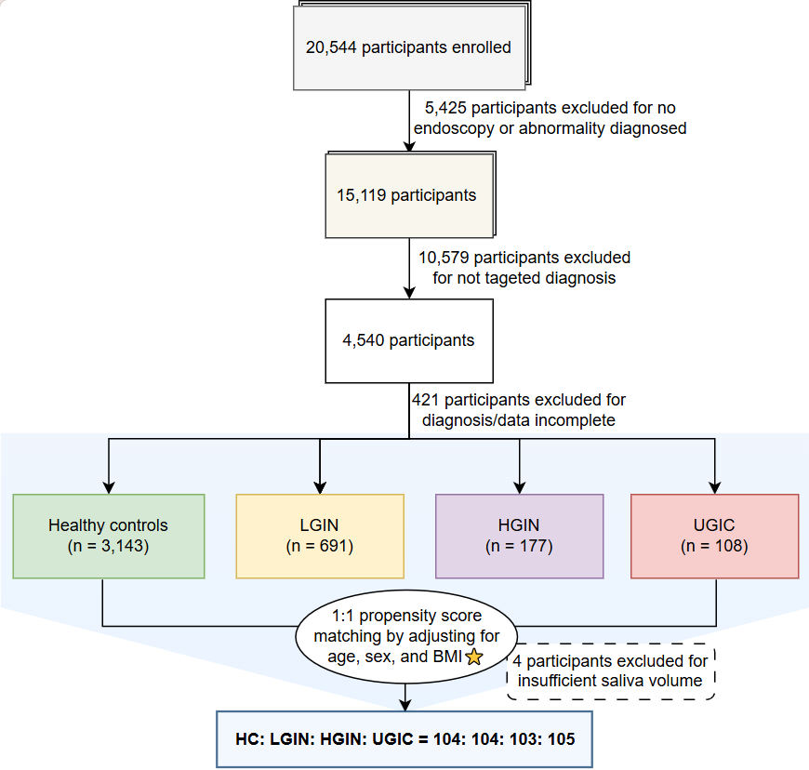
Supplementary Figure 1. Flow diagram of study participant selection and cohort design.
The diagram delineates the step-by-step inclusion and exclusion criteria applied to the initial enrollment pool. Following the sequential exclusion of individuals lacking valid endoscopic records, non-targeted diagnoses, or complete baseline data, the remaining eligible participants were stratified into four clinical stages. To mitigate the confounding effects of host demographic factors, a 1:1:1:1 PSM was performed, adjusting for age, sex, and BMI, yielding a final balanced analytical cohort (n = 416, 104 HC, 104 LGIN, 103 HGIN, and 105 UGIC).
BMI, body mass index; PSM, propensity score matching; HC, healthy controls; LGIN, low-grade intraepithelial neoplasia; HGIN, high-grade intraepithelial neoplasia; UGIC, upper gastrointestinal cancer.
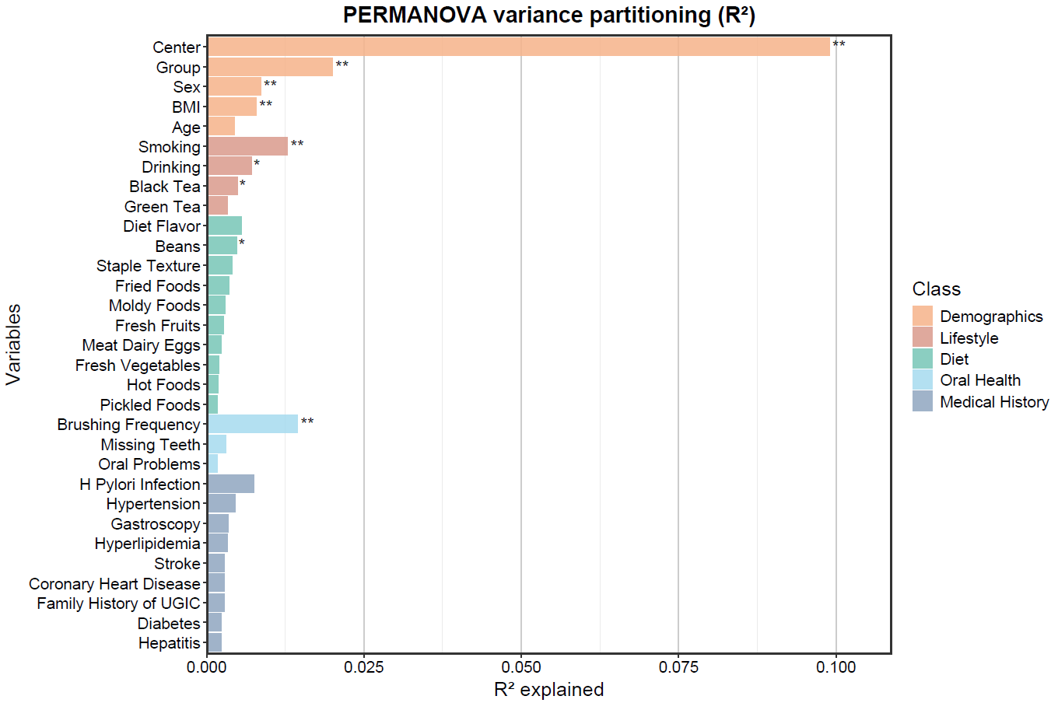
Supplementary Figure 2. Marginal variance partitioning of the salivary microbiome driven by host and environmental metadata.
Effect sizes (R²) of individual covariates on the overall microbial community structure, calculated via univariate permutational multivariate analysis of variance (PERMANOVA). Variables are sorted by the proportion of variance explained and color-coded according to their respective broad categories (Demographics, Lifestyle, Diet, Oral Health, and Medical History). The 'Center' variable represents the 13 recruitment sites, and 'Group' denotes the clinical stages. *P < 0.05, **P < 0.01.
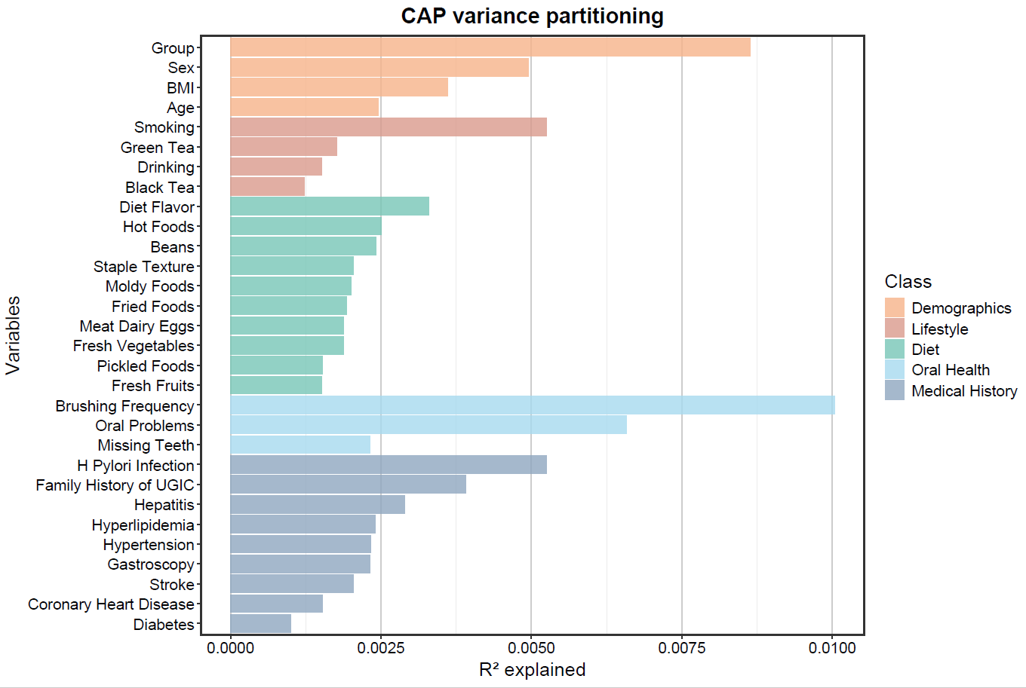
Supplementary Figure 3. Constrained variance partitioning of the salivary microbiome via canonical analysis of principal coordinates (CAP).
Explained variance (R²) of host and environmental covariates on the microbial community structure under the CAP model. Variables are color-coded by metadata categories (Demographics, Lifestyle, Diet, Oral Health, and Medical History). The 'Group' variable explicitly refers to the clinical stages across the UGIC continuum.
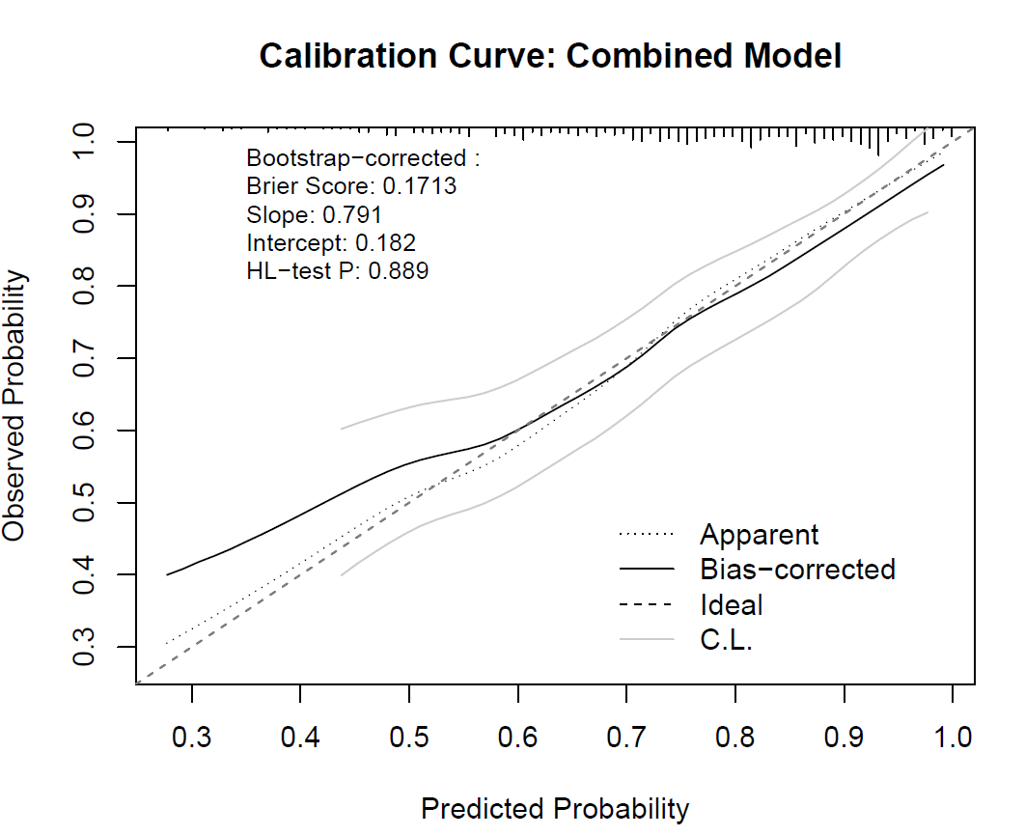
Supplementary Figure 4. Calibration curve of the combined predictive model.
The calibration plot evaluates the agreement between the predicted probabilities generated by the combined model and the actual observed frequencies. The diagonal dashed line represents ideal perfect calibration. The solid and dotted lines indicate the bootstrap bias-corrected and apparent calibration curves, respectively, while the gray flanking lines denote the confidence limits. Key quantitative calibration metrics are annotated within the plot area, including the Brier score (0.1713), calibration slope (0.791), intercept (0.182), and Hosmer-Lemeshow (HL) test P-value (0.889).
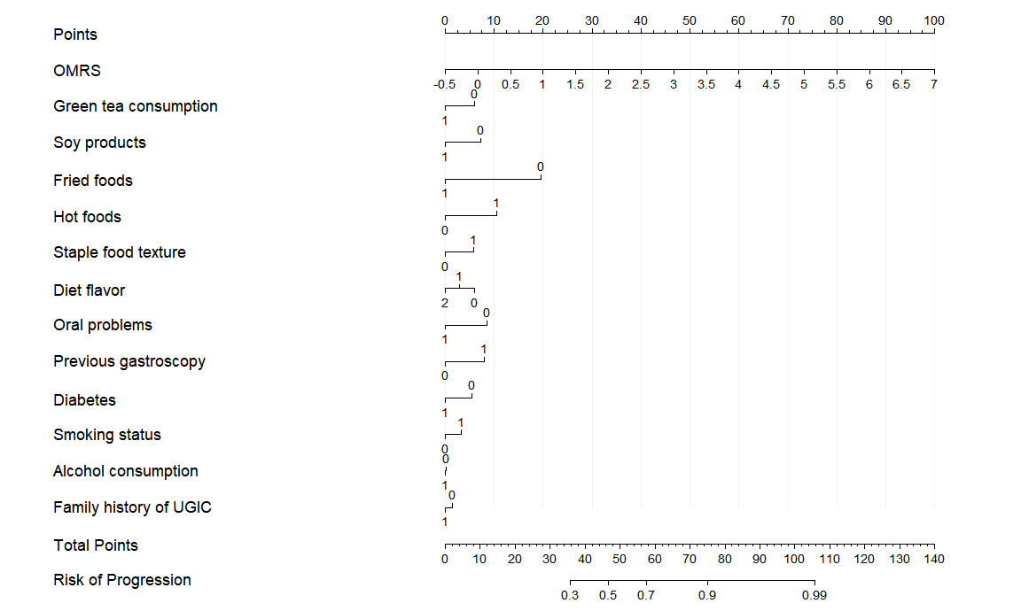
Supplementary Figure 5. Nomogram of the combined predictive model for estimating the risk of UGIC progression.
The nomogram visually integrates the network-derived OMRS with selected clinical, dietary, and lifestyle covariates. To estimate an individual's probability of disease progression, each specific variable state is mapped vertically to the uppermost 'Points' scale to assign a discrete score. The sum of these individual scores is then located on the 'Total Points' axis and mapped downwards to the bottom axis to determine the ultimate 'Risk of Progression'.
UGIC, upper gastrointestinal cancer; OMRS, Oral Microbiome Risk Score.
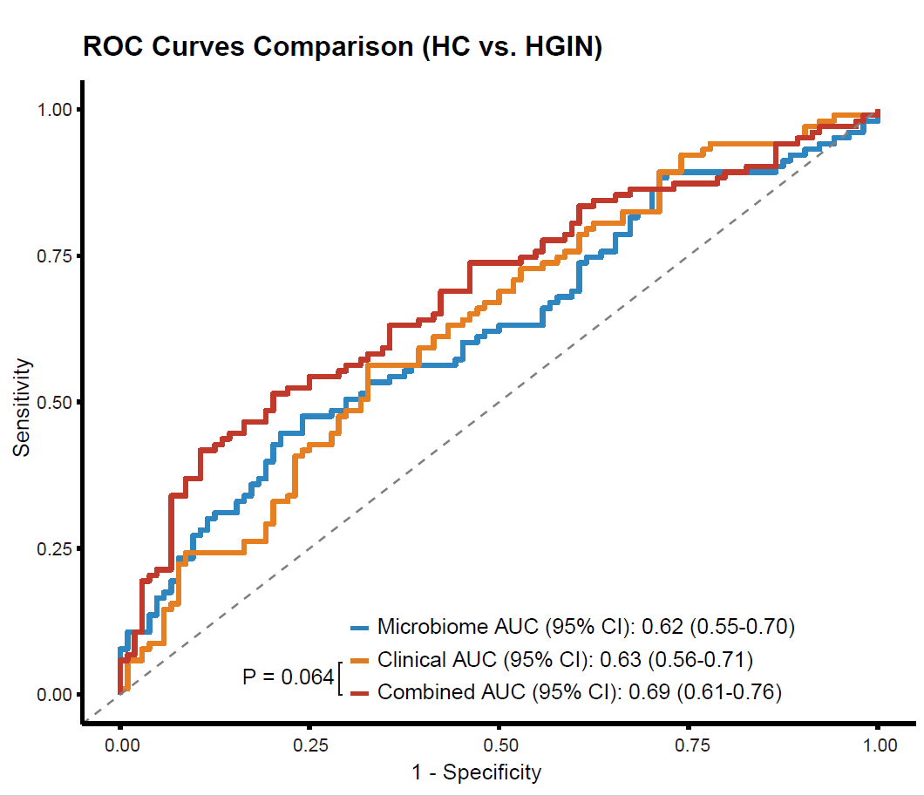
Supplementary Figure 6. Diagnostic performance of the predictive models for distinguishing HGIN from HC.
Receiver Operating Characteristic (ROC) curves evaluating the discriminatory capacity of the microbiome signature, clinical covariates, and their combined predictive framework. The area under the curve (AUC) and its corresponding 95% confidence intervals (CI) for each model are annotated within the plot area. The statistical significance of the difference in AUC between the standalone clinical model and the combined model was assessed using the DeLong test.
HC, healthy controls; HGIN, high-grade intraepithelial neoplasia;

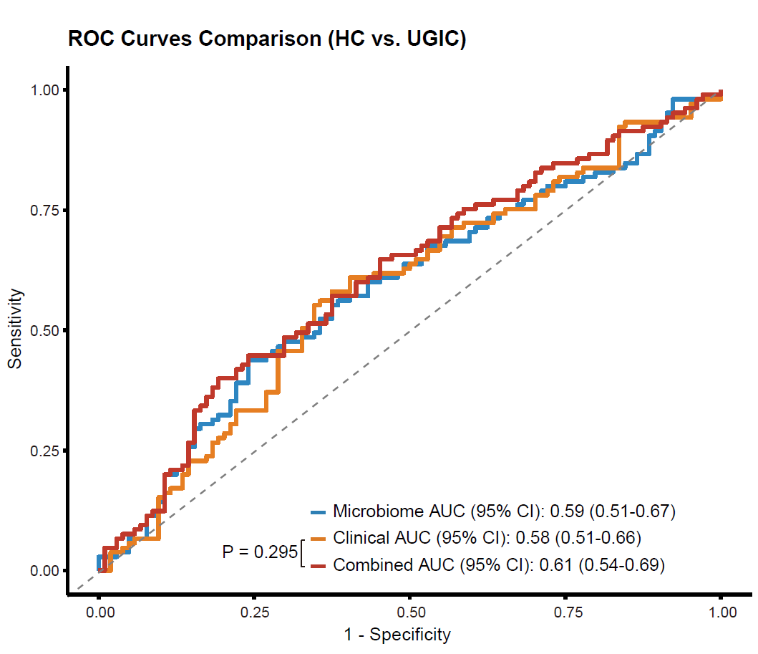
Supplementary Figure 7. Diagnostic performance of the predictive models for distinguishing UGIC from HC.
Receiver Operating Characteristic (ROC) curves evaluating the discriminatory capacity of the microbiome signature, macroscopic clinical covariates, and their combined predictive framework. The area under the curve (AUC) and its corresponding 95% confidence intervals (CI) for each model are annotated within the plot area. The statistical significance of the difference in AUC between the standalone clinical model and the combined model was assessed using the DeLong test.
HC, healthy controls; UGIC, upper gastrointestinal cancer;

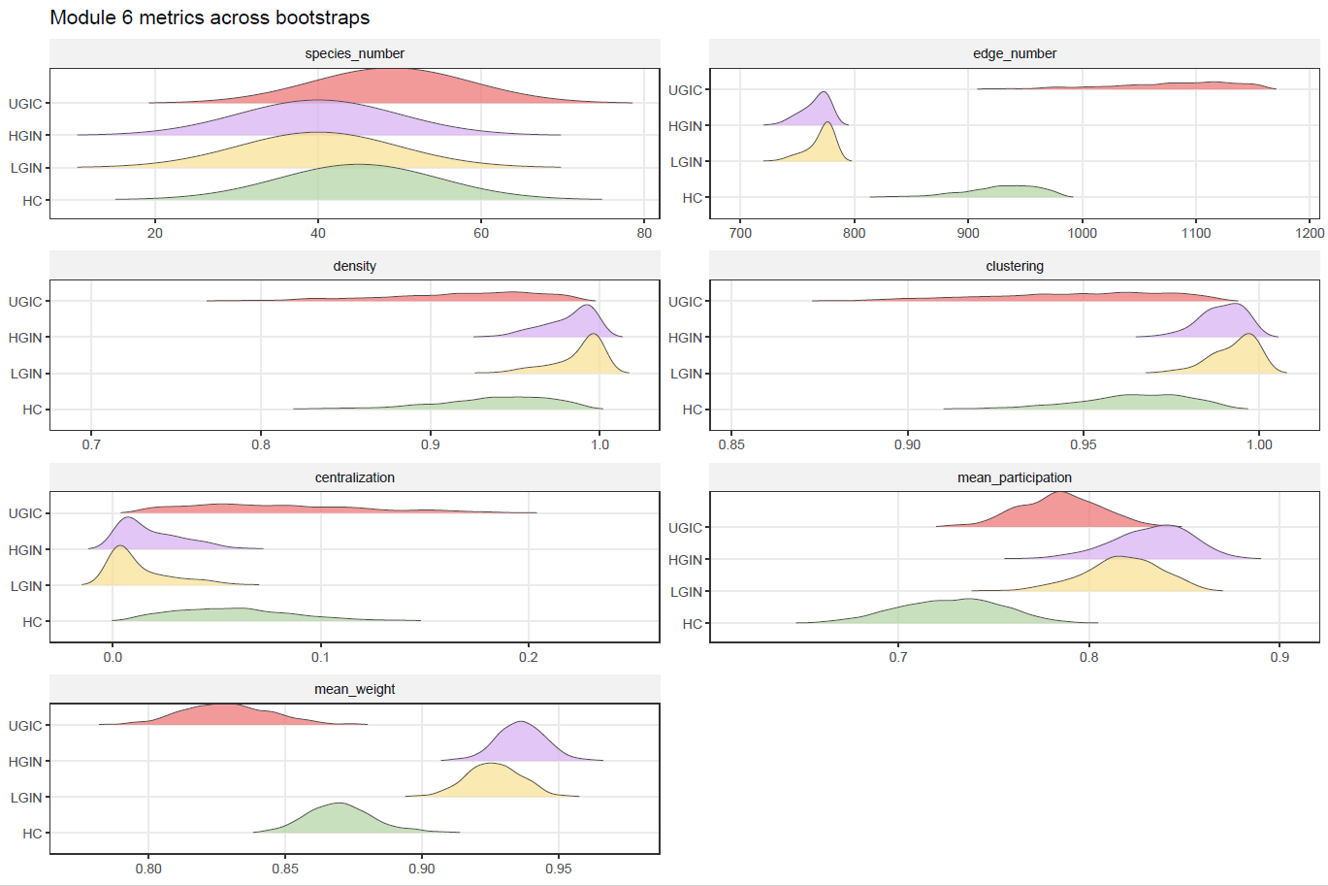
Supplementary Figure 8. Bootstrap distributions of structural metrics for Module 6 across disease stages
The displayed metrics include species number, edge number, network density, clustering coefficient, centralization, mean participation coefficient, and mean edge weight. Together, these metrics characterize the size, compactness, local cohesiveness, hub dependence, cross-module connectivity, and average interaction strength of Module 6. Overall, Module 6 showed stage-dependent structural variation, with more pronounced divergence at the precancerous stages, whereas UGIC appeared relatively closer to HC in several edge- and interaction-related properties.

