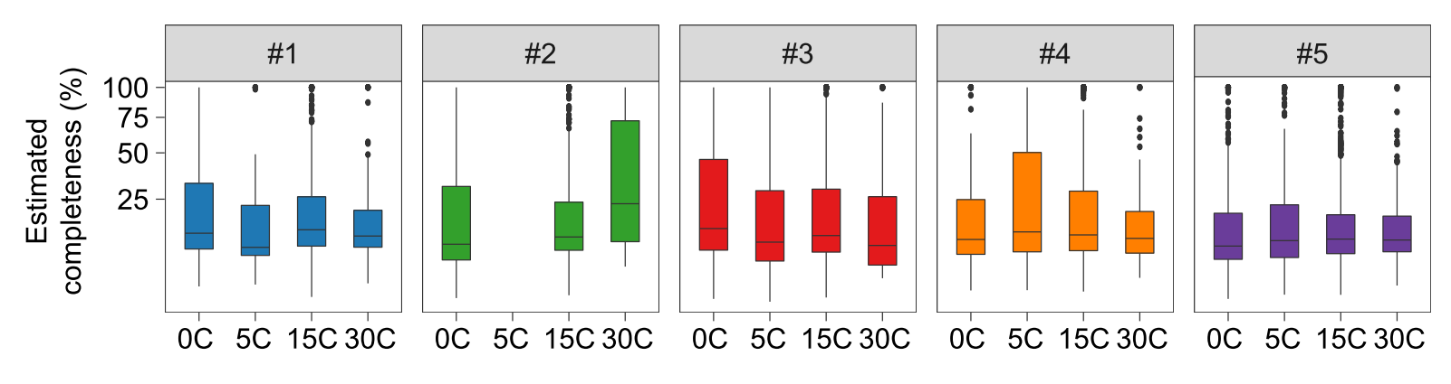
Supplementary Figure 1| Boxplot showing the distribution of completeness of each sample.

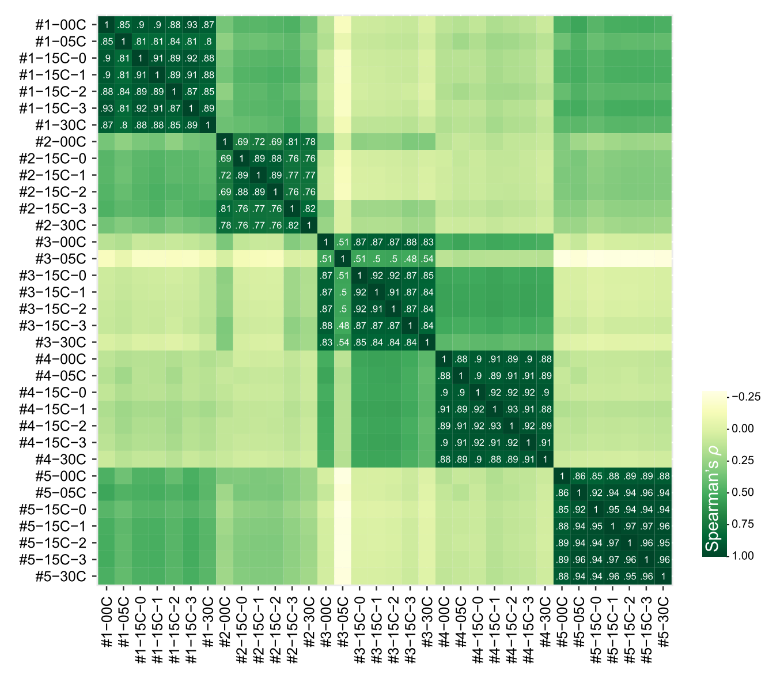
Supplementary Figure 2 Heatmap showing the Spearman correlation coefficients of the viral profiles of all samples.

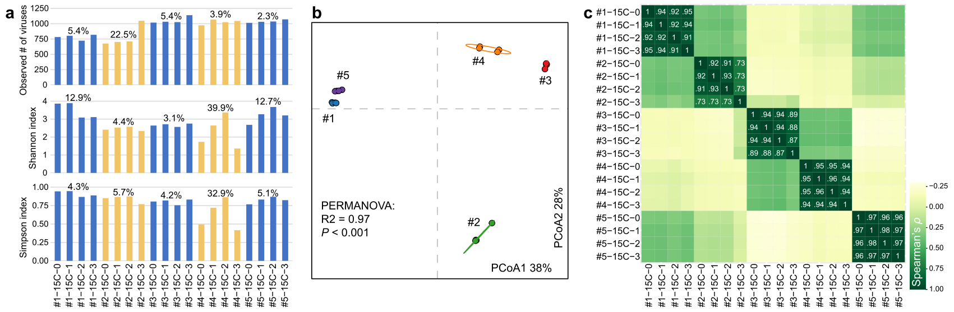
Supplementary Figure 3| Comparison of viral metagenomes with parallel experimental procedures. a, The within-sample (alpha) diversity parameters of all analyzed samples. For each parameter, 4 repetitions of the same individual are grouped by colored bars, and the numbers upon the bars show the coefficient of variation (CV) of these 4 repetitions. b, Principal coordinates analysis (PCoA) of the Bray-Curtis distances of gut viral profiles. Samples are shown at the first and second principal coordinates (PCoA1 and PCoA2), and the ratio of variance contributed by these two principal coordinates is shown. Ellipsoids represent a 95% confidence interval surrounding each group. c, Heatmap shows the Spearman correlation coefficients of the viral profiles of all analyzed samples.

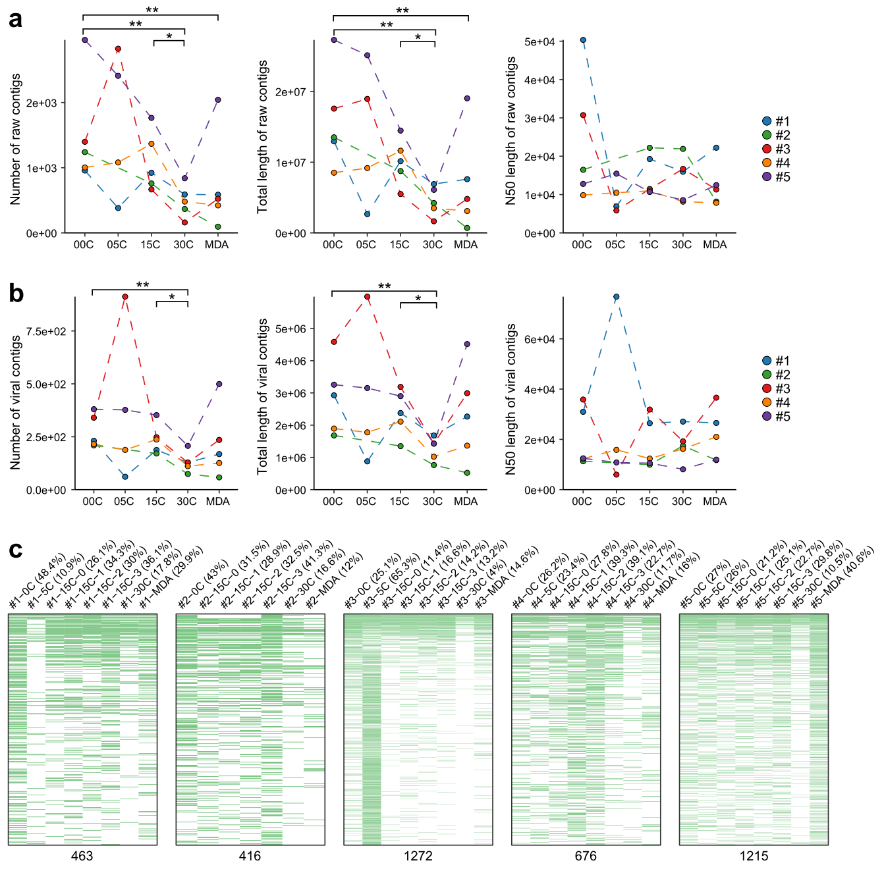
Supplementary Figure 4| Comparison of viral metagenomes between PCR-based amplification and MDA. a-b, Assembly statistics of the raw metagenomic-assembled contigs (a) and identified viral contigs (b) of all analyzed samples. Four repetitions with 15C amplification (i.e., 15C-0, 15C-1, 15C-2, and 15C-3) are shown in average values. Paired Wilcoxon rank-sum test: * p<0.05; ** p<0.01. c, Heatmap showing the identification of viruses for all samples. For each individual, the viruses assembled from each sample are shown in the heatmap with green boxes, and the “recall rate” for each sample are shown bellowing the heatmap.

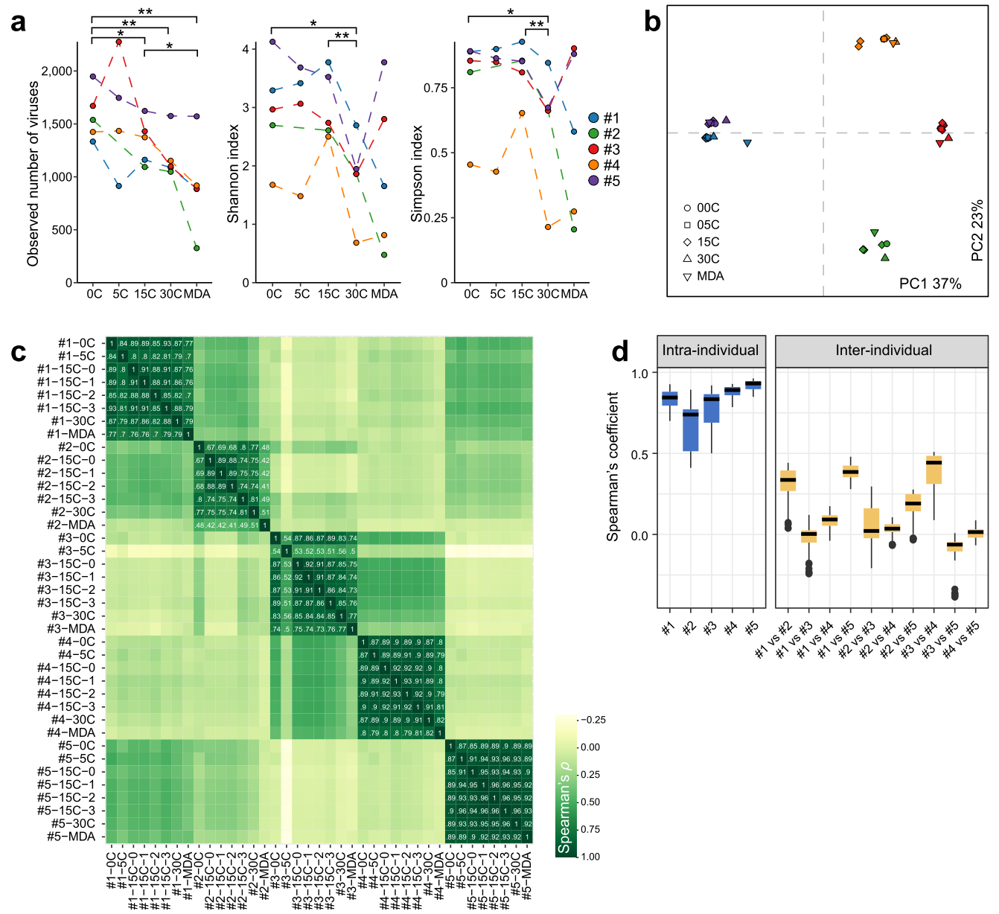
Supplementary Figure 5| Comparison of gut viromes between PCR-based amplification and MDA. a, The within-sample (alpha) diversity parameters of all analyzed samples. Paired Wilcoxon rank-sum test: * p<0.05; ** p<0.01. b, PCoA analysis of the Bray-Curtis distances of gut viral profiles. Samples are shown at the first and second principal coordinates (PCoA1 and PCoA2), and the ratio of variance contributed by these two principal coordinates is shown. c, Heatmap shows the Spearman correlation coefficients of the viral profiles of all samples. d, Boxplot shows the distribution of Spearman correlation coefficients intra- and inter-individuals.

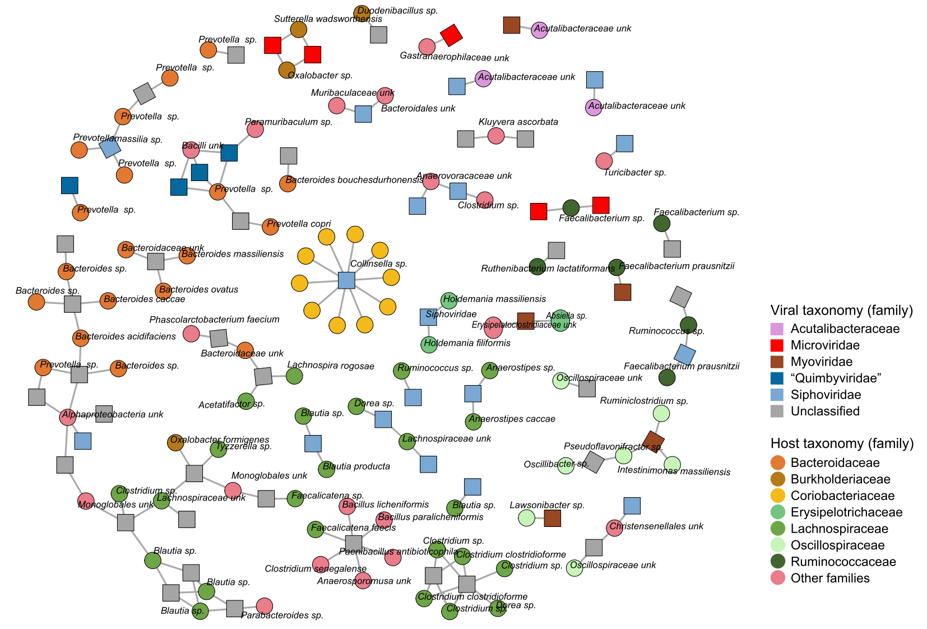
Supplementary Figure 6| Network showing the virus-host relationships. Nodes represent the viruses (squares) and bacterial hosts (circles), and lines connect the nodes represent the virus-host pairs.

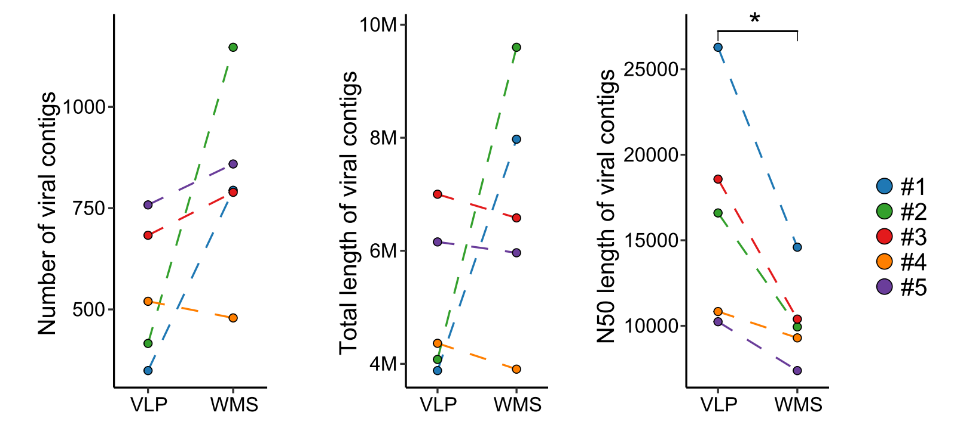
Supplementary Figure 7| Comparison of viral contigs identified by viral metagenome and bulk metagenome. Paired Wilcoxon rank-sum test: * p<0.05; ** p<0.01.

