Supplementary

Table S1. Hyperparameter search space and values selected by 10-fold stratified cross-validation
Model | Search space | Selected values
Logistic regression | C ∈ {0.001, 0.01, 0.1, 1, 10, 100}; penalty = L2 | C = 1
SVM | kernel ∈ {RBF, linear}; C ∈ {0.1, 1, 10}; γ ∈ {scale, auto} (RBF only) | RBF kernel, C = 1, γ = scale
Random forest | n_estimators ∈ {100, 200, 300}; max_depth ∈ {4, 6, 8, none}; min_samples_split ∈ {2, 5, 10}; max_features ∈ {sqrt, log2} | n_estimators = 300, max_depth = none, min_samples_split = 10, max_features = sqrt
CatBoost | iterations ∈ {100, 200, 300}; depth ∈ {4, 6, 8}; learning_rate ∈ {0.01, 0.05, 0.1}; l2_leaf_reg ∈ {1, 3, 5} | iterations = 300, depth = 4, learning_rate = 0.05, l2_leaf_reg = 3
XGBoost | n_estimators ∈ {100, 200, 300}; learning_rate ∈ {0.01, 0.05, 0.1}; max_depth ∈ {3, 5, 7}; subsample ∈ {0.8, 1.0}; colsample_bytree ∈ {0.8, 1.0} | n_estimators = 100, learning_rate = 0.1, max_depth = 5, subsample = 0.8, colsample_bytree = 0.8
All models were tuned by exhaustive grid search on the training set (n = 13,796) with the area under the receiver operating characteristic curve as the selection criterion. Class weights were set to balanced for logistic regression, SVM, random forest and CatBoost; scale_pos_weight = 0.632 (ratio of negative to positive cases in the training set) for XGBoost. Logistic regression and SVM features were standardised within each fold. Random seed 42 throughout.

Table S2. Boruta feature-selection results for the 38 encoded candidate features (training set)
Rank | Feature | Boruta decision | Mean importance | % of total
1 | Age group | Confirmed | 0.3100 | 31.13
2 | Migration status: Stable Resident (15+ years) | Confirmed | 0.1936 | 19.44
3 | Living children | Confirmed | 0.1449 | 14.55
4 | Migration status: Recent Migrant (0-4 years) | Confirmed | 0.1150 | 11.55
5 | Education | Confirmed | 0.0641 | 6.44
6 | Husband's education | Confirmed | 0.0298 | 2.99
7 | Age at marriage | Confirmed | 0.0234 | 2.35
8 | Household size | Confirmed | 0.0168 | 1.69
9 | Digital inclusion | Confirmed | 0.0155 | 1.56
10 | Contraceptive intent: Non-user: No intent | Confirmed | 0.0146 | 1.47
11 | Contraceptive intent: Non-user: Intends to use | Confirmed | 0.0145 | 1.45
12 | Child-loss experience: Yes | Confirmed | 0.0071 | 0.71
13 | Husband presence: Living with her | Confirmed | 0.0063 | 0.63
14 | Husband's occupation: Professional/Technical | Confirmed | 0.0061 | 0.62
15 | Working status: Yes (Working) | Confirmed | 0.0053 | 0.53
16 | Migration status: Stable Resident (Always) | Confirmed | 0.0037 | 0.37
17 | Women's autonomy | Confirmed | 0.0036 | 0.36
18 | Contraceptive intent: Non-user: Unsure/Other | Confirmed | 0.0035 | 0.36
19 | Currently pregnant: Yes | Confirmed | 0.0025 | 0.25
20 | Anxiety severity | Confirmed | 0.0024 | 0.25
21 | Husband's occupation: Business/Services/Sales | Confirmed | 0.0024 | 0.24
22 | Ideal family size | Confirmed | 0.0016 | 0.16
23 | Husband's occupation: Manual Labor | Confirmed | 0.0014 | 0.14
24 | Place of residence: Urban | Confirmed | 0.0013 | 0.13
25 | Wealth index | Confirmed | 0.0012 | 0.12
26 | Household head sex: Male | Confirmed | 0.0011 | 0.11
27 | Depression severity | Confirmed | 0.0007 | 0.07
28 | Husband's occupation: Not working/Other | Tentative | 0.0005 | 0.05
29 | Division: Khulna | Rejected | 0.0003 | 0.03
30 | Division: Dhaka | Rejected | 0.0003 | 0.03
31 | Division: Chattogram | Rejected | 0.0003 | 0.03
32 | Religion: Non-Muslim | Rejected | 0.0003 | 0.03
33 | Media exposure: Yes | Rejected | 0.0003 | 0.03
34 | Division: Rajshahi | Rejected | 0.0003 | 0.03
35 | Division: Mymensingh | Rejected | 0.0003 | 0.03
36 | Attitude toward violence: Yes | Rejected | 0.0002 | 0.02
37 | Division: Sylhet | Rejected | 0.0002 | 0.02
38 | Division: Rangpur | Rejected | 0.0001 | 0.01
Mean importance is the average random-forest importance across the 100 Boruta iterations (features are assigned no importance after rejection). Ordinal variables (age group, education, husband's education, wealth, living children, household size, age at marriage, digital inclusion, autonomy, anxiety, depression, ideal family size) enter as single features; nominal variables enter as one-hot contrasts against the reference category. The one tentative feature was not used in modelling. Implementation: BorutaPy 0.4.3, following the Boruta all-relevant feature selection algorithm [27].

Table S3. Variance inflation factors for the 27 Boruta-confirmed features (training set)
Rank | Feature | VIF
1 | Age group | 2.074
2 | Education | 1.989
3 | Migration status: Stable Resident (15+ years) | 1.956
4 | Husband's education | 1.806
5 | Husband presence: Living with her | 1.78
6 | Husband's occupation: Professional/Technical | 1.733
7 | Husband's occupation: Business/Services/Sales | 1.7
8 | Contraceptive intent: Non-user: Intends to use | 1.564
9 | Household head sex: Male | 1.563
10 | Wealth index | 1.557
11 | Husband's occupation: Manual Labor | 1.554
12 | Living children | 1.509
13 | Anxiety severity | 1.496
14 | Digital inclusion | 1.482
15 | Depression severity | 1.474
16 | Currently pregnant: Yes | 1.471
17 | Migration status: Recent Migrant (0-4 years) | 1.466
18 | Migration status: Stable Resident (Always) | 1.357
19 | Place of residence: Urban | 1.254
20 | Contraceptive intent: Non-user: No intent | 1.229
21 | Age at marriage | 1.204
22 | Household size | 1.115
23 | Working status: Yes (Working) | 1.08
24 | Women's autonomy | 1.078
25 | Ideal family size | 1.077
26 | Child-loss experience: Yes | 1.076
27 | Contraceptive intent: Non-user: Unsure/Other | 1.065
All values are below the conventional threshold of 5, indicating no problematic multicollinearity.

Table S4. Mean absolute SHAP values of the final XGBoost model on the held-out test set (n = 3,449)
Rank | Feature | Mean |SHAP| | % of total | Cumulative %
1 | Age group | 1.098 | 24.3 | 24.3
2 | Living children | 0.592 | 13.1 | 37.5
3 | Contraceptive intent: Non-user: No intent | 0.337 | 7.5 | 44.9
4 | Migration status: Stable Resident (15+ years) | 0.321 | 7.1 | 52.1
5 | Ideal family size | 0.297 | 6.6 | 58.6
6 | Age at marriage | 0.286 | 6.3 | 65.0
7 | Household size | 0.276 | 6.1 | 71.1
8 | Education | 0.167 | 3.7 | 74.8
9 | Migration status: Recent Migrant (0-4 years) | 0.151 | 3.3 | 78.1
10 | Currently pregnant: Yes | 0.139 | 3.1 | 81.2
11 | Contraceptive intent: Non-user: Intends to use | 0.133 | 3.0 | 84.1
12 | Husband's education | 0.100 | 2.2 | 86.4
13 | Household head sex: Male | 0.088 | 2.0 | 88.3
14 | Digital inclusion | 0.073 | 1.6 | 89.9
15 | Anxiety severity | 0.066 | 1.5 | 91.4
16 | Wealth index | 0.063 | 1.4 | 92.8
17 | Contraceptive intent: Non-user: Unsure/Other | 0.056 | 1.2 | 94.0
18 | Place of residence: Urban | 0.049 | 1.1 | 95.1
19 | Husband's occupation: Business/Services/Sales | 0.045 | 1.0 | 96.1
20 | Husband's occupation: Manual Labor | 0.037 | 0.8 | 96.9
21 | Working status: Yes (Working) | 0.026 | 0.6 | 97.5
22 | Women's autonomy | 0.024 | 0.5 | 98.1
23 | Migration status: Stable Resident (Always) | 0.023 | 0.5 | 98.6
24 | Husband presence: Living with her | 0.021 | 0.5 | 99.0
25 | Depression severity | 0.019 | 0.4 | 99.5
26 | Husband's occupation: Professional/Technical | 0.013 | 0.3 | 99.7
27 | Child-loss experience: Yes | 0.011 | 0.3 | 100.0
SHAP values are on the log-odds scale for the limiting class (base value −0.017). The 15 highest-ranked features, accounting for 91.4% of the total, are shown in Fig. 2 of the main text and in Fig. S4 below.

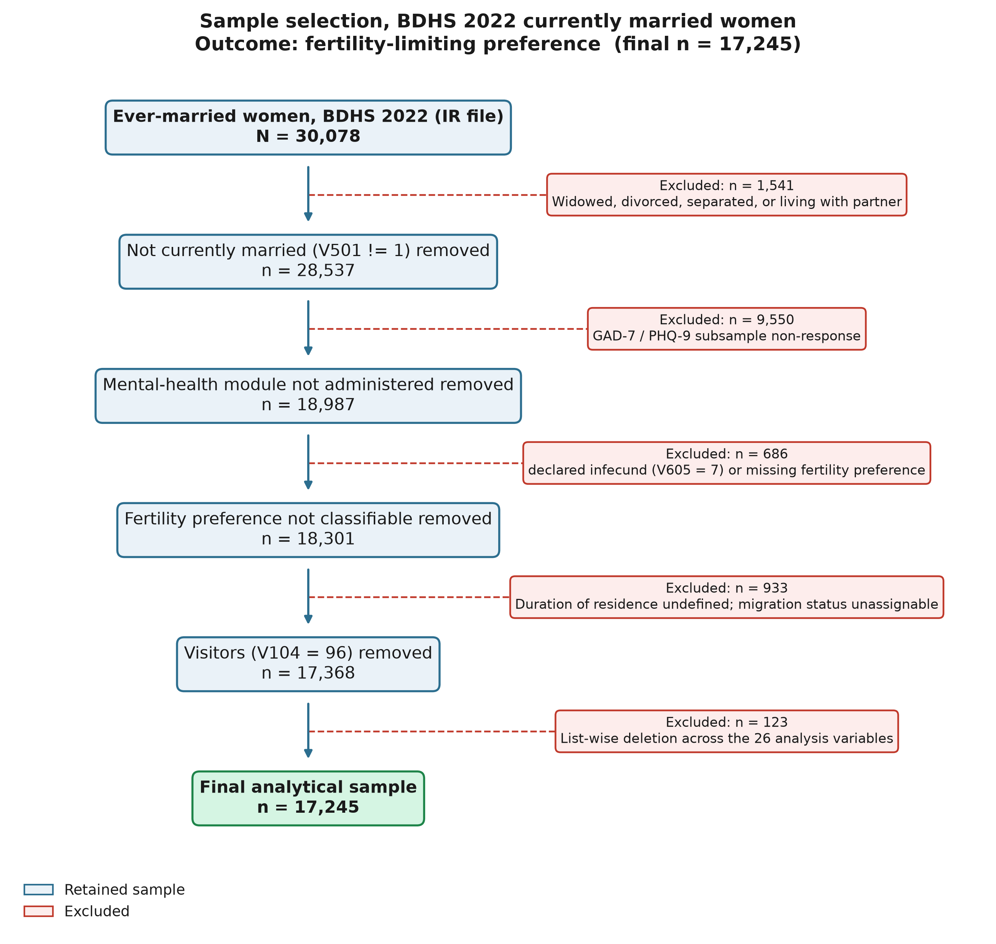
Fig. S1. Sample selection flowchart. Sequential exclusions from the 30,078 ever-married women interviewed in the 2022 BDHS to the final analytical sample of 17,245 currently married women.

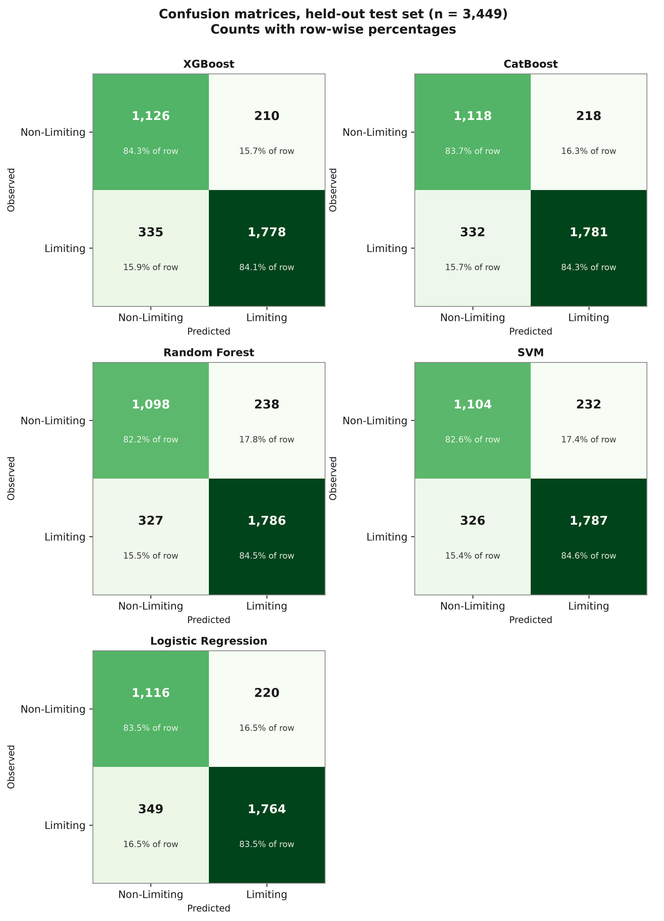
Fig. S2. Confusion matrices of the five classifiers on the held-out test set. Counts with row-wise percentages; rows are observed classes and columns predicted classes (positive class = limiting). Test set n = 3,449 (2,113 limiting, 1,336 non-limiting).

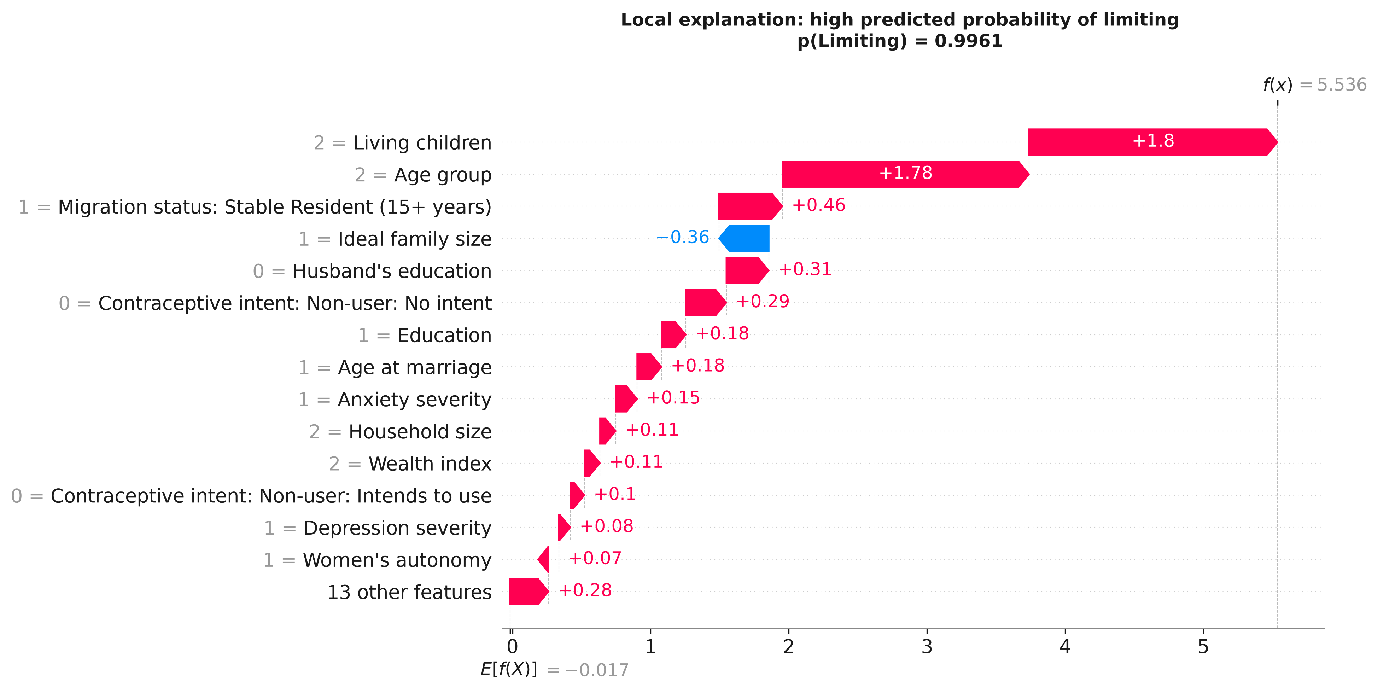
(a)
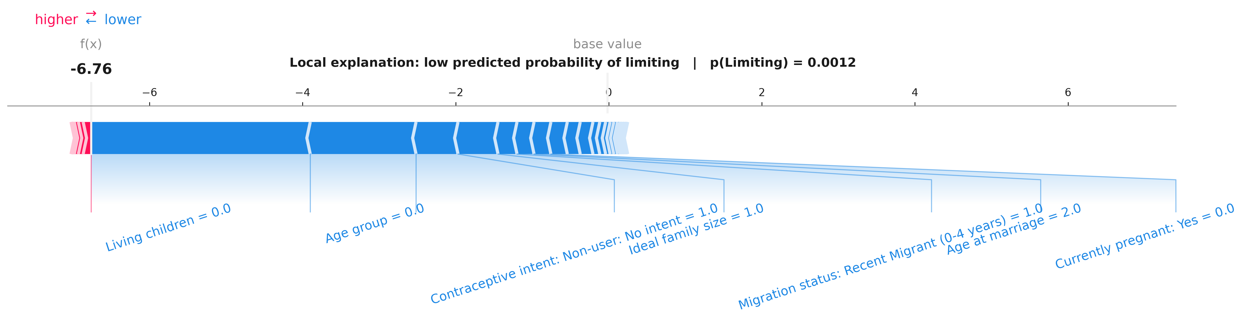
(b)
Fig. S3. Local SHAP explanations for two women in the test set. (a) Waterfall plot for the woman with the highest predicted probability of a limiting preference (0.996; observed: limiting). (b) Force plot for the woman with the lowest predicted probability (0.001; observed: non-limiting). Contributions are on the log-odds scale from a base value of −0.017.

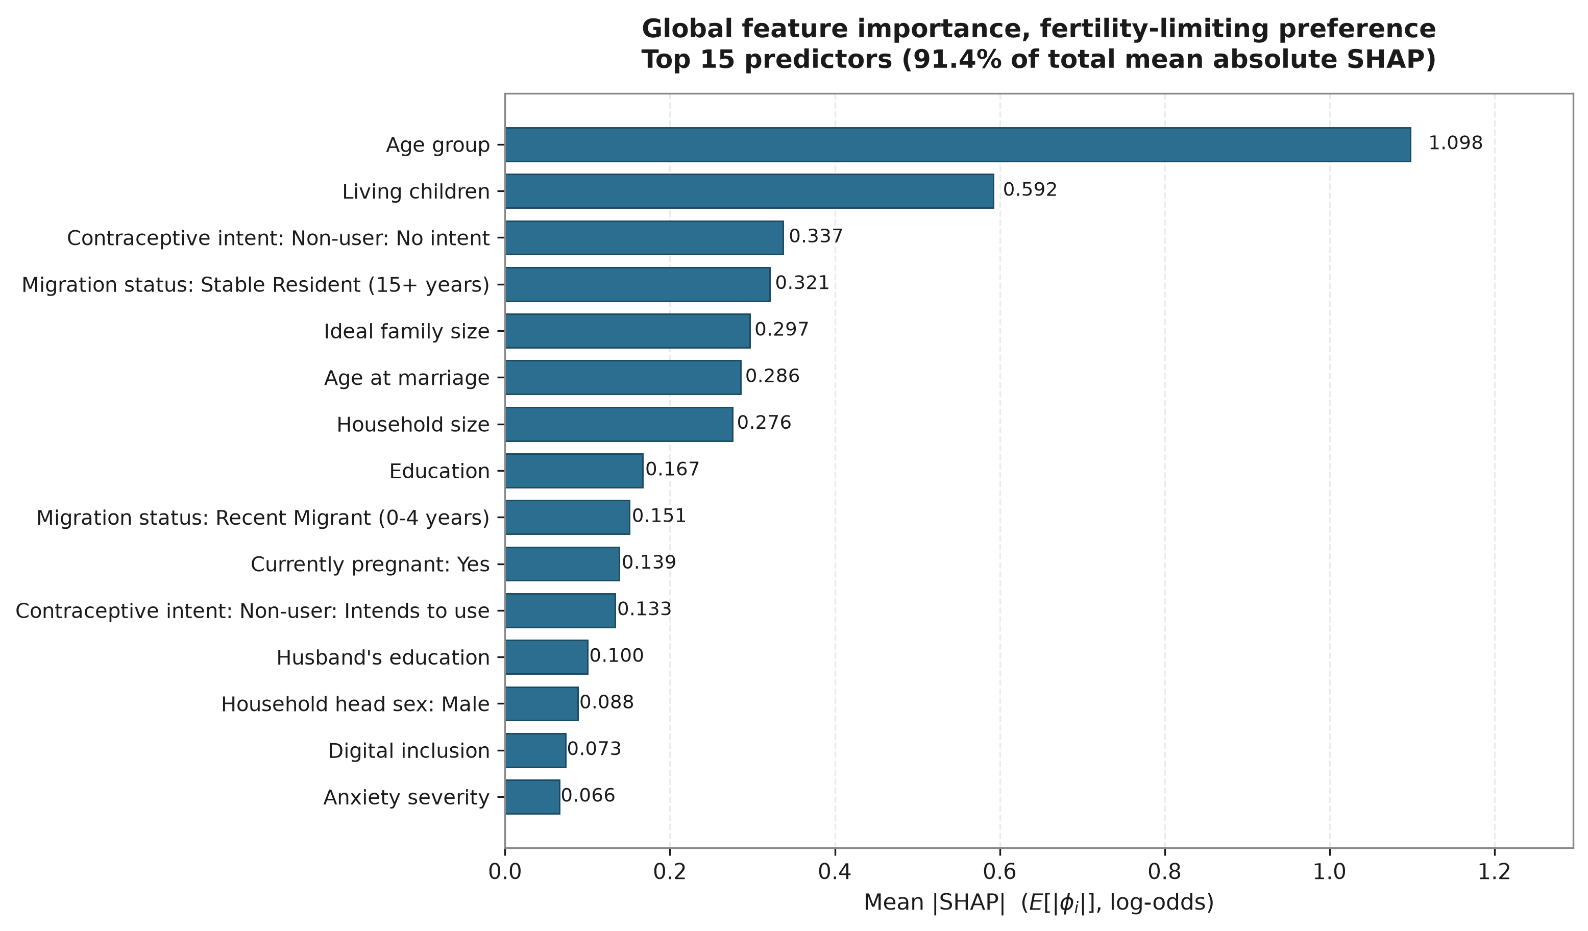
Fig. S4. Mean absolute SHAP values of the 15 leading features of the final XGBoost model. Values correspond to Table S4.

