Supplementary Material

Contents
S1. PRISMA flow diagram 2
S2: Supplementary Methods 3
S3: Differences between the protocol and the review 4
S4. References for included studies 5
S5: Characteristics of included randomized trials 12
S6: Forest plots and risk-of-bias assessments 15
S7: Sensitivity analysis and MCMC diagnostics 23

S1. PRISMA flow diagram
Figure S1. PRISMA 2020 flow diagram depicting record identification, screening, eligibility assessment, and study inclusion.

Identification of studies via other methods
Identification of studies via databases and registers

Records identified from:
Bibliomining (n=8)
Citation searching (n=15)
Records removed before screening:
Duplicate records removed (n = 78)
Records identified from*:
ClinicalTrials.gov (n = 104)
Cochrane Library (n = 8)
PsychInfo (n=128)
PubMed (n=73)
WHO ICTPR (n=89)
Web of Science (n=50)

Identification

Records excluded (n = 258)
Elegible Adult Population (n=120)
Elegible Comparator Group (n=26)
Original Comparative Evidence (n=42)
Relevant Suicidality Outcomes (n=57)
Semaglutide Intervention (n=13)
Records screened
(n = 374)

Reports not retrieved
(n = 0)
Reports sought for retrieval
(n = 17)
Reports sought for retrieval
(n = 116)
Reports not retrieved
(n = 0)

Screening

Reports excluded:
Relevant Suicidality Outcomes (n = 1)

Reports assessed for eligibility
(n = 17)
Reports assessed for eligibility
(n = 116)
Reports excluded (n=89)
Elegible Comparator (n=6)
Ongoing Studies (n=1)
Original Comparative Evidence (n=15)
Relevant Suicidality Outcomes (n=67)

Studies included in review (n = 22)
Reports of included studies (n = 44)

Studies included in meta-analysis (n=15)
Reports of included studies in meta-analysis (n=33)
Included

S2: Supplementary Methods

S2.1 Outcome hierarchy and nonindependence
Completed suicide was the prospectively registered primary outcome. Suicide attempt, suicidal ideation, and overall suicidal behaviour/events were secondary outcomes. The outcome-specific trial sets and event definitions differed, and a composite event may overlap with ideation, attempt, or completed suicide. Consequently, participants and events must not be summed across outcomes.
S2.2 Bayesian likelihood
Arm-level events were modelled with binomial likelihoods and logit links. For study k, logit(p_e,k)=μ_k+θ_k/2 and logit(p_c,k)=μ_k−θ_k/2, with θ_k=θ+τz_k and z_k~Normal(0,1). This symmetric, noncentred formulation estimated pooled and study-specific log-odds ratios while retaining double-zero studies without continuity correction.
S2.3 Primary priors
The primary pooled-effect prior was θ~Normal(0,1). Study baselines followed μ_k~Normal(0,10). Between-study heterogeneity used the implemented Turner 2015 empirical prior log(τ²)~Normal(−3.02,1.85²). The source-table match for these Turner parameters should be verified before journal submission, as noted in each outcome package.
S2.4 Sampling and convergence
Models were fitted directly in Stan through cmdstanr with four chains, 2,000 warm-up and 2,000 retained iterations per chain, adapt_delta=0.95 (raised to 0.99 when required), and max_treedepth=12. Prespecified criteria were R-hat<1.01, bulk and tail effective sample sizes>400, no persistent divergent transitions, and satisfactory trace and autocorrelation plots.
S2.5 Prior sensitivity
The pooled log-OR prior was varied across Normal(0,1), Normal(0,100), and Normal(0,0.5), where the second parameter is the standard deviation. The heterogeneity prior was varied across Turner 2015, half-Normal(0,0.5), and half-Cauchy(0,0.5), producing a 3×3 grid for every outcome. One overall suicidal behaviour/events fit—Normal(0,100) plus half-Cauchy(0,0.5), retained 17 divergences after adapt_delta=0.99 and is flagged as not diagnostically validated.
S2.6 Absolute-risk translation
Posterior OR draws were converted to RR and RD using the pooled placebo risk for each outcome. These conversions are illustrative because the baseline risk was held fixed and uncertainty in baseline risk, ascertainment, and follow-up was not propagated.
S2.7 Model comparison
Study-level PSIS-LOO diagnostics were poor for all outcomes because most or all Pareto-k values exceeded 0.7. LOOIC and related quantities were therefore not used to select priors or models.

S3: Differences between the protocol and the review

The review generally followed protocol version 2.0 and the PROSPERO registration (CRD420251059430). Before data extraction, the outcome scope was broadened from completed suicide alone to include suicide attempt, suicidal ideation, and overall suicidal behaviour/events. This amendment was documented in PROSPERO; completed suicide remained the primary outcome, and the hierarchy was not changed thereafter.
Several implementation differences reflected the available evidence. The primary synthesis was restricted to placebo-controlled randomized trials, while active-comparator trials were analysed separately when sufficient comparable data were available; non-randomized evidence was not quantitatively synthesized. The prespecified Bayesian binomial-logit model was coded directly in Stan through cmdstanr rather than through brms, without changing the likelihood, priors, estimand, or sampling framework. Planned meta-regression, formal small-study-effect tests, and selection-model analyses were not conducted because the required numbers of informative studies were not reached. Risk-of-bias and GRADE assessments were undertaken as planned. No other material departures from the protocol occurred.

S4. References for included studies

S4.1 Placebo-controlled Studies included in the Meta-analysis
- Dose-ranging phase 2 obesity trial - NCT02453711
- O’Neil PM, Birkenfeld AL, McGowan B, Mosenzon O, Pedersen SD, Wharton S, et al. Efficacy and safety of semaglutide compared with liraglutide and placebo for weight loss in patients with obesity: a randomised, double-blind, placebo and active controlled, dose-ranging, phase 2 trial. *Lancet.* 2018;392(10148):637–649. [doi:10.1016/S0140-6736(18)31773-2](https://doi.org/10.1016/S0140-6736(18)31773-2)
- Novo Nordisk A/S. Investigation of safety and efficacy of once-daily semaglutide in obese subjects without diabetes mellitus. ClinicalTrials.gov [Internet]. Bethesda (MD): National Library of Medicine (US); identifier NCT02453711 [cited 2026 Aug 22]. Available from: [ClinicalTrials.gov NCT02453711](https://clinicaltrials.gov/study/NCT02453711)

- FLOW - NCT03819153

- Perkovic V, Tuttle KR, Rossing P, Mahaffey KW, Mann JFE, Bakris G, et al; FLOW Trial Committees and Investigators. Effects of semaglutide on chronic kidney disease in patients with type 2 diabetes. *N Engl J Med.* 2024;391(2):109–121. [doi:10.1056/NEJMoa2403347](https://doi.org/10.1056/NEJMoa2403347)
- Novo Nordisk A/S. Effect of semaglutide versus placebo on the progression of renal impairment in subjects with type 2 diabetes and chronic kidney disease. ClinicalTrials.gov [Internet]. Bethesda (MD): National Library of Medicine (US); identifier NCT03819153 [cited 2026 Aug 22]. Available from: [ClinicalTrials.gov NCT03819153](https://clinicaltrials.gov/study/NCT03819153)

- NN9931-4296 NASH phase 2 - NCT02970942

- Newsome PN, Buchholtz K, Cusi K, Linder M, Okanoue T, Ratziu V, et al. A placebo-controlled trial of subcutaneous semaglutide in nonalcoholic steatohepatitis. *N Engl J Med.* 2021;384(12):1113–1124. [doi:10.1056/NEJMoa2028395](https://doi.org/10.1056/NEJMoa2028395)
- Novo Nordisk A/S. Investigation of efficacy and safety of three dose levels of subcutaneous semaglutide once daily versus placebo in subjects with non-alcoholic steatohepatitis. ClinicalTrials.gov [Internet]. Bethesda (MD): National Library of Medicine (US); identifier NCT02970942 [cited 2026 Aug 22]. Available from: [ClinicalTrials.gov NCT02970942](https://clinicaltrials.gov/study/NCT02970942)

- OASIS 4 - NCT05564117 / EudraCT 2021-006534-40

- Wharton S, Lingvay I, Bogdanski P, Duque do Vale R, Jacob S, Karlsson T, et al. Oral semaglutide at a dose of 25 mg in adults with overweight or obesity. *N Engl J Med.* 2025;393(11):1077–1087. [doi:10.1056/NEJMoa2500969](https://doi.org/10.1056/NEJMoa2500969)
- Novo Nordisk A/S. Efficacy and safety of oral semaglutide 25 mg once daily in adults with overweight or obesity. ClinicalTrials.gov [Internet]. Bethesda (MD): National Library of Medicine (US); identifier NCT05564117 [cited 2026 Aug 22]. Available from: [ClinicalTrials.gov NCT05564117](https://clinicaltrials.gov/study/NCT05564117)
- Novo Nordisk A/S. Research study looking at how well semaglutide tablets taken once daily work in people who have a body weight above the healthy range (OASIS 4). EU Clinical Trials Register [Internet]. Amsterdam: European Medicines Agency; EudraCT 2021-006534-40 [cited 2026 Aug 22]. Available from: [EU Clinical Trials Register 2021-006534-40](https://www.clinicaltrialsregister.eu/ctr-search/search?query=eudract_number:2021-006534-40)

- PIONEER 8 - NCT03021187

- Zinman B, Aroda VR, Buse JB, Cariou B, Harris SB, Hoff STH, et al. Efficacy, safety, and tolerability of oral semaglutide versus placebo added to insulin with or without metformin in patients with type 2 diabetes: the PIONEER 8 trial. *Diabetes Care.* 2019;42(12):2262–2271. [doi:10.2337/dc19-0898](https://doi.org/10.2337/dc19-0898)
- Novo Nordisk A/S. Efficacy and safety of oral semaglutide versus placebo in subjects with type 2 diabetes mellitus treated with insulin: a 52-week, randomised, double-blind, placebo-controlled trial. ClinicalTrials.gov [Internet]. Bethesda (MD): National Library of Medicine (US); identifier NCT03021187 [cited 2026 Aug 22]. Available from: [ClinicalTrials.gov NCT03021187](https://clinicaltrials.gov/study/NCT03021187)

- REMODEL - NCT04865770

- Tuttle KR, Bjornstad P, Pruijm M, Hodgin JB, Cherney DZI, Belmar N, et al. Mechanistic effects of semaglutide on kidney disease in type 2 diabetes: the REMODEL trial. *J Am Soc Nephrol.* 2025;36(10 Suppl). [doi:10.1681/ASN.2025fdqxb4qe](https://doi.org/10.1681/ASN.2025fdqxb4qe)
- Novo Nordisk A/S. Renal mode of action of semaglutide in patients with type 2 diabetes and chronic kidney disease. ClinicalTrials.gov [Internet]. Bethesda (MD): National Library of Medicine (US); identifier NCT04865770 [cited 2026 Aug 22]. Available from: [ClinicalTrials.gov NCT04865770](https://clinicaltrials.gov/study/NCT04865770)

- SELECT - NCT03574597

- Kushner R, et al. Safety profile of semaglutide vs placebo in the SELECT study: a randomized, controlled trial. *Obesity (Silver Spring).* 2024;32:20. [doi:10.1002/oby.24194](https://doi.org/10.1002/oby.24194)
- Kushner RF, Ryan DH, Deanfield J, Kokkinos A, Cercato C, Wilding J, et al. Safety profile of semaglutide versus placebo in the SELECT study: a randomized controlled trial. *Obesity (Silver Spring).* 2025;33(3):452–462. [doi:10.1002/oby.24222](https://doi.org/10.1002/oby.24222)
- Lincoff AM, Brown-Frandsen K, Colhoun HM, Deanfield J, Emerson SS, Esbjerg S, et al; SELECT Trial Investigators. Semaglutide and cardiovascular outcomes in obesity without diabetes. *N Engl J Med.* 2023;389(24):2221–2232. [doi:10.1056/NEJMoa2307563](https://doi.org/10.1056/NEJMoa2307563)
- Novo Nordisk A/S. SELECT—semaglutide effects on cardiovascular outcomes in people with overweight or obesity. ClinicalTrials.gov [Internet]. Bethesda (MD): National Library of Medicine (US); identifier NCT03574597 [cited 2026 Aug 22]. Available from: [ClinicalTrials.gov NCT03574597](https://clinicaltrials.gov/study/NCT03574597)

- Semaglutide + NNC0480-0389 trial - NCT05144984

- Novo Nordisk A/S. Investigation of the safety and efficacy of semaglutide subcutaneous once weekly in combination with NNC0480-0389 in participants with type 2 diabetes: a dose-finding study. ClinicalTrials.gov [Internet]. Bethesda (MD): National Library of Medicine (US); identifier NCT05144984 [cited 2026 Aug 22]. Available from: [ClinicalTrials.gov NCT05144984](https://clinicaltrials.gov/study/NCT05144984)

- Semaglutide in NASH-related cirrhosis - NCT03987451

- Loomba R, Abdelmalek MF, Armstrong MJ, Jara M, Kjær MS, Krarup N, et al. Semaglutide 2.4 mg once weekly in patients with non-alcoholic steatohepatitis-related cirrhosis: a randomised, placebo-controlled phase 2 trial. *Lancet Gastroenterol Hepatol.* 2023;8(6):511–522. [doi:10.1016/S2468-1253(23)00068-7](https://doi.org/10.1016/S2468-1253(23)00068-7)
- Novo Nordisk A/S. Investigation of efficacy and safety of semaglutide subcutaneous once weekly versus placebo in subjects with non-alcoholic steatohepatitis and compensated liver cirrhosis. ClinicalTrials.gov [Internet]. Bethesda (MD): National Library of Medicine (US); identifier NCT03987451 [cited 2026 Aug 22]. Available from: [ClinicalTrials.gov NCT03987451](https://clinicaltrials.gov/study/NCT03987451)

- SOUL - NCT03914326

- McGuire DK, Marx N, Mulvagh SL, Deanfield JE, Inzucchi SE, Pop-Busui R, et al. Oral semaglutide and cardiovascular outcomes in high-risk type 2 diabetes. *N Engl J Med.* 2025;392(20):2001–2012. [doi:10.1056/NEJMoa2501006](https://doi.org/10.1056/NEJMoa2501006)
- Novo Nordisk A/S. Semaglutide cardiovascular outcomes trial in patients with type 2 diabetes. ClinicalTrials.gov [Internet]. Bethesda (MD): National Library of Medicine (US); identifier NCT03914326 [cited 2026 Aug 22]. Available from: [ClinicalTrials.gov NCT03914326](https://clinicaltrials.gov/study/NCT03914326)

- STEP 1 - NCT03548935

- Wilding JPH, Batterham RL, Calanna S, Davies M, Van Gaal LF, Lingvay I, et al. Once-weekly semaglutide in adults with overweight or obesity. *N Engl J Med.* 2021;384(11):989–1002. [doi:10.1056/NEJMoa2032183](https://doi.org/10.1056/NEJMoa2032183)
- Novo Nordisk A/S. Effect and safety of semaglutide 2.4 mg once weekly in subjects with overweight or obesity. ClinicalTrials.gov [Internet]. Bethesda (MD): National Library of Medicine (US); identifier NCT03548935 [cited 2026 Aug 22]. Available from: [ClinicalTrials.gov NCT03548935](https://clinicaltrials.gov/study/NCT03548935)

- STEP 2 - NCT03552757

- Davies M, Færch L, Jeppesen OK, Pakseresht A, Pedersen SD, Perreault L, et al. Semaglutide 2.4 mg once a week in adults with overweight or obesity, and type 2 diabetes (STEP 2): a randomised, double-blind, double-dummy, placebo-controlled, phase 3 trial. *Lancet.* 2021;397(10278):971–984. [doi:10.1016/S0140-6736(21)00213-0](https://doi.org/10.1016/S0140-6736(21)00213-0)
- Novo Nordisk A/S. Effect and safety of semaglutide 2.4 mg once weekly in subjects with overweight or obesity and type 2 diabetes. ClinicalTrials.gov [Internet]. Bethesda (MD): National Library of Medicine (US); identifier NCT03552757 [cited 2026 Aug 22]. Available from: [ClinicalTrials.gov NCT03552757](https://clinicaltrials.gov/study/NCT03552757)

- STEP 3 - NCT03611582

- Wadden TA, Bailey TS, Billings LK, Davies M, Frias JP, Koroleva A, et al. Effect of subcutaneous semaglutide vs placebo as an adjunct to intensive behavioral therapy on body weight in adults with overweight or obesity: the STEP 3 randomized clinical trial. *JAMA.* 2021;325(14):1403–1413. [doi:10.1001/jama.2021.1831](https://doi.org/10.1001/jama.2021.1831)
- Novo Nordisk A/S. Effect and safety of semaglutide 2.4 mg once weekly as adjunct to intensive behavioural therapy in subjects with overweight or obesity. ClinicalTrials.gov [Internet]. Bethesda (MD): National Library of Medicine (US); identifier NCT03611582 [cited 2026 Aug 22]. Available from: [ClinicalTrials.gov NCT03611582](https://clinicaltrials.gov/study/NCT03611582)

- STEP 5 - NCT03693430

- Garvey WT, Batterham RL, Bhatta M, Buscemi S, Christensen LN, Frias JP, et al. Two-year effects of semaglutide in adults with overweight or obesity: the STEP 5 trial. *Nat Med.* 2022;28(10):2083–2091. [doi:10.1038/s41591-022-02026-4](https://doi.org/10.1038/s41591-022-02026-4)
- Novo Nordisk A/S. Two-year effect and safety of semaglutide 2.4 mg once weekly in subjects with overweight or obesity. ClinicalTrials.gov [Internet]. Bethesda (MD): National Library of Medicine (US); identifier NCT03693430 [cited 2026 Aug 22]. Available from: [ClinicalTrials.gov NCT03693430](https://clinicaltrials.gov/study/NCT03693430)

- STEP 1, 2, 3 and 5 Pooled (Just for reference of main studies)
- Wadden TA, Brown GK, Egebjerg C, Frenkel O, Goldman B, Kushner RF, et al. Psychiatric safety of semaglutide for weight management in people without known major psychopathology: post hoc analysis of the STEP 1, 2, 3, and 5 trials. *JAMA Intern Med.* 2024;184(11):1290–1300. [doi:10.1001/jamainternmed.2024.4346](https://doi.org/10.1001/jamainternmed.2024.4346)

- STEP UP - NCT05646706

- Wharton S, Freitas P, Hjelmesæth J, Kabisch M, Kandler K, Lingvay I, et al. Once-weekly semaglutide 7.2 mg in adults with obesity (STEP UP): a randomised, controlled, phase 3b trial. *Lancet Diabetes Endocrinol.* 2025;13(11):949–963. [doi:10.1016/S2213-8587(25)00226-8](https://doi.org/10.1016/S2213-8587(25)00226-8)
- Novo Nordisk A/S. Effect and safety of semaglutide 7.2 mg once weekly in participants with obesity. ClinicalTrials.gov [Internet]. Bethesda (MD): National Library of Medicine (US); identifier NCT05646706 [cited 2026 Aug 22]. Available from: [ClinicalTrials.gov NCT05646706](https://clinicaltrials.gov/study/NCT05646706)

S4.2 Studies included in sistematic review

- Bimagrumab + semaglutide factorial trial - NCT05616013

- Versanis Bio, Inc. A randomized, double-blind, placebo-controlled multicenter study of intravenous bimagrumab, alone or in addition to open-label subcutaneous semaglutide, to investigate efficacy and safety in adults with overweight or obesity. ClinicalTrials.gov [Internet]. Bethesda (MD): National Library of Medicine (US); identifier NCT05616013 [cited 2026 Aug 22]. Available from: [ClinicalTrials.gov NCT05616013](https://clinicaltrials.gov/study/NCT05616013)

- Cotadutide kidney outcomes phase 2b - NCT04515849

- Selvarajah V, Robertson D, Hansen L, Jermutus L, Smith K, Coggi A, et al. A randomized phase 2b trial examined the effects of the glucagon-like peptide-1 and glucagon receptor agonist cotadutide on kidney outcomes in patients with diabetic kidney disease. *Kidney Int.* 2024;106(6):1170–1180. [doi:10.1016/j.kint.2024.08.023](https://doi.org/10.1016/j.kint.2024.08.023)
- AstraZeneca. A phase 2b, multicentre, randomised, double-blind, placebo-controlled, and open-label comparator study of cotadutide in participants with chronic kidney disease and type 2 diabetes mellitus. ClinicalTrials.gov [Internet]. Bethesda (MD): National Library of Medicine (US); identifier NCT04515849 [cited 2026 Aug 22]. Available from: [ClinicalTrials.gov NCT04515849](https://clinicaltrials.gov/study/NCT04515849)

- REALYSE - NCT05035082

- Novo Nordisk A/S. Comparative effectiveness of once-daily oral semaglutide versus any other oral glucose-lowering medication in a real-world adult population with type 2 diabetes on metformin monotherapy in US-based health-care systems: the REALYSE pragmatic randomized trial. ClinicalTrials.gov [Internet]. Bethesda (MD): National Library of Medicine (US); identifier NCT05035082 [cited 2026 Aug 22]. Available from: [ClinicalTrials.gov NCT05035082](https://clinicaltrials.gov/study/NCT05035082)

- SURPASS-2 - NCT03987919

- Frías JP, Davies MJ, Rosenstock J, Pérez Manghi FC, Fernández Landó L, Bergman BK, et al. Tirzepatide versus semaglutide once weekly in patients with type 2 diabetes. *N Engl J Med.* 2021;385(6):503–515. [doi:10.1056/NEJMoa2107519](https://doi.org/10.1056/NEJMoa2107519)
- Eli Lilly and Company. A phase 3, randomized, open-label trial comparing efficacy and safety of tirzepatide versus semaglutide once weekly as add-on therapy to metformin in patients with type 2 diabetes. ClinicalTrials.gov [Internet]. Bethesda (MD): National Library of Medicine (US); identifier NCT03987919 [cited 2026 Aug 22]. Available from: [ClinicalTrials.gov NCT03987919](https://clinicaltrials.gov/study/NCT03987919)

- SUSTAIN 2 - NCT01930188

- Ahrén B, Masmiquel L, Kumar H, Sargin M, Karsbøl JD, Jacobsen SH, et al. Efficacy and safety of once-weekly semaglutide versus once-daily sitagliptin as an add-on to metformin, thiazolidinediones, or both, in patients with type 2 diabetes (SUSTAIN 2): a 56-week, double-blind, phase 3a, randomised trial. *Lancet Diabetes Endocrinol.* 2017;5(5):341–354. [doi:10.1016/S2213-8587(17)30092-X](https://doi.org/10.1016/S2213-8587(17)30092-X)
- Novo Nordisk A/S. Efficacy and safety of semaglutide once weekly versus sitagliptin once daily as add-on to metformin and/or thiazolidinediones in subjects with type 2 diabetes. ClinicalTrials.gov [Internet]. Bethesda (MD): National Library of Medicine (US); identifier NCT01930188 [cited 2026 Aug 22]. Available from: [ClinicalTrials.gov NCT01930188](https://clinicaltrials.gov/study/NCT01930188)

- SUSTAIN 7 - NCT02648204

- Pratley RE, Aroda VR, Lingvay I, Lüdemann J, Andreassen C, Navarria A, et al. Semaglutide versus dulaglutide once weekly in patients with type 2 diabetes (SUSTAIN 7): a randomised, open-label, phase 3b trial. *Lancet Diabetes Endocrinol.* 2018;6(4):275–286. [doi:10.1016/S2213-8587(18)30024-X](https://doi.org/10.1016/S2213-8587(18)30024-X)
- Novo Nordisk A/S. Efficacy and safety of semaglutide versus dulaglutide as add-on to metformin in subjects with type 2 diabetes. ClinicalTrials.gov [Internet]. Bethesda (MD): National Library of Medicine (US); identifier NCT02648204 [cited 2026 Aug 22]. Available from: [ClinicalTrials.gov NCT02648204](https://clinicaltrials.gov/study/NCT02648204)

- Wegovy versus other anti-obesity medications - NCT05579249

- Novo Nordisk A/S. Effectiveness of semaglutide 2.4 mg versus commercially available medications for chronic weight management in participants with obesity in a multi-employer setting in the United States: a pragmatic clinical study. ClinicalTrials.gov [Internet]. Bethesda (MD): National Library of Medicine (US); identifier NCT05579249 [cited 2026 Aug 22]. Available from: [ClinicalTrials.gov NCT05579249](https://clinicaltrials.gov/study/NCT05579249)

S5: Characteristics of included randomized trials
Table S5T1. Placebo-controlled randomized trials included in the meta-analysis.
Canonical study | Included report(s) | Intervention | Comparator | N per arm (I/C) | Outcome/event | Event count, n (I/C) | Population
Dose-ranging phase 2 obesity trial  NCT02453711 | O'Neil et al., 2018  ClinicalTrials.gov record | Once-daily SC semaglutide 0.05–0.4 mg (pooled) | Placebo (pooled) | 713 / 134 | Suicidal ideation  Overall suicidal behaviour/events | 4 / 1  0 / 0 | Obesity without diabetes
FLOW  NCT03819153 | Perkovic et al., 2024  ClinicalTrials.gov record | Semaglutide 1.0 mg | Placebo | 1,767 / 1,766 | Suicide attempt | 0 / 3 | Type 2 diabetes and chronic kidney disease
NN9931-4296 NASH phase 2  NCT02970942 | Newsome et al., 2021 (online 2020)  ClinicalTrials.gov record | Once-daily SC semaglutide 0.1/0.2/0.4 mg (pooled) | Placebo | 239 / 80 | Completed suicide  Suicidal ideation  Suicide attempt  Overall suicidal behaviour/events | 0 / 0  1 / 0  0 / 0  1 / 0 | Non-alcoholic steatohepatitis (NASH)
OASIS 4  NCT05564117 / EudraCT 2021-006534-40 | Wharton et al., 2025 (OASIS 4)  ClinicalTrials.gov record  EU Clinical Trials Register record | Oral semaglutide 25 mg | Placebo | 204 / 102 | Suicidal ideation | 0 / 1 | Overweight or obesity
PIONEER 8  NCT03021187 | Zinman et al., 2019  ClinicalTrials.gov record | Oral semaglutide 3/7/14 mg (pooled) | Placebo | 547 / 184 | Completed suicide  Suicide attempt | 0 / 0  0 / 0 | Insulin-treated type 2 diabetes
REMODEL  NCT04865770 | Tuttle et al., 2025  ClinicalTrials.gov record | Semaglutide 1.0 mg | Placebo | 71 / 35 | Suicidal ideation  Suicide attempt | 1 / 0  1 / 0 | Type 2 diabetes and chronic kidney disease
SELECT  NCT03574597 | Kushner et al., 2024  Kushner et al., 2025  Lincoff et al., 2023  ClinicalTrials.gov record | SC semaglutide 2.4 mg | Placebo | 8,803 / 8,801 | Completed suicide  Suicidal ideation  Suicide attempt  Overall suicidal behaviour/events | 5 / 3  4 / 4  1 / 3  10 / 9 | Overweight or obesity with established cardiovascular disease, without diabetes
Semaglutide + NNC0480-0389 trial  NCT05144984 | ClinicalTrials.gov record | Semaglutide 2.4 mg + NNC0480-0389 placebo | Placebo | 75 / 61 | Suicide attempt | 1 / 0 | Type 2 diabetes
Semaglutide in NASH-related cirrhosis  NCT03987451 | Loomba et al., 2023  ClinicalTrials.gov record | Semaglutide 2.4 mg | Placebo | 47 / 24 | Suicide attempt | 0 / 1 | NASH with compensated cirrhosis
SOUL  NCT03914326 | McGuire et al., 2025  ClinicalTrials.gov record | Oral semaglutide | Placebo | 4,825 / 4,825 | Completed suicide  Suicidal ideation  Suicide attempt | 3 / 1  0 / 1  2 / 2 | Type 2 diabetes with cardiovascular disease or high cardiovascular risk
STEP 1  NCT03548935 | Wilding et al., 2021  Wadden et al., 2024 (STEP pooled psychiatric safety)  ClinicalTrials.gov record | SC semaglutide 2.4 mg | Placebo | 1,306 / 655 | Completed suicide  Suicidal ideation  Suicide attempt  Overall suicidal behaviour/events | 0 / 0  1 / 0  0 / 1  1 / 1 | Overweight or obesity without diabetes
STEP 2  NCT03552757 | Davies et al., 2021  Wadden et al., 2024 (STEP pooled psychiatric safety)  ClinicalTrials.gov record | SC semaglutide 1.0/2.4 mg (pooled) | Placebo | 807 / 403 | Completed suicide  Suicide attempt | 0 / 0  0 / 0 | Overweight or obesity with type 2 diabetes
STEP 3  NCT03611582 | Wadden et al., 2021  Wadden et al., 2024 (STEP pooled psychiatric safety)  ClinicalTrials.gov record | SC semaglutide 2.4 mg | Placebo | 407 / 204 | Completed suicide  Suicide attempt | 0 / 0  0 / 0 | Overweight or obesity without diabetes
STEP 5  NCT03693430 | Garvey et al., 2022  Wadden et al., 2024 (STEP pooled psychiatric safety)  ClinicalTrials.gov record | SC semaglutide 2.4 mg | Placebo | 152 / 152 | Completed suicide  Suicide attempt | 0 / 0  0 / 0 | Overweight or obesity without diabetes
STEP UP  NCT05646706 | Wharton et al., 2025 (STEP UP)  ClinicalTrials.gov record | Semaglutide 2.4/7.2 mg (pooled) | Placebo | 1,205 / 201 | Suicidal ideation | 1 / 0 | Obesity
Abbreviations: C, comparator; C-SSRS, Columbia-Suicide Severity Rating Scale; I, intervention; MedDRA, Medical Dictionary for Regulatory Activities; N, number randomized; NASH, nonalcoholic steatohepatitis; RCT, randomized controlled trial; SC, subcutaneous; SMQ, Standardised MedDRA Query; T2D, type 2 diabetes.

Table S5T2. Additional randomized trials included in the systematic review.
Canonical study | Included report(s) | Intervention | Comparator | N per arm (I/C) | Outcome/event | Event count, n (I/C) | Population
Bimagrumab + semaglutide factorial trial  NCT05616013 | ClinicalTrials.gov record | Semaglutide 1.0/2.4 mg (with or without bimagrumab; pooled) | No semaglutide (placebo or bimagrumab 10/30 mg/kg; pooled) | 333 / 168 | Suicidal ideation | 1 / 0 | Overweight or obesity
Cotadutide kidney outcomes phase 2b  NCT04515849 | Selvarajah et al., 2024  ClinicalTrials.gov record | Semaglutide 1 mg | Placebo | 45 / 51 | Suspected suicide | 0 / 0 | Type 2 diabetes and chronic kidney disease
REALYSE  NCT05035082 | ClinicalTrials.gov record | Oral semaglutide | Other oral glucose-lowering drug | 500 / 492 | Suicide attempt | 1 / 0 | Type 2 diabetes
SURPASS-2  NCT03987919 | Frías et al., 2021  ClinicalTrials.gov record | Semaglutide 1 mg | Tirzepatide 5/10/15 mg (pooled) | 469 / 1,409 | Suicide attempt | 0 / 1 | Type 2 diabetes
SUSTAIN 2  NCT01930188 | Ahrén et al., 2017  ClinicalTrials.gov record | SC semaglutide 0.5/1.0 mg (pooled) | Sitagliptin 100 mg | 818 / 407 | Completed suicide  Suicide attempt | 0 / 0  0 / 0 | Type 2 diabetes
SUSTAIN 7  NCT02648204 | Pratley et al., 2018  ClinicalTrials.gov record | Semaglutide 0.5/1.0 mg (pooled) | Dulaglutide 0.75/1.5 mg (pooled) | 601 / 598 | Suicide attempt | 0 / 1 | Type 2 diabetes
Wegovy vs other AOMs  NCT05579249 | ClinicalTrials.gov record | Semaglutide 2.4 mg | Other anti-obesity medications | 242 / 242 | Suicide attempt | 0 / 1 | Obesity

S6: Forest plots and risk-of-bias assessments
Figure S2. Bayesian forest plot with posterior densities: completed suicide.
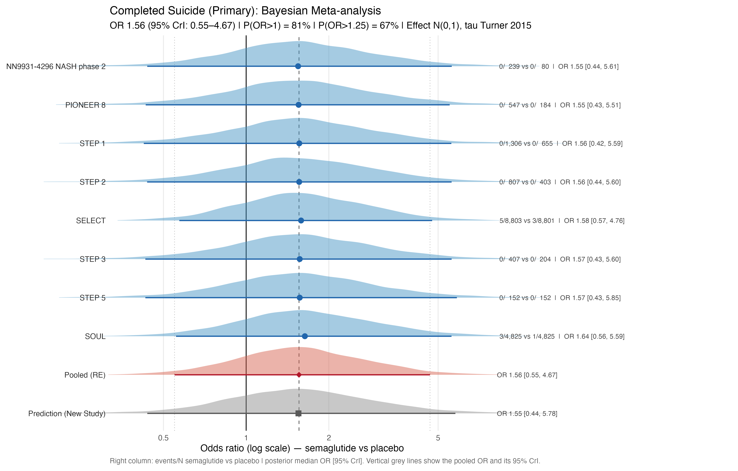
Abbreviations: CrI, credible interval; OR, odds ratio; RE, random effects.

Figure S3. RoB 2 assessment: completed suicide.

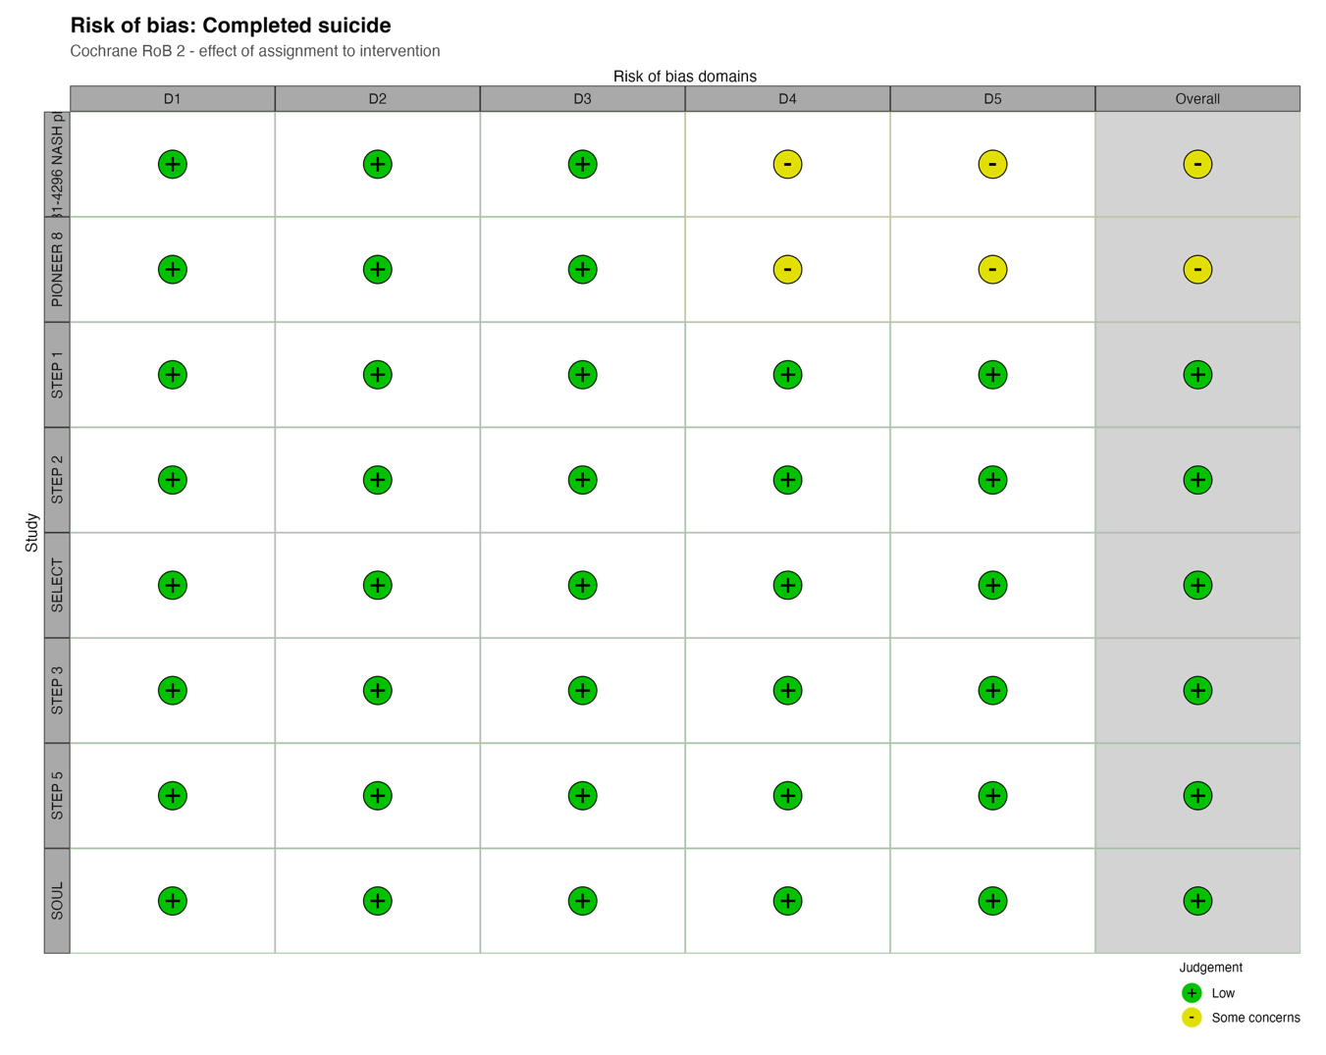
Abbreviations: RoB, risk of bias.

Figure S4. Bayesian forest plot with posterior densities: suicide attempt.
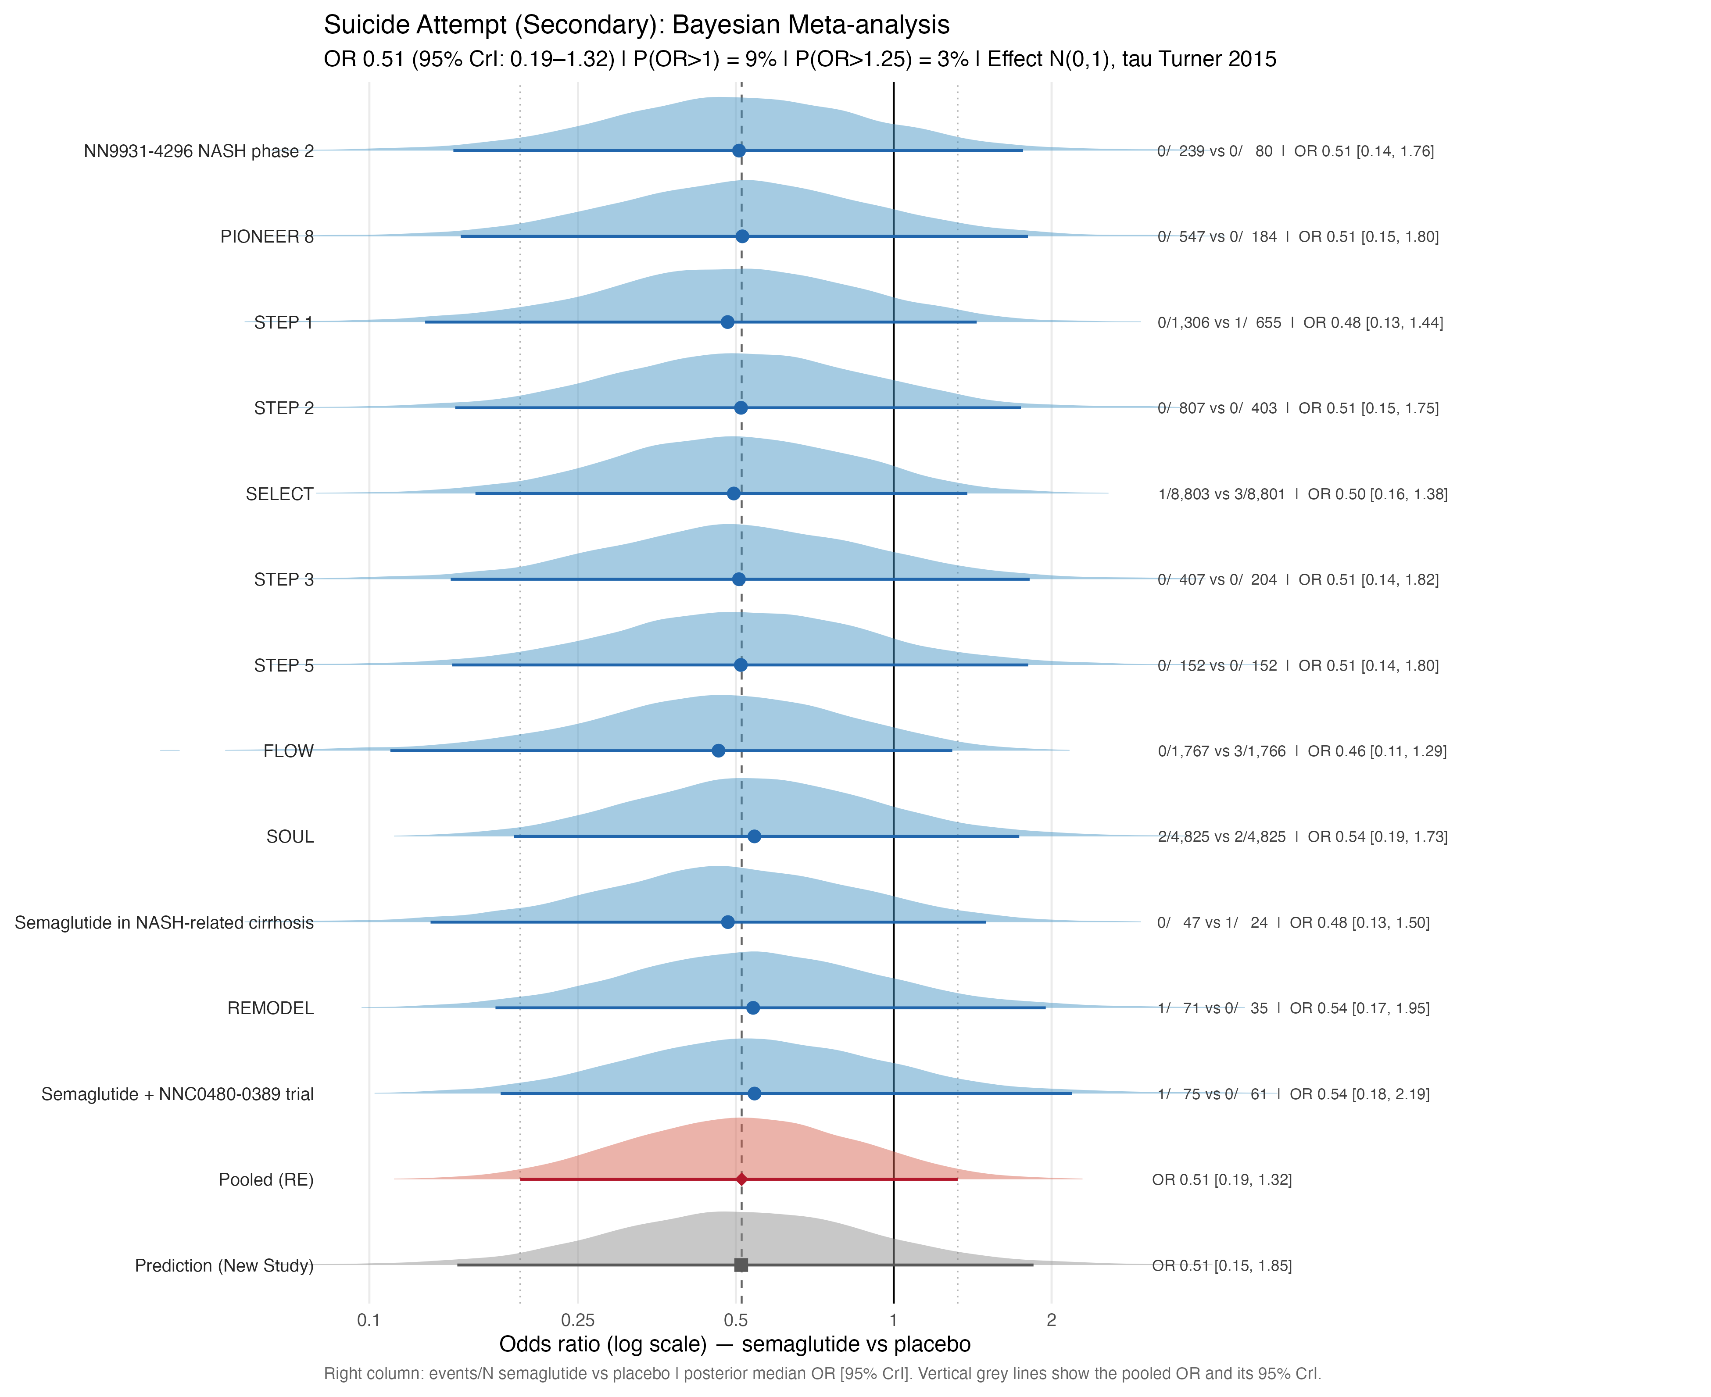

Figure S5. RoB 2 assessment: suicide attempt.

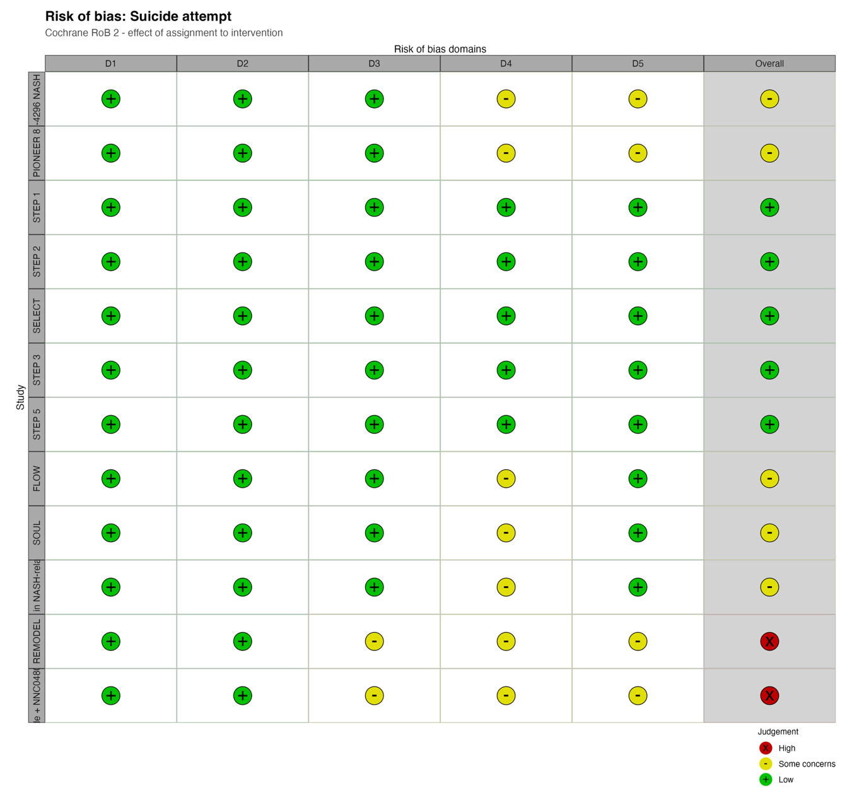

Figure S6. Bayesian forest plot with posterior densities: suicidal ideation.
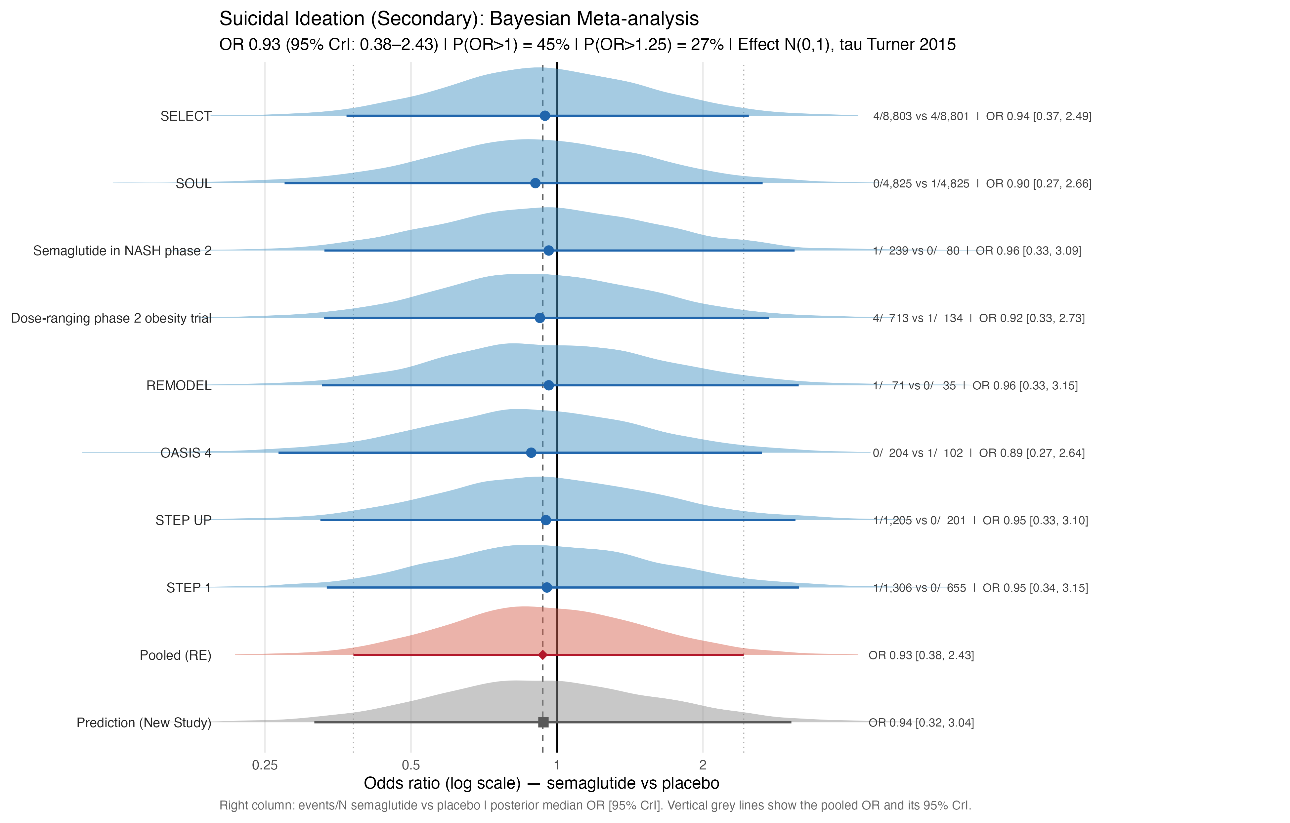

Figure S7. RoB 2 assessment: suicidal ideation.

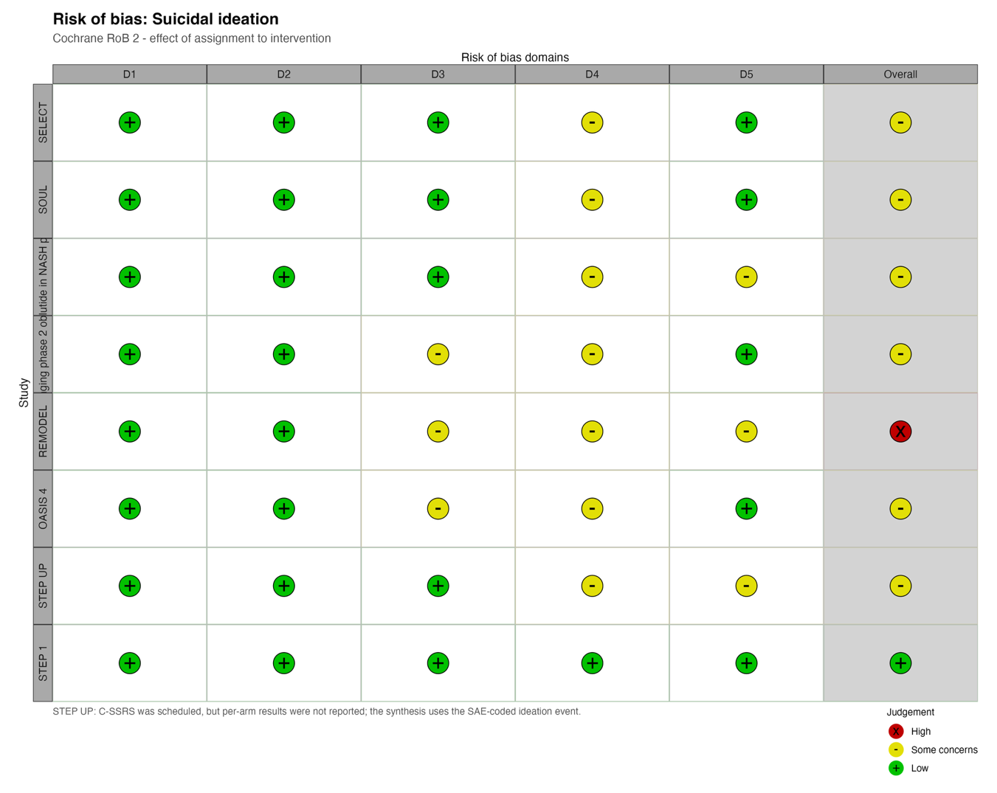

Figure S8. Bayesian forest plot with posterior densities: overall suicidal behaviour/events.
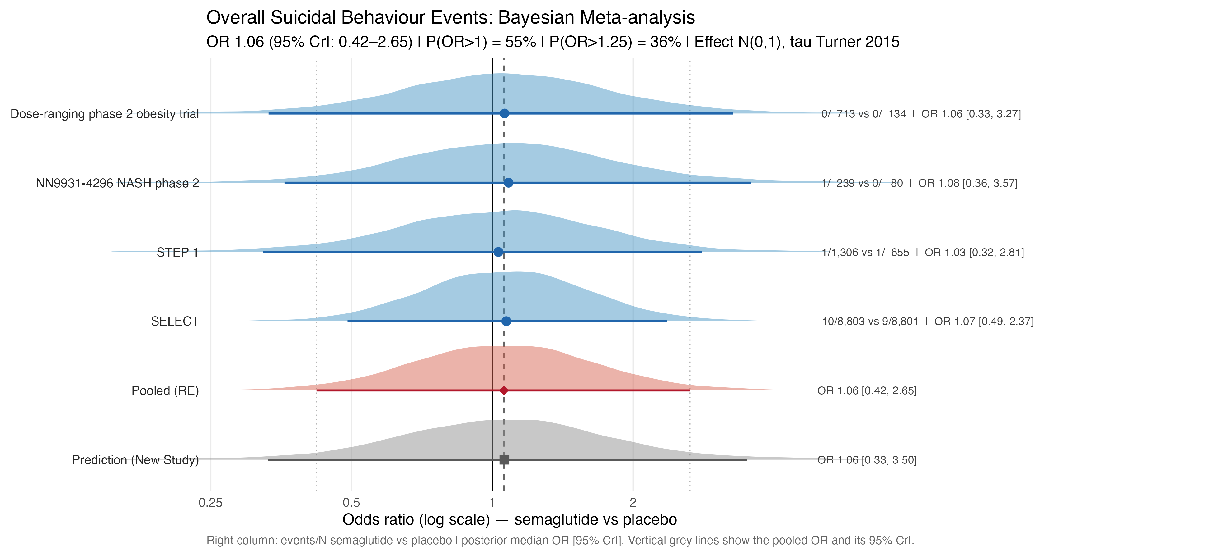

Figure S9. RoB 2 assessment: overall suicidal behaviour/events.

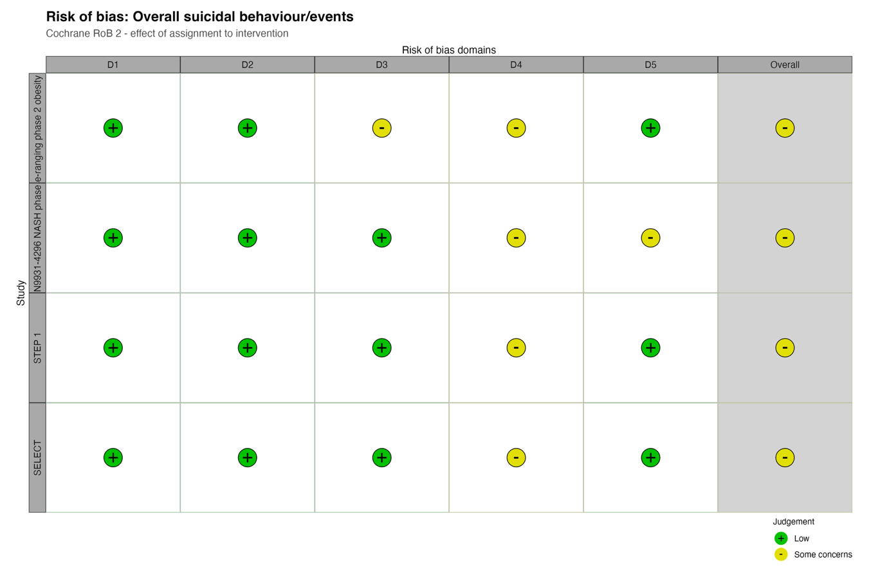

S7: Sensitivity analysis and MCMC diagnostics

Table S7T1. Prior-sensitivity summary across the prespecified 3×3 prior grid.
Outcome | Posterior median OR range | P(OR>1) range | Interpretation/diagnostics
Completed suicide | 1.25–1.91 | 71.5%–84.3% | Every 95% CrI included 1.
Suicide attempt | 0.41–0.69 | 6.0%–16.7% | Every 95% CrI included 1.
Suicidal ideation | 0.92–0.97 | 43.8%–46.6% | Location was stable across priors.
Overall suicidal behaviour/events | 1.03–1.07 | 52.7%–55.3% | One diffuse Normal plus half-Cauchy fit had 17 divergences and was not diagnostically validated.
Abbreviations: CrI, credible interval; OR, odds ratio.

Table S7T2. Frequentist sensitivity analyses.
Outcome | REML-HKSJ OR (95% CI) | Mantel–Haenszel OR (95% CI) | Peto OR (95% CI)
Completed suicide | 1.19 (0.66–2.13) | 2.00 (0.60–6.64) | 1.95 (0.63–6.04)
Suicide attempt | 0.53 (0.30–0.92) | 0.43 (0.15–1.26) | 0.43 (0.16–1.21)
Suicidal ideation | 0.74 (0.45–1.24) | 0.92 (0.34–2.49) | 0.92 (0.34–2.49)
Overall suicidal behaviour/events | 0.93 (0.44–1.99) | 1.08 (0.46–2.52) | 1.08 (0.46–2.52)
Abbreviations: CI, confidence interval; HKSJ, Hartung–Knapp–Sidik–Jonkman; OR, odds ratio; REML, restricted maximum likelihood.

Table S7T3. Ascertainment and active-comparator sensitivity analyses.
Analysis | Pooled OR (95% CrI) | Posterior probability | Interpretation
Suicidal ideation: spontaneous serious-adverse-event reporting | 0.96 (0.37–2.69) | P(OR>1)=47.0% | No material change from the primary estimate.
Overall suicidal behaviour/events: narrow SMQ/MedDRA composites | 1.06 (0.43–2.70) | P(OR>1)=55.2%; P(OR>1.25)=35.0% | No material change from the primary estimate.
Suicide attempt: active-comparator trials | 0.67 (0.15–2.73) | P(OR>1)=29.0% | Exploratory; heterogeneous comparator drugs.
Suicidal ideation: active-comparator trial | Not pooled | Not applicable | Only one trial contributed.
Abbreviations: CrI, credible interval; MedDRA, Medical Dictionary for Regulatory Activities; OR, odds ratio; SMQ, Standardised MedDRA Query.

Figure S10. Posterior OR densities under alternative heterogeneity priors: completed suicide.

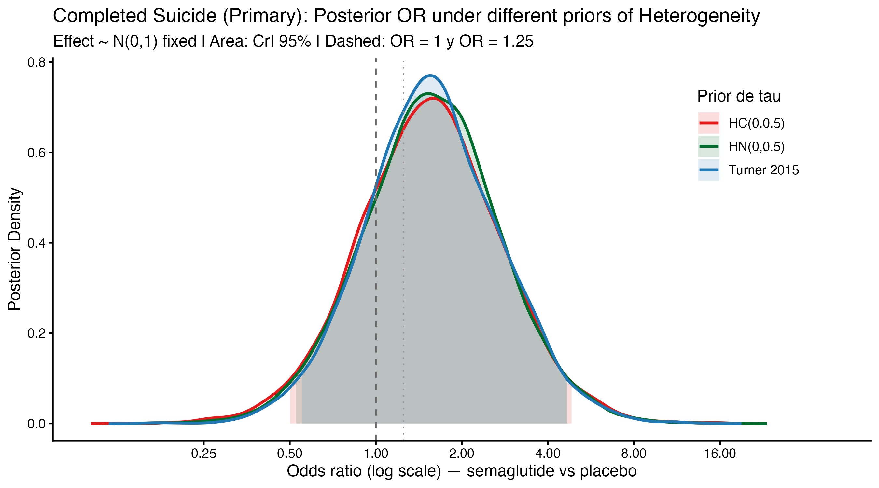
Abbreviations: CrI, credible interval; HC, half-Cauchy; HN, half-Normal; OR, odds ratio; τ, between-study standard deviation.

Figure S11. Posterior OR densities under alternative heterogeneity priors: suicide attempt.
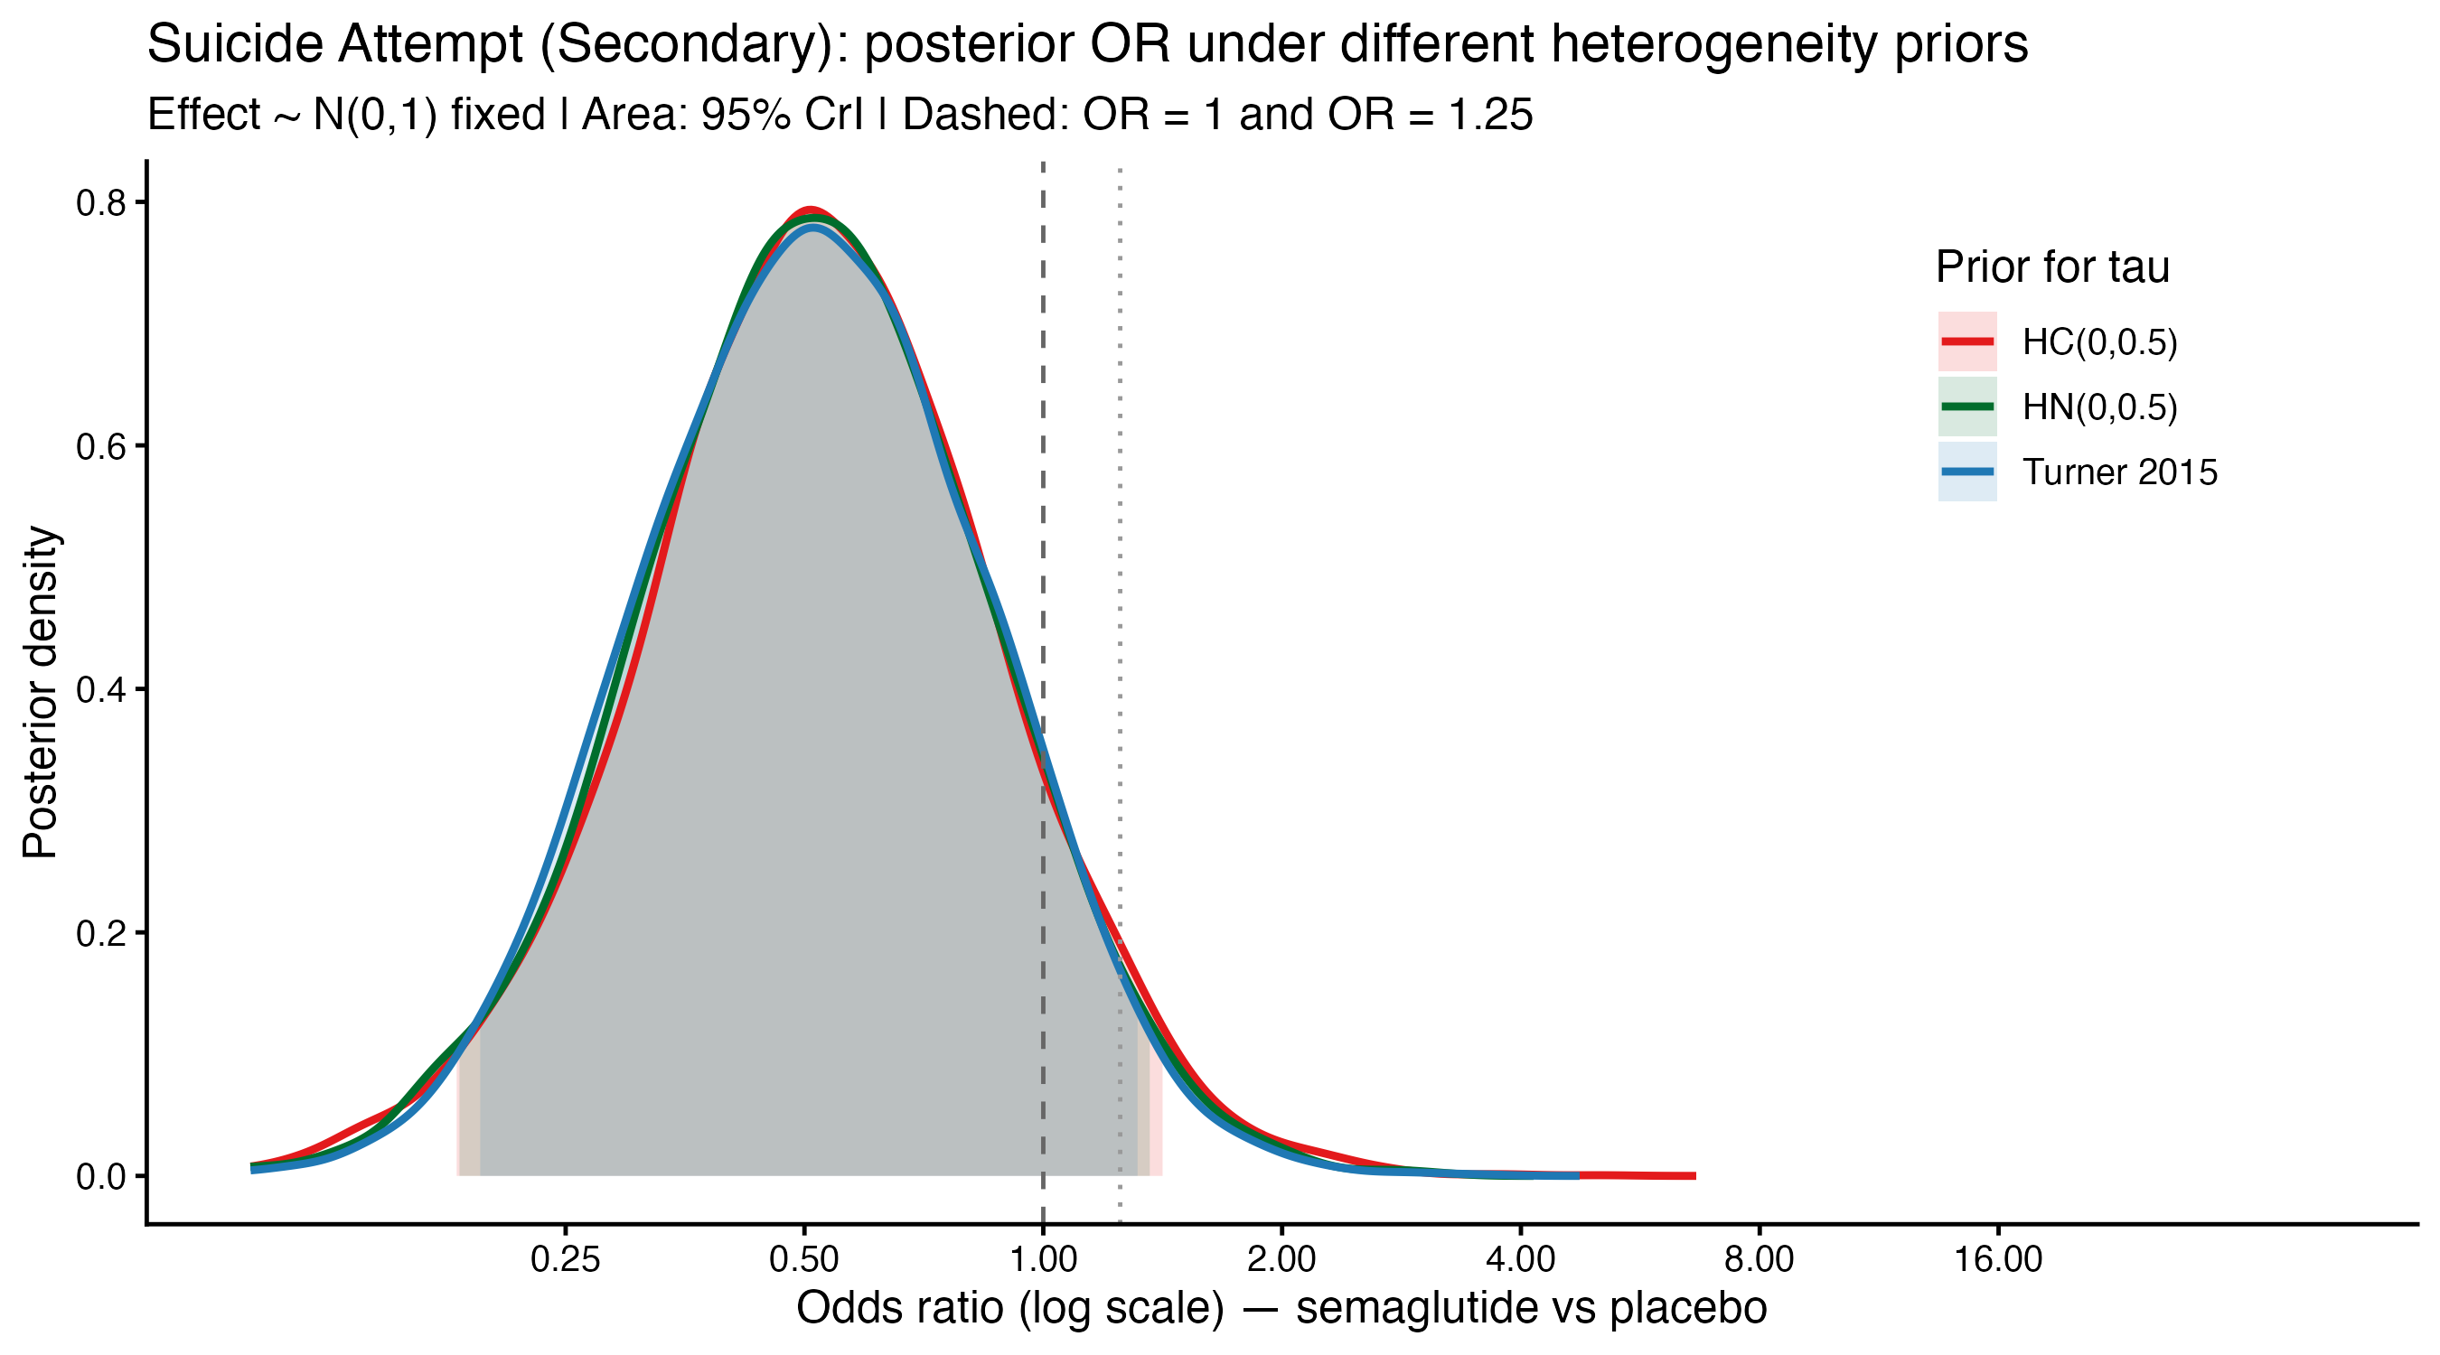
Abbreviations: CrI, credible interval; HC, half-Cauchy; HN, half-Normal; OR, odds ratio; τ, between-study standard deviation.

Figure S12. Posterior OR densities under alternative heterogeneity priors: suicidal ideation.
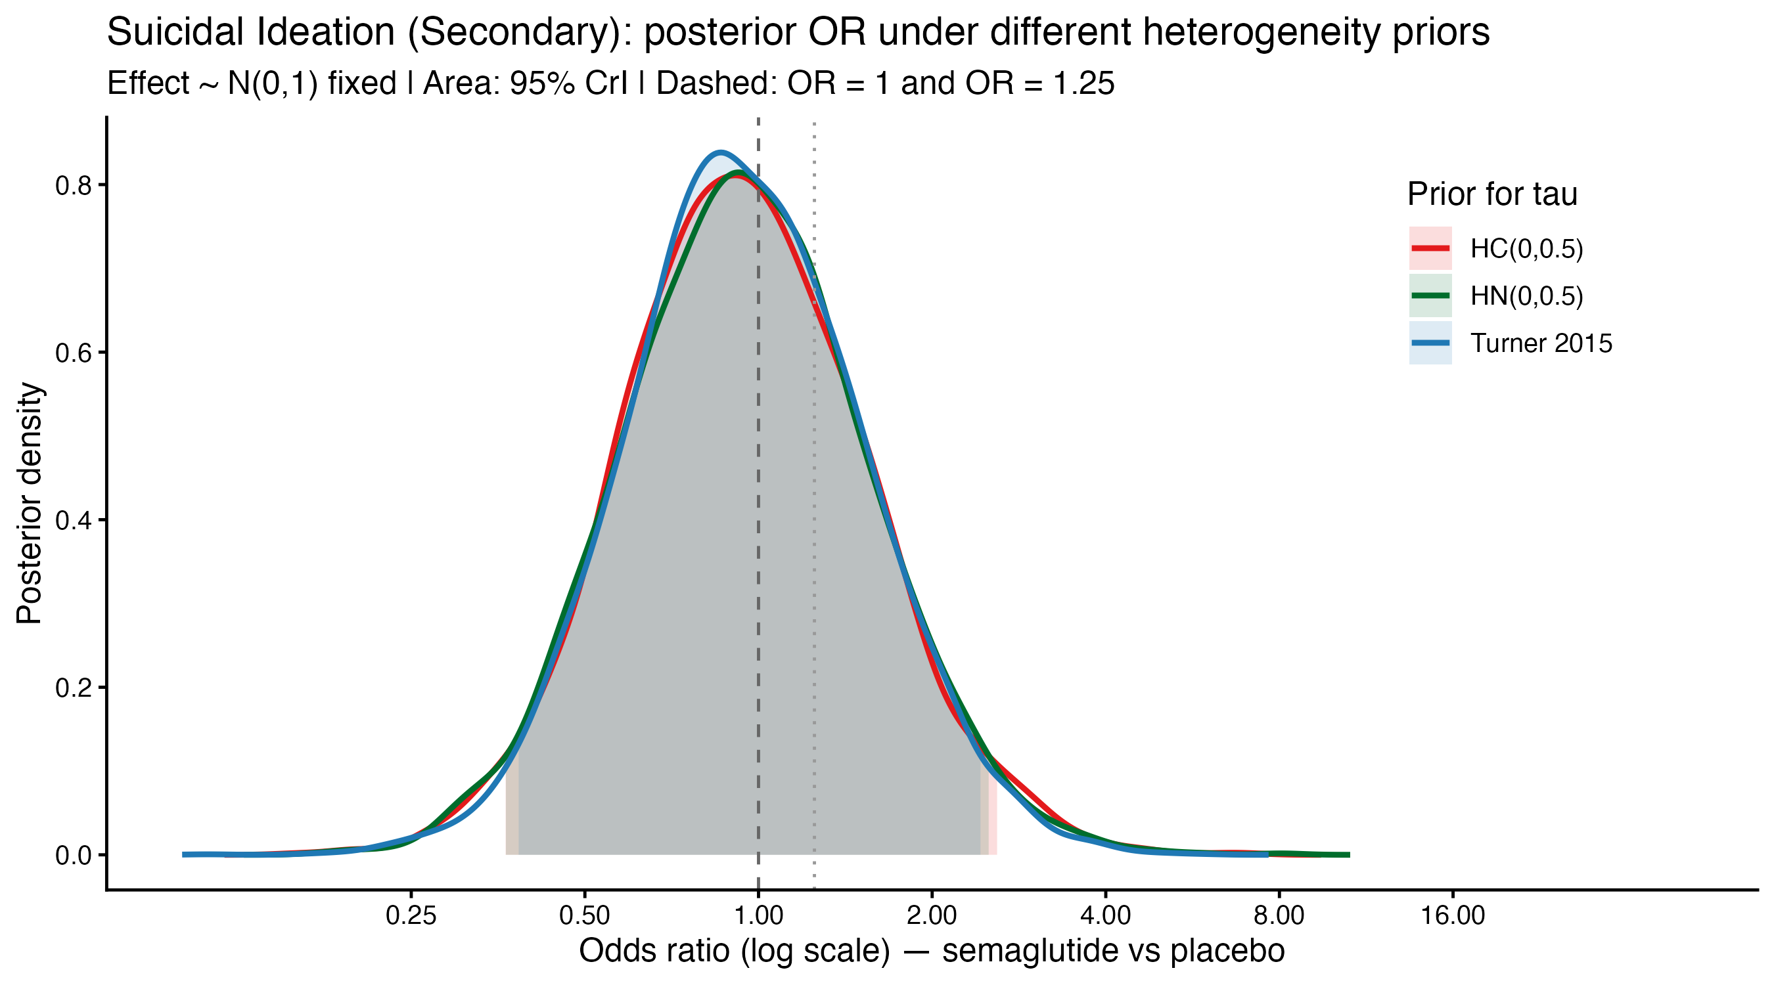

Abbreviations: CrI, credible interval; HC, half-Cauchy; HN, half-Normal; OR, odds ratio; τ, between-study standard deviation.

Figure S13. Posterior OR densities under alternative heterogeneity priors: overall suicidal behaviour/events.

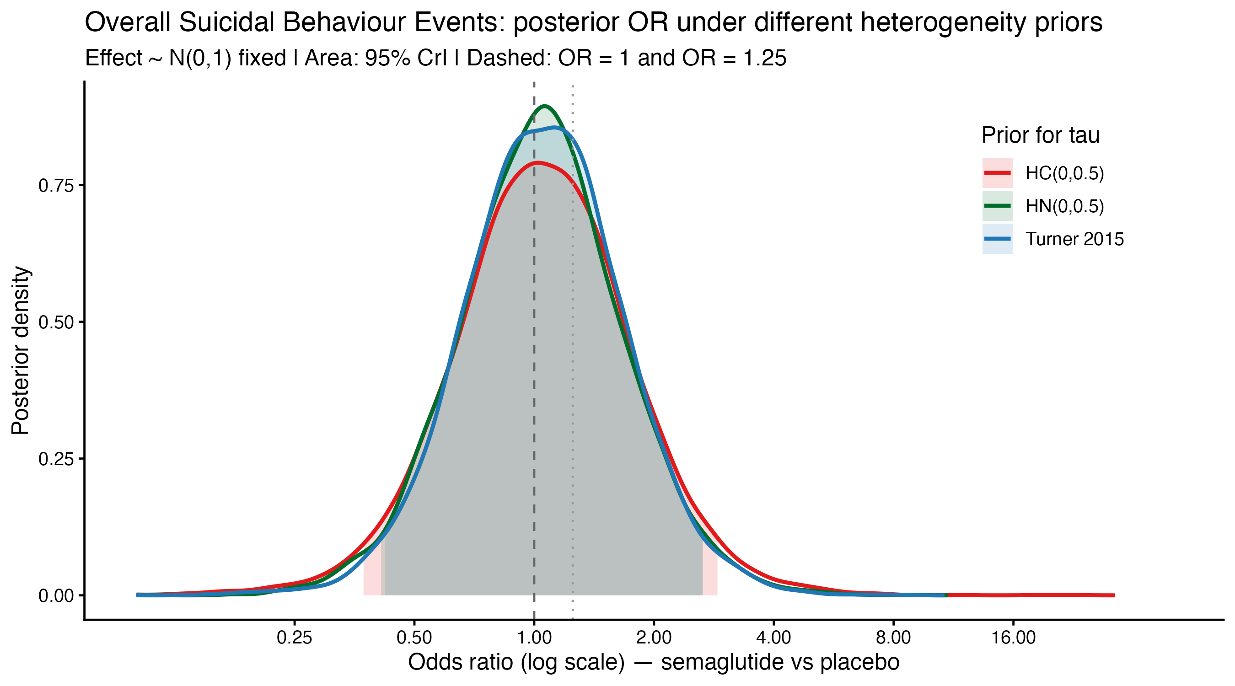
Abbreviations: CrI, credible interval; HC, half-Cauchy; HN, half-Normal; OR, odds ratio; τ, between-study standard deviation.

Figure S14. Trace plot of the pooled log-OR: completed suicide.
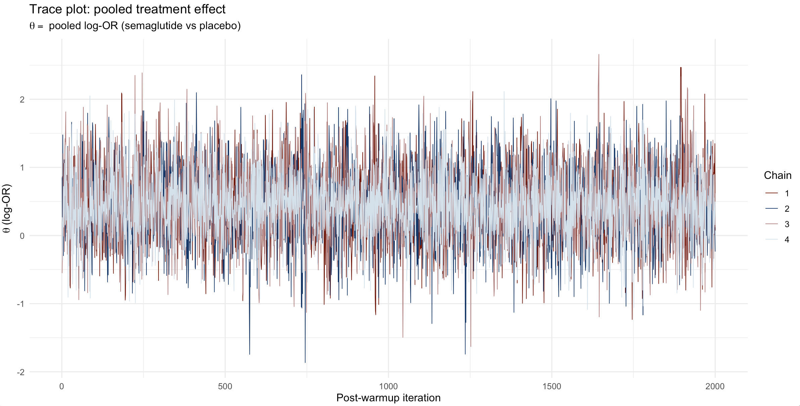

Abbreviations: OR, odds ratio; θ, pooled log-odds ratio.

Figure S15. Trace plot of the pooled log-OR: suicide attempt.
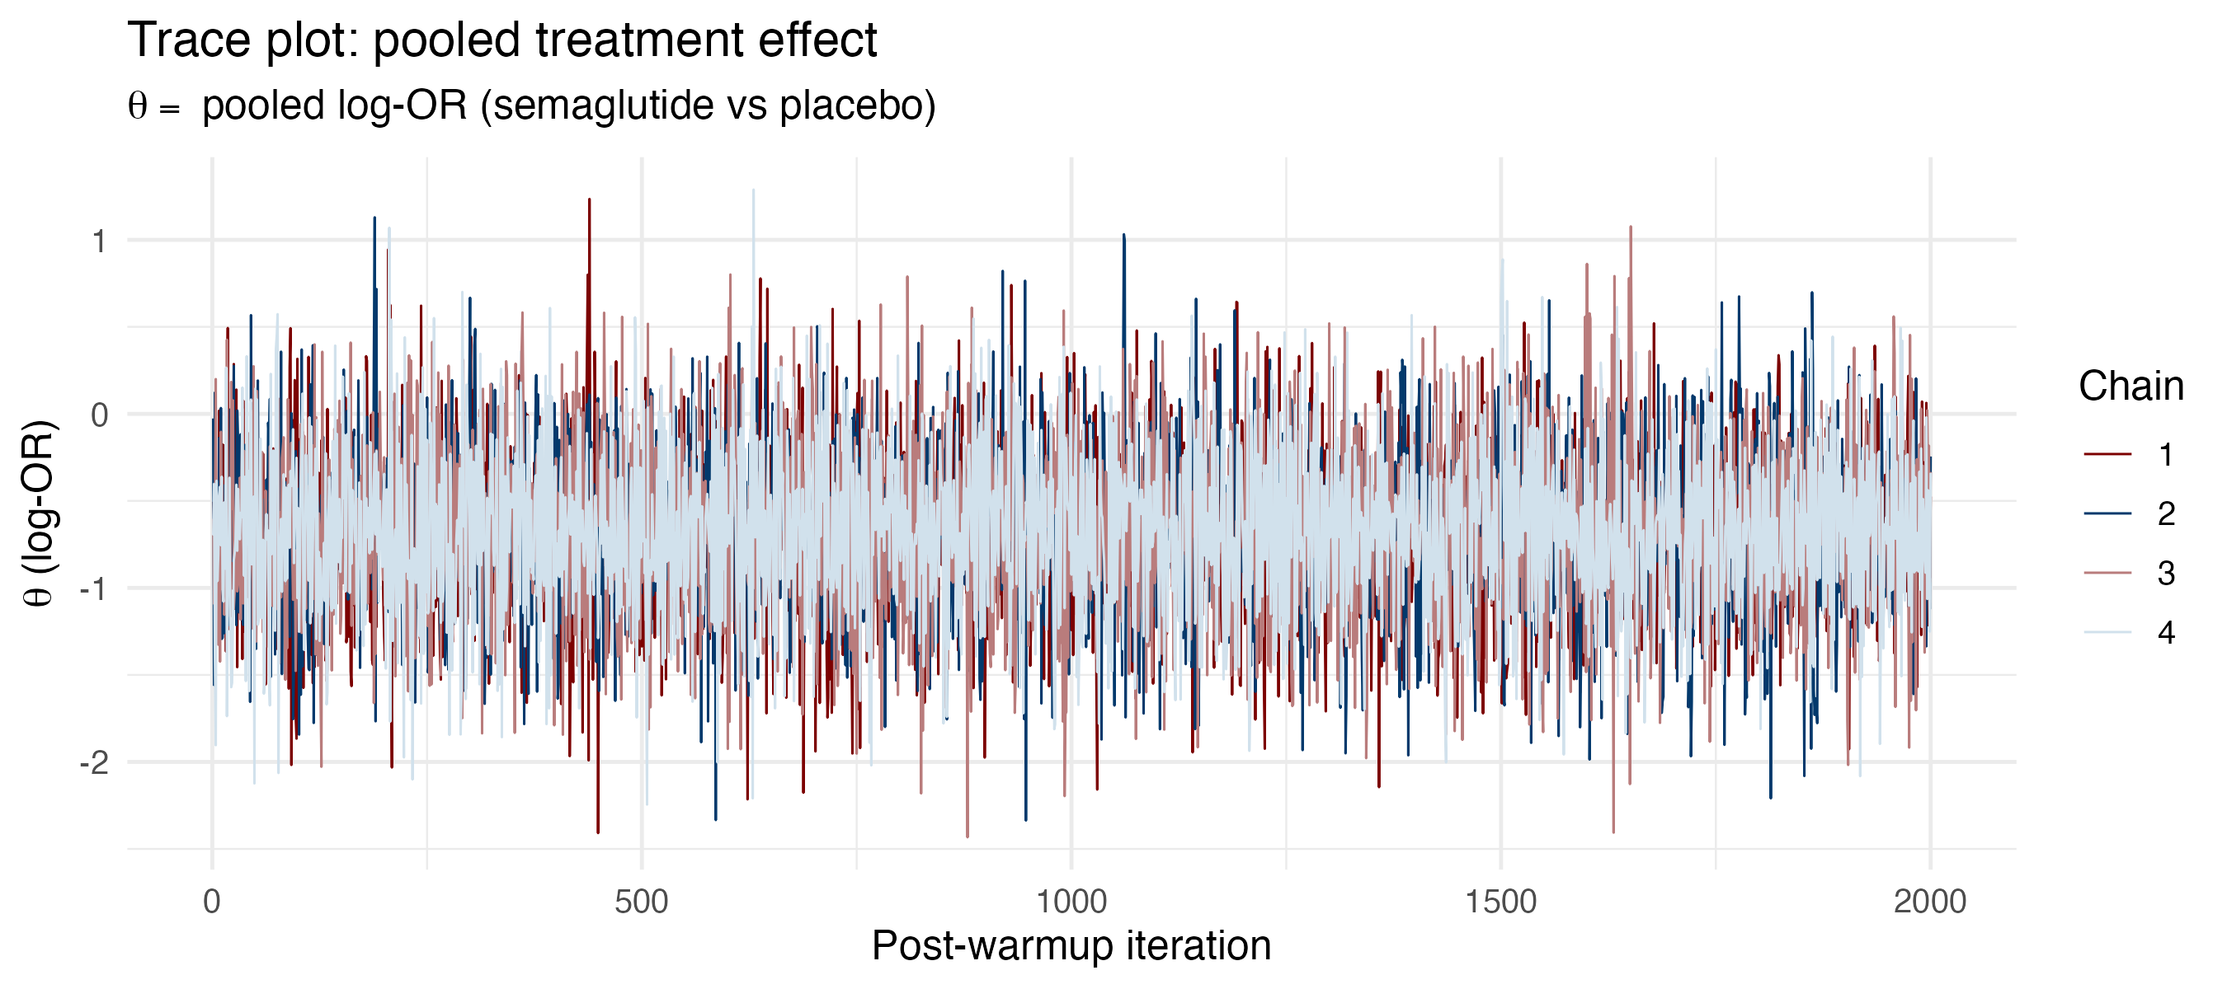
Abbreviations: OR, odds ratio; θ, pooled log-odds ratio.

Figure S16. Trace plot of the pooled log-OR: suicidal ideation.
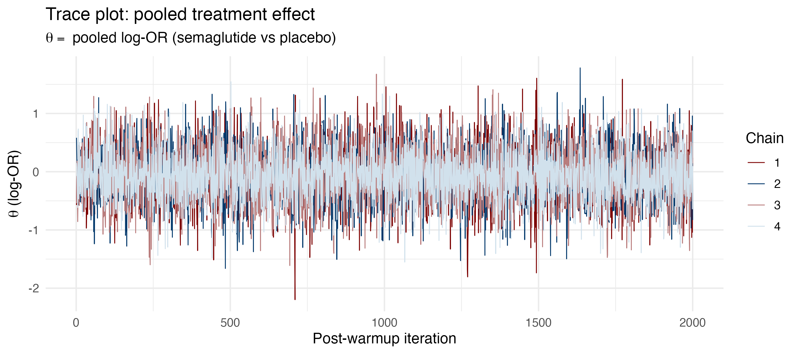
Abbreviations: OR, odds ratio; θ, pooled log-odds ratio.

Figure S17. Trace plot of the pooled log-OR: overall suicidal behaviour/events.
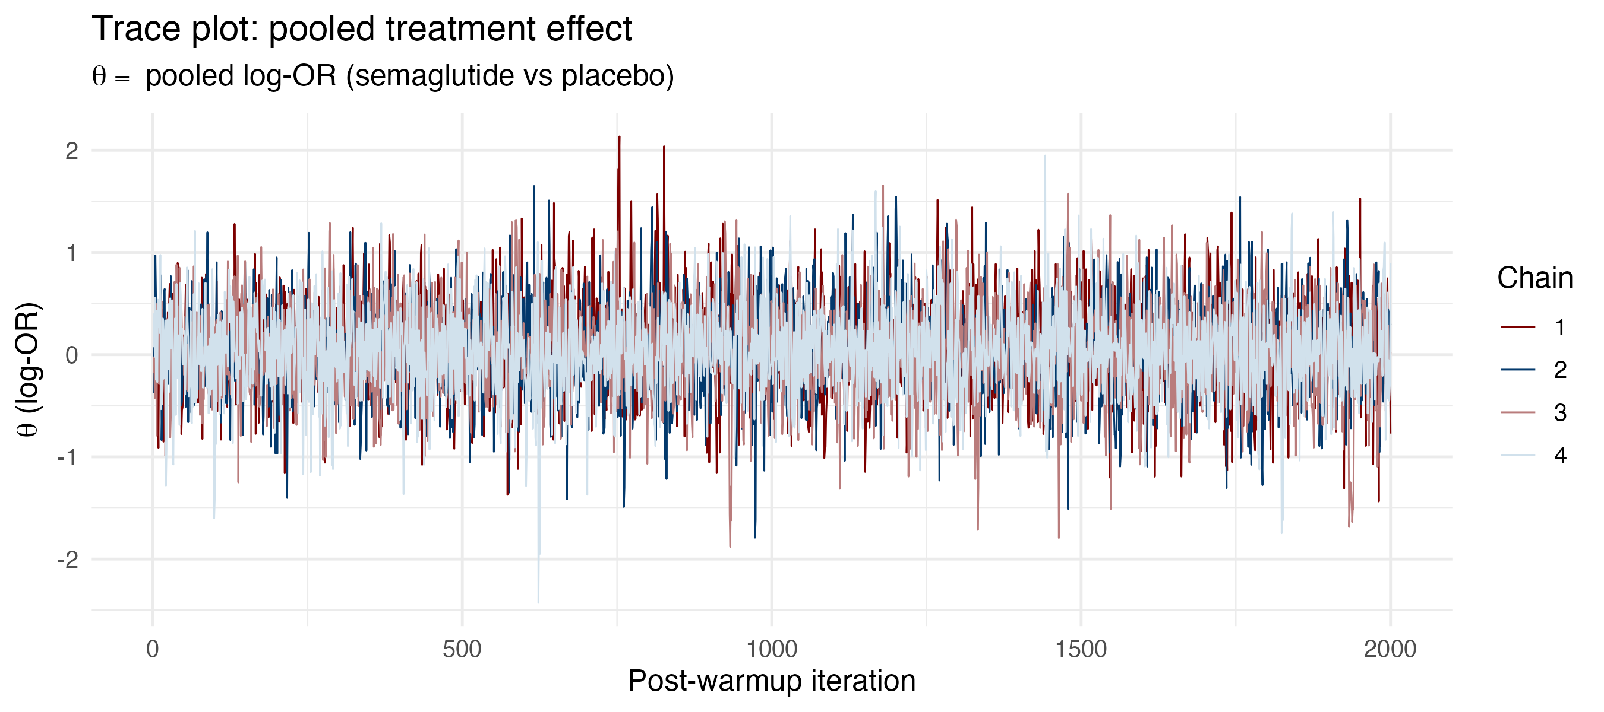
Abbreviations: OR, odds ratio; θ, pooled log-odds ratio.

Figure S18. Trace plot of between-study heterogeneity: completed suicide.

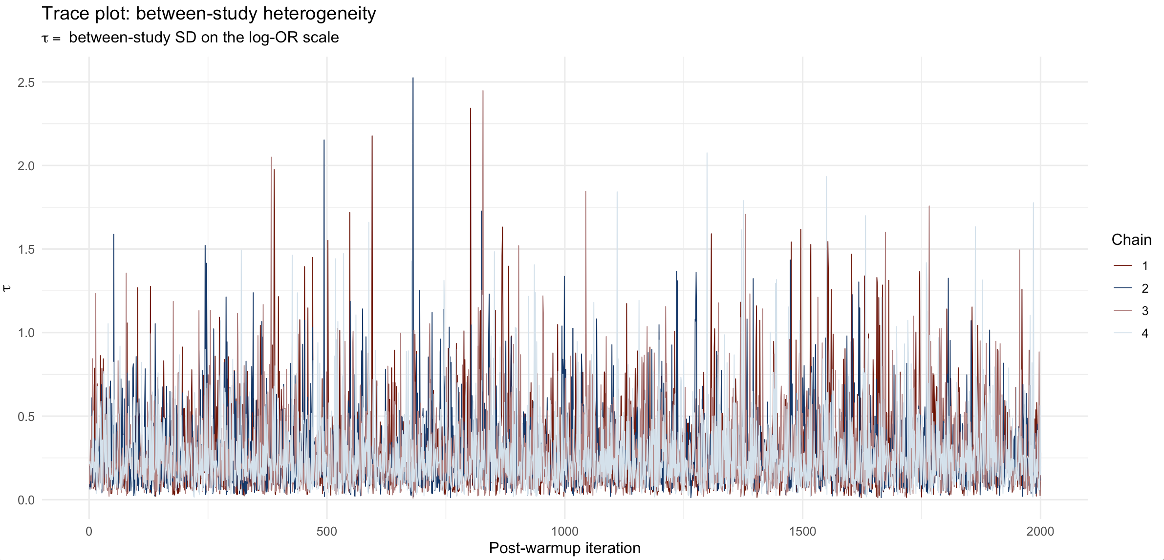
Abbreviations: OR, odds ratio; τ, between-study standard deviation on the log-OR scale.

Figure S19. Trace plot of between-study heterogeneity: suicide attempt.
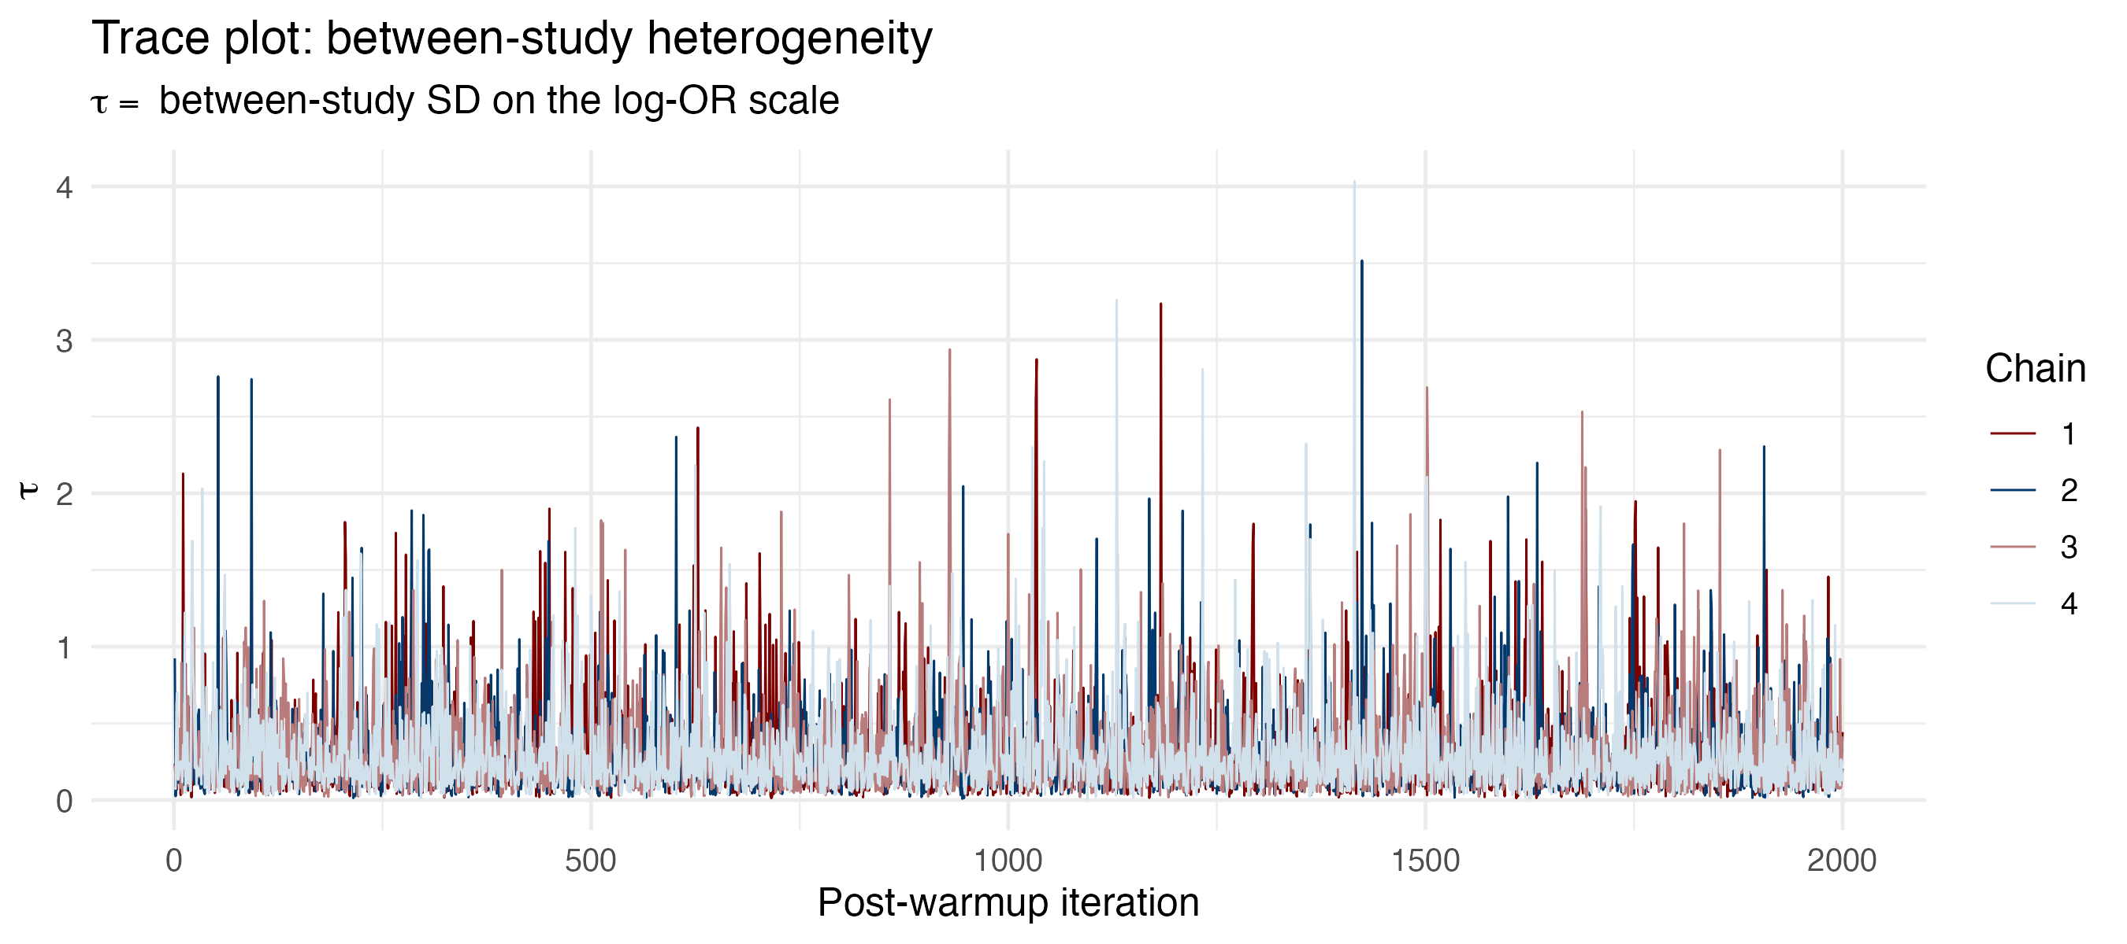
Abbreviations: OR, odds ratio; τ, between-study standard deviation on the log-OR scale.

Figure S20. Trace plot of between-study heterogeneity: suicidal ideation.
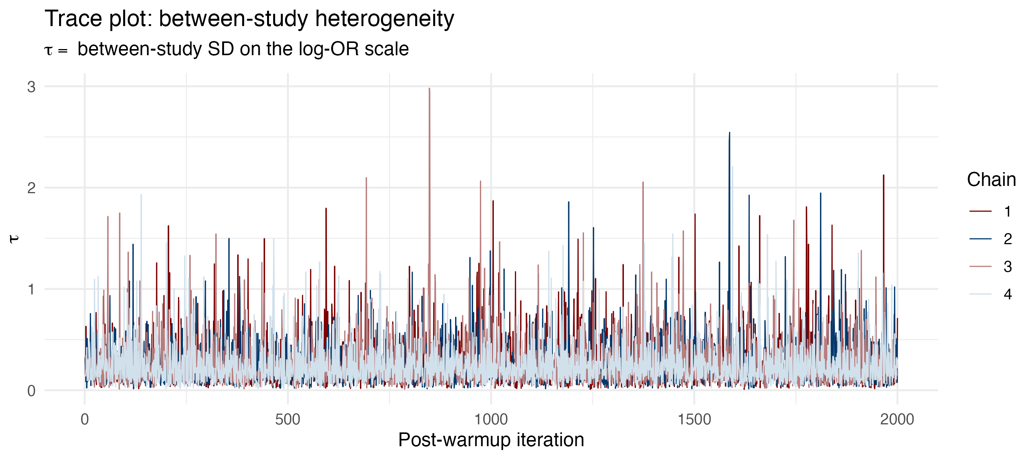
Abbreviations: OR, odds ratio; τ, between-study standard deviation on the log-OR scale.

Figure S21. Trace plot of between-study heterogeneity: overall suicidal behaviour/events.
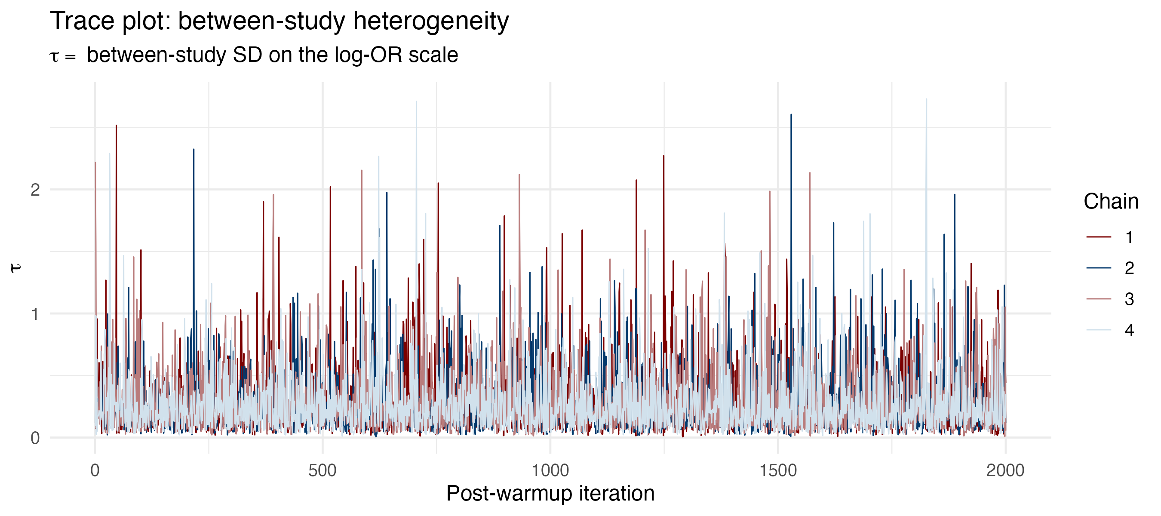
Abbreviations: OR, odds ratio; τ, between-study standard deviation on the log-OR scale.

Figure S22. Autocorrelation of the pooled log-OR: completed suicide.
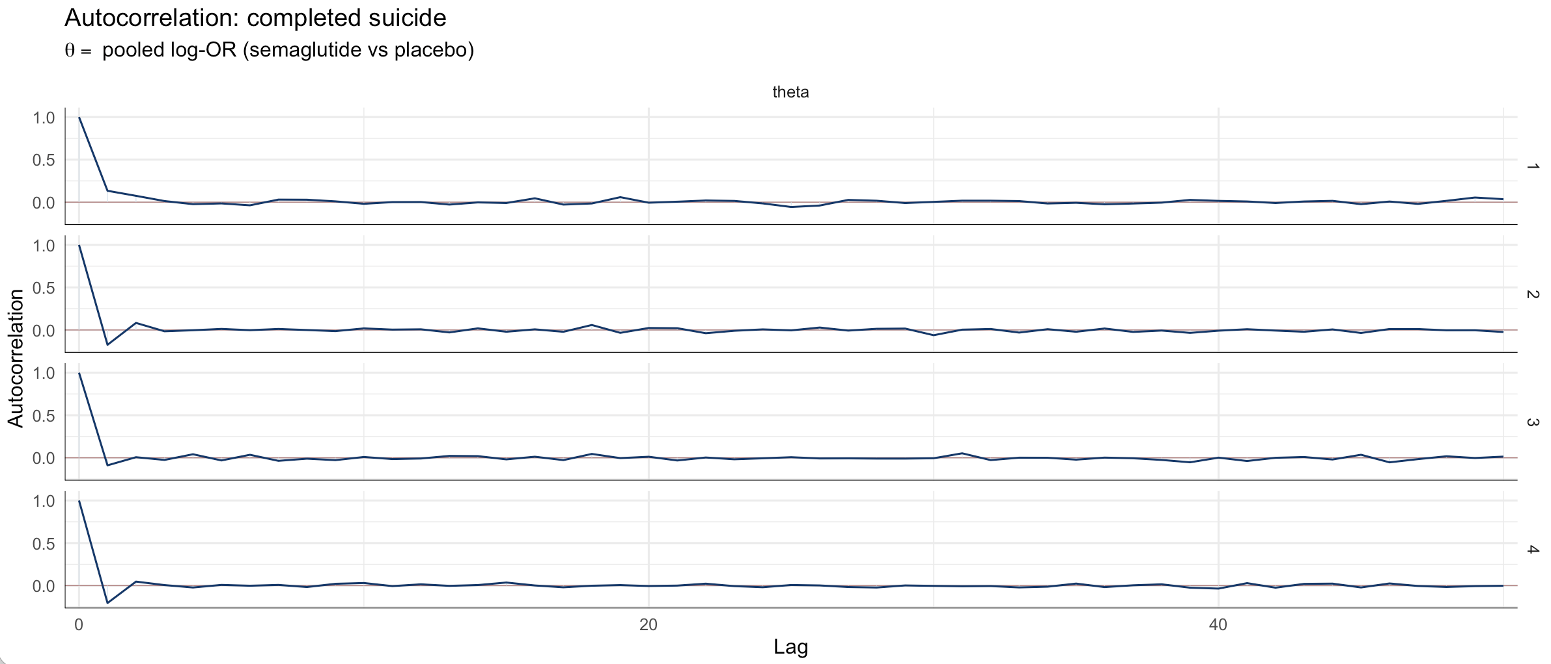
Abbreviations: ACF, autocorrelation function; OR, odds ratio; θ, pooled log-odds ratio.

Figure S23. Autocorrelation of the pooled log-OR: suicidal ideation.
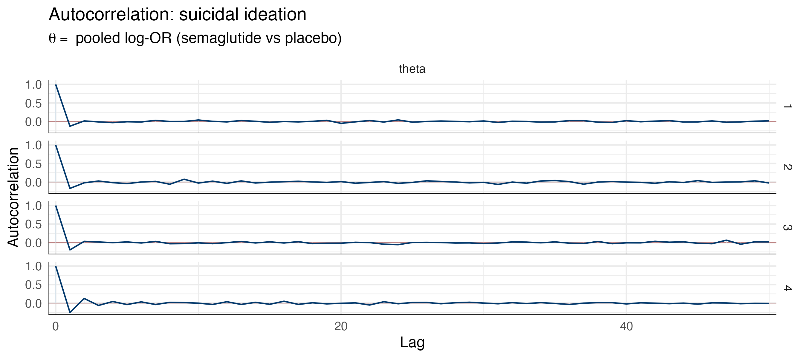
Abbreviations: ACF, autocorrelation function; OR, odds ratio; θ, pooled log-odds ratio.

Figure S24. Autocorrelation of the pooled log-OR: overall suicidal behaviour/events.
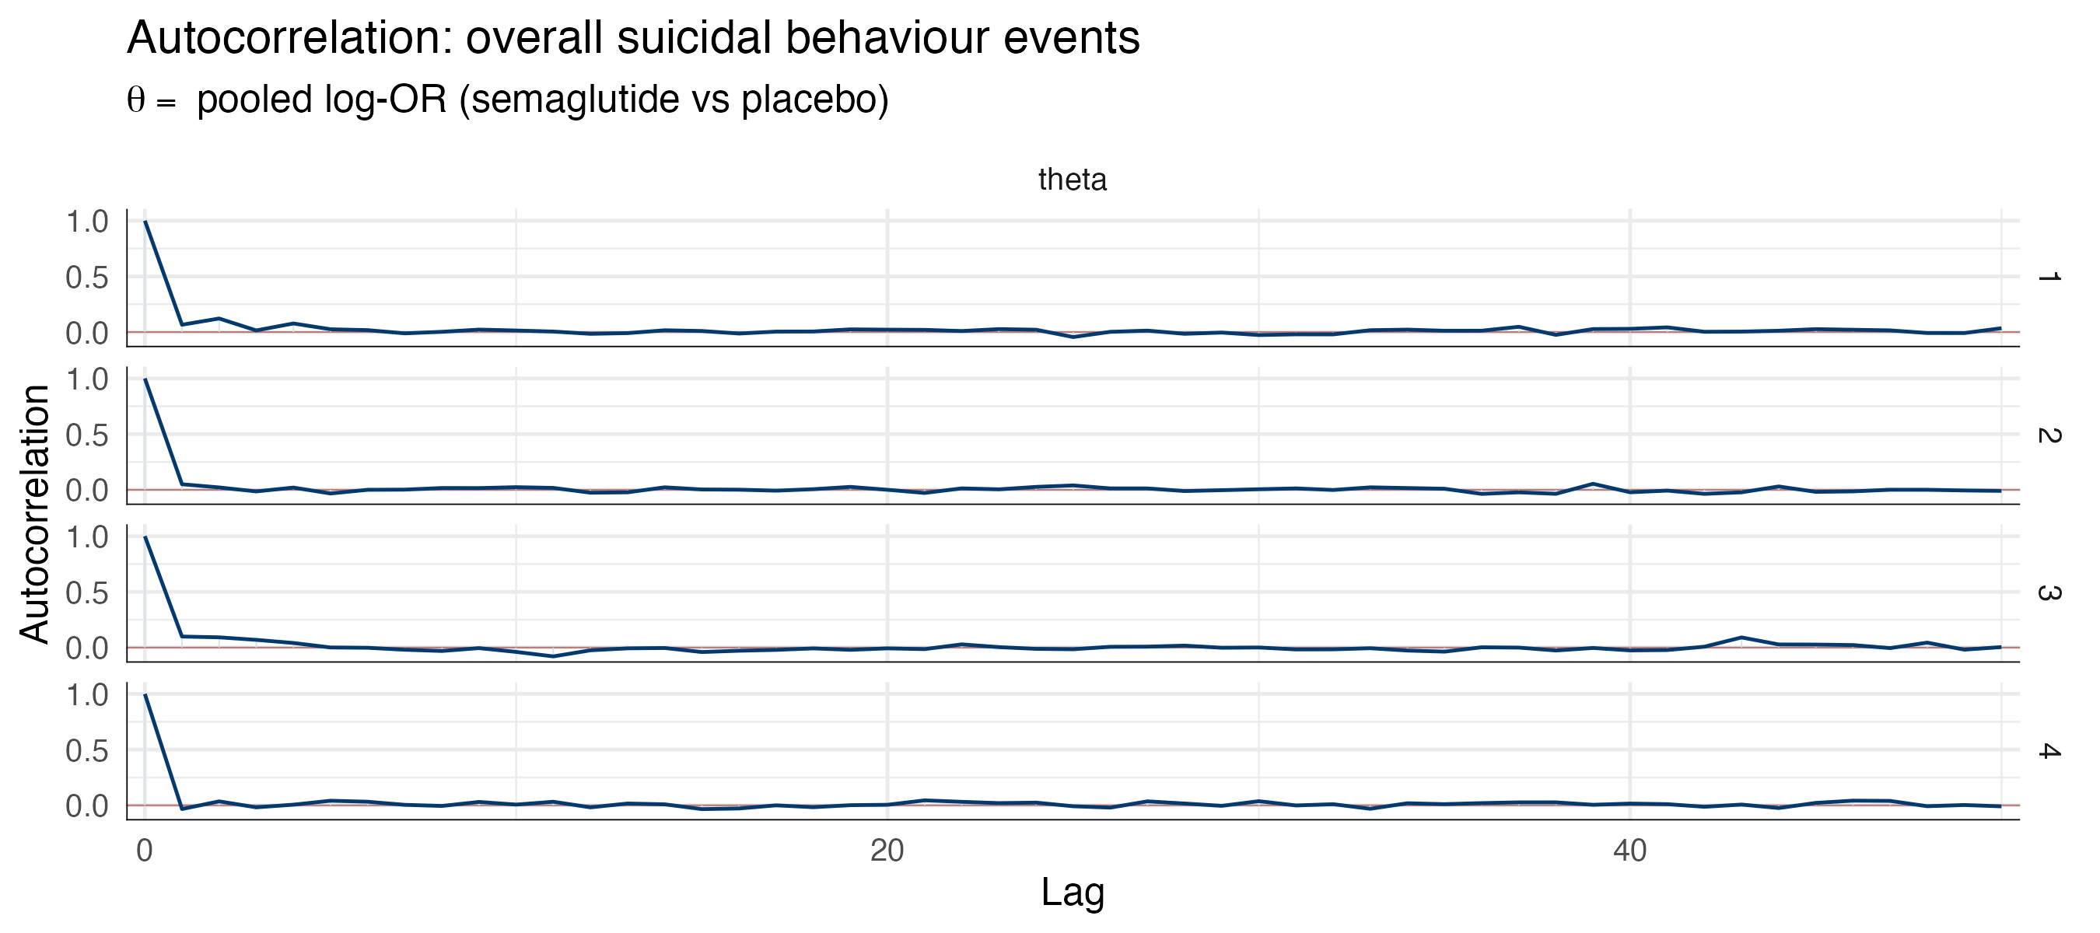
Abbreviations: ACF, autocorrelation function; OR, odds ratio; θ, pooled log-odds ratio.

Figure S25. Autocorrelation of between-study heterogeneity: completed suicide.
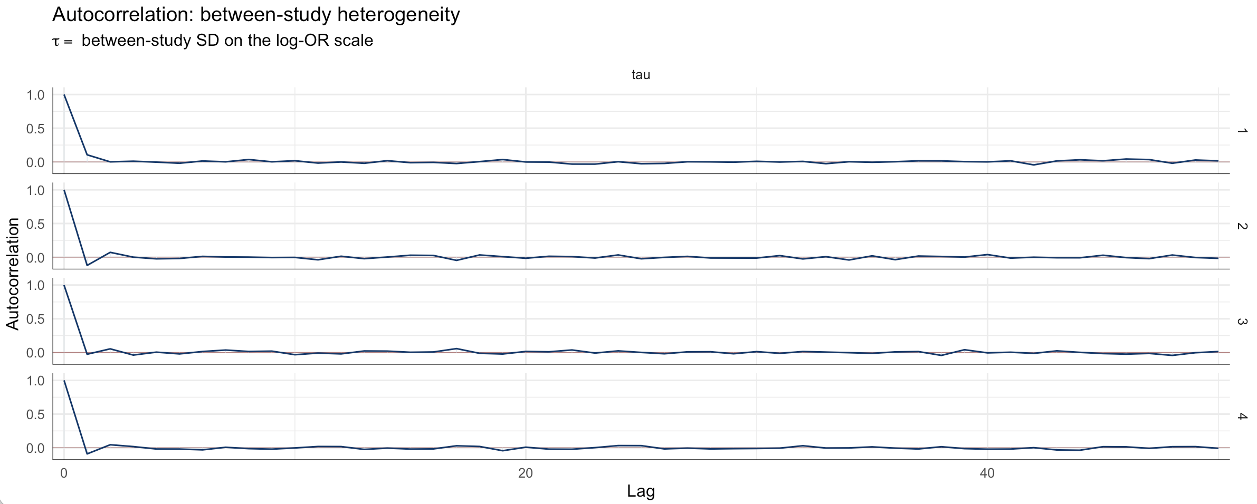
Abbreviations: ACF, autocorrelation function; OR, odds ratio; τ, between-study standard deviation on the log-OR scale.

Figure S26. Autocorrelation of between-study heterogeneity: suicidal ideation.
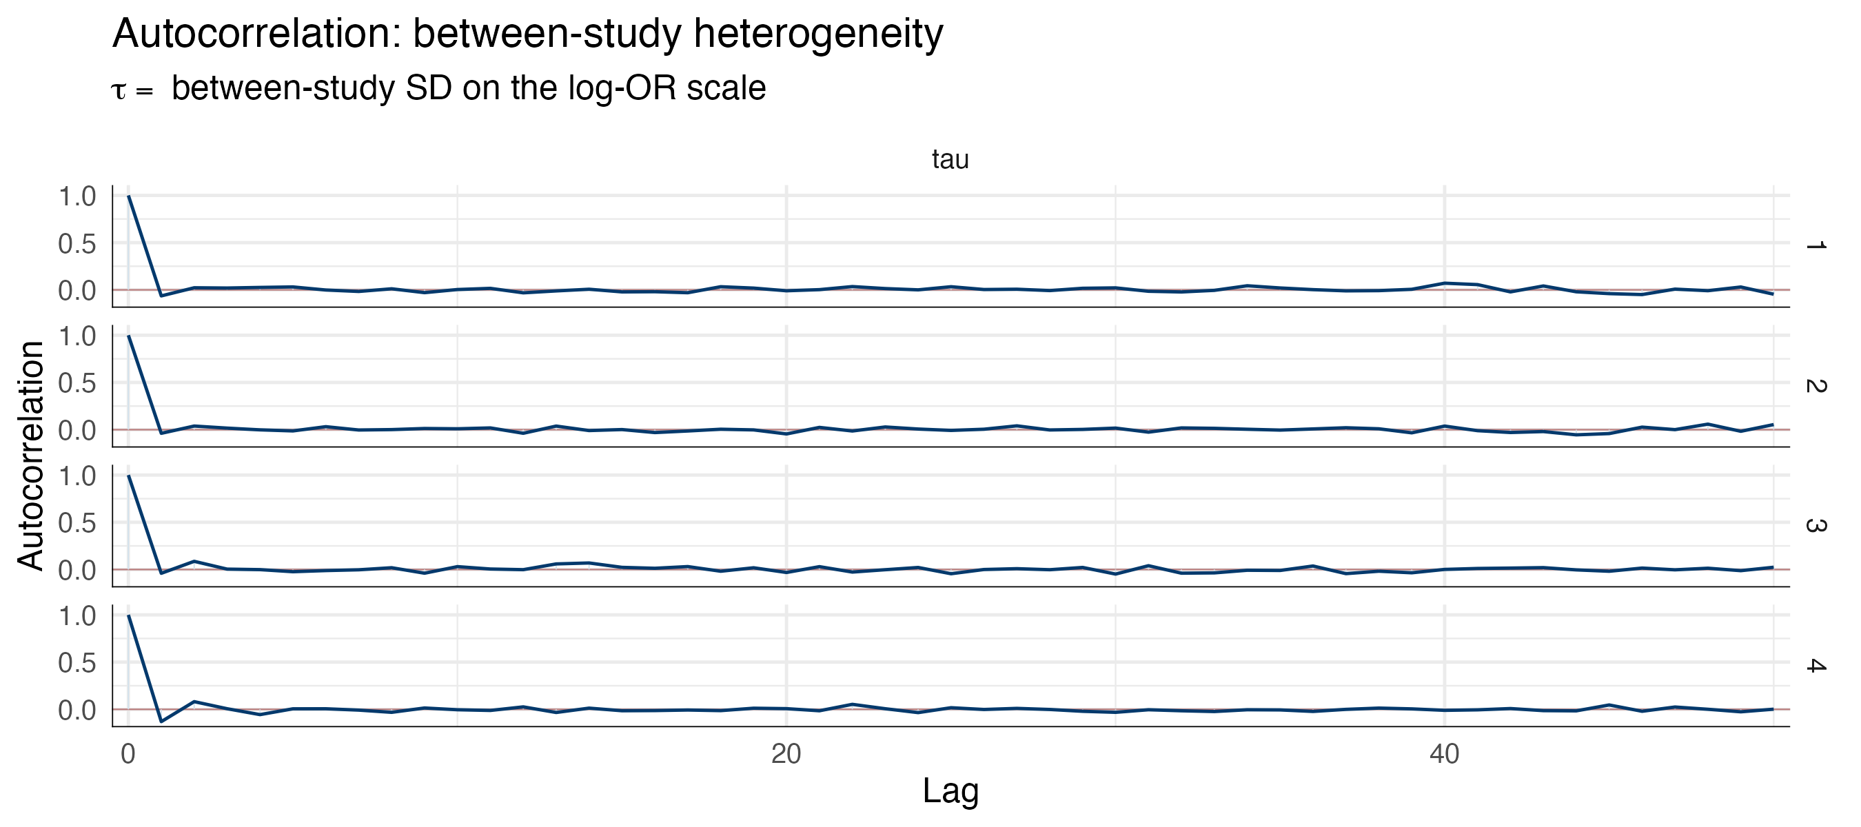
Abbreviations: ACF, autocorrelation function; OR, odds ratio; τ, between-study standard deviation on the log-OR scale.

Figure S27. Autocorrelation of between-study heterogeneity: overall suicidal behaviour/events.
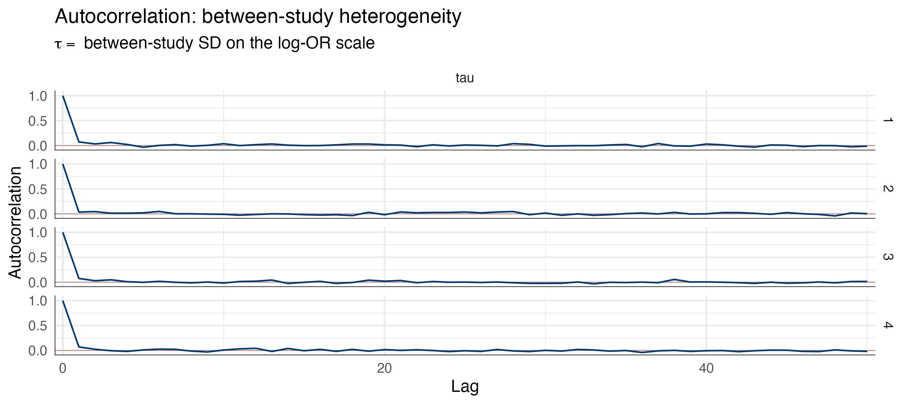
Abbreviations: ACF, autocorrelation function; OR, odds ratio; τ, between-study standard deviation on the log-OR scale.

