Science Supplementary Materials



Supplementary Materials for

Volumetric characterization of CNS Extracellular Space using thick Undehydrated Hippocampal tissue cryosections
Authors: Jesus A Trejos^{1*}, Francis A. X. Schanne²
Affiliations:
¹Regeneron Pharmaceuticals
² St Johns University
³For large groups, use the name of the group or consortium and include a full list of the authors and affiliations at the end of the main manuscript or in the Supplementary Materials.
*Corresponding author. Email: jesus.antonio.trejos@gmail.com

The PDF file includes:

Materials and Methods
Tissue treatment with spot tox and slice immersion:
Treatment with Mercury or a combination cyanide/2-deoxy-glucose consisted of a “spot tox” within the CA3 region of the hippocampal slice; this was delivered as an aliquot of 180 nanoliters (using a micropipette calibrated to go down to 100 nanoliters); control slices were exposed to vehicle solvent used for both toxicants (PBS). The well-understood mechanisms of these 2 toxicants render them as pharmacotoxicants and will be described as such (full results of this study are in published thesis (4)). Pushing the 180 nL droplet out of the micropipette tip and placing on top of the CA3 region will allow the drop to dollop on top of that tissue region, eventually this dollop will be absorbed into the tissue. The Dentate Gyrus region was not treated in order to have a healthy tissue control within the slice. To enable an effective contrast of what MG/CD11+ cells look like within untreated and thus healthier regions versus what they look like in regions in and around the spot tox’s unhealthy tissue. This enables not just contrast but also a gradation of changes in the space in between healthy and injured cells. MG cells and injury regions were evaluated 2 hours after spot tox. In addition, slices fully immersed in media (without semiporous membrane) with several concentrations of toxicants (also for 2 hours) was done to better understand the tissue slice’s holistic toxic dose response and MG morphology in liquid.

Supplemental Figures
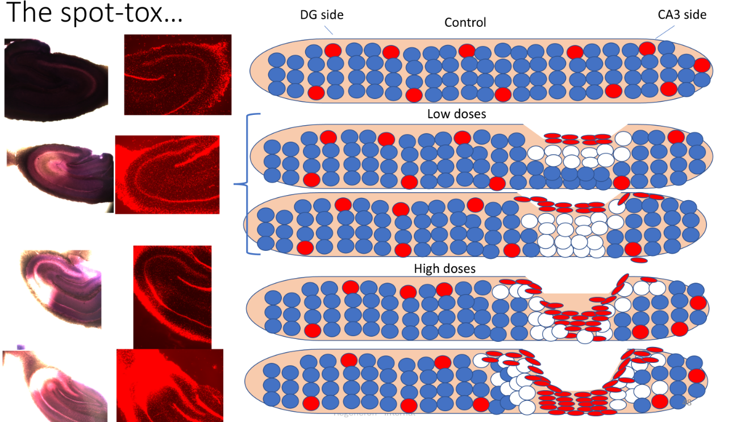
Supplemental Figure 1: Proposed mechanism of biodistribution of 180 nL aliquot of toxicant at high and low doses compared to control.
Lower doses of toxicants cannot reach the bottom of the slice likely due to activated MG obstructing passage of toxic fluid to the bottom portion of the slice and thus are protected from toxic insult. At high doses, likely due to osmotic pressure gradients and induced toxicity the MG barrier is lost, and the bottom portion of the slice is exposed to toxic insult.

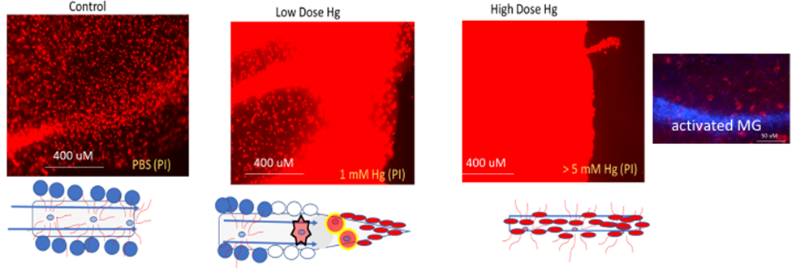
Supplemental Figure 2: Loss of fluid permeability during whole slice immersion into media with toxicant (Hg).
Control slices have sporadic dead cells that, however by in large most cells are excluding PI dye. High doses of toxicant (mercury) the entire slice turns red not just due to PI infiltration into the cell but also due to leakage of nucleic contents into the extracellular space that also interact with PI. During low doses only the outer portion of the slice turn red indicating toxicity in only that portion of the slice; this indicated that the inner portion of the slice is protected by some factor that impedes access of toxic fluid into that compartment of the slice, likely activated MG.

