Supplementary Table
Table S1. Primary antibodies used for Western blotting
Target protein | Host species | Dilution | Company | Catalog number
PDE2A | Rabbit | 1:1000 | Abcam (Cambridge, UK) | AB140650-1001
PKA | Rabbit | 1:1000 | Cell Signaling Technology | 4782S
PKG | Rabbit | 1:800 | Cell Signaling Technology | 3248S
Caspase-3 | Rabbit | 1:1000 | Affinity Biosciences | AF6311
Bax | Rabbit | 1:1000 | Affinity Biosciences | AF0120
Bcl-2 | Rabbit | 1:1000 | Affinity Biosciences | AF6139
TNF-α | Rabbit | 1:1000 | Invitrogen | PA5-19810
IL-1β | Rabbit | 1:1000 | Invitrogen | PA5-119220
NF-κB (p50/p105) | Rabbit | 1:1000 | Invitrogen | PA5-17654

Supplementary Figure Legends
HT-22 cell Western blots
Figure S1–S8: Uncropped blot images for PDE2A, PKA, PKG, IL-1β, TNF-α, NF-κB p50/p105, Bax, Bcl-2, and Caspase-3 from HT-22 cell experiments.
Hippocampal tissue Western blots
Figure S9–S10: Uncropped blot images for Bax and Bcl-2 from mouse hippocampal tissue.
PDE2A overexpression experiments
Figure S11–S13: Uncropped blot images for PDE2A-OE showing PDE2A, IL-1β, and Bcl-2.
PDE2A knockdown experiments
Figure S14–S16: Uncropped blot images for PDE2A-KD showing PDE2A, IL-1β, and Bax.
Figure S1. Uncropped Western blot images corresponding to Figure 2A of the main manuscript
(A) PDE2A chemiluminescent blot
(B) Corresponding β-actin blot
Figure S2. Uncropped Western blot images corresponding to Figure 2Eof the main manuscript
(A-B) PKA chemiluminescent blot
(C-D) Corresponding β-actin blot
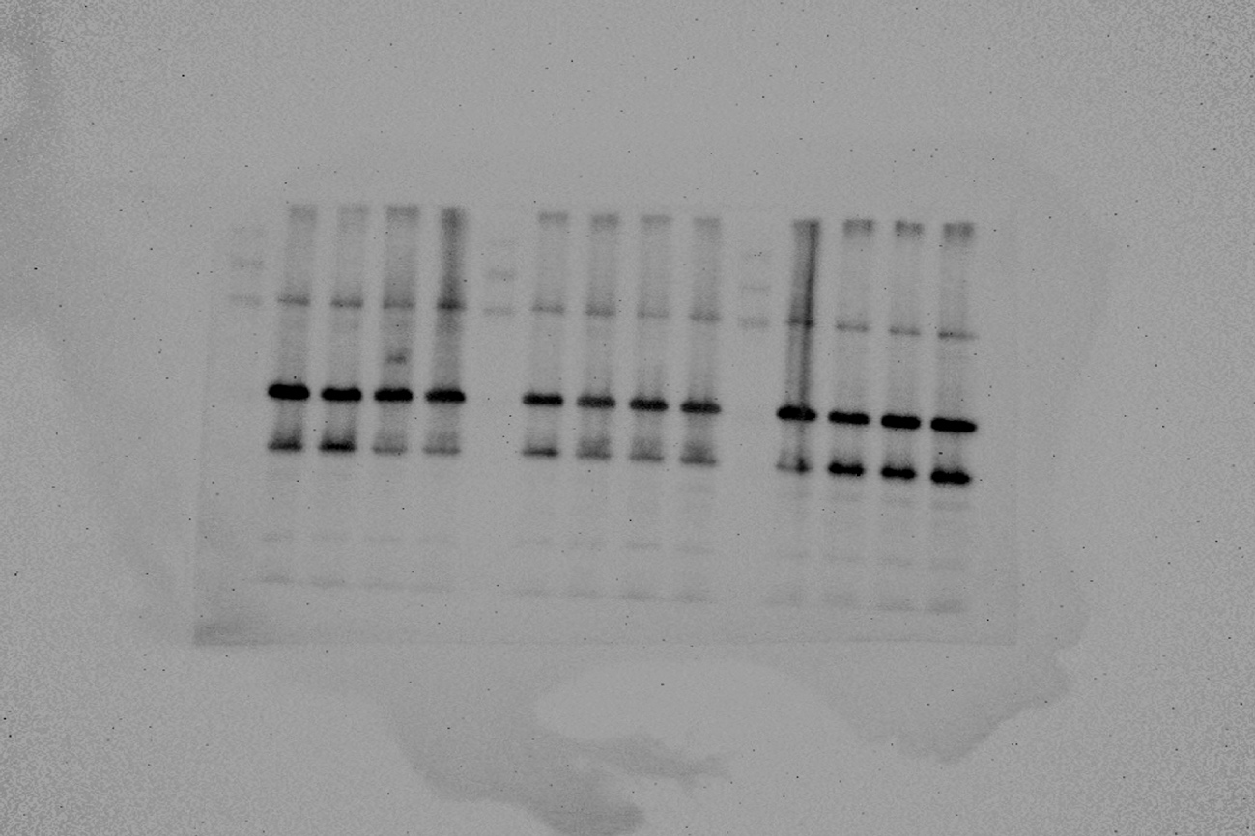
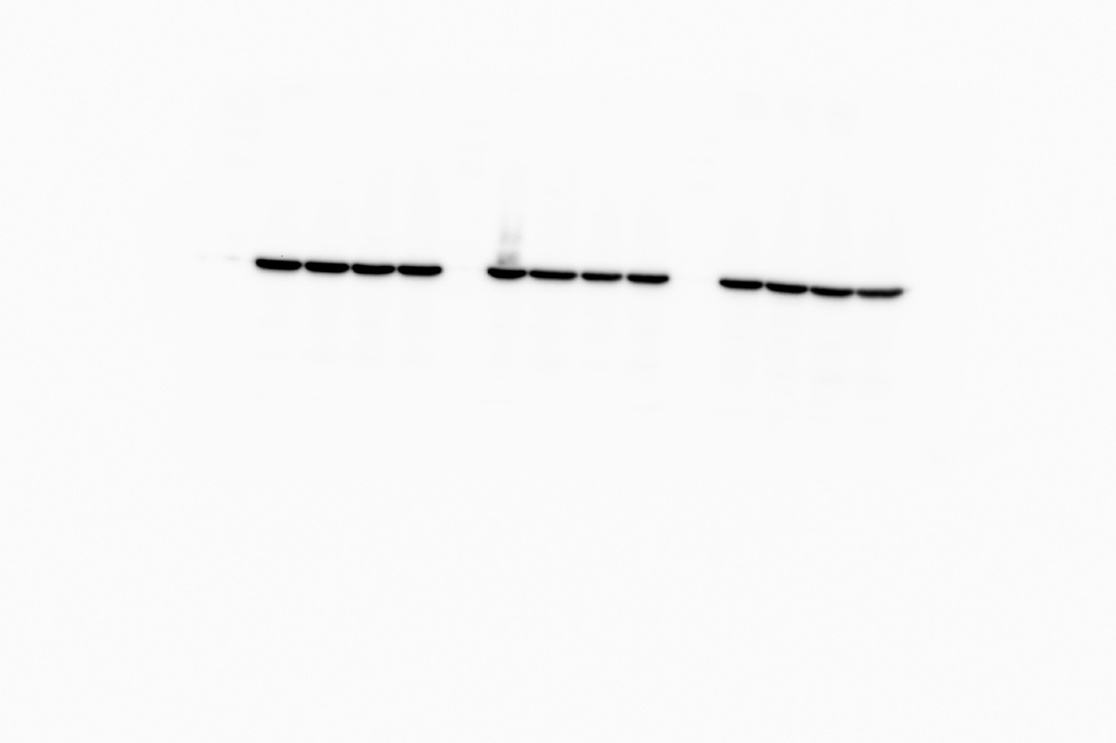
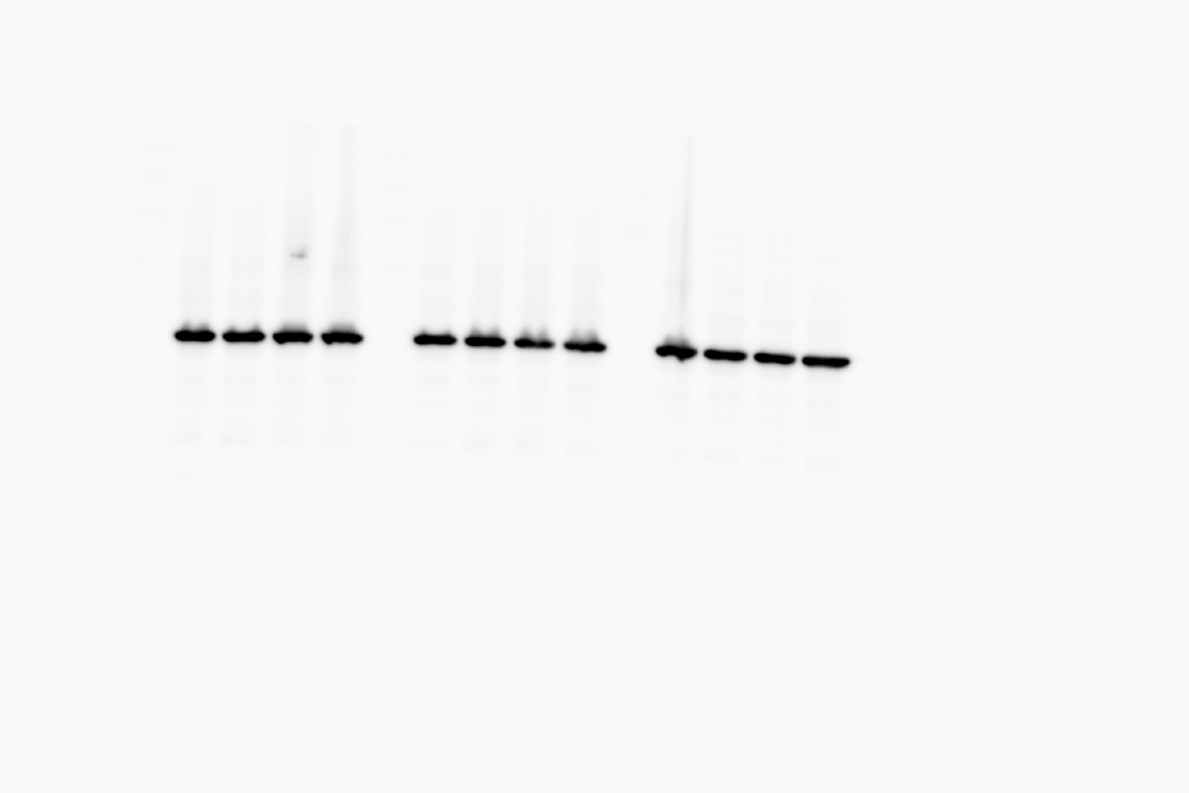

Figure S3. Uncropped Western blot images corresponding to Figure 2G of the main manuscript
(A) PKG chemiluminescent blot
(B) Corresponding β-actin blot
Figure S4. Uncropped Western blot images corresponding to Figure 3A–B of the main manuscript
(A) IL-1β+ TNF-α chemiluminescent blot
(B) Corresponding β-actin blot
Figure S5. Uncropped Western blot images corresponding to Figure 3C of the main manuscript
(A) NF-κB p50/p105 chemiluminescent blot
(B) Corresponding β-actin blot
Figure S6. Uncropped Western blot images corresponding to Figure 5A of the main manuscript
(A) Bcl2 chemiluminescent blot and Corresponding β-actin blot
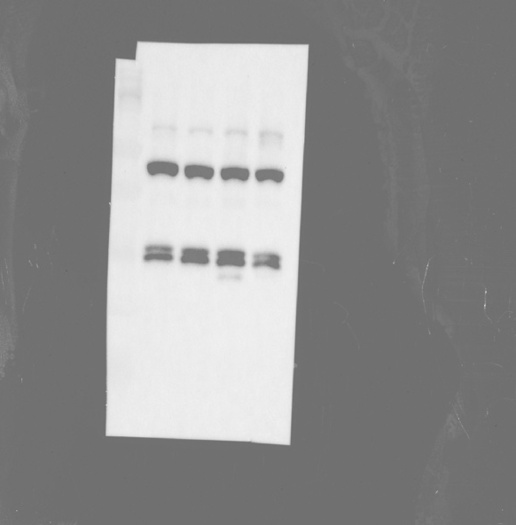
Figure S7. Uncropped Western blot images corresponding to Figure 5C of the main manuscript
(A) Bax chemiluminescent blot
(B) Corresponding β-actin blot
Figure S8. Uncropped Western blot images corresponding to Figure 5E of the main manuscript
- Caspase3 chemiluminescent blot
- Corresponding β-actin blot

Figure S9. Uncropped Western blot images corresponding to Figure 7E of the main manuscript
- Bax chemiluminescent blot
- Corresponding β-actin blot
Figure S10. Uncropped Western blot images corresponding to Figure 7E of the main manuscript
（A）Bcl2 chemiluminescent blot
（B）Corresponding β-actin blot
Figure S11. Uncropped Western blot images corresponding to Figure 8A of the main manuscript
（A）PDE2A chemiluminescent blot
（B）Corresponding β-actin blot
Figure S12. Uncropped Western blot images corresponding to Figure 8B of the main manuscript
（A）IL-1β chemiluminescent blot
（B）Corresponding β-actin blot
Figure S13. Uncropped Western blot images corresponding to Figure 8F of the main manuscript
（A）Bcl2 chemiluminescent blot
（B）Corresponding β-actin blot
Figure S14. Uncropped Western blot images corresponding to Figure 9A of the main manuscript
- PDE2A chemiluminescent blot
（B）Corresponding β-actin blot
Figure S15. Uncropped Western blot images corresponding to Figure 9D-F of the main manuscript
（A）IL-1β chemiluminescent blot
（B）Bax chemiluminescent blot
（C）Corresponding β-actin blot

