Appendix-A: Supporting Information

Synergistic enhancement of grinding efficiency, hydration kinetics, and mechanical properties of Portland cement by ethaline
Kuldeep Rajpurohit, Ashok K. Pandey*, Hemlata K. Bagla*
Department of Nuclear and Radiochemistry, Kishinchand Chellaram College,
HSNC University, Mumbai-400020, India

*Authors for correspondence: ashok.pandey@kccollege.edu.in (AKP); hemlata.bagla@kccollege.edu.in (HKB).

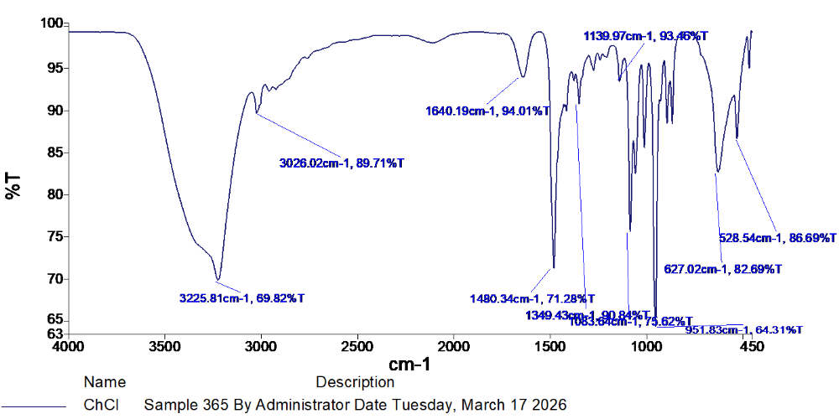
Fig.S1. FTIR spectra of choline chloride (a) ethylene glycol (b) and ethaline formed by choline chloride and ethylene glycol in 1: 2 M ratio (c).
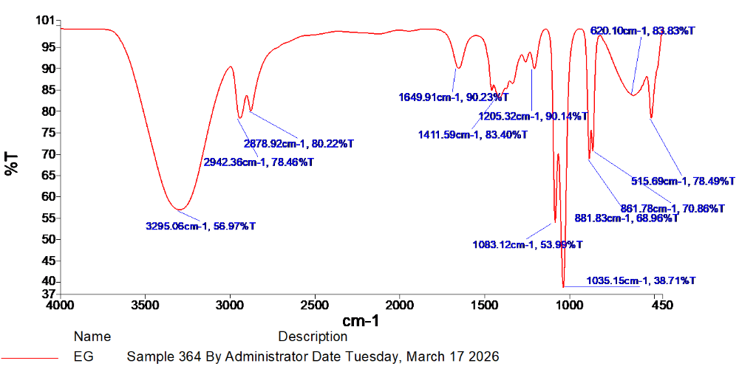
(a)
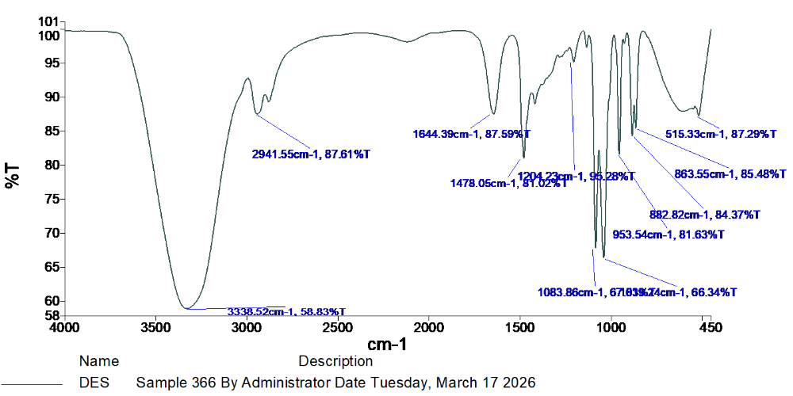
(b)
(c)
Fig. S2. Arrhenius plots of natural logarithm of dynamic viscosity (ln η) versus inverse temperature scaled as 1000/T (K⁻¹) for ethaline DES at shear rates: (a) 10 s⁻¹, (b) 100 s⁻¹, (c) 500 s⁻¹, and (d) 1000 s⁻¹.
(a) 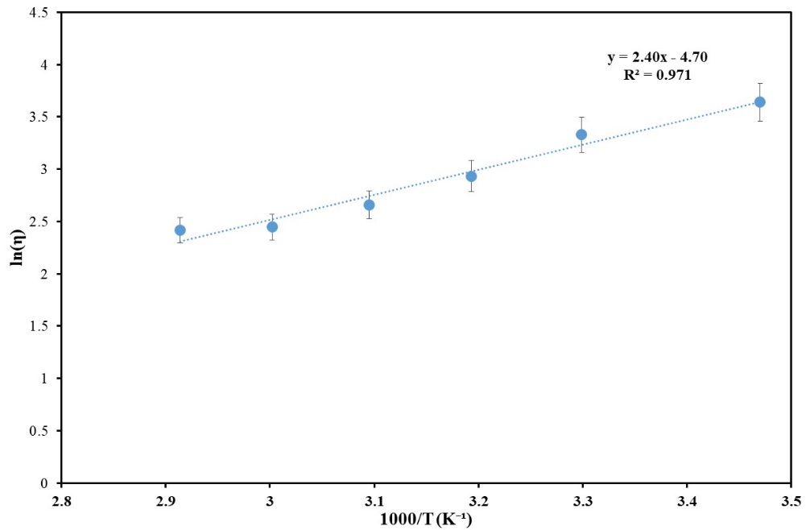
(b)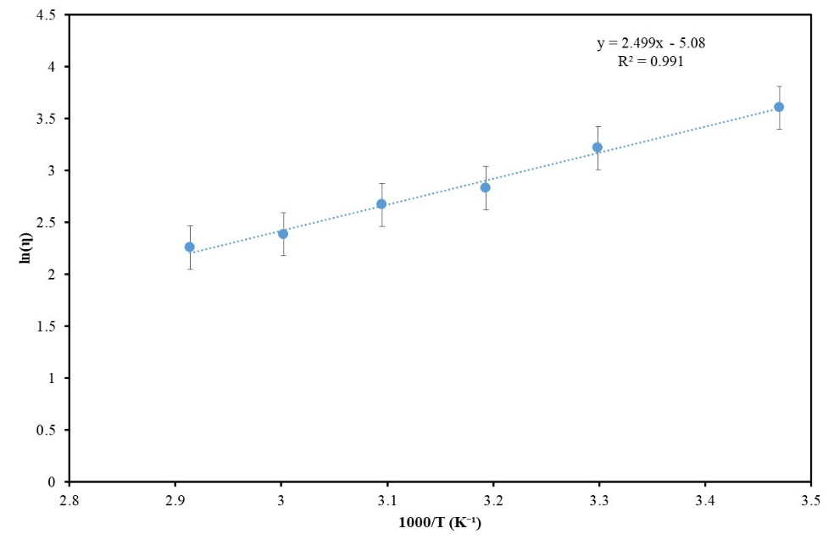
(c)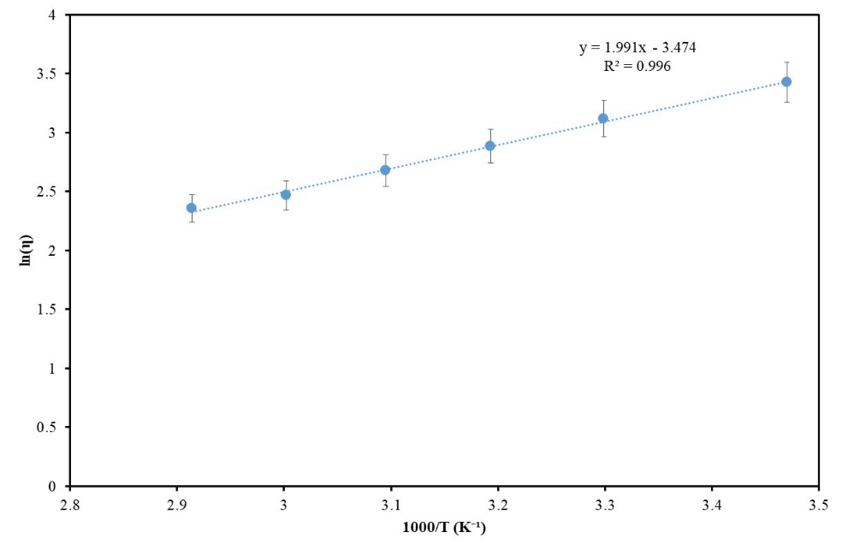
(d)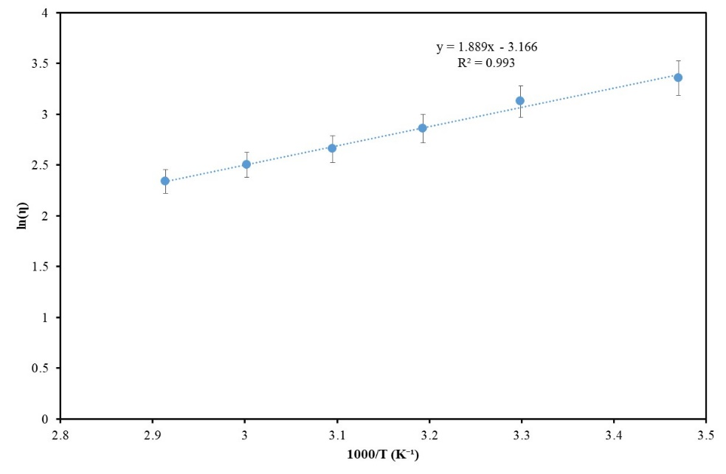

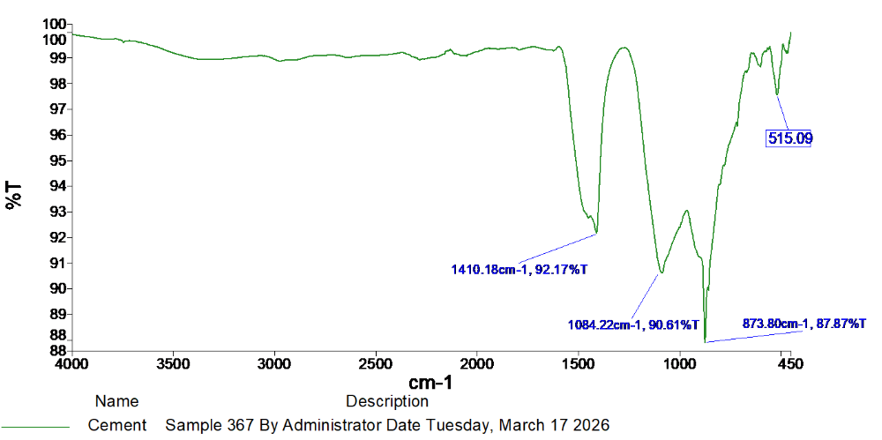
Fig. S3. FTIR spectra of OPC-53 mortar (a) and OPC-53 mortar with 2 wt.% ethaline DES (b). The OPC mortar specimens were cured for 28 d.
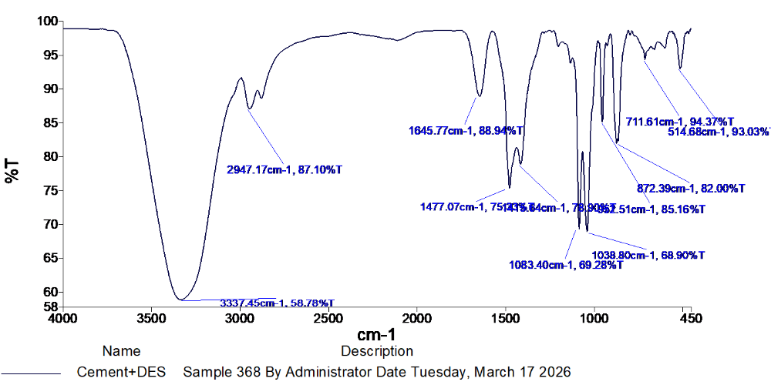
(a)
(b)

