Supplementary Materials
Development and Temporal Validation of an Explainable Machine Learning Model for Identifying Colorectal Adenoma in Patients With Metabolic Syndrome: A Retrospective Study

Supplementary Tables and Figures

Table S1. Baseline characteristics of the training and temporal test sets
Variable | Training set (n = 619) |  |  |  | Temporal test set (n = 155)
Variable | Normal colonoscopy group  (n = 246) | CRA group  (n = 373) | Statistic  (Z/χ²) | P value | Normal colonoscopy group  (n = 61) | CRA group  (n = 94) | Statistic  (Z/χ²) | P value
Demographic and anthropometric characteristics
Age (years) | 58.00 (52.25-64.00) | 61.00 (55.00-67.00) | -3.32 | <0.001 | 59.00 (53.00-66.00) | 61.00 (54.25-68.75) | -1.26 | 0.207
Sex, male | 96 (39.0%) | 219 (58.7%) | 22.21 | <0.001 | 21 (34.4%) | 62 (66.0%) | 13.55 | <0.001
BMI (kg/m²) | 25.18 (22.71-27.39) | 25.76 (23.66-27.76) | -2.34 | 0.019 | 25.25 (22.60-26.67) | 25.34 (23.70-26.90) | -0.38 | 0.707
Hematologic parameters
WBC (10⁹/L) | 5.62 (4.83-6.77) | 6.01 (4.95-7.29) | -1.81 | 0.070 | 5.29 (4.38-6.03) | 5.86 (5.18-7.24) | -3.37 | <0.001
RBC (10¹²/L) | 4.49 (4.15-4.84) | 4.68 (4.32-4.99) | -3.85 | <0.001 | 4.43 (3.98-4.79) | 4.77 (4.40-5.09) | -3.09 | 0.002
Hemoglobin (g/L) | 136.00 (127.00-147.00) | 144.00 (133.00-154.00) | -5.19 | <0.001 | 133.00 (123.00-145.00) | 145.00 (132.00-158.00) | -4.04 | <0.001
Platelets (10⁹/L) | 219.50 (180.25-262.75) | 215.00 (184.00-257.00) | 0.17 | 0.865 | 209.00 (167.00-238.00) | 207.00 (172.75-246.00) | -0.30 | 0.763
Neutrophils (10⁹/L) | 3.28 (2.65-4.30) | 3.54 (2.82-4.50) | -1.99 | 0.046 | 3.11 (2.36-3.75) | 3.54 (2.95-4.47) | -2.92 | 0.003
Lymphocytes (10⁹/L) | 1.83 (1.39-2.29) | 1.83 (1.42-2.27) | -0.19 | 0.850 | 1.67 (1.24-2.04) | 1.94 (1.44-2.30) | -2.44 | 0.015
Monocytes (10⁹/L) | 0.33 (0.27-0.41) | 0.34 (0.28-0.44) | -1.60 | 0.109 | 0.30 (0.24-0.40) | 0.36 (0.29-0.43) | -2.70 | 0.007
Liver-related parameters
ALT (U/L) | 21.45 (15.45-30.88) | 22.70 (16.40-33.40) | -1.56 | 0.119 | 18.60 (14.30-28.70) | 24.10 (17.82-33.15) | -2.22 | 0.027
AST (U/L) | 20.05 (16.80-24.00) | 20.30 (17.20-24.80) | -1.36 | 0.173 | 19.50 (17.00-24.60) | 20.30 (17.32-24.10) | -0.23 | 0.816
ALP (U/L) | 75.00 (62.00-90.00) | 77.00 (63.00-94.00) | -0.76 | 0.447 | 79.00 (62.00-93.00) | 76.00 (64.00-86.00) | 0.68 | 0.496
GGT (U/L) | 22.00 (15.00-32.92) | 24.80 (17.00-39.20) | -2.84 | 0.005 | 21.00 (15.30-33.50) | 24.80 (17.43-34.48) | -1.32 | 0.187
Total bilirubin (μmol/L) | 11.35 (8.62-14.97) | 12.30 (9.50-17.00) | -2.61 | 0.009 | 12.00 (9.80-15.60) | 11.75 (9.10-17.38) | 0.10 | 0.918
Direct bilirubin (μmol/L) | 2.82 (2.20-3.87) | 3.10 (2.30-4.32) | -2.21 | 0.027 | 3.00 (2.20-4.01) | 2.90 (2.02-4.17) | -0.04 | 0.972
Total protein (g/L) | 69.90 (65.90-73.57) | 70.40 (66.30-73.80) | -1.11 | 0.266 | 68.90 (65.90-72.30) | 70.25 (66.12-73.45) | -1.17 | 0.243
Albumin-to-globulin ratio | 1.67 (1.50-1.82) | 1.70 (1.50-1.90) | -0.20 | 0.840 | 1.69 (1.53-1.85) | 1.68 (1.50-1.85) | 0.31 | 0.758
Total bile acids (μmol/L) | 3.05 (2.10-4.90) | 3.20 (2.20-5.30) | -1.03 | 0.302 | 3.40 (2.30-5.80) | 2.95 (2.02-4.07) | 1.64 | 0.102
Renal and metabolic parameters
Urea (mmol/L) | 5.30 (4.50-6.30) | 5.40 (4.40-6.20) | 0.33 | 0.743 | 5.10 (4.40-5.90) | 5.40 (4.60-6.38) | -1.27 | 0.204
Serum creatinine (μmol/L) | 63.00 (52.52-72.50) | 67.20 (55.80-77.00) | -3.09 | 0.002 | 60.50 (53.00-69.00) | 71.85 (57.73-83.12) | -3.11 | 0.002
Uric acid (μmol/L) | 328.00 (268.25-406.25) | 329.00 (269.00-400.00) | 0.30 | 0.763 | 307.00 (254.00-363.00) | 348.00 (289.50-396.50) | -1.94 | 0.053
Fasting plasma glucose (mmol/L) | 5.56 (4.94-6.26) | 5.56 (5.05-6.70) | -0.68 | 0.499 | 5.33 (4.85-6.62) | 5.57 (5.10-6.46) | -0.93 | 0.354
Total cholesterol (mmol/L) | 4.99 (4.14-5.78) | 4.78 (4.15-5.61) | 1.56 | 0.119 | 4.94 (4.12-5.42) | 4.65 (3.96-5.66) | 0.56 | 0.579
Triglycerides (mmol/L) | 1.48 (0.96-2.35) | 1.53 (1.01-2.21) | -0.10 | 0.917 | 1.54 (1.06-2.06) | 1.51 (1.07-2.42) | -0.77 | 0.443
HDL-C (mmol/L) | 1.30 (1.06-1.56) | 1.27 (1.06-1.52) | 0.26 | 0.796 | 1.31 (1.07-1.68) | 1.27 (1.07-1.47) | 1.04 | 0.297
LDL-C (mmol/L) | 2.95 (2.28-3.58) | 2.69 (2.15-3.38) | 1.86 | 0.063 | 2.81 (2.08-3.43) | 2.64 (2.11-3.28) | 0.68 | 0.496
Homocysteine (μmol/L) | 11.55 (10.00-14.40) | 13.00 (10.90-15.60) | -3.97 | <0.001 | 11.40 (10.10-13.60) | 13.35 (11.03-15.97) | -2.84 | 0.005
C-reactive protein (mg/L) | 1.30 (0.60-2.88) | 1.50 (0.80-2.50) | -1.31 | 0.190 | 1.20 (0.60-2.30) | 1.60 (0.70-3.27) | -1.50 | 0.134
Derived indices
NLR | 1.87 (1.41-2.45) | 1.94 (1.45-2.56) | -1.16 | 0.245 | 2.02 (1.34-2.65) | 1.93 (1.49-2.50) | -0.21 | 0.833
PLR | 119.40 (98.06-154.43) | 118.79 (96.76-154.61) | -0.11 | 0.914 | 117.42 (98.98-159.57) | 110.04 (87.53-140.69) | 1.66 | 0.098
LMR | 5.50 (4.38-6.78) | 5.25 (4.18-6.54) | 1.41 | 0.160 | 5.61 (4.03-6.92) | 5.25 (4.18-6.28) | 0.51 | 0.609
SII | 400.79 (276.72-579.86) | 407.78 (309.98-593.36) | -1.36 | 0.173 | 362.72 (260.20-533.78) | 410.14 (291.10-564.35) | -0.93 | 0.353
PNI | 52.83 (49.57-55.59) | 53.75 (50.35-58.65) | -3.79 | <0.001 | 51.20 (49.03-54.06) | 53.39 (50.17-58.44) | -2.91 | 0.004
AST/ALT ratio | 0.91 (0.70-1.22) | 0.91 (0.70-1.13) | 1.08 | 0.279 | 1.00 (0.83-1.23) | 0.84 (0.70-1.03) | 2.93 | 0.003
TG/HDL-C ratio | 1.15 (0.67-2.22) | 1.20 (0.74-1.96) | -0.27 | 0.788 | 1.10 (0.67-1.73) | 1.32 (0.74-2.00) | -1.19 | 0.235
TC/HDL-C ratio | 3.92 (3.07-4.72) | 3.79 (2.96-4.68) | 1.03 | 0.303 | 3.85 (2.86-4.67) | 3.69 (2.86-4.74) | -0.06 | 0.952
Non-HDL-C (mmol/L) | 3.74 (2.83-4.42) | 3.52 (2.74-4.30) | 1.69 | 0.091 | 3.57 (2.74-4.20) | 3.34 (2.73-4.39) | 0.45 | 0.656
TyG index | 8.86 (8.36-9.35) | 8.89 (8.43-9.28) | -0.38 | 0.707 | 8.92 (8.36-9.26) | 8.92 (8.48-9.33) | -0.74 | 0.458
Categorical variables
History of constipation | 10 (4.1%) | 48 (12.9%) | 12.51 | <0.001 | 3 (4.9%) | 17 (18.1%) | 4.60 | 0.032
History of diarrhea | 15 (6.1%) | 62 (16.6%) | 14.12 | <0.001 | 2 (3.3%) | 12 (12.8%) | 2.98 | 0.084
Type 2 diabetes mellitus | 58 (23.6%) | 116 (31.1%) | 3.79 | 0.052 | 13 (21.3%) | 28 (29.8%) | 0.97 | 0.326
Dyslipidemia | 167 (67.9%) | 274 (73.5%) | 1.98 | 0.159 | 39 (63.9%) | 78 (83.0%) | 6.26 | 0.012
Non-alcoholic fatty liver disease | 54 (22.0%) | 90 (24.1%) | 0.28 | 0.596 | 14 (23.0%) | 22 (23.4%) | 0.00 | 1.000
Hypertension | 193 (78.5%) | 285 (76.4%) | 0.25 | 0.620 | 51 (83.6%) | 68 (72.3%) | 2.04 | 0.153
Smoking | 41 (16.7%) | 119 (31.9%) | 17.17 | <0.001 | 9 (14.8%) | 31 (33.0%) | 5.50 | 0.019
History of alcohol consumption | 39 (15.9%) | 117 (31.4%) | 18.11 | <0.001 | 9 (14.8%) | 26 (27.7%) | 2.82 | 0.093
Family cancer history | 17 (6.9%) | 39 (10.5%) | 1.85 | 0.173 | 3 (4.9%) | 10 (10.6%) | 0.92 | 0.338
Note: Continuous variables are presented as median (interquartile range), and categorical variables as n (%). Statistics are Z for continuous variables and χ² for categorical variables.
Table S2. Top GBDT hyperparameter combinations from grid search.
Rank | Mean_CV_AUC | Std_CV_AUC | Parameters
1 | 0.72503 | 0.03347 | {'learning_rate': 0.03, 'max_depth': 2, 'min_samples_leaf': 10, 'n_estimators': 100, 'subsample': 0.8}
2 | 0.72366 | 0.03575 | {'learning_rate': 0.03, 'max_depth': 2, 'min_samples_leaf': 5, 'n_estimators': 100, 'subsample': 0.8}
3 | 0.72046 | 0.03140 | {'learning_rate': 0.08, 'max_depth': 1, 'min_samples_leaf': 10, 'n_estimators': 100, 'subsample': 0.8}
4 | 0.71930 | 0.02983 | {'learning_rate': 0.03, 'max_depth': 1, 'min_samples_leaf': 5, 'n_estimators': 100, 'subsample': 0.8}
4 | 0.71930 | 0.02983 | {'learning_rate': 0.03, 'max_depth': 1, 'min_samples_leaf': 10, 'n_estimators': 100, 'subsample': 0.8}
6 | 0.71845 | 0.03409 | {'learning_rate': 0.03, 'max_depth': 1, 'min_samples_leaf': 10, 'n_estimators': 200, 'subsample': 0.8}
7 | 0.71703 | 0.03454 | {'learning_rate': 0.08, 'max_depth': 1, 'min_samples_leaf': 5, 'n_estimators': 100, 'subsample': 0.8}
8 | 0.71679 | 0.03353 | {'learning_rate': 0.03, 'max_depth': 1, 'min_samples_leaf': 5, 'n_estimators': 200, 'subsample': 0.8}
9 | 0.71532 | 0.03600 | {'learning_rate': 0.03, 'max_depth': 2, 'min_samples_leaf': 10, 'n_estimators': 200, 'subsample': 0.8}
10 | 0.71222 | 0.03743 | {'learning_rate': 0.03, 'max_depth': 2, 'min_samples_leaf': 5, 'n_estimators': 200, 'subsample': 0.8}
11 | 0.70708 | 0.02860 | {'learning_rate': 0.08, 'max_depth': 2, 'min_samples_leaf': 10, 'n_estimators': 100, 'subsample': 0.8}
12 | 0.70242 | 0.03664 | {'learning_rate': 0.08, 'max_depth': 1, 'min_samples_leaf': 10, 'n_estimators': 200, 'subsample': 0.8}
13 | 0.69711 | 0.03293 | {'learning_rate': 0.08, 'max_depth': 2, 'min_samples_leaf': 5, 'n_estimators': 100, 'subsample': 0.8}
14 | 0.69533 | 0.03620 | {'learning_rate': 0.08, 'max_depth': 1, 'min_samples_leaf': 5, 'n_estimators': 200, 'subsample': 0.8}
15 | 0.69368 | 0.03409 | {'learning_rate': 0.08, 'max_depth': 2, 'min_samples_leaf': 10, 'n_estimators': 200, 'subsample': 0.8}
16 | 0.67975 | 0.03876 | {'learning_rate': 0.08, 'max_depth': 2, 'min_samples_leaf': 5, 'n_estimators': 200, 'subsample': 0.8}
Note: GridSearchCV candidates are ranked by mean cross-validated AUC. The top 16 combinations are shown; subsample was fixed at 0.8.

Table S3. Feature selection results from cross-validated permutation importance.
Feature | Mean_IMP | Std_IMP | Pos_Fold_Freq | Selected | Note
PNI | 0.07793 | 0.01754 | 1.0 | True | Selected
Hemoglobin (g/L) | 0.04232 | 0.01497 | 1.0 | True | Selected
Age (years) | 0.02387 | 0.01339 | 1.0 | True | Selected
History of constipation | 0.02356 | 0.00978 | 1.0 | True | Selected
History of diarrhea | 0.01984 | 0.00434 | 1.0 | True | Selected
Sex (coded) | 0.01605 | 0.00402 | 1.0 | True | Selected
LDL-C (mmol/L) | 0.01035 | 0.00608 | 1.0 | True | Selected
History of alcohol consumption | 0.00643 | 0.00481 | 1.0 | True | Selected
Serum creatinine (μmol/L) | 0.00244 | 0.00270 | 0.8 | True | Selected
HDL-C (mmol/L) | 0.00036 | 0.00102 | 0.6 | True | Selected
Direct bilirubin | 0.00030 | 0.00134 | 0.4 | False | Rejected
Note: Features were retained if mean permutation importance was greater than 0 and importance was positive in at least 50% of cross-validation folds.
Table S4. Complete performance metrics in the temporal test set.
Model | AUC (95% CI) | Sensitivity | Specificity | Balanced accuracy | F1 | MCC | Brier | TN | FP | FN | TP
ExtraTrees_Isotonic | 0.811 (0.740–0.875) | 0.8191 | 0.7049 | 0.7620 | 0.8148 | 0.5256 | 0.1760 | 43 | 18 | 17 | 77
ExtraTrees | 0.817 (0.743–0.883) | 0.7979 | 0.7213 | 0.7596 | 0.8065 | 0.5164 | 0.1926 | 44 | 17 | 19 | 75
ExtraTrees_Platt | 0.808 (0.734–0.873) | 0.7872 | 0.7049 | 0.7461 | 0.7957 | 0.4895 | 0.1751 | 43 | 18 | 20 | 74
Voting | 0.809 (0.736–0.873) | 0.8191 | 0.6557 | 0.7374 | 0.8021 | 0.4811 | 0.1809 | 40 | 21 | 17 | 77
Stacking | 0.811 (0.736–0.877) | 0.8191 | 0.6393 | 0.7292 | 0.7979 | 0.4663 | 0.2062 | 39 | 22 | 17 | 77
ElasticNet_LR_Isotonic | 0.796 (0.721–0.864) | 0.7979 | 0.6557 | 0.7268 | 0.7895 | 0.4564 | 0.1787 | 40 | 21 | 19 | 75
ElasticNet_LR_Platt | 0.797 (0.723–0.863) | 0.7234 | 0.7049 | 0.7142 | 0.7556 | 0.4210 | 0.1831 | 43 | 18 | 26 | 68
ElasticNet_LR | 0.796 (0.721–0.863) | 0.6277 | 0.7705 | 0.6991 | 0.7066 | 0.3897 | 0.1896 | 47 | 14 | 35 | 59
XGBoost_Isotonic | 0.772 (0.698–0.843) | 0.7766 | 0.6066 | 0.6916 | 0.7644 | 0.3868 | 0.1862 | 37 | 24 | 21 | 73
XGBoost | 0.760 (0.686–0.833) | 0.7447 | 0.6393 | 0.6920 | 0.7527 | 0.3820 | 0.2067 | 39 | 22 | 24 | 70
XGBoost_Platt | 0.779 (0.704–0.848) | 0.7128 | 0.6557 | 0.6843 | 0.7363 | 0.3634 | 0.1863 | 40 | 21 | 27 | 67
Note: Classification results are based on the Youden thresholds locked during training. TN, true negatives; FP, false positives; FN, false negatives; TP, true positives.
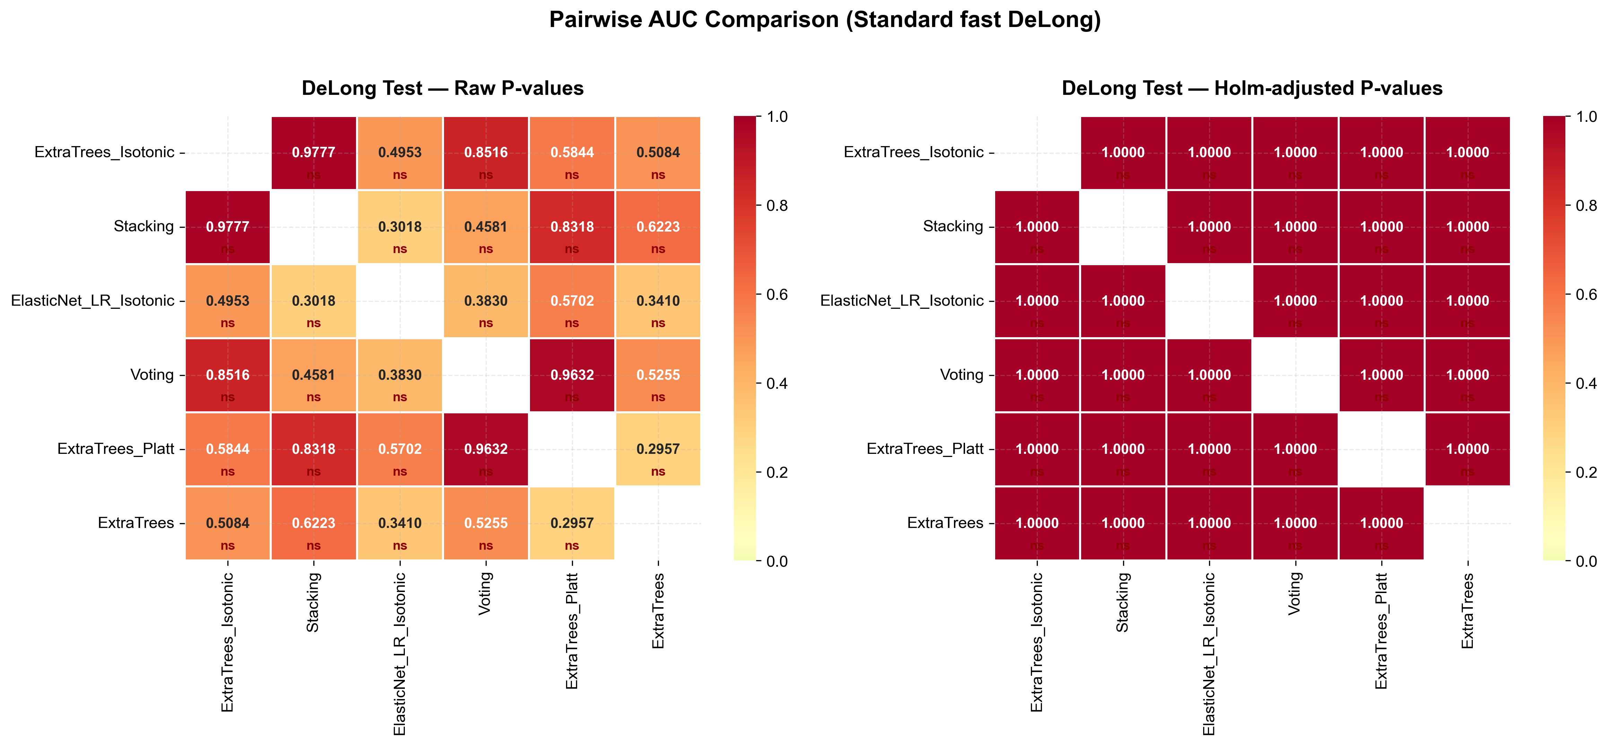
Figure S1. Pairwise DeLong tests comparing model AUCs.
Note: Raw pairwise P values and Holm-adjusted P values are shown.
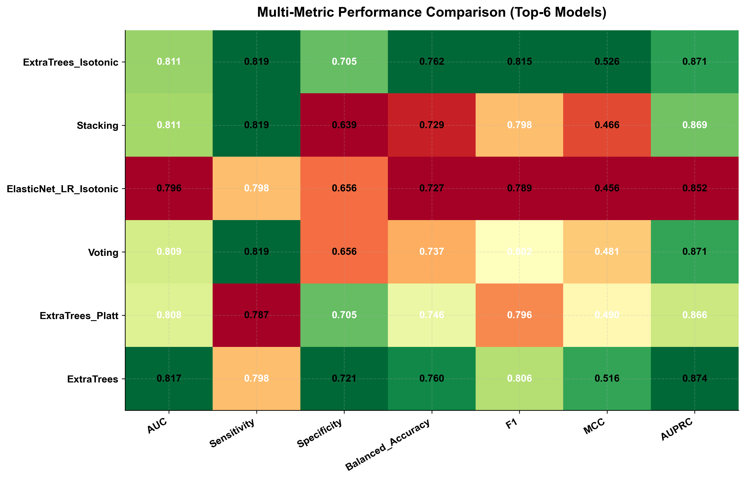
Figure S2. Multi-metric performance comparison of candidate models.
Note: The heatmap summarizes performance across multiple evaluation metrics.
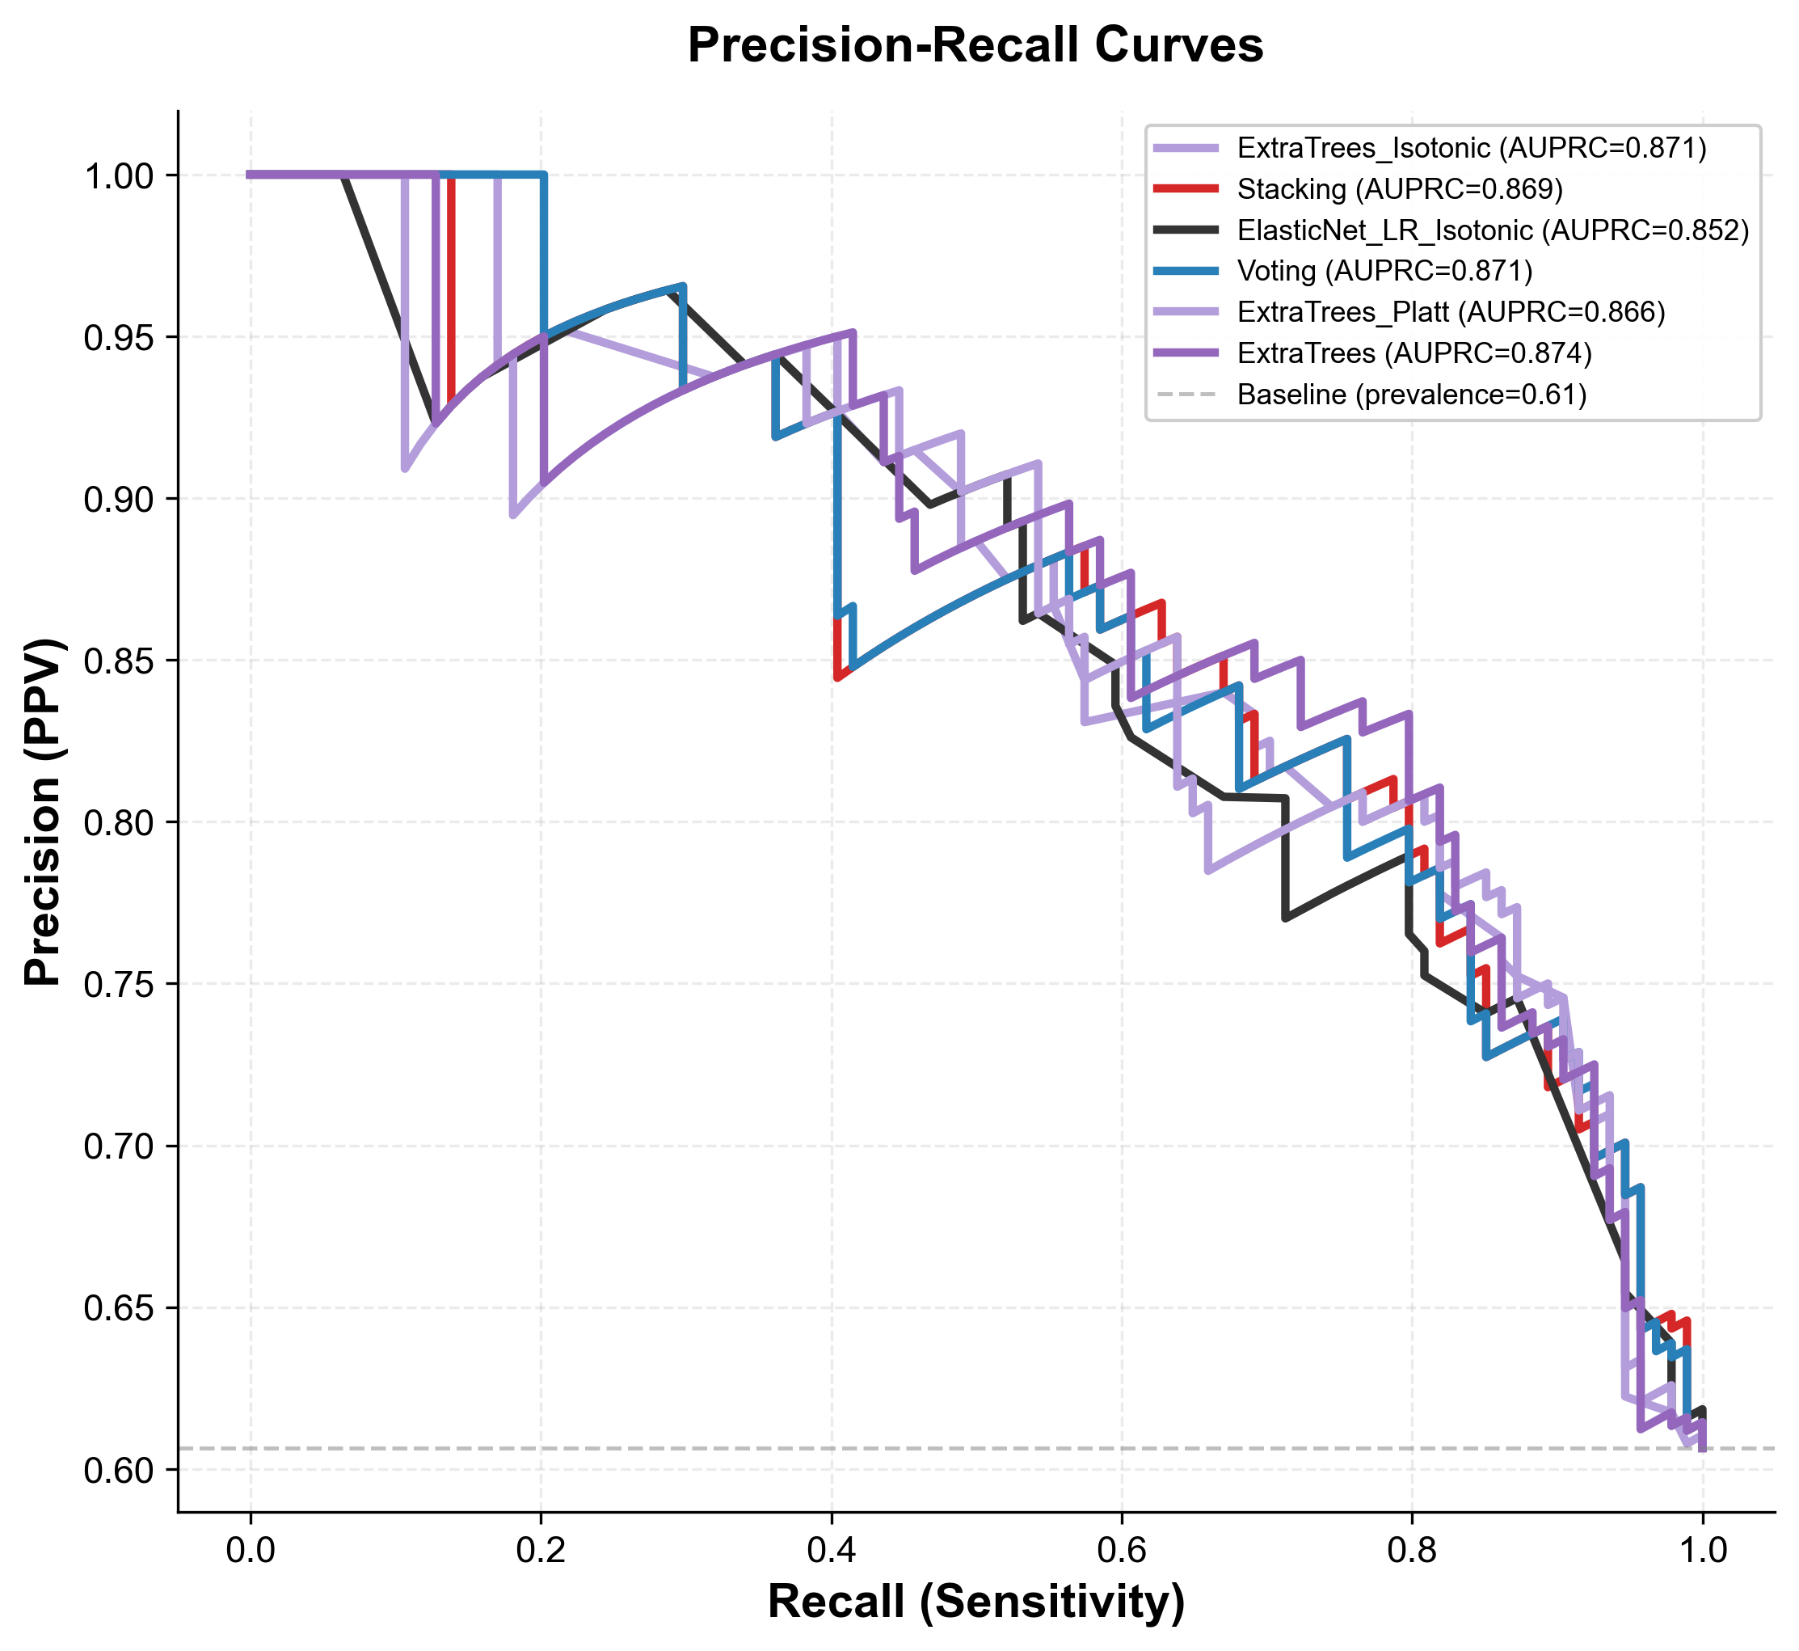
Figure S3. Precision-recall curves of candidate models.
Note: The dashed horizontal line indicates the temporal test-set prevalence baseline.

