Supplementary of articles : “Genetic associations with drinking initiation and cessation in African ancestry populations”
Jean-Tristan Brandenburg

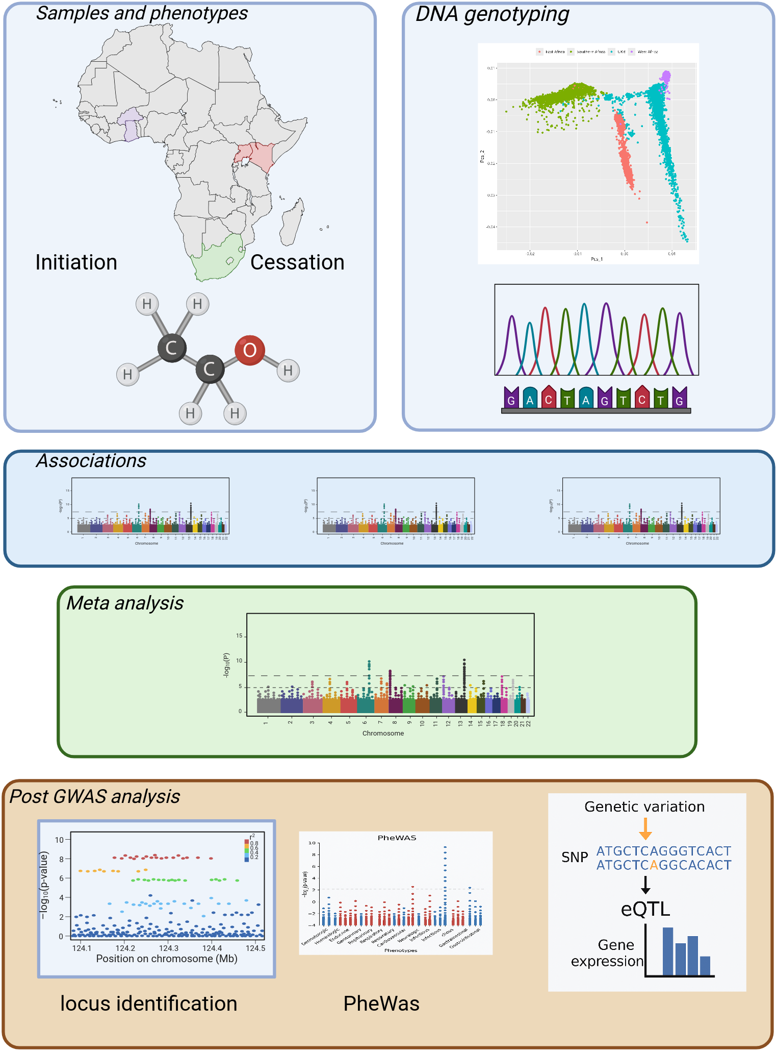
Supplementary Figure 1: Study design showing the data sources, analysis strategy, and post-GWAS analysis approach. PCA was performed using the AWI-GEN and UK Biobank datasets with PLINK. Figure created with BioRender.

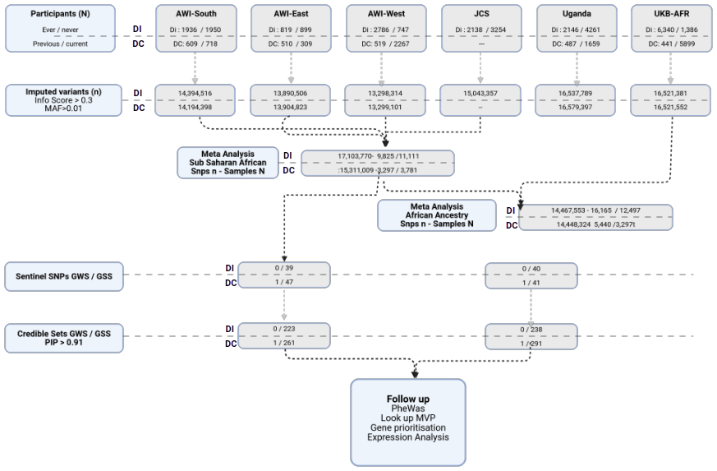
Supplementary Figure 2: Diagram of the overall study design. DI, drinking initiation; DC, drinking cessation; AWI-GEN, Africa Wits-INDEPTH Partnership for Genomic Studies; Uganda Genome Resource (UGR); UK Biobank African ancestry participants (UKB-AFR); JCS, Johannesburg Cancer Study; MAF, minor allele frequency; PIP, posterior inclusion probability.

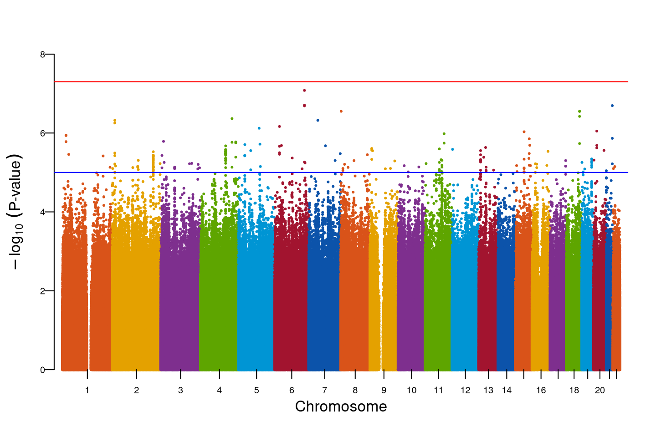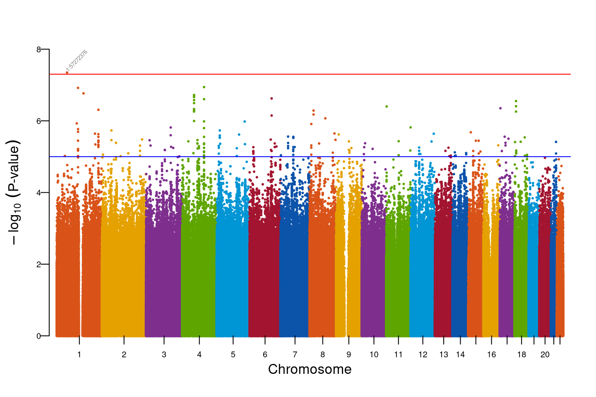
Supplementary Figure 3: Manhattan plots showing the association results for DI_{SSA} (a) and DC_{SSA} (b). Lead SNPs reaching genome-wide significance (P < 5 × 10⁻⁸) are highlighted. The red line indicates the genome-wide significance threshold at P = 5 × 10⁻⁸, and the blue line marks the suggestive significance threshold at P = 5 × 10⁻⁶.

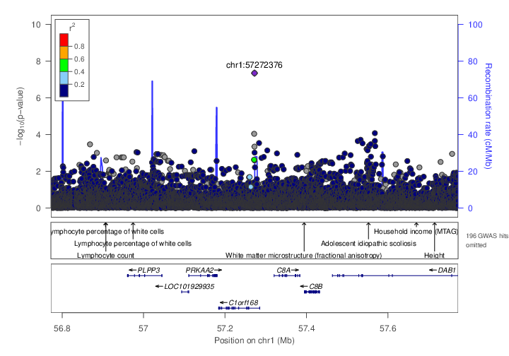
Supplementary figure 4a–b: Regional association plots generated using LocusZoom for the regions surrounding each sentinel SNP that reached genome-wide significance for DC_{SSA} (a) and DC_{AA} (b).

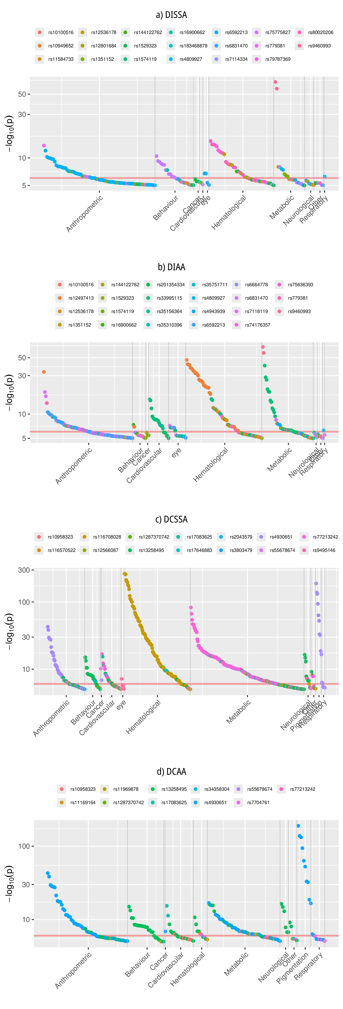

Supplementary Figure 5a–d: PheWAS plots of credible SNPs (coloured) using each sentinel SNP and its corresponding credible set for each meta-analysis. Results are summarized by sentinel SNP for: (a) DISSA, (b) DIAA, (c) DCSSA, and (d) DCAA.

Supplementary Figure 6a–d : Significant Gene set enrichment for Drinking Initiation Canonical pathway, (B) Gene Ontology Biological Process, (C) Gene Ontology Molecular Function, (D) GWAS Catalog enrichment

Supplementary Figure 7 a-c : Significant Gene set enrichment for Drinking Cessation
(A) Canonical pathway, (B)GWAS Catalog enrichment, (C) Reactome gene enrichment

