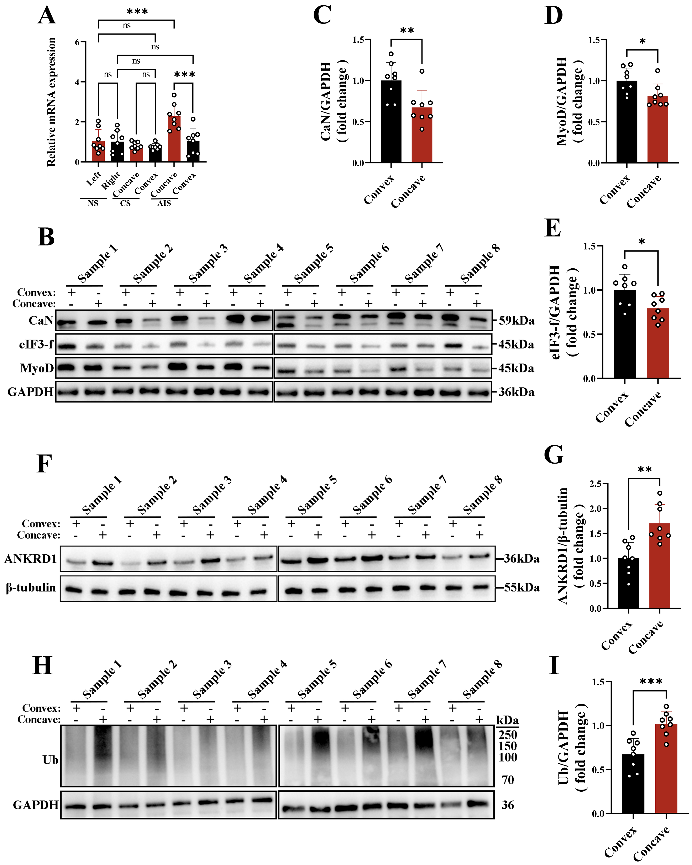
Fig. S1. Increased ANKRD1 expression and protein ubiquitination in the concave side paraspinal muscles of patients with AIS.(A) RT-qPCR quantitative analysis of ANKRD1 mRNA expression in bilateral paraspinal muscle tissues from age matched non-scoliosis controls (NS), congenital scoliosis (CS) patients, and adolescent idiopathic scoliosis (AIS) patients, n = 8. Within group comparisons between bilateral paraspinal muscle samples were performed using paired Student's t test. Comparisons among concave side and convex side samples were performed using one-way ANOVA followed by Tukey's post hoc test. ns= not significant, ***P < 0.001. (B) Representative western blot images of Atrogin‑1 substrate protein levels in concave and convex paraspinal muscles from eight AIS patients.(C–E) Densitometric quantification of the Atrogin‑1 substrate proteins shown in (B), (n = 8). Paired Student’s t‑test, *P < 0.05,**P < 0.01. (F) Representative Western blot images showing ANKRD1 protein expression in concave side and convex side paraspinal muscle tissues from eight AIS patients.(G) Densitometric quantification of ANKRD1 protein expression shown in (F), n = 8. Paired Student's t test, **P < 0.01.(H) Representative Western blot images showing total ubiquitinated protein levels in concave side and convex side paraspinal muscle tissues from eight AIS patients.(I) Densitometric quantification of total ubiquitinated protein levels shown in (H), n = 8. Paired Student's t test, ***P < 0.001.
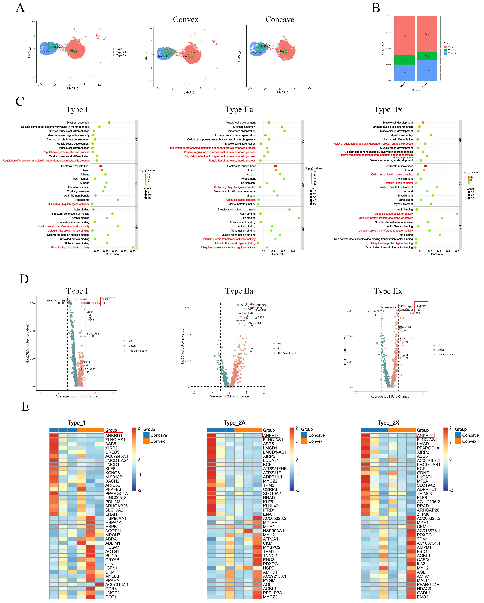
Fig. S2. Asymmetric activation of ANKRD1 in mature myonuclei of the paraspinal muscles.(A) UMAP plot showing mature myonuclear subpopulations in the concave and convex side paraspinal muscles of patients with AIS.(B) Relative proportions of different mature myonuclear subpopulations in the concave and convex side paraspinal muscles.(C) Gene Ontology (GO) enrichment analysis of differentially expressed genes (DEGs) between the concave and convex sides within each mature myonuclear subpopulation.(D) Volcano plots showing DEGs between the concave and convex sides within each mature myonuclear subpopulation, with ANKRD1 highlighted by a red box.(E) Hierarchical clustering heatmaps showing DEGs between the concave and convex sides within each mature myonuclear subpopulation, with ANKRD1 highlighted by a red box.
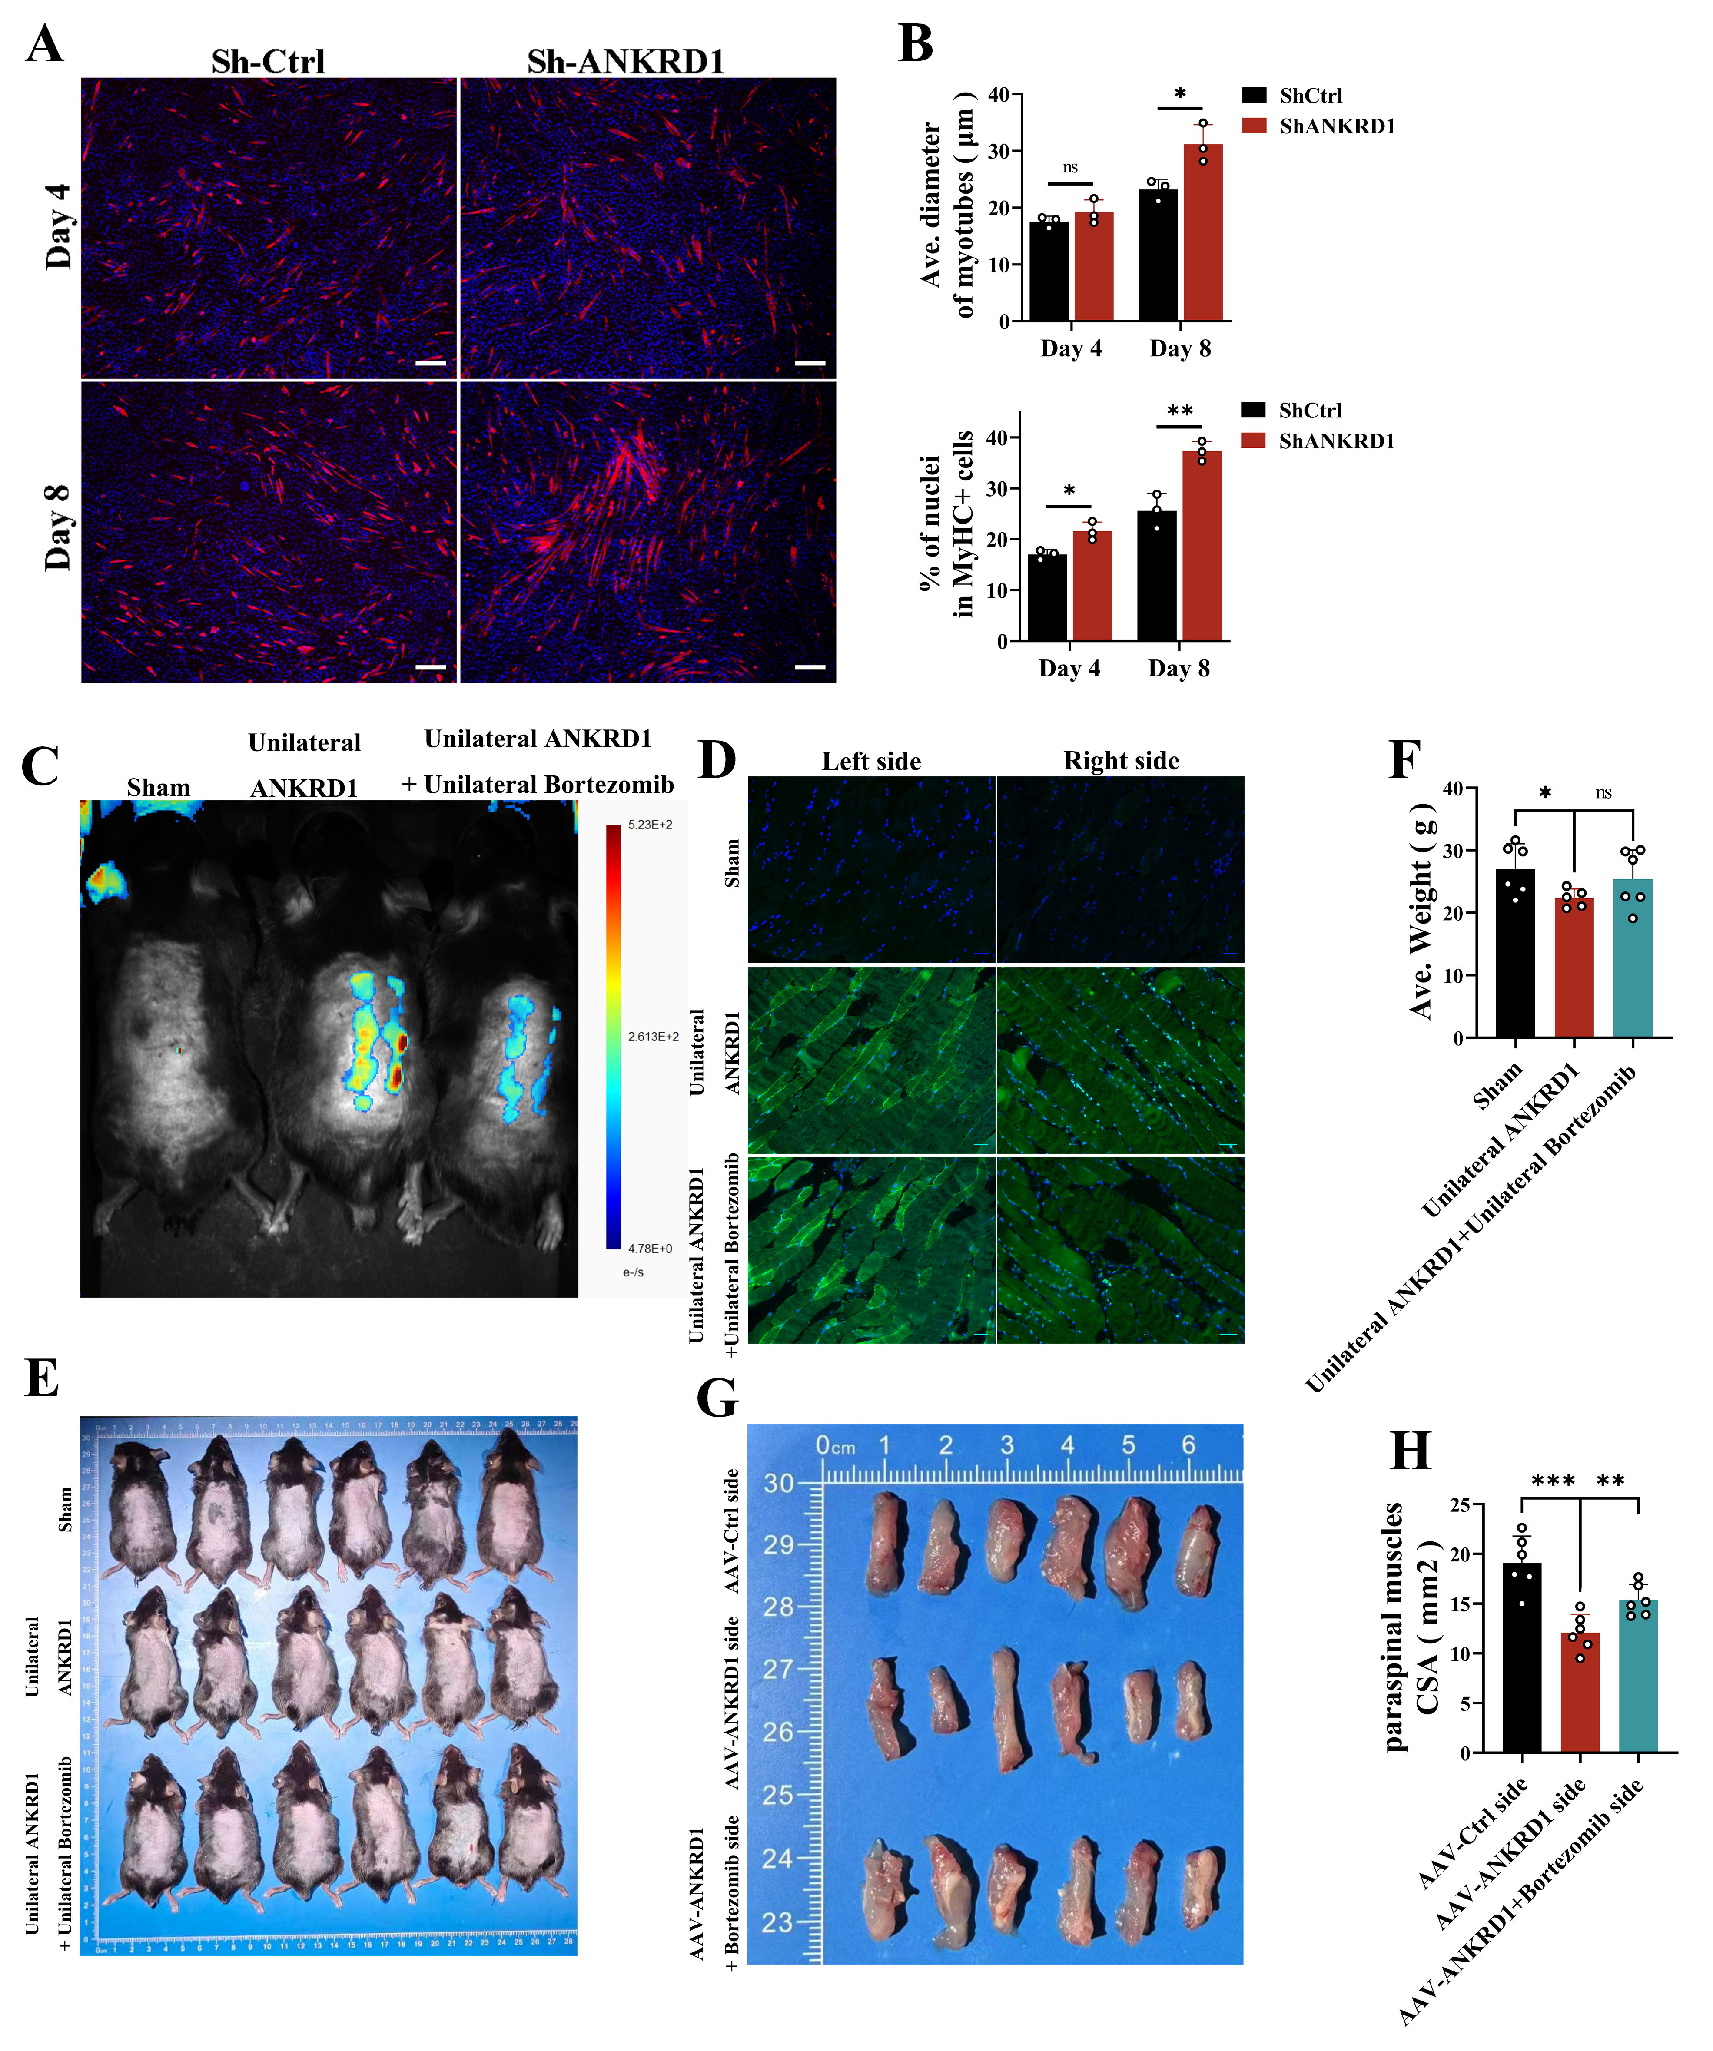
Fig. S3. ANKRD1 knockdown promotes myotube hypertrophy in vitro, together with evaluation of AAV transduction efficiency in paraspinal muscles and representative images of mouse paraspinal muscle collection. (A) Stable ANKRD1 knockdown C2C12 cells were subjected to MyHC immunofluorescence staining on differentiation days 4 and 8. MyHC (red) labels mature myotubes, and DAPI (blue) labels nuclei. Scale bar: 100 μm.(B) Quantitative analysis of the average myotube diameter and myotube fusion index based on the MyHC immunofluorescence images shown in (A), n = 3. Unpaired Student's t test, ns= not significant, *P < 0.05; **P < 0.01.(C) Three weeks after paraspinal muscle injection of EGFP labeled AAV, in vivo transduction efficiency was evaluated using an in vivo fluorescence imaging system.(D) Eight weeks after paraspinal muscle injection of EGFP-labeled AAV, paraspinal muscle tissues were collected for immunofluorescence staining to evaluate AAV transduction efficiency in the tissue. Scale bar: 100 μm.(E) Representative gross images of all experimental mice at 12 weeks of age before sacrifice.(F) Eight weeks after AAV injection, mice were sacrificed and bilateral paraspinal muscles were completely isolated. The images show the bilateral intact paraspinal muscles isolated from mice in the AAV-Ctrl/AAV-ANKRD1 group, as well as the intact paraspinal muscle from the bortezomib-injected side in the bortezomib treatment group.(G) Quantitative analysis of the cross-sectional area (CSA) of the intact paraspinal muscles shown in (F), n = 6. One-way ANOVA followed by Tukey's post hoc test. ns= not significant; **P < 0.01; ***P < 0.001.
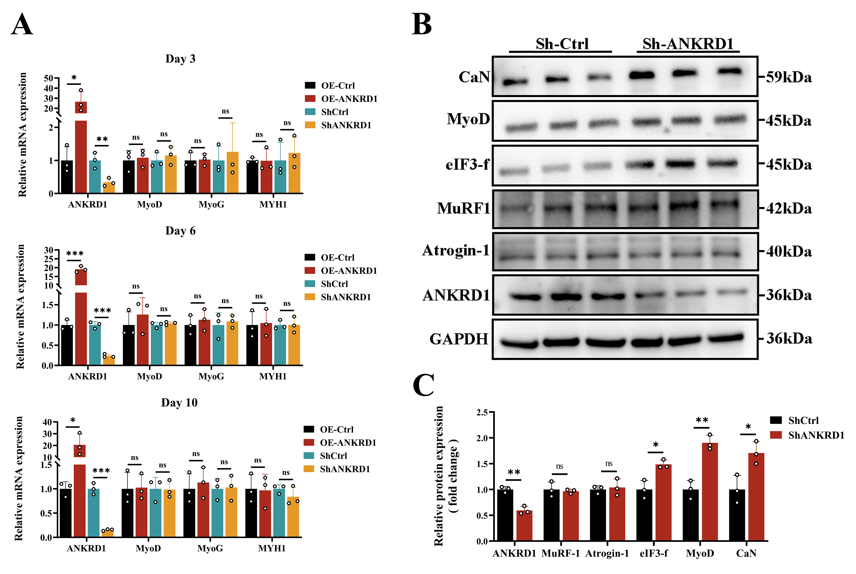
Fig. S4. Effects of ANKRD1 overexpression or knockdown on myogenic differentiation related gene expression and the expression of Atrogin-1 substrate proteins in C2C12 cells.(A) Stable ANKRD1 overexpressing or ANKRD1 knockdown C2C12 cells were induced to differentiate for 3, 6, and 10 days. RT-qPCR was performed to quantify the mRNA expression levels of the myogenic differentiation-related genes MyoD, MyoG, and MYH1, n = 3. Unpaired Student's t test. ns= not significant, *P < 0.05; **P < 0.01; ***P < 0.001.(B) Stable ANKRD1-knockdown C2C12 cells were established by lentiviral transduction. Representative Western blot images showing the protein expression levels of ANKRD1, Atrogin-1, MuRF1, eIF3-f, MyoD, and CaN in Sh-Ctrl and Sh-ANKRD1 cells.(C) Densitometric quantification of the Western blot results shown in (B). In each independent experiment, the densitometric values of three technical replicates within the same group were first averaged before statistical analysis, n = 3. Unpaired Student's t test, ns= not significant, *P < 0.05; **P < 0.01.
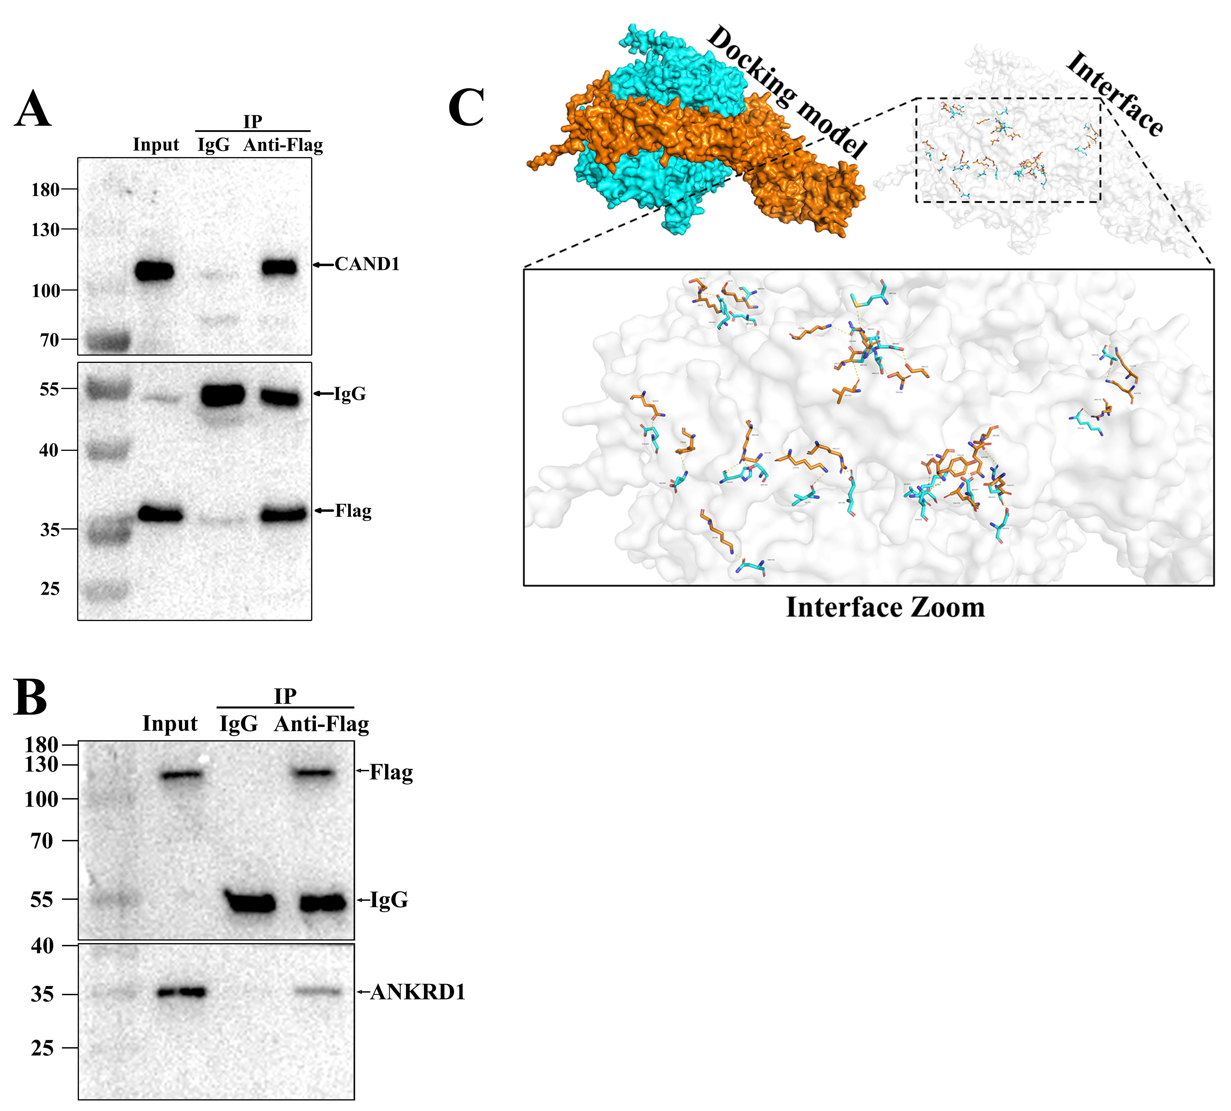
Fig. S5. Interactions among ANKRD1, CAND1, and CUL1.(A) Detection of the interaction between ANKRD1 and CAND1 in C2C12 cells transfected with a FLAG-tagged ANKRD1 expression plasmid. Cell lysates were subjected to immunoprecipitation using IgG or anti-FLAG antibody, followed by immunoblotting with an anti-CAND1 antibody to detect endogenous CAND1 bound to ANKRD1.(B) Detection of the interaction between CAND1 and ANKRD1 in C2C12 cells transfected with a FLAG-tagged CAND1 expression plasmid. Cell lysates were subjected to immunoprecipitation using IgG or anti-FLAG antibody, followed by immunoblotting with an anti-ANKRD1 antibody to detect endogenous ANKRD1 bound to CAND1.(C) Molecular docking analysis predicting the interaction between CAND1 and CUL1. CAND1 was selected as the receptor protein, and CUL1 was selected as the ligand protein. Predicted hydrogen bonds formed between the proteins are indicated by yellow dashed lines.
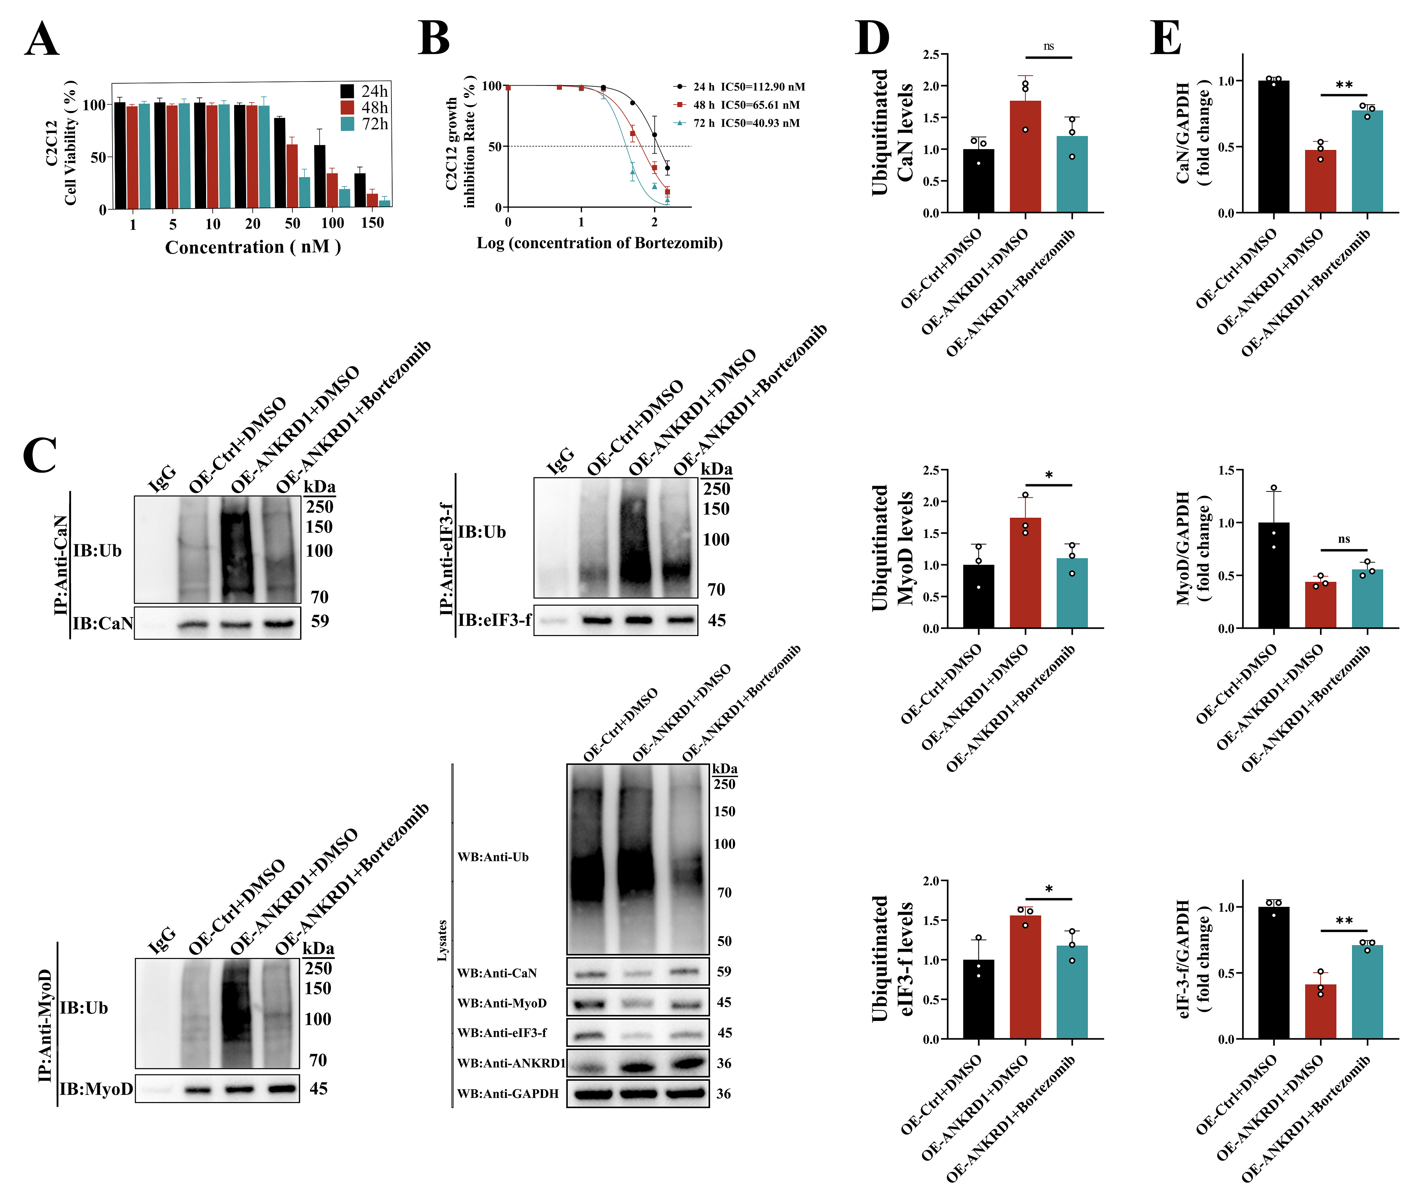
Fig. S6. In vitro safety evaluation of bortezomib and its antagonistic effect on ANKRD1 induced ubiquitin mediated degradation of Atrogin-1 substrate proteins.(A) CCK-8 assays were performed to evaluate C2C12 cell viability after treatment with different concentrations of bortezomib for different time periods, followed by quantitative analysis.(B) Cell survival curves of C2C12 cells treated with different concentrations of bortezomib at different time points.(C) Effect of bortezomib on ANKRD1 mediated ubiquitination of Atrogin-1 substrate proteins. Cell lysates from the OE-Ctrl + DMSO, OE-ANKRD1 + DMSO, and OE-ANKRD1 + Bortezomib groups were immunoprecipitated with IgG or antibodies against CaN, MyoD, or eIF3-f, followed by immunoblotting with an anti-ubiquitin antibody to detect the ubiquitination levels of the corresponding proteins. Immunoprecipitated proteins were detected using antibodies against CaN, MyoD, and eIF3-f. In addition, the protein expression levels of CaN, MyoD, eIF3-f, CAND1, ANKRD1, and total ubiquitinated proteins in the whole cell lysates were analyzed.(D) Quantitative analysis of the relative ubiquitination levels of CaN, MyoD, and eIF3-f shown in (C), n = 3. One-way ANOVA followed by Tukey's post hoc test. ns, not significant, *P < 0.05.(E) Quantitative analysis of the relative protein expression levels of CaN, MyoD, and eIF3-f in the whole cell lysates shown in (C), n = 3. One-way ANOVA followed by Tukey's post hoc test, ns= not significant, **P < 0.01.

