Appendix
Topic Number Selection for the LDA Model
To determine the optimal number of topics, we conducted Latent Dirichlet Allocation (LDA) topic modeling using the sklearn package in Python. Topic number selection was based on a joint assessment of Perplexity and UMass Coherence (see Figure A1). As shown in the figure, Perplexity declined rapidly at lower values of K, but its rate of improvement flattened noticeably between K=20 and K=30, indicating a clear elbow. In contrast, UMass Coherence showed its best local performance around K=22. Taking both model fit and semantic interpretability into account, we selected K=22 as the optimal number of topics for the main analysis.
Figure 1
Perplexity and UMass Coherence Across Different Numbers of Topics
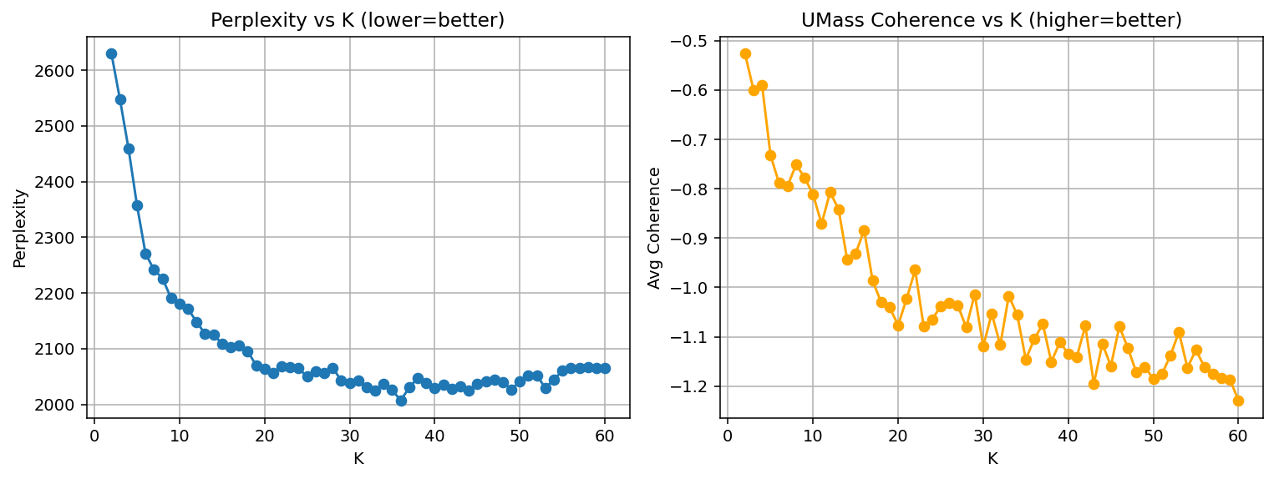
Note. The left panel shows Perplexity scores, where lower values indicate better model fit. The right panel shows average UMass Coherence scores, where higher values indicate better semantic coherence. The final topic number was selected by jointly considering both indicators and choosing a solution that balanced statistical fit with interpretability.

Formula Definitions for Dynamic Frame Relation Analysis
All indicators in the dynamic frame relation analysis were calculated from the annual topic similarity networks and the fixed-block frame aggregation results.
Frame Salience
$$Salience_{F,t}=\frac{1}{N_{t}}\sum_{d∈D_{t}}{\sum_{k∈T_{F}}{θ_{d,k}}}$$
Frame salience measures the average prominence of frame F in year t. For each news article, the probabilities of all topics belonging to the same frame are first summed. These frame-level values are then averaged across all articles published in that year. Higher values indicate that the frame occupied a larger share of the annual communication agenda.
Within-frame Cohesion
$$\begin{matrix}{Cohesion}_{F,t}=\frac{1}{\left(\frac{|T_{F}|}{2}\right)}\sum_{\begin{aligned}i<j \\ i,j∈T_{F}\end{aligned}}{c_{ij}^{(t)}}\end{matrix}$$
Within-frame cohesion measures the average cosine similarity among topics within frame F in year t. The denominator represents the number of unique topic pairs within the frame. Higher values indicate stronger internal connections among topics and a more coherent frame structure.
Between-frame Coupling
$$\begin{matrix}{Coupling}_{F,G,t}=\frac{1}{|T_{F}|⋅|T_{G}|}\sum_{i∈T_{F}}{\sum_{j∈T_{G}}{c_{ij}^{(t)}}}, F≠G\end{matrix}$$
Between-frame coupling measures the average connection strength between two different frames, F and G, in year t. It is calculated by averaging the cosine similarity values of all topic pairs across the two frames. Higher values indicate that the two frames were more likely to co-occur and were more closely linked in that year’s news discourse.
Interpretation
Frame salience is used to compare the relative prominence of the three frames across years. Within-frame cohesion is used to assess the degree of internal integration within a single frame over time. Between-frame coupling is used to examine the strength of association between different frames and whether they became more closely connected in a given year.
These formulas are operational definitions developed for this study within a fixed-block temporal blockmodel framework. To keep the main Methods section concise, detailed formula definitions are provided here in the appendix.

Topics and Top Keywords by Frame
Table 1
Topics and top keywords by frame
Frame | Topic label | Top 15 keywords
Institutional Implementation Frame | National Pledges | unfccc, indc, paris, country, submit, agreement, come, new, change, climate change, global, agree, party, advance, support
Institutional Implementation Frame | Climate Finance | finance, fund, country, project, climate finance, mechanism, develop, cdm, development, meeting, develop country, committee, agreement, article, market
Institutional Implementation Frame | Action Initiatives | change, climate change, action, climate action, initiative, momentum, project, momentum change, award, woman, solution, global, world, energy, sustainable
Institutional Implementation Frame | REDD+ Governance | forest, redd, deforestation, asset, country, financial, degradation, net, management, result, relate, develop, framework, forest degradation, deforestation forest
Institutional Implementation Frame | Climate Technology | technology, country, develop, risk, disaster, climate technology, change, climate change, tec, island, develop country, disaster risk, small, mechanism, development
Institutional Implementation Frame | COP Diplomacy | change, climate change, conference, secretary, cop, agreement, paris, minister, president, government, bonn, general, unfccc, united, say
Institutional Implementation Frame | Urban Climate Solutions | city, urban, say, world, carbon, project, building, emissions, airport, read, local, area, cent, article, work
Transition Pathways Frame | Adaptation Planning | adaptation, country, development, action, support, climate change, change, develop, national, initiative, plan, resilience, need, include, partnership
Transition Pathways Frame | Transport Decarbonization | transport, country, action, emissions, sector, develop, develop country, target, climate action, reduction, emission, fsv, carbon, vehicle, international
Transition Pathways Frame | Nature & Biodiversity | ocean, nature, biodiversity, sustainable, ecosystem, protect, solution, change, base, fashion, world, global, industry, say, area
Transition Pathways Frame | Health & Climate Neutrality | change, emissions, climate change, reduce, health, carbon, air, gas, neutral, greenhouse, greenhouse gas, use, world, climate neutral, gas emissions
Transition Pathways Frame | Green Investment | company, carbon, investment, green, bank, investor, read, photo, new, business, release, credit, photo credit, low carbon, press
Transition Pathways Frame | Food & Agriculture | carbon, food, emissions, agriculture, gas, reduce, land, greenhouse, greenhouse gas, soil, world, methane, country, global, pricing
Transition Pathways Frame | Regional Climate Weeks | unfccc, week, change, climate change, climate week, regional, africa, action, agreement, asia, development, region, climate action, int, unfccc int
Transition Pathways Frame | Emissions Targets | global, emissions, agreement, change, paris, climate change, goal, report, paris agreement, gas, degree, greenhouse, action, greenhouse gas, temperature
Collective Mobilization Frame | Transparency & Reporting | country, party, change, climate change, report, transparency, agreement, paris agreement, develop, support, paris, action, develop country, process, implementation
Collective Mobilization Frame | Climate Impacts | year, temperature, sea, record, rise, level, extreme, weather, global, increase, report, change, world, drought, high
Collective Mobilization Frame | Global Action Appeals | change, climate change, need, world, action, agreement, year, paris, global, country, work, paris agreement, people, finance, nation
Collective Mobilization Frame | Youth Engagement | change, climate change, youth, action, people, education, young, conference, world, say, public, work, unfccc, day, climate action
Collective Mobilization Frame | Non-state Action | action, climate action, global, city, paris, capacity, champion, business, government, actor, building, initiative, change, level, non
Collective Mobilization Frame | Clean Energy | energy, renewable, renewable energy, solar, power, clean, technology, efficiency, fuel, new, wind, energy efficiency, country, year, electricity
Collective Mobilization Frame | Gender & Indigenous Inclusion | change, climate change, gender, woman, people, community, indigenous, action, impact, work, indigenous people, policy, knowledge, include, local

Supplementary Line Charts of Frame Dynamics
These supplementary line charts provide a clearer visualization of the temporal patterns reported in the main text. Figure 2 shows annual changes in within-frame cohesion, making it easier to compare the relative internal stability of the three frames over time. Figure 3 shows annual changes in between-frame coupling, highlighting shifts in the strength of association across frame pairs. These figures do not introduce additional analyses beyond those reported in the main text; rather, they serve as visual complements to the results presented in the section on the longitudinal change and interaction of the three frames.
Figure 2
Annual within-frame cohesion of the three frames in UNFCCC news (2014–2024)
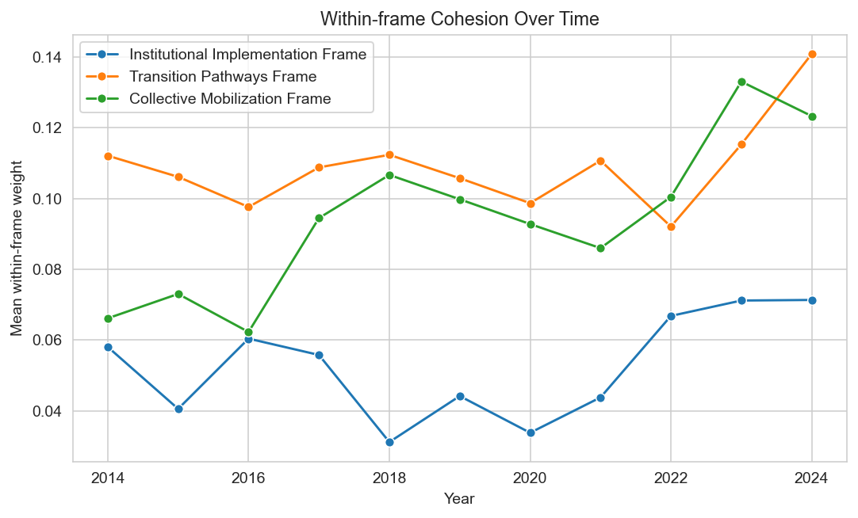
Figure 2
Annual between-frame coupling among the three frames in UNFCCC news (2014–2024)
