Targeting GPX4-mediated lipid peroxidation: Bajitianwan ameliorates iron overload-induced osteoporosis by biphasically regulating osteogenesis and osteoclastogenesis

SUPPLEMENTARY MATERIAL

1 Supplementary Methods

1.1 ADMET screening strategy for candidate active ingredients
To identify potential candidates capable of intervening in osteogenic and osteoclastic differentiation from BJTW DCIAS, a multi-step screening workflow was established based on ADMET principles using the RDKit cheminformatics toolkit (version 2023.03) in Python. The strategy focused on hepatic metabolic stability, plasma protein binding, and bone marrow penetration. The SMILES strings of the 37 components were imported to calculate key physicochemical descriptors, including molecular weight (MW), LogP, topological polar surface area (TPSA), hydrogen bond donors/acceptors (HBD/HBA), and rotatable bonds.
The screening comprised three sequential steps. First, drug-likeness was evaluated via Lipinski’s rule of five (MW≤ 500, LogP≤ 5, HBD≤ 5, HBA≤ 10) and Veber’s rules (RotBonds≤ 10, TPSA≤ 140 Å²), alongside a PAINS filter to eliminate pan-assay interference compounds. Second, to prevent excessive plasma protein binding and ensure sufficient free drug concentration, a threshold of LogP< 5.0 was applied. Third, targeting the bone marrow microenvironment, a strict cutoff of TPSA< 95 Å² was implemented to ensure membrane permeability and bone marrow penetration. Components satisfying all criteria were defined as potential active candidates for subsequent mechanistic studies.

1.2 Network pharmacology analysis
The SMILES notations of candidate compounds were retrieved from the PubChem database and imported into the SwissTargetPrediction platform (species: Mus musculus) to predict potential targets of BJTW components [1]. Concurrently, the PubChem IDs of these compounds were submitted to the BATMAN-TCM database to screen targets with a confidence score≥ 0.84 [2]. The predicted targets from both databases were integrated and deduplicated to construct the final BJTW component-target dataset.
A Venn diagram was generated based on the BJTW active compound targets and bone remodeling-related targets to identify the intersection genes. These shared targets were imported into the STRING database to extract protein-protein interaction (PPI) information, applying a threshold of combined score≥ 0.4 [3]. The PPI network was visualized using Cytoscape 3.9.1. The CytoNCA plugin was employed to calculate the betweenness centrality (BC) of each node [4]. Subsequently, the cytoHubba plugin was utilized to identify the core subnetwork, and the top 10 genes ranked by Maximum Clique Centrality (MCC) were defined as the hub genes [5].

1.3 Molecular docking
For molecular docking, target protein structures were primarily retrieved from the RCSB PDB database. Murine structures were prioritized, and high-identity human homologs were selected if murine structures were absent. Otherwise, homology models were generated via AlphaFold or Swiss-Model. Standard criteria prioritized high-resolution (<2.5 Å) X-ray crystal ligand-bound structures to ensure accurate binding pocket definition and reliable docking. The 3D structures of the active compounds were retrieved from PubChem in SDF format and subjected to energy minimization using the MM2 force field in Chem3D 22.0. Subsequently, the GetBox plugin was utilized to define the binding pocket based on the receptor’s crystal structure. Docking calculations were performed in AutoDock 4.2 to evaluate the binding free energy of the ligand-receptor complexes. The resulting binding conformations were analyzed for intermolecular interactions using the PLIP [6], and the docking outcomes were ultimately visualized via PyMOL 3.0.3.

Supplementary References
1. Daina A, Michielin O, Zoete V. SwissTargetPrediction: updated data and new features for efficient prediction of protein targets of small molecules. Nucleic Acids Res. 2019;47:W357–64. https://doi.org/10.1093/nar/gkz382
2. Kong X, Liu C, Zhang Z, Cheng M, Mei Z, Li X, et al. BATMAN-TCM 2.0: an enhanced integrative database for known and predicted interactions between traditional Chinese medicine ingredients and target proteins. Nucleic Acids Res. 2024;52:D1110–20. https://doi.org/10.1093/nar/gkad926
3. Szklarczyk D, Kirsch R, Koutrouli M, Nastou K, Mehryary F, Hachilif R, et al. The STRING database in 2023: protein-protein association networks and functional enrichment analyses for any sequenced genome of interest. Nucleic Acids Res. 2023;51:D638–46. https://doi.org/10.1093/nar/gkac1000
4. Tang Y, Li M, Wang J, Pan Y, Wu FX. CytoNCA: a cytoscape plugin for centrality analysis and evaluation of protein interaction networks. Biosystems. 2015;127:67–72. https://doi.org/10.1016/j.biosystems.2014.11.005
5. Chin C-H, Chen S-H, Wu H-H, Ho C-W, Ko M-T, Lin C-Y. cytoHubba: identifying hub objects and sub-networks from complex interactome. BMC Syst Biol. 2014;8 Suppl 4:S11. https://doi.org/10.1186/1752-0509-8-S4-S11
6. Schake P, Bolz SN, Linnemann K, Schroeder M. PLIP 2025: introducing protein-protein interactions to the protein-ligand interaction profiler. Nucleic Acids Res. 2025;53:W463–5. https://doi.org/10.1093/nar/gkaf361

Supplementary Figures
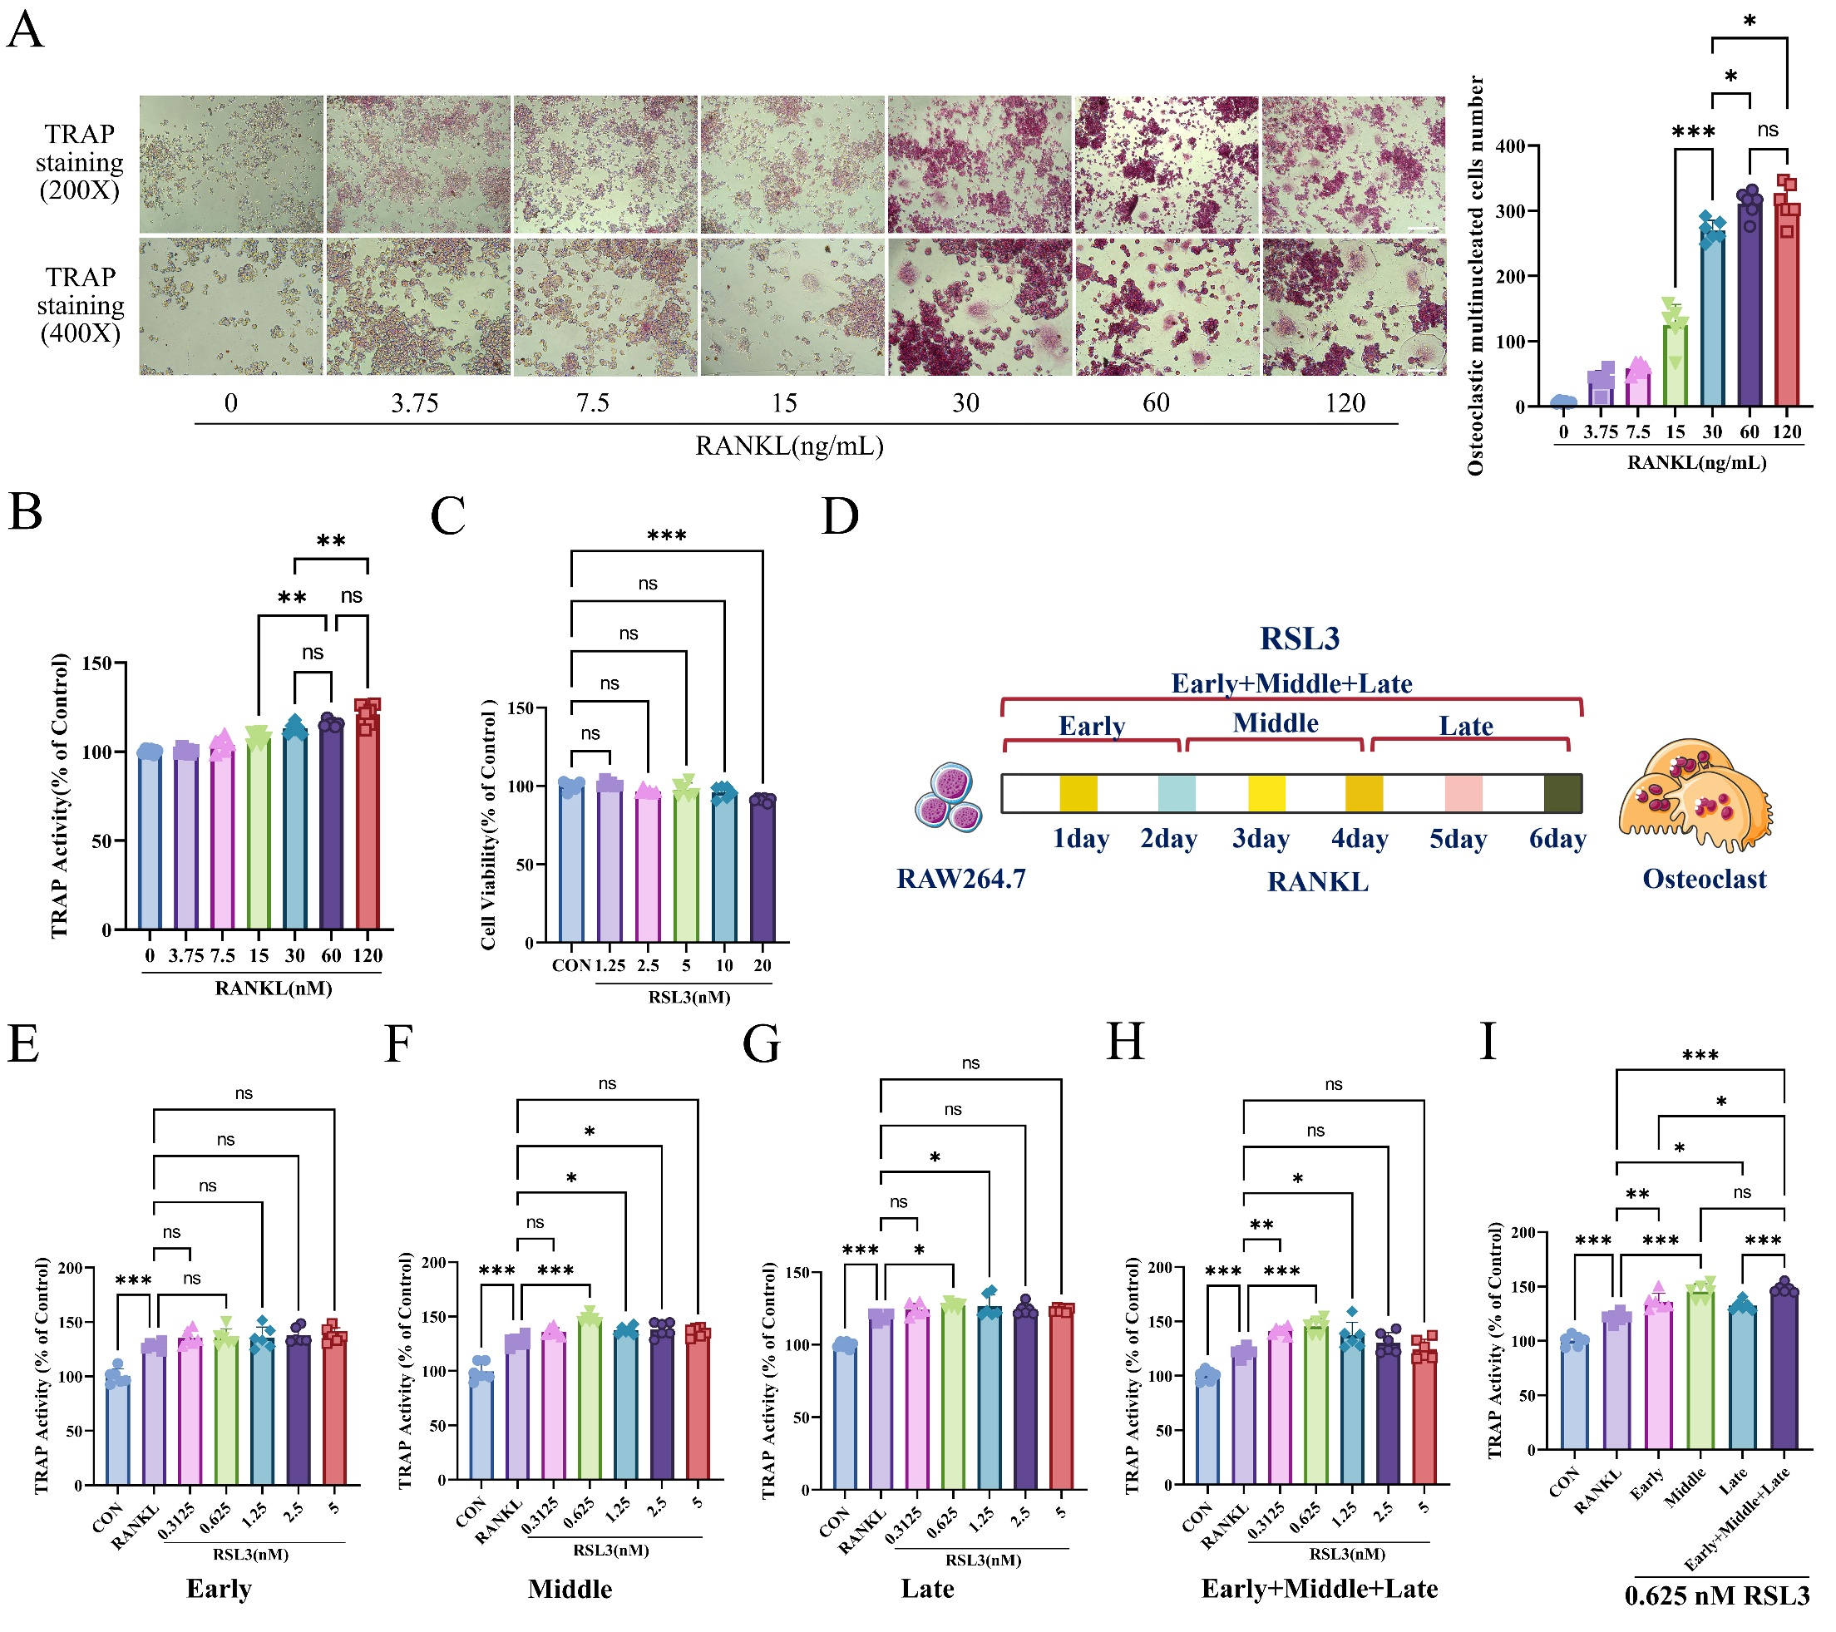
Supplementary Figure S1. Effect of RSL3 on RANKL-induced osteoclast differentiation in RAW264.7 cells.
(A-B) Establishment of the RANKL-induced osteoclast differentiation model in RAW264.7 cells. (A) TRAP staining of osteoclasts and quantification of osteoclast number. Scale bar, 200 μm. (B) TRAP activity. (C-E) Effect of RSL3 on RANKL-induced osteoclast differentiation. (C) Cell viability assessed by MTT assay. (D) Schematic diagram of the treatment protocol. Different doses of RSL3 were administered during the early, middle, late, or whole stage of RANKL-induced differentiation. (E-I) TRAP activity following RSL3 treatment at the same time points with different concentrations, or at different time points with the same concentration (0.625 nM). Data are presented as mean ± SD (n = 6). Statistical significance was determined by one-way ANOVA followed by Tukey’s post hoc test. ns, not statistically significant, *P< 0.05, **P< 0.01, ***P< 0.001.

Supplementary Tables
Supplementary Table S1. ADMET screening results and physicochemical descriptors of 37 prototype constituents in BJTW DCIAS.
NO. | Compound | Pubchem_id | MW | LogP | TPSA | HBD | HBA | RotBonds | PAINS_Filter | Stability | PPB_Free | Penetration | Final_Result
1 | Ginsenoside Rd | 11679800 | 947.17 | -0.03 | 298.14 | 12 | 18 | 13 | Pass | Fail | Pass | Fail | Filtered Out
2 | Ginsenoside Re | 441921 | 947.17 | -0.03 | 298.14 | 12 | 18 | 12 | Pass | Fail | Pass | Fail | Filtered Out
3 | Ginsenoside RG1 | 441923 | 801.02 | 1.12 | 239.22 | 10 | 14 | 10 | Pass | Fail | Pass | Fail | Filtered Out
4 | Ginsenoside Rf | 441922 | 801.02 | 1.12 | 239.22 | 10 | 14 | 10 | Pass | Fail | Pass | Fail | Filtered Out
5 | 20(S)-Ginsenoside F2 | 9918692 | 785.03 | 2.15 | 218.99 | 9 | 13 | 10 | Pass | Fail | Pass | Fail | Filtered Out
6 | 20(R)-Ginsenoside Rg2 | 75412551 | 785.03 | 2.15 | 218.99 | 9 | 13 | 9 | Pass | Fail | Pass | Fail | Filtered Out
7 | 20(R)-Notoginsenoside R2 | 16757287 | 771.00 | 1.76 | 218.99 | 9 | 13 | 9 | Pass | Fail | Pass | Fail | Filtered Out
8 | Ginsenoside Rg5 | 11550001 | 767.01 | 2.95 | 198.76 | 8 | 12 | 9 | Pass | Fail | Pass | Fail | Filtered Out
9 | 3,6’-Disinapoyl sucrose | 11968389 | 754.69 | -1.42 | 279.05 | 8 | 19 | 15 | Pass | Fail | Pass | Fail | Filtered Out
10 | 20(S)-Ginsenoside Rh1 | 12855920 | 638.88 | 3.3 | 160.07 | 7 | 9 | 7 | Pass | Fail | Pass | Fail | Filtered Out
11 | Tenuifoliside A | 46933844 | 682.63 | -1.54 | 249.59 | 7 | 17 | 13 | Pass | Fail | Pass | Fail | Filtered Out
12 | Tenuifolin | 21588226 | 680.83 | 2.07 | 214.44 | 8 | 10 | 6 | Pass | Fail | Pass | Fail | Filtered Out
13 | Tenuifoliside B | 10055215 | 668.60 | -1.84 | 260.59 | 8 | 17 | 12 | Pass | Fail | Pass | Fail | Filtered Out
14 | Ginsenoside Rk3 | 75412555 | 620.87 | 4.10 | 139.84 | 6 | 8 | 7 | Pass | Fail | Pass | Fail | Filtered Out
15 | Glomeratose A | 137947060 | 562.52 | -3.11 | 223.29 | 7 | 15 | 11 | Pass | Fail | Pass | Fail | Filtered Out
16 | Polygalaxanthone III | 11169063 | 568.48 | -1.95 | 249.20 | 9 | 15 | 6 | Pass | Fail | Pass | Fail | Filtered Out
17 | Polygalaxanthone XI | 101740054 | 568.48 | -1.95 | 249.20 | 9 | 15 | 6 | Pass | Fail | Pass | Fail | Filtered Out
18 | Ginsenoside Rb1 | 9898279 | 1109.31 | -2.20 | 377.29 | 15 | 23 | 16 | Pass | Fail | Pass | Fail | Filtered Out
19 | Poricoic acid A | 5471851 | 498.70 | 6.80 | 94.83 | 3 | 3 | 10 | Pass | Fail | Fail | Pass | Filtered Out
20 | Polygalic acid | 138911406 | 488.67 | 5.02 | 115.06 | 4 | 4 | 2 | Pass | Fail | Fail | Fail | Filtered Out
21 | Dehydrotumulosic acid | 15225964 | 484.72 | 6.54 | 77.76 | 3 | 3 | 6 | Pass | Fail | Fail | Pass | Filtered Out
22 | Poricoic acid B | 5471852 | 484.68 | 6.55 | 94.83 | 3 | 3 | 9 | Pass | Fail | Fail | Pass | Filtered Out
23 | Asperulosidic acid | 11968867 | 432.38 | -2.78 | 192.44 | 6 | 11 | 6 | Pass | Fail | Pass | Fail | Filtered Out
24 | Deacetylasperulosidic acid | 12315350 | 390.34 | -3.35 | 186.37 | 7 | 10 | 5 | Pass | Fail | Pass | Fail | Filtered Out
25 | Monotropein | 73466 | 390.34 | -3.35 | 186.37 | 7 | 10 | 5 | Pass | Fail | Pass | Fail | Filtered Out
26 | D-(+)-Trehalose | 7427 | 342.30 | -5.40 | 189.53 | 8 | 11 | 4 | Pass | Fail | Pass | Fail | Filtered Out
27 | Hesperetin | 72281 | 302.28 | 2.52 | 96.22 | 3 | 6 | 2 | Pass | Pass | Pass | Fail | Filtered Out
28 | Sinapic acid | 10743 | 224.21 | 1.51 | 75.99 | 2 | 4 | 4 | Pass | Pass | Pass | Pass | Selected
29 | α-Asarone | 636822 | 208.26 | 2.75 | 27.69 | 0 | 3 | 4 | Pass | Pass | Pass | Pass | Selected
30 | Scopoletin | 5280460 | 192.17 | 1.51 | 59.67 | 1 | 4 | 1 | Pass | Pass | Pass | Pass | Selected
31 | Isoscopoletin | 69894 | 192.17 | 1.51 | 59.67 | 1 | 4 | 1 | Pass | Pass | Pass | Pass | Selected
32 | Ferulic acid | 445858 | 194.19 | 1.50 | 66.76 | 2 | 3 | 3 | Pass | Pass | Pass | Pass | Selected
33 | Isoferulic acid | 736186 | 194.19 | 1.50 | 66.76 | 2 | 3 | 3 | Pass | Pass | Pass | Pass | Selected
34 | Gallic acid | 370 | 170.12 | 0.50 | 97.99 | 4 | 4 | 1 | Fail | Fail | Pass | Fail | Filtered Out
35 | Protocatechuic acid | 72 | 154.12 | 0.80 | 77.76 | 3 | 3 | 1 | Fail | Fail | Pass | Pass | Filtered Out
36 | Vanillin | 1183 | 152.15 | 1.21 | 46.53 | 1 | 3 | 2 | Pass | Pass | Pass | Pass | Selected
37 | P-Coumaric acid | 637542 | 164.16 | 1.49 | 57.53 | 2 | 2 | 2 | Pass | Pass | Pass | Pass | Selected

Supplementary Table S2. Detailed binding interactions of representative BJTW compounds with osteogenic and osteoclastic targets.
Complex | Interaction Type | Residue | Distance (Å) | Angle (°)
Scopoletin-TNF | Hydrophobic | PRO117, TYR119 | 3.42, 2.91 | -
Scopoletin-TNF | Hydrogen Bond | LYS98, PRO117, TYR119 (×2) | 3.14, 2.06, 3.21, 3.01 | 122.1, 144.4, 142.8, 124.7
Scopoletin-TNF | π-Cation | LYS98 | 5.4 | -
Isoscopoletin-TNF | Hydrophobic | PRO117 (×2), TYR119 | 3.06, 3.24, 3.42 | -
Isoscopoletin-TNF | Hydrogen Bond | LYS98, PRO117, TYR119 (×2) | 2.63, 2.23, 1.99, 3.25 | 118.8, 100.0, 152.9, 138.0
Scopoletin-MMP9 | Hydrophobic | LEU222, HIS226, LEU243, TYR248, ARG249 | 3.90, 3.79, 3.33, 3.89, 3.86 | -
Scopoletin-MMP9 | Hydrogen Bond | GLU241, ARG249 (×2) | 2.81, 2.18, 2.11 | 169.5, 168.7, 137.7
Scopoletin-MMP9 | Salt Bridge | HIS226 | 4.46 | -
Isoscopoletin-MMP9 | Hydrophobic | HIS226, LEU243 | 3.85, 3.58 | -
Isoscopoletin-MMP9 | Hydrogen Bond | ALA242, ARG249 (×2) | 1.93, 2.17, 2.11 | 124.7, 169.0, 122.3
Isoscopoletin-MMP9 | Salt Bridge | HIS226 | 4.94 | -
Ferulic acid-HMGCR | Hydrophobic | ASP690, LYS691, HIS752 | 2.88, 3.30, 3.70 | -
Ferulic acid-HMGCR | Hydrogen Bond | GLU559, ARG590, SER684, ASN686 (×2), ASP690, LYS691, ASN755 | 2.10, 2.91, 1.76, 3.11, 1.85, 1.89, 2.14, 1.88 | 118.5, 142.5, 117.8, 118.2, 104.9, 163.3, 121.1, 159.3
Ferulic acid-HMGCR | Salt Bridge | ARG590, LYS692, LYS735 | 5.36, 2.85, 3.71 | -
Isoferulic acid-HMGCR | Hydrophobic | ASP690, LEU853 (×2) | 3.73, 3.77, 3.34 | -
Isoferulic acid-HMGCR | Hydrogen Bond | GLU559, SER684, ASN686, ASP690, LYS691, ASN755 | 2.21, 1.95, 2.11, 2.55, 1.94, 1.73 | 164.5, 132.2, 114.8, 133.7, 128.3, 154.6
Isoferulic acid-HMGCR | Salt Bridge | ARG590, LYS692, LYS735 | 4.97, 2.73, 3.58 | -

