Distinguishing and Replicable Features of Youth Experiencing Psychotic-Like Experiences Via Multimodal Data Integration
Supplementary Information

Materials and Methods
metaSNF
To identify optimal hyperparameters for the Similarity Network Fusion (SNF) procedure, we leveraged metaSNF, an R-based meta-clustering package designed to enhance SNF clustering workflows by exploring a diverse solution space ⁵⁶. This package enables researchers to identify SNF-derived context-optimal cluster solutions, guided by context-specific utility over context-agnostic measures of quality. metaSNF systematically varies SNF hyperparameters, specifically the number of nearest neighbors (k), the normalization parameter (alpha), and the SNF scheme, through a grid search strategy. This generates a broad array of cluster solutions, which are then meta-clustered using adjusted Rand indices to identify sets of similar solutions. A representative cluster solution is selected as the one with the highest overall adjusted Rand index to all other solutions in its cluster, indicating it is the most similar to the rest of the group. Our grid search focused on values ranging from k = 30 to 60 and alpha = 0.3 to 0.8, with the number of SNF iterations fixed at 20, spanned across 722 clustering solutions. We retained the solution that yielded the most stable and contextually relevant clustering as determined by its overlap with held-out features (distress-weighted total PLE score) and internal validation metrics. This enabled a data-driven selection of hyperparameters (k = 44 and alpha = 0.7) for the final SNF analysis. The metaSNF framework ensured that parameter selection was robust, reproducible, and guided by the inherent structure of the data.
Out-of-Model Feature Evaluation and Longitudinal Validation of Data-Driven Clusters
Distressing PLE trajectories were examined using latent growth modeling. Specifically, the total PLE score weighted by distress (as measured by the PQ-BC) was modeled across three longitudinal time points: baseline, 1-year, and 2-year follow-up. These ABCD time points were selected to maximize the availability of complete data for longitudinal modeling (i.e., the greatest attrition, particularly in the most impaired subgroup, occurred after the 2-year follow-up, guiding the decision to limit analyses to this period). Upon verifying that discovery and replication samples demonstrated highly similar clustering solutions, the full primary sample was used to maximize statistical power and generalizability (n = 1,545). We applied both Latent Class Growth Analysis (LCGA; with fixed intercept and slope) and Growth Mixture Modeling (GMM; with random slope and/or intercept) to identify distinct longitudinal trajectories. Models with one to five classes were tested, and model selection was guided by multiple fit indices, including the Bayesian Information Criterion (BIC), and maximum log likelihood, as well as by class interpretability and adequate size consistent with prior recommendations ⁴⁰. Finally, a chi-square test was used to examine the distribution of longitudinal PLE classes across clusters. Post hoc analysis of standardized residuals, reflecting deviations between observed and expected proportions for each latent class, was conducted to identify significant over- or under-representation within clusters, with FDR correction applied for multiple comparisons.
Cognitive performance was assessed at baseline and 2-year follow-up using a composite score derived from SNF cognitive measures (excluding the WISC-V Matrix Reasoning task, as it was collected only at baseline). These ABCD time points were selected to maximize the use of complete data for repeated measures modelling. For each measure at each time point, the mean and standard deviation in the NonPLE group (n = 2,117) were used as a reference to compute z-scores for all participants, which were then averaged within individuals to produce a single composite score for each time point. Similar to above, the full primary sample was used (n = 1,565). Longitudinal group differences in the composite score were evaluated using repeated-measures ANOVA, allowing us to test for both main effects of group and time as well as Group × Time interactions. Post hoc pairwise contrasts were conducted to characterize differences between clusters and relative to the NonPLE group at each time point, with FDR correction applied for multiple comparisons.

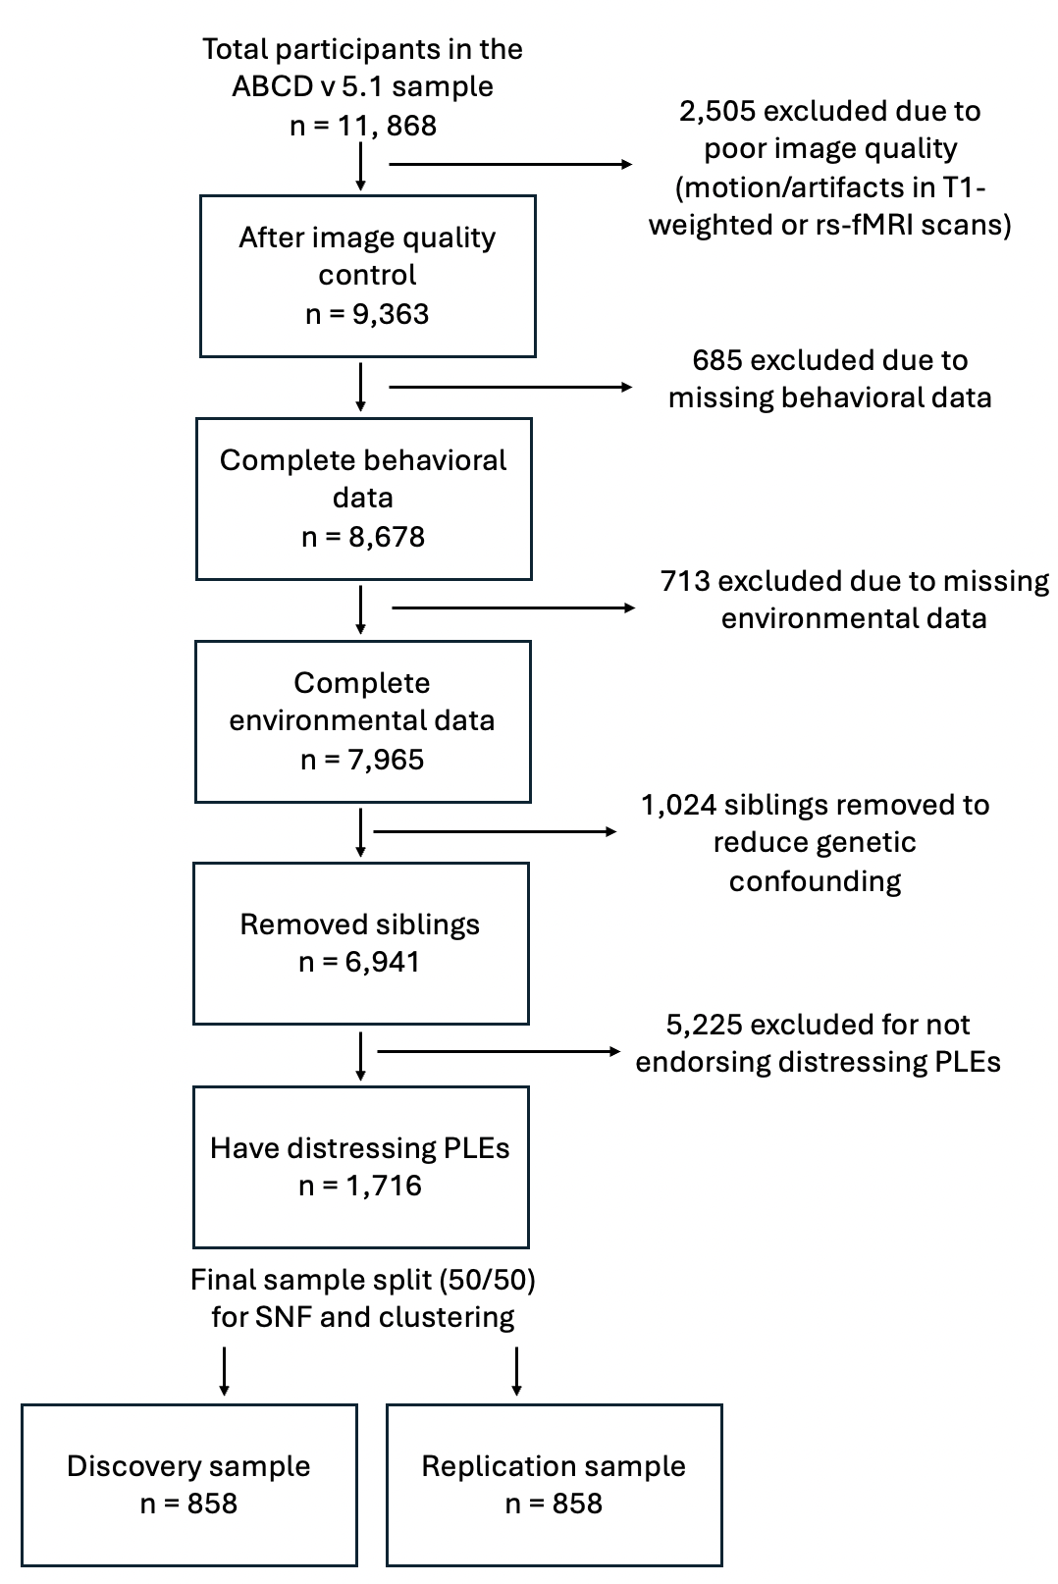
Supplementary Figure S1. Flowchart of total participants and how many were removed at each level of data quality control for the current analysis. Of the 11,868 participants with baseline ABCD data available, 2,505 were excluded due to low-quality MRI data or excessive motion during resting-state functional MRI (rs-fMRI) (mean framewise displacement > 0.2 mm). Participants missing behavioral (n = 685) or environmental data (n = 713) were also excluded, along with 1,024 siblings, to minimize genetic confounds in clustering. To reduce zero inflation and emphasize relevant cognitive, environmental, and neural features, we further excluded 5,225 participants who did not endorse at least one distressing PLE, defined as present and at least moderately distressing. The primary sample consisted of 1,716 youth aged 9-10 years at the time of baseline measurement, endorsing distressing PLEs with complete, high-quality multimodal data. This sample was randomly divided into discovery (n = 858) and replication (n = 858) to enable independent validation of clustering results, while maintaining comparable distributions of key demographic variables, including age, sex, and race/ethnicity. The NonPLE group (n = 5,225), who met all inclusion criteria but did not endorse any distressing PLEs, was retained as a reference sample.

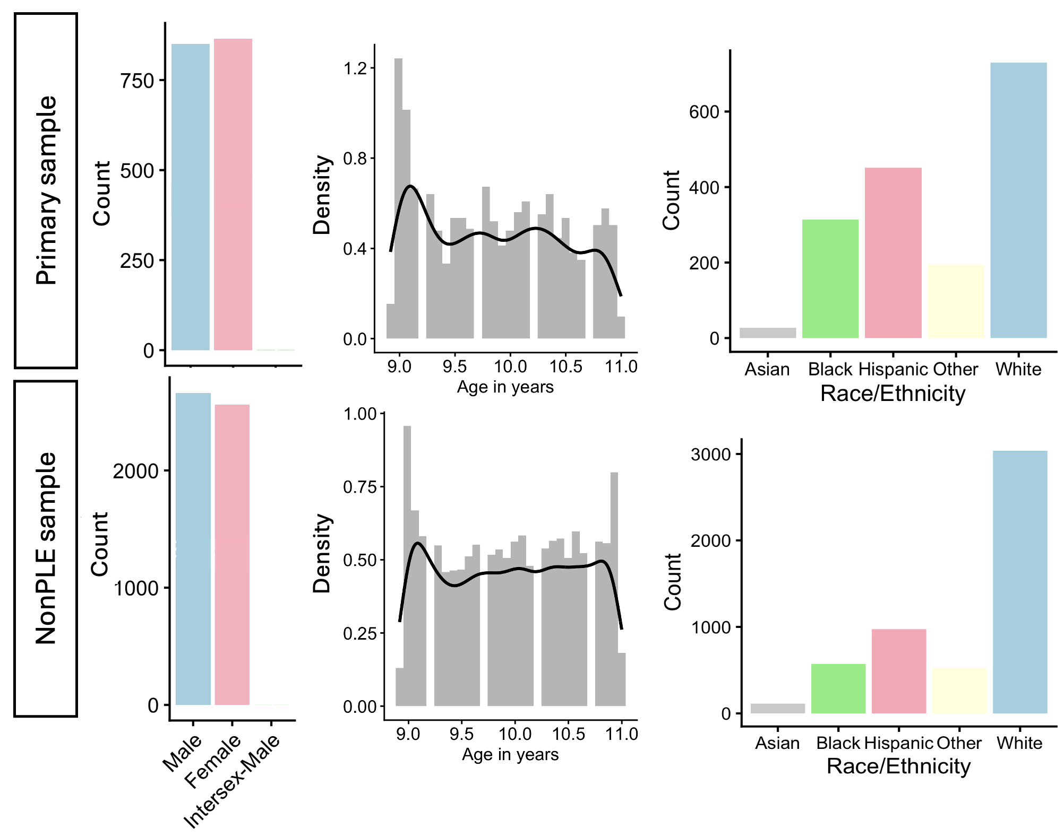
Supplementary Figure S2. Demographic distributions of the primary and NonPLE reference groups. The NonPLE group (n = 5,225) met all inclusion criteria except endorsement of distressing PLEs and showed broadly comparable age, sex, and racial distributions relative to the primary sample (n = 1,716).

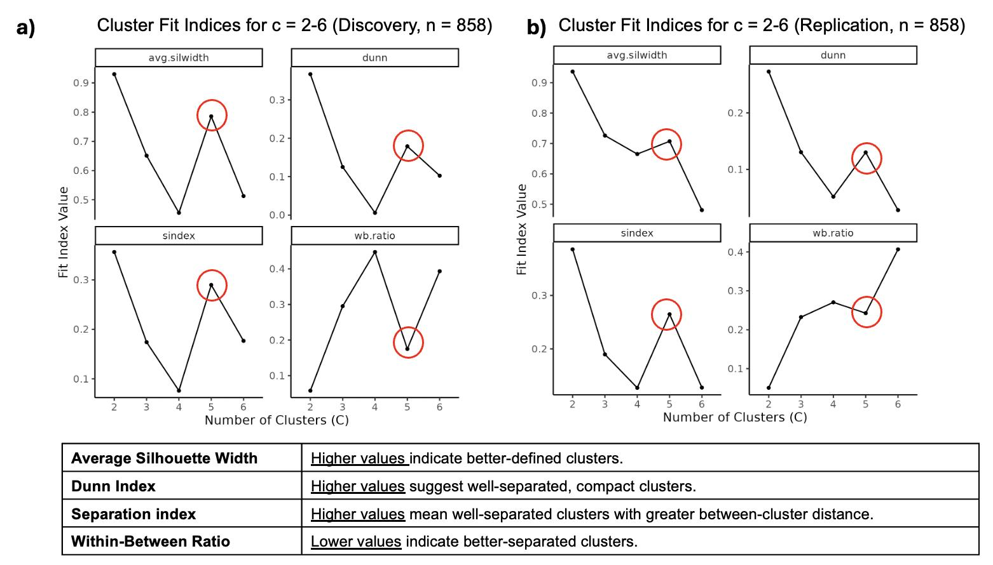Supplementary Figure S3. Cluster fit metrics for Similarity Network Fusion (SNF) across 2 to 6 cluster solutions in discovery and replication samples. (A) Discovery sample (n = 858) and, (B) replication sample (n = 858) were evaluated using cluster fit indices: average silhouette width, Dunn index, separation index, and within-between (WB) ratio. Higher values for silhouette width, Dunn index, and separation index indicate more well-defined and well-separated clusters, whereas lower WB ratios reflect greater between-cluster separation relative to within-cluster cohesion. Consistent patterns across both samples supported the selection of a five-cluster solution.

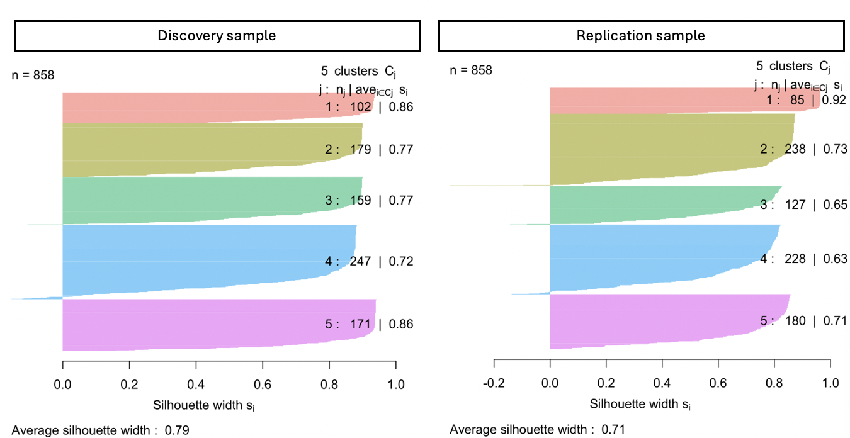
Supplementary Figure S4. Silhouette plot illustrating how similar each participant is to others within their assigned cluster compared to participants in other clusters. Cluster labels are annotated as Cluster n (i.e., the number of participants in each cluster), with average silhouette widths for each cluster displayed on the right side of the plot.

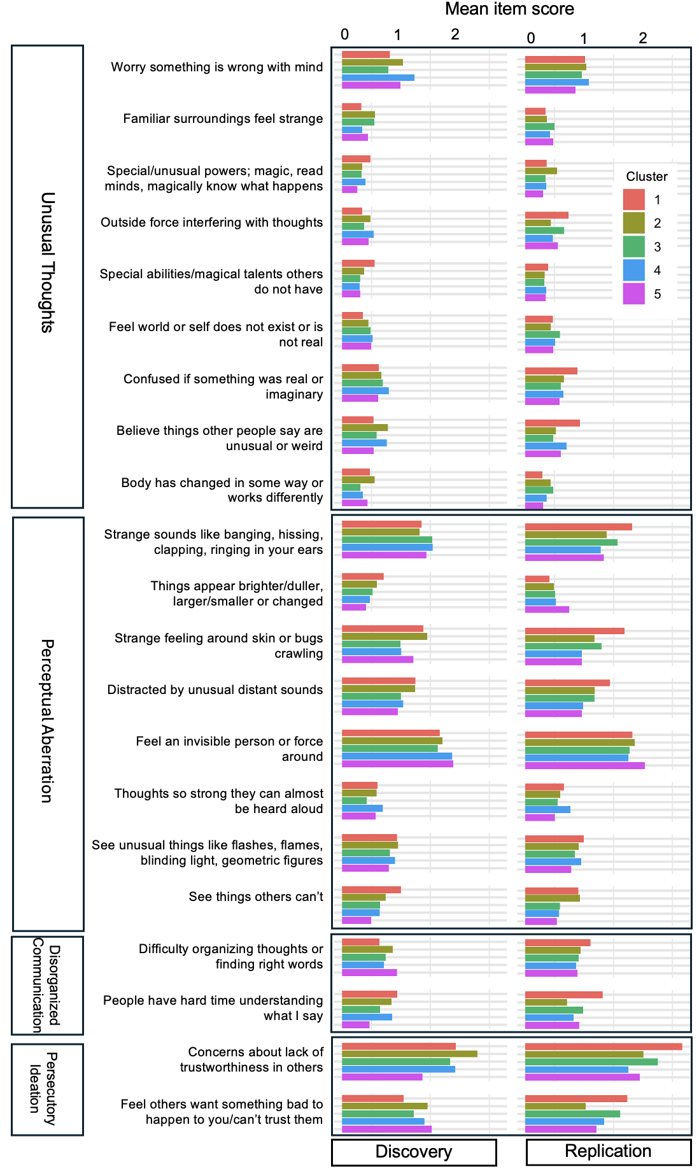
Supplementary Figure S5. Cluster-wise average PLE item severity in discovery and replication cohorts. Horizontal bar plots show the mean PLE symptom scores for each item, stratified by cluster membership (1–5), in discovery (left) and replication (right) cohorts. Each row corresponds to a distinct PLE symptom item, with higher values indicating greater symptom severity. Colors denote cluster membership.

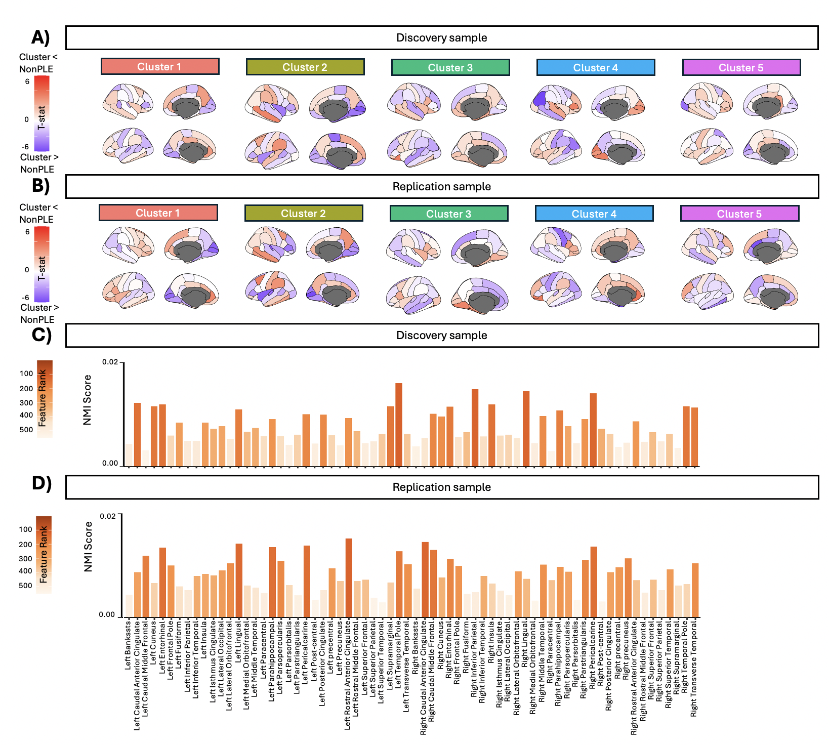Supplementary Figure S6. Cortical surface area differences across data-driven clusters relative to the non-PLE group in discovery and replication samples. Brain maps illustrate cortical surface area differences (t-statistics) between each cluster and a comparison group of youth with no distressing PLEs (NonPLE). T-statistics are shown for visualization purposes only and are not thresholded for statistical significance. Warmer colors indicate regions where clusters show lower surface area than non-PLE (i.e., Cluster < NonPLE), and cooler colors indicate regions with greater surface area (i.e., Cluster > NonPLE). Barplots display Normalized Mutual Information (NMI) scores for all surface area (n = 68) regions used in clustering, with higher scores indicating stronger feature importance. Bars are colored by rank, with darker colors representing higher-ranking features. Results are shown for the discovery (A, C) and replication sample (B, D).
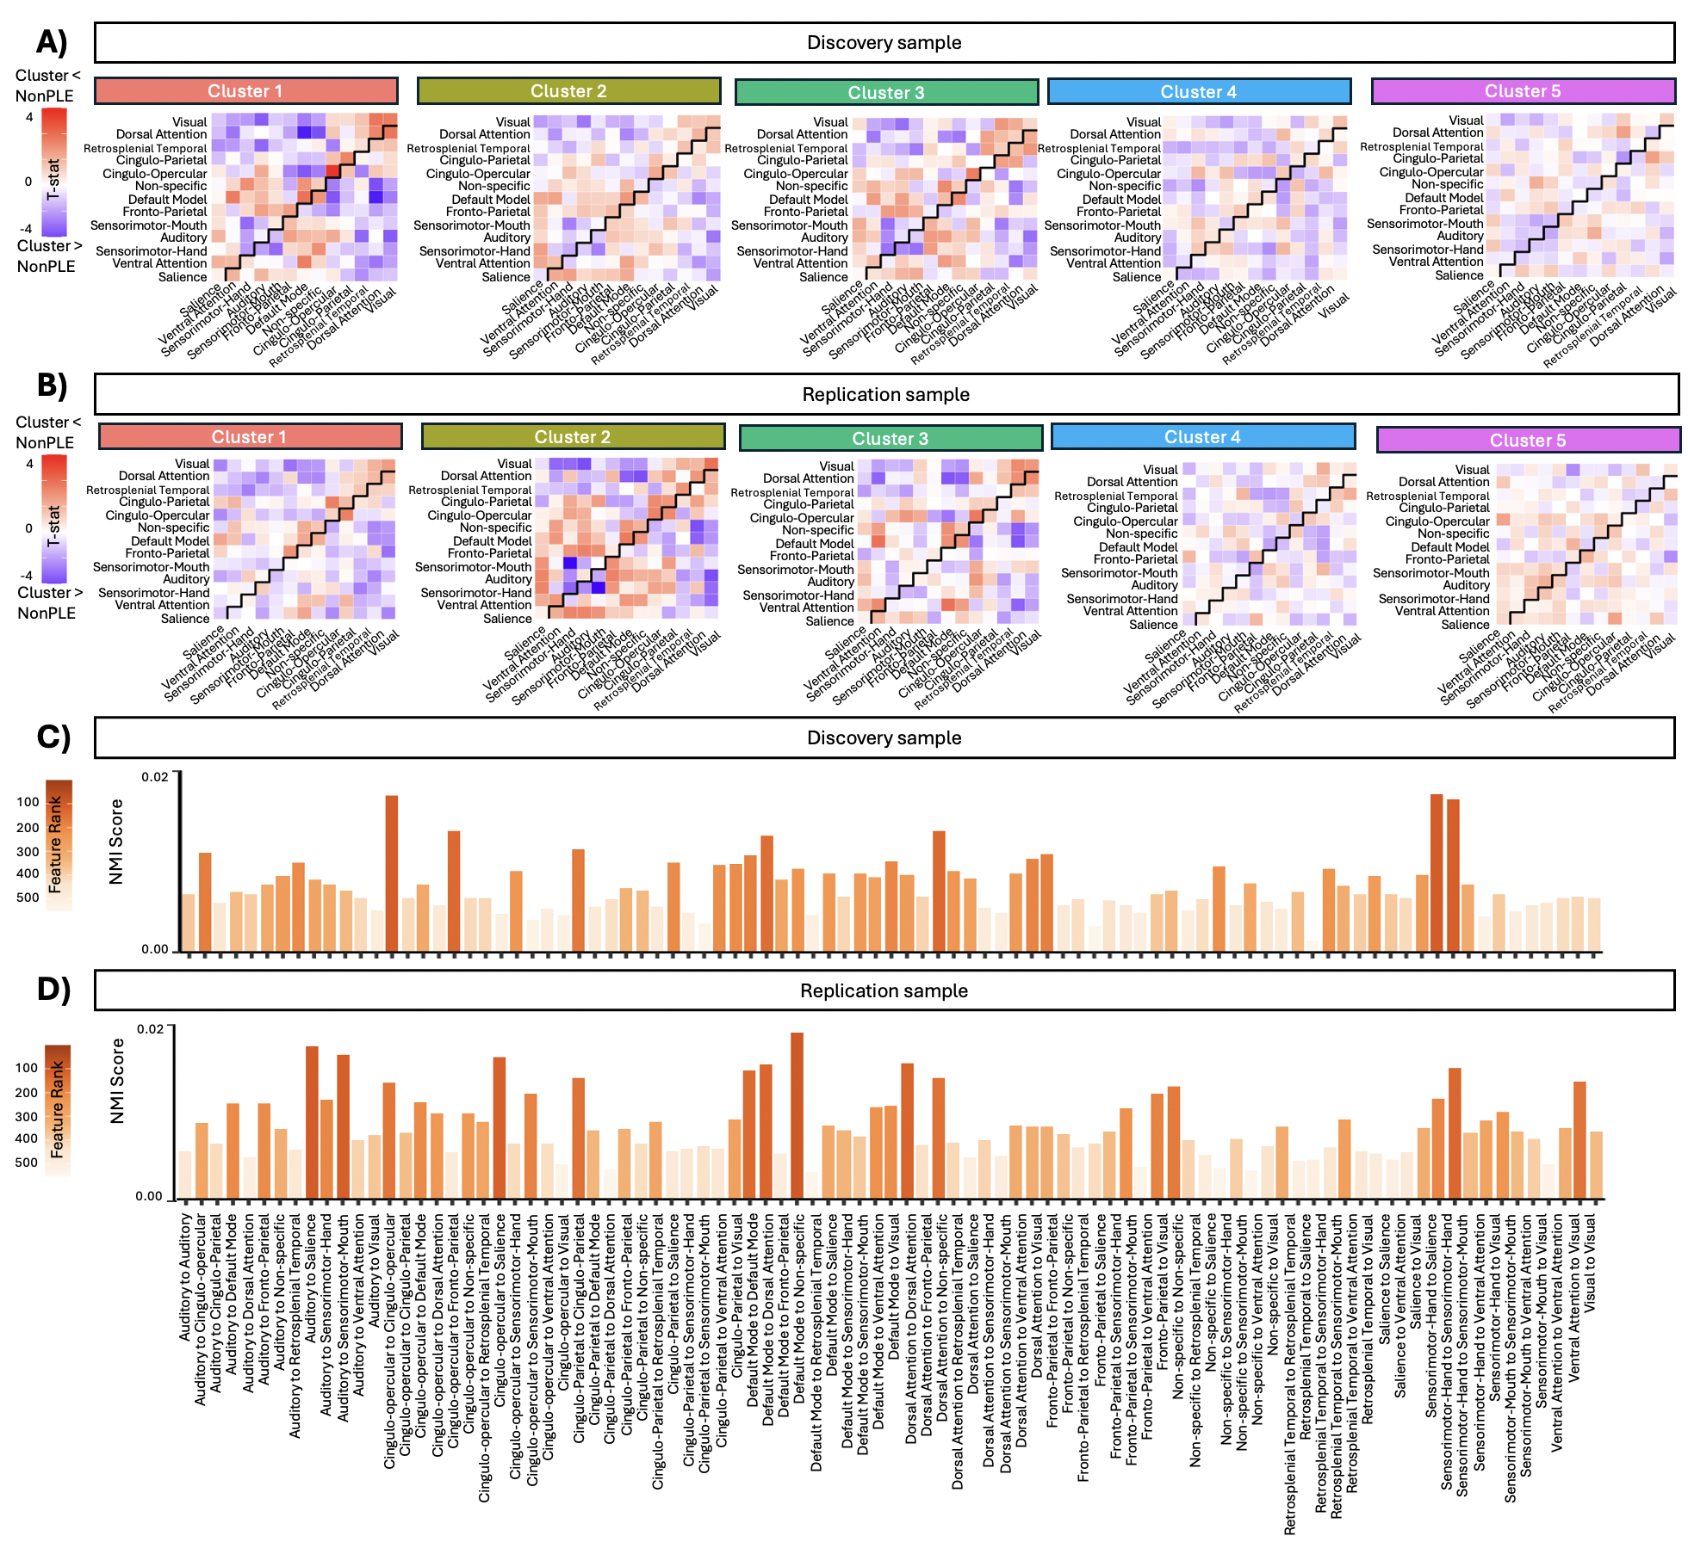
Supplementary Figure S7. Resting-state within and between-cortical network connectivity across data-driven clusters relative to the non-PLE group in discovery and replication samples. Heat maps illustrate resting-state connectivity differences (t-statistics) between each cluster and a comparison group of youth with no distressing psychotic-like experiences (NonPLE). T-statistics are shown for visualization purposes only and are not thresholded for statistical significance. Warmer colors indicate regions where clusters show lower connectivity than non-PLE (i.e., Cluster < NonPLE), and cooler colors indicate regions with greater connectivity (i.e., Cluster > NonPLE). Barplots display Normalized Mutual Information (NMI) scores for all resting-state within and between cortical network features (n = 91) used in clustering, with higher scores indicating stronger feature importance. Bars are colored by rank, with darker colors representing higher-ranking features. Results are shown for the discovery (A, C) and replication sample (B, D).
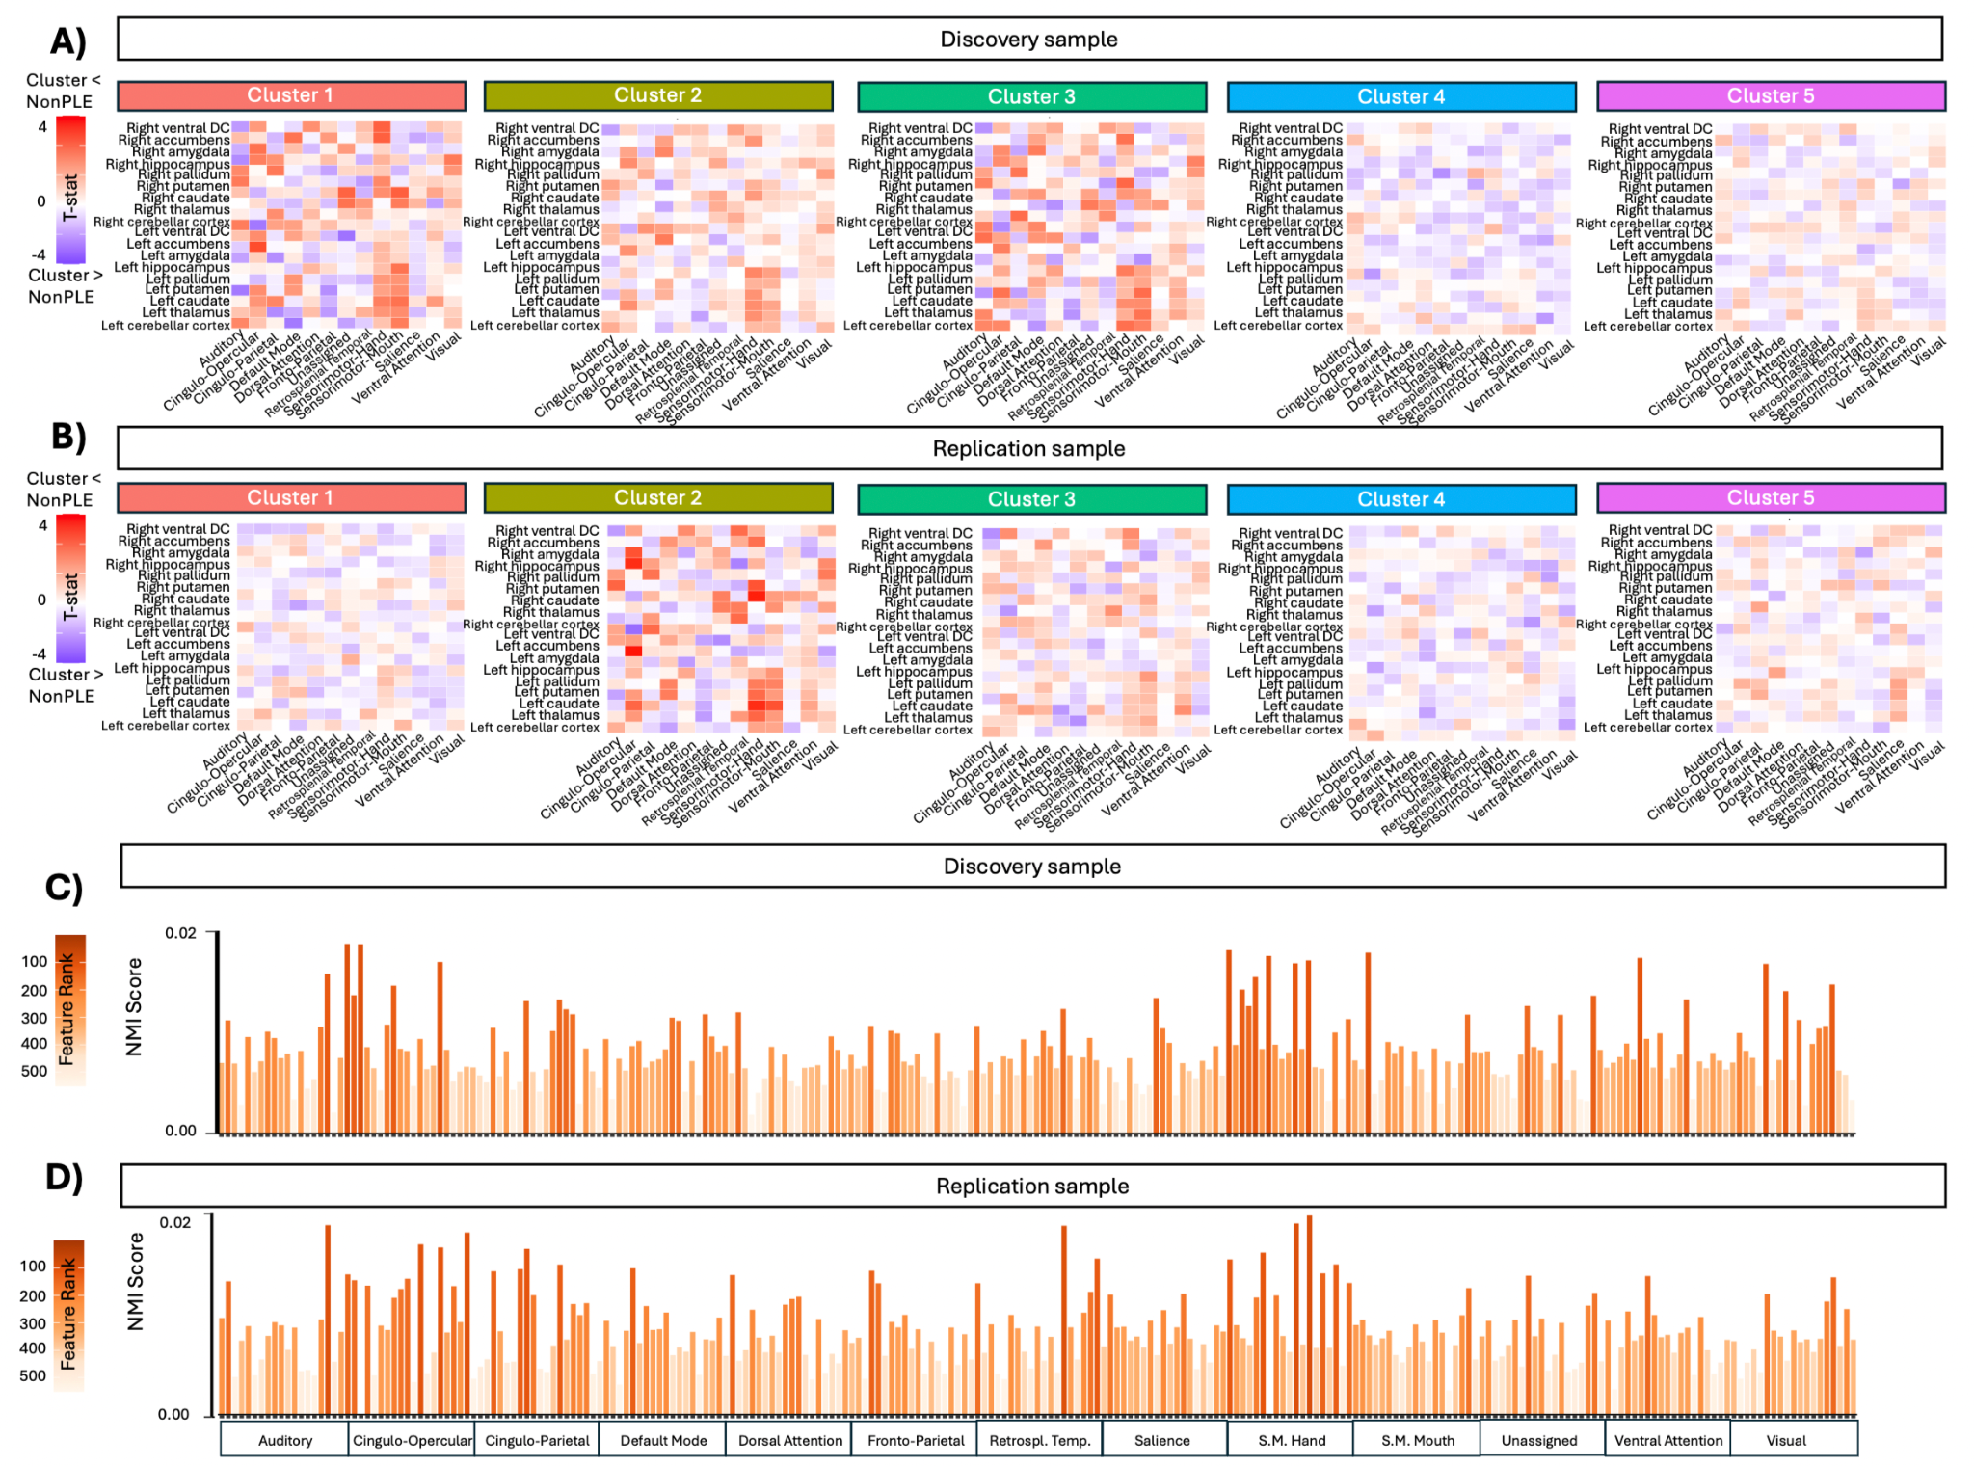
Supplementary Figure S8. Resting-state network to subcortical Regions of Interest (ROI) connectivity across data-driven clusters relative to the non-PLE group in discovery and replication samples. Heat maps illustrate resting-state connectivity differences (t-statistics) between each cluster and a comparison group of youth with no distressing psychotic-like experiences (NonPLE). T-statistics are shown for visualization purposes only and are not thresholded for statistical significance. Warmer colors indicate regions where clusters show lower connectivity than non-PLE (i.e., Cluster < NonPLE), and cooler colors indicate regions with greater connectivity (i.e., Cluster > NonPLE). Barplots display Normalized Mutual Information (NMI) scores for all resting-state network-to-subcortical ROI features (n = 247) used in clustering, with higher scores indicating stronger feature importance. Bars are colored by rank, with darker colors representing higher-ranking features. Labels are presented by network for simplicity and ease of reading. Results are shown for the discovery (A, C) and replication sample (B, D).
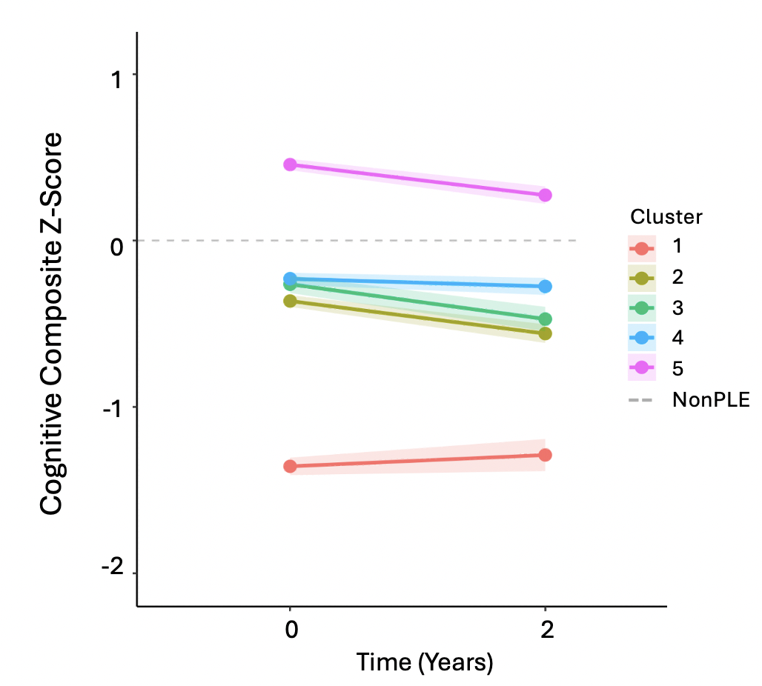
Supplementary Figure S9. Cognitive composite scores at baseline and 2-year follow-up (z-scored to the NonPLE group at each time point). Dots represent group means, shaded ribbons show ±95% confidence intervals, and the dashed horizontal line indicates the NonPLE reference (z = 0).
Supplementary Table S1: Overview of Environmental Measures and Source Instruments

Measure | Category: Informant | Source
Family Mental Health | Broad Psychopathology: Parent | Family History Assessment Survey
Total Neighborhood Safety | Community: Parent | PhenX Neighborhood Safety/Crime Survey
Perceived discrimination | Community: Youth | ABCD Youth Discrimination Measure
Ethnic Identity | Culture: Youth | Multi-Group Ethnic Identity
Family Independence | Culture: Youth | Mexican American Cultural Values Scale
Family Obligation | Culture: Youth | Mexican American Cultural Values Scale
Family Referent | Culture: Youth | Mexican American Cultural Values Scale
Family Support | Culture: Youth | Mexican American Cultural Values Scale
Economic Deprivation | Demographics: Parent | ABCD Parent Demographics Survey
Income | Demographics: Parent | ABCD Parent Demographics Survey
Maternal Age | Demographics: Parent | ABCD Parent Demographics Survey
Parental Education | Demographics: Parent | ABCD Parent Demographics Survey
Paternal Age | Demographics: Parent | ABCD Parent Demographics Survey
Birth Complications | Development: Parent | Developmental History Questionnaire
Birth Weight | Development: Parent | Developmental History Questionnaire
Breastfeeding | Development: Parent | Developmental History Questionnaire
Illness | Development: Parent | Developmental History Questionnaire
Maternal Substance Use | Development: Parent | Developmental History Questionnaire
Motor Development | Development: Parent | Developmental History Questionnaire
Pregnancy Complication | Development: Parent | Developmental History Questionnaire
Premature | Development: Parent | Developmental History Questionnaire
Verbal Development | Development: Parent | Developmental History Questionnaire
Family Conflict Total | Family: Youth | PhenX Family Environment Scale
NO2 Pollution | Linked data- Air Pollution | Air Quality Data for Health-Related Applications
PM Pollution | Linked data- Air Pollution | Air Quality Data for Health-Related Applications
Crime | Linked data- Built Environment | ICPSR
Population Density | Linked data- Built Environment | EPA
Lead Risk | Linked data- Built Environment | Vox
Road proximity | Linked data- Built Environment | Kalibrate
Walk index | Linked data- Built Environment | EPA
Area Deprivation Index National Percentage | Linked data- Neighborhood Composite Measures | Residential Geocodes
Traumatic Brain Injury | Medical: Parent | Ohio State TBI Screen
Parenting Monitoring Total | Parenting: Youth | Parental Monitoring Survey
Total Caregiver Support | Parenting: Youth | Children's Report of Parental Behavioral Inventory
Total Parental Support | Parenting: Youth | Children's Report of Parental Behavior Inventory
Number of Friends | Peers: Youth | Youth Resilience Scale
Total School Environment | School: Youth | PhenX School Risk & Protective Factors Survey
Total Traumatic Events | Stress: Parent | KSADS Diagnostic Interview for DSM-5
Bad Events | Stress: Youth | Life Events Scale
Good events | Stress: Youth | Life Events Scale
Substance Availability | SU Environment: Parent | PhenX Community Risk and Protective Factors
Note. This table summarizes the environmental variables included in analyses, categorized by domain and, where applicable, informant type (i.e., parent or youth). Each measure is listed alongside the original scale or questionnaire from which it was derived.

Supplementary Table S2: Participant Demographics and Baseline Behavioral Scores Stratified by Cluster
A) Discovery sample (n = 858)
 | Non-PLE  (n = 5,225) | Cluster 1  (n = 102) | Cluster 2  (n = 179) | Cluster 3  (n = 159) | Cluster 4  (n = 247) | Cluster 5  (n = 171) | Stat (p-value) | Post hoc
Sex (Male) | 2,661 (50.9%) | 47 (46.1%) | 80 (44.7%) | 87 (54.7%) | 135 (54.7%) | 83 (48.5%) | x² =6.31  (p=0.178) | n.s.
Age (Years) | 10.0 ± 0.6 | 9.7 ± 0.6 | 9.8 ± 0.6 | 9.9 ± 0.6 | 9.7 ± 0.6 | 10.2 ± 0.6 | F=17.12  (p<0.001) | 5 > 1, 2, 3, 4;  3 > 1, 4
Race  White  Black  Hispanic  Asian  Other | 3036 (58.1%)  574 (11.0%)  974 (28.6%)  112 (2.1%)  529 (10.1%) | 18 (17.8%)  41 (40.6%)  33 (32.7%)  0 (0.0%)  9 (8.9%) | 57 (31.8%)  36 (20.1%)  64 (35.8%)  2 (1.1%)  20 (11.2%) | 37 (23.3%)  49 (30.8%)  57 (35.8%)  4 (2.5%)  12 (7.5%) | 151 (61.1%)  21 (8.5%)  44 (17.8%)  1 (0.4%)  30 (12.1%) | 102 (59.6%)  11 (6.4%)  36 (21.1%)  5 (2.9%)  17 (9.9%) | x² =162.38  (p<0.001) | 4, 5 ↑; 1, 2, 3 ↓  1, 3 ↑; 4, 5 ↓  2, 3 ↑; 4, 5 ↓  n.s.  n.s.
NIH Toolbox Total | 88.2 ± 8.6 | 68.9 ± 5.33 | 84.4 ± 6.12 | 84.8 ± 6.25 | 83.6 ± 5.98 | 94.9 ± 4.48 | F=333.90  (p<0.001) | 2, 3, 4, 5, > 1; 5 > 2, 3, 4
PQ-BC Total | 1.7 ± 2.8 | 22.0 ± 16.2 | 18.0 ± 12.7 | 19.0 ± 12.7 | 17.5 ± 12.1 | 17.4 ± 13.0 | F=2.62  (p=0.034) | 1 > 4, 5
CBCL Total | 44.8 ± 10.7 | 51.4 ± 12.4 | 48.4 ± 12.3 | 46.9 ± 12.6 | 48.1 ± 11.5 | 47.8 ± 10.4 | F=2.42  (p=0.047) | 1 > 3
B) Replication sample (n = 858)
 | Non-PLE  (n = 5,225) | Cluster 1  (n = 85) | Cluster 2  (n = 238) | Cluster 3  (n = 127) | Cluster 4  (n = 228) | Cluster 5  (n = 180) | Stat (p-value) | Post hoc
Sex (Male) | 2,661 (50.9%) | 50 (58.8%) | 102 (42.9%) | 70 (55.1%) | 95 (41.7%) | 101 (56.1%) | x² =19.71  (p=0.011) | 5 ↑; 2, 4 ↓
Age (Years) | 10.0 ± 0.6 | 9.5 ± 0.5 | 9.8 ± 0.6 | 10.0 ± 0.6 | 9.8 ± 0.6 | 10.0 ± 0.6 | F=12.41  (p<0.001) | 5 > 1, 2, 4;  3 > 1, 4;  2, 4 > 1
Race  White  Black  Hispanic  Asian  Other | 3036 (58.1%)  574 (11.0%)  974 (28.6%)  112 (2.1%)  529 (10.1%) | 20 (23.5%)  30 (35.3%)  23 (27.1%)  0 (0.0%)  12 (14.1%) | 56 (23.5%)  77 (32.4%)  70 (29.4%)  3 (1.3%)  32 (13.4%) | 47 (37.0%)  19 (15.0%)  40 (31.5%)  2 (1.6%)  19 (15.0%) | 129 (56.6%)  20 (8.8%)  54 (23.7%)  3 (1.3%)  22 (9.6%) | 112 (62.2%)  9 (5.0%)  30 (16.7%)  7 (3.9%)  22 (12.2%) | x² =143.32  (p<0.001) | 4, 5 ↑; 1, 2 ↓  1, 2 ↑; 4, 5 ↓  5 ↓  5 ↑  n.s.
NIH Toolbox Total | 88.2 ± 8.6 | 69.3 ± 4.7 | 82.4 ± 4.6 | 84.1 ± 7.0 | 85.4 ± 6.2 | 93.4 ± 5.1 | F=282.80  (p<0.001) | 2, 3, 4, 5 > 1;  5 > 2, 3, 4;  3, 4 > 2
PQ-BC Total | 1.7 ± 2.8 | 17.9 ±12.0 | 19.2 ± 15.5 | 16.4 ± 10.7 | 18.3 ±14.2 | 16.6 ±11.2 | F=1.51  (p=0.197) | n.s.
CBCL Total | 44.8 ± 10.7 | 51.1 ± 11.5 | 48.2 ± 12.3 | 48.4 ±12.1 | 47.4 ± 10.8 | 47.0 ± 11.3 | F=2.02  (p=0.089) | n.s.
Note. All descriptive statistics are represented as means with standard deviations, except for sex and race, where counts are reported with percentages in brackets. The reference group (Non-PLE) is shown for descriptive purposes only; pairwise comparisons were conducted among the five data-driven clusters. For categorical tests, standardized residual > |2|, indicated significant deviations from expected counts based on the Chi-square test (↑ represents higher than expected, lower than expected ↓). For all other measures, ANOVAS followed by Tukey’s HSD tests were used to test cluster differences. PQ-BC (Prodromal Questionnaire–Brief Child Version) total scores are distress-weighted. CBCL = Child Behavior Checklist

Supplementary Table S3: Analysis of variance (ANOVA) results for cognitive performance cluster differences in the discovery sample (n = 858).
Feature | Sum of Squares | F-stat | Eta squared | p-value | pFDR | post hoc
NIH Tbx List Sorting Working Memory | 45664.04 | 113.93 | 0.348 | <0.001 | <0.001 | 2, 3, 4, 5 > 1  5 > 2, 3, 4
NIH Tbx Picture Sequence Memory | 42051.96 | 109.08 | 0.338 | <0.001 | <0.001 | 2, 3, 4, 5 > 1  5 > 2, 3, 4  2 > 3, 4
NIH Tbx Flanker Inhibitory Control and Attention | 24797.23 | 98.08 | 0.315 | <0.001 | <0.001 | 2, 3, 4, 5 >1  5 > 2, 4  3 > 4
NIH Tbx Dimensional Change Card Sort | 24908.70 | 93.59 | 0.305 | <0.001 | <0.001 | 2, 3, 4, 5 >1  5 > 2, 3, 4  2, 3 > 4
NIH Tbx Picture Vocabulary | 16097.28 | 91.86 | 0.301 | <0.001 | <0.001 | 2, 3, 4, 5 > 1  5 > 2, 3, 4  4 > 2, 3
WISC-V Matrix Reasoning Task | 3551.06 | 86.81 | 0.289 | <0.001 | <0.001 | 2, 3, 4, 5 > 1  5 > 2, 3, 4  3, 4 > 2
Rey Auditory Verbal Learning Task | 43159.57 | 82.40 | 0.279 | <0.001 | <0.001 | 2, 3, 4, 5 > 2  5 > 2, 3, 4
Little Man Task | 6677.95 | 82.15 | 0.278 | <0.001 | <0.001 | 2, 3, 4, 5 > 1  5 > 2, 3, 4
NIH Tbx Pattern Comparison Processing Speed | 48864.62 | 78.07 | 0.268 | <0.001 | <0.001 | 2, 3, 4, 5 > 1  5 > 2, 3, 4  2,3 > 4
NIH Tbx Oral Reading Recognition | 9313.73 | 70.63 | 0.249 | <0.001 | <0.001 | 2, 3, 4, 5 > 1  5 > 2, 3, 4  3, 4 > 2
Note. only significant group and pairwise differences after FDR correction are shown

Supplementary Table S4: Analysis of variance (ANOVA) results for cognitive performance cluster differences in the replication sample (n = 858).
Feature | Sum of Squares | F-stat | Eta squared | p-value | pFDR | post hoc
NIH Tbx Flanker Inhibitory Control and Attention | 24560.61 | 98.31 | 0.316 | <0.001 | <0.001 | 2, 3, 4, 5 > 1  5 > 2, 3, 4  2 > 3, 4
NIH Tbx Picture Vocabulary | 14870.65 | 96.12 | 0.311 | <0.001 | <0.001 | 2, 3, 4, 5 > 1  5 > 2, 3, 4  3, 4 > 2
NIH Tbx Pattern Comparison Processing Speed | 52327.70 | 89.25 | 0.295 | <0.001 | <0.001 | 2, 3, 5 > 1  5 > 2, 3, 4  2, 3 > 4  2 > 3
WISC-V Matrix Reasoning Task | 3292.41 | 85.25 | 0.286 | <0.001 | <0.001 | 2, 3, 4, 5 > 1  5 > 2, 3, 4  4 > 2, 3
NIH Tbx List Sorting Working Memory | 38491.79 | 85.13 | 0.285 | <0.001 | <0.001 | 2, 3, 4, 5 > 1  5 > 2, 3, 4  3, 4 > 2
NIH Tbx Oral Reading Recognition | 10450.38 | 84.63 | 0.284 | <0.001 | <0.001 | 2, 3, 4, 5 > 1  5 > 2, 3, 4  3, 4 > 2
Rey Auditory Verbal Learning Task | 38172.45 | 81.95 | 0.278 | <0.001 | <0.001 | 2, 3, 4, 5 > 1  4, 5 > 3, 2  3 > 2
NIH Tbx Dimensional Change Card Sort | 21156.86 | 79.94 | 0.273 | <0.001 | <0.001 | 2, 3, 4, 5 > 1  5 > 2, 3, 4  2 > 4
Little Man Task | 6041.41 | 66.35 | 0.237 | <0.001 | <0.001 | 2, 4, 5 > 1  5 > 2, 3, 4  4 > 3
NIH Tbx Picture Sequence Memory | 16164.07 | 33.39 | 0.135 | <0.001 | <0.001 | 2, 3, 4, 5 > 1  4, 5 > 2, 3
Note. only significant group and pairwise differences after FDR correction are shown
Supplementary Table S5: Analysis of variance (ANOVA) results for environmental factors cluster differences in the Discovery sample (n = 858).
Feature | Sum of Squares | F-stat | Eta squared | p-value | pFDR | post hoc
Income | 860.64 | 41.83 | 0.164 | <0.001 | <0.001 | 2, 4, 5 > 1  4, 5 > 2, 3
Parental Education | 756.68 | 29.43 | 0.121 | <0.001 | <0.001 | 4, 5 > 1, 2, 3
Area Deprivation Index National Percentage | 60120.94 | 22.21 | 0.094 | <0.001 | <0.001 | 1 > 2, 4, 5  2, 3 > 4, 5
Lead Risk | 657.88 | 18.62 | 0.080 | <0.001 | <0.001 | 1 > 2, 4, 5  2, 3 > 4, 5
Maternal Age | 2362.53 | 14.15 | 0.062 | <0.001 | <0.001 | 4, 5 > 1, 2, 3
Paternal Age | 2772.04 | 12.7 | 0.056 | <0.001 | <0.001 | 4, 5 > 1, 2, 3
Total Neighbourhood Safety | 49.63 | 12.55 | 0.056 | <0.001 | <0.001 | 4, 5 > 1, 3  5 > 2
Family Independence | 15.28 | 10.17 | 0.046 | <0.001 | <0.001 | 1 > 4, 5  2, 3 > 4, 5
Family Referent | 22.87 | 10.02 | 0.045 | <0.001 | <0.001 | 1, 3 > 4, 5  2 > 5
Substance Availability | 175.59 | 9.61 | 0.043 | <0.001 | <0.001 | 4, 5 > 1, 3  4 > 2
Family Obligation | 15.93 | 9.29 | 0.042 | <0.001 | <0.001 | 1, 3 > 4, 5  2 > 5
Discrimination | 2.18 | 8.15 | 0.037 | <0.001 | <0.001 | 1 > 2, 4, 5  3 > 5
Bad Events | 1317.33 | 7.26 | 0.033 | <0.001 | <0.001 | 1, 2, 3 > 5
Family Support | 6.86 | 5.12 | 0.023 | <0.001 | <0.001 | 1 > 5  2 > 4, 5
Total School Environment | 187.08 | 4.92 | 0.023 | <0.001 | 0.0017 | 2 > 3, 4, 5
Total Caregiver Support | 2.68 | 4.76 | 0.022 | <0.001 | 0.0022 | 1 > 4, 5
Gross Density | 773.4 | 4.68 | 0.021 | 0.001 | 0.0024 | 1 > 4
Verbal Development | 20.26 | 4.34 | 0.020 | 0.0018 | 0.004 | 1, 4 > 5
Parental Monitoring Total | 5.31 | 4.28 | 0.020 | 0.002 | 0.0042 | 5 > 3, 4  2 > 3
Pregnancy Complications | 16.83 | 4.16 | 0.019 | 0.0024 | 0.0049 | 1, 3 > 5
PM Pollution | 33.34 | 4.14 | 0.019 | 0.0025 | 0.0049 | 2 > 4, 5
Good Events | 93.39 | 3.6 | 0.017 | 0.0064 | 0.0119 | 5 > 4
Crime | 93566880000 | 3.13 | 0.014 | 0.0143 | 0.0245 | 2 > 4
Proximity to Roads | 10289180 | 3.08 | 0.014 | 0.0156 | 0.0256 | 2 > 4
Maternal Substance Use | 1.44 | 2.64 | 0.012 | 0.0328 | 0.0499 | 4 > 5
Note. only significant group and pairwise differences after FDR correction are shown
Supplementary Table S6: Analysis of variance (ANOVA) results for environmental factors cluster differences in the replication sample (n = 858).
Feature | Sum of Squares | F-stat | Eta squared | p-value | pFDR | post hoc
Parental Education | 1071.76 | 43.61 | 0.170 | <0.001 | <0.001 | 3, 4, 5 > 1, 2  4, 5 > 3
Income | 766.72 | 39.36 | 0.156 | <0.001 | <0.001 | 3, 4, 5 > 1, 2  4, 5 > 3
Maternal Age | 3501.64 | 24.59 | 0.103 | <0.001 | <0.001 | 4, 5 > 1, 2, 3  3 > 2
Area Deprivation Index National Percentage | 63030.11 | 23.98 | 0.101 | <0.001 | <0.001 | 1 > 3, 4, 5  2 > 4, 5  3 > 5
Paternal Age | 3405.49 | 17.84 | 0.077 | <0.001 | <0.001 | 1, 3, 4, 5 > 2  4 > 3
Family Referent | 26.24 | 12.26 | 0.054 | <0.001 | <0.001 | 1, 2 > 4, 5
Total Neighbourhood Safety | 44.92 | 11.92 | 0.053 | <0.001 | <0.001 | 4, 5 > 1, 2  3 > 1
Lead Risk | 399.39 | 11.49 | 0.051 | <0.001 | <0.001 | 1, 2 > 4, 5  3 > 5
Discrimination | 2.15 | 9.98 | 0.045 | <0.001 | <0.001 | 1 > 2, 3, 4, 5  2 > 4
Months breastfed | 2147.11 | 9.19 | 0.041 | <0.001 | <0.001 | 4, 5 > 1, 2
Family obligation | 15.39 | 9.06 | 0.041 | <0.001 | <0.001 | 1, 2 > 4  2 > 5
Bad events | 1134.47 | 8.29 | 0.037 | <0.001 | <0.001 | 1, 2 > 4, 5
Family Support | 8.74 | 6.58 | 0.03 | <0.001 | <0.001 | 2 > 4, 5
Motor Development | 15.92 | 5.87 | 0.027 | <0.001 | <0.001 | 1, 3, 4 > 2
Verbal Development | 20.45 | 5.54 | 0.025 | <0.001 | <0.001 | 1 > 2, 4, 5
Pregnancy Complications | 21.5 | 5.05 | 0.023 | <0.001 | 0.001 | 1, 2, 3 > 5
Substance Availability | 75.63 | 4.66 | 0.021 | <0.001 | 0.002 | 4, 5 > 2  5 > 1
Parental Monitoring | 4.69 | 4.00 | 0.018 | 0.003 | 0.007 | 4 > 1, 2
Ethnic Identity | 12.79 | 3.94 | 0.018 | 0.003 | 0.008 | 2, 3 > 4
Total Caregiver Support | 2.4 | 3.91 | 0.018 | 0.004 | 0.008 | 3, 4 > 5
PM Pollution | 31.17 | 3.76 | 0.017 | 0.005 | 0.010 | 2 > 5
Family Independence | 5.26 | 3.67 | 0.017 | 0.006 | 0.010 | 1 > 3
Weeks Premature | 54.09 | 3.66 | 0.017 | 0.006 | 0.010 | 3 > 2
Good Events | 94.56 | 3.53 | 0.016 | 0.007 | 0.012 | 5 > 1
Traumatic Events | 9.02 | 3.47 | 0.016 | 0.008 | 0.013 | 2 > 5
Total School Environment | 114.67 | 3.00 | 0.014 | 0.018 | 0.028 | 1 > 5
Note. only significant group and pairwise differences after FDR correction are shown
Supplementary Table S7: Analysis of variance (ANOVA) results for cortical thickness features cluster differences in the discovery sample (n = 858).
Feature | Sum of Squares | F-stat | Eta squared | p-value | pFDR | post hoc
Right Inferior Parietal | 1.83 | 48.52 | 0.185 | <0.001 | <0.001 | 1, 2, 4, 5 > 3  4 > 1, 2, 5
Right Middle Temporal | 2.78 | 45.9 | 0.177 | <0.001 | <0.001 | 1, 2, 4, 5 > 3  4 > 1, 5
Left Lateral Occipital | 1.84 | 43.35 | 0.169 | <0.001 | <0.001 | 1, 2, 4, 5 > 3  4 >1, 2, 5  5 > 1
Left Rostral Middle Frontal | 1.49 | 40.15 | 0.158 | <0.001 | <0.001 | 1, 2, 4, 5 > 3  4 > 1, 5
Left Inferior Parietal | 1.61 | 40.06 | 0.158 | <0.001 | <0.001 | 1, 2, 4, 5 > 3  4 > 2, 5
Right Lateral Occipital | 1.71 | 39.74 | 0.157 | <0.001 | <0.001 | 1, 2, 4, 5 > 3  4 > 1, 2, 5  5 > 1
Left Superior Parietal | 1.43 | 38.6 | 0.153 | <0.001 | <0.001 | 1, 2, 4, 5 > 3  4 > 1, 2, 5
Left Precuneus | 1.19 | 37.9 | 0.151 | <0.001 | <0.001 | 1, 2, 4, 5 > 3  4 > 1, 2, 5
Right Precuneus | 1.21 | 37.77 | 0.15 | <0.001 | <0.001 | 1, 2, 4, 5 > 3  4 > 1, 2, 5
Right Superior Parietal | 1.41 | 37.73 | 0.15 | <0.001 | <0.001 | 1, 2, 4, 5 > 3  4 > 1, 2, 5
Right Rostral Middle Frontal | 1.35 | 35.75 | 0.144 | <0.001 | <0.001 | 1, 2, 4, 5 > 3  4 > 5
Left Lingual | 1.67 | 34.93 | 0.141 | <0.001 | <0.001 | 1, 2, 4, 5 > 3  4 > 1, 2, 5  5 > 1
Right Superior Temporal | 2.13 | 34.76 | 0.140 | <0.001 | <0.001 | 1, 2, 4, 5 > 3  4 > 1, 2, 5
Right Paracentral | 1.84 | 34.3 | 0.139 | <0.001 | <0.001 | 1, 2, 4, 5 > 3  4 > 1, 2, 5
Left Fusiform | 1.24 | 33.78 | 0.137 | <0.001 | <0.001 | 1, 2, 4, 5 > 3  4 > 1, 2, 5
Left Supramarginal | 1.86 | 33.74 | 0.137 | <0.001 | <0.001 | 1, 2, 4, 5 > 3  4 > 1, 5
Right Cuneus | 1.87 | 32.8 | 0.133 | <0.001 | <0.001 | 1, 2, 4, 5 > 3  4 > 1, 2
Right Supramarginal | 1.61 | 31.61 | 0.129 | <0.001 | <0.001 | 1, 2, 4, 5 > 3  4 > 1, 5
Right Fusiform | 1.24 | 30.61 | 0.126 | <0.001 | <0.001 | 1, 2, 4, 5 > 3  4 > 1, 2, 5
Right Superior Frontal | 1.35 | 30.05 | 0.124 | <0.001 | <0.001 | 1, 2, 4, 5 > 3
Left Inferior Temporal | 1.59 | 29.77 | 0.123 | <0.001 | <0.001 | 1, 2, 4, 5 > 3  4 > 1, 2  5 > 1
Right Lingual | 1.4 | 29.27 | 0.121 | <0.001 | <0.001 | 1, 2, 4, 5 > 3  4 > 1, 2, 5
Right Inferior Temporal | 1.57 | 29.1 | 0.120 | <0.001 | <0.001 | 1, 2, 4, 5 > 3  4 > 1, 2, 5
Left Superior Temporal | 1.9 | 29 | 0.120 | <0.001 | <0.001 | 1, 2, 4, 5 > 3  4 > 1, 5
Left Cuneus | 1.77 | 28.32 | 0.117 | <0.001 | <0.001 | 1, 2, 4, 5 > 3  4 > 1, 2
Left Superior Frontal | 1.33 | 28.08 | 0.116 | <0.001 | <0.001 | 1, 4, 5, 3 > 3  2, 4 > 5
Left Lateral Orbitofrontal | 1.22 | 26.82 | 0.112 | <0.001 | <0.001 | 1, 2, 4, 5 > 3  4 > 1, 5
Right Pars Triangularis | 1.45 | 26.77 | 0.112 | <0.001 | <0.001 | 1, 2, 4, 5 > 3  4 > 5
Left Middle Temporal | 2.16 | 26.69 | 0.111 | <0.001 | <0.001 | 1, 2, 4, 5 > 3  4 > 1, 5  2 > 1
Left Postcentral | 1.57 | 25.74 | 0.108 | <0.001 | <0.001 | 1, 2, 4, 5 > 3  4 > 1, 2
Right Pars Orbitalis | 2.45 | 25.29 | 0.106 | <0.001 | <0.001 | 1, 2, 4, 5 > 3  2, 4 > 5
Left Precentral | 1.32 | 24.46 | 0.103 | <0.001 | <0.001 | 2, 4, 5 > 3  4, 5 > 1, 2
Left Pars Triangularis | 1.39 | 23.51 | 0.099 | <0.001 | <0.001 | 1, 2, 4, 5 > 3  4 > 1, 5
Right Lateral Orbitofrontal | 1.21 | 23.15 | 0.098 | <0.001 | <0.001 | 1, 2, 4, 5 > 3  4 > 1, 2, 5
Left Paracentral | 1.2 | 21.53 | 0.092 | <0.001 | <0.001 | 1, 2, 4, 5 > 3  4 > 1, 2
Right Postcentral | 1.51 | 20.81 | 0.089 | <0.001 | <0.001 | 1, 2, 4, 5 > 3  4 > 1
Left Pars Orbitalis | 1.99 | 20.31 | 0.087 | <0.001 | <0.001 | 1, 2, 4, 5 > 3
Left Pericalcarine | 1.46 | 20.19 | 0.087 | <0.001 | <0.001 | 1, 2, 4, 5 > 3  4 > 1, 2
Right Precentral | 1.53 | 19.81 | 0.085 | <0.001 | <0.001 | 1, 2, 4, 5 > 3  4, 5 > 1, 2
Right Pericalcarine | 1.5 | 19.35 | 0.083 | <0.001 | <0.001 | 1, 2, 4, 5 > 3  4 > 1, 2  5 > 2
Right Transverse Temporal | 2.3 | 18.63 | 0.080 | <0.001 | <0.001 | 1, 2, 4, 5 > 3  4 > 1, 2, 5
Right Bankssts | 1.69 | 18.58 | 0.080 | <0.001 | <0.001 | 1, 2, 4, 5 > 3
Left Caudal Middle Frontal | 1.04 | 18.33 | 0.079 | <0.001 | <0.001 | 1, 4, 5, 2 >3  4 > 1
Left Bankssts | 1.43 | 17.25 | 0.075 | <0.001 | <0.001 | 1, 2, 4, 5 > 3  4 > 1
Right Caudal Middle Frontal | 1.04 | 16.83 | 0.073 | <0.001 | <0.001 | 1, 2, 4, 5 >3
Right Pars Opercularis | 0.97 | 16.77 | 0.073 | <0.001 | <0.001 | 1, 2, 4, 5 > 3
Right Frontal Pole | 3.3 | 16.1 | 0.070 | <0.001 | <0.001 | 1, 2, 4, 5 > 3  1, 2, 4 > 5
Left Transverse Temporal | 1.81 | 16 | 0.070 | <0.001 | <0.001 | 2, 4, 5 > 3  4 > 1, 5
Left Insula | 0.91 | 14.43 | 0.063 | <0.001 | <0.001 | 1, 2, 4, 5 > 3
Left Parahippocampal | 3.03 | 14.3 | 0.063 | <0.001 | <0.001 | 2, 4, 5 > 3  4 > 1
Left Pars Opercularis | 0.75 | 13.21 | 0.058 | <0.001 | <0.001 | 1, 2, 4, 5 > 3
Left Frontal Pole | 2.57 | 12.53 | 0.055 | <0.001 | <0.001 | 1, 2, 4 >3, 5
Left Medial Orbitofrontal | 0.64 | 11.98 | 0.053 | <0.001 | <0.001 | 1, 2, 4 > 3, 5
Right Temporal Pole | 2.8 | 11.74 | 0.052 | <0.001 | <0.001 | 1, 2, 4, 5 > 3
Right Posterior Cingulate | 0.54 | 11.47 | 0.051 | <0.001 | <0.001 | 1, 2, 4, 5 >3
Right Medial Orbitofrontal | 0.54 | 10.21 | 0.046 | <0.001 | <0.001 | 1, 2, 4, 5 > 3  4 > 5
Right Parahippocampal | 1.47 | 9.99 | 0.045 | <0.001 | <0.001 | 2, 4, 5 > 3
Right Isthmus Cingulate | 0.66 | 9.08 | 0.041 | <0.001 | <0.001 | 1, 2, 4, 5 > 3
Left Temporal Pole | 1.93 | 8.59 | 0.039 | <0.001 | <0.001 | 2, 4, 5 > 3  4 > 1
Right Insula | 0.58 | 7.89 | 0.036 | <0.001 | <0.001 | 1, 2, 4, 5 > 3
Left Entorhinal | 1.78 | 7.16 | 0.032 | <0.001 | <0.001 | 2, 4, 5 > 3  5 > 1
Left Isthmus Cingulate | 0.52 | 7.12 | 0.032 | <0.001 | <0.001 | 1, 2, 4, 5 > 3
Left Posterior Cingulate | 0.39 | 7.01 | 0.032 | <0.001 | <0.001 | 4, 5 > 3  4 > 1
Right Caudal Anterior Cingulate | 0.64 | 5.4 | 0.025 | <0.001 | <0.001 | 1, 2, 4 > 3
Left Rostral Anterior Cingulate | 0.46 | 4.71 | 0.022 | <0.001 | 0.001 | 4 > 3
Right Rostral Anterior Cingulate | 0.52 | 4.14 | 0.019 | 0.0025 | 0.0026 | 1, 2, 4 > 3
Right Entorhinal | 1.23 | 3.9 | 0.018 | 0.0038 | 0.0039 | 4, 5 > 1
Left Caudal Anterior Cingulate | 0.35 | 2.6 | 0.012 | 0.0347 | 0.0347 | 1, 4 > 3
Note. only significant group and pairwise differences after FDR correction are shown
Supplementary Table S8: Analysis of variance (ANOVA) results for cortical thickness features cluster differences in the replication sample (n = 858).
Feature | Sum of Squares | F-stat | Eta squared | p-value | pFDR | post hoc
Left Superior Frontal | 2.38 | 57.39 | 0.212 | <0.001 | <0.001 | 1, 2, 4, 5 > 3  4 > 2, 5
Right Superior Frontal | 2.41 | 54.19 | 0.203 | <0.001 | <0.001 | 1, 2, 4, 5 > 3  4 > 2, 5
Left Precuneus | 1.57 | 52.44 | 0.197 | <0.001 | <0.001 | 1, 2, 4, 5 > 3  4 > 2, 5
Right Precuneus | 1.55 | 47.89 | 0.183 | <0.001 | <0.001 | 1, 2, 4, 5 > 3  4 > 2
Left Superior Parietal | 1.38 | 40.29 | 0.159 | <0.001 | <0.001 | 1, 2, 4, 5 > 3  4 > 2, 5
Left Rostral Middle Frontal | 1.43 | 40.09 | 0.158 | <0.001 | <0.001 | 1, 2, 4, 5 > 3  4 > 2, 5  1 > 5
Right Superior Parietal | 1.38 | 39.81 | 0.157 | <0.001 | <0.001 | 1, 2, 4, 5 > 3  4 > 2
Right Rostral Middle Frontal | 1.56 | 37.94 | 0.151 | <0.001 | <0.001 | 1, 2, 4, 5 > 3  1, 4 > 2, 5
Right Inferior Parietal | 1.39 | 37.79 | 0.151 | <0.001 | <0.001 | 1, 2, 4, 5 > 3  4 > 2
Left Caudal Middle Frontal | 1.91 | 37.08 | 0.148 | <0.001 | <0.001 | 1, 2, 4, 5 > 3  4 > 2
Right Lateral Occipital | 1.5.0 | 35.73 | 0.143 | <0.001 | <0.001 | 1, 2, 4, 5 > 3  4, 5 > 2  5 > 1
Right Supramarginal | 2.00 | 34.9 | 0.141 | <0.001 | <0.001 | 1, 2, 4, 5 > 3  4 > 2
Left Precentral | 1.93 | 34.83 | 0.140 | <0.001 | <0.001 | 1, 2, 4, 5 > 3  4, 5 > 1, 2
Left Inferior Parietal | 1.23 | 32.56 | 0.132 | <0.001 | <0.001 | 1, 2, 4, 5 > 3  4 > 2
Right Middle Temporal | 2.14 | 32.33 | 0.132 | <0.001 | <0.001 | 1, 2, 4, 5 > 3  4, 5 > 2
Right Superior Temporal | 1.93 | 31.9 | 0.130 | <0.001 | <0.001 | 1, 2, 4, 5 > 3  4 > 2
Right Paracentral | 1.76 | 31.44 | 0.128 | <0.001 | <0.001 | 1, 2, 4, 5 > 3  4, 5 > 1, 2
Left Fusiform | 1.21 | 30.96 | 0.127 | <0.001 | <0.001 | 1, 2, 4, 5 > 3  4, 5 > 2
Right Caudal Middle Frontal | 1.83 | 30.47 | 0.125 | <0.001 | <0.001 | 1, 2, 4, 5 > 3
Right Inferior Temporal | 1.73 | 30.21 | 0.124 | <0.001 | <0.001 | 1, 2, 4, 5 > 3  4, 5 > 2
Left Superior Temporal | 2.00 | 29.39 | 0.121 | <0.001 | <0.001 | 1, 2, 4, 5 > 3  4 > 2
Left Lingual | 1.45 | 28.95 | 0.120 | <0.001 | <0.001 | 1, 2, 4, 5 > 3  4, 5 > 2
Left Lateral Occipital | 1.16 | 28.81 | 0.119 | <0.001 | <0.001 | 1, 2, 4, 5 > 3  4, 5 > 2
Left Supramarginal | 1.52 | 28.1 | 0.116 | <0.001 | <0.001 | 1, 2, 4, 5 > 3  4 > 2
Right Pars Orbitalis | 2.86 | 27.86 | 0.116 | <0.001 | <0.001 | 1, 2, 4, 5 > 3  4 > 2, 5
Left Cuneus | 1.80 | 27.54 | 0.114 | <0.001 | <0.001 | 1, 2, 4, 5 > 3  4, 5 > 2
Left Paracentral | 1.65 | 27.18 | 0.113 | <0.001 | <0.001 | 1, 2, 4, 5 > 3  4, 5 > 1, 2
Right Fusiform | 1.08 | 26.59 | 0.111 | <0.001 | <0.001 | 1, 2, 4, 5 > 3  4, 5 > 2
Left Lateral Orbitofrontal | 1.17 | 26.51 | 0.111 | <0.001 | <0.001 | 1, 2, 4, 5 > 3  4 > 2, 5
Left Pars Triangularis | 1.57 | 25.98 | 0.109 | <0.001 | <0.001 | 1, 2, 4, 5 > 3  4 > 5
Right Postcentral | 1.81 | 25.88 | 0.108 | <0.001 | <0.001 | 1, 2, 4, 5 > 3  4 > 2
Right Lateral Orbitofrontal | 1.19 | 25.65 | 0.107 | <0.001 | <0.001 | 1, 2, 4, 5 > 3  1, 4 > 2
Right Lingual | 1.30 | 24.96 | 0.105 | <0.001 | <0.001 | 1, 2, 4, 5 > 3  4, 5 > 2
Left Inferior Temporal | 1.39 | 24.93 | 0.105 | <0.001 | <0.001 | 1, 2, 4, 5 > 3  4 > 2
Left Postcentral | 1.46 | 24.77 | 0.104 | <0.001 | <0.001 | 1, 2, 4, 5 > 3  4, 5 > 2
Right Pars Opercularis | 1.27 | 24.43 | 0.103 | <0.001 | <0.001 | 1, 2, 4, 5 > 3  4 > 5
Right Pars Triangularis | 1.42 | 24.22 | 0.102 | <0.001 | <0.001 | 1, 2, 4, 5 > 3  4 > 2, 5
Right Cuneus | 1.44 | 23.76 | 0.100 | <0.001 | <0.001 | 1, 2, 4, 5 > 3  4 > 2
Left Middle Temporal | 1.73 | 23.61 | 0.100 | <0.001 | <0.001 | 1, 2, 4, 5 > 3  4, 5 > 2
Right Precentral | 1.71 | 23.48 | 0.099 | <0.001 | <0.001 | 1, 2, 4, 5 > 3  4 > 2
Right Parahippocampal | 3.27 | 22.52 | 0.096 | <0.001 | <0.001 | 1, 2, 4, 5 > 3  4 > 1, 2
Left Parahippocampal | 4.27 | 21.79 | 0.093 | <0.001 | <0.001 | 1, 2, 4, 5 > 3  4 > 1, 2, 5
Right Medial Orbitofrontal | 1.06 | 21.46 | 0.091 | <0.001 | <0.001 | 1, 2, 4, 5 > 3  1, 4 > 2, 5
Left Parsorbitalis | 2.15 | 21.13 | 0.090 | <0.001 | <0.001 | 1, 2, 4, 5 > 3
Left Bankssts | 1.62 | 20 | 0.086 | <0.001 | <0.001 | 1, 2, 4, 5 > 3  1, 4, 5 > 2
Left Transverse Temporal | 2.52 | 19.88 | 0.085 | <0.001 | <0.001 | 1, 2, 4, 5 > 3  1, 4 > 2
Left Pericalcarine | 1.22 | 18.25 | 0.079 | <0.001 | <0.001 | 1, 2, 4, 5 > 3
Left Pars Opercularis | 0.84 | 17.46 | 0.076 | <0.001 | <0.001 | 1, 2, 4, 5 > 3
Right Transverse Temporal | 1.97 | 16.84 | 0.073 | <0.001 | <0.001 | 1, 2, 4, 5 > 3  4 > 2
Left Frontal Pole | 3.54 | 15.75 | 0.069 | <0.001 | <0.001 | 1, 2, 4, 5 > 3  1, 4 > 5
Left Temporal Pole | 3.69 | 15.15 | 0.066 | <0.001 | <0.001 | 1, 2, 4, 5 > 3
Right Temporal Pole | 3.48 | 13.53 | 0.060 | <0.001 | <0.001 | 1, 2, 4, 5 > 3
Right Bankssts | 1.13 | 12.7 | 0.056 | <0.001 | <0.001 | 1,4, 5, 2 > 3  4 > 2
Left Medial Orbitofrontal | 0.72 | 12.14 | 0.054 | <0.001 | <0.001 | 1, 2, 4, 5 > 3
Right Pericalcarine | 0.91 | 12.13 | 0.054 | <0.001 | <0.001 | 1, 2, 4, 5 > 3
Right Isthmus Cingulate | 0.76 | 10.12 | 0.045 | <0.001 | <0.001 | 1, 4, 5 > 3  4 > 2
Left Entorhinal | 2.55 | 9.85 | 0.044 | <0.001 | <0.001 | 2, 4, 5 > 3  5 > 2, 4
Right Rostral Anterior Cingulate | 1.05 | 8.58 | 0.039 | <0.001 | <0.001 | 1, 2, 4 > 3, 5
Left Insula | 0.55 | 8.39 | 0.038 | <0.001 | <0.001 | 1, 2, 4, 5 > 3
Right Posterior Cingulate | 0.37 | 8.33 | 0.038 | <0.001 | <0.001 | 1, 2, 4, 5 > 3  4 > 2
Left Isthmus Cingulate | 0.56 | 7.84 | 0.035 | <0.001 | <0.001 | 1, 2, 4, 5 > 3  4 > 2
Right Frontal Pole | 1.43 | 6.96 | 0.032 | <0.001 | <0.001 | 1, 2, 4 > 3  1 > 5
Right Insula | 0.52 | 6.91 | 0.031 | <0.001 | <0.001 | 1, 4, 5 > 3  4 > 2
Left Posterior Cingulate | 0.32 | 5.87 | 0.027 | <0.001 | <0.001 | 4, 5 > 3  4 > 2
Left Rostral Anterior Cingulate | 0.61 | 5.54 | 0.025 | <0.001 | 0.001 | 1, 2, 4 > 3
Right Entorhinal | 1.37 | 4.35 | 0.020 | 0.0017 | 0.0017 | 4, 5 > 3
Right Caudal Anterior Cingulate | 0.32 | 2.64 | 0.012 | 0.033 | 0.033 | 1, 2, 4 > 5, 3
Note. only significant group and pairwise differences after FDR correction are shown

Supplementary Table S9: Analysis of variance (ANOVA) results for subcortical volume features cluster differences in the discovery sample (n = 858).
Feature | Sum of Squares | F-stat | Eta squared | p-value | pFDR | post hoc
Right Ventral DC | 3.90E-06 | 41.36 | 0.162 | <0.001 | <0.001 | 2 > 1, 3, 4, 5  5 > 3
Right Hippocampus | 6.10E-06 | 38.99 | 0.155 | <0.001 | <0.001 | 2 > 1, 3, 4, 5  1, 4, 5 > 3
Left Ventral DC | 3.50E-06 | 38.43 | 0.153 | <0.001 | <0.001 | 2 > 1, 3, 4, 5  5 > 3, 4  1 > 3
Left Hippocampus | 4.80E-06 | 34.54 | 0.139 | <0.001 | <0.001 | 2 > 1, 3, 4, 5  1, 4, 5 > 3
Right Thalamus Proper | 1.17E-05 | 34.07 | 0.138 | <0.001 | <0.001 | 2 > 1, 3, 4, 5  1 > 3, 4  5 > 3
Brain Stem | 7.52E-05 | 24.76 | 0.104 | <0.001 | <0.001 | 2 > 1, 3, 4, 5  5 > 3, 4
Left Thalamus Proper | 1.08E-05 | 24.37 | 0.103 | <0.001 | <0.001 | 2 > 1, 3, 4, 5  1, 5 > 3
Left Amygdala | 1.30E-06 | 24.28 | 0.102 | <0.001 | <0.001 | 2 > 1, 3, 4, 5  1, 4, 5 > 3
Right Amygdala | 1.00E-06 | 20.68 | 0.088 | <0.001 | <0.001 | 2 > 1, 3, 4, 5  1, 4, 5 > 3
Left Putamen | 8.10E-06 | 20.67 | 0.088 | <0.001 | <0.001 | 2 > 1, 3, 4, 5
Right Putamen | 7.50E-06 | 20.20 | 0.087 | <0.001 | <0.001 | 2 > 1, 3, 4, 5
Right Pallidum | 1.10E-06 | 19.71 | 0.085 | <0.001 | <0.001 | 2 > 1, 3, 4, 5
Left Cerebellum Cortex | 5.55E-04 | 18.17 | 0.079 | <0.001 | <0.001 | 2 > 1, 3, 4, 5  4, 5 > 3
Right Cerebellum Cortex | 5.94E-04 | 17.59 | 0.076 | <0.001 | <0.001 | 2 > 1, 3, 4, 5  1, 4, 5 > 3
Right Accumbens Area | 1.00E-07 | 13.99 | 0.062 | <0.001 | <0.001 | 2 > 1, 3, 4, 5  4, 5 > 3
Left Lateral Ventricle | 1.22E-04 | 12.30 | 0.055 | <0.001 | <0.001 | 3 > 1, 2, 4, 5  4 > 2
Left Pallidum | 8.00E-07 | 11.72 | 0.052 | <0.001 | <0.001 | 2 > 1, 3, 4, 5
Right Cerebellum White Matter | 4.71E-05 | 11.40 | 0.051 | <0.001 | <0.001 | 2 > 1, 3, 4, 5
3rd Ventricle | 6.00E-07 | 11.19 | 0.05 | <0.001 | <0.001 | 3 > 1, 2, 4, 5  4 > 2, 5
Right Caudate | 2.90E-06 | 10.74 | 0.048 | <0.001 | <0.001 | 2 > 1, 3, 4, 5
Left Accumbens Area | 1.00E-07 | 10.57 | 0.047 | <0.001 | <0.001 | 2 > 1, 3, 4  4, 5 > 3
Right Lateral Ventricle | 9.03E-05 | 10.53 | 0.047 | <0.001 | <0.001 | 3 > 1, 2, 4, 5  4 > 2
Left Caudate | 2.30E-06 | 8.43 | 0.038 | <0.001 | <0.001 | 2 > 1, 3, 4, 5
Note. only significant group and pairwise differences after FDR correction are shown
Supplementary Table S10: Analysis of variance (ANOVA) results for subcortical volume features cluster differences in the replication sample (n = 858).
Feature | Sum of Squares | F-stat | Eta squared | p-value | pFDR | post hoc
Right Putamen | 1.00E-05 | 26.68 | 0.111 | <0.001 | <0.001 | 2, 4 > 1, 3, 5  1, 5 > 3
Right Hippocampus | 4.40E-06 | 25.39 | 0.106 | <0.001 | <0.001 | 4 > 1, 2, 3, 5  2, 5 > 3
Right Ventral DC | 2.50E-06 | 23.51 | 0.099 | <0.001 | <0.001 | 2, 4 > 1, 3, 5  5 > 3
Left Thalamus Proper | 1.10E-05 | 21.13 | 0.090 | <0.001 | <0.001 | 2, 4 > 1, 3, 5  5 > 3
Left Ventral DC | 2.40E-06 | 21.08 | 0.090 | <0.001 | <0.001 | 2, 4 > 1, 3, 5  1 > 3
Left Putamen | 8.60E-06 | 20.64 | 0.088 | <0.001 | <0.001 | 2, 4 > 1, 3, 5  1, 5 > 3
Left Hippocampus | 3.20E-06 | 18.41 | 0.079 | <0.001 | <0.001 | 4 > 1, 2, 3, 5  2, 5 > 3
Right Thalamus Proper | 7.60E-06 | 18.28 | 0.079 | <0.001 | <0.001 | 2, 4 > 1, 3, 5
Right Amygdala | 7.00E-07 | 16.27 | 0.071 | <0.001 | <0.001 | 4 > 1, 2, 3, 5  1, 2, 5 > 3
Left Pallidum | 1.00E-06 | 14.35 | 0.063 | <0.001 | <0.001 | 2, 4 > 1, 3, 5
Left Amygdala | 7.00E-07 | 13.67 | 0.060 | <0.001 | <0.001 | 4 > 1, 2, 3, 5  2, 5 > 3
Brain Stem | 4.66E-05 | 13.52 | 0.060 | <0.001 | <0.001 | 4 > 1, 5, 3  2 > 1, 5, 3
Right Caudate | 3.40E-06 | 12.49 | 0.055 | <0.001 | <0.001 | 4 > 1, 3, 5  2 > 1, 3
Left Caudate | 3.30E-06 | 12.04 | 0.053 | <0.001 | <0.001 | 4 > 1, 3, 5  2 > 1, 3
Left Cerebellum Cortex | 4.23E-04 | 11.98 | 0.053 | <0.001 | <0.001 | 4 > 1, 2, 3, 5  2 > 3
Right Cerebellum Cortex | 4.34E-04 | 10.97 | 0.049 | <0.001 | <0.001 | 4 > 1, 2, 3, 5
Right Pallidum | 6.00E-07 | 9.86 | 0.044 | <0.001 | <0.001 | 4, 2 > 1, 3  2 > 5
Left Lateral Ventricle | 9.76E-05 | 8.80 | 0.040 | <0.001 | <0.001 | 1, 3, 5 > 4, 2
3rd Ventricle | 4.00E-07 | 8.46 | 0.038 | <0.001 | <0.001 | 3 > 2, 4, 5  1, 5 > 4
Right Accumbens Area | 1.00E-07 | 7.78 | 0.035 | <0.001 | <0.001 | 4 > 1, 2, 3, 5
Right Lateral Ventricle | 6.37E-05 | 6.55 | 0.030 | <0.001 | <0.001 | 3 > 2, 4
Left Accumbens Area | 1.00E-07 | 4.29 | 0.020 | 0.002 | 0.002 | 4 > 1, 3, 5
Right Cerebellum White Matter | 1.85E-05 | 3.55 | 0.016 | 0.007 | 0.008 | 4 > 3
Note. only significant group and pairwise differences after FDR correction are shown
Supplementary Table S11: Analysis of variance (ANOVA) results for surface area features cluster differences in the discovery sample (n = 858).
Feature | Sum of Squares | F-stat | Eta squared | p-value | pFDR | post hoc
Right Pericalcarine | 4.58E-05 | 6.58 | 0.030 | <0.001 | 0.0022 | 1, 2 > 4
Left Cuneus | 2.50E-05 | 6.04 | 0.028 | <0.001 | 0.0025 | 1, 2, 5 > 4
Left Temporal Pole | 1.90E-06 | 5.91 | 0.027 | <0.001 | 0.0025 | 2 > 3, 4, 5
Right Temporal Pole | 1.70E-06 | 4.97 | 0.023 | <0.001 | 0.0099 | 1 > 3, 4, 5
Right Pars Triangularis | 3.35E-05 | 4.84 | 0.022 | <0.001 | 0.0099 | 1, 2 > 4
Left Lingual | 6.77E-05 | 4.72 | 0.022 | <0.001 | 0.0103 | 1, 2 > 4
Left Pericalcarine | 2.96E-05 | 4.56 | 0.021 | 0.0012 | 0.0115 | 2, 5 > 4
Left Entorhinal | 3.90E-06 | 4.49 | 0.021 | 0.0013 | 0.0115 | 2 > 1, 3
Right Cuneus | 1.78E-05 | 4.27 | 0.020 | 0.002 | 0.0152 | 1, 2 > 4
Right Entorhinal | 2.80E-06 | 4.20 | 0.019 | 0.0023 | 0.0154 | 2, 5 > 3
Right Transverse Temporal | 6.00E-07 | 3.90 | 0.018 | 0.0038 | 0.022 | 1, 3 > 4
Right Lingual | 6.36E-05 | 3.89 | 0.018 | 0.0039 | 0.022 | 2 > 4
Left Rostral Anterior Cingulate | 6.70E-06 | 3.77 | 0.017 | 0.0048 | 0.0239 | 4, 5 > 1
Right Inferior Parietal | 1.63E-04 | 3.75 | 0.017 | 0.0049 | 0.0239 | 4 > 1, 2
Right Parahippocampal | 2.10E-06 | 3.69 | 0.017 | 0.0055 | 0.0251 | 2 > 3, 5
Right Middle Temporal | 3.53E-05 | 3.60 | 0.017 | 0.0064 | 0.0271 | 4 > 2
Right Insula | 1.43E-05 | 3.53 | 0.016 | 0.0073 | 0.0288 | 2 > 1, 3
Left Supramarginal | 1.33E-04 | 3.50 | 0.016 | 0.0076 | 0.0288 | 3, 4 > 2
Note. only significant group and pairwise differences after FDR correction are shown
Supplementary Table S12: Analysis of variance (ANOVA) results for surface area features cluster differences in the replication sample (n = 858).
Feature | Sum of Squares | F-stat | Eta squared | p-value | pFDR | post hoc
Left Entorhinal | 6.30E-06 | 8.02 | 0.036 | <0.001 | <0.001 | 4 > 1, 2, 3, 5
Left Rostral Anterior Cingulate | 1.29E-05 | 7.3 | 0.033 | <0.001 | <0.001 | 3, 5 > 1, 4  3 > 2
Left Lingual | 7.04E-05 | 5.55 | 0.025 | <0.001 | 0.0039 | 1, 2, 4 > 3
Left Pericalcarine | 3.24E-05 | 5.49 | 0.025 | <0.001 | 0.0039 | 1 > 3, 4, 5  2 > 3
Right Entorhinal | 3.20E-06 | 5.04 | 0.023 | <0.001 | 0.007 | 4 > 2, 3, 5
Left Parahippocampal | 2.80E-06 | 4.42 | 0.020 | 0.0015 | 0.015 | 1, 2, 4 > 3
Right Pars Triangularis | 2.75E-05 | 4.38 | 0.020 | 0.0016 | 0.015 | 2 > 3, 4  5 > 4
Left Caudal Middle Frontal | 5.26E-05 | 4.3 | 0.020 | 0.0019 | 0.015 | 4, 5 > 2
Left Temporal Pole | 1.40E-06 | 4.27 | 0.020 | 0.002 | 0.015 | 2 > 3, 5  4 > 3
Left Caudal Anterior Cingulate | 8.00E-06 | 4.12 | 0.019 | 0.0026 | 0.0177 | 3 > 1, 2, 4
Left Inferior Temporal | 5.42E-05 | 4.04 | 0.019 | 0.003 | 0.0184 | 4, 5 > 2
Right Caudal Anterior Cingulate | 9.30E-06 | 3.98 | 0.018 | 0.0033 | 0.0189 | 5 > 2, 3, 4
Right Middle Temporal | 3.89E-05 | 3.92 | 0.018 | 0.0037 | 0.0191 | 3, 4, 5 > 2
Left Insula | 1.49E-05 | 3.81 | 0.018 | 0.0045 | 0.0218 | 2 > 1, 3
Right Caudal Middle Frontal | 4.63E-05 | 3.61 | 0.017 | 0.0063 | 0.027 | 4 > 2
Right Superior Frontal | 1.51E-04 | 3.6 | 0.017 | 0.0064 | 0.027 | 3 > 1, 5
Right Lingual | 5.69E-05 | 3.52 | 0.016 | 0.0074 | 0.0279 | 1, 2 > 3
Right Pericalcarine | 2.40E-05 | 3.52 | 0.016 | 0.0074 | 0.0279 | 1 > 3, 4, 5
Right Parahippocampal | 2.40E-06 | 3.48 | 0.016 | 0.0079 | 0.0282 | 1, 2 > 3
Right Rostral Anterior Cingulate | 4.00E-06 | 3.16 | 0.015 | 0.0136 | 0.0439 | 5 > 2, 4
Right Cuneus | 1.28E-05 | 3.13 | 0.014 | 0.0144 | 0.0444 | 1 > 5
Note. only significant group and pairwise differences after FDR correction are shown
Supplementary Table S13: Analysis of variance (ANOVA) results for resting-state connectivity features cluster differences in the discovery sample (n = 858).
Feature | Sum of Squares | F-stat | Eta squared | p-value | pFDR | post hoc
Sensorimotor-Hand to Right Accumbens | 4.54E-01 | 12.02 | 0.053 | <0.001 | <0.001 | 4, 5 > 1, 2, 3
Cingulo-Opercular to Left Amygdala | 4.60E-01 | 11.91 | 0.053 | <0.001 | <0.001 | 2, 4, 5 > 1  4, 5 > 2, 3
Sensorimotor-Hand to Left Pallidum | 4.16E-01 | 10.12 | 0.045 | <0.001 | <0.001 | 4, 5 > 1, 3  4 > 2
Cingulo-Opercular to Right Hippocampus | 3.45E-01 | 9.28 | 0.042 | <0.001 | <0.001 | 4 > 1, 2, 3  5 > 1
Visual to Left Hippocampus | 3.15E-01 | 9.20 | 0.041 | <0.001 | <0.001 | 4, 5 > 1, 2, 3
Auditory to Right Putamen | 4.53E-01 | 8.89 | 0.040 | <0.001 | <0.001 | 4, 5 > 2, 3
Sensorimotor-Mouth to Left Amygdala | 4.58E-01 | 8.82 | 0.040 | <0.001 | <0.001 | 4, 5 > 1, 3
Sensorimotor-Hand to Brainstem | 2.00E-01 | 8.66 | 0.039 | <0.001 | <0.001 | 4, 5 > 1, 3  2 > 1
Sensorimotor-Mouth to Right Thalamus | 2.51E-01 | 8.25 | 0.037 | <0.001 | <0.001 | 2, 4, 5 > 1  4 > 3
Cingulo-Parietal to Left Thalamus | 3.16E-01 | 8.14 | 0.037 | <0.001 | <0.001 | 4, 5 > 1, 3  4 > 2
Cingulo-opercular to Cingulo-opercular | 1.41E-01 | 7.88 | 0.036 | <0.001 | <0.001 | 2, 4, 5 > 1  5 > 3
Cingulo-Opercular to Left Accumbens | 1.77E-01 | 7.75 | 0.035 | <0.001 | <0.001 | 2, 4, 5 > 1  4 > 3
Unassigned to Right Caudate | 3.76E-01 | 7.72 | 0.035 | <0.001 | <0.001 | 4 > 1, 2, 3  5 > 1
Cingulo-Opercular to Left Putamen | 4.60E-01 | 7.51 | 0.034 | <0.001 | <0.001 | 4 > 1, 2, 3
Visual to Right Pallidum | 1.98E-01 | 7.30 | 0.033 | <0.001 | <0.001 | 4, 5 >1, 2, 3
Cingulo-Parietal to Right Pallidum | 2.26E-01 | 7.27 | 0.033 | <0.001 | <0.001 | 4, 5 > 1, 3
Unassigned to Left Outamen | 2.41E-01 | 7.09 | 0.032 | <0.001 | <0.001 | 4 > 1, 2, 3  5 > 1
Sensorimotor-Hand to Right Caudate | 2.67E-01 | 7.03 | 0.032 | <0.001 | <0.001 | 4 > 1, 2, 3
Auditory to Right Pallidum | 1.76E-01 | 6.79 | 0.031 | <0.001 | <0.001 | 4, 5 > 1  4 > 3
Sensorimotor-Hand to Sensorimotor-Mouth | 2.75E-01 | 6.74 | 0.031 | <0.001 | <0.001 | 1, 2, 3 > 4
Unassigned to Right Thalamus | 1.85E-01 | 6.53 | 0.030 | <0.001 | <0.001 | 4, 5 > 1, 3
Default to Right Amygdala | 1.68E-01 | 6.44 | 0.029 | <0.001 | <0.001 | 4, 5 > 2, 3
Visual to Right Hippocampus | 2.88E-01 | 6.33 | 0.029 | <0.001 | <0.001 | 2, 4, 5 > 1  4 > 3
Visual to Left Thalamus | 1.06E-01 | 6.29 | 0.029 | <0.001 | <0.001 | 4, 3 > 1  4 > 2
Cingulo-Opercular to Brainstem | 1.42E-01 | 6.23 | 0.028 | <0.001 | <0.001 | 4 > 2, 3
Sensorimotor-Hand to Left Cerebellar Cortex | 3.89E-01 | 6.10 | 0.028 | <0.001 | 0.001 | 4 > 1, 2, 3
Non-specific to Sensorimotor-Hand | 1.31E-02 | 6.06 | 0.028 | <0.001 | 0.001 | 2, 4, 5 > 1
Default Mode to Dorsal Attention | 6.23E-02 | 6.04 | 0.028 | <0.001 | 0.001 | 1 > 2, 4, 5
Cingulo-Parietal to Right Cerebellar Cortex | 3.02E-01 | 5.87 | 0.027 | <0.001 | 0.0014 | 4, 5 > 1, 3
Retrosplenial Temporal to Right Cerebellar Cortex | 2.95E-01 | 5.76 | 0.026 | <0.001 | 0.0016 | 4 > 1, 2, 3
Default to Left Accumbens | 1.86E-01 | 5.71 | 0.026 | <0.001 | 0.0017 | 4 > 1, 2, 3
Sensorimotor-Mouth to Right Caudate | 1.42E-01 | 5.68 | 0.026 | <0.001 | 0.0017 | 2, 4, 5 > 1  5 > 3
Ventral Attention to Left Hippocampus | 2.35E-01 | 5.63 | 0.026 | <0.001 | 0.0018 | 4 > 2, 3
Cingulo-Parietal to Cingulo-Parietal | 7.80E-01 | 5.31 | 0.024 | <0.001 | 0.0032 | 3, 5 > 1
Cingulo-Parietal to Right Hippocampus | 1.14E-01 | 5.06 | 0.023 | <0.001 | 0.0047 | 4, 5 > 1
Sensorimotor-Hand to Right Ventral DC | 1.27E-01 | 4.83 | 0.022 | <0.001 | 0.007 | 2, 4, 5 > 1
Sensorimotor-Hand to Sensorimotor-Hand | 1.39E-01 | 4.80 | 0.022 | <0.001 | 0.0071 | 1, 3 > 4
Salience to Left Thalamus | 2.36E-01 | 4.75 | 0.022 | <0.001 | 0.0077 | 4 > 1, 3
Default to Right Accumbens | 2.48E-01 | 4.72 | 0.022 | <0.001 | 0.0077 | 4, 5 > 1
Dorsal Attention to Non-specific | 9.82E-03 | 4.71 | 0.022 | <0.001 | 0.0077 | 1 > 4, 5  3 > 5
Sensorimotor-Hand to Left Hippocampus | 2.39E-01 | 4.65 | 0.021 | 0.001 | 0.0083 | 1, 3 > 4
Retrosplenial Temporal to Brainstem | 1.43E-01 | 4.63 | 0.021 | 0.0011 | 0.0083 | 4 > 3
Cingulo-Parietal to Left Caudate | 1.11E-01 | 4.63 | 0.021 | 0.0011 | 0.0083 | 4, 5 > 1
Dorsal Attention to Dorsal Attention | 8.51E-02 | 4.62 | 0.021 | 0.0011 | 0.0083 | 4, 5 > 1  5 > 2
Sensorimotor-Hand to Left Amygdala | 9.19E-02 | 4.52 | 0.021 | 0.0013 | 0.0096 | 3 > 2, 4
Default to Left Pallidum | 2.21E-01 | 4.50 | 0.021 | 0.0013 | 0.0097 | 4, 5 > 1
Cingulo-Parietal to Right Caudate | 1.04E-01 | 4.49 | 0.021 | 0.0013 | 0.0097 | 4, 5 > 3
Cingulo-Opercular to Right Ventral DC | 9.95E-02 | 4.44 | 0.020 | 0.0015 | 0.0104 | 4, 5 > 1
Default Mode to Non-specific | 1.07E-02 | 4.31 | 0.020 | 0.0019 | 0.0129 | 5 > 1, 3
Auditory to Left Cerebellar Cortex | 1.43E-01 | 4.22 | 0.019 | 0.0022 | 0.0146 | 4, 5 > 1, 3
Sensorimotor-Hand to Left Caudate | 9.30E-02 | 4.21 | 0.019 | 0.0022 | 0.0146 | 4 > 2, 3
Auditory to Left Putamen | 9.37E-02 | 4.14 | 0.019 | 0.0025 | 0.0159 | 1, 3 > 4
Unassigned to Left Thalamus | 6.25E-02 | 4.14 | 0.019 | 0.0025 | 0.0159 | 4 > 1, 2, 5
Cingulo-Opercular to Right Amygdala | 2.05E-01 | 4.13 | 0.019 | 0.0026 | 0.0161 | 4, 5 > 1
Retrosplenial Temporal to Right Thalamus | 1.17E-01 | 4.10 | 0.019 | 0.0027 | 0.0165 | 4 > 1, 3
Default to Left Ventral DC | 8.12E-02 | 4.06 | 0.019 | 0.0029 | 0.0175 | 4 > 1, 3
Sensorimotor-Hand to Right Putamen | 1.99E-01 | 4.02 | 0.018 | 0.0031 | 0.0184 | 4 > 1, 3
Unassigned to Right Amygdala | 1.23E-01 | 3.90 | 0.018 | 0.0038 | 0.0219 | 4, 5 > 1
Default Mode to Default Mode | 4.76E-02 | 3.90 | 0.018 | 0.0038 | 0.0219 | 4, 5 > 1
Auditory to Left Ventral DC | 2.06E-01 | 3.86 | 0.018 | 0.0041 | 0.0232 | 5 > 1, 3
Default Mode to Ventral Attention | 3.33E-02 | 3.84 | 0.018 | 0.0042 | 0.0235 | 4 > 1, 3
Sensorimotor-Mouth to Left Hippocampus | 1.22E-01 | 3.82 | 0.018 | 0.0044 | 0.0237 | 4 > 2
Dorsal Attention to Visual | 3.83E-02 | 3.81 | 0.018 | 0.0045 | 0.0241 | 4, 5 > 1
Salience to Ventral Attention | 5.82E-02 | 3.74 | 0.017 | 0.0051 | 0.0268 | 4 > 1, 2
Sensorimotor-Hand to Salience | 4.89E-02 | 3.65 | 0.017 | 0.0059 | 0.0308 | 4 > 2
Sensorimotor-Hand to Right Amygdala | 1.12E-01 | 3.63 | 0.017 | 0.0061 | 0.031 | 4 > 3
Dorsal Attention to Ventral Attention | 3.14E-02 | 3.59 | 0.017 | 0.0065 | 0.0327 | 1 > 4
Cingulo-Opercular to Left Ventral DC | 1.90E-01 | 3.56 | 0.016 | 0.0069 | 0.0342 | 1 > 4
Cingulo-Opercular to Left Caudate | 1.58E-01 | 3.54 | 0.016 | 0.0071 | 0.0347 | 4 > 1, 2
Dorsal Attention to Right Thalamus | 1.31E-01 | 3.52 | 0.016 | 0.0074 | 0.0354 | 3 > 1, 2
Auditory to Left Accumbens | 1.25E-01 | 3.51 | 0.016 | 0.0074 | 0.0354 | 4 > 3
Dorsal Attention to Left Accumbens | 2.75E-02 | 3.48 | 0.016 | 0.0079 | 0.037 | 2, 4 > 3
Salience to Left Cerebellar Cortex | 8.22E-02 | 3.40 | 0.016 | 0.0091 | 0.0421 | 4 > 2
Visual to Left Amygdala | 7.94E-02 | 3.38 | 0.016 | 0.0093 | 0.0421 | 4 > 1, 3
Sensorimotor-Hand to Left Ventral DC | 6.49E-02 | 3.38 | 0.016 | 0.0094 | 0.0421 | 3 > 4
Auditory to Fronto-Parietal | 2.79E-02 | 3.37 | 0.016 | 0.0095 | 0.0421 | 4 > 1, 3
Ventral Attention to Right Caudate | 6.59E-02 | 3.34 | 0.015 | 0.01 | 0.0439 | 4 > 1
Sensorimotor-Mouth to Left Ventral DC | 7.68E-02 | 3.28 | 0.015 | 0.0111 | 0.048 | 4, 5 > 3
Visual to Right Accumbens | 6.12E-02 | 3.27 | 0.015 | 0.0113 | 0.0482 | 4 > 2, 3
Note. only significant group differences and pairwise differences after FDR correction are shown
Supplementary Table S14: Analysis of variance (ANOVA) results for resting-state connectivity features cluster differences in the replication sample (n = 858).
Feature | Sum of Squares | F-stat | Eta squared | p-value | pFDR | post hoc
Sensorimotor-Hand to Left Pallidum | 5.64E-01 | 13.97 | 0.061 | <0.001 | <0.001 | 1, 3, 4, 5 > 2
Cingulo-Opercular to Left Amygdala | 4.89E-01 | 12.55 | 0.056 | <0.001 | <0.001 | 1, 3, 4, 5 > 2
Sensorimotor-Hand to Right Caudate | 4.25E-01 | 11.56 | 0.051 | <0.001 | <0.001 | 1, 3, 4, 5 > 2
Cingulo-Opercular to Right Hippocampus | 3.65E-01 | 10.61 | 0.047 | <0.001 | <0.001 | 1, 3, 4, 5 > 2
Default Mode to Default Mode | 1.16E-01 | 9.55 | 0.043 | <0.001 | <0.001 | 4, 5 > 1, 2, 3
Sensorimotor-Hand to Right Putamen | 4.41E-01 | 9.35 | 0.042 | <0.001 | <0.001 | 4, 5 > 2
Sensorimotor-Hand to Sensorimotor-Mouth | 3.03E-01 | 8.80 | 0.04 | <0.001 | <0.001 | 2 > 4, 5
Cingulo-Opercular to Right Amygdala | 3.71E-01 | 8.46 | 0.038 | <0.001 | <0.001 | 1, 4, 5 > 2
Cingulo-Parietal to Left Thalamus | 3.11E-01 | 8.23 | 0.037 | <0.001 | <0.001 | 1, 4, 5 > 2
Sensorimotor-Hand to Left Putamen | 2.20E-01 | 7.55 | 0.034 | <0.001 | <0.001 | 4, 5 > 2  4 > 1
Sensorimotor-Hand to Right Accumbens | 2.55E-01 | 7.45 | 0.034 | <0.001 | <0.001 | 1, 4, 5 > 2  1 > 3
Sensorimotor-Hand to Left Hippocampus | 3.40E-01 | 7.04 | 0.032 | <0.001 | <0.001 | 2 > 1, 4, 5
Retrosplenial Temporal to Right Ventral DC | 2.72E-01 | 6.76 | 0.031 | <0.001 | <0.001 | 1, 4, 5 > 2
Visual to Right Pallidum | 1.75E-01 | 6.72 | 0.031 | <0.001 | <0.001 | 4, 5 > 2
Default Mode to Non-specific | 1.71E-02 | 6.48 | 0.030 | <0.001 | <0.001 | 4, 5 > 2, 3  4 > 1
Cingulo-Opercular to Right Ventral DC | 1.36E-01 | 6.48 | 0.029 | <0.001 | <0.001 | 1, 4, 5 > 2, 3
Cingulo-Opercular to Left Caudate | 2.58E-01 | 6.36 | 0.029 | <0.001 | 0.001 | 1, 4, 5 > 2
Auditory to Salience | 1.19E-01 | 6.33 | 0.029 | <0.001 | 0.001 | 1 > 5, 2, 3  4 > 2
Default Mode to Dorsal Attention | 6.12E-02 | 6.29 | 0.029 | <0.001 | 0.001 | 1, 3 > 4, 5  2 > 5
Auditory to Right Putamen | 3.07E-01 | 6.20 | 0.028 | <0.001 | 0.001 | 1, 4, 5 > 2
Cingulo-Opercular to Left Ventral DC | 3.05E-01 | 6.18 | 0.028 | <0.001 | 0.001 | 2 > 4, 5
Sensorimotor-Hand to Brainstem | 1.55E-01 | 6.16 | 0.028 | <0.001 | 0.001 | 3, 4, 5 > 2
Retrosplenial Temporal to Right Cerebellar Cortex | 2.90E-01 | 6.16 | 0.028 | <0.001 | 0.001 | 1, 4, 5 > 2
Dorsal Attention to Non-specific | 1.39E-02 | 6.15 | 0.028 | <0.001 | 0.001 | 2 > 4, 5  1, 3 > 5
Cingulo-Parietal to Left Ventral DC | 1.76E-01 | 5.91 | 0.027 | <0.001 | 0.0015 | 4, 5 > 2
Cingulo-Opercular to Cingulo-Opercular | 9.63E-02 | 5.62 | 0.026 | <0.001 | 0.0024 | 4 > 2, 3
Ventral Attention to Left Caudate | 9.72E-02 | 5.52 | 0.025 | <0.001 | 0.0027 | 4 > 2
Default to Right Accumbens | 2.74E-01 | 5.44 | 0.025 | <0.001 | 0.003 | 4, 5 >2, 3
Unassigned to Right Thalamus | 1.37E-01 | 5.39 | 0.025 | <0.001 | 0.0031 | 4, 5 > 2
Sensorimotor-Hand to Sensorimotor-Hand | 1.41E-01 | 5.38 | 0.025 | <0.001 | 0.0031 | 2 > 4, 5
Auditory to Right Pallidum | 1.46E-01 | 5.36 | 0.025 | <0.001 | 0.0031 | 4 > 2
Fronto-Parietal to Left Cerebellar Cortex | 9.89E-02 | 5.33 | 0.024 | <0.001 | 0.0031 | 2 > 4, 5  3 > 4
Retrosplenial Temporal to Right Thalamus | 1.42E-01 | 5.33 | 0.024 | <0.001 | 0.0031 | 4, 5 > 2
Default to Left Putamen | 1.21E-01 | 5.30 | 0.024 | <0.001 | 0.0032 | 4, 5 > 2
Auditory to Left Ventral DC | 2.57E-01 | 5.25 | 0.024 | <0.001 | 0.0034 | 5 > 1, 2
Retrosplenial Temporal to Left Hippocampus | 2.45E-01 | 5.23 | 0.024 | <0.001 | 0.0034 | 5 > 1, 2
Fronto-Parietal to Sensorimotor-Mouth | 4.81E-02 | 5.16 | 0.024 | <0.001 | 0.0038 | 4, 5 > 2
Cingulo-Opercular to Salience | 8.95E-02 | 5.09 | 0.023 | <0.001 | 0.0042 | 1, 4 > 5
Cingulo-Parietal to Right Cerebellar Cortex | 2.62E-01 | 5.05 | 0.023 | <0.001 | 0.0043 | 1, 5 > 2
Salience to Left Accumbens | 1.09E-01 | 4.92 | 0.023 | <0.001 | 0.0053 | 4, 5 > 2
Sensorimotor-Mouth to Right Thalamus | 1.35E-01 | 4.89 | 0.022 | <0.001 | 0.0055 | 1, 4, 5 > 2
Retrosplenial Temporal to Right Hippocampus | 8.49E-02 | 4.87 | 0.022 | <0.001 | 0.0056 | 2, 3 > 5
Sensorimotor-Hand to Right Hippocampus | 1.00E-01 | 4.85 | 0.022 | <0.001 | 0.0056 | 1, 4, 5 > 2
Retrosplenial Temporal to Brainstem | 1.47E-01 | 4.84 | 0.022 | <0.001 | 0.0056 | 4 > 2, 3
Sensorimotor-Hand to Left Cerebellar Cortex | 2.90E-01 | 4.82 | 0.022 | <0.001 | 0.0056 | 4, 5 > 2  4 > 3
Auditory to Fronto-Parietal | 3.72E-02 | 4.72 | 0.022 | <0.001 | 0.0066 | 4, 5 > 2
Cingulo-Opercular to Left Accumbens | 1.19E-01 | 4.64 | 0.021 | 0.0010 | 0.0074 | 1, 3, 4 > 2
Cingulo-Opercular to Left Thalamus | 1.78E-01 | 4.60 | 0.021 | 0.0011 | 0.0079 | 5 > 1, 2
Auditory to Cingulo-Opercular | 4.92E-02 | 4.57 | 0.021 | 0.0012 | 0.008 | 1, 4 > 3
Sensorimotor-Hand to Right Ventral DC | 1.10E-01 | 4.56 | 0.021 | 0.0012 | 0.008 | 1 > 2, 3
Auditory to Sensorimotor-Hand | 6.90E-02 | 4.43 | 0.02 | 0.0015 | 0.0099 | 2 > 1, 5
Retrosplenial Temporal to Right Putamen | 9.42E-02 | 4.43 | 0.02 | 0.0015 | 0.0099 | 2, 3 > 5
Dorsal Attention to Dorsal Attention | 7.88E-02 | 4.40 | 0.02 | 0.0016 | 0.0102 | 4, 5 > 3  5 > 2
Cingulo-Parietal to Left Caudate | 1.05E-01 | 4.33 | 0.02 | 0.0018 | 0.0112 | 1 > 2, 3
Auditory to Right Ventral DC | 7.71E-02 | 4.22 | 0.019 | 0.0022 | 0.0134 | 2, 3 > 5
Cingulo-Opercular to Left Putamen | 2.67E-01 | 4.20 | 0.019 | 0.0023 | 0.0136 | 4 > 2, 3
Fronto-Parietal to Sensorimotor-Hand | 3.38E-02 | 4.19 | 0.019 | 0.0023 | 0.0136 | 4, 5 > 2
Cingulo-Parietal to Right Pallidum | 1.21E-01 | 4.01 | 0.018 | 0.0031 | 0.0182 | 4, 5 > 2
Sensorimotor-Mouth to Left Hippocampus | 1.18E-01 | 3.92 | 0.018 | 0.0037 | 0.021 | 4, 5 > 2
Cingulo-Opercular to Cingulo-Parietal | 7.54E-02 | 3.87 | 0.018 | 0.004 | 0.0225 | 4, 5 > 1
Cingulo-Opercular to Right Thalamus | 6.75E-02 | 3.86 | 0.018 | 0.0041 | 0.0225 | 4, 3 > 2
Cingulo-Parietal to Right Thalamus | 1.77E-01 | 3.76 | 0.017 | 0.0049 | 0.0265 | 1, 2, 4 > 5
Salience to Left Cerebellar Cortex | 8.45E-02 | 3.68 | 0.017 | 0.0056 | 0.0294 | 4, 5 > 2
Unassigned to Left Accumbens | 5.91E-02 | 3.63 | 0.017 | 0.0060 | 0.0314 | 2 > 5
Cingulo-Opercular to Left hippocampus | 9.66E-02 | 3.61 | 0.017 | 0.0063 | 0.0322 | 4 > 2
Auditory to Left Accumbens | 1.16E-01 | 3.50 | 0.016 | 0.0076 | 0.0383 | 4, 5 >2
Retrosplenial Temporal to Right Accumbens | 1.31E-01 | 3.42 | 0.016 | 0.0088 | 0.0424 | 4 > 2
Visual to Left Hippocampus | 1.19E-01 | 3.42 | 0.016 | 0.0088 | 0.0424 | 4, 5 > 2
Cingulo-Parietal to Right Caudate | 8.30E-02 | 3.42 | 0.016 | 0.0088 | 0.0424 | 1 > 2, 3
Unassigned to Right Caudate | 1.52E-01 | 3.41 | 0.016 | 0.0089 | 0.0424 | 4, 5 > 2
Dorsal Attention to Right Ventral DC | 6.62E-02 | 3.36 | 0.016 | 0.0096 | 0.0445 | 4 > 2
Salience to Right Caudate | 1.76E-01 | 3.34 | 0.015 | 0.0100 | 0.0458 | 4 > 2
Auditory to Left Cerebellar Cortex | 1.12E-01 | 3.33 | 0.015 | 0.0103 | 0.0463 | 5 > 2, 3
Ventral Attention to Ventral Attention | 4.62E-02 | 3.31 | 0.015 | 0.0106 | 0.047 | 4 > 3
Sensorimotor-Mouth to Left Accumbens | 1.58E-01 | 3.29 | 0.015 | 0.0109 | 0.0478 | 1 > 5
Unassigned to Right Amygdala | 1.06E-01 | 3.27 | 0.015 | 0.0113 | 0.0491 | 5 > 2
Note. only significant group differences and pairwise differences after FDR correction are shown
Supplementary Table S15: Analysis of variance (ANOVA) results for diffusion MRI features cluster differences in the discovery sample (n = 858).
Fractional Anisotropy
Feature | Sum of Squares | F-stat | Eta squared | p-value | pFDR | post hoc
Right Fornix | 2.19E-02 | 10.3 | 0.047 | <0.001 | <0.001 | 5 > 1, 2, 3, 4  2 > 3
All tracts in left hemisphere without Corpus Callosum | 1.05E-02 | 10.11 | 0.046 | <0.001 | <0.001 | 5 > 1, 2, 3, 4
All tracts in right hemisphere without Corpus Callosum | 9.66E-03 | 9.4 | 0.043 | <0.001 | <0.001 | 5 > 1, 2, 3, 4
Left Superior Corticostriate- Frontal Cortex Only | 1.77E-02 | 9.17 | 0.042 | <0.001 | <0.001 | 5 > 1, 2, 4  3, 4 > 1
Left Superior Longitudinal Fasiculus | 1.95E-02 | 9.01 | 0.041 | <0.001 | <0.001 | 5 > 1, 2, 3, 4
Left Parietal Superior Longitudinal Fasiculus | 1.97E-02 | 8.7 | 0.04 | <0.001 | <0.001 | 5 > 1, 2, 3, 4
Left Temporal Superior Longitudinal Fasiculus | 1.86E-02 | 8.13 | 0.037 | <0.001 | <0.001 | 5 > 1, 2, 3, 4
Left Fornix | 1.61E-02 | 7.97 | 0.037 | <0.001 | <0.001 | 5 > 1, 3, 4  2 > 3
All tracts | 9.13E-03 | 7.88 | 0.036 | <0.001 | <0.001 | 5 > 1, 2, 3, 4
All tracts in right hemisphere | 9.16E-03 | 7.74 | 0.036 | <0.001 | <0.001 | 5 > 1, 2, 3, 4
All tracts in left hemisphere | 9.04E-03 | 7.55 | 0.035 | <0.001 | <0.001 | 5 > 1, 2, 3, 4
Left Fornix- Excluding Fimbria | 1.62E-02 | 7.33 | 0.034 | <0.001 | <0.001 | 5, 2 > 1, 4,3
Right Superior Corticostriate- Frontal Cortex Only | 1.95E-02 | 7.26 | 0.034 | <0.001 | <0.001 | 5 > 1, 2, 3, 4
Right Temporal Superior Longitudinal Fasiculus | 1.53E-02 | 7.17 | 0.033 | <0.001 | <0.001 | 5 > 1, 2, 3, 4
Left Superior Corticostriate | 1.25E-02 | 7.15 | 0.033 | <0.001 | <0.001 | 5 > 1, 2, 4
Left Inferior-Fronto-occipital Fasiculus | 1.46E-02 | 6.66 | 0.031 | <0.001 | <0.001 | 5 > 1, 2, 4  3 > 2
Right Superior Corticostriate | 1.67E-02 | 6.18 | 0.029 | <0.001 | <0.001 | 5 > 1, 2, 4
Right Superior Longitudinal Fasiculus | 1.27E-02 | 6.11 | 0.028 | <0.001 | <0.001 | 5 > 1, 2, 3, 4
Right Fornix- Excluding Fimbria | 1.67E-02 | 5.93 | 0.028 | <0.001 | <0.001 | 5 > 1, 2, 3, 4  2 > 1
Right Inferior Longitudinal Fasiculus | 1.48E-02 | 5.45 | 0.025 | <0.001 | <0.001 | 5 > 1, 2, 4
Right Corticospinal/Pyramidal | 1.19E-02 | 5.44 | 0.025 | <0.001 | <0.001 | 5 > 1, 2, 3, 4
Left Inferior Frontal Superior Frontal Cortex | 1.02E-02 | 5.44 | 0.025 | <0.001 | <0.001 | 5 > 1, 3, 2
Left Anterior Thalamic Radiations | 1.09E-02 | 5.22 | 0.024 | <0.001 | <0.001 | 5 > 1, 3, 4
Right Parietal Superior Longitudinal Fasiculus | 1.13E-02 | 5.19 | 0.024 | <0.001 | <0.001 | 5 > 1, 2, 3, 4
Left Inferior Longitudinal Fasiculus | 1.34E-02 | 5.1 | 0.024 | <0.001 | <0.001 | 5 > 4, 2
Right Inferior-Fronto-occipital Fasiculus | 9.93E-03 | 4.95 | 0.023 | <0.001 | 0.0010 | 5 > 1, 2, 4
Right Superior Corticostriate- Parietal Cortex Only | 1.46E-02 | 4.88 | 0.023 | <0.001 | 0.0011 | 5 > 1, 2, 4
Right Inferior Frontal Superior Frontal Cortex | 8.64E-03 | 4.59 | 0.021 | 0.0011 | 0.0017 | 5 > 1, 3, 2
Left Superior Corticostriate- Parietal Cortex Only | 1.00E-02 | 4.2 | 0.02 | 0.0022 | 0.0032 | 5 > 1, 2, 4
Right Striatal Inferior Frontal Cortex | 9.29E-03 | 4.19 | 0.02 | 0.0023 | 0.0032 | 5 > 1, 2, 4
Right Anterior Thalamic Radiations | 8.43E-03 | 4.08 | 0.019 | 0.0028 | 0.0037 | 5 > 3, 4
Corpus Callosum | 7.80E-03 | 3.88 | 0.018 | 0.004 | 0.0052 | 5 > 2, 3, 4
Right Parahippocampal Cingulum | 1.32E-02 | 3.82 | 0.018 | 0.0044 | 0.0055 | 5 > 2
Right Uncinate | 8.69E-03 | 3.69 | 0.017 | 0.0055 | 0.0067 | 5 > 2
Left Corticospinal/Pyramidal | 8.08E-03 | 3.57 | 0.017 | 0.0067 | 0.008 | 5 > 1, 3, 2
Forceps Major | 1.10E-02 | 3.24 | 0.015 | 0.0118 | 0.0138 | 5 > 3, 4
Left Striatal Inferior Frontal Cortex | 6.55E-03 | 3.01 | 0.014 | 0.0177 | 0.0201 | 5 > 2
Left Parahippocampal Cingulum | 9.91E-03 | 2.6 | 0.012 | 0.0349 | 0.0386 | 5 > 2
Mean Diffusivity
Left Superior Corticostriate- Frontal Cortex Only | 5.23E-03 | 7.42 | 0.034 | <0.001 | <0.001 | 1, 2, 4 > 5
Right Superior Corticostriate- Frontal Cortex Only | 4.37E-03 | 6.31 | 0.029 | <0.001 | <0.001 | 1, 2, 3, 4 > 5
Left Superior Corticostriate | 4.45E-03 | 6.29 | 0.029 | <0.001 | <0.001 | 1, 2, 4 > 5
Right Inferior Frontal Superior Frontal Cortex | 5.59E-03 | 6.10 | 0.028 | <0.001 | <0.001 | 1, 2, 3, 4 > 5
All tracts in left hemisphere without Corpus Callosum | 4.28E-03 | 6.05 | 0.028 | <0.001 | <0.001 | 1, 2, 4 > 5
Left Inferior Frontal Superior Frontal Cortex | 5.82E-03 | 6.04 | 0.028 | <0.001 | <0.001 | 1, 2, 3, 4 > 5
All tracts in right hemisphere without Corpus Callosum | 4.00E-03 | 5.48 | 0.026 | <0.001 | 0.0013 | 1, 2, 4 > 5
All tracts | 4.00E-03 | 5.30 | 0.025 | <0.001 | 0.0013 | 2, 4 > 5
Left Superior Corticostriate- Parietal Cortex Only | 4.38E-03 | 5.28 | 0.025 | <0.001 | 0.0013 | 4 > 5
Left Striatal Inferior Frontal Cortex | 5.14E-03 | 5.24 | 0.024 | <0.001 | 0.0013 | 1, 2, 4 > 5
All tracts in left hemisphere | 3.92E-03 | 5.19 | 0.024 | <0.001 | 0.0013 | 2, 4 > 5
All tracts in right hemisphere | 4.04E-03 | 5.18 | 0.024 | <0.001 | 0.0013 | 2, 4 > 5
Left Anterior Thalamic Radiations | 4.41E-03 | 5.14 | 0.024 | <0.001 | 0.0013 | 4 > 5
Right Fornix | 7.96E-03 | 5.12 | 0.024 | <0.001 | 0.0013 | 1, 3, 4 > 5
Right Uncinate | 6.48E-03 | 5.02 | 0.023 | <0.001 | 0.0015 | 2, 4 > 5
Left Fornix | 7.15E-03 | 4.82 | 0.023 | <0.001 | 0.0018 | 3, 4 > 5
Left Superior Longitudinal Fasiculus | 5.08E-03 | 4.79 | 0.022 | <0.001 | 0.0018 | 2, 3, 4 > 5
Left Uncinate | 6.33E-03 | 4.78 | 0.022 | <0.001 | 0.0018 | 2, 4 > 5
Left Parietal Superior Longitudinal Fasiculus | 5.09E-03 | 4.74 | 0.022 | <0.001 | 0.0018 | 2, 3, 4 > 5
Right Corticospinal/Pyramidal | 2.99E-03 | 4.73 | 0.022 | <0.001 | 0.0018 | 1, 2, 4 > 5
Left Inferior-Fronto-occipital Fasiculus | 4.59E-03 | 4.71 | 0.022 | <0.001 | 0.0019 | 2, 4 > 5
Left Temporal Superior Longitudinal Fasiculus | 4.97E-03 | 4.58 | 0.021 | 0.0011 | 0.0021 | 3, 4 > 5
Left Corticospinal/Pyramidal | 2.98E-03 | 4.57 | 0.021 | 0.0012 | 0.0021 | 1, 2, 4 > 5
Right Inferior Longitudinal Fasiculus | 6.00E-03 | 4.43 | 0.021 | 0.0015 | 0.0025 | 2, 4 > 5
Right Superior Corticostriate | 3.31E-03 | 4.43 | 0.021 | 0.0015 | 0.0025 | 3, 4 > 5
Right Striatal Inferior Frontal Cortex | 4.73E-03 | 4.33 | 0.02 | 0.0018 | 0.0029 | 1, 2, 4 > 5
Right Superior Corticostriate- Parietal Cortex Only | 3.44E-03 | 4.17 | 0.02 | 0.0024 | 0.0036 | 3, 4 > 5
Right Inferior-Fronto-occipital Fasiculus | 4.16E-03 | 4.16 | 0.02 | 0.0024 | 0.0036 | 2, 4 > 5
Right Anterior Thalamic Radiations | 3.71E-03 | 4.07 | 0.019 | 0.0028 | 0.0041 | 4 > 5
Corpus Callosum | 4.00E-03 | 4.03 | 0.019 | 0.0031 | 0.0041 | 4 > 5
Right Fornix- Excluding Fimbria | 7.46E-03 | 4.03 | 0.019 | 0.0031 | 0.0041 | 3, 4 > 5
Left Cingulate Cingulum | 5.05E-03 | 3.71 | 0.017 | 0.0053 | 0.0069 | 4 > 5
Right Cingulate Cingulum | 5.17E-03 | 3.62 | 0.017 | 0.0062 | 0.0077 | 1, 4 > 5
Right Superior Longitudinal Fasiculus | 3.59E-03 | 3.62 | 0.017 | 0.0062 | 0.0077 | 3, 4 > 5
Right Parietal Superior Longitudinal Fasiculus | 3.60E-03 | 3.55 | 0.017 | 0.007 | 0.0084 | 3, 4 > 5
Left Inferior Longitudinal Fasiculus | 4.81E-03 | 3.5 | 0.016 | 0.0076 | 0.0089 | 2, 4 > 5
Right Temporal Superior Longitudinal Fasiculus | 3.39E-03 | 3.37 | 0.016 | 0.0096 | 0.0109 | 4 > 5
Forceps Minor | 5.22E-03 | 3.22 | 0.015 | 0.0124 | 0.0137 | 4 > 5
Forceps Major | 3.77E-03 | 2.93 | 0.014 | 0.02 | 0.0216 | 4 > 5
Left Parahippocampal Cingulum | 4.40E-03 | 2.85 | 0.013 | 0.0231 | 0.0243 | 4 > 5
Right Parahippocampal Cingulum | 4.23E-03 | 2.77 | 0.013 | 0.0262 | 0.0269 | 4 > 5
Note. only significant group differences and pairwise differences after FDR correction are shown

Supplementary Table S16: Analysis of variance (ANOVA) results for diffusion MRI features cluster differences in the replication sample (n = 858).
Fractional Anisotropy
Feature | Sum of Squares | F-stat | Eta squared | p-value | pFDR | post hoc
All tracts in left hemisphere without Corpus Callosum | 7.95E-03 | 7.62 | 0.035 | <0.001 | <0.001 | 5 > 1, 2, 3, 4
Left Superior Longitudinal Fasiculus | 1.53E-02 | 6.64 | 0.031 | <0.001 | <0.001 | 5 > 1, 2, 3, 4
Left Temporal Superior Longitudinal Fasiculus | 1.59E-02 | 6.5 | 0.03 | <0.001 | <0.001 | 5 > 1, 2, 3, 4
Right Inferior Frontal Superior Frontal Cortex | 1.12E-02 | 6.42 | 0.03 | <0.001 | <0.001 | 5 > 1, 2, 3, 4
Left Parahippocampal Cingulum | 2.59E-02 | 6.36 | 0.029 | <0.001 | <0.001 | 5 > 1, 2, 3  4 > 3
All tracts in left hemisphere | 7.83E-03 | 6.27 | 0.029 | <0.001 | <0.001 | 5 > 1, 3
Left Parietal Superior Longitudinal Fasiculus | 1.48E-02 | 6.26 | 0.029 | <0.001 | <0.001 | 5 > 1, 2, 3
Left Superior Corticostriate- Frontal Cortex Only | 1.14E-02 | 5.82 | 0.027 | <0.001 | <0.001 | 5 > 1, 2, 4
Left Superior Corticostriate | 1.06E-02 | 5.75 | 0.027 | <0.001 | <0.001 | 5 > 1, 2, 4
All tracts | 6.84E-03 | 5.66 | 0.026 | <0.001 | <0.001 | 5 > 1, 3
All tracts in right hemisphere without Corpus Callosum | 5.12E-03 | 5.02 | 0.023 | <0.001 | 0.0019 | 5 > 1, 2, 3
Left Anterior Thalamic Radiations | 1.11E-02 | 5.01 | 0.023 | <0.001 | 0.0019 | 5 > 1, 3
Right Temporal Superior Longitudinal Fasiculus | 9.94E-03 | 4.74 | 0.022 | <0.001 | 0.0025 | 5 > 1, 2, 3, 4
Right Anterior Thalamic Radiations | 1.05E-02 | 4.73 | 0.022 | <0.001 | 0.0025 | 5 > 1, 3  2, 4 > 3
Forceps Major | 1.93E-02 | 4.72 | 0.022 | <0.001 | 0.0025 | 2, 4, 5 > 3
All tracts in right hemisphere | 5.82E-03 | 4.66 | 0.022 | 0.001 | 0.0026 | 5 > 1, 3
Corpus Callosum | 1.04E-02 | 4.59 | 0.021 | 0.0011 | 0.0028 | 2, 5 > 3
Left Striatal Inferior Frontal Cortex | 9.23E-03 | 4.51 | 0.021 | 0.0013 | 0.003 | 5 > 1, 3
Right Superior Longitudinal Fasiculus | 9.31E-03 | 4.42 | 0.021 | 0.0015 | 0.0034 | 5 > 1, 2, 3
Left Superior Corticostriate- Parietal Cortex Only | 1.12E-02 | 4.38 | 0.021 | 0.0016 | 0.0034 | 5 > 2, 4
Left Fornix | 9.34E-03 | 4.21 | 0.02 | 0.0022 | 0.0045 | 2, 4, 5 > 3
Right Parietal Superior Longitudinal Fasiculus | 8.99E-03 | 4.08 | 0.019 | 0.0028 | 0.0053 | 5 > 1, 2, 3
Left Fornix- Excluding Fimbria | 1.02E-02 | 3.95 | 0.019 | 0.0035 | 0.0064 | 4 > 3
Left Inferior Longitudinal Fasiculus | 1.07E-02 | 3.9 | 0.018 | 0.0038 | 0.0066 | 5 > 1, 3, 4
Left Uncinate | 1.12E-02 | 3.81 | 0.018 | 0.0044 | 0.0075 | 5 > 1, 3
Left Corticospinal/Pyramidal | 7.57E-03 | 3.59 | 0.017 | 0.0065 | 0.0105 | 5 > 2, 3
Left Inferior-Fronto-occipital Fasiculus | 7.93E-03 | 3.51 | 0.016 | 0.0075 | 0.0116 | 5 > 1
Right Fornix | 8.02E-03 | 3.26 | 0.015 | 0.0114 | 0.0172 | 4 > 3
Left Inferior Frontal Superior Frontal Cortex | 6.55E-03 | 3.19 | 0.015 | 0.0129 | 0.0186 | 5 > 3
Right Uncinate | 8.21E-03 | 3.05 | 0.014 | 0.0164 | 0.023 | 5 > 1, 3
Right Cingulate Cingulum | 2.16E-02 | 2.9 | 0.014 | 0.0211 | 0.0276 | 2 > 3
Right Inferior Longitudinal Fasiculus | 7.79E-03 | 2.78 | 0.013 | 0.0257 | 0.0327 | 5 > 1
Mean diffusivity
Left Uncinate | 9.26E-03 | 7.23 | 0.033 | <.001 | <.001 | 1, 4 > 2, 5
Right Uncinate | 7.66E-03 | 5.95 | 0.028 | <.001 | 0.0017 | 1, 4 > 2, 5
All tracts in left hemisphere without Corpus Callosum | 3.84E-03 | 5.68 | 0.026 | <.001 | 0.0017 | 1 > 2, 5
Left Striatal Inferior Frontal Cortex | 5.34E-03 | 5.53 | 0.026 | <.001 | 0.0017 | 1 > 2, 5
Right Superior Corticostriate | 3.66E-03 | 5.49 | 0.026 | <.001 | 0.0017 | 1, 3 > 5  1 > 2
Right Superior Corticostriate- Frontal Cortex Only | 3.44E-03 | 5.46 | 0.025 | <.001 | 0.0017 | 1 > 2, 4, 5
All tracts in right hemisphere without Corpus Callosum | 3.63E-03 | 5.2 | 0.024 | <.001 | 0.0021 | 1 > 2, 5
Right Superior Corticostriate- Parietal Cortex Only | 3.82E-03 | 5.16 | 0.024 | <.001 | 0.0021 | 1, 3 > 5  1 > 2
Right Parahippocampal Cingulum | 8.26E-03 | 5.11 | 0.024 | <.001 | 0.0021 | 1, 4 > 5
Left Superior Corticostriate | 3.25E-03 | 4.98 | 0.023 | <.001 | 0.0022 | 1, 3 > 2, 5
Left Cingulate Cingulum | 7.40E-03 | 4.91 | 0.023 | <.001 | 0.0022 | 1 > 2, 3, 5
Right Inferior Frontal Superior Frontal Cortex | 4.47E-03 | 4.89 | 0.023 | <.001 | 0.0022 | 1 > 2, 5
All tracts in left hemisphere | 3.67E-03 | 4.84 | 0.023 | <.001 | 0.0022 | 1 > 2, 5
All tracts | 3.62E-03 | 4.82 | 0.022 | <.001 | 0.0022 | 1 > 2, 5
Left Superior Corticostriate- Parietal Cortex Only | 3.54E-03 | 4.79 | 0.022 | <.001 | 0.0022 | 1, 3 > 5  3 > 2
Right Inferior Longitudinal Fasiculus | 7.04E-03 | 4.76 | 0.022 | <.001 | 0.0022 | 1 > 2, 5
Right Striatal Inferior Frontal Cortex | 5.00E-03 | 4.7 | 0.022 | <.001 | 0.0023 | 1 > 2, 5
Left Inferior-Fronto-occipital Fasiculus | 4.70E-03 | 4.66 | 0.022 | 0.001 | 0.0024 | 1, 4 > 2  1 > 5
All tracts in right hemisphere | 3.54E-03 | 4.59 | 0.021 | 0.0011 | 0.0025 | 1 > 2, 5
Right Inferior-Fronto-occipital Fasiculus | 4.86E-03 | 4.57 | 0.021 | 0.0012 | 0.0025 | 1, 4 > 2
Left Superior Corticostriate- Frontal Cortex Only | 3.07E-03 | 4.53 | 0.021 | 0.0013 | 0.0025 | 1 > 2, 5
Left Anterior Thalamic Radiations | 3.70E-03 | 4.5 | 0.021 | 0.0013 | 0.0026 | 1 > 2, 5
Right Fornix- Excluding Fimbria | 8.41E-03 | 4.44 | 0.021 | 0.0015 | 0.0027 | 1, 3 > 2
Left Fornix | 6.33E-03 | 4.43 | 0.021 | 0.0015 | 0.0027 | 1, 3 > 2
Left Inferior Frontal Superior Frontal Cortex | 4.60E-03 | 4.38 | 0.02 | 0.0017 | 0.0028 | 1 > 2, 5
Left Inferior Longitudinal Fasiculus | 5.94E-03 | 4.27 | 0.02 | 0.002 | 0.0032 | 1 > 2
Left Parahippocampal Cingulum | 6.57E-03 | 4.16 | 0.019 | 0.0024 | 0.0036 | 1, 4 > 5
Left Parietal Superior Longitudinal Fasiculus | 4.48E-03 | 4.16 | 0.019 | 0.0024 | 0.0036 | 1 > 2, 5
Right Corticospinal/Pyramidal | 2.19E-03 | 3.96 | 0.019 | 0.0034 | 0.005 | 1, 4 > 5
Right Parietal Superior Longitudinal Fasiculus | 3.87E-03 | 3.91 | 0.018 | 0.0038 | 0.0053 | 1, 3 > 5  1 > 2
Right Superior Longitudinal Fasiculus | 3.75E-03 | 3.88 | 0.018 | 0.0039 | 0.0053 | 1, 3 > 5
Right Temporal Superior Longitudinal Fasiculus | 3.59E-03 | 3.78 | 0.018 | 0.0047 | 0.0061 | 1, 3 >5
Right Cingulate Cingulum | 5.66E-03 | 3.61 | 0.017 | 0.0064 | 0.0081 | 1 > 5
Left Corticospinal/Pyramidal | 1.95E-03 | 3.54 | 0.017 | 0.0071 | 0.0088 | 3, 4 > 5
Forceps Major | 5.06E-03 | 3.51 | 0.016 | 0.0074 | 0.0089 | 1 > 2, 5
Left Superior Longitudinal Fasiculus | 3.53E-03 | 3.43 | 0.016 | 0.0086 | 0.0101 | 1 > 5
Right Anterior Thalamic Radiations | 2.80E-03 | 3.38 | 0.016 | 0.0094 | 0.0106 | 1 > 2, 5
Corpus Callosum | 3.45E-03 | 3.24 | 0.015 | 0.0119 | 0.0131 | 1 > 2, 5
Left Fornix- Excluding Fimbria | 5.79E-03 | 3.15 | 0.015 | 0.0138 | 0.0149 | 1, 3 > 2
Right Fornix | 4.69E-03 | 3.05 | 0.014 | 0.0165 | 0.0174 | 1 > 2
Left Temporal Superior Longitudinal Fasiculus | 3.12E-03 | 3 | 0.014 | 0.018 | 0.0184 | 1 > 5
Note. only significant group differences and pairwise differences after FDR correction are shown
Supplementary Table S17: Analysis of variance (ANOVA) results for CBCL cluster differences in the discovery sample (n = 858).
Feature | Sum of Squares | F-stat | Eta squared | p-value | pFDR | post hoc
Attention Problems | 1272.66 | 6.15 | 0.028 | <.001 | <.001 | 1 > 3, 4, 5
Rule-Breaking Behavior | 628.18 | 5.78 | 0.026 | <.001 | <.001 | 1 > 4, 5  2 > 5
Social Problems | 512.54 | 4.16 | 0.019 | 0.002 | 0.007 | 1 > 5
Aggressive Behavior | 484.38 | 3.27 | 0.015 | 0.011 | 0.022 | 1 > 4, 5
Note. only significant group differences and pairwise differences after FDR correction are shown
Supplementary Table S18: Analysis of variance (ANOVA) results for CBCL cluster differences in the replication sample (n = 858).
Feature | Sum of Squares | F-stat | Eta squared | p-value | pFDR | post hoc
Social Problems | 522.09 | 5.23 | 0.024 | <.001 | 0.003 | 1 > 4, 5
Rule-Breaking Behavior | 519.99 | 4.61 | 0.021 | 0.001 | 0.003 | 1 > 4, 5  2 > 4
Attention Problems | 816.12 | 4.56 | 0.021 | 0.001 | 0.003 | 1 > 4, 5
Note. only significant group differences and pairwise differences after FDR correction are shown
Supplementary Table S19: Longitudinal trajectory models of psychotic-like experiences (PLEs) (n = 1,545).
Model | Log likelihood | n | BIC | Class 1% | Class 2% | Class 3% | Class 4% | Class 5%
LCGA
1 | -18276.38 | 3 | 36574.78 | 100.00
2 | -17843.73 | 6 | 35731.52 | 90.10 | 9.90
3 | -17692.63 | 9 | 35451.35 | 5.89 | 86.99 | 7.12
4 | -17585.40 | 12 | 35258.91 | 9.70 | 6.21 | 82.98 | 1.10
5 | -17585.40 | 15 | 35280.94 | 6.73 | 0.00 | 1.10 | 81.49 | 10.68
GMM¹
1 | -18064.12 | 4 | 36157.61 | 100.00
2 | -17780.58 | 8 | 35619.90 | 85.37 | 14.63
3 | -17583.79 | 12 | 35255.69 | 6.86 | 82.27 | 10.87
4 | -17539.76 | 16 | 35197.01 | 78.45 | 6.21 | 13.14 | 2.20
5 | -17508.75 | 20 | 35164.35 | 4.60 | 4.79 | 77.67 | 10.16 | 2.78
GMM²
1 | -18039.36 | 6 | 36122.79 | 100.00
2 | -17555.07 | 10 | 35183.57 | 80.78 | 19.22
3 | -17521.22 | 14 | 35145.24 | 13.20 | 77.15 | 9.64
4 | 17502.93 | 18 | 35138.03 | 13.07 | 1.10 | 77.09 | 8.74
5 | 17504.57 | 22 | 35170.68 | 76.83 | 0.00 | 4.01 | 7.12 | 12.04
¹Growth Mixture Model (GMM) with random intercept only.
²GMM with random intercept and slope.
Model selection was guided by the Bayesian Information Criterion (BIC) and class interpretability. A three-class solution from the GMM² model was selected (bolded) based on the lowest Bayesian Information Criterion (BIC = 35145.24) and adequate class sizes, with all classes representing >5% of the sample.

Supplementary Table S20: Cognitive Composite Scores Across Groups Over Time
Baseline
Contrast | Estimate | SE | df | T-ratio | pFDR
1-5 | -1.8137 | 0.0485 | 3676 | -37.367 | <.0001
1- NonPLE | -1.4224 | 0.0413 | 3676 | -34.442 | <.0001
1-4 | -1.1275 | 0.0463 | 3676 | -24.341 | <.0001
1-3 | -1.0945 | 0.0507 | 3676 | -21.598 | <.0001
1-2 | -0.9936 | 0.0472 | 3676 | -21.053 | <.0001
2-5 | -0.8201 | 0.0375 | 3676 | -21.871 | <.0001
3-5 | -0.7192 | 0.0418 | 3676 | -17.207 | <.0001
4-5 | -0.6862 | 0.0364 | 3676 | -18.858 | <.0001
2- NonPLE | -0.4289 | 0.0275 | 3676 | -15.6 | <.0001
3- NonPLE | -0.3279 | 0.0331 | 3676 | -9.903 | <.0001
4- NonPLE | -0.295 | 0.026 | 3676 | -11.362 | <.0001
2-4 | -0.1339 | 0.0346 | 3676 | -3.872 | 0.0001
2-3 | -0.1009 | 0.0402 | 3676 | -2.509 | 0.013
3-4 | -0.033 | 0.0392 | 3676 | -0.841 | 0.4005
5- NonPLE | 0.3912 | 0.0297 | 3676 | 13.156 | <.0001
Year 2
Contrast | Estimate | SE | df | T-ratio | pFDR
1-5 | -1.5618 | 0.0573 | 3676 | -27.244 | <.0001
1- NonPLE | -1.2892 | 0.0488 | 3676 | -26.429 | <.0001
1-4 | -1.0131 | 0.0547 | 3676 | -18.518 | <.0001
2-5 | -0.8319 | 0.0443 | 3676 | -18.785 | <.0001
1-3 | -0.8171 | 0.0599 | 3676 | -13.652 | <.0001
3-5 | -0.7447 | 0.0494 | 3676 | -15.086 | <.0001
1-2 | -0.7299 | 0.0557 | 3676 | -13.094 | <.0001
2- NonPLE | -0.5593 | 0.0325 | 3676 | -17.225 | <.0001
4-5 | -0.5487 | 0.043 | 3676 | -12.767 | <.0001
3- NonPLE | -0.4721 | 0.0391 | 3676 | -12.07 | <.0001
2-4 | -0.2832 | 0.0408 | 3676 | -6.935 | <.0001
4- NonPLE | -0.2761 | 0.0307 | 3676 | -9.004 | <.0001
3-4 | -0.196 | 0.0463 | 3676 | -4.233 | <.0001
2-3 | -0.0872 | 0.0475 | 3676 | -1.836 | 0.0665
5- NonPLE | 0.2726 | 0.0351 | 3676 | 7.762 | <.0001

