Supplementary Material

Map 1S: Brazilian Legal Amazon boundaries.

Source: Elaborated by the authors, with data from INPE-TerraBrasilis, available at: < https://terrabrasilis,dpi,inpe,br/downloads/>, Note: Acre (AC), Amazonas (AM), Amapá (AP), Maranhão (MA), Mato Grosso (MT), Pará (PA), Rondônia (RO), Roraima (RR) e Tocantins (TO).

Table 1S: Models adequacy metrics, for models of increasing complexity. Final model (IM-3.1) is the presented model in results.

 |  | Hospitalization |  | Death
Modeling Steps | Models | DIC | LogScore | DIC | LogScore | Component
Random Effect | BM - 1 | 47,0317 | 2.3 | 16,127 | 0.79 | Y ~ Random effect (S3, model='bym2', replicate=T1)
Random Effect | BM - 2 | 46,6319 | 2.3 | 16,0141 | 0.79 | Y ~ Random effect (S3, model='bym2', replicate=T1) + (T3, model='rw1')
Random Effect | BM - 3 | 46,6306 | 2.3 | 16,0171 | 0.79 | Y ~ Random effect (S3, model='bym2', replicate=T1) + (T3, model='rw2')
Cross-Basis | IM - 1 | 46,6331 | 2.3 | 16,0251 | 0.79 | BM – 3 / 2 + cross-basis PM_{2.5}
Interaction term | IM - 2 | 46,6331 | 2.3 | 16,0251 | 0.79 | IM - 1 + interaction term
Covariables | IM - 3 | 46,6246 | 2.3 | 16,0252 | 0.79 | IM - 2 + ns(temper, df = 8) + precip
Covariables | IM - 3.1 | 46,6224 | 2.3 | 16,0297 | 0.79 | IM - 2 + ns(temperature, df = 8) + precipitation + health.s + flus_sea

Note¹: The deviance information criterion (DIC) and mean logarithmic score (LogScore). Lower DIC and LogScore scores indicate a better fitting model.

Note²: BM: Base Model; IM: Intermediate Model; IM – 3.4 – Intermediate Model selected for children and adolescent’s hospitalization and elderly mortality; S3: municipality indicator, which accounts for variability at the municipal level; T1:T3: Time indicators, T1 month variable indicator, capturing monthly variability, T2 year variable indicator, T3 time continuum indicator aggregating both yearly and monthly variations; NS: Natural spline; Health.s: number of Health establishments in the municipality, flu_sea: Flu season indicator.

Figure 1S: Monthly distribution of, children and adolescents hospitalizations and elderlies death due to respiratory diseases at Brazilian Amazon, 2009 to 2019, Dry months, more prone to fires goes from June to October, Dark gray bars represent critical month of fires and high PM_{2.5} concentrations.
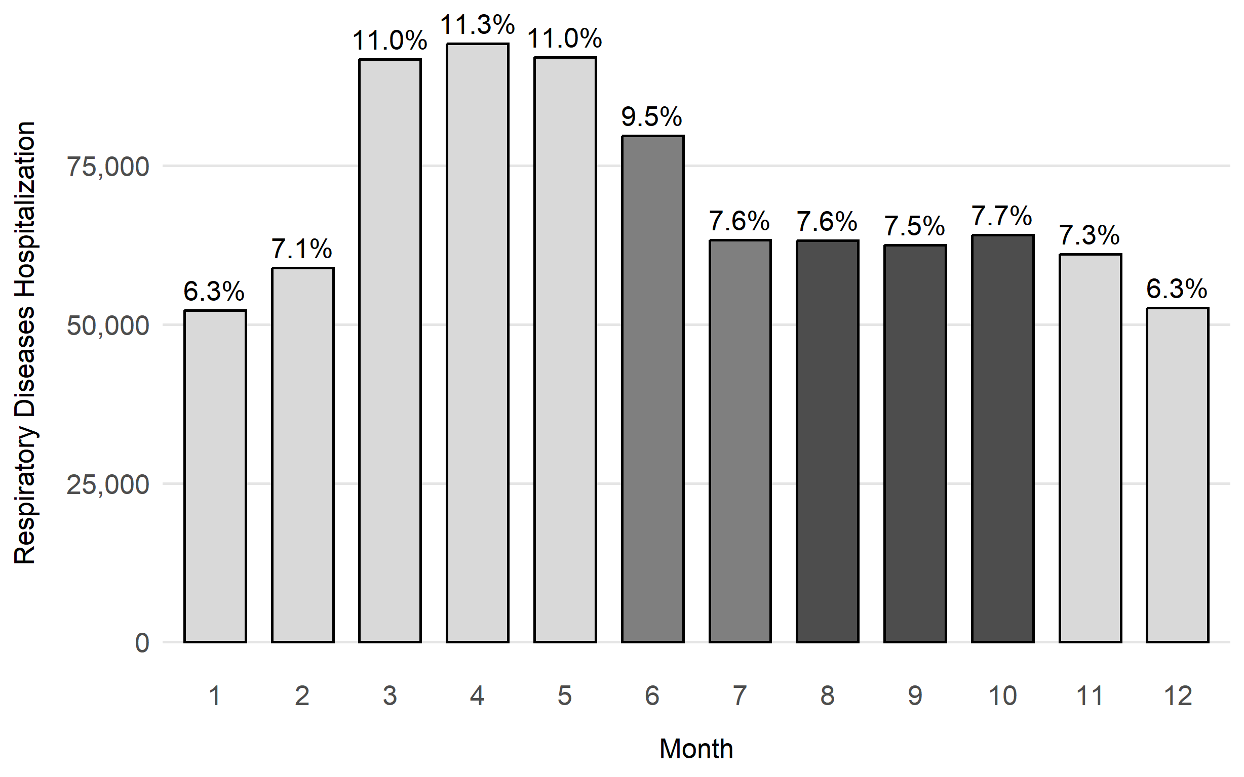
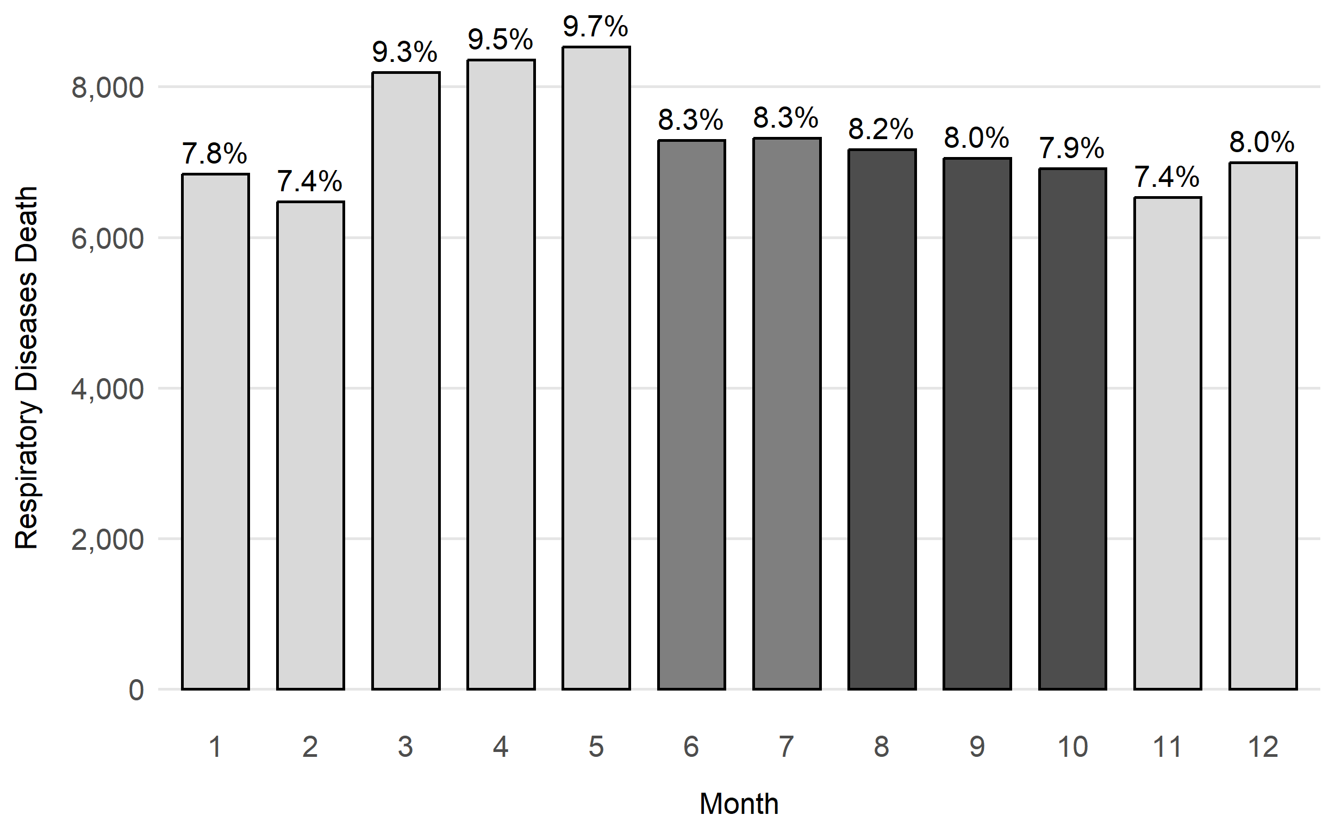

Source: Elaborated by the authors with data from: Hospital Information System DataSUS available at: < https://datasus,saude,gov,br/acesso-a-informacao/morbidade-hospitalar-do-sus-sih-sus/ >; Mortality Information System DataSUS available at:< https://datasus,saude,gov,br/mortalidade-desde-1996-pela-cid-10 >.

Note: Height of the bars show the sum of hospitalization and mortality due to respiratory diseases in a specific month between 2009-2019; the percentage above the bars represent the contribution of each month to de total of hospitalization and mortality due to respiratory diseases.

Table 2S: Summary statistics, environmental variables, hospital admissions and mortality from respiratory diseases from, August to October, at the Brazilian Amazon between 2009 to 2019.

 | Variable | Min. | P.25 | Mean | P.75 | Max. | Standard Deviation | Total (n)
Brazilian Amazon | Hospitalization - RD | 4,122 | 4,679 | 5,756 | 6,507 | 8,747 | 1,236 | 189,937
Brazilian Amazon | Mortality - RD | 408 | 515 | 640 | 742 | 886 | 135.4 | 21,127
Brazilian Amazon | PM_{2.5} (µm/m³) | 3.5 | 12.8 | 26.2 | 34.9 | 135.1 | 18.8
Brazilian Amazon | Temperature (C) | 18.2 | 26.0 | 27.1 | 28.4 | 32.4 | 1.9
Brazilian Amazon | Relative Humidity (%) | 28.0 | 65.5 | 73.9 | 84.9 | 98.7 | 14.8
Source: Elaborated by the authors with data from: Hospital Information System DataSUS available at: < https://datasus,saude,gov,br/acesso-a-informacao/morbidade-hospitalar-do-sus-sih-sus/ >; Mortality Information System DataSUS available at:< https://datasus,saude,gov,br/mortalidade-desde-1996-pela-cid-10>; VAN DONKELAAR et al., 2021, available at: <Satellite-derived PM2,5 | Atmospheric Composition Analysis Group | Washington University in St, Louis >; SISAM, 2019, available at: < https://dataserver-coids,inpe,br/queimadas/queimadas/sisam/ >.

Note: RD: Respiratory Diseases; PM_{2,5}: Particulate Matter < 2.5 µm.

Figure 2S: Monthly distribution of estimated PM_{2.5} and temperature at Brazilian Amazon, 2009 to 2019.

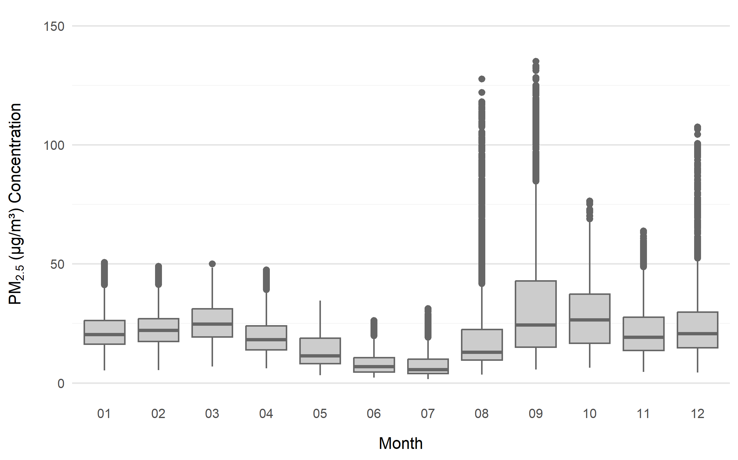

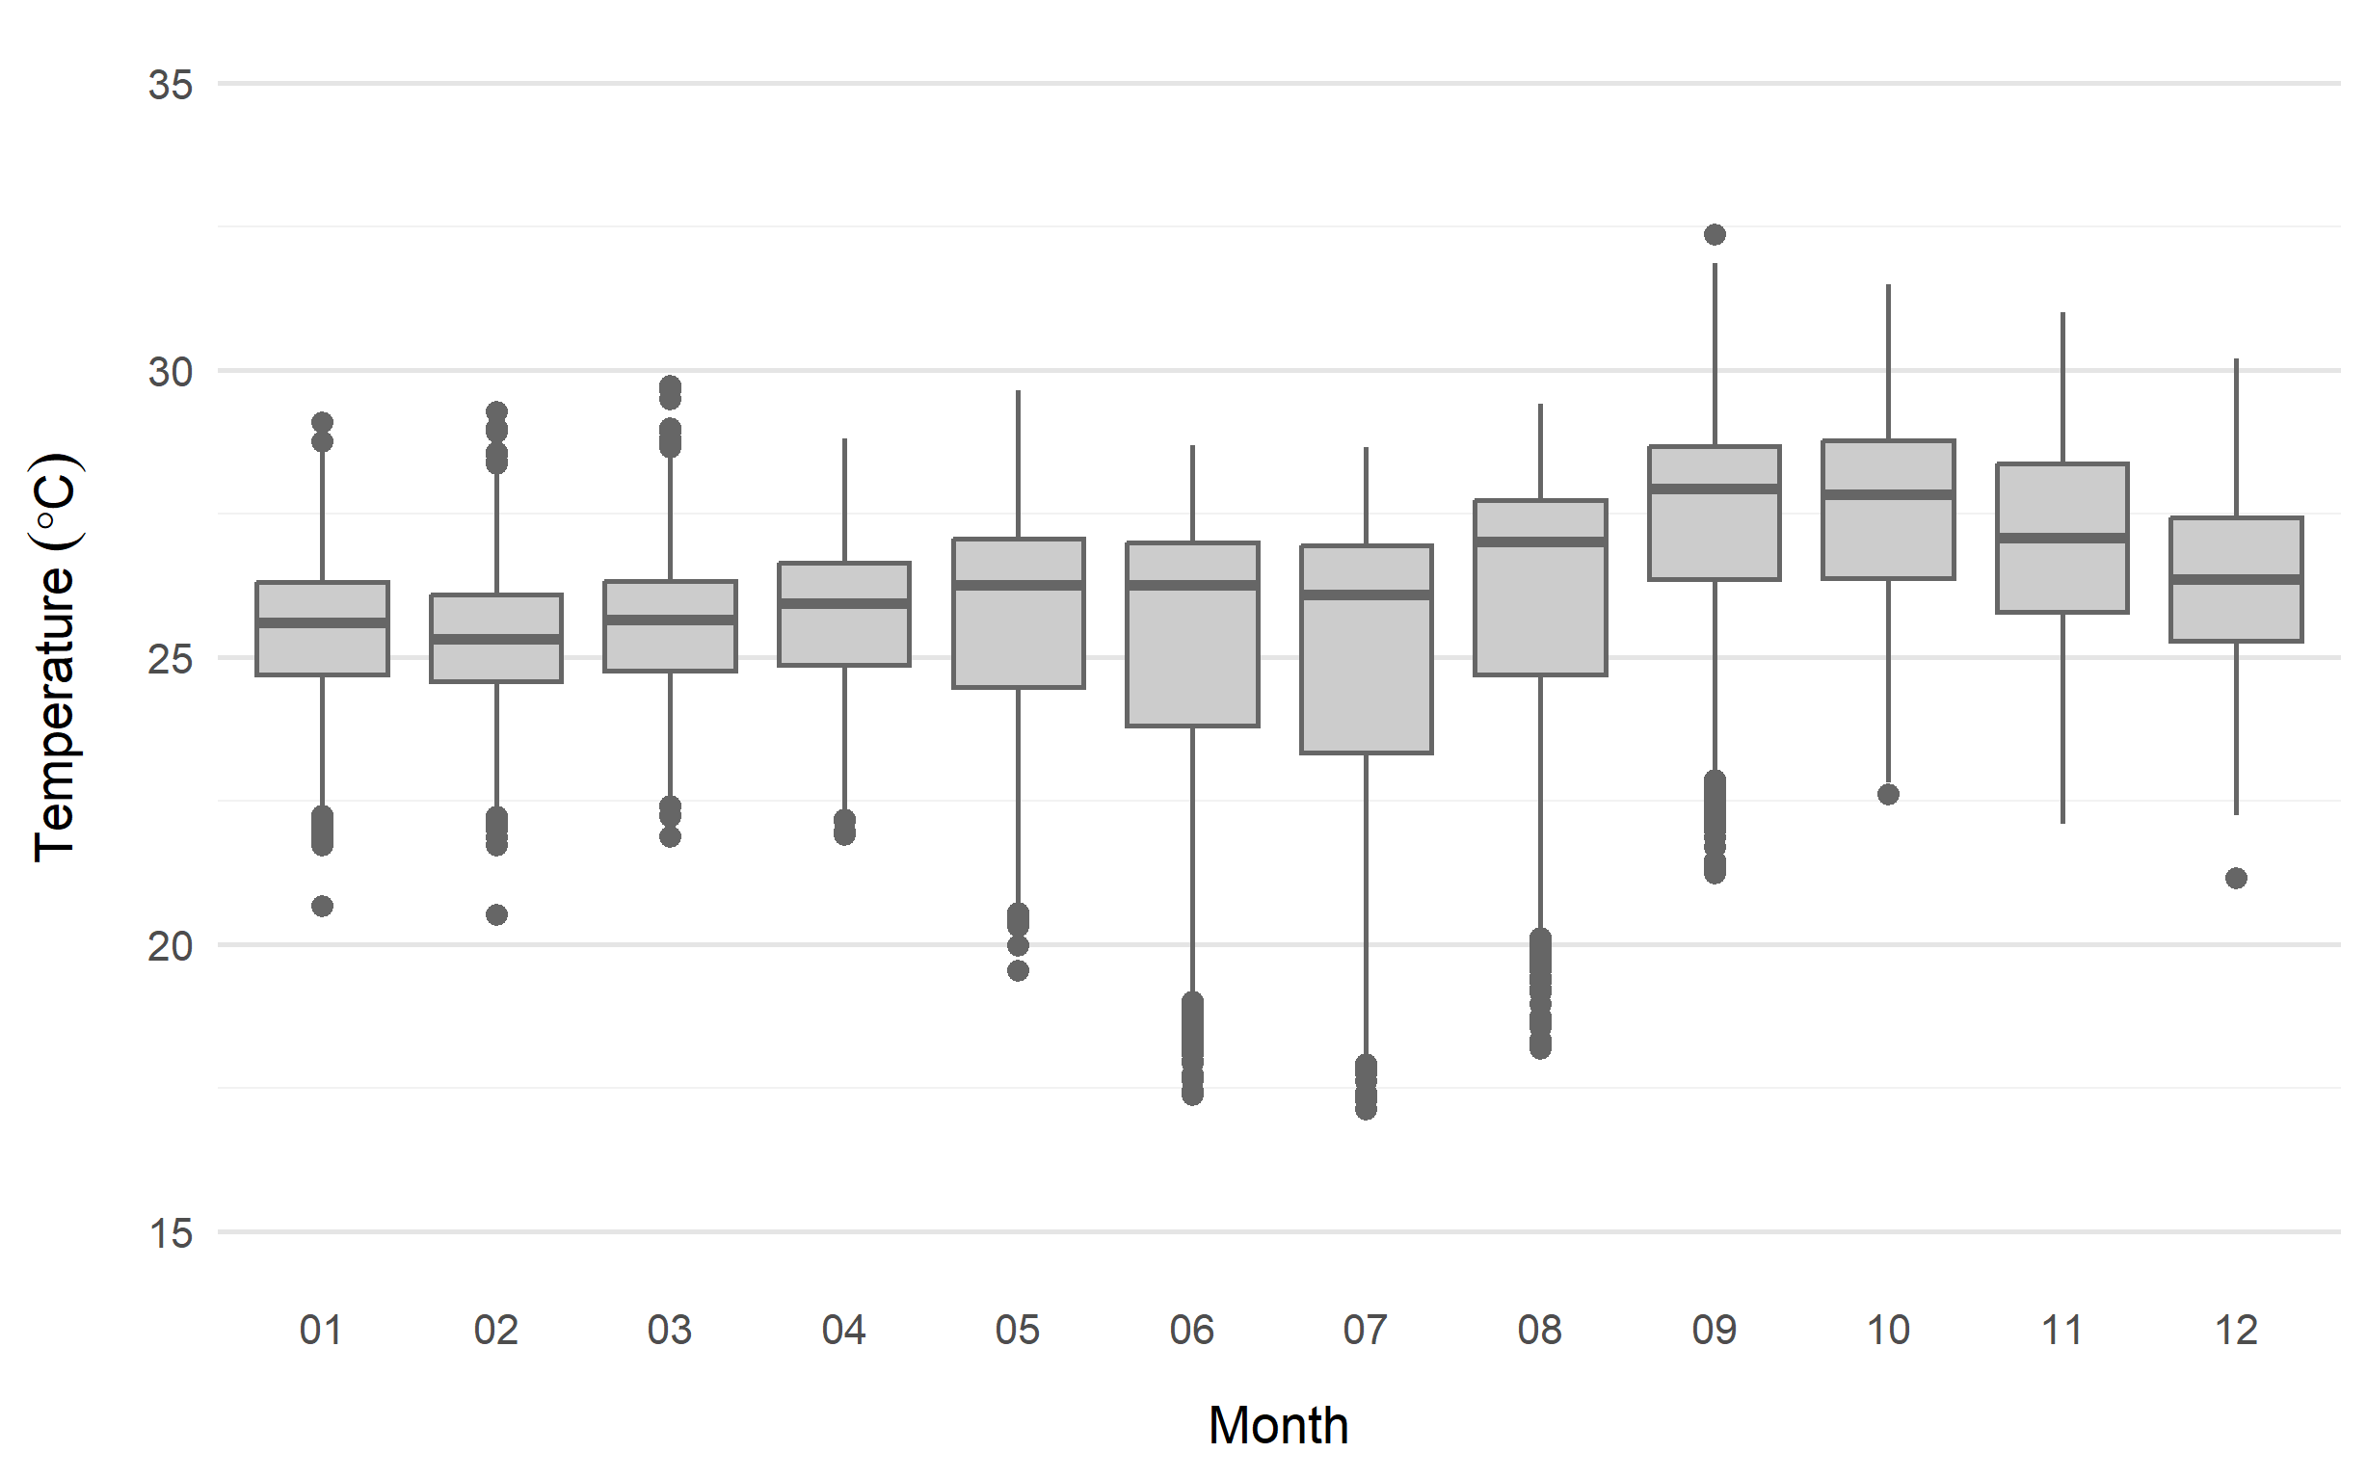

Source: Elaborated by the authors, with data from: VAN DONKELAAR et al., 2021, available at: < Satellite-derived PM2,5 | Atmospheric Composition Analysis Group | Washington University in St, Louis >; SISAM, 2019, available at: < https://dataserver-coids,inpe,br/queimadas/queimadas/sisam/ >.

Table 3S: Summary statistics, environmental variables, hospitalizations and mortality due to respiratory diseases and population.

FU | Variable | Min. | P25 | Mean | P75 | Max. | Standard Deviation
AC | Hospital Admissions - RD | 42 | 84 | 123 | 153 | 277 | 45
AC | Child and Adolescent Population |  |  | 336,541
AC | Mortality - RD | 11 | 21 | 28 | 31 | 65 | 9
AC | Elderly Population |  |  | 56,050
AC | PM_{2.5} (µm/m³) | 3.4 | 23.0 | 31.1 | 37.9 | 117.1 | 14.8
AC | Temperature (C°) | 19.2 | 22.7 | 23.3 | 24.1 | 27.2 | 1.3
AC | Relative Humidity (%) | 56.8 | 91.3 | 93.2 | 95.8 | 98.9 | 4.6
AM | Hospital Admissions - RD | 274 | 465 | 614 | 732 | 1.128 | 183
AM | Child and Adolescent Population |  |  | 1,506,031
AM | Mortality - RD | 42 | 65 | 78 | 91 | 132 | 19
AM | Elderly Population |  |  | 252,977
AM | PM_{2.5} (µm/m³) | 3.1 | 23.2 | 29.7 | 35.3 | 108.8 | 10.2
AM | Temperature (C°) | 19.7 | 24.5 | 25.3 | 26.1 | 29.6 | 1.3
AM | Relative Humidity (%) | 63.7 | 88.7 | 91.3 | 95.4 | 99.1 | 5.5
AP | Hospital Admissions - RD | 47 | 111 | 149 | 182 | 313 | 51
AP | Child and Adolescent Population |  |  | 305,506
AP | Mortality - RD | 3 | 10 | 15 | 18 | 35 | 7
AP | Elderly Population |  |  | 43,576
AP | PM_{2.5} (µm/m³) | 5.7 | 12.0 | 16.5 | 20.9 | 39.9 | 6.0
AP | Temperature (C°) | 24.4 | 25.9 | 26.8 | 27.8 | 30.2 | 1.2
AP | Relative Humidity (%) | 65.4 | 82.9 | 87.3 | 92.2 | 98.5 | 7.3
MA | Hospital Admissions - RD | 677 | 1.202 | 1.520 | 1.780 | 2.693 | 418
MA | Child and Adolescent Population |  |  | 2,108,866
MA | Mortality - RD | 56 | 92 | 127 | 153 | 293 | 45
MA | Elderly Population |  |  | 527,952
MA | PM_{2.5} (µm/m³) | 2.1 | 9.4 | 14.3 | 18.3 | 97.1 | 6.5
MA | Temperature (C°) | 24.2 | 26.5 | 27.3 | 28.0 | 31.2 | 1.1
MA | Relative Humidity (%) | 40.9 | 73.7 | 80.7 | 88.2 | 98.1 | 10.7
MT | Hospital Admissions - RD | 270 | 489 | 640 | 761 | 1.321 | 217
MT | Child and Adolescent Population |  |  | 1,039,918
MT | Mortality - RD | 48 | 86 | 105 | 119 | 174 | 24
MT | Elderly Population |  |  | 297,384
MT | PM_{2.5} (µm/m³) | 1.9 | 12.2 | 23.4 | 29.7 | 135.1 | 16.4
MT | Temperature (C°) | 17.1 | 23.7 | 24.5 | 25.7 | 32.4 | 2.0
MT | Relative Humidity (%) | 28.0 | 74.7 | 81.0 | 90.2 | 99.0 | 13.0
 |  |  |  |  |  |  | Continue
PA | Hospital Admissions - RD | 915 | 1.705 | 2.412 | 2.873 | 4.480 | 842
PA | Child and Adolescent Population |  |  | 3,041,734
PA | Mortality - RD | 118 | 168 | 216 | 253 | 417 | 61
PA | Elderly Population |  |  | 633,757
PA | PM_{2.5} (µm/m³) | 2.3 | 12.0 | 19.0 | 24.4 | 119.2 | 9.7
PA | Temperature (C°) | 22.7 | 26.0 | 26.9 | 27.9 | 31.2 | 1.3
PA | Relative Humidity (%) | 37.0 | 79.1 | 84.7 | 91.3 | 98.7 | 9.0
RO | Hospital Admissions - RD | 160 | 355 | 456 | 548 | 801 | 140
RO | Child and Adolescent Population |  |  | 558,647
RO | Mortality - RD | 21 | 39 | 48 | 54 | 86 | 12
RO | Elderly Population |  |  | 136,853
RO | PM_{2.5} (µm/m³) | 1.6 | 24.5 | 33.8 | 41.3 | 128.3 | 18.6
RO | Temperature (C°) | 18.6 | 23.2 | 2.38 | 24.5 | 28.8 | 1.3
RO | Relative Humidity (%) | 44.6 | 86.2 | 89.3 | 95.0 | 99.3 | 8.7
RR | Hospital Admissions - RD | 13 | 77 | 102 | 128 | 215 | 36
RR | Child and Adolescent Population |  |  | 197,124
RR | Mortality - RD | 1 | 6 | 9 | 12 | 22 | 4
RR | Elderly Population |  |  | 31,242
RR | PM_{2.5} (µm/m³) | 8.3 | 14.9 | 19.0 | 22.3 | 50.0 | 5.4
RR | Temperature (C°) | 20.5 | 24.7 | 25.5 | 26.5 | 29.7 | 1.5
RR | Relative Humidity (%) | 53.4 | 77.6 | 84.1 | 91.7 | 98.6 | 9.5
TO | Hospital Admissions - RD | 94 | 202 | 318 | 402 | 770 | 144
TO | Child and Adolescent Population |  |  | 517,085
TO | Mortality - RD | 20 | 29 | 37 | 44 | 70 | 11
TO | Elderly Population |  |  | 138,189
TO | PM_{2.5} (µm/m³) | 2.2 | 7.2 | 15.2 | 21.0 | 104.5 | 9.8
TO | Temperature (C°) | 21.5 | 25.8 | 26.8 | 27.6 | 31.9 | 1.4
TO | Relative Humidity (%) | 29.2 | 66.3 | 75.8 | 86.7 | 97.7 | 15.0
Source: Elaborated by the authors with data from: Hospital Information System DataSUS available at: < https://datasus,saude,gov,br/acesso-a-informacao/morbidade-hospitalar-do-sus-sih-sus/ >; Mortality Information System DataSUS available at:< https://datasus,saude,gov,br/mortalidade-desde-1996-pela-cid-10>; VAN DONKELAAR et al., 2021, available at: <Satellite-derived PM2.5 | Atmospheric Composition Analysis Group | Washington University in St, Louis >; SISAM, 2019, available at: < https://dataserver-coids,inpe,br/queimadas/queimadas/sisam/ >.

Note¹: RD: Respiratory Diseases; *Mean Annual Population, between 2009 – 2019; FU: Federative Unit,
Note²: Acre (AC), Amazonas (AM), Amapá (AP), Maranhão (MA), Mato Grosso (MT), Pará (PA), Rondônia (RO), Roraima (RR) e Tocantins (TO).

Map 2S: Monthly average PM_{2.5} concentration estimated for August to November between 2009 and 2019 in municipalities of the Amazon.
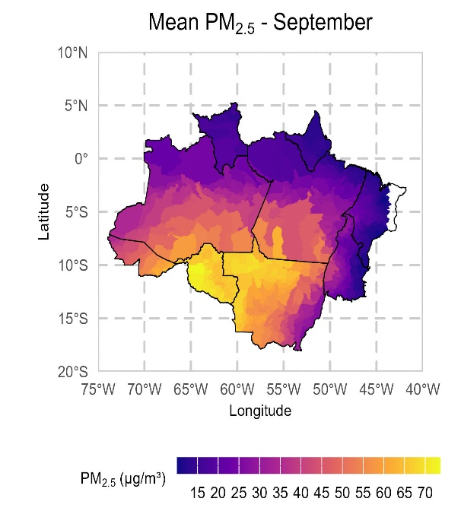
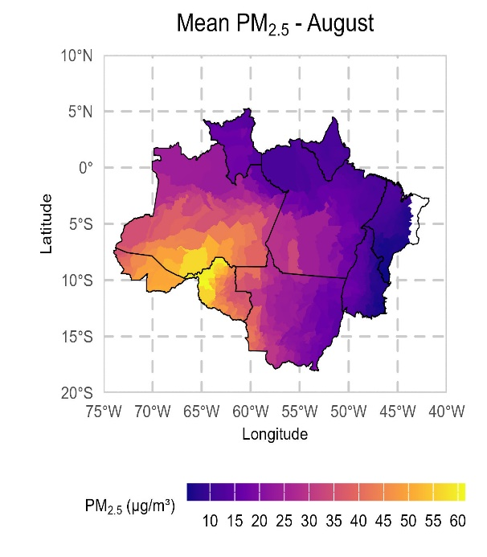

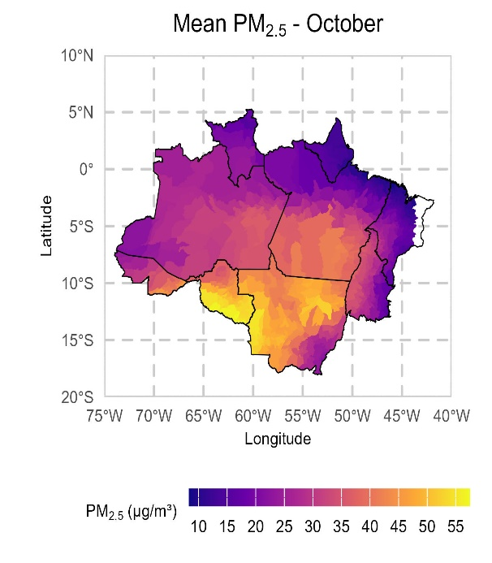
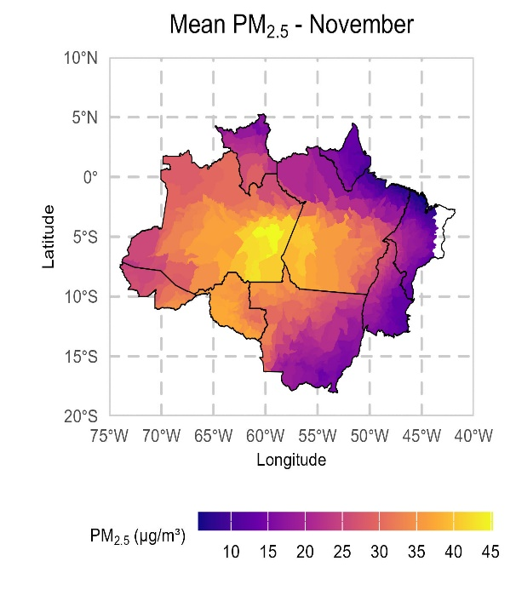

Source: Prepared by the authors using data from available at <Satellite-derived PM2,5 | Atmospheric Composition Analysis Group | Washington University in St, Louis> VAN DONKELAAR et al., 2021,
Note: These values correspond to the average concentration for August to November, estimated between 2009 and 2019.
Figure 3S-A: Comparison of lagged percentage change in hospitalization risk per 10 µg/m³ increase in PM_{2.5}, with and without the interaction term for high temperature conditions. Left: Overall effect model; Right: Interaction effect model (Main results).
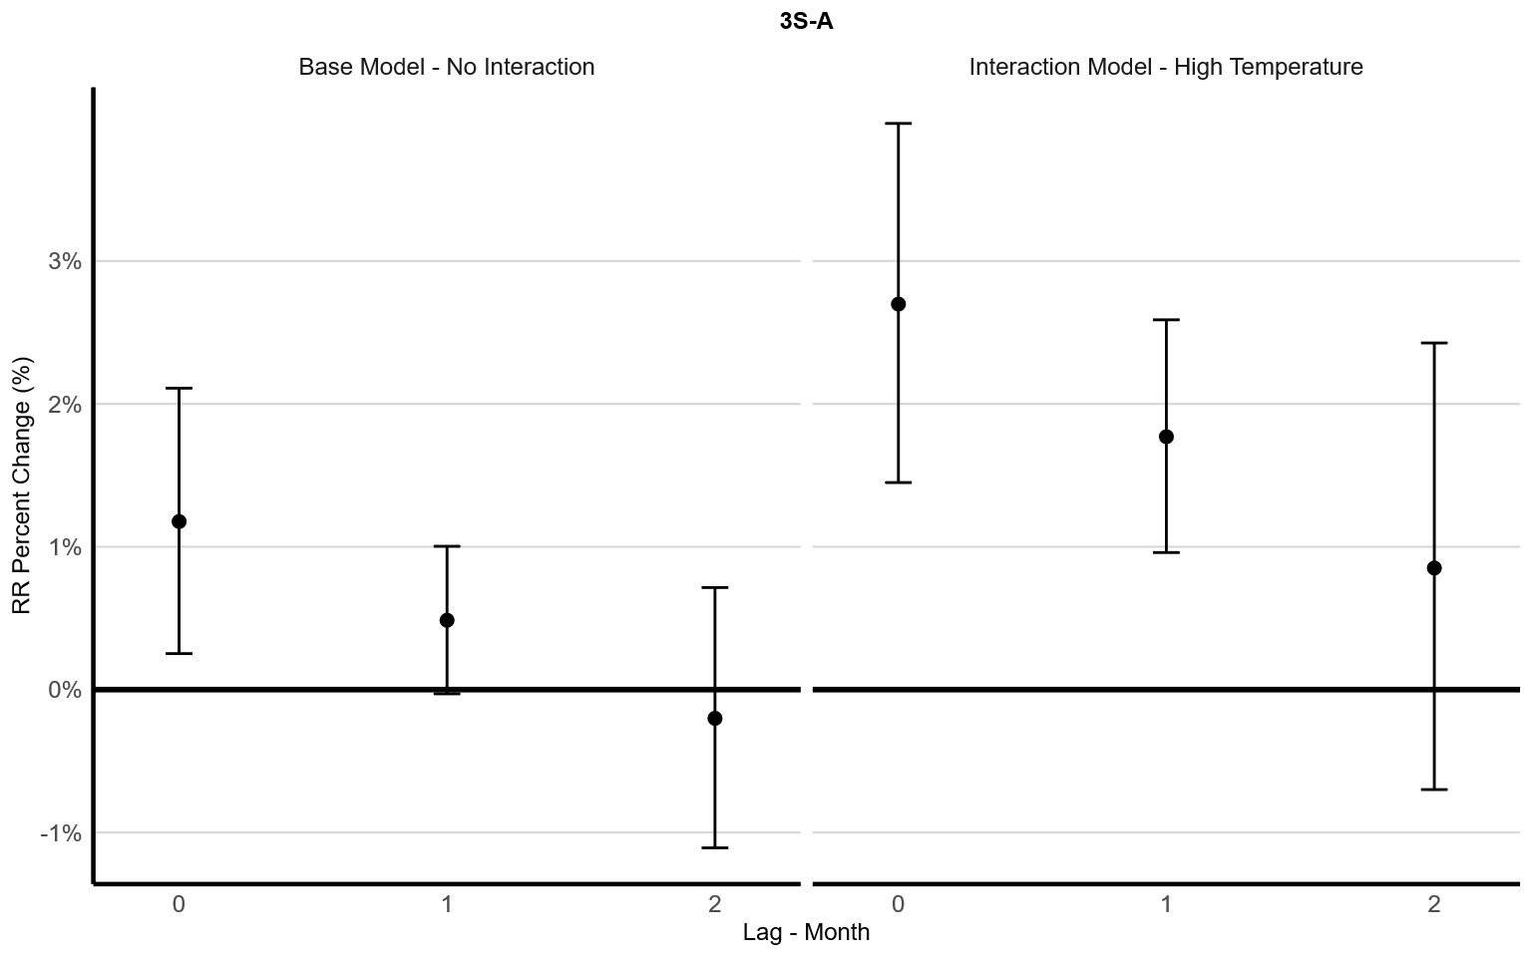

Source: Prepared by the authors using data from: Hospital Information System, DataSUS, available at: <https://datasus,saude,gov,br/acesso-a-informacao/morbidade-hospitalar-do-sus-sih-sus/>; Mortality Information System, DataSUS, available at:< https://datasus,saude,gov,br/mortalidade-desde-1996-pela-cid-10>; VAN DONKELAAR et al., 2021, available at: <Satellite-derived PM2,5 | Atmospheric Composition Analysis Group | Washington University in St, Louis>.
Note: The Overall effect model includes the same variables as the final model (IM - 3.4) described in Table 1S, but excludes the interaction term.

Figure 3S-B: Figure 3S-B: Comparison of lagged percentage change in mortality risk per 10 µg/m³ increase in PM_{2.5}, with and without the interaction term for high temperature conditions. Left: Overall effect model; Right: Interaction effect model (Main results).

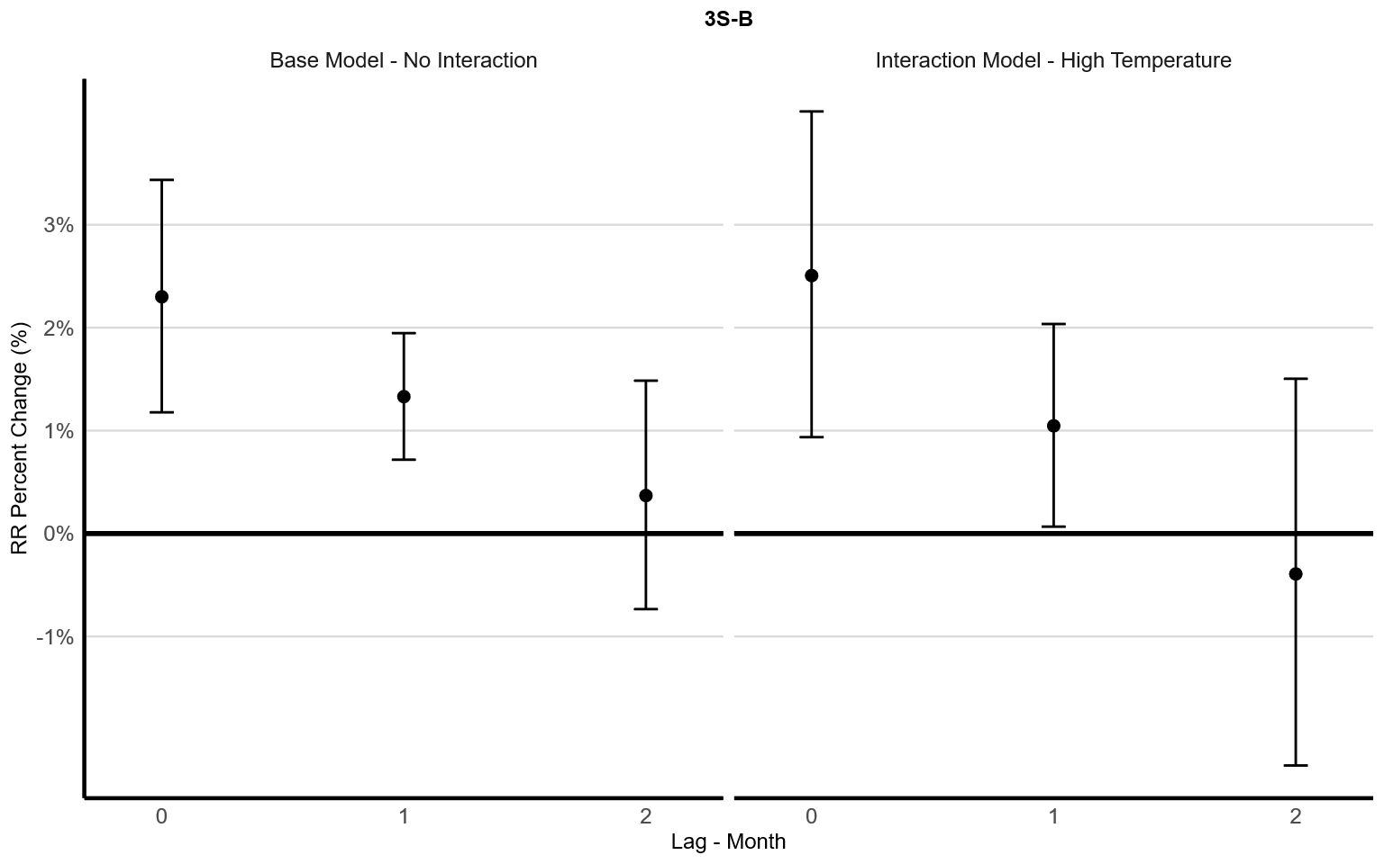
Source: Prepared by the authors using data from: Hospital Information System, DataSUS, available at: <https://datasus,saude,gov,br/acesso-a-informacao/morbidade-hospitalar-do-sus-sih-sus/>; Mortality Information System, DataSUS, available at:< https://datasus,saude,gov,br/mortalidade-desde-1996-pela-cid-10>; VAN DONKELAAR et al., 2021, available at: <Satellite-derived PM2,5 | Atmospheric Composition Analysis Group | Washington University in St, Louis>.
Note: The Overall effect model includes the same variables as the final model (IM - 3.4) described in Table 1S, but excludes the interaction term.

Table 4S: Interaction effects of PM_{2.5} exposure and high temperatures on hospitalizations and mortality due to RD at different concentrations of PM_{2.5}.
Parameter | PM_{2.5} (µg/m³) | Outcome | RR - Lag 0 | RR - Lag 1 | RR - Lag 2
CONAMA (FS) | 15 | hospitalization | 1.04 (1.02-1.06) | 1.03 (1.01-1.04) | 1.01 (0.99-1.04)
CONAMA (IS-4) | 25 | hospitalization | 1.07 (1.04-1.10) | 1.04 (1.02-1.07) | 1.02 (0.98-1.06)
CONAMA (IS-3) | 37 | hospitalization | 1.10 (1.05-1.15) | 1.07 (1.04-1.10) | 1.03 (0.97-1.09)
CONAMA (IS-2) | 50 | hospitalization | 1.14 (1.07-1.21) | 1.09 (1.05-1.14) | 1.04 (0.97-1.13)
CONAMA (IS-1) | 60 | hospitalization | 1.17 (1.09-1.26) | 1.11 (1.06-1.17) | 1.05 (0.96-1.15)
CONAMA (FS) | 15 | death | 1.04 (1.01-1.06) | 1.02 (1.00-1.06) | 0.99 (0.97-1.02)
CONAMA (IS-4) | 25 | death | 1.06 (1.02-1.11) | 1.03 (1.00-1.05) | 0.99 (0.94-1.04)
CONAMA (IS-3) | 37 | death | 1.10 (1.04-1.16) | 1.04 (1.00-1.08) | 0.99 (0.92-1.06)
CONAMA (IS-2) | 50 | death | 1.13 (1.05-1.22) | 1.05 (1.00-1.11) | 0.98 (0.89-1.08)
CONAMA (IS-1) | 60 | death | 1.16 (1.06-1.27) | 1.06 (1.00-1.30) | 0.98 (0.87-1.09)
Source: Prepared by the authors using data from: Hospital Information System (DataSUS); Mortality Information System (DataSUS); Van Donkelaar et al., 2021; SISAM, 2019; Brazilian National Environmental Council – CONAMA.
Note¹: The table illustrates the interaction effects of PM_{2.5} and temperature on hospital admissions and mortality from respiratory diseases across different monthly PM_{2.5} concentrations, referencing the CONAMA Resolution Nº, 506, 2024 for daily standard concentrations, These values contextualize the estimated Relative Risks within the regulatory standards, It is important to note that our dataset is monthly, and therefore, these are approximations, due to the absence of monthly concentration guidelines,
Note²: Brazil's CONAMA air quality standards are categorized into intermediate (IS) and final (FS) levels, with the final stage aligning with the WHO's 2021 recommendations, Following the publication of the resolution, the PI-1 standards take immediate effect, PI-2 will be effective from January 1, 2025, PI-3 from January 1, 2033, PI-4 from January 1, 2044, and the FS (Final Standard) is yet to be defined.

