Table 1. Summary of Sentinel-2 satellite images and corresponding UAV orthomosaic acquisition metadata.
Study Site | S2 Acquisition Date | UAV Acquisition Date | UAV Orthomosaic
Asalouyeh | 2020-02-06 | 2020-02-09 | 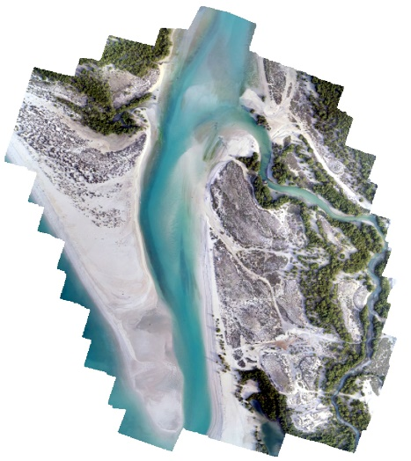
Dayyer | 2023-03-05 | 2023-03-07 | 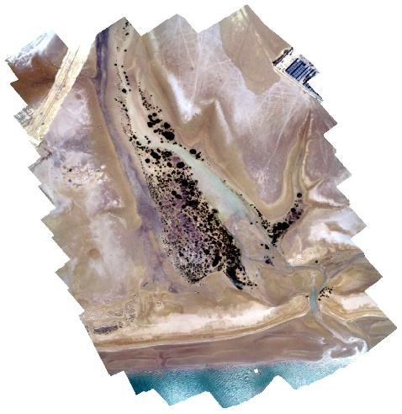
Khour-e Azini | 2022-05-13 | 2022-05-15 | 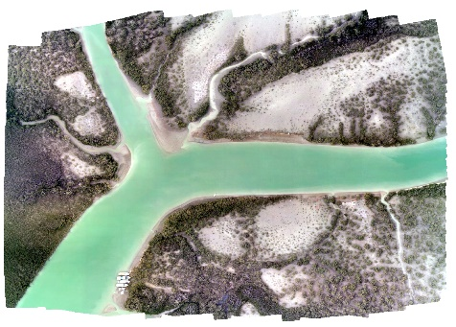
Melgonzeh | 2020-02-14 | 2020-02-09 | 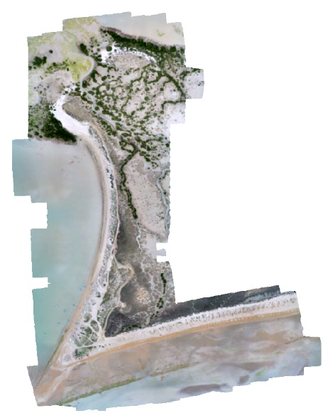
Tiyab | 2022-05-13 | 2022-05-15 | 