Supplementary material for
Role of Winter Surface Longwave Cloud Radiative Effect over the Ural Mountains in the Arctic–Eurasian Teleconnection
Huiru Yang^{1,2,5}, Shuoyi Ding^{1,2,5}, Zhang Chen³ and Shaoyin Wang⁴
1. Department of Atmospheric and Oceanic Sciences & Institute of Atmospheric Sciences, Fudan University, Shanghai 200438, China
2. Key Laboratory of Polar Atmosphere-ocean-ice System for Weather and Climate, Ministry of Education, Fudan University, Shanghai 200438，China
3. School of Atmospheric Sciences, Chengdu University of Information Technology, Chengdu 610225, China
4. School of Geospatial Engineering and Science, Sun Yat-sen University, and Southern Marine Science and Engineering Guangdong Laboratory (Zhuhai), Zhuhai 519082, China
5. CMA-FDU Joint Laboratory of Marine Meteorology, Shanghai 200438, China
Correspondence: dsy@fudan.edu.cn

Introduction
This Supplementary material contains four figures: Figure S1, Figure S2, Figure S3, Figure S4.

Supplementary information.
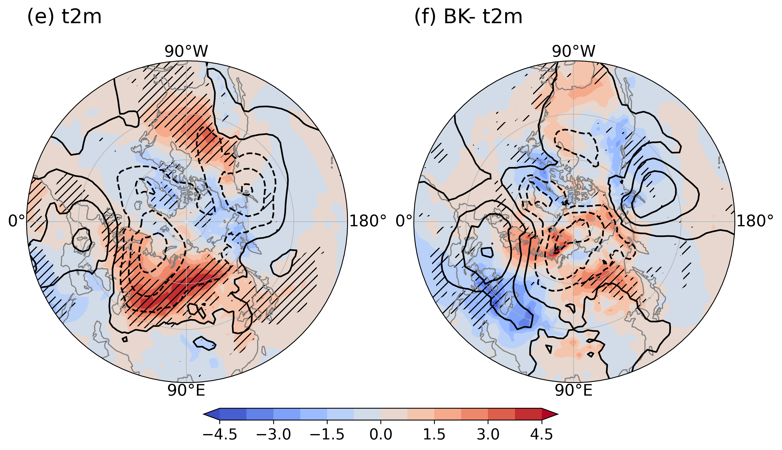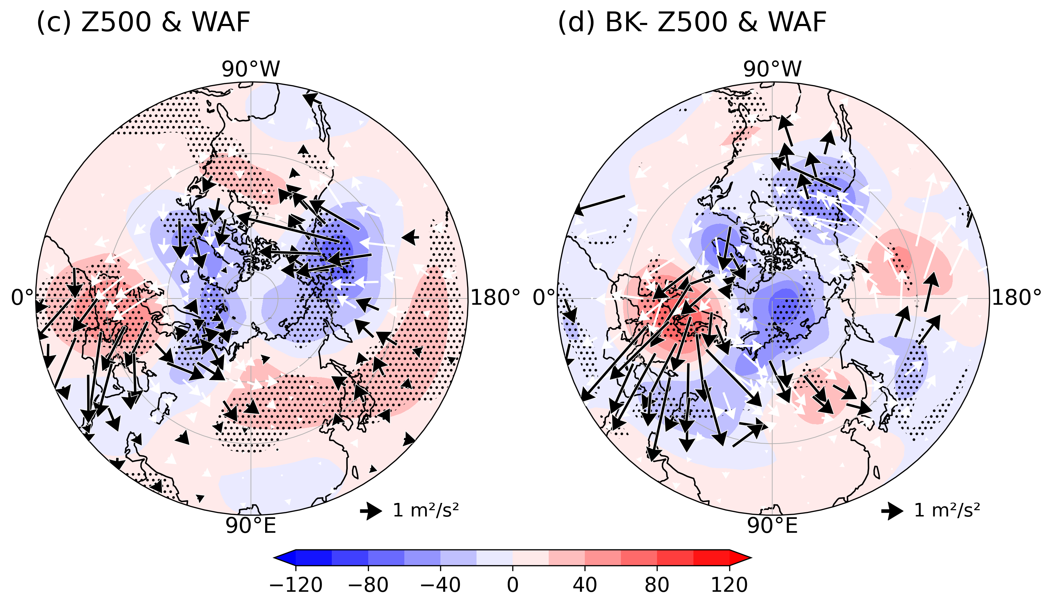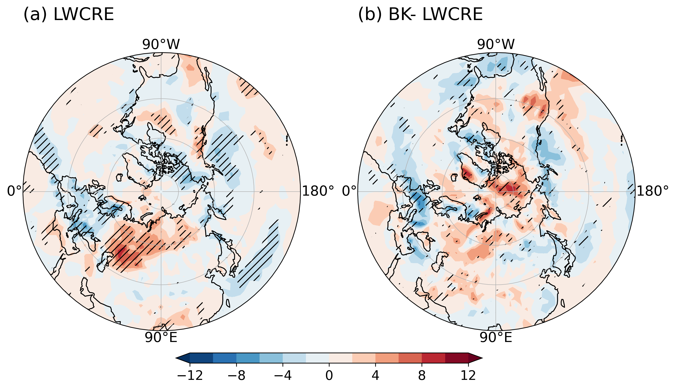
Fig. S1. Winter composites based on ERA5 data under PC1− for normal sea ice years (a, c, e) (N=4) and reduced BKS sea ice years (b, d, f) (N=2). The number of years (N) is indicated in the top-right corner of each panel. (a, b) LWCRE (units: W m⁻²); (c, d) 500-hPa geopotential height (shading; units: gpm) and TN wave activity flux (arrows; units: m² s⁻²); (e, f) 2-m air temperature (units: K). Stippling denotes anomalies significant at the 90% confidence level. In (c) and (d), black arrows indicate significance at the 90% confidence level, while white arrows indicate non-significance.
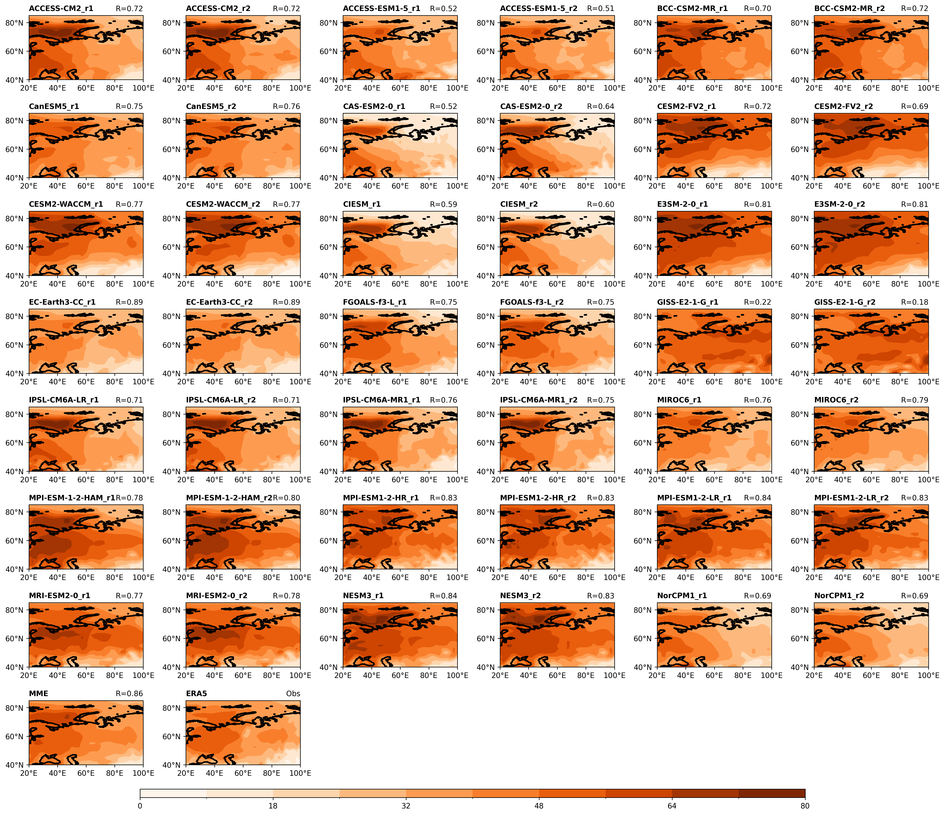
Fig. S2. Distributions of the winter surface LWCRE (units: W m⁻²) climatological mean across 21 CMIP6 models, the MME, and ERA5 observational data. The text in the upper-left corner indicates the model names (where r1 denotes the r1i1p1f1, and r2 denotes the r2i1p1f1), and the numbers in the upper-right corner represent the spatial correlation coefficients between each individual model/MME and ERA5.
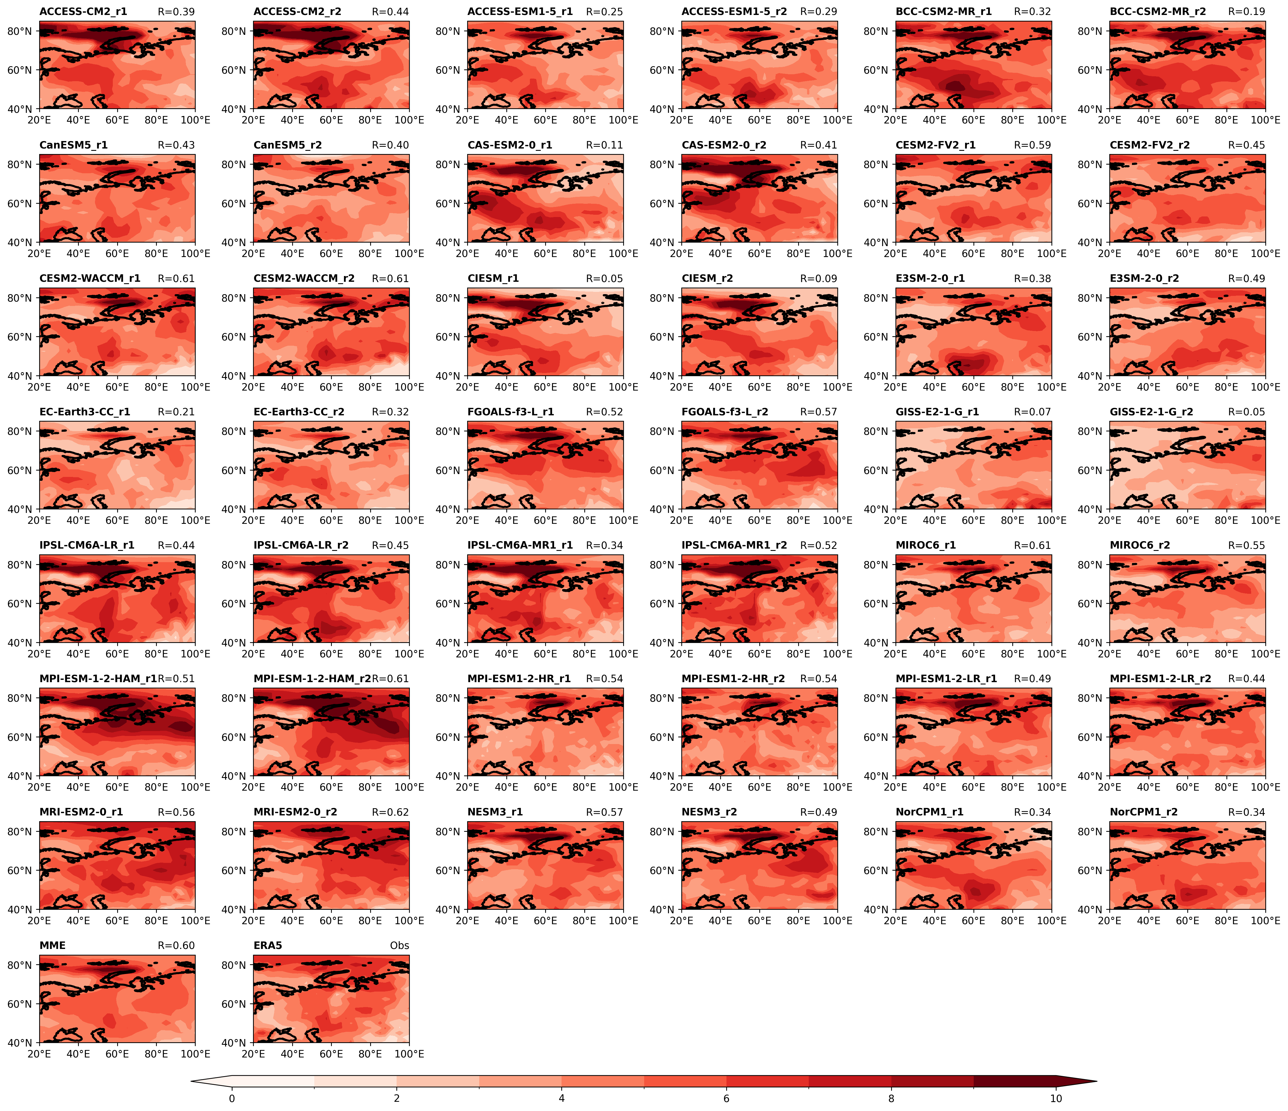
Fig. S3. Distributions of the winter surface LWCRE (units: W m⁻²) standard deviation across 21 CMIP6 models, the MME, and ERA5 observational data. The text in the upper-left corner indicates the model names (where r1 denotes the r1i1p1f1, and r2 denotes the r2i1p1f1), and the numbers in the upper-right corner represent the spatial correlation coefficients between each individual model/MME and ERA5.
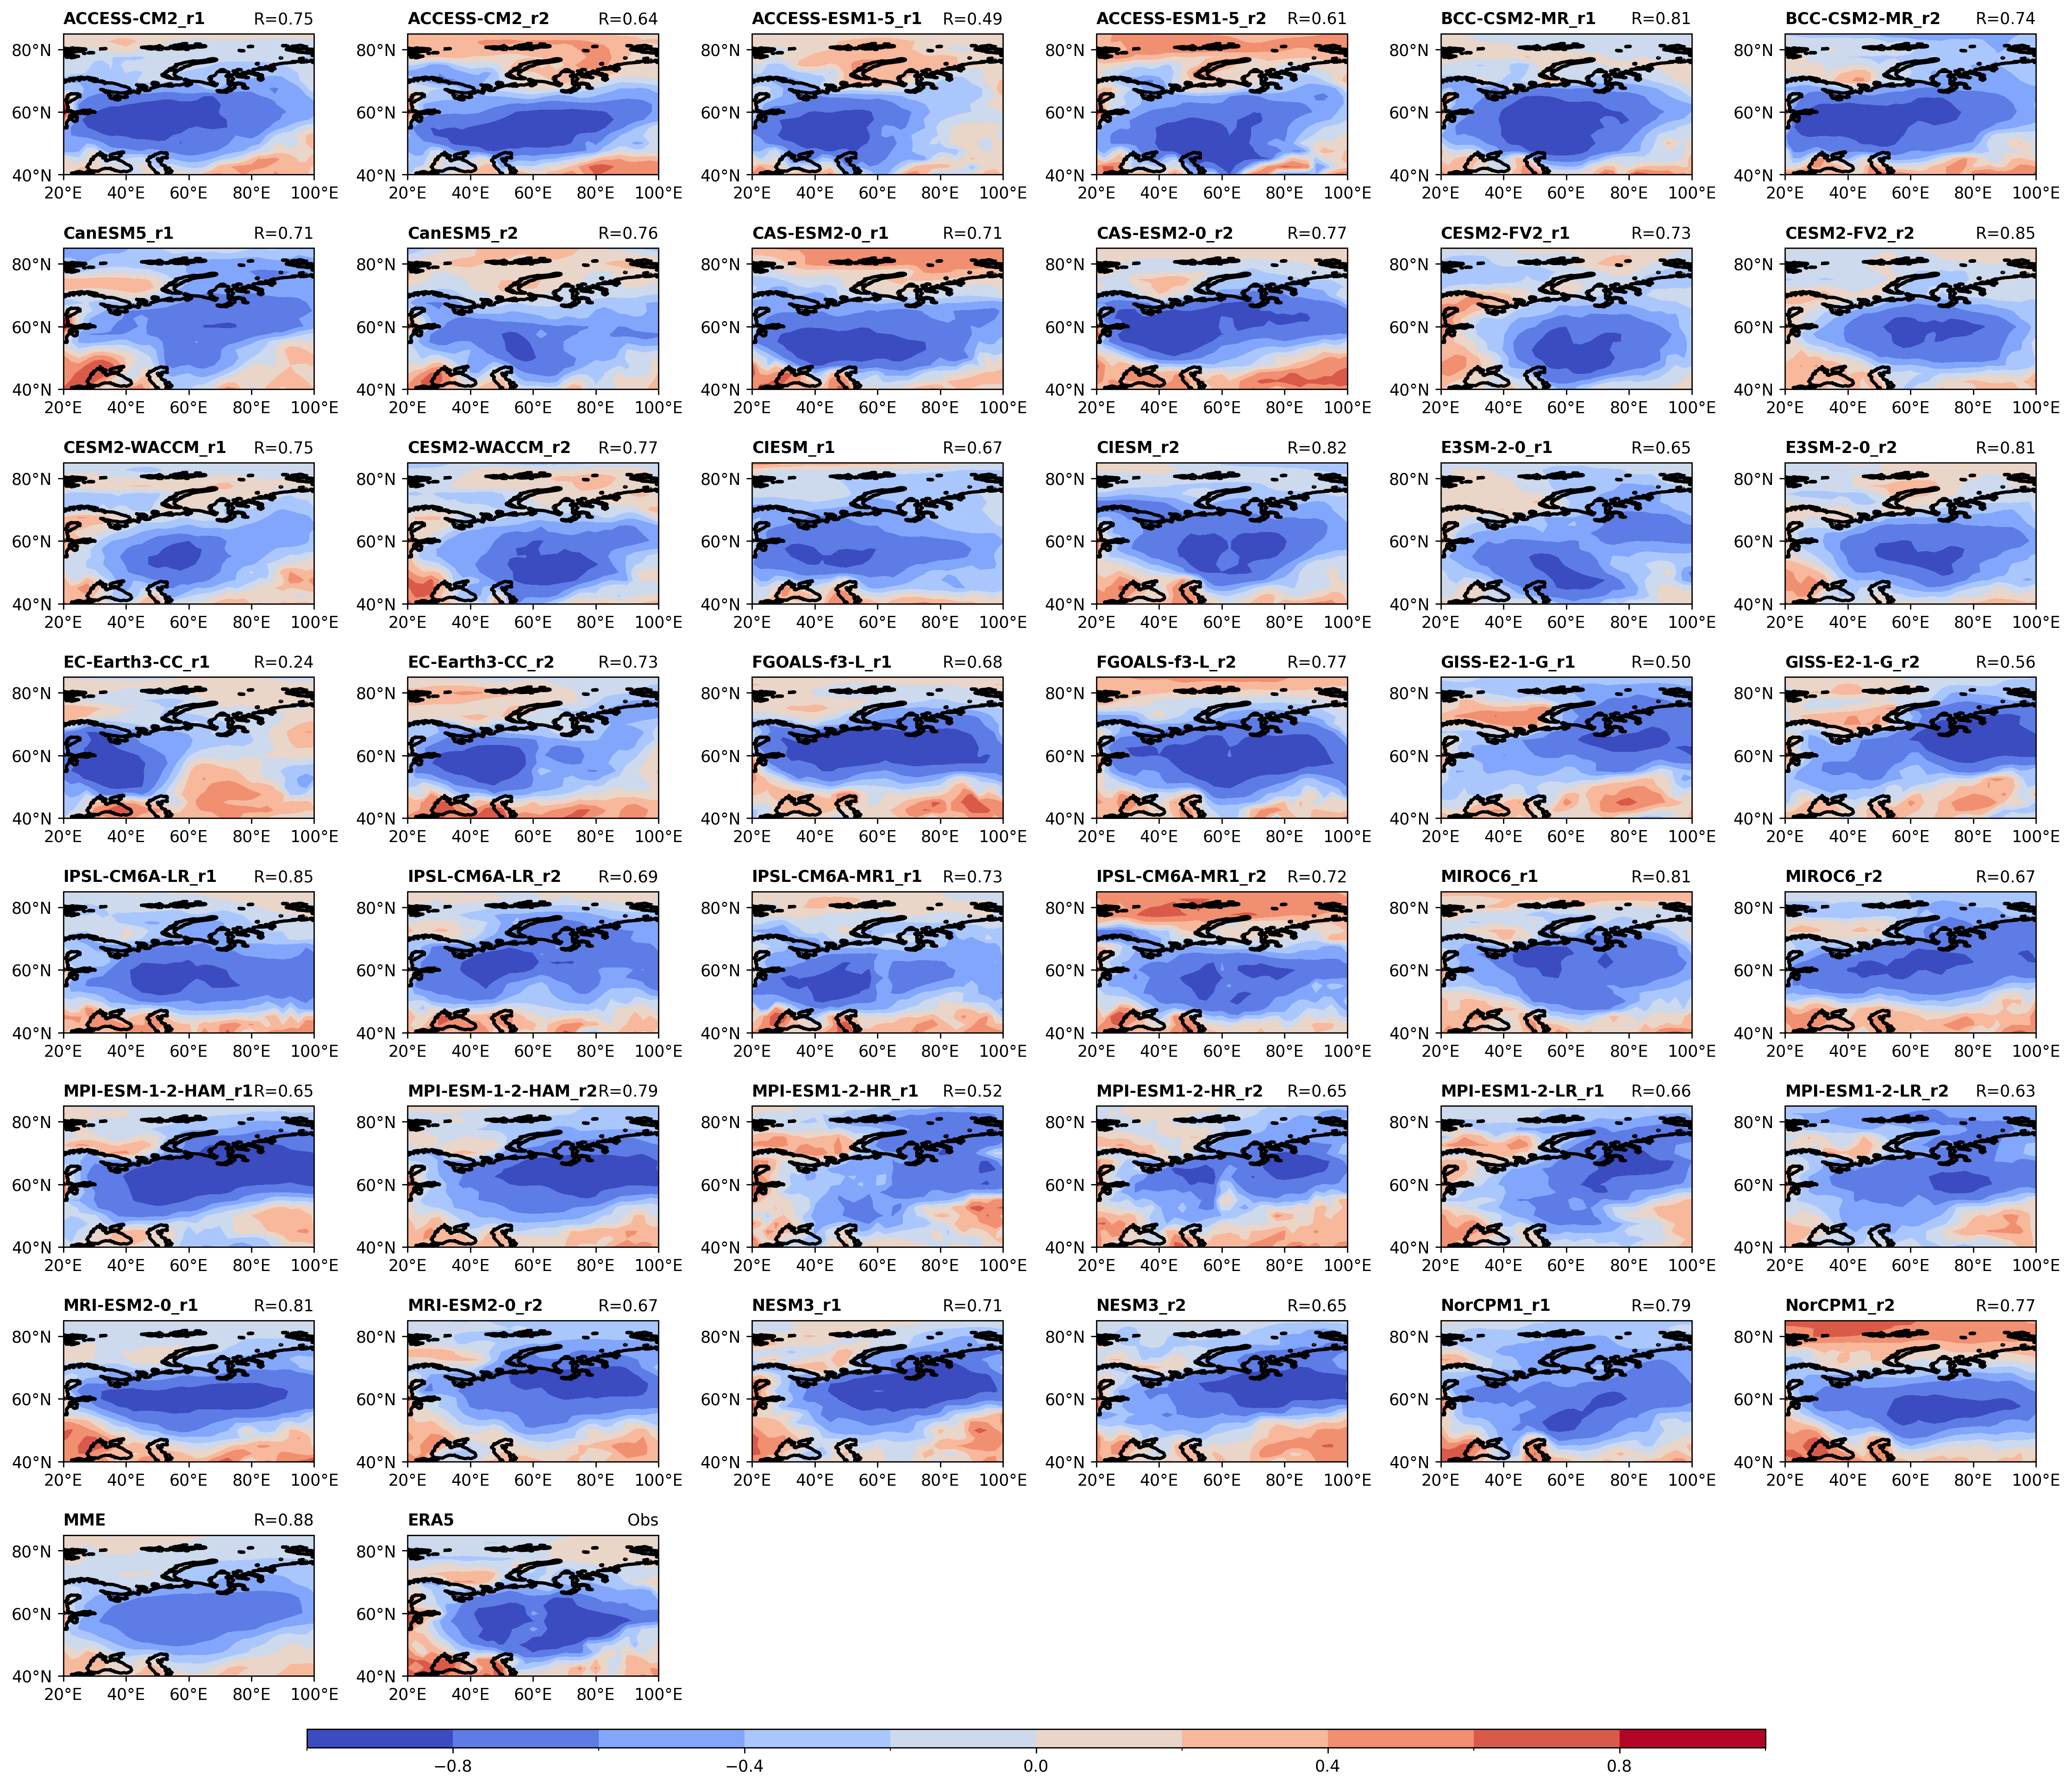
Fig. S4. Distributions of the winter surface LWCRE (units: W m⁻²) EOF1 across 21 CMIP6 models, the MME, and ERA5 observational data. The text in the upper-left corner indicates the model names (where r1 denotes the r1i1p1f1, and r2 denotes the r2i1p1f1), and the numbers in the upper-right corner represent the spatial correlation coefficients between each individual model/MME and ERA5.

