An aerosol dry deposition theory connects landcover geometry to climate

Junchen Guo¹, Ganzhen Chen³, Xinyan Zhao¹, Shengzhen Zhou⁴, Shixin Mai⁴, Minghao Wang¹, Runlong Cai⁵, Yijing Chen¹, Haiyan Yue⁷, Taofeng Gu⁷, Hao Wu⁶, Douglas R. Worsnop^{8,9}, Jiandong Wang², Jingkun Jiang¹

¹ State Key Joint Laboratory of Environment Simulation and Pollution Control, School of Environment, Tsinghua University, Beijing, China.
² State Key Laboratory of Climate System Prediction and Risk Management, Nanjing University of Information Science and Technology, Nanjing 210044, China
³ College of Meteorology and Oceanography, National University of Defense Technology, Changsha, 410073, China
⁴ School of Atmospheric Sciences, Guangdong Provincial Observation and Research Station for Climate Environment and Air Quality Change in the Pearl River Estuary, Sun Yat-sen University, Zhuhai, 519082, China.
⁵ Shanghai Key Laboratory of Air Quality and Environmental Health, Department of Environmental Science & Engineering, Fudan University, Shanghai, China.
⁶ Key Laboratory of China Meteorological Administration Atmospheric Sounding, College of Electronic Engineering, Chengdu University of Information Technology, Chengdu 610225, China.
⁷ Guangzhou meteorological bureau, Guangzhou, China.
⁸ Aerodyne Research Inc., Billerica, Massachusetts 01821, USA.
⁹ Institute for Atmospheric and Earth System Research/Physics, University of Helsinki, 1100014 Helsinki, Finland.
Correspondence to:
Jiandong Wang, jiandong.wang@nuist.edu.cn
Jingkun Jiang, jiangjk@tsinghua.edu.cn

The file includes:
1 Phase-wise migration theory (section 1.1-1.4)
2 Relating $λ_{f}^{b}$ and $λ_{f}^{v}$ to $A_{b}$ and $A_{v}$
3 Canopy meteorology
4 Supplementary tables
5 Supplementary figures

1 Phase-wise migration theory

1.1 Particle migration in inertial sublayer
In this section, we will derive two key mathematical relationships: (i) the relationship among aerosol dry deposition (ADD) velocity ($V_{d}$), gravitational settling velocity ($V_{g}$), and the first collisional deposition velocity ($V_{fc}$); (ii) the relationship between the first collisional deposition velocity and the second collisional deposition velocity ($V_{sc}$). The first and the second collisional deposition velocities are the ADD velocities induced by air-particle collisions at an observation site (in inertial sublayer) and at the top of roughness sublayer respectively (see Extended Data Fig. 8 for the illustration).
Gravitational settling, air entrainment (includes advection and turbulent entrainments), Brownian motion, and turbophresis are the four mechanisms driving ADD. The scale analysis of particle motion (Extended Data Fig. 5) shows that particle vertical migration in inertial sublayer is dominantly driven by gravitational settling and turbulent entrainment. Thus (the direction away from the ground is positive):
(10)
$F={-K}_{p}\frac{dc}{dz}-V_{g} C=-V_{d}C$

Where F is the total particle flux within inertial sublayer. $K_{p}\frac{dc}{dz}$ refers to the particle flux caused by turbulent entrainment. $V_{g} C$ refers to the particle flux caused by gravitational settling. $K_{p}$ is the turbulent diffusion coefficient for particles. C is the particle concentration. $V_{d}$ is the ADD velocity. $V_{g}$ is the gravitational settling velocity. In general, the particle flux caused by turbulent entrainment within inertial sublayer is assumed to be constant with height, similar to heat or momentum flux. Thus, equation (10) can evolve as
(11)
$K_{p}\frac{dc}{dz}= \left(V_{d}\left(z^{*}\right)-V_{g}\right)C\left(z^{*}\right)= \left(V_{d}\left(z_{r}\right)-V_{g}\right)C\left(z_{r}\right)$

Where $z_{r}$ is the height of the top of roughness sublayer, which equals mean canopy height when canopies exist ($z_{r}$ is the height of the top of ground buffer layer when canopies don’t exist). $z^{*}$ is the height of an observation site, which should be higher than $z_{r}$. z is any height between $z_{r}$ and $z^{*}$. Equation (11) can further evolve as follows:
(12)
(13)
$K_{p}\frac{dc}{dz}= \left(V_{d}\left(z^{*}\right)-V_{g}\right)C\left(z^{*}\right)$
$\int_{C\left(z_{r}\right)}^{C\left(z^{*}\right)}{\frac{1}{C\left(z^{*}\right)}dc}= \int_{z_{r}}^{z^{*}}{\left(V_{d}\left(z^{*}\right)-V_{g}\right)\frac{1}{K_{p}}dz}$
$\frac{C\left(z^{*}\right)- C\left(z_{r}\right)}{C\left(z^{*}\right)}= \left(V_{d}\left(z^{*}\right)-V_{g}\right)\int_{z_{r}}^{z^{*}}{\frac{1}{K_{p}}dz}$
(14)
Equation (11) can also evolve as follows:
(16)
(15)
$\left(V_{d}\left(z^{*}\right)-V_{g}\right)C\left(z^{*}\right)= \left(V_{d}\left(z_{r}\right)-V_{g}\right)C\left(z_{r}\right)$
$\frac{C\left(z_{r}\right)}{C\left(z^{*}\right)}= \frac{\left(V_{d}\left(z^{*}\right)-V_{g}\right)}{\left(V_{d}\left(z_{r}\right)-V_{g}\right)}$

Combing equation (14) and (16):
(17)
(18)
$1-\frac{\left(V_{d}\left(z^{*}\right)-V_{g}\right)}{\left(V_{d}\left(z_{r}\right)-V_{g}\right)} = \left(V_{d}\left(z^{*}\right)-V_{g}\right)\int_{z_{r}}^{z^{*}}{\frac{1}{K_{p}}dz}$
$V_{d}\left(z^{*}\right)= V_{g}+\frac{1}{\int_{z_{r}}^{z^{*}}{\frac{1}{K_{p}}dz}+\frac{1}{\left(V_{d}\left(z_{r}\right)-V_{g}\right)}}$
Replacing $V_{d}\left(z^{*}\right)$ with $V_{d}$ and replacing $\left(V_{d}\left(z_{r}\right)-V_{g}\right)$ with $V_{sc}$ ($V_{tc}$ for canopy-free landcover)
(19)
$V_{d}= V_{g}+\frac{1}{\int_{z_{r}}^{z^{*}}{\frac{1}{K_{p}}dz}+\frac{1}{V_{sc}}}$

In general, turbulent diffusion coefficient for particles ($K_{p}$) is assumed to equal that for heat ($K_{h}$).
$K_{h}$ within inertial sublayer is determined by atmospheric motion here and can be expressed based on Monin-Obukhov similarity theory:
(20)
$K_{p}=K_{h}=\frac{κzu^{*}}{Ф_{h}}$

Where $κ$ is the von Karman constant and generally taken as 0.4. $u^{*}$ is the friction velocity within inertial sublayer which keeps constant with height. $Ф_{h}$ is the non-dimensional potential temperature gradient. Based on equation (20), $\int_{z_{r}}^{z^{*}}{\frac{1}{K_{p}}dz}$ is proved to be expressed as¹:
(21)
$\int_{z_{r}}^{z^{*}}{\frac{1}{K_{p}}}dz=\frac{1}{{κu}^{*}}\left(\ln\left(\frac{z^{*}-d}{z_{r}-d}\right)-ψ_{h}\left(\frac{z^{*}-d}{L}\right)+ψ_{h}\left(\frac{z_{r}-d}{L}\right)\right)$ = $\frac{Г}{u^{*}}$

Where $d$ is the zero-plane displacement. For canopy-free landcover, d=0. $ψ_{h}$ is the atmospheric stability correction for heat. L is the Monin–Obukhov length. Thus,
(22)
$V_{d}= V_{g}+\frac{1}{\frac{Г}{u^{*}}+\frac{1}{V_{sc}}}=V_{g}+V_{fc}$

1.2 Particle migration in drag domain
Drag domain is the subspace of roughness sublayer (bottom of surface layer) defined in this study (see main text for details). Particle migration here is characterized by two physical parameters, landcover-induced particle scavenging rate ($γ_{L}$) and the second collisional deposition velocity ($V_{sc}$). The goal of this section is to derive the connection and mathematical expressions of the two parameters. $γ_{L}$ is defined as the particles settling onto landcover surface within drag domain per unit time and per unit volume. The definition of $V_{sc}$ has been mentioned before (see section 1.1 or Methods in main text).

1.2.1 Derivation of $γ_{L}$
A simplified description about how particles settle onto landcover surface in drag domain is shown in Fig. S3. Although ignoring lots of complicated details in real conditions, this physical framework captures the key aspect of particle migration in drag domain and perfectly explains atmospheric flux observations over canopy-containing landcover. As shown in Fig. S3, we separately discuss particle settling at windward and leeward conditions. The windward condition means that the angle between the mean wind vector and the normal of a surface (direction away from the surface is positive) ranges from $\frac{π}{2}$ to $π$. The leeward condition means that the angle between the mean wind vector and the normal of a surface ranges from 0 to $\frac{π}{2}$. According to the scale analysis of particle motion (Extended Data Fig. 5), particle migration in drag domain is dominantly driven by air entrainment (advection entrainment and turbulent entrainment) and gravitational settling. For the windward condition, assuming that the particle settling flux toward an area element of landcover surface (i.e., ground/vegetation/building surface) is constant along the normal direction of the area element, we have (the direction away from the area element is positive.):
(23)
$I^{ww}=-C\left(y\right)u_{d}^{n}\left(y\right)-K_{d}^{p}\left(y\right)\frac{dC}{dy}\left(y\right)+V_{g}^{n}C\left(y\right)= {-V}_{d}^{v}C\left(y_{v}\right)$

Where $I^{ww}$ is the total particle settling flux toward an area element of landcover surface in the windward condition. $-C\left(y\right)u_{d}^{n}\left(y\right)$ is the particle settling flux caused by advection entrainment. $-K_{d}^{p}\left(y\right)\frac{dC}{dy}\left(y\right)$ is the particle settling flux caused by turbulent entrainment. $V_{g}^{n}C\left(y\right)$ is the particle settling flux caused by gravitational settling. y is any site at the normal of the area element within drag domain. $y_{v}$ is the outer edge of the viscous domain of the area element (the definition of viscous domain has been mentioned before. See main text for details). C is the particle concentration. $u_{d}^{n}$ is the component of mean wind along the normal direction of the area element. $K_{d}^{p}$ is the particle turbulent diffusion coefficient within drag domain. $V_{g}^{n}$ is the component of gravitational settling velocity along the normal direction of the area element. The sign (+/-) of $V_{g}^{n}$ depends on the angle between gravity and the normal of the area element. $V_{d}^{v}$ is the ADD velocity at the outer edge of the viscous domain of the area element and is the sum of $V_{g}^{n}$ and $V_{tc}$.($V_{tc}$ is the third collisional deposition velocity of the area element and has been mentioned in main text). Approximating $\frac{dC}{dy}\left(y\right)$ as $\frac{C\left(y\right)-C\left(y_{v}\right)}{y-y_{v}}$ and expressing $K_{d}^{p}\left(y\right)$ as $u_{d}^{*}\left(y\right)L_{m}^{d}\left(y\right)$ based on Prantl mixing length theory, equation (23) can evolve as follows:
(24)
$-C\left(y\right)u_{d}^{n}\left(y\right)-u_{d}^{*}\left(y\right)L_{m}^{d}\left(y\right)\frac{C\left(y\right)-C\left(y_{v}\right)}{y-y_{v}}+V_{g}^{n}C\left(y\right)= -V_{d}^{v}C\left(y_{v}\right)$

Where $u_{d}^{*}$ is the friction velocity within drag domain. $L_{m}^{d}$ is the mixing length within drag domain. Eddy size (i.e., $L_{m}^{d}$) decreases toward a surface. We assume that the decay of eddy size within drag domain toward the area element is similar to that in inertial sublayer toward the land. Thus, $L_{m}^{d}\left(y\right)$ can be expressed as $κ\left(y-y_{v}\right)$ and we therefore have:
(26)
(25)
$-C\left(y\right)u_{d}^{n}\left(y\right)-u_{d}^{*}\left(y\right)κ\left(C\left(y\right)-C\left(y_{v}\right)\right)+V_{g}^{n}C\left(y\right)= -V_{d}^{v}C\left(y_{v}\right)$
$\left(u_{d}^{n}\left(y\right)+u_{d}^{*}\left(y\right)κ-V_{g}^{n}\right)C\left(y\right)= \left(u_{d}^{*}\left(y\right)κ+V_{d}^{v}\right)C\left(y_{v}\right)$

Because $V_{d}^{v}≪u_{d}^{*}\left(y\right)κ$, equation (26) becomes:
(27)
$C\left(y_{v}\right)=\left(\frac{u_{d}^{n}\left(y\right)}{u_{d}^{*}\left(y\right)κ}+1\right)C\left(y\right)-\frac{V_{g}^{n}}{u_{d}^{*}\left(y\right)κ}C\left(y\right)$

Thus, particle concentration at $y_{v}$ can be related to ambient particle concentration:
(28)
$C\left(y_{v}\right)=\left(\frac{\hat{u_{d}}\left|cosθ_{1}\right|}{\hat{u_{d}^{*}}κ}+1\right)\hat{C}-\frac{V_{g}cosθ_{2}}{\hat{u_{d}^{*}}κ}\hat{C}$

Where $\hat{u_{d}}$, $\hat{u_{d}^{*}}$ and $\hat{C}$ are the ambient mean wind speed, friction velocity and particle concentration within drag domain. $θ_{1}$ is the angle between mean wind and the normal of the area element. For windward condition, $\frac{π}{2}<θ_{1}<π$. $θ_{2}$ is the angle between gravity and the normal of the area element. $θ_{2}$ ranges from 0 to $π$. Thus, the total particle flux toward an area element of landcover surface in the windward condition can be expressed as:
(29)
${\left|I\right|}^{ww}= \left|V_{d}^{v}C\left(y_{v}\right)\right|=\left(\frac{\hat{u_{d}}\left|cosθ_{1}\right|}{\hat{u_{d}^{*}}κ}+1\right)\hat{C}V_{d}^{v}-\frac{V_{g}cosθ_{2}}{\hat{u_{d}^{*}}κ}\hat{C}V_{d}^{v}$

For leeward condition, the total particle flux toward an area element of landcover surface is:
(30)
$I^{lw}=-K_{d}^{p}\left(y\right)\frac{dC}{dy}\left(y\right)+V_{g}^{n}C\left(y\right)= {-V}_{d}^{v}C\left(y_{v}\right)$

Similar to derivation from equation (23) to equation (29), we get:
(31)
${\left|I\right|}^{lw}=\hat{C}V_{d}^{v}-\frac{V_{g}cosθ_{2}}{\hat{u_{d}^{*}}κ}\hat{C}V_{d}^{v}$

Landcover-induced particle scavenging rate, $γ_{L}$, is defined as the particles settling to landcover within drag domain per unit time and per unit volume. Thus, $γ_{L}$ can be derived by integrating all particle fluxes toward landcover surface per unit volume. Here we first discuss the simplest case, the homogeneous canopy, where the canopy only contains vegetations or buildings and all vegetations or buildings have the same micro surface roughness ($k_{L}$, see main text for details). Then, $γ_{L}$ can therefore be expressed as:
(32)
$γ_{L}=\int{{\left|I\right|}^{ww}da^{ww}+\int{{\left|I\right|}^{lw}da^{lw}}}$

Where $a^{ww}$ is the total windward landcover surface area per unit volume (m²/m³). $a^{lw}$ is the total leeward landcover surface area per unit volume (m²/m³). We first discuss particle scavenging at windward landcover surface.
(33)
$\int{{\left|I\right|}^{ww}da^{ww}}=\int{\left(\frac{\hat{u_{d}}\left|cosθ_{1}\right|}{\hat{u_{d}^{*}}κ}+1\right)\hat{C}V_{d}^{v}da^{ww}}-\int{\frac{V_{g}cosθ_{2}}{\hat{u_{d}^{*}}κ}\hat{C}V_{d}^{v}}da^{ww}$

As mentioned before, $V_{d}^{v}$ can be expressed as the sum of $V_{tc}$ and $V_{g}^{n}$. $da^{ww}$ can be expressed as $Ω_{ww}dθ_{1}dθ_{2}$, in which $Ω_{ww}$ means windward landcover surface area per unit volume unit $θ_{1}$ unit $θ_{2}$ (m²/m³/rad²). Then, assuming constant $Ω_{ww}$, the first term in right hand side (RHS) of equation (33) can further evolve as follows:
(34)
$\int{\left(\frac{\hat{u_{d}}\left|cosθ_{1}\right|}{\hat{u_{d}^{*}}κ}+1\right)\hat{C}V_{d}^{v}da^{ww}}=\int_{\frac{π}{2}}^{π}{\left(\frac{\hat{u_{d}}\left|cosθ_{1}\right|}{\hat{u_{d}^{*}}κ}+1\right)\hat{C}V_{tc}}Ω_{ww}dθ_{1}\int_{0}^{π}{dθ_{2}}-$
$\int_{\frac{π}{2}}^{π}{\left(\frac{\hat{u_{d}}\left|cosθ_{1}\right|}{\hat{u_{d}^{*}}κ}+1\right)\hat{C}V_{g}Ω_{ww}dθ_{1}\int_{0}^{π}{cosθ_{2}}}dθ_{2}=\frac{\hat{u_{d}}}{\hat{u_{d}^{*}}κ}\hat{C}V_{tc}{πΩ}_{ww}+\frac{π}{2}\hat{C}V_{tc}{πΩ}_{ww}$

Notice:
(35)
$\iint{Ω_{ww}dθ_{1}dθ_{2}}=\int_{\frac{π}{2}}^{π}{Ω_{ww}dθ_{1}\int_{0}^{π}{dθ_{2}}}=a^{ww}$
(36)
$Ω_{ww}={\frac{2}{π^{2}}a}^{ww}$

Thus, equation (34) becomes:
(37)
$\int{\left(\frac{\hat{u_{d}}\left|cosθ_{1}\right|}{\hat{u_{d}^{*}}κ}+1\right)\hat{C}V_{d}^{v}da^{ww}}=\left(\frac{2}{π}\frac{\hat{u_{d}}}{\hat{u_{d}^{*}}κ}+1\right)a^{ww}\hat{C}V_{tc}$

Similarly, the second term in RHS of equation (33) can further evolve as follows:
(38)
$\int{\frac{V_{g}cosθ_{2}}{\hat{u_{d}^{*}}κ}\hat{C}V_{d}^{v}}da^{ww}=\int_{\frac{π}{2}}^{π}{\frac{V_{g}}{\hat{u_{d}^{*}}κ}\hat{C}V_{tc}Ω_{ww}dθ_{1}\int_{0}^{π}{cosθ_{2}}dθ_{2}}-$
$\int_{\frac{π}{2}}^{π}{\frac{V_{g}}{\hat{u_{d}^{*}}κ}\hat{C}V_{g}Ω_{ww}dθ_{1}\int_{0}^{π}{\cos^{2}θ_{2}}dθ_{2}}=-\frac{V_{g}}{2\hat{u_{d}^{*}}κ}a^{ww}\hat{C}V_{g}$

Combining equations (33), (37) and (38):
(39)
$\int{{\left|I\right|}^{ww}da^{ww}}=\left(\frac{2}{π}\frac{\hat{u_{d}}}{\hat{u_{d}^{*}}κ}+1\right)a^{ww}\hat{C}V_{tc}+\frac{V_{g}}{2\hat{u_{d}^{*}}κ}a^{ww}\hat{C}V_{g}$

Similar to the derivation from equations (33) to equation (39), we can get:
(40)
$\int{{\left|I\right|}^{lw}da^{lw}}=a^{lw}\hat{C}V_{tc}+\frac{V_{g}}{2\hat{u_{d}^{*}}κ}a^{lw}\hat{C}V_{g}$

Combing equation (39) and equation (40) and assuming that $a^{lw}$and $a^{ww}$each account for half of total landcover surface area per unit volume ($a$). We get:
(41)
$γ_{L}=\left(\frac{1}{π}\frac{\hat{u_{d}}}{\hat{u_{d}^{*}}κ}+1\right)a\hat{C}\left(V_{tc}+\frac{πV_{g}}{2\hat{u_{d}}+2\hat{u_{d}^{*}}κπ}V_{g}\right)≈\left(\frac{1}{π}\frac{\hat{u_{d}}}{\hat{u_{d}^{*}}κ}+1\right)a\hat{C}V_{tc}$

$\frac{πV_{g}}{2\hat{u_{d}}+2\hat{u_{d}^{*}}κπ}V_{g}$ is ignored because $V_{g}≪\hat{u_{d}^{*}}≪\hat{u_{d}}$ in general. It should be noticed that equation (41) is only valid when ambient particles are able to settle onto all landcover surface. However, the situation may not be so in forest canopies. Landcover surface in a forest canopy is mainly contributed by leaves of trees. If a tree is too lush, outer leaves of the tree will block particles from settling onto inner leaves. We consider such effect by introducing the effective area correction coefficient $ξ$. When single tree total leaf area (STA) of a tree is so small that the outer leaves of the tree cannot block ambient air flow from transporting particles onto the inner leaves, double side of all leaves of the tree are “effective”. In this case, the total effective area of a tree (EAT) is approximated as STA. When STA of a tree is large enough so that the outer leaves of the tree effectively block ambient air flow from transporting particles onto the inner leaves, only one side of the outer leaves of the tree are “effective”. In this case, EAT is approximated as the crown surface area of a tree (CAT), which is usually calculated by considering the crown as an ellipsoid in forestry. Thus, EAT varies from STA to CAT with increasing STA. Despite numerous ways in which EAT varies from STA to CAT, we choose a simple way in this work for simplicity. We assume that EAT equals STA when STA is smaller than CAT but keeps CAT when STA is larger than or equal to CAT. The effective area correction coefficient $ξ$ for a forest canopy can therefore be expressed as:
(42)
$ξ=\frac{{A_{v}}^{*}}{A_{v}}, A_{v}>{A_{v}}^{*}$
$A_{v}=STA∙TD$
${A_{v}}^{*}=EAT∙TD$
$EAT=\left\{\begin{aligned}STA, STA<CAT \\ a \\ CAT, STA≥CAT\end{aligned}\right.$
$CAT=4π∙{\left(\frac{2{\left(r_{c}∙l_{c}^{h}\right)}^{1.6075}+{r_{c}}^{3.215}}{3}\right)}^{\frac{1}{1.6075}}$

Where ${A_{v}}^{*}$ is the effective vegetation geometric area per unit ground. TD is the tree density (number of trees per unit ground, ha⁻¹). $CAT$ is calculated by Knud Thomsen’s ellipsoid surface area formula. $l_{c}^{h}$ is the half tree crown length. $r_{c}$ is the tree crown radius. $l_{c}^{h}$ and $r_{c}$ is calculated by observation-constrained allometry equations provided by Pretzsch et al. 2019²:
(43)
$r_{c}=\sqrt{\frac{1}{π}e^{(-0.1+1.25ln\left(h_{v}\right))}}$
$l_{c}^{h}=0.5\left(h_{v}-e^{\left(-1.91+1.46ln⁡(h_{v})\right)}\right)$

Where $h_{v}$ is the tree height. Then, $γ_{L}$ can be further expressed as:
(44)
$γ_{L}=ξεa\hat{C}V_{tc}$

Where $ξ$ is the effective area correction coefficient and is less than 1 only for forest canopies with high $A_{v}$. $ε$ characterizes the extent of particle enrichment near landcover surface and is expressed as $\left(\frac{1}{π}\frac{\hat{u_{d}}}{\hat{u_{d}^{*}}κ}+1\right)$. We therefore name $ε$ as enrichment coefficient. According to equations (88) and (90) in section 3, $\frac{\hat{u_{d}}}{\hat{u_{d}^{*}}}$ in $ε$ can be replaced with $\frac{u_{H}}{u^{*}}$ ($u_{H}$ is the mean wind speed at canopy top). Equation (44) can be easily extended to the condition of a heterogeneous canopy:
(45)
$γ_{L}=\sum_{i=1}^{i=n}{{ξ_{i}∙a}_{i}{∙V}_{tc}^{i}(D_{p}, k_{c, i}, \hat{u_{d}^{*}})∙}ε∙\hat{C}$

Where i is the building/vegetation type classified by building/vegetation micro surface roughness ($k_{c}$); $ξ_{i}$ is the effective area correction coefficient of building/vegetation type i; $a_{i}$ is the total surface area of building/vegetation type i per unit volume within a canopy; $V_{tc}^{i}$ is the third colliding deposition velocity for building/vegetation type i; $\hat{u_{d}^{*}}$ is the friction velocity in drag domain near surface of building/vegetation type i; $k_{c, i}$ is the micro surface roughness of building/vegetation type i.

1.2.2 Derivation of $V_{sc}$
We link $V_{sc}$ to $γ_{L}$ by assuming an ideal condition that particle vertical transport is in balance with landcover-induced particle scavenging:
(47)
(46)
$\frac{-dF_{d}}{dz}=γ_{L}$
$F_{d}\left(H\right)=\left(V_{sc}+V_{g}\right)*C(H)$

Where $F_{d}$ is the total particle vertical transport flux in drag domain (differing from the settling flux towards landcover external surface mentioned before). C is the particle concentration in drag domain; H is the height of drag domain top (i.e., the canopy height). We can only give an analytical solution of equation (46) and (47) for a homogeneous canopy. We discuss the forest canopy first. In general, a tree filtrates ambient particles primarily through its crown, which accounts for the majority of the tree’s condensable surface area. Thus, we extend equation (46) as:
(48)
$\frac{d\left(K_{p}^{d}\frac{dC}{dz}+V_{g}C\right)}{dz}=ξ_{t}εa_{v}CV_{tc}^{c}, z_{cb}<z≤H$
$\frac{d\left(K_{p}^{d}\frac{dC}{dz}+V_{g}C\right)}{dz}=0, 0<z≤z_{cb}$
(49)
Where $K_{p}^{d}$ is the particle turbulent diffusion coefficient in a canopy. z is the height above ground and ranges from 0 to H. $V_{g}$ is the gravitational settling velocity. $ξ_{t}$ is the effective area correction coefficient for trees. $ε$ is the enrichment coefficient. $a_{v}$ is the total surface area of vegetations (here referring to total leaf area of trees) per unit volume within drag domain. $V_{tc}^{c}$ is the third collisional deposition velocity for canopy surface (canopy surface doesn’t include the ground). $z_{cb}$ is the mean height of crowns’ bottom. As detailed in section 3 and Fig. S4, mean wind and friction velocity are exponentially attenuated toward the ground at upper space of a forest canopy where the crown exists. According to equation (92) in section 3, turbulent mixing length is independent of height at upper space of forest canopies. Thus, particle turbulent diffusion coefficient, which can be approximated as the product of mixing length and friction velocity, should be also exponentially attenuated toward ground. If we define $z^{+}=\frac{z-z_{cb}}{H-z_{cb}}$ and $C^{+}=\frac{C\left(z\right)}{C\left(H\right)}$, we have:
(50)
$K_{p}^{d}=K_{p}^{H}e^{β_{v}\left(z^{+}-1\right)}$

Where $K_{p}^{H}$ is the particle turbulent diffusion coefficient at top of drag domain. $β_{v}$ is the wind attenuation coefficient of vegetations (see section 3 and Extended Data Fig. 6). Combing equations (48) and (50) and introducing $z^{+}$ and $C^{+}$ to equation (48), we have:
(51)
$\frac{d^{2}\left(C^{+}\right)}{{dz^{+}}^{2}}+\left(β_{v}+\frac{\left(H-z_{cb}\right)}{K_{p}^{d}}V_{g}\right)\frac{dC^{+}}{dz^{+}}=\frac{{\left(H-z_{cb}\right)}^{2}ξ_{t}εa_{v}V_{tc}^{c}C^{+}}{K_{p}^{d}}$

Because of $K_{p}^{d}=u_{d}^{*}L_{m}^{d}$, $\frac{\left(H-z_{cb}\right)}{K_{p}^{d}}V_{g}$ can evolve as $\frac{V_{g}\left(H-z_{cb}\right)}{u_{d}^{*}L_{m}^{d}}$. In general, $V_{g}$<<$u_{d}^{*}$. In the meantime, $a_{v}$=$\frac{A_{v}}{H-z_{cb}}$ if we assume that leaves are uniformly distributed in the crown. Then, equation (51) becomes:
(52)
$\frac{d^{2}\left(C^{+}\right)}{{dz^{+}}^{2}}+β_{v}\frac{dC^{+}}{dz^{+}}=QC^{+}$

Where $Q=\frac{\left(H-z_{cb}\right){∙ξ}_{t}∙εV_{tc}^{c,+}∙A_{v}}{L_{m}^{d}}$. $V_{tc}^{c,+}$ is the dimensionless $V_{tc}^{c}$ ($V_{tc}^{c,+}=\frac{V_{tc}^{c}}{u_{d}^{*}}$). $V_{tc}^{c,+}$ is the function of ambient friction velocity $u_{d}^{*}$ and therefore depends on height (section 3). However, the relation between $V_{tc}^{c,+}$ and $z^{+}$ is very complicated and implicit. For simplicity, we assume $V_{tc}^{c,+}$ (hence $Q$) is independent of $z^{+}$ to derive an analytical solution for equation (52). We will prove the following relationship later in equations (63) to (66):
(53)
$F_{d}\left(z=z_{cb}\right)$=$V_{d}^{g} C\left({z=z}_{cb}\right)$

Where $V_{d}^{g}$ is the ADD velocity at outer edge of viscous domain of the ground. Boundary condition for equation (52) is derived by rewriting equation (53) as:
(55)
(54)
$\frac{dC^{+}}{dz^{+}}\left(z^{+}=0\right)=Q_{0}C^{+}\left(z^{+}=0\right)$
$Q_{0}=\frac{\left(H-z_{cb}\right)\left(V_{d}^{g}-V_{g}\right)}{K_{p}^{d}\left(z^{+}=0\right)}$

The analytical solution of equation (52) with the mentioned boundary condition and assumption has been provided in Petroff et al. 2010³:
(56)
$C^{+}=e^{\frac{β_{v}}{2}\left(1-z^{+}\right)}∙\left(\frac{Я\cosh\left(Яz^{+}\right)+\left(Q_{0}+\frac{β_{v}}{2}\right)sinh\left(Яz^{+}\right)}{Я\cosh\left(Я\right)+\left(Q_{0}+\frac{β_{v}}{2}\right)sinh\left(Я\right)}\right)$

Where $Я=\sqrt{\frac{{β_{v}}^{2}}{4}+Q}$. In general, $Q$<<$\frac{{β_{v}}^{2}}{4}$ and $Q_{0}$<<$\frac{β_{v}}{2}$. Then equation (56) can be simplified as:
(57)
$C^{+}=e^{\frac{β_{v}}{2}\left(1-z^{+}\right)}∙\left(\frac{\frac{β_{v}}{2}\cosh\left(\frac{β_{v}}{2}z^{+}\right)+\frac{β_{v}}{2}sinh\left(\frac{β_{v}}{2}z^{+}\right)}{\frac{β_{v}}{2}\cosh\left(\frac{β_{v}}{2}\right)+\frac{β_{v}}{2}sinh\left(\frac{β_{v}}{2}\right)}\right)$

Equation (46) can also evolve as:
(59)
(58)
$F_{d}\left(z^{+}=1\right)-F_{d}\left(z^{+}=0\right)=\int_{0}^{1}{\left(H-z_{cb}\right)γ_{L}}dz^{+}$
$\left(V_{sc}+V_{g}\right)=\frac{F_{d}\left(z^{+}=0\right)}{C\left(H\right)}+ξ_{t}∙ε∙A_{v}∙\int_{0}^{1}{C^{+}V_{tc}^{c,+}u_{d}^{*}}dz^{+}$

Introducing $u_{d}^{*}=u^{*}e^{β_{v}\left(z^{+}-1\right)}$ to equation (59):
(60)
$V_{sc}=\frac{F_{d}\left(z^{+}=0\right)}{C\left(H\right)}+ξ_{t}∙ε∙A_{v}∙u^{*}\int_{0}^{1}{C^{+}V_{tc}^{c,+}e^{β_{v}\left(z^{+}-1\right)}}dz^{+}-V_{g}$

As mentioned above, $V_{tc}^{c,+}$ have implicit and complicated relation with height ($z^{+}$). To give an explicit expression of $V_{sc}$, we replace $V_{tc}^{c,+}$ with $\tilde{V_{tc}^{c,+}}$, which is independent of height $z^{+}$ and ensures:
(61)
$\int_{0}^{1}{C^{+}V_{tc}^{c,+}e^{β_{v}\left(z^{+}-1\right)}}dz^{+}=\tilde{V_{tc}^{c,+}}\int_{0}^{1}{C^{+}e^{β_{v}\left(z^{+}-1\right)}}dz^{+}$

$\tilde{V_{tc}^{c,+}}$ is derived by numerically calculating $\int_{0}^{1}{C^{+}V_{tc}^{c,+}e^{β_{v}\left(z^{+}-1\right)}dz^{+}}$ at typical atmospheric ($u^{*}$=0.1~0.5 m s⁻¹) and vegetational (LAI=$A_{v}/2$=1~5) conditions and is expressed as:
(62)
$\tilde{V_{tc}^{c,+}}=V_{tc}^{+}\left(D_{p}, k_{v}, \left(\frac{1-{ e}^{-\frac{{β_{v}}^{2}}{2}}}{2{β_{v}}^{2}}\right)u^{*}\right)$

Where $k_{v}$ is the surface micro roughness of leaves and is generally taken as 0.005~0.03 mm based on reported measurements. $V_{tc}^{+}$ is the dimensionless third collisional deposition velocity for a given type of surface which is the function of particle diameter, surface micro roughness, and friction velocity at outer edge of viscous domain of the surface. The mathematic expression of $V_{tc}^{+}$ is provided later in section 1.3. $F_{d}\left(z^{+}=0\right)$ in equation (60) is derived from equation (49), which can evolve as:
(64)
(63)
$K_{p}^{d}\frac{dC}{dz}+V_{g}C=V_{d}^{g}C_{g}$
$\int_{C_{g}}^{C\left(z=z_{cb}\right)}{\frac{dC}{C-\frac{V_{d}^{g}C_{g}}{V_{g}}}}=\int_{z_{g}}^{z_{cb}}{\frac{-V_{g}}{K_{p}^{d}}dz}$

Where $z_{g}$ is the thickness of viscous domain of the ground. $V_{d}^{g}$ and $C_{g}$ are the ADD velocity and concentration at z=$z_{g}$. There are evidences from forest observations^{4,5} that friction velocity below crowns (denoted as $u_{‡}^{*}$) is nearly independent of height. In the meantime, because of limited surface area of trees below crowns, mixing length here is supposed to depend on the distance above ground and is expressed as $κz$. Then, introducing $K_{p}^{d}=u_{‡}^{*}κz$ to equation (64), we get:
(65)
$ln\left(\frac{C\left(z=z_{cb}\right)-\frac{V_{d}^{g}C_{g}}{V_{g}}}{C_{g}-\frac{V_{d}^{g}C_{g}}{V_{g}}}\right)=\frac{-V_{g}}{κu_{‡}^{*}}ln\left(\frac{z_{cb}}{z_{g}}\right)$

In general, $V_{g}$ << $u_{‡}^{*}$ and $\frac{-V_{g}}{κu_{‡}^{*}}ln\left(\frac{z_{cb}}{z_{g}}\right)≈0$. Thus, $C\left(z=z_{cb}\right)≈C_{g}$ and we have:
(66)
$F_{d}\left(z^{+}=0\right)=F_{d}\left(z=z_{cb}\right)=F_{d}\left(z=z_{g}\right)=V_{d}^{g}C_{g}=V_{d}^{g}C\left(z^{+}=0\right)$

Introducing $V_{d}^{g}=V_{g}+V_{tc}^{g,+}∙e^{-β_{v}}{∙u}^{*}$ and combing equation (60), (61) and (66), we get:
(67)
$V_{sc}=\left(\frac{V_{tc}^{g,+}\left(1-tanh\left(\frac{β_{v}}{2}\right)\right)}{1+tanh\left(\frac{β_{v}}{2}\right)}+\frac{ε∙ξ_{t}∙A_{v}∙\tilde{V_{tc}^{c,+}}∙tanh\left(\frac{β_{v}}{2}\right)}{\frac{β_{v}}{2}\left(1+tanh\left(\frac{β_{v}}{2}\right)\right)}\right)∙u^{*}$
$V_{tc}^{g,+}=V_{tc}^{+}\left(D_{p},{ k}_{g},{ e}^{-β_{v}}u^{*}\right)$

Where $V_{tc}^{g,+}$ is the dimensionless third collisional deposition velocity for the ground. $k_{g}$ is the surface micro roughness of the ground. Equation (67) is used for forest canopies. The first term indicates the contribution of ground, while second term indicates the contribution of canopy surface. When $β_{v}=0$ (i.e., canopy-free landcover), equation (67) becomes $V_{sc}=V_{tc}^{g}$ ($V_{tc}^{g}$ is the third collisional deposition velocity for the ground). Based on similar derivations from equation (46) to equation (66) but $z_{cb}$=0, one can prove that the expressions of $V_{sc}$ for building canopies and grass/crop canopies have mathematical forms similar to equation (67). To be brief, the general mathematical expression of $V_{sc}$ for all types of landcover (no canopy, forest canopy, grass/crop canopy, and building canopy) is directly presented in section 1.4.

1.3 Particle migration in viscous domain
In section 1.1 and 1.2, we have derived the relationship among ADD velocity ($V_{d}$), the second collisional deposition velocity ($V_{sc}$), and the third collisional deposition velocity ($V_{tc}$ or $V_{tc}^{+}$). The last piece of the expression of $V_{d}$ is the expression of $V_{tc}$ (or $V_{tc}^{+}$) which is derived in this section.
The scale analysis of particle motion (Extended Data Fig. 5) shows that particle migration in viscous domain is driven by turbulent entrainment, Brownian motion, turbophresis and gravitational settling. Because the target is the third collisional deposition velocity, we only consider the particle motion driven by air-particle collisions. The collisional particle settling flux toward an area element of landcover surface within viscous domain is:
(68)
$J_{y}=V_{tc}C_{v}=\left(ϰ_{p}+D\right)\frac{∂C}{∂y}+ V_{tur}C$

Where y is the distance away from the surface within viscous domain. $J_{y}$ is the particle settling flux toward the area element caused by air-particle collision. $C_{v}$ is the particle concentration at outer edge of viscous domain. $D$ is the particle Brownian diffusion coefficient. C is the particle concentration at any site within viscous domain. $V_{tur}$ is the turbophoresis velocity. $ϰ_{p}$ is the particle diffusion coefficient within viscous domain. $ϰ_{p}$ is related to the turbulent momentum diffusion coefficient ($ϰ_{m}$) within viscous domain, which can be calculated from direct numerical simulation (DNS) of Navier-Stokes Equation. According to results in Kim et al. 1987⁶, $ϰ_{m}$ can be expressed as:
(69)
$ϰ_{m}=7.669× {10}^{-4} {\left(y^{+}\right)}^{3}ϑ$, $0 ≤ y^{+}≤4.3$
$ϰ_{m}=1× {10}^{-3} {\left(y^{+}\right)}^{2.8214}ϑ$, $4.3 ≤ y^{+}≤12.5$
$ϰ_{m}=1.07× {10}^{-2} {\left(y^{+}\right)}^{1.8895}ϑ$, $12.5≤ y^{+}≤30$

Where $ϑ$ is the air kinetic viscosity. $y^{+}$is the normalized distance away from the surface ($y^{+}=y∙u^{*}/ϑ$). Hinze et al. 1975⁷ proposed a relation between $ϰ_{m}$ and $ϰ_{p}$:
(70)
$\frac{ ϰ_{p}}{ϰ_{m}}= \frac{τ_{L}}{τ_{p}+τ_{L}}$

Where $τ_{p}$ is the particle relaxing time due to inertia. $τ_{L}$ is the Lagrangian time scale. The expression of turbophoresis velocity is derived by integrating theoretical analysis⁸ and numerical simulations⁹ of multi-phase flows:
(71)
$V_{tur} = -\left(\frac{20*(D_{p}+A_{1})}{A_{2}+D_{p}}\right)τ_{p}\frac{d\left(\overline{{v_{y}^{'}}^{2}}\right)}{dy}$

Where $A_{1}$ and $A_{2}$ are characteristic lengths, with values of 1 $μm$ and 0.01 $μm$ respectively. $A_{1}$ and $A_{2}$ are obtained by fitting near-wall particle concentration profiles from numerical simulations of multi-phase flows. $v_{y}^{'}$ is the wind velocity pulse. The particle Brownian diffusion coefficient can be expressed as¹⁰:
(72)
$D=\frac{BTC_{c}}{3πηD_{p}}$

Where B is the Boltzmann constant. T is the temperature. $C_{c}$ is the Cunningham coefficient caused by slippage. $η$ is the dynamic viscosity. With explicit expression of $ϰ_{p}$, D and $V_{tur}$, we can derive $V_{tc}^{+}$ based on Zhao et al. 2006¹¹:
(73)
$V_{tc}^{+}= \frac{V_{tc}}{u_{v}^{*}}=\frac{Fun(60)}{\int_{r^{+}}^{60}{Fun\left(y^{+}\right){\left[{S_{c}}^{-1}+\left(\frac{τ_{L}}{τ_{p}+τ_{L}}\right){ϰ_{m}}^{+}\right]}^{-1}dy^{+}}}$

Where $u_{v}^{*}$ is the friction velocity at outer edge of viscous domain. Fun is the complicated mathematical expression with no explicit physical meaning. $S_{c}$ is the Schmidt number. $τ_{L}$ is the Lagrangian time scale. $τ_{p}$ is the particle relaxing time. ${ϰ_{m}}^{+}$ is the dimensionless turbulent momentum diffusion coefficient in viscous domain. $r^{+}$ characterizes the effective trapping sites of landcover surface (surface of the ground, vegetations, and buildings) within viscous domain. Larger landcover micro roughness shortens the distance of particle migration in viscous domain. This effect is described by $r^{+}$ in equation (73). According to measured turbulent structures in wind tunnel with different roughness¹²⁻¹⁴, $r^{+}$ can be expressed as:
(74)
$r^{+}=\frac{D_{p}u_{v}^{*}}{2ϑ}+\frac{ku_{v}^{*}}{ϑ}-e^{+}$
$e^{+}= 0, \frac{ku_{v}^{*}}{ϑ}<4.3$
$e^{+}= \left(0.3219\ln\left(\frac{ku_{v}^{*}}{ϑ}\right)-0.3456\right)∙\frac{ku_{v}^{*}}{ϑ}, 4.3≤\frac{ku_{v}^{*}}{ϑ}<30$
$e^{+}= \left(0.0835\ln\left(\frac{ku_{v}^{*}}{ϑ}\right)+0.4652\right)∙\frac{ku_{v}^{*}}{ϑ}, 30≤\frac{ku_{v}^{*}}{ϑ}<70$
$e^{+}= 0.82∙\frac{ku_{v}^{*}}{ϑ}, \frac{ku_{v}^{*}}{ϑ}≥70$

The detailed expressions of all parameters of $V_{tc}^{+}$ are presented in section 1.4

1.4 General mathematical expression of $V_{d}$
Here we present the general mathematical expression of $V_{d}$ by integrating all results from section 1.1~1.3. This mathematical expression is also used to develop a new dry deposition module coupled in Community Earth System Model (CESM). $V_{d}$ is expressed as:
(75)
$V_{d} =V_{g}+V_{fc}$

Where $V_{g}$ is the gravitational settling velocity. $V_{fc}$ is the first collisional deposition velocity. $V_{g}$ is expressed as¹⁰:
(76)
$V_{g}=\frac{ρ{D_{p}}^{2}gC_{c}}{18η}$

Where:
$ρ$ is the density of particles.
$D_{p}$ is the particle diameter.
$g$ is the acceleration of gravity.
$η$ is the dynamic viscosity.
$C_{c}$ is the Cunningham coefficient caused by slippage and is expressed as $C_{c}=1+\frac{2λ}{D_{p}}\left(1.257+0.4e^{\frac{-0.55D_{p}}{λ}}\right)$.

$V_{fc}$ is expressed as:

$V_{fc}=\frac{1}{\frac{Г}{u^{*}}+\frac{1}{V_{sc}}}$
(77)
Where $u^{*}$ is the friction velocity in inertial sublayer which is constant with height. $Г$ is the parameter related to atmospheric thermal condition. $V_{sc}$ is the second collisional deposition velocity. $Г$ is expressed as:
(78)
$Г$ =$\frac{1}{κ}\left(\ln\left(\frac{z-d}{z_{r}-d}\right)-ψ_{p}\left(\frac{z-d}{L}\right)+ψ_{p}\left(\frac{z_{r}-d}{L}\right)\right)$

Where:
$κ$ is the von Karman constant and is taken as 0.4 in general.
$ψ_{p}$ is the atmospheric stability correction for particles, which is assumed to be equal to the atmospheric stability correction for heat¹. For x<0, $ψ_{p}(x)=2ln\left(\frac{1+{(1-16x)}^{\frac{1}{2}}}{2}\right)$. For x>=0, $ψ_{h}(x)=-5x$.
L is the Monin–Obukhov length.
z is the height of the interested site in inertial sublayer.
d is the zero-plane displacement, which is determined by experiments and atmospheric observations. For canopy-free landcover (includes desert, water, and ice in this study), d=0. For vegetated land (includes forest and grass land)¹⁵, $d=\left(0.086*\log_{10}\left(λ_{f}^{v}\right)+0.758\right)*H_{v}$. For built-up land¹⁶, $d$=$H_{b}\left(1+4^{-λ_{p}}\left(λ_{p}-1\right)\right)$. $H_{v}$ and $H_{b}$ are the mean vegetation height and mean building height. $λ_{f}^{v}$ and $λ_{f}^{b}$ are the front area of the vegetations or buildings per unit ground. $λ_{p}$ is plan area of the buildings per unit ground which is calculated based on high-resolution building height data (Methods). See the detailed illustration about $λ_{f}^{v}$, $λ_{f}^{b}$ and $λ_{p}$ in Fig. S5. $λ_{f}^{v}$, $λ_{f}^{b}$ can be further related to $A_{v}$ and $A_{b}$ (section 2). Landcover types in this study (desert, water, ice, forest, grass land and built-up land) are determined according to MODIS landcover type data (https://www.earthdata.nasa.gov/).
$z_{r}$ is the height where Monin-Obukhov similarity theory is invalid. $z_{r}$=$z_{0}$ for canopy-free landcover (desert, water, and ice) and $z_{r}$=H for canopy-containing landcover (forest, grass land, and built-up land). H is the mean canopy height. $z_{0}$ is the aerodynamic roughness length of a surface which is determined by integrating experiments, atmospheric observations and classic turbulent theories. For canopy-free landcover¹⁷, $z_{0}$ is expressed as 0.14$ϑ$/u*+ e ($ϑ$ and e are the kinematic viscosity and zero-point displacement caused by the ground micro roughness). For canopy-containing landcover, $z_{0}$ depends on canopy features^{15,16} (forest&grass land: $z_{0}=\frac{0.9 λ_{f}^{v}H_{v}}{({1+2.56 λ_{f}^{v})}^{1.93}}$; built-up land: $z_{0}=H_{b}\left(1-\frac{d}{H_{b}}\right)e^{-{\left(\frac{c_{d}^{b}}{2κ^{2}}\left(1-\frac{d}{H_{b}}\right) λ_{f}^{b}\right)}^{-\frac{1}{2}}}$). $c_{d}^{b}$ is the drag coefficient for buildings¹⁸ and is taken as 2.

$V_{sc}$ is expressed as:
(79)
$V_{sc}=\left(\frac{V_{tc}^{g,+}\left(1-tanh\left(\frac{β}{2}\right)\right)}{1+tanh\left(\frac{β}{2}\right)}+\frac{ε∙ξ∙A_{c}∙\tilde{V_{tc}^{c,+}}∙tanh\left(\frac{β}{2}\right)}{\frac{β}{2}\left(1+tanh\left(\frac{β}{2}\right)\right)}\right)∙u^{*}$
$V_{tc}^{g,+}=V_{tc}^{+}\left(D_{p},{ k}_{ground},{ e}^{-β}u^{*}\right)$
$\tilde{V_{tc}^{c,+}}=V_{tc}^{+}\left(D_{p},{ k}_{canopy}, \left(\frac{1-{ e}^{-\frac{β^{2}}{2}}}{2β^{2}}\right)u^{*}\right)$

Where:
$V_{tc}^{g,+}$ and $\tilde{V_{tc}^{c,+}}$ are the dimensionless third collisional deposition velocities for the ground and canopy surface. $V_{tc}^{+}$ is the dimensionless third collisional deposition velocity for a given type of surface which is the function of particle diameter ($D_{p}$), surface micro roughness (${ k}_{canopy}$ or ${ k}_{ground}$), and friction velocity at outer edge of viscous domain of the surface ($u_{v}^{*}$). The detailed expression of $V_{tc}^{+}$ is presented in equations (81).
$A_{c}$ is the canopy surface area per unit ground, which corresponds to the vegetation geometric area per unit ground ($A_{v}$) for vegetated land (forest or grass land) and to the building geometric area per unit ground ($A_{b}$) for built-up land.
$β$ is the wind attenuation coefficient of canopy-containing landcover. $β$ is the function of $λ_{f}^{v}$ and $λ_{f}^{b}$ (Extended Data Fig. 6) which can be further related to $A_{v}$ and $A_{b}$ (section 2). For vegetated land, $β=0.15{\left(\frac{A_{v}}{2} \right)}^{1.8}$. For built-up land, $β=9.6\frac{A_{b}}{π}$.
$k_{canopy}$ is the canopy surface micro roughness and is determined by reported measurements¹⁹⁻²¹. For vegetated land, $k_{canopy}=15 μm$ (the optimal measured value based on Fig. 1). For built-up land, $k_{canopy}=80 μm$ (the optimal measured value based on Fig. 1).
$k_{ground}$ is the ground micro roughness. For vegetated land and built-up land, $k_{ground}$ is assumed to be the same as $k_{canopy}$. For water and ice, their surface is assumed to be smooth and $k_{ground}$ is set as 0.001 $μm$, a scale of molecules. For desert, $k_{ground}$ is set as $20 μm$ (typical value of sandy land).
$ε$ is the enrichment coefficient and is expressed as $ε=\left(\frac{u_{H}}{πκu^{*}}+1\right)$. According to Monin-Obukhov similarity theory¹⁰ , $\frac{u_{H}}{u^{*}}$ can be extended as $\frac{u_{H}}{u^{*}}=\frac{1}{κ}\left(ln\left(\frac{H-d}{z_{0}}\right)-ψ_{m}\left(\frac{H-d}{L}\right)+ψ_{m}\left(\frac{z_{0}}{L}\right)\right)$. $κ$, $z_{0}$, $d$, L and H have been mentioned before. $ψ_{m}$ is the atmospheric stability correction for momentum whose expression can be found elsewhere¹.
$ξ$ is the effective area correction coefficient. For built-up land or grass land, $ξ=1$. For forest, $ξ$ can be expressed as:
(80)
$ξ=\frac{{A_{v}}^{*}}{A_{v}}, A_{v}>{A_{v}}^{*}$
$A_{v}=STA∙TD$
${A_{v}}^{*}=EAT∙TD$
$EAT=\left\{\begin{aligned}STA, STA<CAT \\ a \\ CAT, STA≥CAT\end{aligned}\right.$
$CAT=4π∙{\left(\frac{2{\left(r_{c}∙l_{c}^{h}\right)}^{1.6075}+{r_{c}}^{3.215}}{3}\right)}^{\frac{1}{1.6075}}$
$r_{c}=\sqrt{\frac{1}{π}e^{(-0.1+1.25ln\left(h_{v}\right))}}$
$l_{c}^{h}=0.5\left(h_{v}-e^{\left(-1.91+1.46ln⁡(h_{v})\right)}\right)$

Where ${A_{v}}^{*}$ is the effective vegetation surface area per unit ground. TD is the tree density (number of trees per unit ground, ha⁻¹). $STA$ is the single tree leaf area. $CAT$ is the crown area of a tree. $l_{c}^{h}$ is the half tree crown length. $r_{c}$ is the tree crown radius. $ξ$ is actually the function of $A_{v}$, TD, and $h_{v}$.

$V_{tc}^{+}$ is expressed as
(81)
$V_{tc}^{+}\left(D_{p},k_{L},u_{v}^{*} \right)=\frac{Fun(60)}{\int_{r^{+}}^{60}{Fun\left(y^{+}\right){\left[{S_{c}}^{-1}+\left(\frac{τ_{L}}{τ_{p}+τ_{L}}\right){ϰ_{m}}^{+}\right]}^{-1}dy^{+}}}$
$Fun\left(y^{+}\right)=e^{\int_{r^{+}}^{y^{+}}{p\left(y^{+}\right)dy^{+}}}$
$p\left(y^{+}\right)=\left(τ^{+}\frac{d\left(\left(\frac{20*(D_{p}+A_{1})}{A_{2}+D_{p}}\right)\left(\frac{τ_{L}}{τ_{p}+τ_{L}}\right)∙{\overline{{v_{y}^{'}}^{2}}}^{+}\right)}{dy^{+}}\right)∙{\left[{S_{c}}^{-1}+\left(\frac{τ_{L}}{τ_{p}+τ_{L}}\right){ϰ_{m}}^{+}\right]}^{-1}$
$r^{+}=\frac{D_{p}u_{v}^{*}}{2ϑ}+\frac{k_{L}u_{v}^{*}}{ϑ}-e^{+}$
$e^{+}=\left\{\begin{aligned}0 \\ \\ \left(0.3219\ln\left(\frac{k_{L}u_{v}^{*}}{ϑ}\right)-0.3456\right)∙\frac{k_{L}u_{v}^{*}}{ϑ} \\ \\ \left(0.0835\ln\left(\frac{k_{L}u_{v}^{*}}{ϑ}\right)+0.4652\right)∙\frac{k_{L}u_{v}^{*}}{ϑ} \\ \\ 0.82∙\frac{k_{L}u_{v}^{*}}{ϑ}\end{aligned}\right.$
$S_{c}=\frac{ϑ}{D}$ $D=\frac{BTC_{c}}{3πηD_{p}}$
${ϰ_{m}}^{+}=\left\{\begin{aligned}7.669×{10}^{-4}{\left(y^{+}\right)}^{3} \\ \\ 1×{10}^{-3}{\left(y^{+}\right)}^{2.8214} \\ \\ 1.07×{10}^{-2}{\left(y^{+}\right)}^{1.8895}\end{aligned}\right.$
$$4.3≤\frac{k_{L}u_{v}^{*}}{ϑ}<30$$
$${12.5≤y}^{+}≤60$$
$${4.3≤y}^{+}<12.5$$
$${0≤y}^{+}<4.3$$
$$30≤\frac{k_{L}u_{v}^{*}}{ϑ}<70$$
$$\frac{k_{L}u_{v}^{*}}{ϑ}<4.3$$
$$\frac{k_{L}u_{v}^{*}}{ϑ}≥70$$
${\overline{{v_{y}^{'}}^{2}}}^{+}={\left(\frac{0.005{\left(y^{+}\right)}^{2}}{1+0.002923{\left(y^{+}\right)}^{2.128}}\right)}^{2}$
$τ_{L}=\frac{{ϰ_{m}}^{+}∙ϑ}{{\overline{{v_{y}^{'}}^{2}}}^{+}∙{u_{v}^{*}}^{2}}$
$τ_{p}=\frac{ρ{D_{p}}^{2}C_{c}}{18η}$
$τ^{+}=τ_{p}\frac{{u_{v}^{*}}^{2}}{ϑ}$
$y^{+}=y\frac{u_{v}^{*}}{ϑ}$

Where:
$D_{p}$ is the particle diameter.
$k_{L}$ is the landcover micro roughness.
$u_{v}^{*}$ is the friction velocity at outer edge of viscous domain of landcover surface.
y is the distance away from a surface and $y^{+}$ is the dimensionless y.
$r^{+}$ is the dimensionless distance between effective particle trapping sites of a surface and the surface.
$A_{1}$ and $A_{2}$ are the characteristic lengths, with values of 1 $μm$ and 0.01 $μm$ respectively (determined from reported numerical simulations of multi-phase flows⁹).
$τ_{L}$ is the Lagrangian time scale.
$τ_{p}$ is the particle relaxing time and $τ^{+}$ is the dimensionless $τ_{p}$.
$ϰ_{m}$ is the particle turbulent diffusion coefficient within viscous domain of landcover surface and ${ϰ_{m}}^{+}$ is the dimensionless $ϰ_{m}$.
$e^{+}$ is the roughness-induced dimensionless zero-point displacement of turbulence within viscous domain of landcover surface^{13,14}.
${\overline{{v_{y}^{'}}^{2}}}^{+}$ is the dimensionless fluctuating velocity intensity
$S_{c}$ is the Schmidt number.
$ϑ$ is the air kinematic viscosity.
$D$ is the Brownian diffusion coefficient of particles.
B is the Boltzmann constant.
T: is the Temperature.

2 Relating $λ_{f}^{b}$ and $λ_{f}^{v}$ to $A_{b}$ and $A_{v}$
$λ_{f}^{b}$ and $λ_{f}^{v}$ are the front area of buildings and vegetations per unit ground respectively (Fig. S5). $A_{b}$ and $A_{v}$ are the building and vegetation geometric area per unit ground respectively. $θ$ is the angle between the normal of a surface (direction away from the surface is positive) and mean wind. $λ_{f}^{b}$ and $λ_{f}^{v}$ can be related to $A_{b}$ and $A_{v}$ by:
(82)
$λ_{f}^{b}=\int_{\frac{π}{2}}^{π}{\frac{dA_{b}}{dθ}cos⁡\left(π-θ\right)}dθ$
$λ_{f}^{v}=\int_{\frac{π}{2}}^{π}{\frac{dA_{v}}{dθ}}cos⁡\left(π-θ\right)dθ$

Assuming $\frac{dA_{b}}{dθ}$ and $\frac{dA_{v}}{dθ}$ are constants with $θ$, we have:
(83)
$\int_{0}^{π}{\frac{dA_{b}}{dθ}}dθ=\frac{dA_{b}}{dθ}\int_{0}^{π}{1}dθ=A_{b}$
$\int_{0}^{π}{\frac{dA_{v}}{dθ}}dθ=\frac{dA_{v}}{dθ}\int_{0}^{π}{1}dθ=A_{v}$

Combining the equation set (82) and (83), we have:
(84)
$λ_{f}^{b}=\frac{1}{π}A_{b}$
$λ_{f}^{v}=\frac{1}{π}A_{v}$

3 Canopy meteorology
In order to derive the expression of $V_{d}$, canopy meteorology is used to simplify particle motion equations. In this section, we detail the mathematical expressions of canopy meteorology used in this work, along with their origins.
According to a classical theory from Raupach and Shaw et al. 1982²² and Finnigan et al. 2000²³, atmospheric motion in a canopy is controlled by:
(85)
$\frac{d\left\langle \overline{u_{і}}\right\rangle }{dt}=-\frac{1}{ρ}\frac{∂P}{∂x_{і}} - \frac{∂}{∂x_{ϳ}}\left\langle \overline{u_{і}^{'}u_{ϳ}^{'}}\right\rangle - \frac{∂}{∂x_{ϳ}}\left\langle \tilde{u_{і}}\tilde{u_{ϳ}}\right\rangle - D_{і}$

Where $\frac{1}{ρ}\frac{∂P}{∂x_{і}}$ is the pressure gradient force. $\frac{∂}{∂x_{ϳ}}\left\langle \overline{u_{і}^{'}u_{ϳ}^{'}}\right\rangle$ is the spatially averaged Reynolds stress, which represents spatially averaged momentum transport due to turbulent velocity fluctuations. $\frac{∂}{∂x_{ϳ}}\left\langle \tilde{u_{і}}\tilde{u_{ϳ}}\right\rangle$ is the dispersive stress caused by momentum transport by the spatial deviations from the spatially averaged wind. $D_{і}$ is the spatially averaged drag force from the canopy. There are experimental evidences that near the top of the canopy the dispersive stress is very small compared to the Reynolds stress¹⁶. The dispersive stress may be larger near the bottom of the canopy, but both Reynolds and dispersive stresses tend to be small there. Hence, as we shall see, the drag term is important through the whole volume of the canopy, whereas the dispersive stress can be neglected^{16,18}. In the local scale, pressure gradient is also negligible. Thus, for horizontally homogeneous steady flow, equation (85) can be simplified as^{16,18}:
(86)
$\frac{∂}{∂z}\left\langle \overline{u'w'}\right\rangle = D_{і}$

Based on Prandtl mixing length theory and experiment-derived expressions of drag forces, equation (86) for canopies consisting of pure vegetations or pure buildings further evolves as:
(87)
$\frac{d{\left(L_{m}^{c}\frac{d\left\langle \overline{u}\right\rangle }{dz}\right)}^{2}}{dz}= 0.5\frac{c_{d}^{c}λ_{f}^{c}}{H_{c}}{\left\langle \overline{u}\right\rangle }^{2}$

Where $c_{d}^{c}$ is the drag coefficient of the canopy. $λ_{f}^{c}$ is the front area of the canopy per unit ground (Fig. S5). $H_{c}$ is the mean height of the canopy. $L_{m}^{c}$ is the vertical turbulent mixing length in the canopy. Equation (87) has an exponential solution²⁴:
(88)
$\left\langle \overline{u}(z)\right\rangle = \left\langle \overline{u}(H_{c})\right\rangle e^{β\left(\frac{z}{H_{c}}-1\right)}$
$β^{3}= \frac{{H_{c}}^{2}c_{d}^{c}λ_{f}^{c}}{4{L_{m}^{c}}^{2}}$

Where $β$ is the wind attenuation coefficient which describes the ability of a canopy to weaken turbulence within the canopy. Exponentially attenuated wind profiles have been observed in real forests and cube array wind tunnel experiments designed for urban canopy (Fig. S4), which proves the rationality of equation (88). It should be noticed that the exponentially attenuated wind profiles are only observed at upper space of forest canopies where crowns exist. $u_{d}^{*}$(z) (friction velocity within drag domain) can be linked to $\left\langle \overline{u}(z)\right\rangle$ by:

${u_{d}^{*}\left(z\right)=L}_{m}^{c}\frac{d\left\langle \overline{u}\right\rangle }{dz}$
$u_{d}^{*}\left(H_{c}\right)=u^{*}$
(89)
Where $u^{*}$ is the friction velocity within inertial sublayer. Combining equation (88) and (89), it is found that $u_{d}^{*}$ is also exponentially attenuated within canopy:
(90)
$u_{d}^{*}\left(z\right)= u^{*}e^{β\left(\frac{z}{H_{c}}-1\right)}$

The wind attenuation coefficient for a building canopy ($β_{b}$) is obtained from the cube array wind tunnel experiment in Macdonald et al. 2000¹⁸, while the wind attenuation coefficients for a forest canopy ($β_{v}$) is obtained from reported wind profiles^{4,5,25-27} of different forests (Extended Data Fig. 6):
(91)
$β_{b}=9.6 λ_{f}^{b}$
$β_{v}=0.15{\left(\frac{π}{2} λ_{f}^{v}\right)}^{1.8}$

Where $λ_{f}^{b}$ is expressed as $\frac{1}{π} A_{b}$ and $λ_{f}^{v}$ is expressed as $\frac{1}{π} A_{v}$ (see section 2). The mixing length for a pure vegetation canopy or a pure building canopy is:
(92)
$L_{m}^{v}= \sqrt{\frac{{H_{v}}^{2}c_{d}^{v}λ_{f}^{v}}{4{β_{v}}^{3}}}$
$L_{m}^{b}= \sqrt{\frac{{H_{b}}^{2}c_{d}^{b}λ_{f}^{b}}{4{β_{b}}^{3}}}$

Where $c_{d}^{v}$ and $c_{d}^{b}$ are the drag coefficients for vegetations and buildings, which are taken as 0.2 and 2 respectively from reported experiments. $H_{v}$ and $H_{b}$ are the mean vegetation height and building height respectively.

4 Supplementary tables
Table S1| Typical surface layer conditions for aerosol motion

Key parameters influencing aerosol motion | minimum | maximum
Friction velocity in inertial sublayer | 0.01 m s⁻¹ | 0.8 m s⁻¹
Monin-Obukhov length | -10000 | +10000
Aerosol diameter | 1 nm | 10000 nm
Aerosol density | 1000 kg m⁻³ | 2000 kg m⁻³
Temperature | -243 K | 323 K
Vegetation geometric area per unit ground | 0 m² m⁻² | 12 m² m⁻²
Building geometric area per unit ground | 0 m² m⁻² | 3 m² m⁻²
Canopy height | 0 m | 30 m

Table S2| A summary of reported controlled laboratory deposition experiments

Data source | Aerosol diameter (nm) | Friction velocity  (m s⁻¹) | Surface material | ADD velocity (cm s⁻¹)
Shimada et al. (1993)  https://aiche.onlinelibrary.wiley.com/doi/epdf/10.1002/aic.690390104 | 60-400 | 0.65 | Glass | 0.007-0.15
Mcfarland et al. (1997)  https://pubs.acs.org/doi/full/10.1021/es960975c | 2400-18000 | 0.45 | Wax coated | 0.4-12
Guillaume et al. (2015)  https://link.springer.com/article/10.1007/s11356-014-2859-y | 475-3150 | 0.7 | Aluminum | 0.08-1.5
Wu et al. (2012)  https://www.sciencedirect.com/science/article/pii/S0301932212000626 | 2800-11500 | 0.5 | Stainless steel | 0.09-3.6
Ei-shobokshy et al. (1983)  https://www.sciencedirect.com/science/article/abs/pii/0004698183901385 | 1000-6000 | 0.42 | Glass/roughened brass | 0.02-12
Liu et al. (1973)  https://www.sciencedirect.com/science/article/abs/pii/0021850274900469 | 1400-18000 | 0.3 | Glass | 0.0045-11
Wells et al. (1967)  https://iopscience.iop.org/article/10.1088/0508-3443/18/12/317/pdf | 650-2100 | 0.2 | Brass | 0.0007-0.01
Postma et al. (1960)  https://www.osti.gov/biblio/4134589 | 800-4000 | 0.06/0.2 | Glass | 0.00005-0.025
Lai et al. (2005)  https://www.sciencedirect.com/science/article/pii/S1352231005004231 | 900-9200 | 0.025 | Glass/diverse sandpapers | 0.000057-0.001
Lee et al. (1994)  https://www.sciencedirect.com/science/article/abs/pii/0021850294900116 | 35-1300 | 0.15 | Copper | 0.0008-0.004
Sippola et al. (2004)  https://www.tandfonline.com/doi/full/10.1080/027868290507213 | 1000-16000 | 0.05-0.18 | Stainless steel | 0.0001-0.96
Sun et al. (2013)  https://www.tandfonline.com/doi/full/10.1080/02786826.2012.731094 | 1000-25000 | 0.15 | Acrylic glass | 0.006-1.95
Chen et al. (1997)  https://www.tandfonline.com/doi/pdf/10.1080/02786829708965462 | 5-500 | 0.05 | Aluminum | 0.0001-0.007

5 Supplementary figures
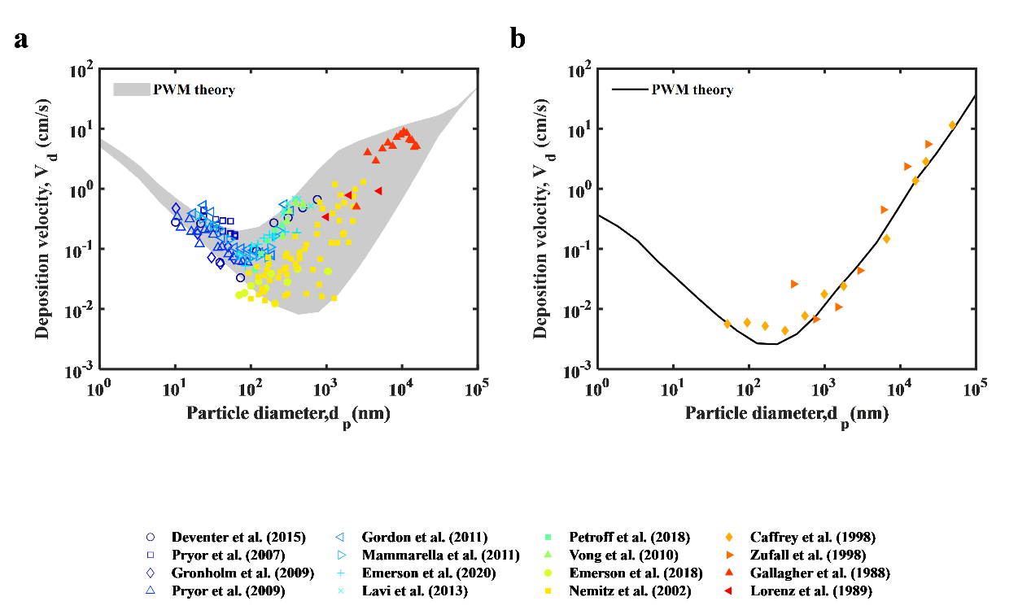
Fig. S1| Comparison between PWM theory and published atmospheric flux observations. a, The comparison for vegetated regions. The colorful marks are observed ADD velocity data over 14 vegetated regions worldwide. Vegetation geometric area per unit ground ($A_{v}$) in these regions ranges from 1.4 to 10 (m²/m²). b, The comparison for water regions. The colorful marks are observed ADD velocity data over 2 water regions in America.

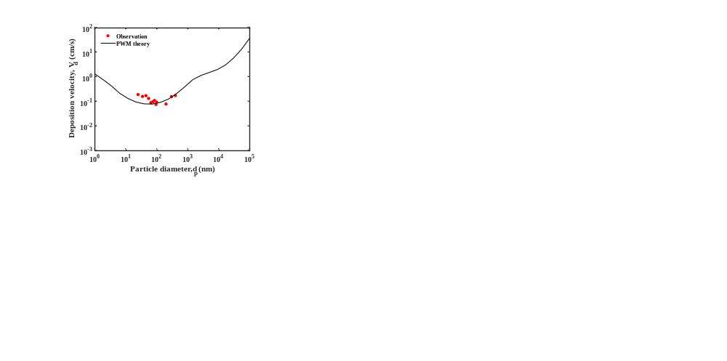

Fig. S2| Comparison between PWM theory and the atmospheric flux observation in this work. The red dots are the first observed ADD velocity data over a built-up region. Building geometric area per unit ground ($A_{b}$) here is ~0.6 (m²/m²).

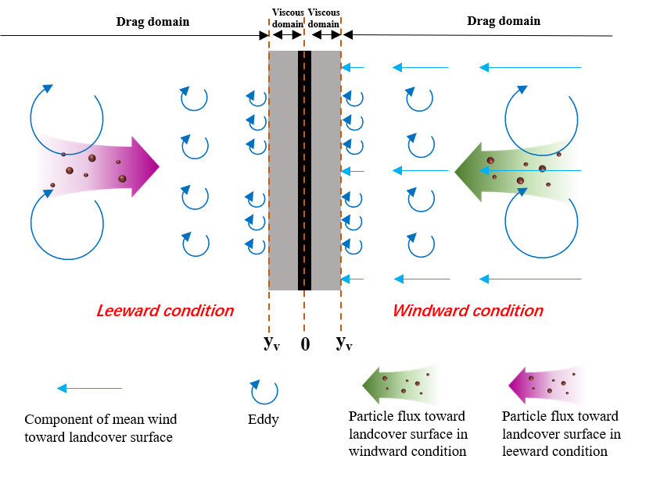

Fig. S3| Illustration of particle motion within drag domain.

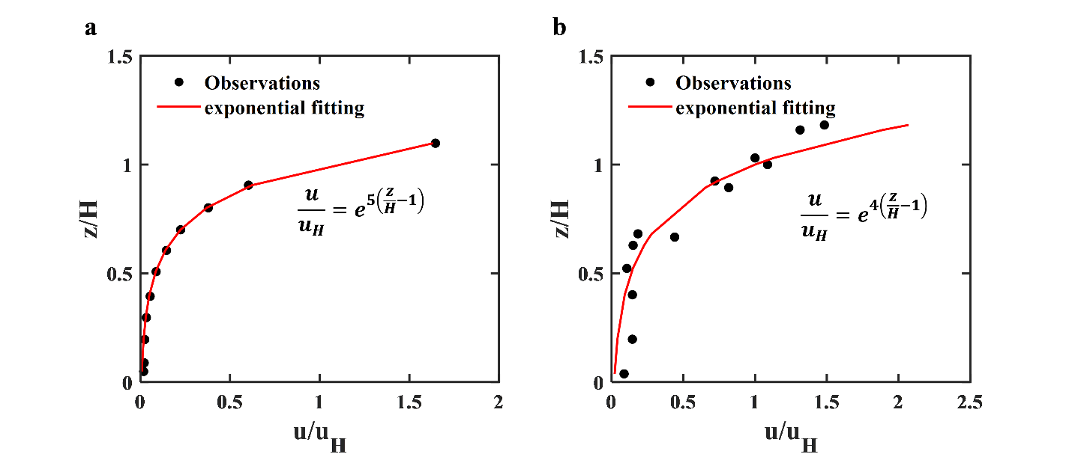

Fig. S4| Typical wind profile observed within a canopy. a, A building canopy modeled with cube arrays in wind tunnel experiments. b, A forest canopy in Brazil.

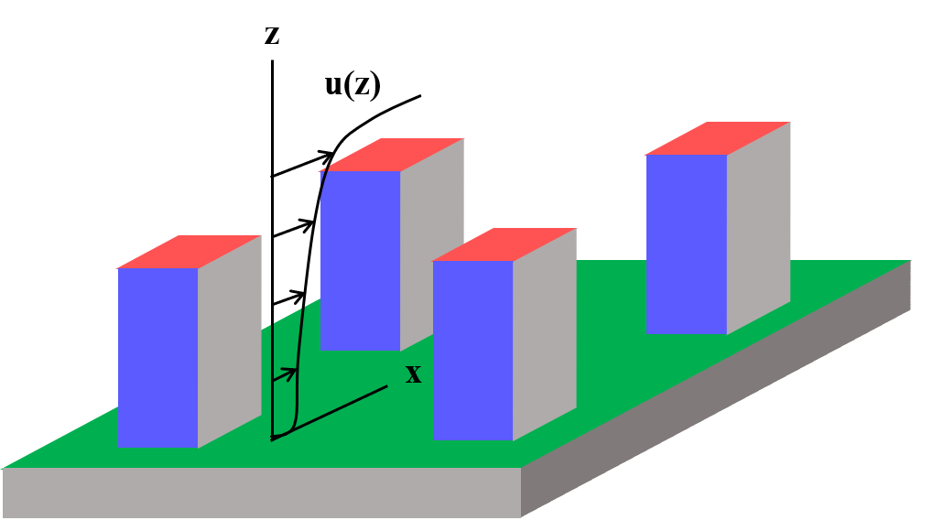

Fig. S5| Illustration about front area and plan area of landcover. Red surface is the plan area ($λ_{p}$). Blue surface is the front area ($λ_{f}$). Dark arrows are wind vectors, which are perpendicular to the blue surface.

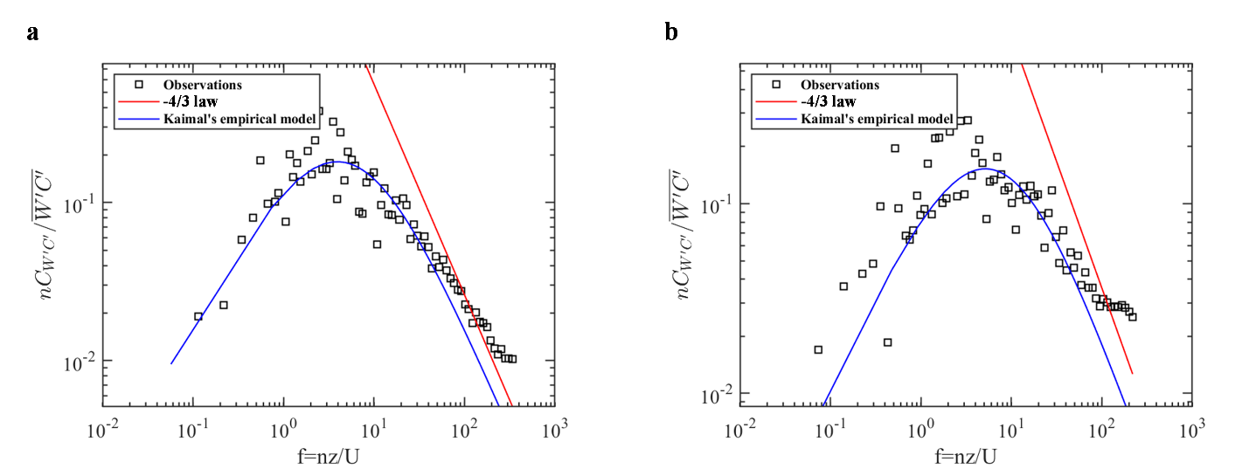
Fig. S6| Typical cospectra of measured deposition fluxes in this study. a, A typical cospectrum in the first period. b, A typical cospectrum in the second period.

Fig. S7| Multiple Influences of landcover geometry most unfavorable to ADD under observation constraint. a, Influence of landcover geometry on global ADD velocity. b, Relative changes of global column aerosol mass induced by landcover geometry (%). c, Absolute changes of global aerosol forcing induced by landcover geometry (W/m²). d, Relative changes of global aerosol forcing induced by landcover geometry (%). These results are obtained by comparing the scenario considering landcover geometry predicted by PWM theory with the scenario ignoring landcover geometry predicted by resistance model configured with conventional parameters. According to this landcover geometry input, terrestrial aerosol cooling effect is reduced by 30%.

Fig. S8| Multiple Influences of landcover geometry most favorable to ADD under observation constraint. a, Influence of landcover geometry on global ADD velocity. b, Relative changes of global column aerosol mass induced by landcover geometry (%). c, Absolute changes of global aerosol forcing induced by landcover geometry (W/m²). d, Relative changes of global aerosol forcing induced by landcover geometry (%). These results are obtained by comparing the scenario considering landcover geometry predicted by PWM theory with the scenario ignoring landcover geometry predicted by resistance model configured with conventional parameters. According to this landcover geometry input, terrestrial aerosol cooling effect is reduced by 60%.

Fig. S9| Mean ground-level PM_{2.5} concentration during 2018-2020. a, Retrieved from satellites. b, Modeled by CESM coupled with PWM theory. c, Modeled by CESM coupled with the resistance model (conventional parameters). d, The comparison between PM_{2.5} concentration retrieved from satellites and modeled by CESM coupled with PWM theory. e, The comparison between PM_{2.5} concentration retrieved from satellites and modeled by CESM coupled with the resistance model.

Fig. S10| Ground-level PM_{2.5} relative changes induced by landcover geometry during 2018-2020. This result is obtained by comparing the scenario considering landcover geometry predicted by PWM theory with the scenario ignoring landcover geometry predicted by resistance model configured with conventional parameters. Overall, landcover geometry cause ground level PM_{2.5} to vary by -73% to +139%.

6 References
1 Paulson, C. A. The mathematical representation of wind speed and temperature profiles in the unstable atmospheric surface layer. Journal of Applied Meteorology (1962-1982), 857–861 (1970).
2 Pretzsch, H. The effect of tree crown allometry on community dynamics in mixed-species stands versus monocultures. A review and perspectives for modeling and silvicultural regulation. Forests 10, 810 (2019).
3 Petroff, A. & Zhang, L. Development and validation of a size-resolved particle dry deposition scheme for application in aerosol transport models. Geoscientific Model Development 3, 753–769 (2010).
4 Santana, R. A. et al. Air turbulence characteristics at multiple sites in and above the Amazon rainforest canopy. Agricultural and Forest Meteorology 260, 41–54 (2018).
5 Moon, K., Duff, T. J. & Tolhurst, K. G. Sub-canopy forest winds: understanding wind profiles for fire behaviour simulation. Fire safety journal 105, 320–329 (2019).
6 Kim, J., Moin, P. & Moser, R. Turbulence statistics in fully developed channel flow at low Reynolds number. Journal of fluid mechanics 177, 133–166 (1987).
7 Hinze, J. O. Turbulence, McGraw-Hill Series in Mechanical Engineering. New York (1975).
8 Caporaloni, M., Tampieri, F., Trombetti, F. & Vittori, O. Transfer of particles in nonisotropic air turbulence. Journal of the atmospheric sciences 32, 565–568 (1975).
9 Soldati, A. & Marchioli, C. Physics and modelling of turbulent particle deposition and entrainment: Review of a systematic study. International Journal of Multiphase Flow 35, 827–839 (2009).
10 Seinfeld, J. H. & Pandis, S. N. Atmospheric chemistry and physics: from air pollution to climate change. (John Wiley & Sons, 2016).
11 Zhao, B. & Wu, J. Modeling particle deposition from fully developed turbulent flow in ventilation duct. Atmospheric Environment 40, 457–466 (2006).
12 Zhao, B. & Wu, J. Modeling particle deposition onto rough walls in ventilation duct. Atmospheric Environment 40, 6918–6927 (2006).
13 Wan, S. G. Experimental study on turbulence near walls. Chin. Sci. Bull 26, e1148 (1981).
14 Grass, A. J. Structural features of turbulent flow over smooth and rough boundaries. Journal of Fluid Mechanics 50, 233–255 (1971). https://doi.org/10.1017/S0022112071002556
15 Raupach, M. R., Antonia, R. A. & Rajagopalan, S. Rough-Wall Turbulent Boundary Layers. Applied Mechanics Reviews 44, 1–25 (1991). https://doi.org/10.1115/1.3119492
16 Coceal, O. & Belcher, S. E. A canopy model of mean winds through urban areas. Quarterly Journal of the Royal Meteorological Society 130, 1349–1372 (2004).
17 Zhang, J., Shao, Y. & Huang, N. Measurements of dust deposition velocity in a wind-tunnel experiment. Atmospheric Chemistry and Physics 14, 8869–8882 (2014).
18 Macdonald, R. W. Modelling the mean velocity profile in the urban canopy layer. Boundary-Layer Meteorology 97, 25–45 (2000).
19 Zhang, Z., Liu, F., Zhou, Z., He, Y. & Fang, H. Roughness measurement of leaf surface based on shape from focus. Plant methods 17, 1746–4811 (2021).
20 Seker, D. Z. & Tavil, A. Evaluation of exterior building surface roughness degrees by photogrammetric methods. Building and Environment 31, 0360–1323 (1996).
21 Ma, J. et al. Effects of leaf surface roughness and contact angle on in vivo measurement of droplet retention. Agronomy 12, 2073–4395 (2022).
22 Raupach, M. R. & Shaw, R. H. Averaging procedures for flow within vegetation canopies. Boundary-layer meteorology 22, 79–90 (1982).
23 Finnigan, J. Turbulence in plant canopies. Annual review of fluid mechanics 32, 519–571 (2000).
24 Cionco, R. M. A mathematical model for air flow in a vegetative canopy. Journal of Applied Meteorology (1962-1982), 517–522 (1965).
25 Queck, R. & Bernhofer, C. Constructing wind profiles in forests from limited measurements of wind and vegetation structure. Agricultural and forest meteorology 150, 724–735 (2010).
26 Santana, R. A. S. d., Dias-Júnior, C. Q., Vale, R. S. d., Tóta, J. & Fitzjarrald, D. R. Observing and modeling the vertical wind profile at multiple sites in and above the Amazon rain forest canopy. Advances in Meteorology 2017, 5436157 (2017).
27 Yi, C. et al. Modeling and measuring the nocturnal drainage flow in a high‐elevation, subalpine forest with complex terrain. Journal of Geophysical Research: Atmospheres 110 (2005).

