Supplementary tables
Beyond pathogen enrichment: restructuring of the foliar mycobiome in declining giant sequoia

Blessing Alabi¹, Abiodun Abeeb Azeez², Emma Lührs¹, Frederik Siebert¹, Kathrin Blumenstein¹

¹Chair of Pathology of Trees, Institute of Forestry, Faculty of Environment and Natural
Resources, University of Freiburg, Bertoldstr. 17, 79098 Freiburg, Germany
²Department of Forest Sciences, University of Helsinki, Latokartanonkaari 5, P. O. Box 27, 00014, Helsinki.
Table S1. PERMANOVA result for the health status and vitality class on fungal community composition
Factor | Df | R² | F | Pr(>F)
Health status | 1 | 0.158 | 7.13 | 0.001
Vitality class | 2 | 0.178 | 4.01 | 0.001

Table S2. Pairwise PERMANOVA between vitality classes (VC0, VC2, VC3)
Pairs | R² |  | F | p-value | q (BH)
VC0 vs VC2 | 0.144 | 4.384 |  | 0.001 | 0.002
VC0 vs VC3 | 0.156 | 5.538 |  | 0.001 | 0.002
VC2 vs VC3 | 0.050 | 0.915 |  | 0.525 | 0.525

Table S3. Global network properties and centrality comparisons for asymptomatic and symptomatic fungal co-occurrence networks constructed using SPRING (NetCoMi v1.1.0). Significance codes: ** p < 0.01; * p < 0.05.
Network feature | Asymptomatic | Symptomatic
Number of edges | 141 | 126
Number of nodes | 80 | 80
Number of components | 1 | 4
Relative size of the largest connected component | 1.00 | 0.95
Edge density | 0.044 | 0.039
Modularity | 0.527 | 0.602
Average path length | 3.59 | 4.07
Positive edge percentage | 70.213 | 73.016
Clustering coefficient | 0.175 | 0.167
Average dissimilarity | 0.69 | 0.70
Centrality measure | J | P(≤J) | P(≥J)
Degree | 0.207 | 0.103 | 0.955
Betweenness centrality | 0.258 | 0.246 | 0.861
Closeness centrality | 0.143 | 0.009** | 0.997
Eigenvector centrality | 0.143 | 0.009** | 0.997
Hub taxa | 0.000 | 0.039* | 1.000

Supplementary Figures
Beyond pathogen enrichment: restructuring of the foliar mycobiome in declining giant sequoia

Blessing Alabi¹, Abiodun Abeeb Azeez², Emma Lührs¹, Frederik Siebert¹, Kathrin Blumenstein¹

¹Chair of Pathology of Trees, Institute of Forestry, Faculty of Environment and Natural
Resources, University of Freiburg, Bertoldstr. 17, 79098 Freiburg, Germany
²Department of Forest Sciences, University of Helsinki, Latokartanonkaari 5, P. O. Box 27, 00014, Helsinki.
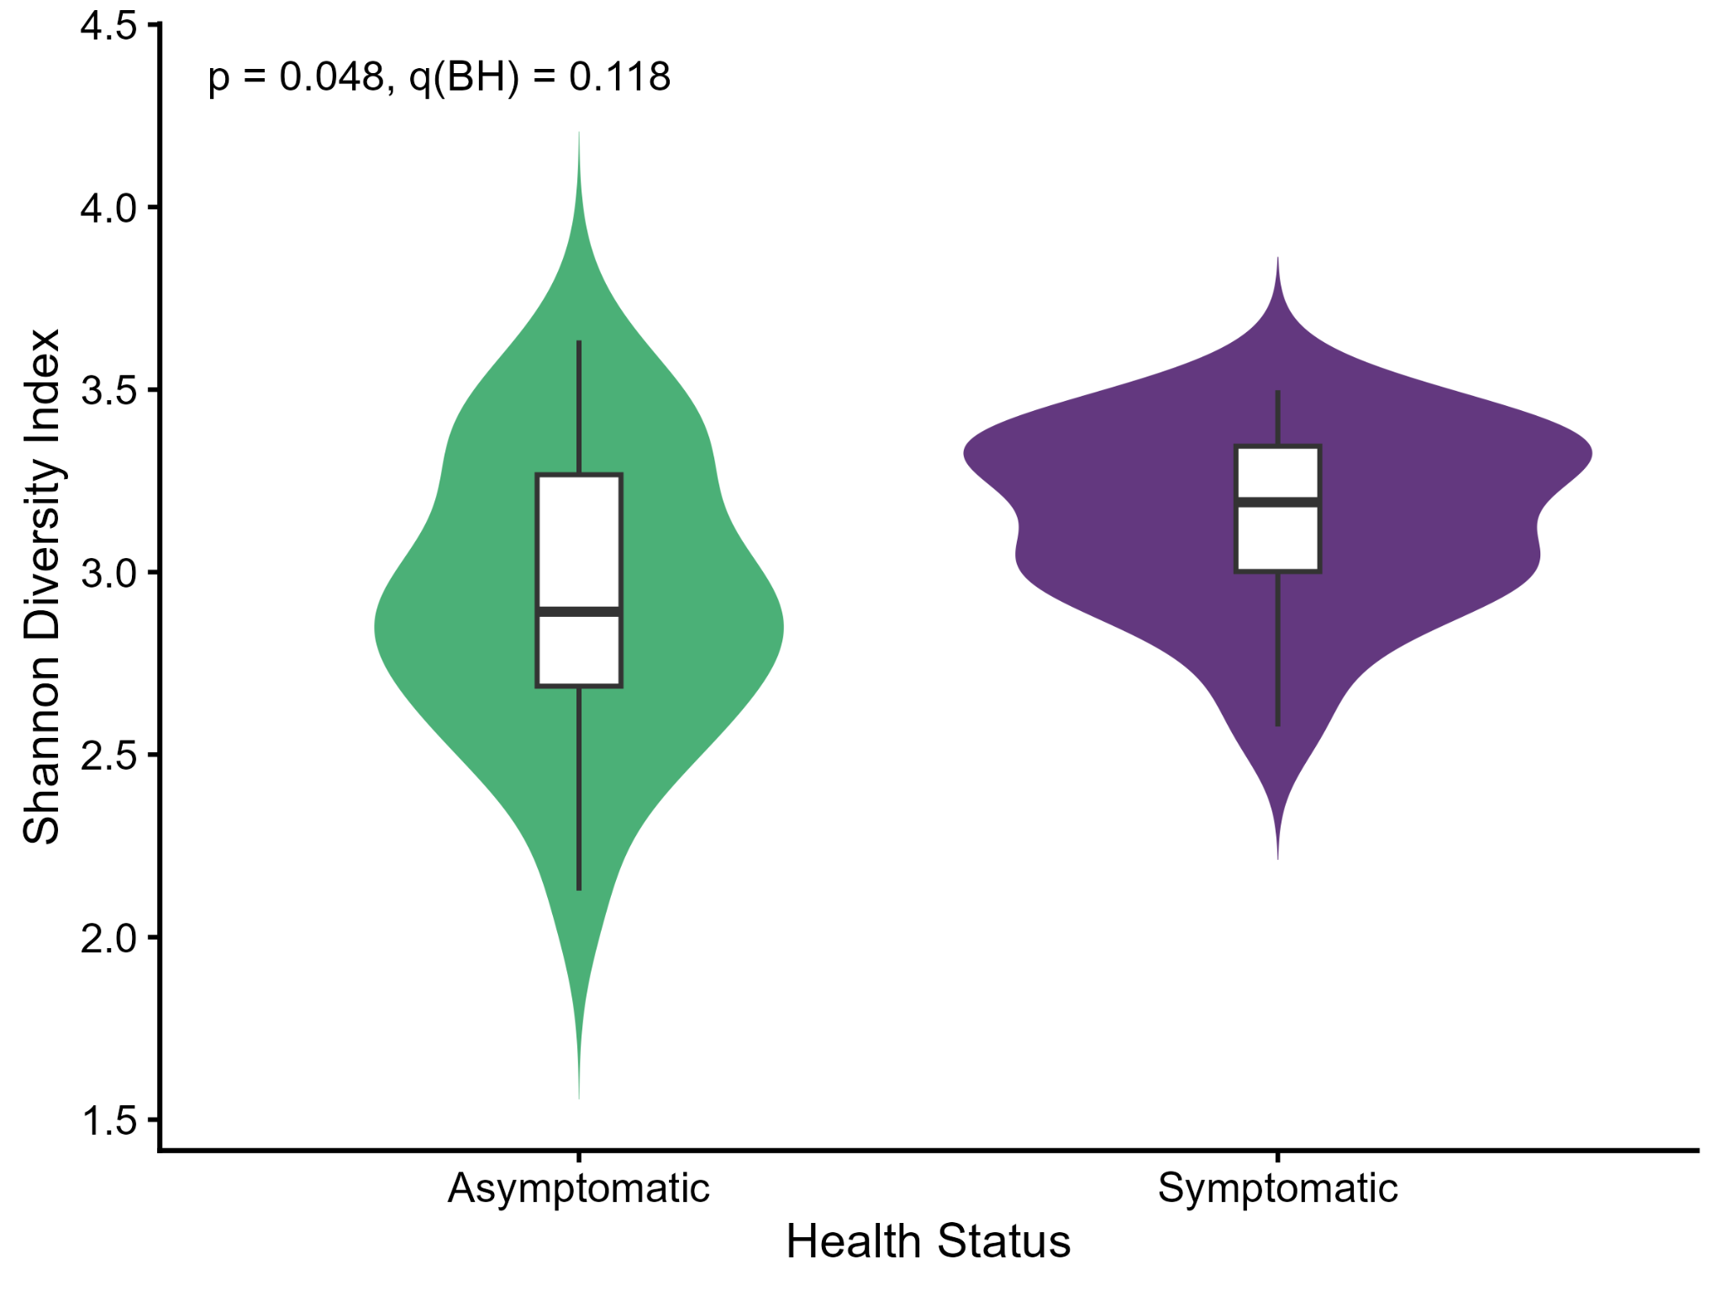
Fig. S1. Shannon diversity (violin plots with embedded boxplot) in asymptomatic symptomatic S. giganteum trees; t-test p = 0.048 (BH-adjusted = 0.119); n = 20 per group.
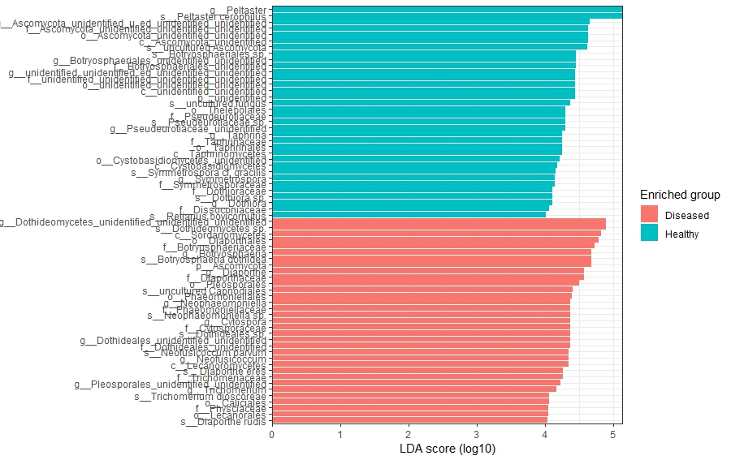

Fig. S2. LEfSe analysis of differentially enriched fungal taxa among health groups.

