Supplementary materials
Supplementary Methods S1 Radiomics feature extraction and reproducibility
S1.1 Image preprocessing and feature extraction
Radiomics features were extracted using PyRadiomics version 2.2.0 in accordance with Image Biomarker Standardization Initiative recommendations. Before feature extraction, N4 bias-field correction was applied to all magnetic resonance imaging (MRI) sequences. T2-weighted imaging (T2WI) and delayed-phase three-dimensional volumetric interpolated breath-hold examination (3D-VIBE) images were resampled to 0.9 × 0.9 × 4 mm³, whereas diffusion-weighted imaging (DWI) and apparent diffusion coefficient (ADC) images were resampled to 1.2 × 1.2 × 4 mm³. Linear interpolation was used for images and nearest-neighbor interpolation for binary masks. Because image and mask resampling was completed before feature extraction, additional resampling within PyRadiomics was disabled.
For radiomics feature extraction, each resampled three-dimensional (3D) MRI volume was independently normalized using the PyRadiomics z-score normalization procedure (normalize = true), with the mean and standard deviation calculated from all voxel intensities within the entire input image volume rather than from individual slices or the tumor mask. The z-score-normalized intensities were clipped to [−3, 3] (removeOutliers = 3) and then multiplied by 100 (normalizeScale = 100). Gray-level discretization was performed using a fixed bin width of 25 (binWidth = 25), and voxelArrayShift was set to 0. Although radiomics features were subsequently calculated in two dimensions (2D) for individual tumor-containing axial slices, the intensity-normalization parameters were derived from the corresponding full 3D input volume.
For wavelet-derived features, filtering and feature calculation were performed in two separate stages. First, one-level Coiflet-1 wavelet decomposition was applied to each complete 3D MRI volume with 3D filtering enabled (force2D = false during wavelet-image generation), yielding the eight three-axis decomposition volumes (HHH, HHL, HLH, HLL, LHH, LHL, LLH, and LLL). Second, radiomics features were calculated from individual tumor-containing axial slices of each derived volume using 2D feature extraction (force2D = true, force2Ddimension = 0). Thus, wavelet filtering was 3D, whereas the subsequent texture-feature calculation was 2D. For the original and other derived images, 2D radiomics features were likewise calculated from individual tumor-containing axial slices. Texture matrices were calculated using a voxel distance of 1 without distance weighting. Laplacian-of-Gaussian filtered images with σ values of 1.0 and 5.0 mm, square, square-root, logarithm, exponential, gradient, and 2D local binary-pattern (LBP2D) images were included. Gradient calculation accounted for physical voxel spacing. For LBP2D, a radius of 1, eight neighboring samples, and the uniform method were used. 2D shape features were calculated, whereas 3D shape features were not included.
S1.2 Patient-level aggregation of radiomics features
For radiomics, tumor segmentation was originally defined on T2WI and propagated to the corresponding DWI, ADC, and 3D-VIBE images. All propagated masks were visually inspected on the corresponding registered images and manually corrected when necessary to ensure adequate tumor coverage and spatial alignment. After sequence-specific image and mask resampling, slice-level radiomics features were first aggregated across all tumor-containing slices within each MRI sequence using a tumor-area-weighted mean to generate patient-level radiomics features. For a given radiomics feature, the patient-level value was calculated as
$$F_{patient}=\frac{\sum_{j=1}^{n}{A_{j}F_{j}}}{\sum_{j=1}^{n}{A_{j}}}$$
where $F_{j}$ represents the feature value from the $j$th tumor-containing slice, $A_{j}$ denotes the tumor area derived from the corresponding propagated T2WI-derived tumor mask in that sequence's analysis space. Thus, although all sequence-specific masks originated from the same T2WI segmentation, the area weights for radiomics were calculated from the mask after propagation and resampling to the corresponding sequence space. The resulting patient-level radiomics feature vectors subsequently entered the radiomics development pipeline, including Borderline Synthetic Minority Oversampling Technique (Borderline-SMOTE), input-feature z-score standardization, Pearson correlation coefficient (PCC)-based redundancy reduction, least absolute shrinkage and selection operator (LASSO) feature selection, and logistic-regression fitting.
S1.3 Feature reproducibility assessment
Feature reproducibility was assessed in 30 patients randomly selected from the training cohort (Center A; n = 268). Two radiologists independently delineated the tumor regions of interest (ROIs), and the delineation procedure was repeated after a 1-month interval. Intraobserver and interobserver reproducibility were quantified using a two-way random-effects, absolute-agreement, single-measure intraclass correlation coefficient [ICC (2,1)]. Features with both intraobserver and interobserver ICCs greater than 0.75 were considered reproducible and were retained for subsequent analysis.
Supplementary Methods S2 Deep transfer learning
S2.1 Network architecture and ROI inputs
Four independently parameterized 50-layer residual network (ResNet-50) branches were implemented to process T2WI, DWI, ADC, and delayed-phase 3D-VIBE ROI crops. Although all branches were initialized from the same ImageNet-pretrained ResNet-50 model, they were instantiated independently and optimized with separate learnable parameters, with no weight sharing across sequences.
For the deep learning (DL) pipeline, T2WI served as the common spatial reference. After rigid registration of DWI, ADC, and delayed-phase 3D-VIBE to T2WI, the original T2WI-derived tumor mask in T2WI space was used as the common reference mask for all four sequences. Tumor-containing slices and tumor-centered bounding boxes were identified from this reference mask, and the same spatial coordinates were applied to the registered DWI, ADC, and delayed-phase 3D-VIBE images. For each tumor-containing slice, tumor area used for patient-level probability weighting was calculated from the corresponding T2WI-space reference-mask slice before the ROI crop was resized to 224 × 224 pixels. The resized mask was not used for area estimation.
Because the MRI inputs were single-channel images, the first convolutional layer of each ResNet-50 branch was modified from 64 × 3 × 7 × 7 to 64 × 1 × 7 × 7. The single-channel convolutional kernels were initialized by averaging the corresponding ImageNet-pretrained weights across the three red, green, and blue (RGB) input channels. All other compatible ImageNet-pretrained parameters were loaded without modification. Each sequence-specific ROI crop defined using the T2WI-space reference bounding box was subsequently resized to 224 × 224 pixels and independently z-score normalized before network input. The 224 × 224 resizing was performed only for convolutional neural network (CNN) input preparation and did not affect the tumor-area measurements used for subsequent slice weighting. For an input tensor of 1 × 224 × 224, each ResNet-50 branch generated a 2048 × 7 × 7 feature map after the final residual block. Global average pooling reduced this feature map to a 2048-dimensional sequence-specific feature vector. The four feature vectors were concatenated into an 8192-dimensional representation and passed through a fully connected fusion classifier with two output units corresponding to lymph node metastasis (LNM)-negative and LNM-positive classes. This classifier served only as the supervision head for task-specific fine-tuning and was not used as the final patient-level prediction model.
S2.2 Network development and fine-tuning
The four sequence-specific ResNet-50 branches were jointly optimized for binary LNM classification using focal loss (focusing parameter γ = 2.0; class-balancing weights of 0.75 and 0.25 for the LNM-positive and LNM-negative classes, respectively). Network-development data from the 268-patient training cohort were divided at the patient level into training and validation subsets at an 8:2 ratio, stratified by pathological LNM status. All sequences, slices, and augmented images from the same patient were retained in the same subset.
Hyperparameter tuning was restricted to the training cohort. Candidate learning rates were 1 × 10⁻⁵, 3 × 10⁻⁵, 1 × 10⁻⁴, and 3 × 10⁻⁴; batch sizes of 16 and 32 were evaluated; and weight-decay values of 0, 1 × 10⁻⁵, and 1 × 10⁻⁴ were considered. Three transfer-learning strategies were compared: fine-tuning of layer4 only, fine-tuning of layers3–4, and fine-tuning of the entire ResNet-50 backbone. Hyperparameter selection was based primarily on patient-level validation area under the receiver operating characteristic curve (AUC).
The final configuration used the Adam optimizer (β1 = 0.9, β2 = 0.999), an initial learning rate of 1 × 10⁻⁴, a batch size of 32, and a weight decay of 1 × 10⁻⁴. The modified first convolutional layer and residual layers3–4 were fine-tuned together with the randomly initialized fusion classifier, whereas residual layers1–2 were frozen. Batch-normalization running statistics were kept fixed during fine-tuning. Training was performed for a maximum of 1000 epochs, with early stopping if the validation loss did not improve for 10 consecutive epochs. This network-development stage preceded downstream five-fold out-of-fold (OOF) evaluation and was not repeated within its folds. Neither the held-out internal validation cohort nor the external validation cohort was used for network optimization, hyperparameter selection, early stopping, or model selection.
S2.3 Data augmentation
Dynamic data augmentation was applied only during network training. For each spatially aligned four-sequence slice set, geometric transformations were applied synchronously to T2WI, DWI, ADC, and delayed-phase 3D-VIBE crops to preserve intersequence spatial correspondence. Random rotation within ±10° was applied with a probability of 0.5, translation within ±10% of the image width and height with a probability of 0.5, isotropic scaling within 0.90–1.10 with a probability of 0.5, and shearing within ±5° with a probability of 0.3. Intensity-level augmentation was applied independently to each sequence and included Gaussian noise with a standard deviation randomly sampled from 0 to 0.05 relative to the standardized image intensity (probability, 0.3) and Gaussian blurring with σ randomly sampled from 0.1 to 1.0 pixels (probability, 0.2). Each augmentation operation was independently sampled according to its predefined probability. No augmentation was applied to the network-development validation subset, held-out internal validation cohort, or external validation cohort.
S2.4 Deep feature extraction and patient-level probability aggregation
After fine-tuning, the fusion classifier was removed and the network parameters were fixed. For each spatially aligned tumor-containing slice set, the four 2048-dimensional sequence-specific feature vectors were concatenated into an 8192-dimensional representation. Cross-slice averaging of the DL feature vectors was not performed. Within each downstream training fold, Borderline-SMOTE was applied only to the slice-level feature data in the training portion of that fold. Input-feature means and standard deviations were subsequently estimated from the resampled training data and used for z-score standardization. PCC-based redundancy reduction and LASSO feature selection were then performed, followed by logistic-regression fitting using the selected standardized features.
The fitted logistic-regression model generated an LNM-positive probability for each spatially aligned four-sequence slice set. Slice-level probabilities were aggregated at the patient level using tumor-area-weighted soft voting. For all four sequences, the weighting area was derived from the T2WI-space reference tumor mask because T2WI served as the common spatial reference after registration. Specifically, for each tumor-containing slice, the tumor area was measured from the corresponding binary T2WI reference-mask slice before ROI cropping was resized to 224 × 224 pixels. Thus, the area used for probability weighting was independent of the image resizing performed for CNN input. For a patient with $n$ tumor-containing slices, the patient-level probability was calculated as
$$P_{patient}=\frac{\sum_{j=1}^{n}{A_{j}P_{j}}}{\sum_{j=1}^{n}{A_{j}}}$$
where $P_{j}$ denotes the predicted LNM-positive probability for the $j$th aligned four-sequence slice set and $A_{j}$ denotes the tumor area derived from the corresponding slice of the T2WI-space reference tumor mask before 224 × 224 resizing.
The resulting patient-level probability was logit-transformed to obtain the unstandardized DL signature:
$$DL {signature}_{raw}=log\left(\frac{P_{patient}}{1-P_{patient}}\right)$$
Image-intensity normalization was performed independently within each sequence-specific ROI crop. Input-feature standardization used the resampled training feature data, whereas patient-level signature standardization used the original, non-oversampled training patients. These distinct procedures and their reference data are described in Supplementary Methods S3. All performance evaluation was conducted at the patient level.
Supplementary Methods S3 Feature selection and imaging signature construction
S3.1 Borderline-SMOTE
Borderline-SMOTE was applied only during development of the radiomics and DL signatures and was restricted to the training portion of each patient-level OOF fold. For radiomics, the inputs to oversampling were patient-level feature vectors obtained by tumor-area-weighted averaging of slice-level radiomics features. For DL, the inputs were slice-level deep-feature vectors extracted by the fixed CNN from patients belonging to the corresponding training fold. The Borderline-SMOTE1 variant was used, with five nearest neighbors (k_neighbors = 5) for synthetic-sample generation and 10 nearest neighbors (m_neighbors = 10) for identifying minority-class observations located near the decision boundary. The minority class was oversampled to 50% of the majority-class size (sampling_strategy = 0.5), rather than to complete class balance, to limit excessive generation of synthetic observations. Accordingly, the specified sampling ratio was applied at the patient-feature level for radiomics and at the slice-feature level for DL. The random seed was fixed at 42 to ensure reproducibility.
Oversampling preceded input-feature z-score standardization, PCC-based redundancy reduction, LASSO feature selection, and logistic-regression fitting. Input-feature means and standard deviations were estimated exclusively from the corresponding resampled training data. Neither held-out OOF folds nor the held-out internal or external validation cohorts were resampled. Each resulting patient-level imaging signature underwent a separate z-score transformation before inclusion in the combined models, whereas the clinical and patient-level combined models were fitted without oversampling.
Boundary sample identification. Minority-class observations near the class boundary were identified according to the class composition of their m_neighbors = 10 nearest neighbors. Observations classified as borderline (“danger”) samples were eligible for synthetic-sample generation according to the Borderline-SMOTE1 procedure.
Synthetic sample generation. For each eligible boundary observation, one of its five minority-class neighbors (k_neighbors = 5) was randomly selected. A synthetic observation was generated by linear interpolation between the boundary observation and the selected neighbor:
$$x_{new} = x_{i} + λ(x_{j} - x_{i})$$
Here, $x_{i}$ denotes the boundary minority-class observation, and $x_{j}$ denotes its randomly selected minority-class neighbor. The interpolation weight λ was sampled uniformly from [0, 1]. Each synthetic observation therefore lay on the line segment between the two observations in feature space.
Synthetic observations were used exclusively for fitting the imaging-signature models. All reported performance metrics were calculated using original observations only. For DL, slice-level logistic-regression probabilities were first aggregated to the patient level using tumor-area-weighted soft voting, with slice weights derived from the pre-resize T2WI-space reference tumor mask as defined in Supplementary Methods S2.4, before calculation of patient-level performance. For final model development, the same imaging-signature procedures were repeated using the complete training cohort, after which the preprocessing parameters, selected features, model coefficients, and signature-transformation parameters were locked and applied unchanged to the internal and external validation cohorts.
S3.2 Input-feature standardization and PCC filtering
Within each inner cross-validation training partition, Borderline-SMOTE was first applied to the training observations only. Input-feature means and standard deviations were then estimated exclusively from the corresponding resampled inner-training data and used to z-score standardize both the inner-training and inner-validation data; the inner-validation data were not used to estimate any normalization parameters. PCC-based redundancy reduction was subsequently performed using the inner-training data only and was repeated independently in each inner training partition.
Pairwise PCCs were calculated separately for the radiomics and DL feature sets. Feature pairs with an absolute PCC of $\left|r\right|>0.90$ were considered highly correlated. For each highly correlated pair, the feature showing the weaker absolute point-biserial correlation with pathological LNM status among the original, non-oversampled patients or observations in the corresponding inner-training partition was removed. This procedure was repeated iteratively until no remaining feature pair exceeded the predefined correlation threshold.
The resulting feature-retention decisions were then applied unchanged to the corresponding inner-validation partition. At no stage were inner-validation outcomes used for normalization, PCC calculation, point-biserial correlation assessment, or feature-retention decisions. For DL features, all slice-level observations originating from the same patient remained confined to the same data partition throughout the procedure.
S3.3 Nested LASSO feature selection
Following PCC-based redundancy reduction, LASSO feature selection was performed separately for the radiomics and DL feature sets using L1-penalized logistic regression with a binomial distribution and logit link ($α=1$).
Within each outer OOF training partition, the original patients were assigned to five patient-level inner cross-validation folds. For each inner fold, the complete preprocessing sequence was re-estimated using the inner-training partition only: Borderline-SMOTE was applied to the inner-training data, input-feature means and standard deviations were estimated from the resampled inner-training data, and PCC-based redundancy reduction was repeated using only the inner-training observations. The corresponding normalization parameters and retained feature set were then applied unchanged to the inner-validation partition. For DL features, all slice-level observations from the same patient remained in the same inner fold.
Candidate values of the LASSO regularization parameter $λ$ were evaluated using mean binomial deviance across the five inner validation folds. A sequence of 100 $λ$ values logarithmically spaced from $λ_{max}$ to 0.001×$λ_{max}$ was evaluated using mean binomial deviance. The largest $λ$ whose cross-validated deviance was within one standard error of the minimum ($λ_{1se}$) was selected to favor a parsimonious and stable feature set.
After $λ_{1se}$ had been selected, Borderline-SMOTE, input-feature standardization, and PCC-based redundancy reduction were repeated using the complete outer-training partition, and the LASSO model was refitted at the selected ​$λ_{1se}$. Features with non-zero coefficients in this refitted model were retained for downstream logistic-regression fitting.
For final model development using all 268 training patients, the LASSO regularization parameter was selected de novo using a new patient-level five-fold cross-validation procedure within the complete training cohort. In each cross-validation split, Borderline-SMOTE, input-feature standardization, and PCC-based redundancy reduction were again performed using only the corresponding training partition, and the resulting preprocessing parameters and retained feature set were applied unchanged to the validation partition. The final $λ_{1se}$ was selected from the pooled cross-validation results. The complete preprocessing pipeline was then repeated using all 268 training patients, and the final LASSO model was fitted at this selected $λ_{1se}$. The resulting feature set was subsequently locked for evaluation in the held-out internal and external validation cohorts.
S3.4 Logistic imaging signatures and patient-level standardization
Logistic regression was fitted using the selected standardized radiomics features, and the unstandardized radiomics signature was defined as the linear predictor of the fitted model, including its intercept.
The unstandardized DL signature was the logit of the patient-level probability obtained by tumor-area-weighted aggregation of slice-level logistic-regression probabilities (Supplementary Methods S2.4). Probability aggregation preceded logit transformation; CNN feature vectors were not averaged across slices.
The radiomics and DL signatures were subsequently standardized separately. Within each OOF training fold, the mean and standard deviation used for signature standardization were calculated from the unstandardized patient-level signatures generated for the original, non-oversampled training patients using that fold's fitted imaging model. Each patient contributed one signature value, and synthetic observations generated by Borderline-SMOTE were excluded from estimation of these parameters. The corresponding training-derived mean and standard deviation were then applied unchanged to the held-out patients.
The z-score transformation was calculated as
$$z=\frac{x-μ}{σ}$$
where $x$ represents the unstandardized patient-level imaging signature, $μ$ denotes its mean in the corresponding training data, and $σ$ denotes the corresponding standard deviation. The resulting standardized radiomics and DL signatures could therefore take either positive or negative values.
For final model development, the imaging-feature selection and fitting procedures were repeated using the complete training cohort. Signature-standardization parameters were recalculated from the original 268 training patients using the final fitted imaging models and were subsequently fixed and applied unchanged to both the held-out internal and external validation cohorts.
Supplementary Methods S4 Clinical and combined-model development and OOF evaluation
S4.1 Clinical predictor selection
The initial multivariable clinical logistic-regression model included all nine preoperative candidate variables listed in Table 1: age, body mass index, postmenopausal status, reproductive history, cancer antigen 125 (CA125), human epididymis protein 4 (HE4), magnetic resonance (MR) report-based deep myometrial invasion (DMI), MR report-based maximum tumor diameter, and MR report-based LNM status. The three MR report-based variables were extracted directly from the original preoperative clinical MR reports, without retrospective reassignment or remeasurement. Postoperative pathological variables were not considered as candidate predictors. CA125 and HE4 were coded as normal or abnormal according to the classification reported by the testing laboratory at each center.
Backward elimination was guided by the Akaike information criterion (AIC). At each step, the variable whose removal produced the greatest reduction in AIC was excluded, and the procedure continued until no further reduction in AIC was achieved. No univariable P-value screening was performed before multivariable clinical-model development. Clinical predictor selection was repeated independently within each OOF training fold and subsequently using the complete training cohort for final model development.
S4.2 Combined-model development and patient-level OOF evaluation
Five-fold OOF splits were generated at the patient level and stratified by pathological LNM status, with all sequences, slices, and augmented images from each patient assigned to the same fold. Within each OOF training fold, clinical predictor selection was repeated using backward elimination based on AIC. Imaging-feature preprocessing, PCC/LASSO selection, and radiomics and DL logistic-regression fitting were also repeated exclusively within that fold. Borderline-SMOTE was confined to the training portion of each fold and was applied only during development of the radiomics and DL signatures; held-out patients retained their original observations and class distributions.
Within each OOF training fold, the Clinical+Radiomics model incorporated all predictors retained in the corresponding clinical model together with the standardized radiomics signature. The nomogram additionally incorporated the standardized DL signature. No additional variable-selection procedure was applied after construction of either combined model, and their logistic-regression coefficients were estimated separately. No oversampling was used when fitting the clinical or combined patient-level models.
Predictions for the corresponding held-out patients were generated without refitting, feature reselection, or recalibration, and the held-out predictions from all five folds were pooled to estimate downstream OOF performance.
ResNet-50 representation learning, including hyperparameter tuning, fine-tuning, and early stopping, preceded the downstream OOF procedure and was not repeated within individual OOF folds. Consequently, although all downstream feature-selection and model-fitting steps were performed within the OOF framework, performance estimates for models incorporating DL features were conditional on a previously developed representation and may therefore retain some optimism.
A model-specific classification threshold was selected by maximizing the Youden index using pooled patient-level OOF predictions from the training cohort. The nomogram threshold was 0.161. These thresholds were fixed before evaluation of either validation cohort and were not re-optimized in validation subgroups.
S4.3 Final refitting and locked validation
Following OOF evaluation, the downstream feature-selection and model-fitting procedures were repeated using all 268 training patients. The resulting feature sets, preprocessing parameters, model coefficients, and signature-standardization parameters were locked and applied unchanged to the held-out internal and external validation cohorts. The clinical and combined patient-level models were fitted to the original training patients without oversampling. AIC values for the clinical model and nomogram, and the nomogram display, were derived from these final full-training fits rather than from averaged fold-specific coefficients or pooled OOF predictions.
Supplementary Methods S5 Calibration analysis
S5.1 Flexible calibration curves
Calibration curves were estimated separately in each cohort by fitting logistic regression to cubic B-spline basis functions of the logit-transformed predicted probabilities. Three quantile-based knots were used within each cohort, with a spline degree of 3, four basis functions, and an intercept (SplineTransformer: n_knots = 3, degree = 3, knots = "quantile", include_bias = False). Weak L2 regularization was applied (LogisticRegression: C = 10⁶, solver = "lbfgs", max_iter = 10000). Predicted probabilities were clipped to [10⁻⁶, 1 − 10⁻⁶] before logit transformation. Curves were displayed over the observed probability range of each cohort. These fits were used solely to describe calibration and did not modify the original nomogram probabilities.
S5.2 Calibration metrics and goodness-of-fit assessment
The Brier score was calculated as the mean squared difference between observed binary outcomes and predicted probabilities:
$$Brier=\frac{1}{N}\sum_{i=1}^{N}{{(y_{i}-{\hat{p}}_{i})}^{2}}$$
Calibration intercept and slope were estimated jointly using the logistic recalibration model
$$logit\left\{P\left(Y=1\right)\right\}=a+blogit\left(\hat{P}\right)$$
where $a$ and $b$ denote the calibration intercept and slope, respectively. Ideal calibration corresponds to an intercept of 0 and a slope of 1. The Hosmer–Lemeshow goodness-of-fit test was performed after dividing patients into ten approximately equal-sized groups according to deciles of predicted probability.

Supplementary Table S1. Parameters of magnetic resonance examination
 | Center A | Center B
Magnetic Resonance Scanner | 1.5-T Avanto Siemens | 3.0-T Trio Siemens
Axial T2WI | TR/TE = 4340/92 ms,  Matrix = 320 × 256,  Slice thickness = 4 mm,  Slice gap = 0.4 mm  FOV = 280 mm × 224 mm | TR/TE = 2770/64,  Matrix = 320 × 320,  Slice thickness = 4 mm,  Slice gap = 0.4 mm  FOV= 320 mm × 320 mm
Axial DWI | TR/TE = 7000/80 ms,  b = 0, 1000 s/mm²,  Matrix = 256 × 192,  Slice thickness = 4 mm,  Slice gap = 0.4 mm  FOV = 280mm × 224 mm | TR/TE = 7100/79 ms,  b = 0, 1000 s/mm²,  Matrix = 256 × 256,  Slice thickness = 4 mm,  Slice gap = 0.4 mm  FOV= 320 mm × 320 mm
Axial 3D-VIBE | TR/TE = 4.4/2.2 ms,  Matrix = 320 × 256,  Slice thickness = 4 mm,  Slice gap = 0 mm  FOV= 280 mm × 224 mm | TR/TE = 3.4/1.3 ms,  Matrix = 320 × 320,  Slice thickness = 4 mm,  Slice gap = 0 mm  FOV= 320 mm × 320 mm
Note: T2WI: T2-weighted imaging; DWI: diffusion-weighted imaging; 3D-VIBE: three-dimensional volumetric interpolated breath-hold examination; TR: repetition time; TE: echo time; FOV: field of view

Supplementary Table S2. Variables and coefficients of the clinical model
Variable | β | Adjusted OR (95% Wald CI) | P
Intercept | -4.889 | Not applicable | <0.001
HE4 (abnormal vs. normal) | 0.986 | 2.679 (1.274, 5.635) | 0.009
MR report-based DMI (positive vs. negative) | 1.256 | 3.513 (1.563, 7.896) | 0.002
MR report-based maximum tumor diameter (per 1-cm increase) | 0.327 | 1.387 (1.110, 1.734) | 0.004
MR report-based LNM status (positive vs. negative) | 1.517 | 4.560 (2.109, 9.862) | <0.001
Note: Predictors were retained by backward selection based on AIC using the original full training cohort, without univariable P-value screening or oversampling. CIs and P values are Wald estimates from this fitted model. AIC, Akaike information criterion; HE4, human epididymis protein 4; MR, magnetic resonance; DMI, deep myometrial invasion; LNM, lymph node metastasis; OR, odds ratio; CI, confidence interval.

Supplementary Table S3. Selected features and logistic-regression coefficients for the radiomics and DL models
Signatures | Sequences | Features | Coefficients
Radiomics signature |  | Intercept | 0.5
 | T2WI | T2WI_wavelet_HLL_glcm_Imc2 | 0.076
 |  | T2WI_wavelet_LHL_glszm_LargeAreaEmphasis | -0.324
 |  | T2WI_logarithm_gldm_DependenceNonUniformity | 0.512
 |  | T2WI_wavelet_LLL_glszm_ZoneVariance | -0.173
 | DWI | DWI_ wavelet_HLL_glcm_DifferenceVariance | -0.458
 |  | DWI_wavelet_LLH_glrlm_GrayLevelNonUniformityNormalized | 0.064
 |  | DWI_exponential_gldm_SmallDependenceLowGrayLevelEmphasis | -0.123
 |  | DWI_wavelet_HHH_glcm_ClusterShade | 0.297
 | ADC | ADC_original_glszm_GrayLevelNonUniformity | 0.421
 |  | ADC_wavelet_HHL_glcm_JointAverage | -0.297
 |  | ADC_wavelet_HLL_glszm_SizeZoneNonUniformity | -0.237
 |  | ADC_gradient_firstorder_Entropy | 0.359
 |  | ADC_lbp_2D_glcm_DifferenceAverage | 0.068
 |  | ADC_logarithm_firstorder_RootMeanSquared | 0.128
 |  | ADC_squareroot_glrlm_ShortRunEmphasis | -0.311
 |  | ADC_wavelet_HHL_glszm_GrayLevelNonUniformity | -0.084
 |  | ADC_wavelet_HHL_glszm_GrayLevelNonUniformityNormalized | -0.175
 | 3D-VIBE | Delayed_wavelet_HLH_glszm_GrayLevelNonUniformityNormalized | 0.215
 |  | Delayed_wavelet_LLH_glcm_SumAverage | 0.043
Deep learning signature |  | Intercept | 0.5
 | T2WI | T2WI_25 | -0.18
 |  | T2WI_1419 | -0.497
 | ADC | ADC_710 | 0.454
 |  | ADC_312 | -0.165
 |  | ADC_1211 | -0.117
 |  | ADC_678 | -0.199
Note: Coefficients were obtained from the final imaging-model pipelines developed using data from all 268 training patients, with Borderline-SMOTE applied during imaging-model fitting; they are not averages of fold-specific coefficients. Radiomics coefficients apply to standardized patient-level features obtained by tumor-area-weighted aggregation and yield the unstandardized radiomics linear predictor. DL coefficients apply to standardized slice-level deep features and yield slice-level logistic probabilities. These probabilities were combined by tumor-area-weighted soft voting, followed by logit transformation of the patient-level probability. Both patient-level signatures were subsequently z-score standardized before inclusion in the combined models. Borderline-SMOTE, Borderline Synthetic Minority Oversampling Technique; DL, deep learning; T2WI, T2-weighted imaging; DWI, diffusion-weighted imaging; ADC, apparent diffusion coefficient; 3D-VIBE, three-dimensional volumetric interpolated breath-hold examination.

Supplementary Table S4. Differences in P-R AUC between the deep learning model and comparator models across cohorts
Set | Comparator model | Difference in P-R AUC | 95% bootstrap CI
Training set (OOF) | Clinical | 0.261 | 0.082 to 0.435
 | Radiomics | 0.152 | -0.056 to 0.333
Internal validation set | Clinical | 0.158 | -0.101 to 0.386
 | Radiomics | 0.118 | -0.154 to 0.378
External validation set | Clinical | 0.094 | -0.135 to 0.311
 | Radiomics | 0.009 | -0.240 to 0.278
Note: Differences were calculated as P-R AUC of the DL model minus that of the comparator model. CIs were obtained from 1000 paired patient-level bootstrap replicates (seed 978). Intervals containing 0 indicate that the difference was not statistically distinguishable from 0. OOF, out of fold; DL, deep learning; P-R AUC, area under the precision-recall curve; CI, confidence interval.

Supplementary Table S5. Differences in P-R AUC between the nomogram and comparator models across cohorts
Set | Comparator model | Difference in P-R AUC | 95% bootstrap CI
Training set (OOF) | Clinical | 0.441 | 0.297 to 0.553
 | Radiomics | 0.332 | 0.208 to 0.464
 | DL | 0.180 | 0.083 to 0.300
 | Clinical+Radiomics | 0.256 | 0.137 to 0.375
Internal validation set | Clinical | 0.268 | 0.069 to 0.441
 | Radiomics | 0.227 | 0.024 to 0.421
 | DL | 0.109 | -0.084 to 0.297
 | Clinical+Radiomics | 0.123 | -0.075 to 0.299
External validation set | Clinical | 0.419 | 0.199 to 0.582
 | Radiomics | 0.333 | 0.157 to 0.505
 | DL | 0.325 | 0.100 to 0.483
 | Clinical+Radiomics | 0.317 | 0.154 to 0.464
Note: Differences were calculated as P-R AUC of the nomogram minus that of the comparator model. CIs were obtained from 1000 paired patient-level bootstrap replicates (seed 978). Intervals containing 0 indicate that the difference was not statistically distinguishable from 0. OOF, out of fold; DL, deep learning; P-R AUC, area under the precision-recall curve; CI, confidence interval.
Supplementary Table S6. Decision-curve analysis of the nomogram across cohorts
Cohort | Main continuous threshold range with highest net benefit | pt = 0.10  Nomogram / best comparator | pt = 0.20  Nomogram / best comparator | pt = 0.30  Nomogram / best comparator
Training OOF | 0.01–0.80 | 0.122 / 0.101 (DL) | 0.108 / 0.076 (DL) | 0.092 / 0.048 (Clinical+Radiomics)
Internal validation | 0.02–0.39 | 0.126 / 0.121 (DL) | 0.109 / 0.081 (DL) | 0.077 / 0.034 (Clinical+Radiomics)
External validation | 0.01–0.71 | 0.110 / 0.088 (DL) | 0.080 / 0.052 (DL) | 0.065 / 0.034 (DL)
Note: Decision curve analysis (DCA) was displayed over threshold probabilities of 0.00–0.80. The superiority range denotes the main continuous interval in which the nomogram had a higher net benefit than all four comparator models and both default strategies (treat all and treat none), evaluated on a 0.01-spaced grid. Values at pt = 0.10, 0.20, and 0.30 are shown as nomogram net benefit / highest net benefit among the four comparator models. No externally established clinical decision threshold was prespecified; therefore, these thresholds are reported descriptively rather than designated as clinically relevant. OOF, out of fold; DL, deep learning.

Supplementary Table S7. Performance of the nomogram among patients with MR report-based lymph node metastasis-negative status
Characteristic or performance metric | Internal validation subgroup | External validation subgroup
Number of patients | 80 | 80
Pathological LNM-positive, n | 11 | 9
Pathological LNM-negative, n | 69 | 71
ROC AUC (95% CI) | 0.843 (0.717–0.969) | 0.858 (0.756–0.959)
Sensitivity | 0.636 | 0.444
Specificity | 0.826 | 0.930
Accuracy | 0.800 | 0.875
Positive predictive value | 0.368 | 0.444
Negative predictive value | 0.934 | 0.930
P-R AUC (95% bootstrap CI) | 0.535 (0.272–0.814) | 0.497 (0.170–0.778)
F1 score at the locked threshold | 0.467 | 0.444
Note: The prespecified subgroup comprised patients with negative MR report-based LNM status in the internal and external validation cohorts. MR report-based LNM status was obtained directly from the original preoperative clinical MR reports without retrospective reassignment. The training OOF-derived nomogram threshold of 0.161 was applied without refitting, recalibration, feature selection, or threshold optimization. ROC AUC CIs were calculated using the DeLong method, whereas P-R AUC CIs were obtained from 1000 patient-level bootstrap replicates (seed 978). LNM, lymph node metastasis; MR, magnetic resonance; OOF, out of fold; ROC AUC, area under the receiver operating characteristic curve; P-R AUC, area under the precision–recall curve; CI, confidence interval; F1, F1 score.

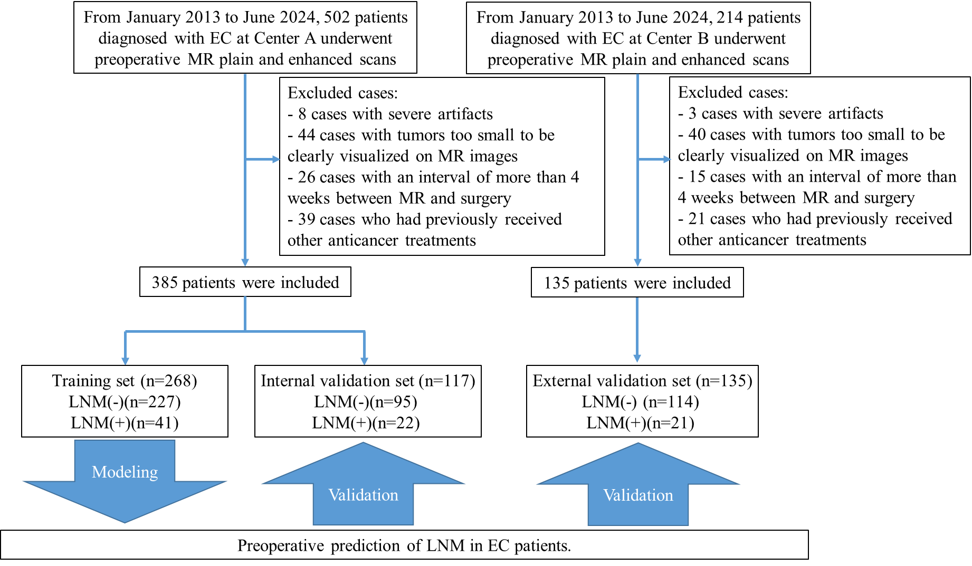
Supplementary Fig. S1 Inclusion and exclusion pathway for patients in the study.
EC: Endometrial cancer; MR: Magnetic resonance; LNM: Lymph node metastasis.

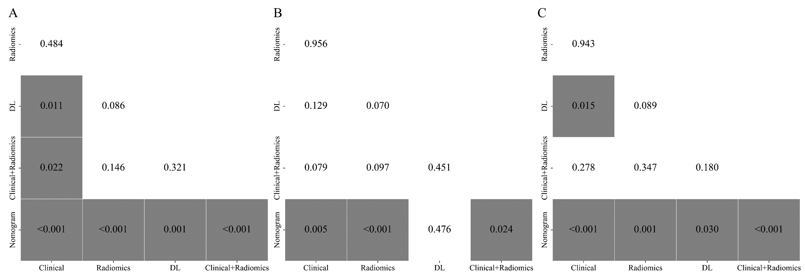
Supplementary Fig. S2 Pairwise comparison of receiver operating characteristic curves using the DeLong test. The values in the matrix cells represent P values from the DeLong test. (A–C) Comparison results for (A) the training cohort based on out-of-fold (OOF) predictions, (B) the internal validation cohort, and (C) the external validation cohort, respectively. DL, deep learning.
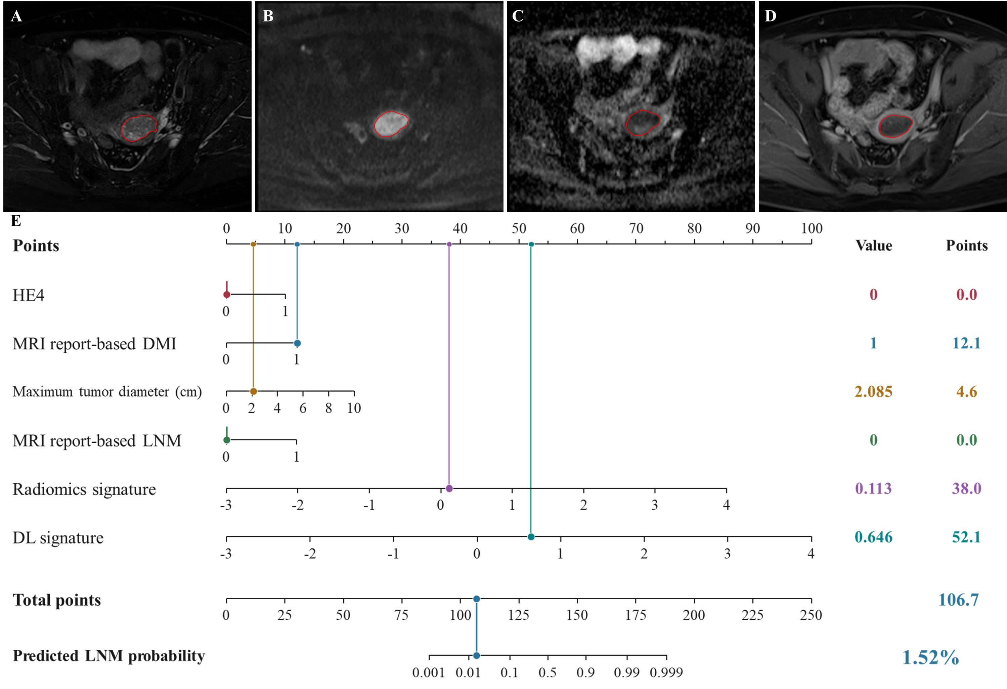
Supplementary Fig. S3 Nomogram and Multi-Sequence MRI for LNM Risk Prediction in an LNM-negative EC Patient. (A–D) Representative axial fat-suppressed T2-weighted imaging (T2WI), diffusion-weighted imaging (DWI), apparent diffusion coefficient (ADC) map, and three-dimensional volumetric interpolated breath-hold examination (3D-VIBE), respectively. The red contours indicate the tumor region of interest. (E) Individualized nomogram predicting lymph node metastasis (LNM) risk. The 61-year-old patient had a normal HE4 level (HE4 = 0), MR report-based deep myometrial invasion (DMI = 1), a MR report-based maximum tumor diameter of 2.085 cm, and negative MR report-based LNM status (LNM = 0). Radiomics and deep learning (DL) signatures were 0.113 and 0.646, contributing 38.0 and 52.1 points, respectively. The total score was 106.7 points, corresponding to a predicted LNM probability of 1.52%. Pathological examination confirmed the absence of LNM. MRI, magnetic resonance imaging; MR, magnetic resonance; EC, endometrial cancer; HE4, human epididymis protein 4.

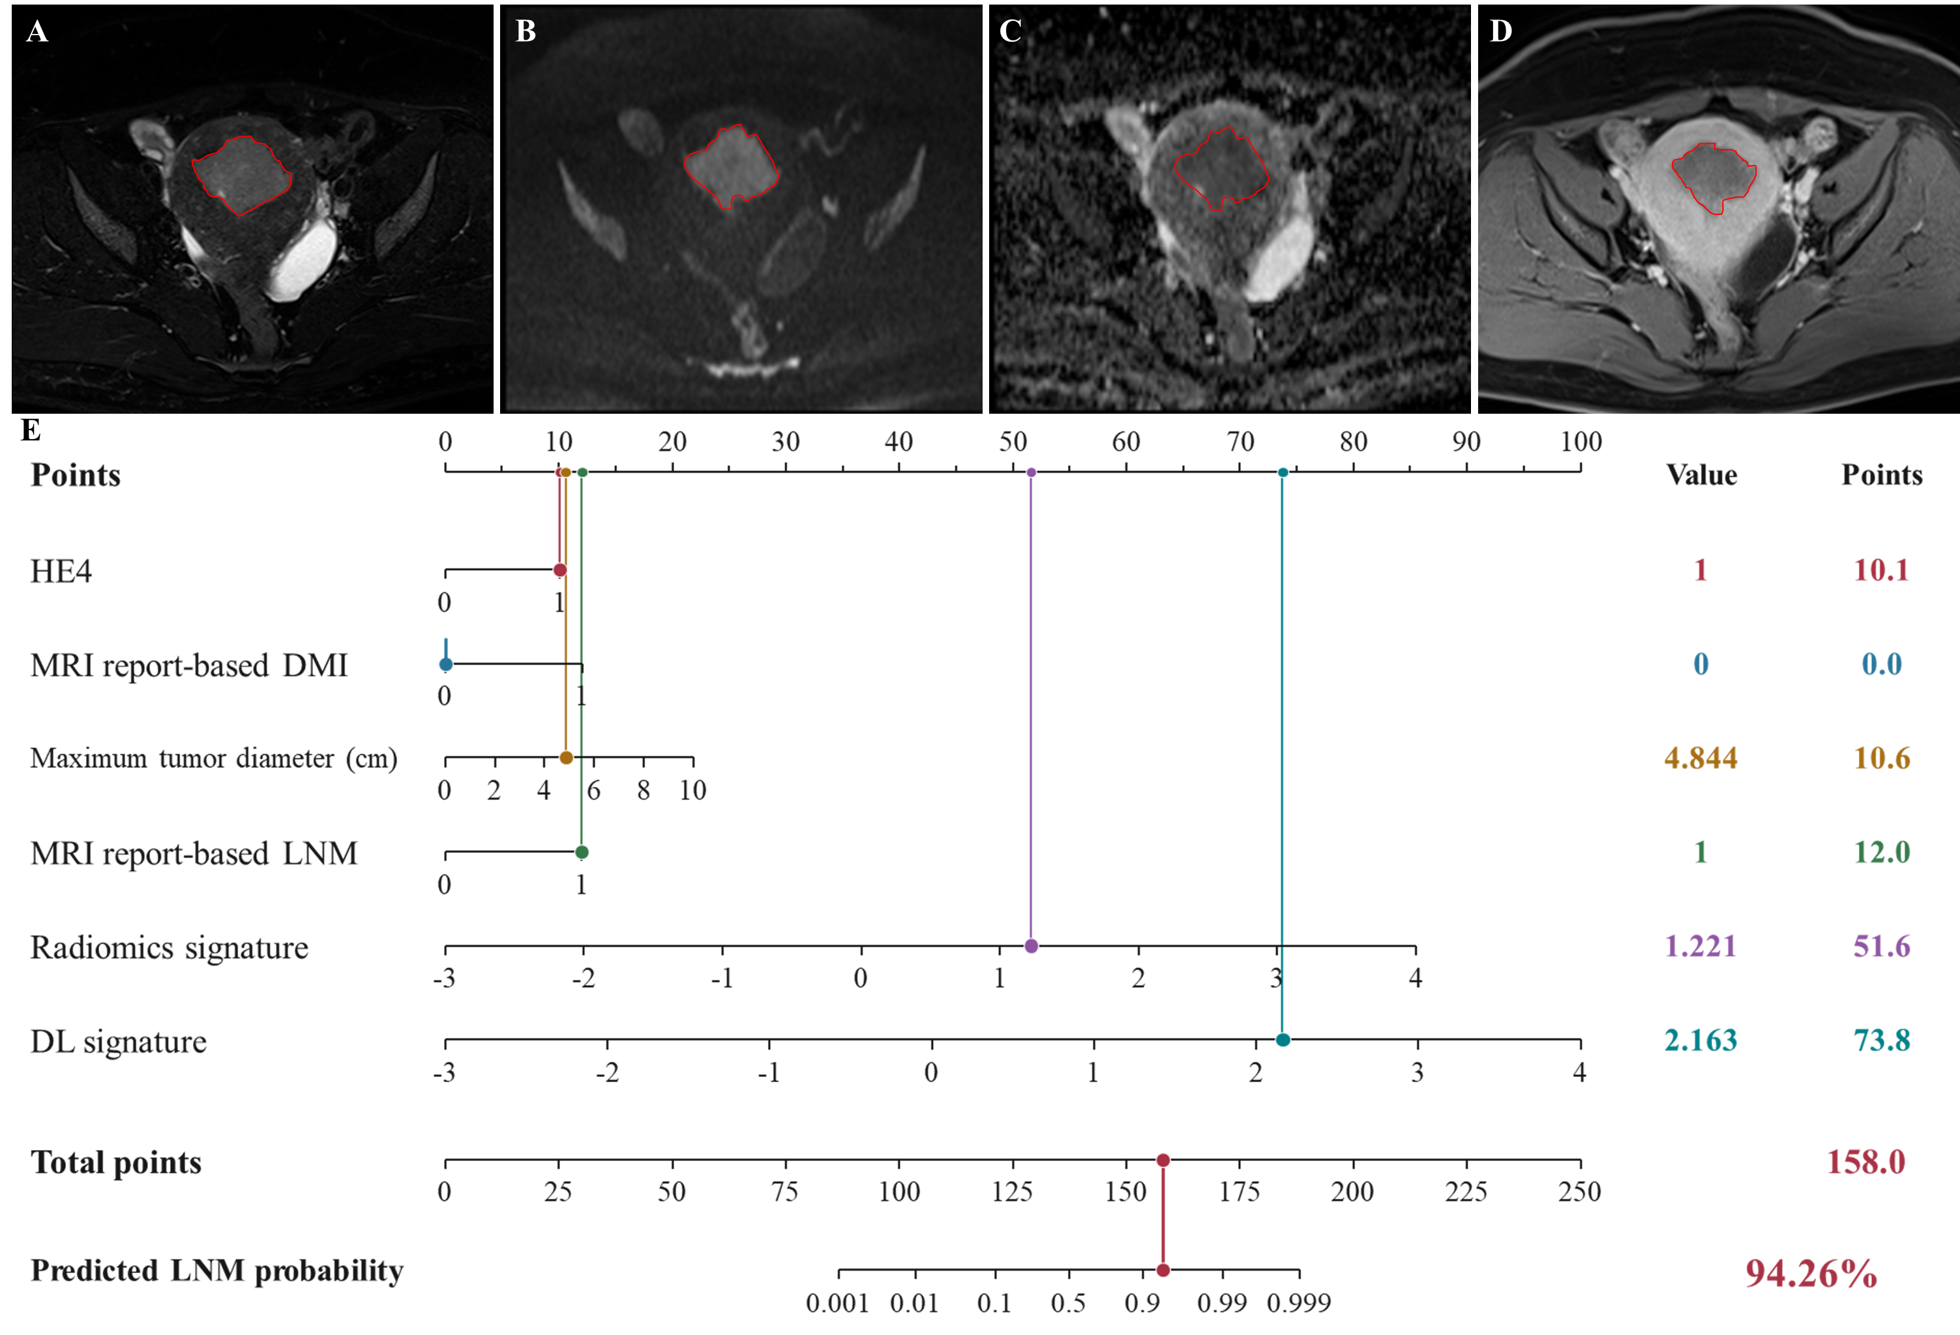
Supplementary Fig. S4 Nomogram and Multi-Sequence MRI for LNM Risk Prediction in an LNM-positive EC Patient. (A–D) Representative axial fat-suppressed T2-weighted imaging (T2WI), diffusion-weighted imaging (DWI), apparent diffusion coefficient (ADC) map, and three-dimensional volumetric interpolated breath-hold examination (3D-VIBE), respectively. The red contours indicate the tumor region of interest. (E) Individualized nomogram predicting lymph node metastasis (LNM) risk. The 72-year-old patient had an abnormal HE4 level (HE4 = 1), no MR report-based deep myometrial invasion (DMI = 0), a MR report-based maximum tumor diameter of 4.844 cm, and positive MR report-based LNM status (LNM = 1). Radiomics and deep learning (DL) signatures were 1.221 and 2.163, contributing 51.6 and 73.8 points, respectively. The total score was 158.0 points, corresponding to a predicted LNM probability of 94.26%. Pathological examination confirmed the presence of LNM. MRI, magnetic resonance imaging; MR, magnetic resonance; EC, endometrial cancer; HE4, human epididymis protein 4.

