Conservation genomics reveals low connectivity among populations of threatened roseate terns in the Atlantic Basin
Paige A. Byerly^{1,4*}, R. Terry Chesser^{2,3}, Robert C. Fleischer⁴, Nancy McInerney⁴,
Natalia A. S. Przelomska^{3,4,5}, Paul L. Leberg¹
Supplementary Materials
Table S1. The 16 microsatellite loci with forward and reverse sequences (ª Szczys et al. 2005; ^{b}Janowski et al. 2016; ^{c} Given et al. 2002; ^{d}Tirard et al. 2002; ^{e}Jiang et al. 2011; ^{e}Yannic et al. 2011; ^{f}Schlesselmann and Robertson 2017)
Locus | Forward | Reverse
AAC 20ª | CTTCATAGTGCCCAATACATCAG | TCACTTGTTTAGGCATTTGGTT
AAT 20ª | CTGGCTATGCTGCAGACTGA | GCATCAAGTGCTCGATACCA
AAT 27ª | TGAAAACAGATGAATCAAACCAA | ATCTGGTCTCCCTCCAGCTT
MsSh 18^{b} | TGTATCCATGGCTCAGCTACC | AGAGCCAGGCACCCATATTC
MsSh 20^{b} | GTCCGTACAGAGGTTAACGC | ATGGTCACACTCGTCTCACC
MsSh 22^{b} | GCCAGCTCTGCAATTCTACG | ACCCAGTAACCAGGCAGATG
RBG 29^{c} | CCTAGCTTTTTGGACTCAGT | GTGGTGTTGCAATAGGATTC
RBG 18^{c} | AAAGGGCTGCTCATAGTACG | GTAGCATCATGTCTTCCCGC
RBG 27^{c} | GGAATTTTCGTTGGCAGGAT | GAAATCACAGTGAAAACGCC
K 16^{d} | TGCAATTTGTACAACCAGATTT | GGGTTCCTGTTTGCAATGAA
K-6^{d} | AAAAAGAAAGCACCCTCTTC | AAGTGGGATATGAAAGATGC
Laza 2e | TTGCAACACCTCCATGCTG | CACGCTCAACCTTGCTGG
IVGU D103e | GGGGACCACTTGATGACC | TTCAGGCAGCAGAGATGC
Calbo 2^{f} | TGTAAAACGACGGCCAGTTGACTGCTCATCTACCCTGC | GTTTCTTAGGTATCAGACATCTCAGCCG
Calbo 35^{f} | TGTAAAACGACGGCCAGTATGCCTTCCTCTTACCACCG | GTTTCTTCTGGTTCCAGCATGTACCC
Calbo 40^{f} | TGTAAAACGACGGCCAGTTCCTCCATCCTTACAACTGGG | GTTTCTTAGGTTGACTGGTTGACTTTGC

Table S2. Null allele frequency of microsatellite loci from FreeNA by marker and population
Locus | AZ | FL | MA | USVI
MsSh-20 | 0.000 | 0.000 | 0.044 | 0.000
AAC-20 | 0.001 | 0.203 | 0.024 | 0.117
AAT-20 | 0.016 | 0.004 | 0.047 | 0.045
AAT-27 | 0.052 | 0.000 | 0.134 | 0.109
MsSh-22 | 0.000 | 0.001 | 0.000 | 0.001
K-16 | 0.000 | 0.024 | 0.031 | 0.025
LAZA 2 | 0.161 | 0.000 | 0.022 | 0.000
RGB-18 | 0.000 | 0.193 | 0.000 | 0.036
RGB-29 | 0.111 | 0.001 | 0.001 | 0.001
RGB-27 | 0.192 | 0.057 | 0.034 | 0.031
CALDO 2 | 0.146 | 0.000 | 0.000 | 0.017
CALDO 35 | 0.075 | 0.071 | 0.059 | 0.000
CALDO 40 | 0.000 | 0.211 | 0.002 | 0.013

Figure S1. Output from StructureHarvester depicting results from the Evanno method of evaluating optimal values of delta K for k = 2-4 for a. microsatellite loci with no population prior, b. microsatellite loci with population included as a prior.

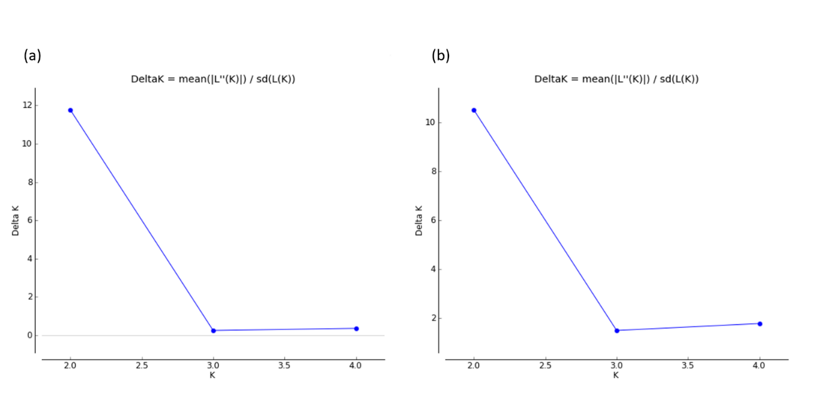

Figure S2. Genetic clustering inferred by Bayesian structure analysis in STRUCTURE for K= 2–4 for a. microsatellite and b. SNP loci, with the x-axis representing sampling location and the y-axis representing proportion of group membership, and without sampling location as prior information.

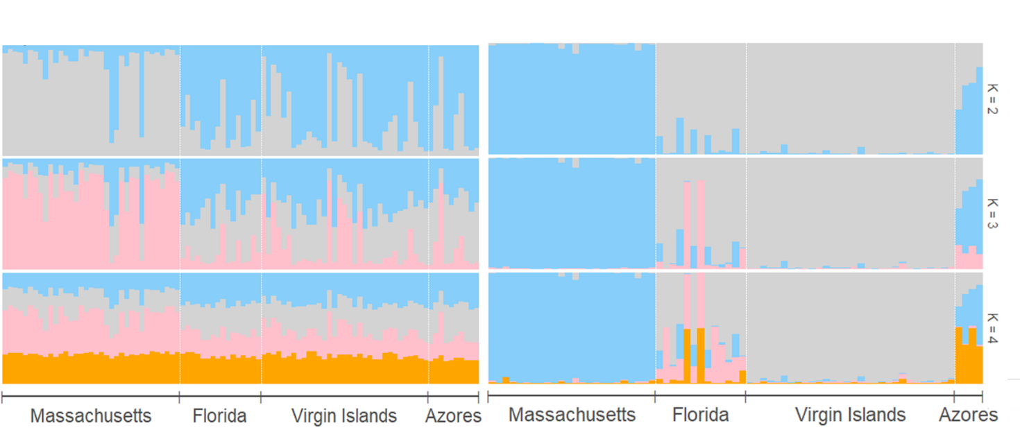

Figure S3. Population assignment based on microsatellite analysis of roseate terns from 4 sampling locations using clustering via Discriminant Analysis of Principal Components (DAPC). The x axis represents sampling location and the y axis individual samples. Blue crosses mark sampling locations. Colors represent population assignment, with assignment probability on a scale of red (high probability of assignment) to yellow (low probability of assignment).
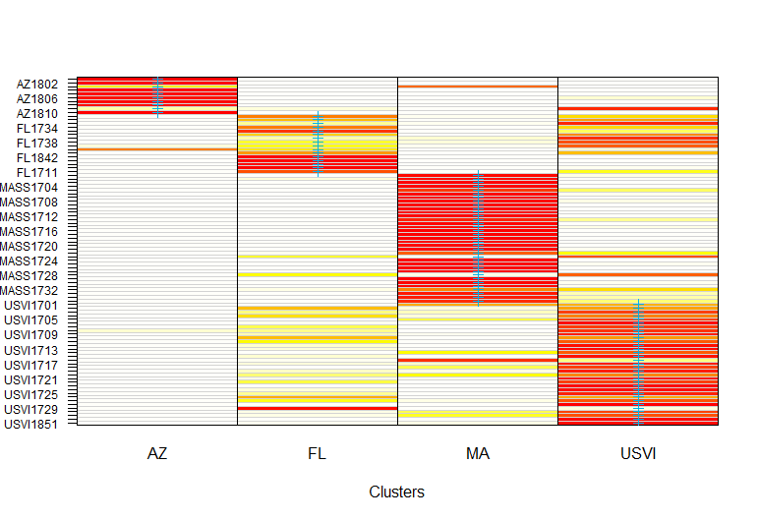

Figure S4. Accuracy of individual population assignment derived from Discriminant Analysis of Principal Components (DAPC) cross-validation of microsatellite loci from a reduced set of roseate tern samples. Columns represent a priori sampling locations and rows represent assigned genetic clusters. Squares correspond to number of individuals.
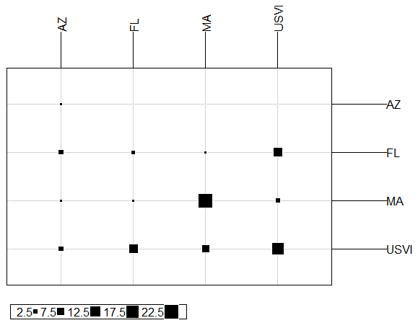

Figure S5. Cross-validation of Monte Carlo assignment testing with 100 replicates at 3 training levels of sample proportion (0.5, 0.7, 0.9) and loci completeness (0.5, 0.75, 1) for 2,085 SNP loci.
