Factors associated with knowledge attitudes practices and training interest and antibiotic dispensing challenges related to antimicrobial resistance among drug sellers in urban Bangladesh

Supplemental file

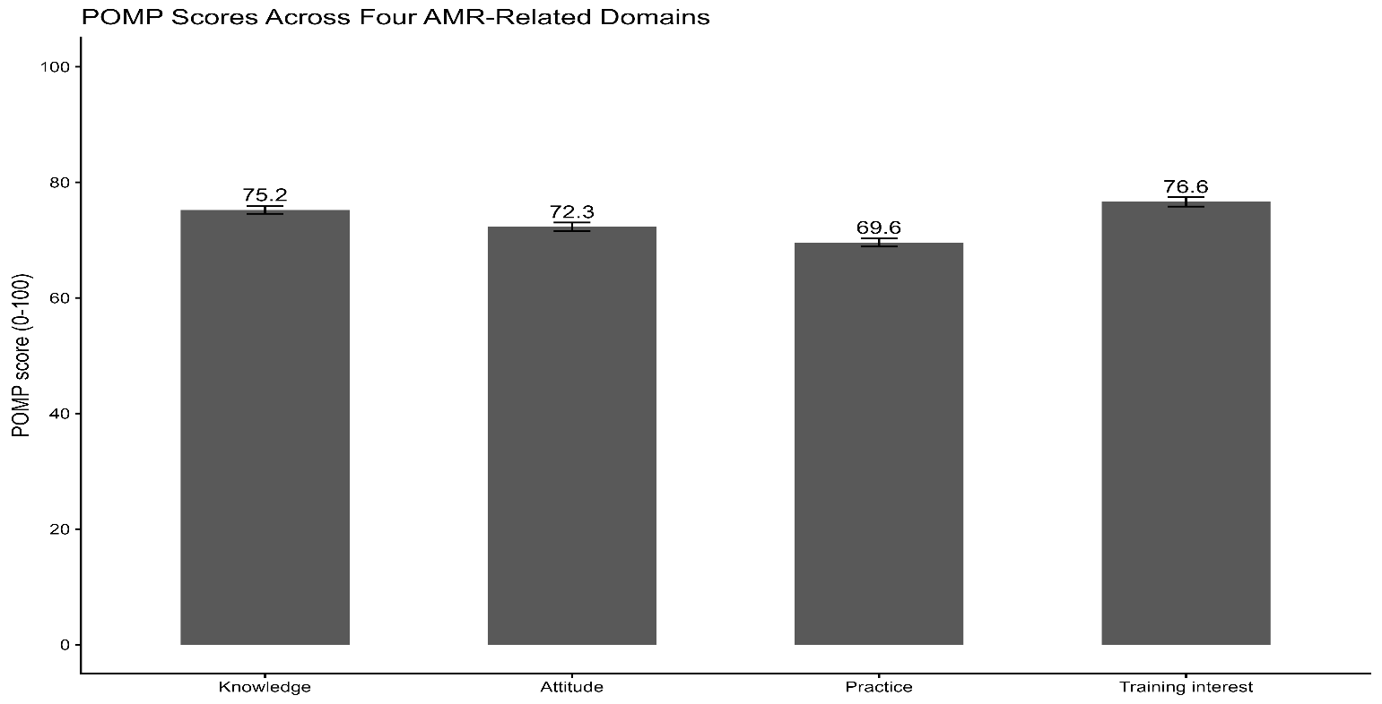
Figure SF1: Overall POMP scores across the four AMR related domains
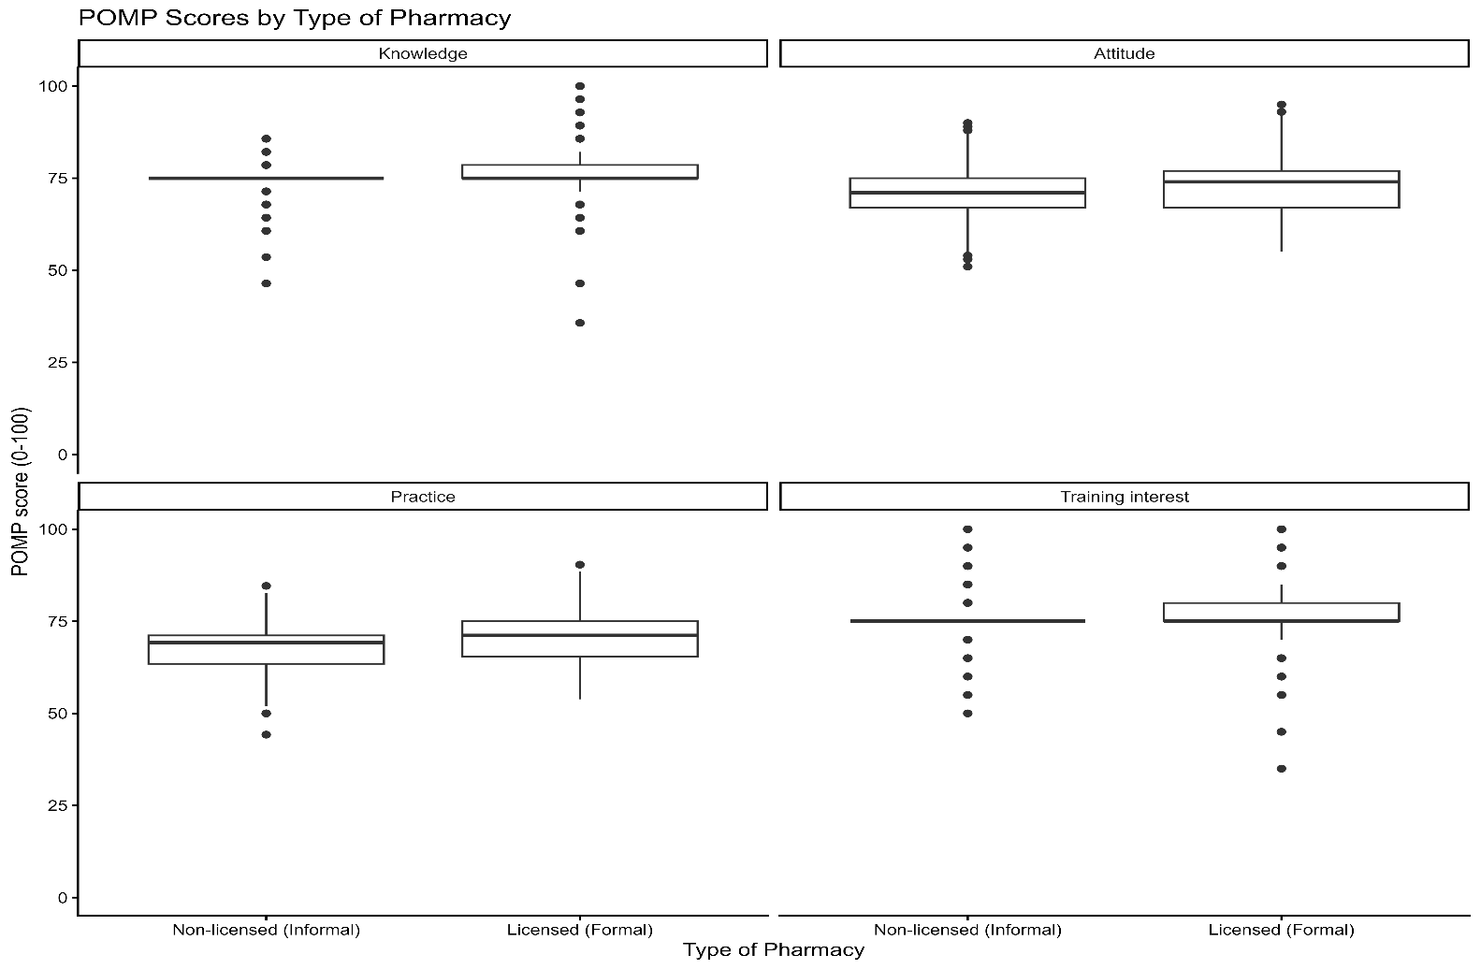
Figure SF2: POMP scores by type of pharmacy
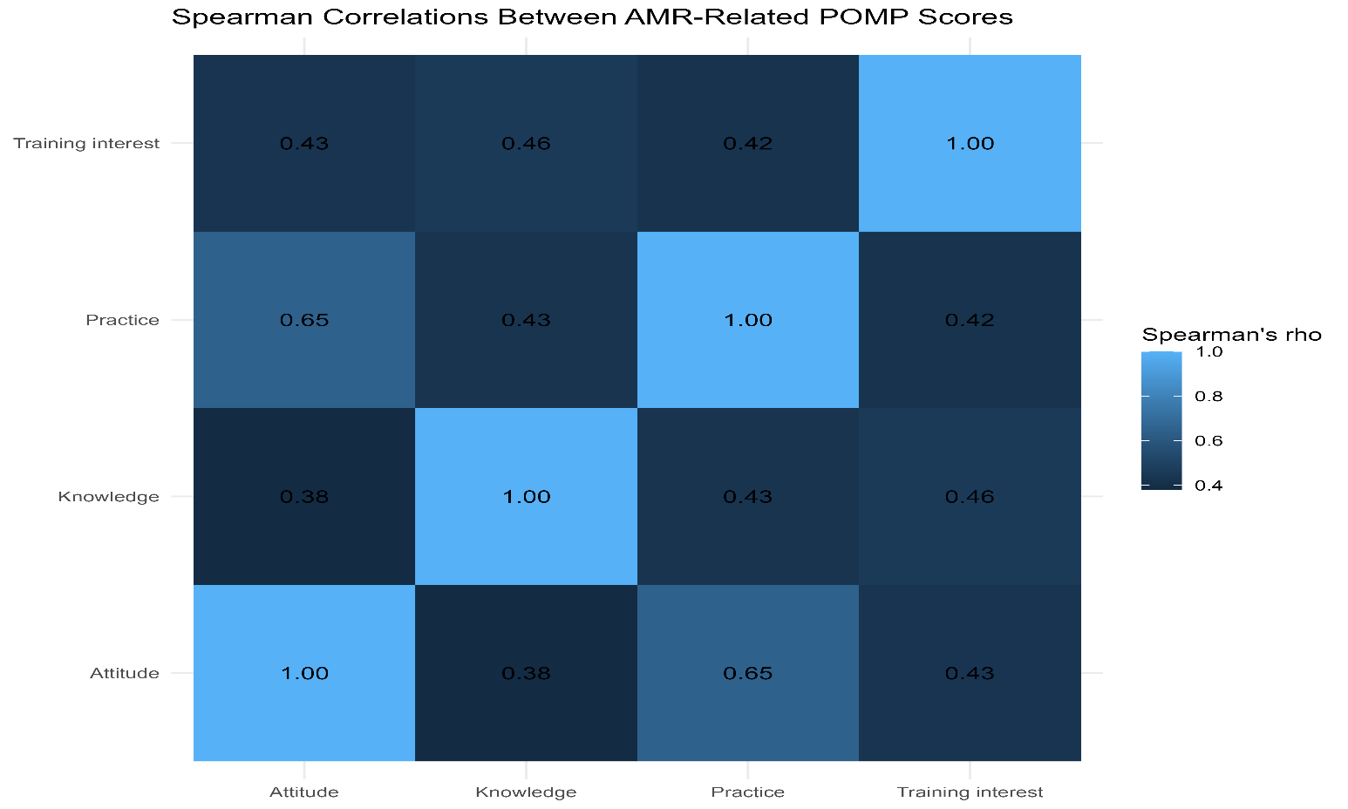
Figure SF3: Spearman correlation heatmap

