Supplementary Information

Direct tsunami wavefield sensing on submarine telecom cables enables coastal wave height forecasting

Yuqing Xie^{1,2}, Diane Rivet^{1*}, Anthony Sladen¹, Martijn van den Ende¹, Marie Baillet¹, Alister Trabattoni¹, Jean-Paul Ampuero¹, Sergio Barrientos³

- Observatoire de la Côte d'Azur, Université Côte d'Azur, CNRS, IRD, Géoazur, 250 rue Albert Einstein, Sophia Antipolis 06560 Valbonne, France.
- Now at Institute of Geology and Geophysics(IGG), Chinese Academy of Sciences(CAS)
- Centro Sismológico Nacional, Universidad de Chile, Santiago, Chile.

Corresponding author: diane.rivet@geoazur.unice.fr

This Supplementary Information contains:
- Supplementary Texts S1–S3
- Supplementary Figures S1–S9
- Supplementary Table S1

Supplementary Text S1. Synthetic validation of the wavefield reconstruction framework

The synthetic reconstruction experiment isolates the forecasting value of continuous offshore line observations from uncertainties in DAS amplitude calibration, nearshore amplification, tide-gauge siting and coastal bathymetric resolution. We use synthetic water-level waveforms sampled along the cable as input and compare the reconstructed coastal waveforms with the reference solution, thereby testing how well cable observations alone can constrain the evolving tsunami wavefield and coastal forecasts using the current geometry and algorithm.

Synthetic cable input
The input waveforms were extracted from the reference Kamchatka tsunami simulation constrained by DART buoys at 520 virtual stations distributed along the ABYSS cable geometry. The reconstruction tests used a finite time window beginning shortly before the first cable arrival. To emulate real-time forecasting, only the portion of the cable record available at each update time was imposed, with all subsequent values set to zero. The imposed signal was water elevation.

Coastal waveform comparison
From the reconstructed wavefield, predicted waveforms were extracted at virtual validation points along the coast-facing margin. To avoid numerical artefacts associated with unresolved shallow-water dynamics near the coastline, the main comparison points were placed near the 100 m isobath rather than directly along the coast. The same points were sampled from the reference forward simulation, providing the synthetic ground truth. We then compared the reconstructed and reference waveforms in terms of waveform shape, the timing and the amplitude of the first major positive peak.

Supplementary Text S2. Evaluation of effective tsunami forecast lead times from cable observations
We defined effective lead time based on the evolution of first-peak amplitude error with increasing available cable-record length (Fig. S5). For each validation point and each available recording length, we stored the peak-amplitude error, defined as ∣A_{pred}−A_{ref}∣, where A_{pred} and A_{ref} are the first-peak amplitudes of the predicted and reference waveforms. These errors were saved for all update windows and used to quantify the reconstruction performance for each target validation point as longer sections of the cable record became available. Let T_{ref} denote the arrival time of the first major positive peak in the reference coastal waveform. For each validation point, we identified the earliest effective update time T_{avail} at which the absolute first-peak amplitude error satisfied ∣A_{pred}−A_{ref}∣/A_{ref}<30%. The effective lead time was then calculated as T_{ref}−T_{avail}. Positive values indicate that the first major peak amplitude was predicted with the specified accuracy before its arrival. This quantity represents the lead time between obtaining a reliable prediction of the first peak amplitude at a target coastal site and the arrival of that peak at the site.
The target coastal sites near the 100 m isobath were grouped into five operational categories based on forecast lead time: <3 min, 3-5 min, 5-10 min, 10-15 min and >15 min. These lead times represent a theoretical estimate based on idealized water-level-equivalent cable observations. Their spatial variability reflects the combined effects of cable geometry, tsunami propagation over regional bathymetry and the coastal configuration represented by the virtual validation points.
Because the target validation points are located near the 100 m isobath, the lead times in Figure 3f are conservative with respect to the actual coastline. This offshore placement avoids unresolved nearshore amplification, harbour response and wetting-drying effects, but excludes the final propagation time from the 100 m contour to the coast. To estimate this offset, we used the high-resolution WGS84 coastline derived from OpenStreetMap. For each validation point, we identified the nearest coastline point and measured the horizontal distance using a local Cartesian approximation. We then estimated a point-specific additional travel time with a simple shallow-water wave-speed model, assuming linear shoaling from 100 m water depth at the validation point to an effective nearshore depth of 2 m at the coastline. Across the 60 validation points, the median distance to the coastline is 3.38 km, corresponding to a median additional travel time of 3.2 min. Adding these point-specific corrections gives the coastline-adjusted lead-time estimate shown in Fig. S5b. This estimate is intended only as an approximate correction for the offshore placement of the validation points, not as a full nearshore inundation or harbour-response model.
Supplementary Text S3 Observation-driven reconstruction and tide-gauge validation
After the synthetic benchmark, we applied the same reconstruction framework to the processed observation-derived tsunami waveforms. The resulting water-elevation waveforms at 520 reconstruction stations, obtained through DAS-to-water-level conversion, time integration, demeaning and linear detrending, were imposed as a time-varying internal boundary condition along the cable.
Tide-gauge validation
Observation-driven reconstructions were evaluated at five Chilean tide gauges. Gauge records were demeaned using the median pre-event water level, filtered with a zero-phase 300–2000 s band-pass filter, consistent with the DAS preprocessing. The reconstructed and observed tide-gauge waveforms were then compared in both waveform shape and amplitude. Because unresolved nearshore bathymetry can introduce timing offsets between simulated and observed coastal waveforms, we cross-correlated each reconstructed waveform with the corresponding tide-gauge record over 0–4000 s to estimate the station-specific timing offset and waveform similarity. The lag maximizing their cross-correlation was determined within ±400 s and applied to the reconstructed waveform for the aligned comparison in Fig. 3; the unshifted waveforms are shown in Fig. S7. This search range was chosen because previous tsunami waveform-alignment studies report nearshore timing uncertainties of several minutes, up to about 7 min, associated with coarse local bathymetry [1,2]. The estimated shifts were <150 s at four of the five stations, whereas Quintero required a 347 s shift. After alignment, the reconstructions reproduced the main tsunami waveform shapes and amplitudes, with the highest correlations at coastal sites constrained by high-fidelity cable segments (Fig. 3, Table S1).
Nearshore timing uncertainty at Quintero
The substantially larger timing offset at Quintero was investigated as a potential consequence of unresolved nearshore propagation. The 15 arcsec pCOMCOT bathymetry smooths the peninsula and harbour geometry near Quintero, permitting a more direct wet-cell propagation route than that implied by the high-resolution coastline (Fig. S6). The resulting estimate of the unresolved nearshore delay ranges from 176 to 439 s for effective water depths of 4–1 m. The independently estimated cross-correlation shift of 347 s falls within this range, indicating that unresolved nearshore propagation is a plausible contributor to the timing offset, although local depth, friction and harbour response remain uncertain. Similar minute-scale tide-gauge timing offsets have been reported in optimal-time-alignment tsunami inversions and are attributed mainly to coarse or inaccurate local bathymetry and tide-gauge location uncertainty [1,2].

Supplementary Figures S1–S9

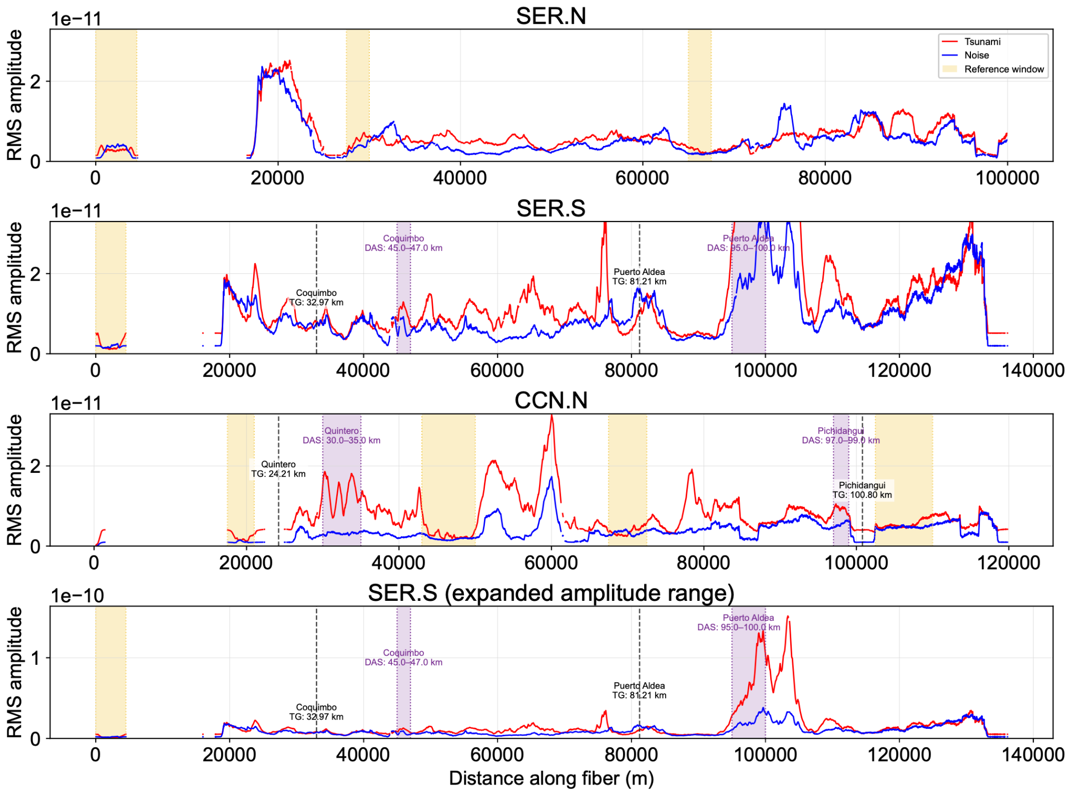
Figure S1. The variation of the amplitudes of tsunami and noise after a 2400 m spatial median filtering, with the reference windows selected for a refined estimation of common mode noise as marked. The purple shaded areas indicate the segments selected for the waveforms shown in Fig. 1d of the main manuscript, avoiding noisy sections while remaining close to the tide gauges.

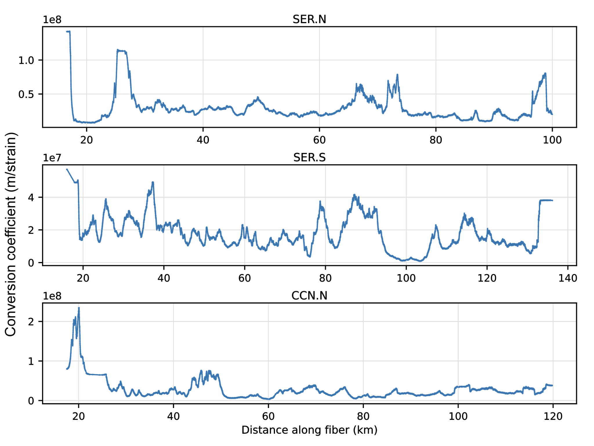
Figure S2. DAS strain-rate-to-water-elevation-rate conversion coefficients along the three cables. For each DAS channel, the coefficient is calculated as the RMS amplitude of the synthetic water-elevation-rate waveform divided by that of the processed observed strain-rate waveform over the tsunami window from 20:00 to 23:00 UTC on 30 July 2025.
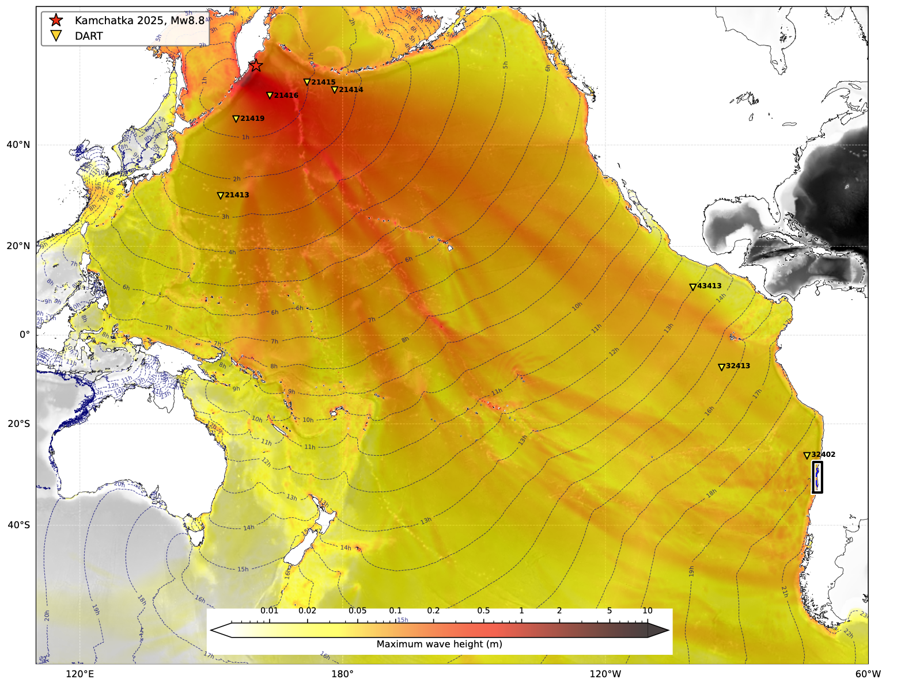
Figure S3. DART station distribution and synthetic tsunami model used for source inversion and validation. Three DART stations (21415, 21416 and 21419) were used to constrain the tsunami source inversion, and five additional DART stations were used for model validation. The map also shows the earthquake epicenter (red star), the location of the DAS array (black box), the simulated maximum tsunami wave height across the Pacific and tsunami travel-time contours.

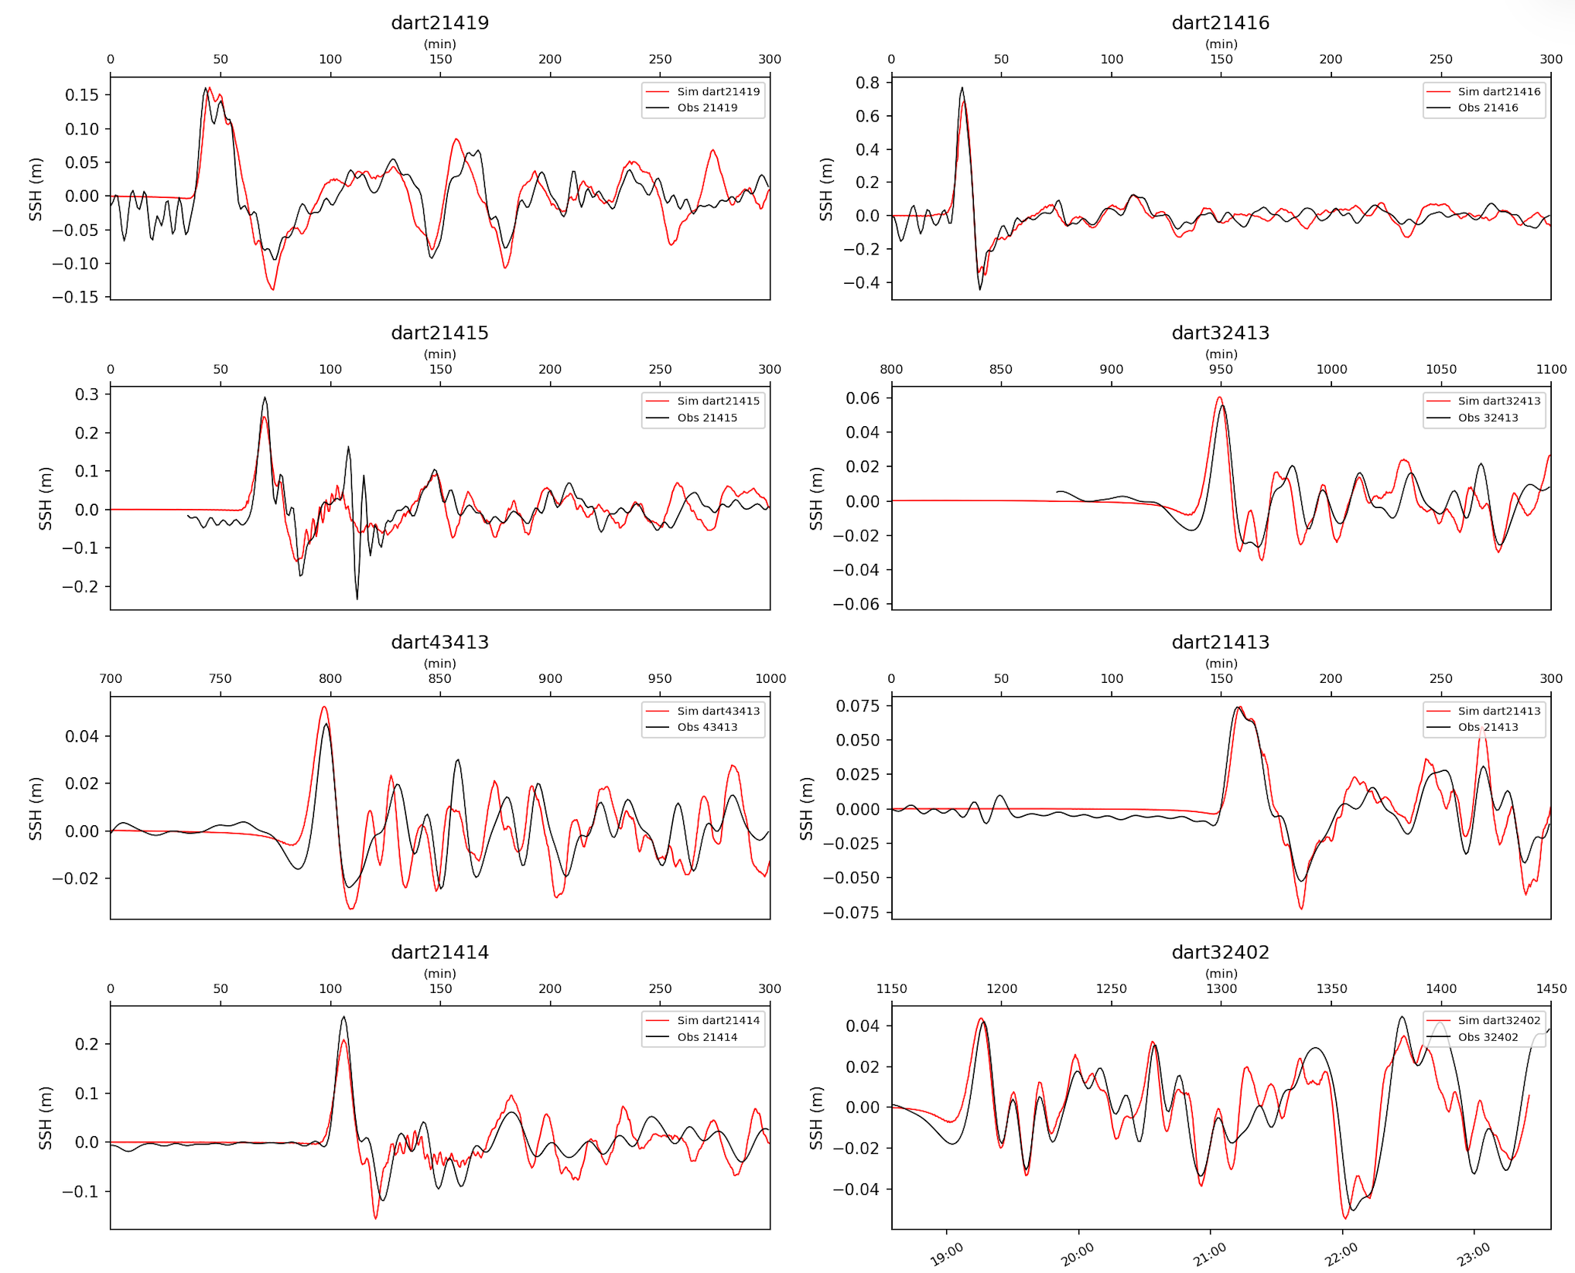
Figure S4. Data fitting for tsunami source inversion using three DART stations (21415, 21416, and 21419). The inverted source model was used to generate the reference tsunami waveforms for DAS amplitude conversion and the synthetic cable waveforms for the wavefield reconstruction benchmark. The x-axis represents time relative to the earthquake origin time.

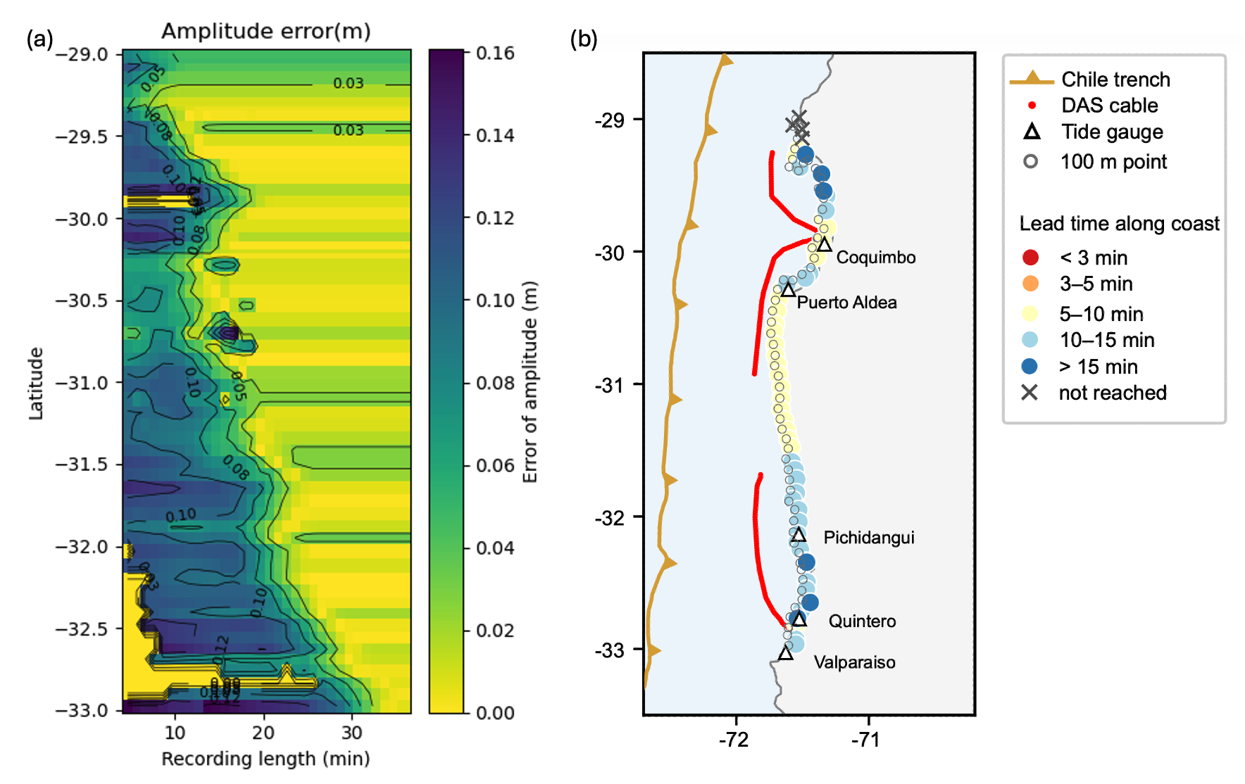
Figure S5. Estimation of lead time for coastal first-peak forecasting. (a) Evolution of first-peak prediction accuracy at the 100 m isobath with increasing available cable-record length. The forward wavefield reconstruction was repeated using progressively longer portions of the synthetic cable waveform to mimic real-time operation. The horizontal axis shows the available record length measured after 19:35 UTC on 30 July, and the colour indicates the relative error in the predicted first-peak amplitude for each coastal validation site. The earliest time at which the prediction reaches 70% accuracy (relative error <30%) defines the effective lead time shown in Fig. 3f (Text S2). (b) Coastline-adjusted lead time obtained by adding the estimated nearshore propagation time from each 100 m-isobath validation site to the nearest high-resolution OpenStreetMap coastline point (Text S2).
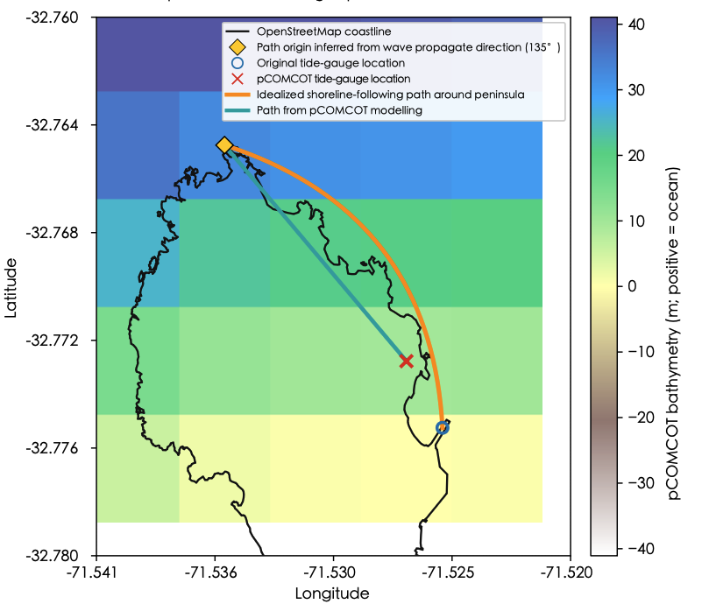
Figure S6. Nearshore travel-time uncertainty at the Quintero tide gauge. Background colours show the bathymetry used in the pCOMCOT simulation. The black line shows the high-resolution OpenStreetMap coastline. The yellow diamond marks pCOMCOT cell centre nearest to the northern end of the Quintero peninsula, approximately aligned with the assumed tsunami propagation direction of 135° towards the tide-gauge location. The blue circle and red cross denote the actual tide-gauge location and its corresponding pCOMCOT location, respectively; The letter is shifted to the nearest wet cell. Both path estimates start from the yellow diamond. The orange curve represents an idealized smooth shoreline-following path around the peninsula to the actual tide-gauge location, whereas the cyan curve represents the estimated pCOMCOT path through eight-connected wet grid cells. For each step between adjacent pCOMCOT grid cells, the travel time was calculated using the local shallow-water wave speed, $\sqrt{g\underline{h}}$, where $\underline{h}$ is the mean water depth of the two cells, $g$ is gravitational acceleration. The route with the shortest accumulated travel time was selected to estimate the travel time using pCOMCOT. The shoreline-following and pCOMCOT paths are 1647 and 1213 m long, respectively, and the estimated pCOMCOT travel time is 86.6 s. Uniform effective shoreline depths of 1, 2 and 4 m give additional delays of 439, 285 and 176 s relative to the pCOMCOT path. The independently estimated cross-correlation shift of 347 s (Table S1, Text S3) lies between the estimates for effective depths of 1 and 2 m.
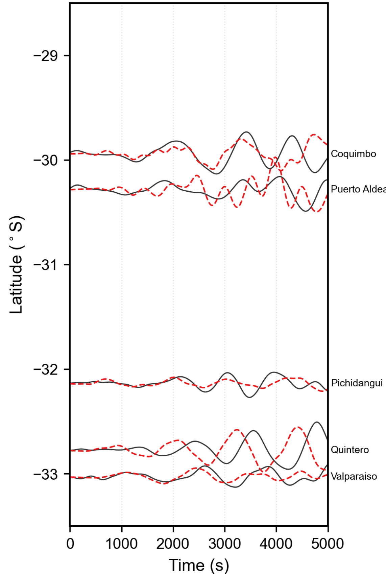

Figure S7. Unshifted waveform comparison between tide-gauge observations and observation-based reconstruction. Tide-gauge water elevation is shown in black and the observation-based reconstruction in red dashed lines at five tide gauges along the coast. Symbols and station ordering are the same as in Fig. 3e, but the reconstructed waveforms are shown without the station-wise cross-correlation time shifts applied after extraction from the reconstructed wavefield.

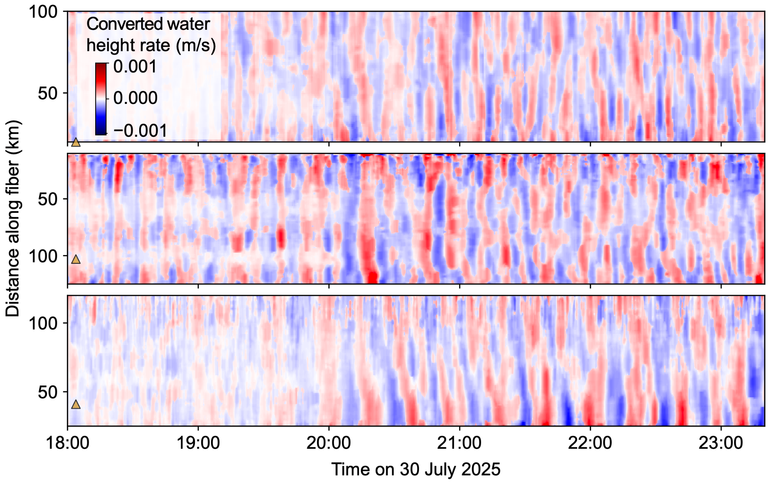
Figure S8. Calibrated water-elevation-rate-equivalent DAS waveforms after 10-km spatial median filtering, shown for the SER.N, SER.S and CCN.N cable segments from top to bottom. The waveforms were subsequently integrated, demeaned and linearly detrended for observation-driven wavefield reconstruction.

(a)
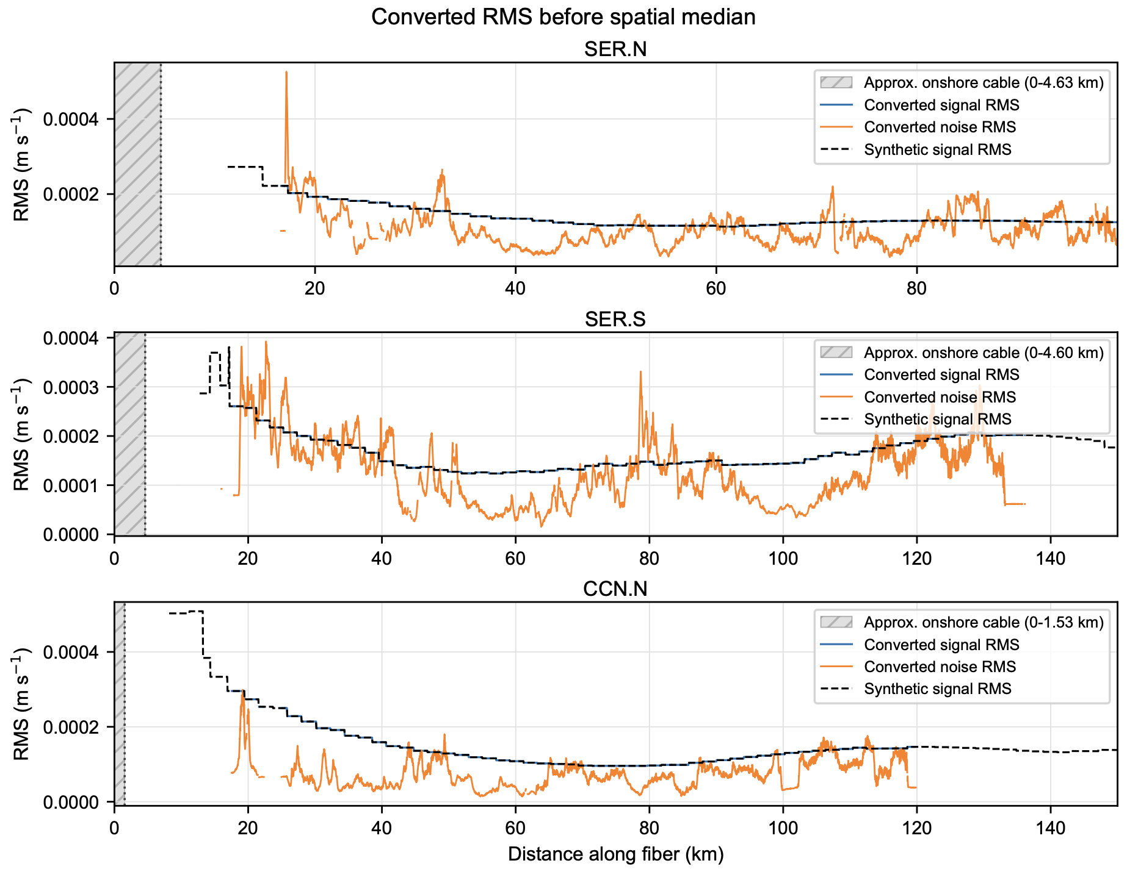
(b)
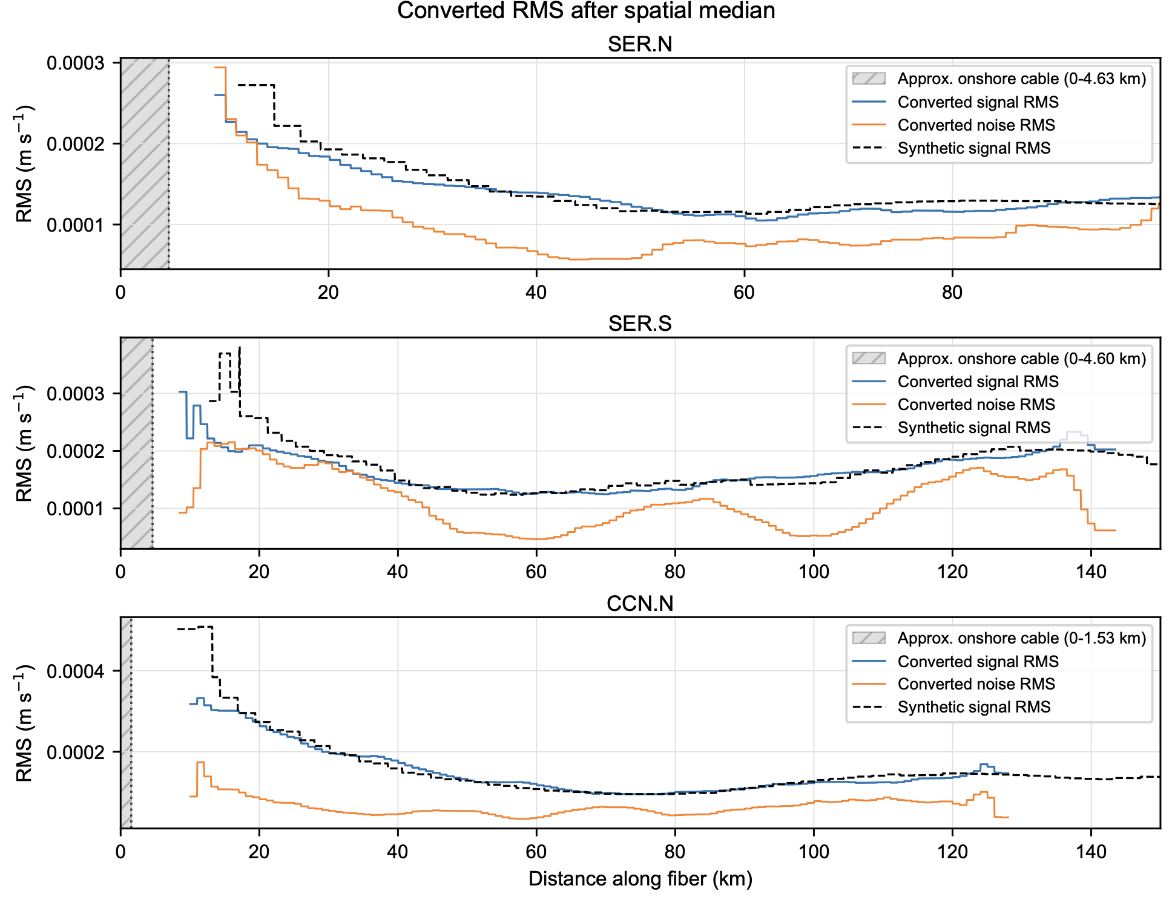
Figure S9. Spatial RMS profiles of the converted DAS observations before and after spatial median filtering. a, Water-elevation-rate RMS before spatial median filtering. b, Water-elevation-rate RMS after spatial median filtering. Rows show the SER.N, SER.S and CCN.N cable segments. Blue and orange curves indicate the RMS of the converted DAS records during the tsunami window (20:00–23:00 UTC) and pre-arrival noise window (00:00–19:00 UTC), respectively. Dashed black curves show the synthetic water-elevation-rate RMS during the tsunami window, interpolated to the DAS channel locations. The same channel-dependent conversion coefficients were used before and after spatial filtering, without amplitude refitting after the spatial median.

Supplementary Table S1. Time shift for each tide gauge station using cross-correlation

Station | Cross-correlation shift (s) | Peak coefficient
Coquimbo | 63 | 0.91
Puerto_Aldea | -127 | 0.43
Pichidangui | -48 | 0.58
Quintero | 347 | 0.98
Valparaiso | 146 | 0.89

Reference for supplemental information

[1] Romano, F., Piatanesi, A., Lorito, S., Tolomei, C., Atzori, S. & Murphy, S. Optimal time alignment of tide-gauge tsunami waveforms in nonlinear inversions: application to the 2015 Illapel (Chile) earthquake. Geophys. Res. Lett. 43, 11226-11235 (2016).
[2] Romano, F. et al. Benchmarking the optimal time alignment of tsunami waveforms in nonlinear joint inversions for the Mw 8.8 2010 Maule (Chile) earthquake. Front. Earth Sci. 8, 585429 (2020).

