Centrosymmetric imidazolium hydrogen squarate structure:
Catalytic properties, chemical reactivity and electronic structure

Ivaylo Tankov^{a*}, Rumyana Yankova^{b}, Zilya Mustafa^{c}

ªChemical Technologies Department, Burgas State University “Prof. Dr. Assen Zlatarov”,
Burgas, Bulgaria
^{b}Medical Sciences Department, Burgas State University “Prof. Dr. Assen Zlatarov”,
Burgas, Bulgaria
^{c}Central Scientific Research Laboratory, Burgas State University “Prof. Dr. Assen Zlatarov”, Burgas, Bulgaria

*Corresponding Author: Ivaylo Tankov; e-mail address: igtankov@yahoo.com

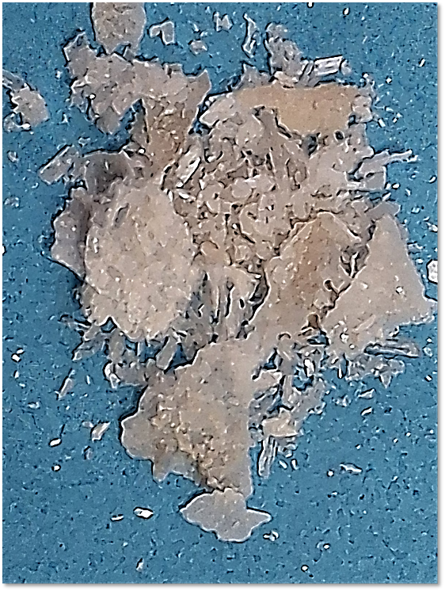

Fig. S1. Photograph of the centrosymmetric ion pair imidazolium hydrogen squarate.

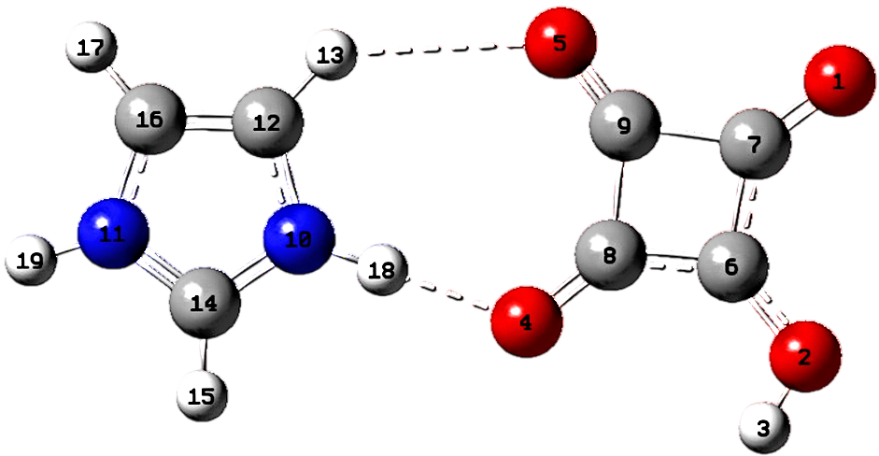

Fig. S2. Optimized molecular geometry of the centrosymmetric imidazolium hydrogen squarate:
N-atoms are in blue, O-atoms are in red, C-atoms are in gray and H-atoms are in white.

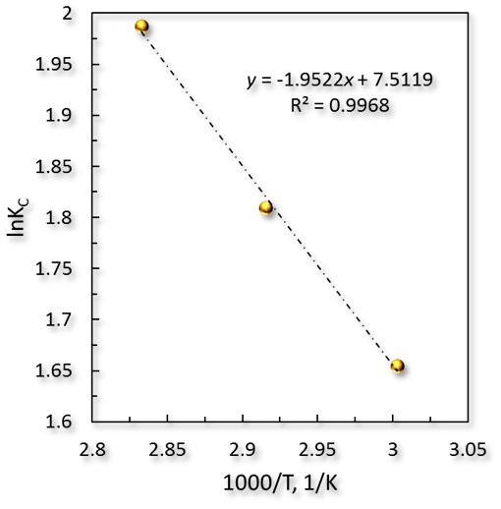
Fig. S3. Van't Hoff plot for finding ${\text{∆H}}_{\text{r}}^{\text{°}}$ and ${\text{∆S}}_{\text{r}}^{\text{°}}$ of butyl acetate production using the [C₃H₅N₂]⁺[C₄O₄H]– catalyst. Reaction conditions: catalyst loading of 10 wt.%, initial reactants molar ratio of 1.0, 6 h of reaction.

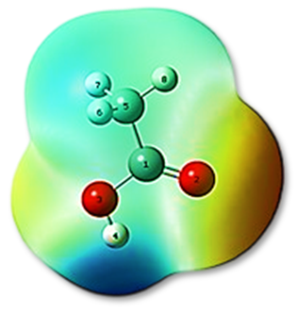

Fig. S4. Electrostatic potential surface for bare acetic acid.

