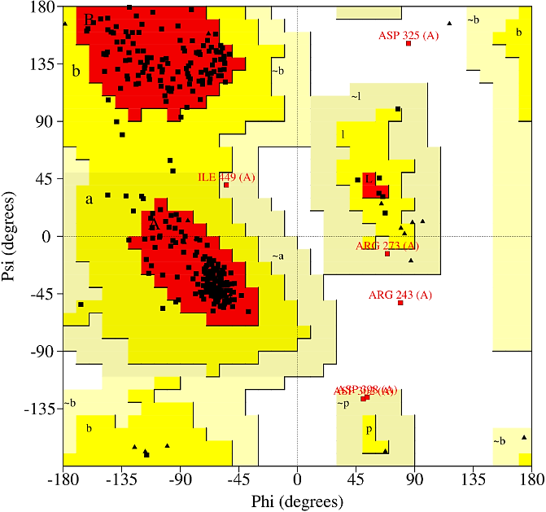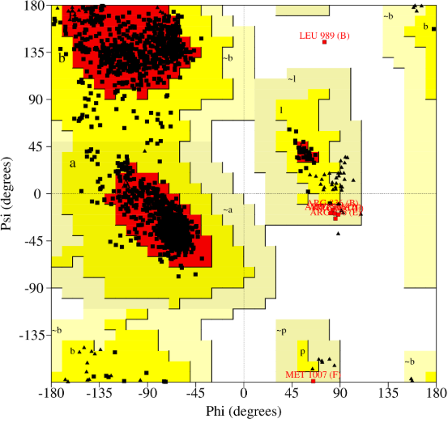
AKT1 EGFR
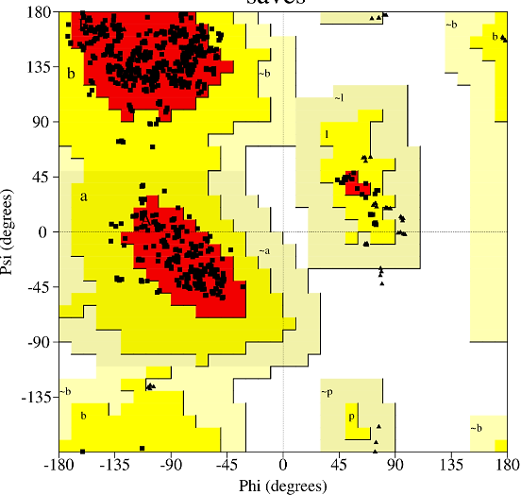
SRC
Supplementary Figure 1. Ramachandran plot for validation of the target proteins AKT1 and SRC. Amino acids are represented by black dots, with those in the red regions (A, B, L) denoting the most favored conformations. Residues located within the yellow zones (a, b, l, p) correspond to additionally allowed conformations, while those in the grey areas (~a, ~b, ~l, ~p) represent generously permitted conformations. The white regions mark disallowed conformations, indicating unfavorable stereochemistry for docking analyses. Proline and glycine residues are uniquely illustrated as triangles.
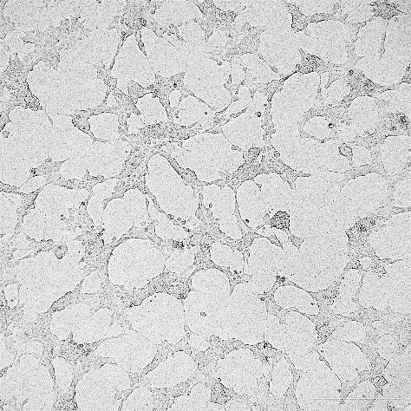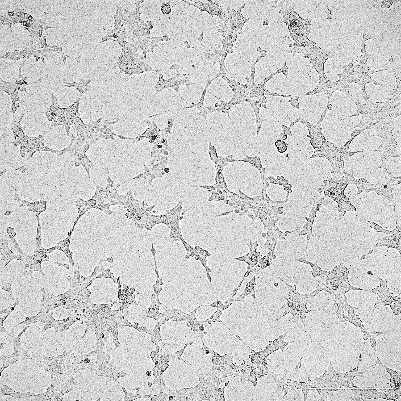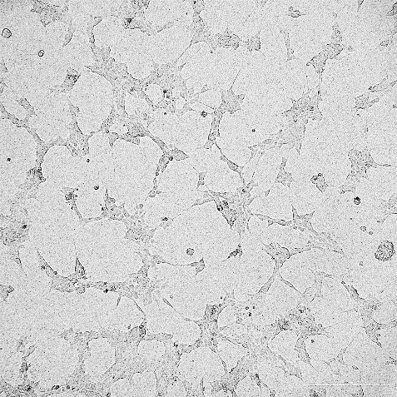
Control (0 µg/mL) C. oppositifolia (62.5 µg/mL) C. oppositifolia (125 µg/mL)
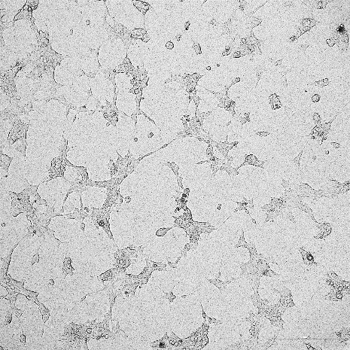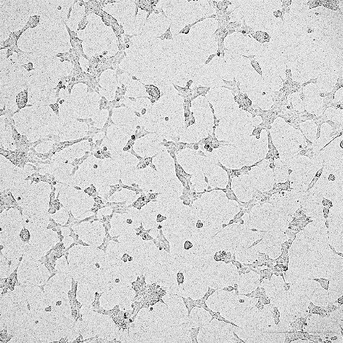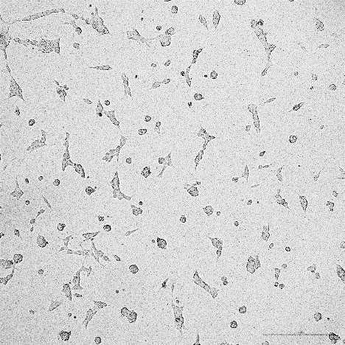
C. oppositifolia (250 µg/mL) C. oppositifolia (500 µg/mL) C. oppositifolia (1000 µg/mL)
Supplementary Figure 2. Microscopic images (10X) showing the viability of PC-3 prostate cancer cells after treatment with different concentrations of C. oppositifolia flower extract in an MTT assay.
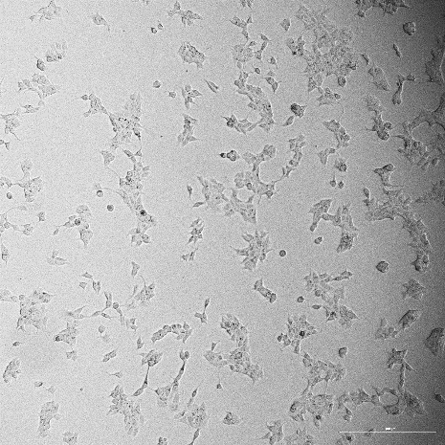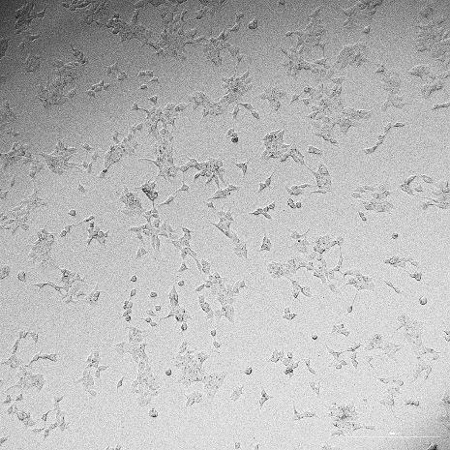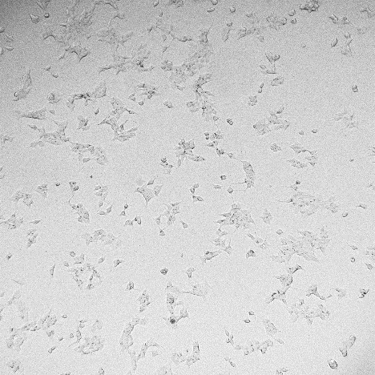
Control (0 µg/mL) C. oppositifolia (62.5 µg/mL) C. oppositifolia (125 µg/mL) 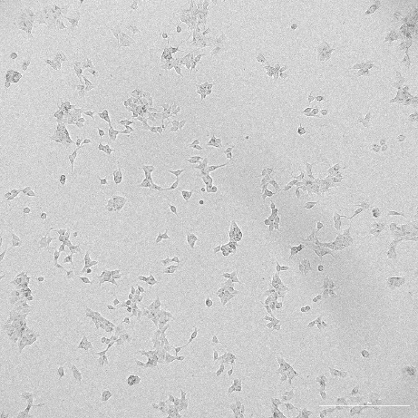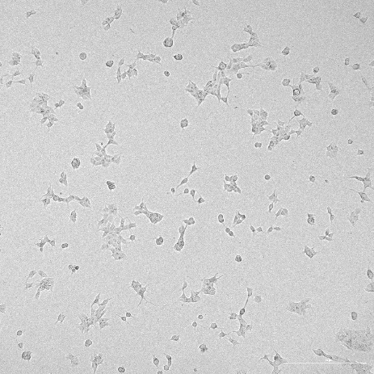 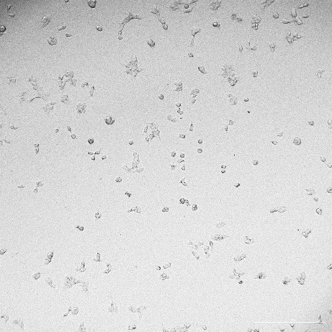
C. oppositifolia (250 µg/mL) C. oppositifolia (500 µg/mL) C. oppositifolia (1000 µg/mL)
Supplementary Figure 3. Microscopic images (10X) showing the viability of MCF-7 breast cancer cells after treatment with different concentrations of C. oppositifolia flower extract in an MTT assay.

