PRL-1-Enhanced PD-MSCs Promote Liver Regeneration by Improving Endothelial Barrier Function via HGF/c-Met Signaling in Liver Injury

Supplementary Materials:
Figure S1: Pentamidine modulation of PRL-1 and HGF readouts in PD-MSCs^{PRL-1}.
Figure S2: TAA-associated c-Met phosphorylation-linked readouts in WB-F344 cells.
Figure S3: Tivantinib-associated suppression of c-Met phosphorylation, proliferation-related readouts, and PI3K/Akt-associated signaling in WB-F344 cells.
Table S1: Primer sequences used for qRT-PCR.

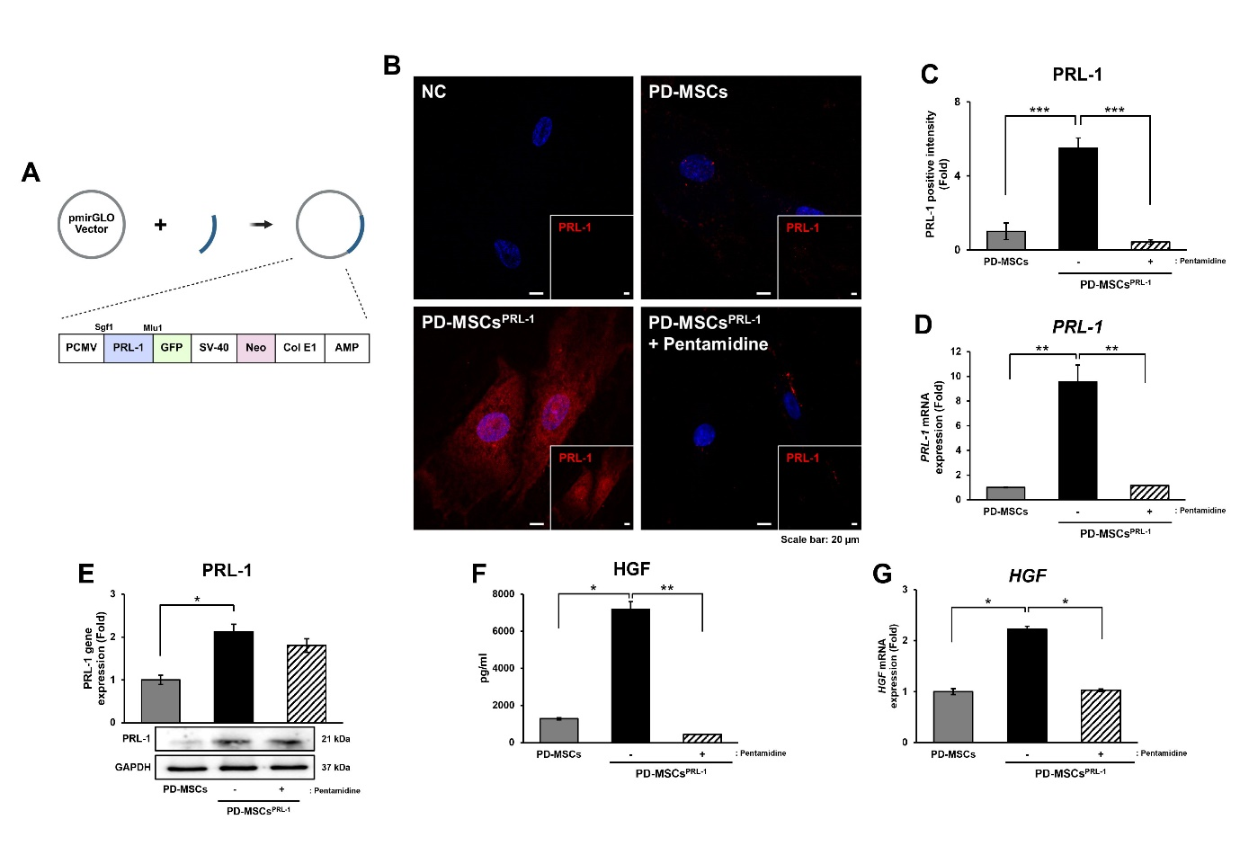

Supplementary Figure S1. Validation of PD-MSCs^{PRL-1} and attenuation by pentamidine. (A) Schematic of the AMAXA non-viral gene delivery vector used to generate PRL-1–enhanced PD-MSCs (PD-MSCs^{PRL-1}). (B) Representative immunofluorescence images of PRL-1 in naïve PD-MSCs, PD-MSCs^{PRL-1}, and PD-MSCs^{PRL-1} treated with pentamidine. (C) Quantification of PRL-1 immunofluorescence intensity. (D) qRT-PCR analysis of PRL-1 mRNA expression. (E) Representative immunoblot and densitometric analysis of PRL-1 protein expression. (F) HGF level in culture medium of naïve PD-MSCs, PD-MSCs^{PRL-1}, and PD-MSCs^{PRL-1} treated with pentamidine. (G) qRT-PCR analysis of HGF mRNA expression.

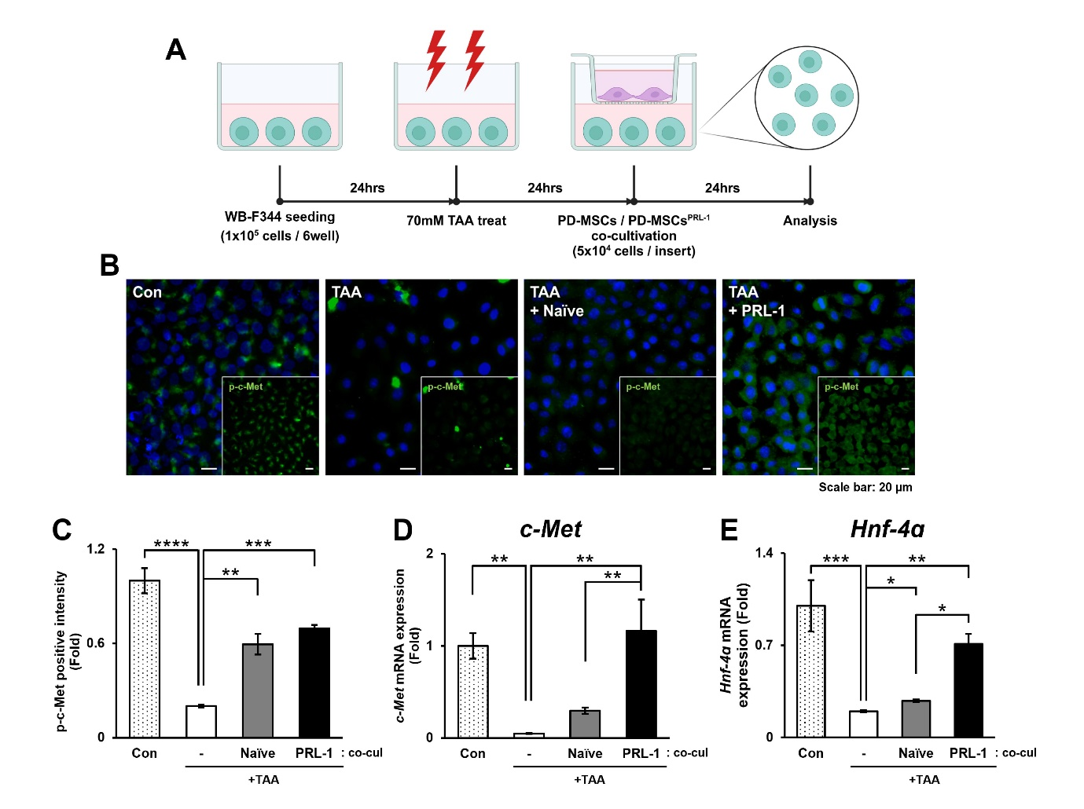

Supplementary Figure S2. TAA treatment is associated with reduced c-Met activation and hepatocyte-associated transcripts in WB-F344 cells. (A) Schematic overview of the WB-F344 culture and TAA treatment workflow. (B) Representative immunofluorescence images of phospho–c-Met in WB-F344 cells following TAA treatment. (C) Quantification of phospho–c-Met immunofluorescence intensity. (D, E) qRT-PCR analysis of c-Met (D) and Hnf-4α (E) mRNA expression in WB-F344 cells.

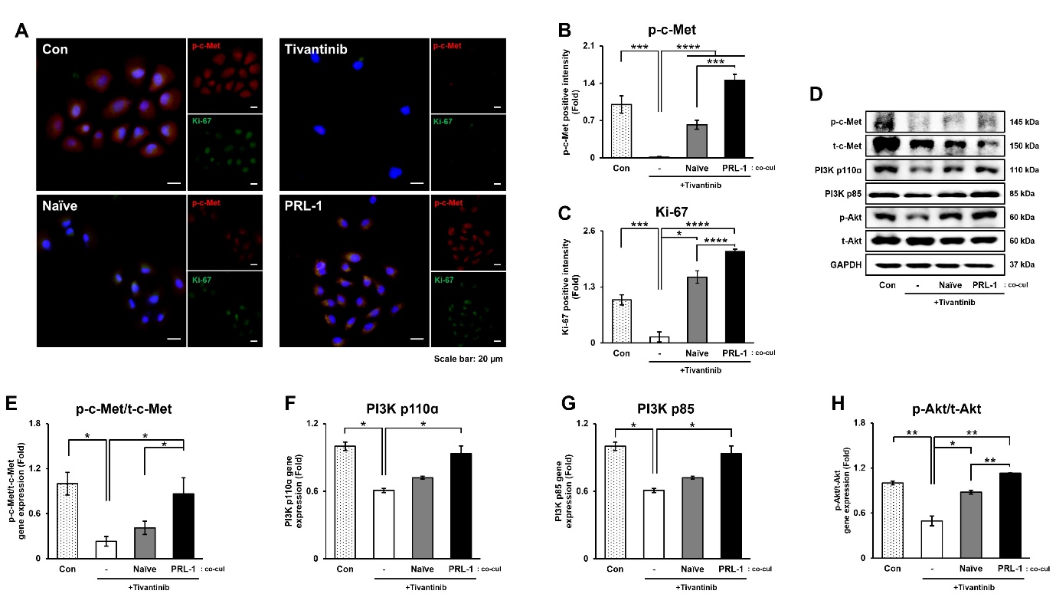

Supplementary Figure S3. Tivantinib treatment is associated with reduced c-Met activation, proliferation, and PI3K/Akt pathway activity in WB-F344 cells. (A) Representative immunofluorescence images of phospho–c-Met and Ki-67 in tivantinib-treated WB-F344 cells. (B, C) Quantification of phospho–c-Met (B) and Ki-67 (C) fluorescence intensities. (D) Representative immunoblot bands. (E–H) Densitometric quantification of phospho–c-Met/total c-Met (E), PI3K p110α (F), PI3K p85 (G), and phospho-Akt/total Akt (H).

Supplementary Table S1. Primer sequences used for qRT-PCR. Forward and reverse primer sequences for qRT-PCR assays used in this study are listed.

Species | Gene | Accession No. | Sequence
Human | hAlu | N/A (human Alu repetitive element) | F | 5'-GGT GAA ACC CCG TCT CTA CT-3'
Human | hAlu | N/A (human Alu repetitive element) | R | 5'-GGT TCA AGC GAT TCT CCT GC-3'
Human | PRL-1 | NM_003463.4 | F | 5'-TAC TGC TCC ACC AAG AAG CC-3'
Human | PRL-1 | NM_003463.4 | R | 5'-AGG TTT ACC CCA TCC AGG TC-3'
Human | HGF | NM_000601.6 | F | 5'-GCT ATC GGG GTA AAG ACC TAC A-3'
Human | HGF | NM_000601.6 | R | 5'-CGT AGC GTA CCT CTG GAT TGC-3'
Human | VEGF | NM_003376.6 | F | 5'-GCC TTG CCT TGC TGC TCT AC-3'
Human | VEGF | NM_003376.6 | R | 5'-ACA TCC ATG AAC TTC ACC ACT TCG-3'
Human | ASEF | NM_015320.2 | F | 5'-GCG GAC CAA CGT CAT CAA C-3'
Human | ASEF | NM_015320.2 | R | 5'-CCC GCA GGT GCT TGA TGT A-3'
Human | ERG | NM_182918.4 | F | 5'-AAG TAG CCG CCT TGC AAA TC-3'
Human | ERG | NM_182918.4 | R | 5'-GTG ATA GGA GCC CAT GTA C-3'
Human | GAPDH | NM_002046.7 | F | 5'-CTG GTG GCT GGC TCA GAA AA-3'
Human | GAPDH | NM_002046.7 | R | 5'-TGG TCC AGG GGT CTT ACT CC-3'
Rat | Alb | NM_134326.2 | F | 5'-GCA GGC TTG CTG TGA TAA GC-3'
Rat | Alb | NM_134326.2 | R | 5'-ACA AAA ACG TGC CCA GGA AG-3'
Rat | Hnf-4α | NM_001270933.1 | F | 5'-GCA GAG ATG AGC CGT GTG TC-3'
Rat | Hnf-4α | NM_001270933.1 | R | 5'-TTG ATC TTG CCT GGG TCA CTC-3'
Rat | Hgf | NM_017017.2 | F | 5'-CTT CTG CCG GTC CTG TTG-3'
Rat | Hgf | NM_017017.2 | R | 5'-TCT TCT CTT CTT CTG TCC TTC TGC-3'
Rat | c-Met | NM_031517.3 | F | 5'-ACC CAG ATT GTT TTC CTT GT-3'
Rat | c-Met | NM_031517.3 | R | 5'-ATT GTC AGG AGG AAG GAC AT-3'
Rat | Vegf | NM_031836.2 | F | 5'-ACT GGA CCC TGG CTT TAC TG-3'
Rat | Vegf | NM_031836.2 | R | 5'-ACG CAC TCC AGG GCT TCA TC-3'
Rat | Vegfr2 | NM_013062.2 | F | 5'-AAG CAA ATG CTC AGC AGG AT-3'
Rat | Vegfr2 | NM_013062.2 | R | 5'-TAG GCA GGG AGA GTC CAG AA-3'
Rat | Asef | NM_001427642.1 | F | 5'-AGC CAC AGG GAA GCC TAA AG-3'
Rat | Asef | NM_001427642.1 | R | 5'-AGT TAG ATG GCT TCC GCC TG-3'
Rat | Erg | NM_133397.2 | F | 5'-CAT GCT AGA AAC ACA GAT TTA CCT T-3'
Rat | Erg | NM_133397.2 | R | 5'-ACC TGG ATT AGC AAG GCG AC-3'
Rat | Gapdh | NM_017008.4 | F | 5'-TCC CTC AAG ATT GTC AGC AA-3'
Rat | Gapdh | NM_017008.4 | R | 5'-AGA TCC ACA ACG GAT ACA TT-3'

