Supplementary material
Supplementary Table 1 | Sample demographics according to neurodevelopmental domains at 5 years
Sample characteristics | Cognition  (N = 471) | Expressive language  (N = 505) | Receptive language  (N = 493) | Fine motor skills  (N = 501)
Child factors
Birth factors
Sex | 232 (49%) | 245 (49%) | 240 (49%) | 246 (49%)
Prematurity | 72 (15%) | 75 (15%) | 74 (15%) | 75 (15%)
Gravida | 1.13 (1.12) | 1.15 (1.14) | 1.16 (1.14) | 1.15 (1.14)
Maternal age at birth | 27.30 (5.95) | 27.33 (5.96) | 27.35 (5.97) | 27.34 (5.94)
Birth weight | 3.00 (0.57) | 3.00 (0.56) | 3.00 (0.57) | 3.01 (0.57)
Birth head circumference | 33.55 (1.92) | 33.57 (1.92) | 33.56 (1.92) | 33.57 (1.92)
Child Health factors
Hospitalisation | 118 (25%) | 130 (26%) | 130 (26%) | 128 (26%)
HIV in-utero exposure | 99 (21%) | 109 (22%) | 105 (21%) | 108 (22%)
Antenatal maternal anaemia | 77 (17%) | 79 (17%) | 80 (17%) | 78 (17%)
Nutritional and growth factors
Exclusive breastfeeding duration | 81 (17%) | 88 (17%) | 88 (18%) | 87 (17%)
Age at start of solid food | 4.70 (1.76) | 4.71 (1.75) | 4.74 (1.75) | 4.71 (1.75)
Height-for-age at 24 months | -1.05 (1.16) | -1.08 (1.15) | -1.08 (1.16) | -1.09 (1.15)
Weight-for-height at 24 months | 0.35 (1.26) | 0.34 (1.23) | 0.34 (1.23) | 0.35 (1.22)
Socio-economic factors
Marital status | 177 (38%) | 194 (38%) | 185 (38%) | 191 (38%)
Maternal education | 180 (38%) | 189 (37%) | 184 (37%) | 188 (38%)
Employment and income
Antenatal maternal employment | 115 (24%) | 121 (24%) | 120 (24%) | 121 (24%)
Postnatal parental employment¹ | 0.60 (0.36) | 0.60 (0.36) | 0.60 (0.36) | 0.60 (0.36)
Any postnatal parental employment | 405 (87%) | 435 (87%) | 425 (87%) | 432 (87%)
Antenatal household income | 283 (60%) | 310 (62%) | 295 (60%) | 307 (62%)
Postnatal household income¹ | 0.81 (0.23) | 0.81 (0.23) | 0.81 (0.23) | 0.81 (0.23)
Any postnatal household income | 463 (99%) | 497 (99%) | 485 (99%) | 493 (99%)
Resources and household factors
Antenatal electricity access | 445 (95%) | 445 (95%) | 477 (95%) | 466 (95%)
Postnatal electricity access¹ | 0.94 (0.17) | 0.94 (0.17) | 0.94 (0.17) | 0.94 (0.17)
Any postnatal electricity access | 463 (99%) | 463 (99%) | 497 (99%) | 485 (99%)
Antenatal running water access | 313 (67%) | 313 (67%) | 340 (68%) | 324 (66%)
Postnatal running water access¹ | 0.77 (0.28) | 0.77 (0.28) | 0.77 (0.28) | 0.77 (0.28)
Any postnatal running water access | 452 (97%) | 452 (97%) | 487 (97%) | 474 (97%)
Antenatal household crowding | 5.33 (2.77) | 5.33 (2.77) | 5.32 (2.86) | 5.34 (2.86)
Postnatal household crowding | 5.37 (2.01) | 5.37 (2.01) | 5.35 (2.00) | 5.36 (1.97)
Maternal mental health factors
Trauma
Childhood trauma | 269 (63%) | 290 (63%) | 284 (63%) | 287 (63%)
Antenatal PTSD:  Suspected PTSD  trauma-exposed  trauma unexposed | 55 (13%)  57 (13%)  315 (74%) | 59 (13%)  60 (13%)  342 (74%) | 61 (13%)  60 (13%)  331 (73%) | 58 (13%)  61 (13%)  338 (74%)
Antenatal lifetime IPV | 201 (47%) | 221 (48%) | 215 (48%) | 222 (49%)
Any postnatal IPV (any recent) | 235 (50%) | 252 (50%) | 243 (50%) | 252 (51%)
IPV combination Latent Classes  Class 1  Class 2  Class 3  Class 4 | 38 (9.2%)  38 (9.2%)  88 (21%)  249 (60%) | 41 (9.1%)  37 (8.2%)  101 (22%)  270 (60%) | 39 (8.9%)  38 (8.7%)  97 (22%)  264 (60%) | 41 (9.3%)  38 (8.6%)  98 (22%)  266 (60%)
Antenatal psychological distress (SRQ-20) | 100 (23%) | 104 (23%) | 105 (23%) | 106 (23%)
Postnatal psychological distress (SRQ-20)¹ | 0.08 (0.22) | 0.09 (0.22) | 0.09 (0.22) | 0.09 (0.22)
Depression
Antenatal depression (BDI) | 93 (22%) | 290 (63%) | 284 (63%) | 287 (63%)
Postnatal depression (BDI)¹ | 0.08 (0.24) | 59 (13%)  60 (13%)  342 (74%) | 61 (13%)  60 (13%)  331 (73%) | 58 (13%)  61 (13%)  338 (74%)
Antenatal depression (EPDS) | 111 (26%) | 221 (48%) | 215 (48%) | 222 (49%)
Postnatal depression (EPDS)¹ | 0.14 (0.26) | 252 (50%) | 243 (50%) | 252 (51%)
EPDS latent classes:  Class 1  Class 2  Class 3  Class 4  Class 5 | 368 (91%)  16 (4.0%)  5 (1.2%)  5 (1.2%)  11 (2.7%) | 400 (91%)  18 (4.1%)  6 (1.4%)  5 (1.1%)  10 (2.3%) | 392 (92%)  11 (2.6%)  6 (1.4%)  6 (1.4%)  11 (2.6%) | 394 (91%)  18 (4.1%)  6 (1.4%)  5 (1.2%)  11 (2.5%)
Substance use
Antenatal alcohol use | 100(14%) | 70 (14%) | 68 (14%) | 69 (14%)
Antenatal and postnatal tobacco use:  No use  Prenatal smoking  Postnatal smoking  Pre & postnatal smoking | 449 (62%)  14(1.9%)  44(6.1%)  215(30%) | 306 (61%)  11 (2.2%)  31 (6.2%)  153 (31%) | 300 (61%)  11 (2.2%)  30 (6.1%)  148 (30%) | 306 (62%)  11 (2.2%)  31 (6.2%)  149 (30%)
Parenting & social support
Coercive parenting (PAFAS) | 5.90 (3.75) | 5.94 (3.78) | 5.96 (3.77) | 5.95 (3.71)
Positive encouragement (PAFAS) | 1.22 (1.61) | 1.13 (1.58) | 1.17 (1.58) | 1.16 (1.59)
Parent-child relationship (PAFAS) | 1.07 (1.87) | 1.05 (1.83) | 1.04 (1.81) | 1.06 (1.84)
Parental adjustment (PAFAS) | 2.56 (2.65) | 2.48 (2.63) | 2.54 (2.64) | 2.52 (2.62)
Family relationships (PAFAS) | 2.06 (2.54) | 1.99 (2.52) | 2.01 (2.53) | 1.99 (2.51)
Parental teamwork (PAFAS) | 1.85 (1.83) | 1.78 (1.81) | 1.87 (1.85) | 1.81 (1.83)
Perceived social support (MSPSS) | 5.50 (1.33) | 5.51 (1.31) | 5.48 (1.33) | 5.49 (1.32)
CHEU, children who are HIV-exposed uninfected; PTSD, post-traumatic stress disorder; IPV, intimate partner violence; BDI, Beck Depression Inventory; EPDS, The Edinburgh Postnatal Depression Rating Scale; SRQ-20, The Self reporting Questionnaire; PAFAS, The Parenting and Family Adjustment Scale

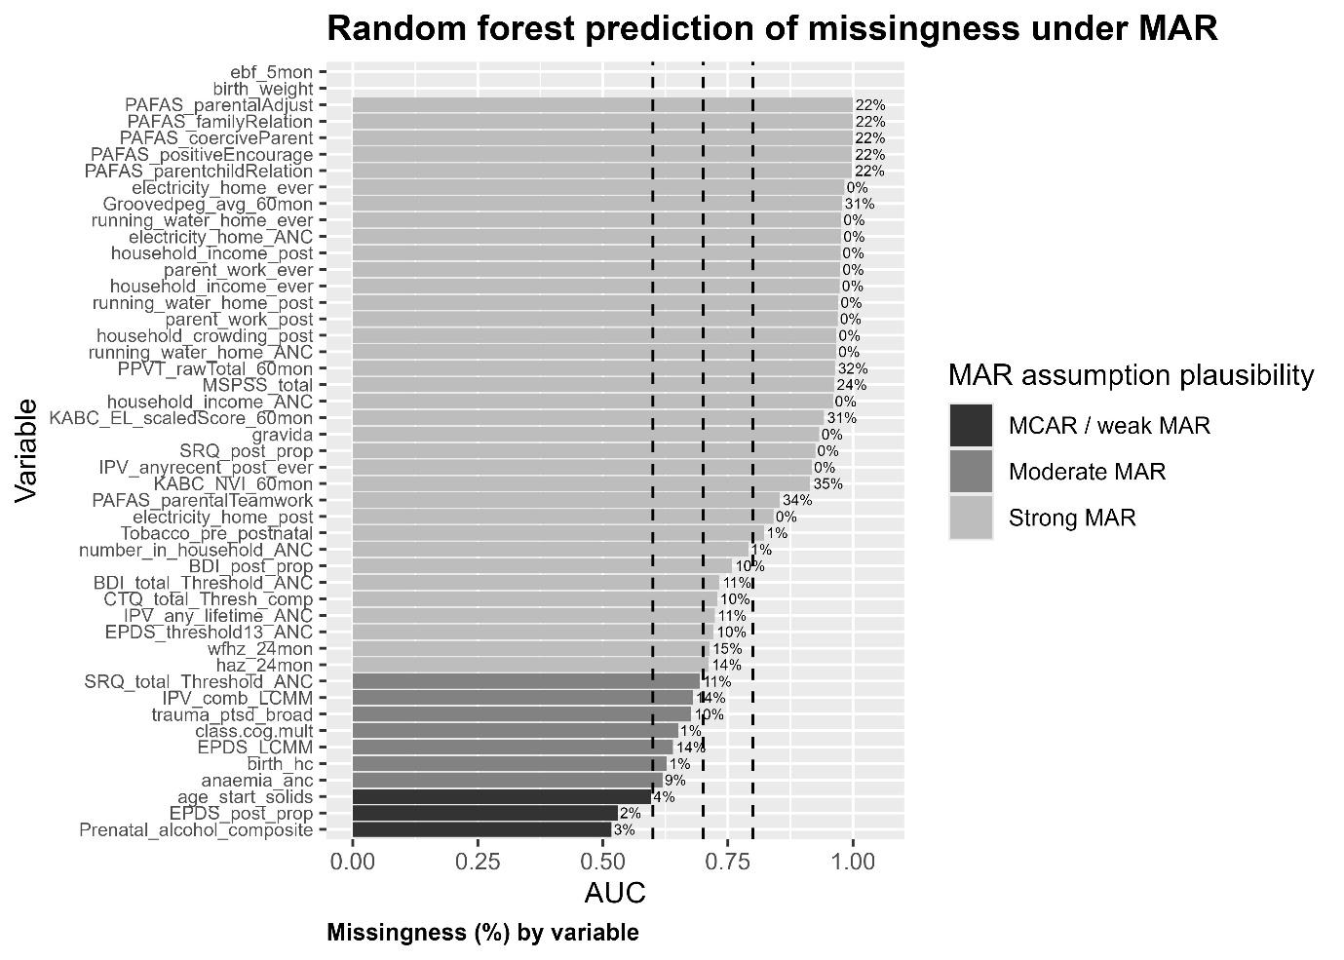
Supplementary Figure 1 | Random forest sensitivity analysis of Missingness-at-Random (MAR) assumption of missing candidate predictor data

IPV, intimate partner violence

