Supplementary material
Synthesis, characterization and antimicrobial activity of novel Pd(II) complexes with athracenyl-based Schiff bases

Ana Kandić,^{a, 0009-0002-4709-5628} Tamara Petrović^{b, 0000-0003-1818-8710} Marija Tanović,^{c, 0000-0002-4363-7824} Jovana Anđelković,^{d,} ⁰⁰⁰⁹⁻⁰⁰⁰⁹⁻⁵⁷⁸⁶⁻³¹⁸⁵ Marija Dimitrijević,^{e, 0000-0003-1816-0400} Stefan Nikolić,^{a, 0000-0002-0164-134X} Tatjana Mihajilov-Krstev, ^{d, 0000-0002-7642-5879} Sanja Grgurić-Šipka,^{b, 0000-0003-1906-535X} Ivan Milutinović,^{b, 0009-0001-4806-413X}, Milena Krstić,^{f, 0000-0001-6915-062X} Jelena Poljarević*^{b, 0000-0002-6706-0281}

ª Innovative centre, Faculty of Chemistry, Studentski trg 12-16, 11000 Belgrade, Serbia
^{b} University of Belgrade - Faculty of Chemistry, Department for General and Inorganic Chemistry, Studentski trg 12-16, 11 000 Belgrade
^{c} University of Belgrade - Institute for Multidisciplinary Research, Kneza Višeslava 1, 11030 Beograd
^{d} Department of Biology and Ecology, Faculty of Sciences and Mathematics, University of Niš, Višegradska 33, 18000 Niš, Serbia
^{e} Department of Pharmacy, Faculty of Medicine, University of Niš, Blvd. Dr Zorana Đinđića 81, 18000 Niš, Serbia
^{f} Faculty of Veterinary Medicine, University of Belgrade, Bulevar oslobođenja 18, 11000 Belgrade

*Corresponding author: jelenal@chem.bg.ac.rs

Table of contents
Figure S1. IR spectrum of L1 3
Figure S2. IR spectrum of L2 3
Figure S3. IR spectrum of L3 4
Figure S4. IR spectrum of L4 4
Figure S5. IR spectrum of L5 5
Figure S6. IR spectrum of C1 5
Figure S7. IR spectrum of C2 6
Figure S8. IR spectrum of C3 6
Figure S9. IR spectrum of C4 7
Figure S10. IR spectrum of C5 7
Figure S11. ¹HNMR spectrum of L1 recorded in CDCl₃ 8
Figure S12. ¹HNMR spectrum of L1 (aromatic part) recorded in CDCl₃ 8
Figure S13. ¹³C NMR spectrum of L1 recorded in CDCl₃ 9
Figure S14. ¹HNMR spectrum of C1 recorded in CDCl₃ 9
Figure S15. ¹HNMR spectrum of C1 (aromatic part) recorded in CDCl₃ 10
Figure S16. ¹³C NMR spectrum of C1 recorded in CDCl₃ 10
Figure S17. Overlapped ¹H NMR spectra of L1 (red) and C1 (blue) 11
Figure S18. ¹HNMR spectrum of L2 recorded in DMSO-d6 11
Figure S19. ¹HNMR spectrum of L2 recorded in acetone-d6 12
Figure S20. ¹³C NMR spectrum of L2 recorded in DMSO-d6 12
Figure S21. ¹HNMR spectrum of C2 recorded in DMSO-d6 13
Figure S22. ¹³C NMR spectrum of C2 recorded in DMSO-d6 13
Figure S23. Overlapped ¹H NMR spectra of L2 (blue) and C2 (red) 14
Figure S24. ¹HNMR spectrum of L3 recorded in DMSO-d6. 14
Figure S25. ¹³CNMR spectrum of L3 recorded in DMSO-d6. 15
Figure S26. ¹HNMR spectrum of C3 recorded in DMSO-d6. 15
Figure S27. ¹³CNMR spectrum of C3 recorded in DMSO-d6. 16
Figure S28. Overlapped ¹H NMR spectra of L3 (red) and C3 (blue) 16
Figure S29. ¹HNMR spectrum of L4 recorded in DMSO-d6. 17
Figure S30. ¹³CNMR spectrum of L4 recorded in DMSO-d6. 17
Figure S31. ¹HNMR spectrum of C4 recorded in DMSO-d6. 18
Figure S32. ¹³CNMR spectrum of C4 recorded in DMSO-d6. 18
Figure S33. Overlapped ¹H NMR spectra of L4 (red) and C4 (blue) 19
Figure S34. ¹HNMR spectrum of L5 recorded in DMSO-d6. 19
Figure S35. ¹³CNMR spectrum of L5 recorded in DMSO-d6. 20
Figure S36. ¹HNMR spectrum of C5 recorded in DMSO-d6. 20
Figure S37. ¹³CNMR spectrum of C5 recorded in DMSO-d6. 21
Figure S38. Overlapped ¹H NMR spectra of L5 (red) and C5 (blue) 21
Figure S39. Mass spectra of L1 22
Figure S40. Mass spectra of C1 23
Figure S41. Mass spectra of L2 24
Figure S42. Mass spectra of C2 25
Figure S43. Mass spectra of L3 26
Figure S44. Mass spectra of C3 27
Figure S45. Mass spectra of L4 28
Figure S46. Mass spectra of C4 29
Figure S47. Mass spectra of L5 30
Figure S48. Mass spectra of C5 31

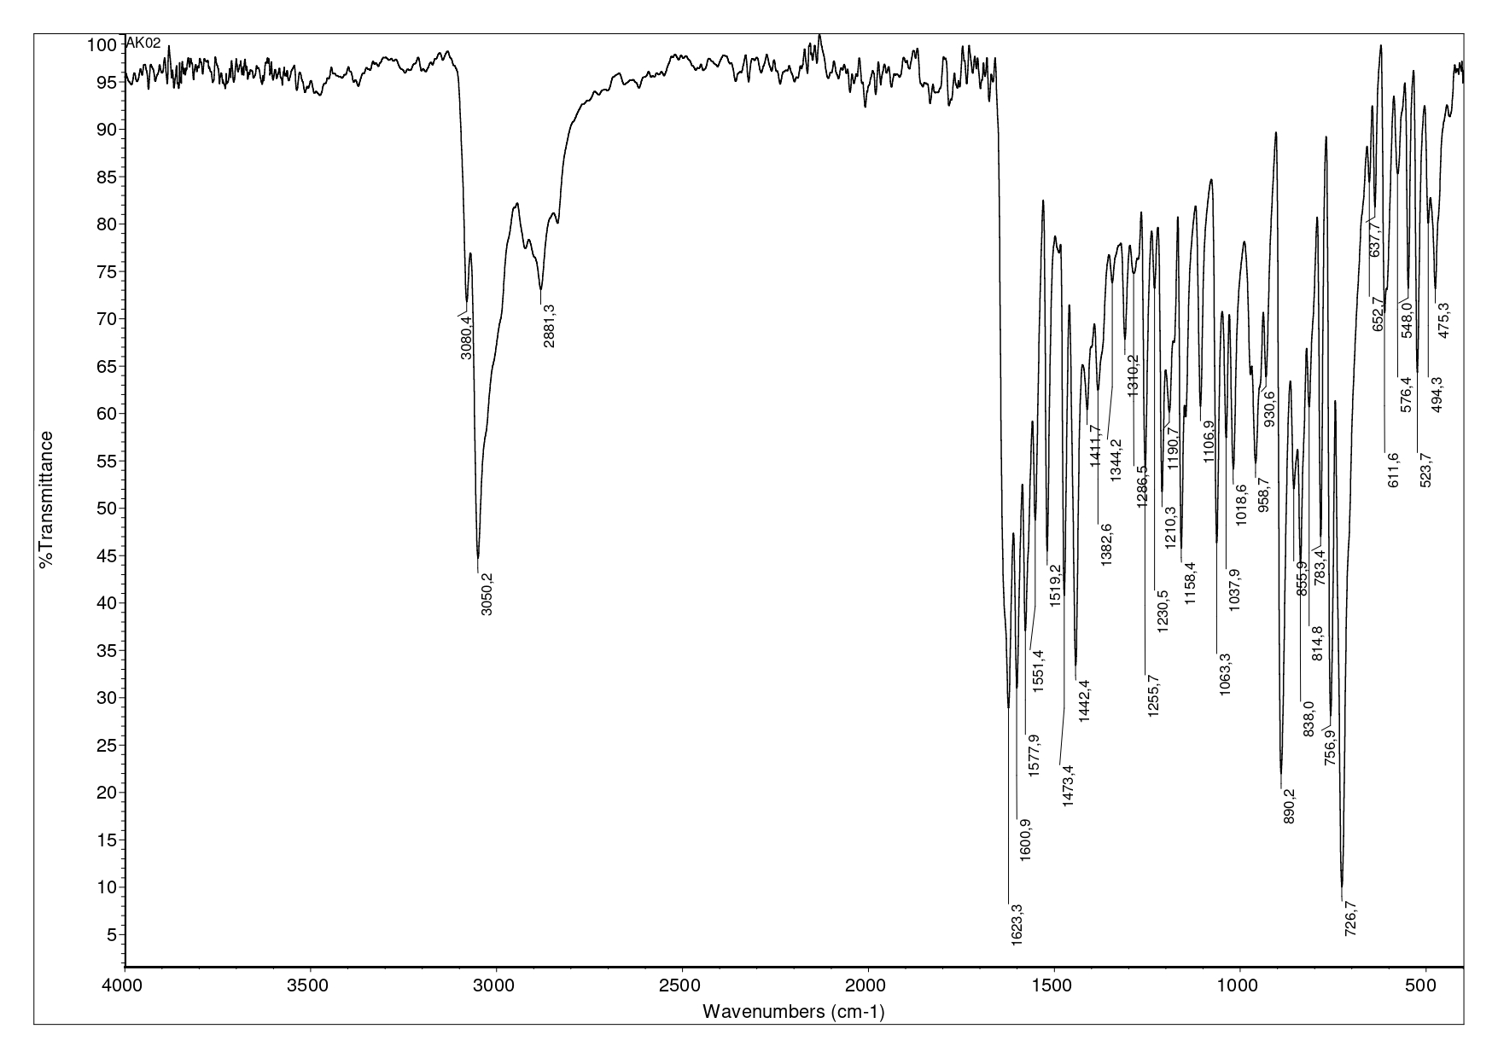
Figure S1. IR spectrum of L1
Figure S2. IR spectrum of L2
Figure S3. IR spectrum of L3
Figure S4. IR spectrum of L4
Figure S5. IR spectrum of L5
Figure S6. IR spectrum of C1
Figure S7. IR spectrum of C2
Figure S8. IR spectrum of C3
Figure S9. IR spectrum of C4
Figure S10. IR spectrum of C5
Figure S11. ¹HNMR spectrum of L1 recorded in CDCl₃
Figure S12. ¹HNMR spectrum of L1 (aromatic part) recorded in CDCl₃
Figure S13. ¹³C NMR spectrum of L1 recorded in CDCl₃
Figure S14. ¹HNMR spectrum of C1 recorded in CDCl₃
Figure S15. ¹HNMR spectrum of C1 (aromatic part) recorded in CDCl₃
Figure S16. ¹³C NMR spectrum of C1 recorded in CDCl₃
Figure S17. Overlapped ¹H NMR spectra of L1 (red) and C1 (blue)
Figure S18. ¹HNMR spectrum of L2 recorded in DMSO-d6
Figure S19. ¹HNMR spectrum of L2 recorded in acetone-d6
Figure S20. ¹³C NMR spectrum of L2 recorded in DMSO-d6
Figure S21. ¹HNMR spectrum of C2 recorded in DMSO-d6
Figure S22. ¹³C NMR spectrum of C2 recorded in DMSO-d6
Figure S23. Overlapped ¹H NMR spectra of L2 (blue) and C2 (red)

Figure S24. ¹HNMR spectrum of L3 recorded in DMSO-d6.
Figure S25. ¹³CNMR spectrum of L3 recorded in DMSO-d6.
Figure S26. ¹HNMR spectrum of C3 recorded in DMSO-d6.
Figure S27. ¹³CNMR spectrum of C3 recorded in DMSO-d6.
Figure S28. Overlapped ¹H NMR spectra of L3 (red) and C3 (blue)
Figure S29. ¹HNMR spectrum of L4 recorded in DMSO-d6.
Figure S30. ¹³CNMR spectrum of L4 recorded in DMSO-d6.
Figure S31. ¹HNMR spectrum of C4 recorded in DMSO-d6.
Figure S32. ¹³CNMR spectrum of C4 recorded in DMSO-d6.
Figure S33. Overlapped ¹H NMR spectra of L4 (red) and C4 (blue)
Figure S34. ¹HNMR spectrum of L5 recorded in DMSO-d6.
Figure S35. ¹³CNMR spectrum of L5 recorded in DMSO-d6.
Figure S36. ¹HNMR spectrum of C5 recorded in DMSO-d6.
Figure S37. ¹³CNMR spectrum of C5 recorded in DMSO-d6.
Figure S38. Overlapped ¹H NMR spectra of L5 (red) and C5 (blue)
Figure S39. Mass spectra of L1
Figure S40. Mass spectra of C1
Figure S41. Mass spectra of L2
Figure S42. Mass spectra of C2
Figure S43. Mass spectra of L3
Figure S44. Mass spectra of C3
Figure S45. Mass spectra of L4
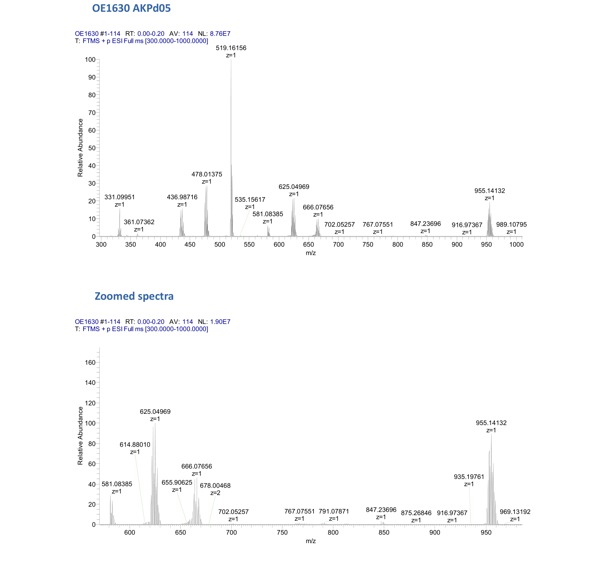
Figure S46. Mass spectra of C4
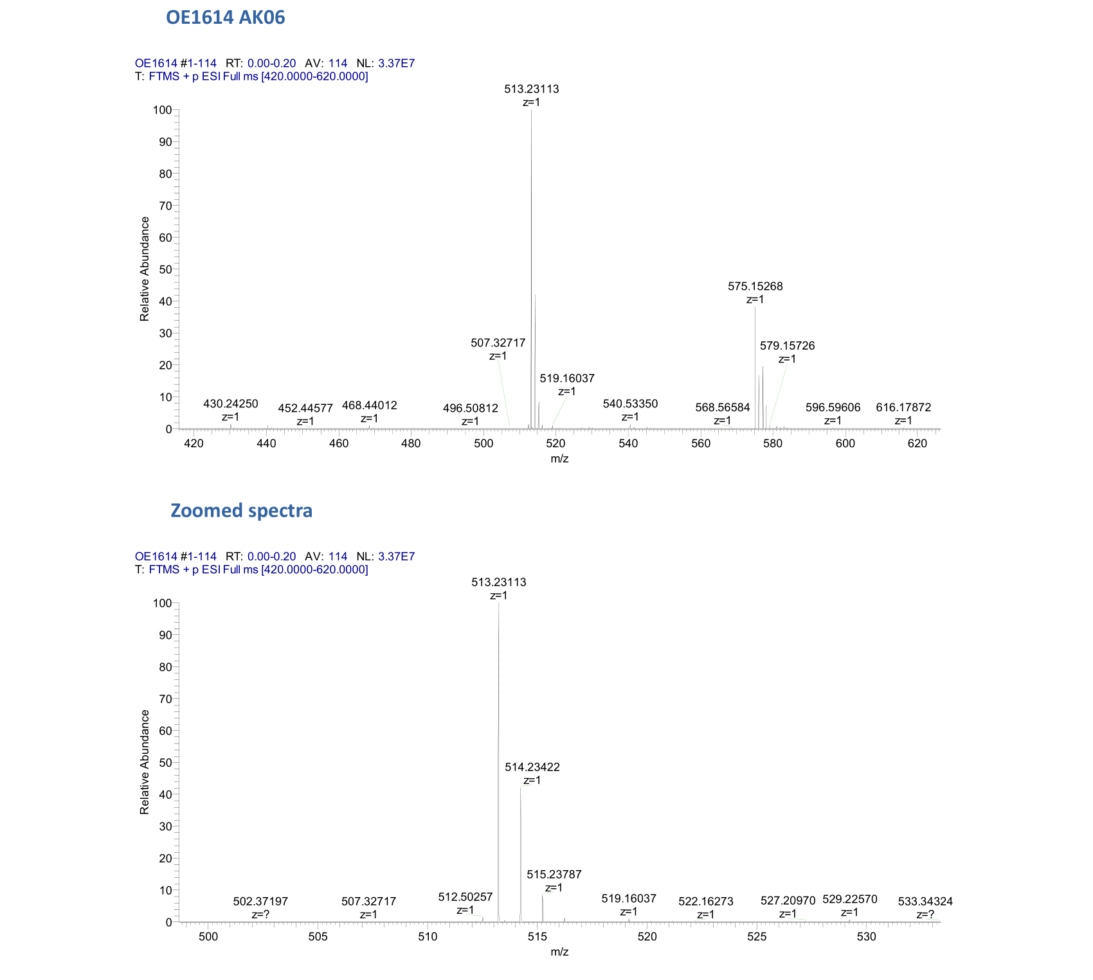
Figure S47. Mass spectra of L5
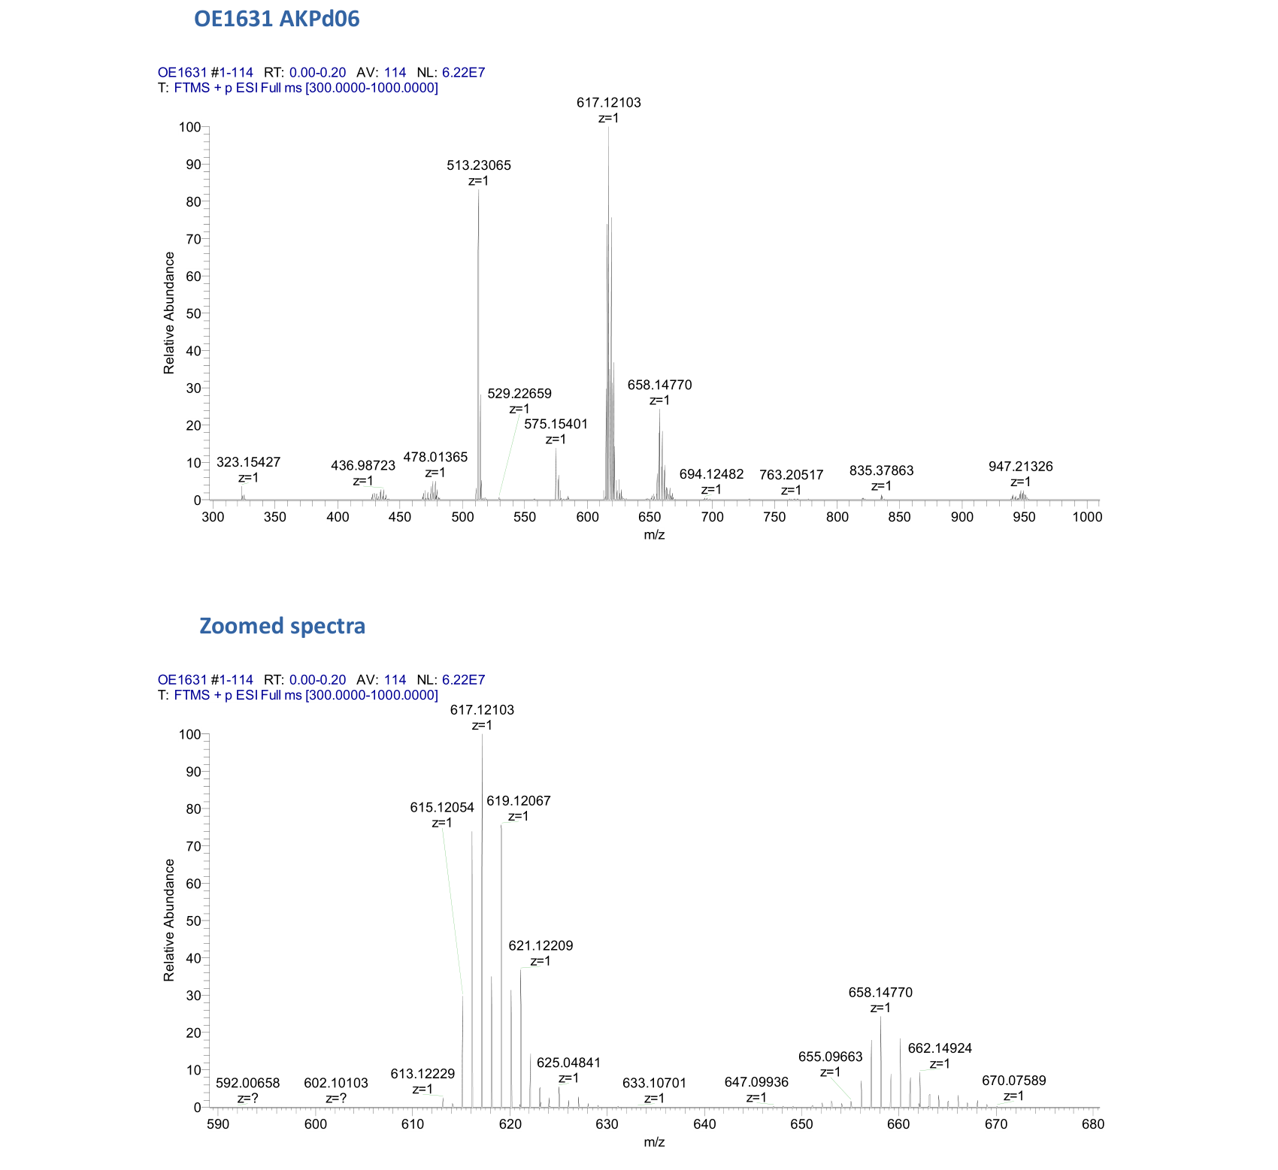
Figure S48. Mass spectra of C5

