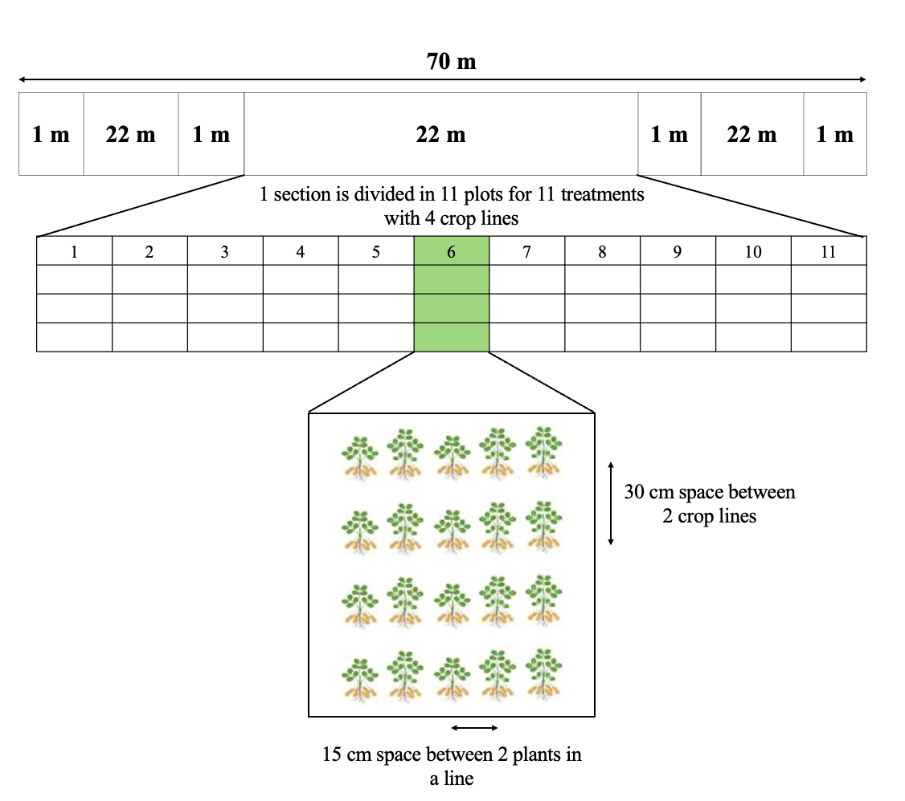
Supplementary figure 1: Field trial set up using randomized complete block design

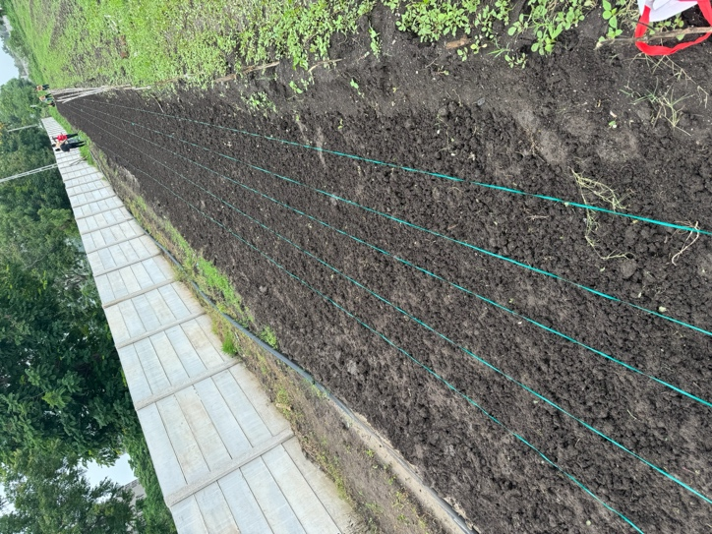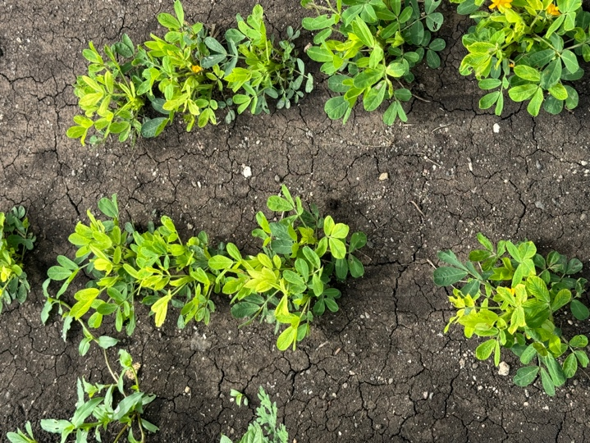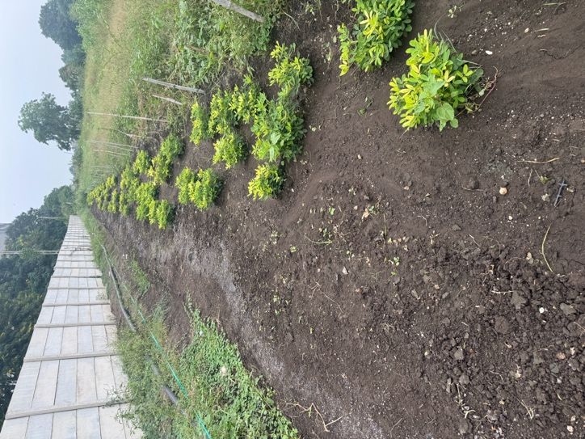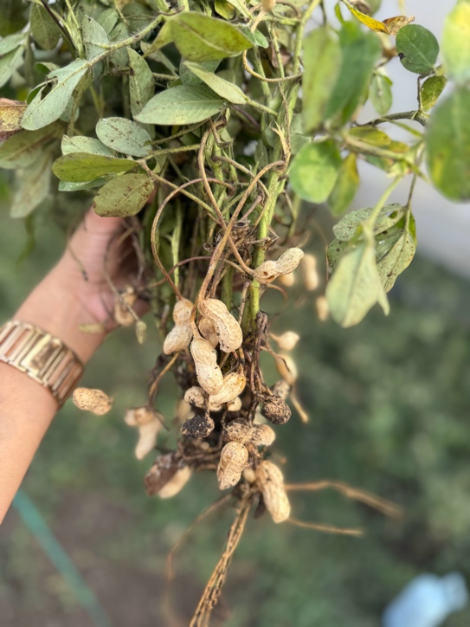

Supplementary figure 2: Field trial images at sowing, 45, 90 and 120 DAS.

Supplementary table 1:Summary of the randomized complete block design (RCBD) experimental structure
Design element | Specification
Treatment factor | Isolate/inoculant identity — 11 levels (T1–T11)
Block factor | Spatial replicate block — 3 levels (R1, R2, R3 = Block 1–3)
Experimental unit | 2 m × 1.5 m plot per treatment per block (33 plots total)
Observational unit | 3 plants sampled per plot per timepoint, averaged to one plot value before recording (Section 2.5.4)
Replication | n = 3 (blocks) per treatment — balanced, complete
Randomization | Treatments randomized within each block (standard RCBD layout, Supplementary figure 1)
Timepoints | 45, 90, 120 DAS (destructive sampling — different plants each time, not a repeated-measures/longitudinal design on the same subjects)
Response variables | Plant length, shoot length, root length, no. of branches, no. of leaves, stem girth, chlorophyll content, relative water content (all 3 DAS); no. of pods (90 & 120 DAS only)
Sample size per cell | n = 3 blocks; total N = 33 per trait per DAS

