Genome-resolved metagenomics of Naini Lake reveals diverse microbial community and uncharacterized biosynthetic gene clusters
Saraswati Awasthi ^{1,2}, Vishal Maurya^{1,2}, Samiksha Maurya^{1,#}, and Rakesh Sharma ^{1,2*}
*Correspondence: Rakesh Sharma (rakesh.igib@csir.res.in)
¹CSIR-Institute of Genomics and Integrative Biology, New Delhi, India
²Academy of Scientific and Innovative Research (AcSIR), Ghaziabad, India

# Current address: Indian Institute of Technology, Hyderabad, India

Supplementary Figures
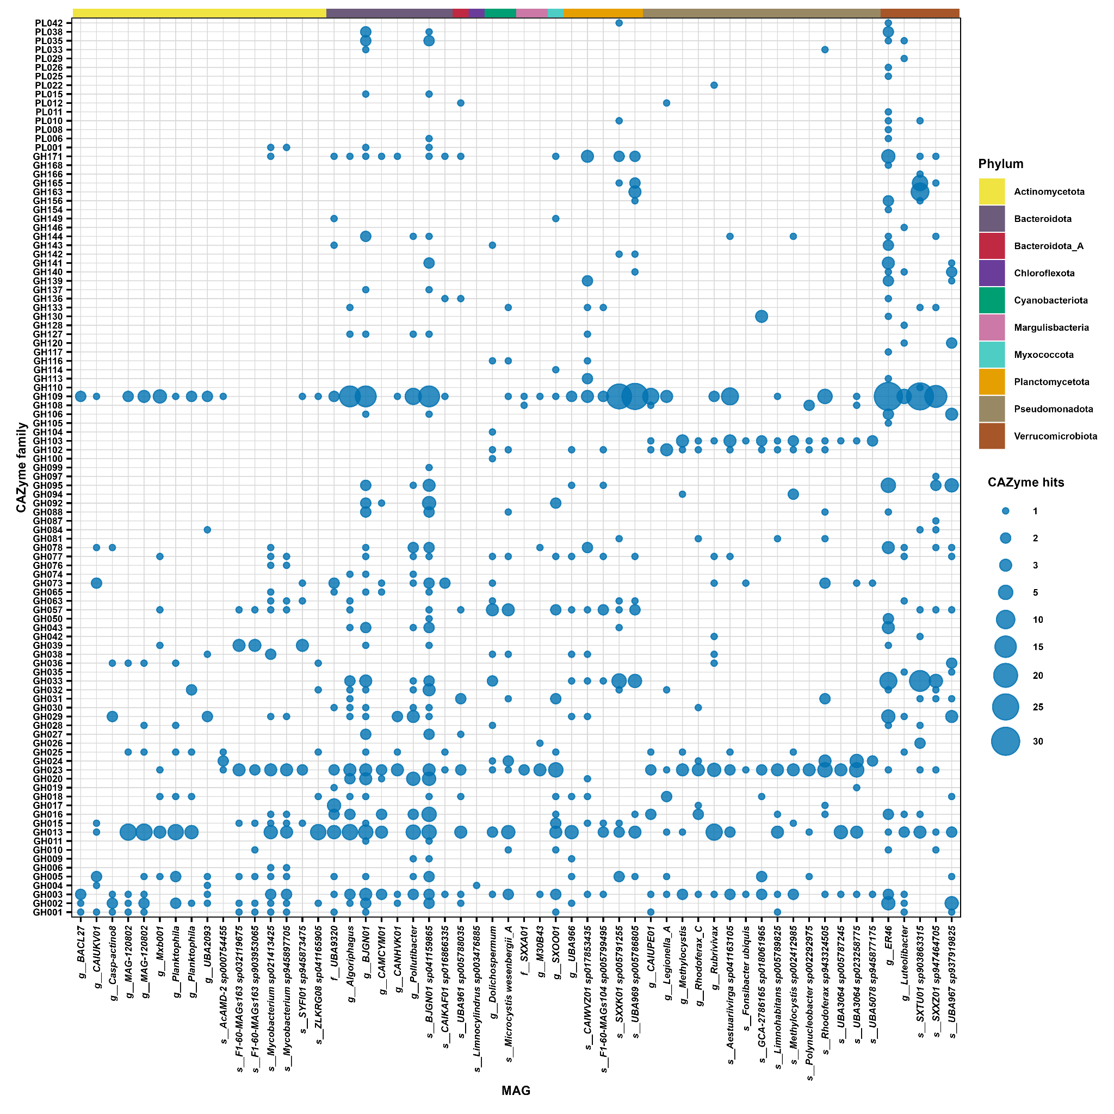
Supplementary Figure 1: A diverse CAZyme repertoire of MAGs from Naini Lake: Distribution of different CAZyme families across the MAGs arranged by phylum, the bubble size represents the number of hits for each family across the MAGs.

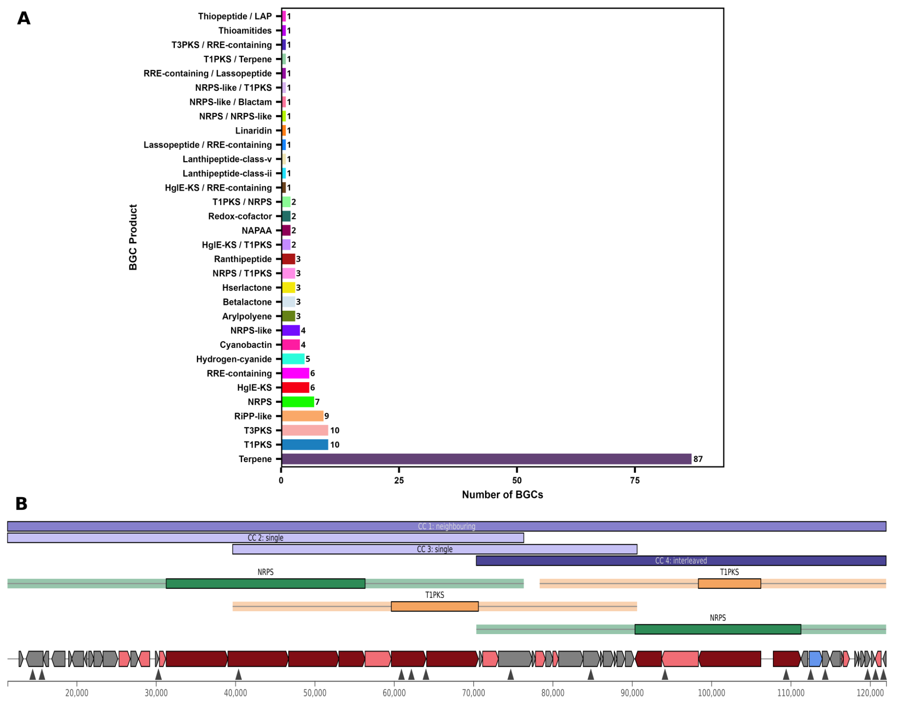

Supplementary Figure 2: Biosynthetic potential of MAGs: A) All the different types of Biosynthetic gene clusters (BGCs) detected across the MAGs. B) A distinct large size (~110.7kb) NRPS-PKS cluster predicted in MAG assigned to genus ER46 of phylum Verrucomicrobiota.

