Supplementary Information
Journal of Hematopathology
Title: Integrated Clinical, Cytogenetic and Molecular Profiling in Chronic Myelomonocytic Leukemia: Genotype–Phenotype Associations and Risk-Model Discordance in an Indian Cohort.
Authors:
Alpeshkumar Bipinbhai Kapadia¹, Madhavi Maddali¹, Phaneendra Datari¹, Arun Kumar Arunachalam¹, Sathya Mani¹, Bexy Bensega¹, Uday Prakash Kulkarni¹, Anu Korula¹, Biju George¹, Aby Abraham¹, Vikram Mathews¹, Poonkuzhali Balasubramanian¹
Affiliations
¹Department of Haematology, Christian Medical College, Vellore, Ranipet campus, Tamil Nadu, India

Correspondence:
Poonkuzhali Balasubramanian,
Department of Haematology,
Christian Medical College, Ranipet Campus
Vellore 632517, Tamil Nadu, India.
Email: bpoonkuzhali@cmcvellore.ac.in

Supplementary Methods:
Sequencing data met predefined quality criteria, including ≥98% bases with Q30 quality, alignment pass rate >80%, overall duplicate reads <2%, and panel breadth of coverage ≥90%. The median insert size was approximately 150–200 bp, the median mapping quality was 60, the mean panel depth was approximately 500×, and approximately 99% of targeted regions achieved ≥100× coverage. Reads were aligned to the human reference genome hg38 using BWA-MEM, followed by Sentieon- and GATK-based processing and variant calling. Variant annotation was performed using VEP/Ensembl and curated population and disease databases, including 1000 Genomes, ExAC, dbSNP, ClinVar, OMIM, HGMD, HPO, and SwissVar. Variants were considered reportable only if they met laboratory-defined quality metrics, including adequate locus-level coverage and variant read support. Variants near the 5% VAF threshold generally required ≥200× locus depth and ≥10 independent variant-supporting reads. Lower-coverage or borderline calls were manually reviewed in Integrative Genomics Viewer and retained only if supported by consistent read-level evidence without significant strand bias, mapping artefact, or background sequencing noise.

Supplementary Tables:
Supplementary Table S1: Targeted 57 myeloid gene panel
ABL1 | BRAF | CEBPA | EZH2 | HRAS | KDM6A | MYD88 | PHF6 | SF3B1 | TP53
ASXL1 | CALR | CREBBP | FBXW7 | IDH1 | KIT | NF1 | PTEN | SMC1A | U2AF1*
ATM | CBL | CSF3R | FLT3 | IDH2 | KMT2A | NOTCH1 | PTPN11 | SMC3 | WT1
ATRX | CBLB | CUX1 | GATA1 | IKZF1 | KMT2D | NPM1 | RAD21 | SRSF2 | ZRSR2
BCOR | CBLC | DNMT3A | GATA2 | JAK2 | KRAS | NRAS | RUNX1 | STAG2
BCORL1 | CDKN2A | ETV6 | GNAS | JAK3 | MPL | PDGFRA | SETBP1 | TET2
*All the genes in this panel have 100% coverage except the U2AF1 gene, which has 50% coverage.
Supplementary Table S2: Risk stratification of CMML patients according to conventional and molecular prognostic models
Type of Model | Model | Variable (Score Assignment) | Risk Group based on Overall score | Published cohort distribution, n/N (%) | Present cohort distribution, n/N (%)
Clinical | MDAPS  Onida et al., 2002 | - Hb <12 g/dL=1  - ALC >2.5×10⁹/L=1  - Circulating IMC present=1  - BM blasts ≥10%=1 | 0-1 = Low | 35/190 (18.4) | 5/29 (17.2)
Clinical | MDAPS  Onida et al., 2002 |  | 2 = Intermediate-1 | 60/190 (31.6) | 10/29 (34.5)
Clinical | MDAPS  Onida et al., 2002 |  | 3= Intermediate-2 | 75/190 (39.5) | 12/29 (41.4)
Clinical | MDAPS  Onida et al., 2002 |  | 4 = High | 20/190 (10.5) | 2/29 (6.9)
Clinical | MPM*  Patnaik et al., 2013 | - AMC ≥10×10⁹/L=1  - Circulating IMC present=1  - Hb <10 g/dL=1  - Platelets <100×10⁹/L=1 | 0 = Low | 115 (50.7) | 0/29 (0.0)
Clinical | MPM*  Patnaik et al., 2013 |  | 1 = Intermediate | 58 (25.6) | 6/29 (20.7)
Clinical | MPM*  Patnaik et al., 2013 |  | ≥2 = High | 54 (23.8) | 23/29 (79.3)
Clinical | BLAST  Tefferi et al., 2025 | - PB blasts ≥2%=1  - WBC ≥13×10⁹/L=1  - Moderate/Severe anemia=1–2 | 0 = Low | 167/457 (36.5) | 2/29 (6.9)
Clinical | BLAST  Tefferi et al., 2025 |  | 1 = Intermediate | 120/457 (26.3) | 4/29 (13.8)
Clinical | BLAST  Tefferi et al., 2025 |  | ≥2 = High | 170/457 (37.2) | 23/29 (79.3)
Clinical + Cytogenetic | CPSS#  Such et al., 2013 | - CMML subtype: MD=0, MP=1  - BM blasts <5%=0, ≥5%=1  - Transfusion dependence: No=0, Yes=1  - CMML-specific cytogenetic risk classification:  - Low=0, Intermediate=1, High=2 | 0 = Low | 217/532 (40.8) | 2/28 (7.1)
Clinical + Cytogenetic | CPSS#  Such et al., 2013 |  | 1 = Intermediate-1 | 155/532 (29.1) | 12/28 (42.9)
Clinical + Cytogenetic | CPSS#  Such et al., 2013 |  | 2–3 = Intermediate-2 | 141/532 (26.5) | 10/28 (35.7)
Clinical + Cytogenetic | CPSS#  Such et al., 2013 |  | 4–5 = High | 19/532 (3.6) | 4/28 (14.3)
Clinical + Molecular | GFM†  Itzykson et al., 2013 | - WBC >15×10⁹/L=3  - Age >65 yr=2  - Hb <10 g/dL(females) and <11 g/dl (males)=2  - Platelets <100×10⁹/L=2  - ASXL1 mutation=2 | 0-4 = Low | 188/477 (39.4) | 7/29 (24.1)
Clinical + Molecular | GFM†  Itzykson et al., 2013 |  | 5-7 = Intermediate | 163/477 (34.2) | 10/29 (34.5)
Clinical + Molecular | GFM†  Itzykson et al., 2013 |  | 8-12= High | 126/477 (26.4) | 12/29 (41.4)
Clinical + Molecular | MMM  Patnaik et al., 2014 | - AMC ≥10×10⁹/L=2  - IMC present=2  - Hb <10 g/dL=2  - Platelets <100×10⁹/L=1.5  - ASXL1 mutation=1.5 | 0 = Low | 64/420 (15.2) | 0/29 (0.0)
Clinical + Molecular | MMM  Patnaik et al., 2014 |  | ≤2 = Intermediate-1 | 128/420 (30.5) | 5/29 (17.2)
Clinical + Molecular | MMM  Patnaik et al., 2014 |  | 2.5-4.5 = Intermediate-2 | 118/420 (28.1) | 8/29 (27.6)
Clinical + Molecular | MMM  Patnaik et al., 2014 |  | ≥5 = High | 110/420 (26.2) | 16/29 (55.2)
Clinical + Cytogenetic + Molecular | CPSS-Mol†  Elena et al., 2016 | - CMML subtype: MD=0, MP=1  - BM blasts <5%=0, ≥5%=1  - Transfusion dependence: No=0, Yes=1  - Genetic risk group | 0 = Low | 77/444 (17.3) | 0/28 (0.0)
Clinical + Cytogenetic + Molecular | CPSS-Mol†  Elena et al., 2016 |  | 1 = Intermediate-1 | 106/444 (23.9) | 4/28 (14.3)
Clinical + Cytogenetic + Molecular | CPSS-Mol†  Elena et al., 2016 |  | 2–3 = Intermediate-2 | 160/444 (36.0) | 14/28 (50.0)
Clinical + Cytogenetic + Molecular | CPSS-Mol†  Elena et al., 2016 |  | ≥4 = High | 101/444 (22.7) | 10/28 (35.7)
Clinical + Cytogenetic + Molecular | BLAST-Mol  Tefferi et al., 2025 | - BLAST score  - Cytogenetics: Low=0, Adverse=1  Molecular risk‡:  - LMR=0, IMR=1, HMR=2 | Low: 0–1 | 149/448 (33.3) | 2/28 (7.1)
Clinical + Cytogenetic + Molecular | BLAST-Mol  Tefferi et al., 2025 |  | Intermediate: 2–3 | 180/448 (40.2) | 12/28 (42.9)
Clinical + Cytogenetic + Molecular | BLAST-Mol  Tefferi et al., 2025 |  | High: 4–6 | 119/448 (26.6) | 14/28 (50.0)
Clinical + Cytogenetic + Molecular | iCPSS (Molecular CPSS)  Lanino et al., 2026 | - WBC, ×10⁹/L  - Hemoglobin, g/dL  - Platelet, ×10⁹/L  - BM blast%  - Cytogenetic risk  - Gene mutations (ASXL1, DNMT3A, EZH2, RUNX1, SETBP1, STAG2, TET2, TP53, U2AF1) | Very Low | 504/3,012 (16.7) | 1/28 (3.6)
Clinical + Cytogenetic + Molecular | iCPSS (Molecular CPSS)  Lanino et al., 2026 |  | Low | 1,249/3,012 (41.5) | 8/28 (28.6)
Clinical + Cytogenetic + Molecular | iCPSS (Molecular CPSS)  Lanino et al., 2026 |  | Intermediate | 528/3,012 (17.5) | 9/28 (32.1)
Clinical + Cytogenetic + Molecular | iCPSS (Molecular CPSS)  Lanino et al., 2026 |  | High | 508/3,012 (16.9) | 6/28 (21.4)
Clinical + Cytogenetic + Molecular | iCPSS (Molecular CPSS)  Lanino et al., 2026 |  | Very High | 223/3,012 (7.4) | 4/28 (14.3)
Data are presented as n/N (%), where N is the number evaluable for the corresponding model. Published distributions were obtained from original development cohorts or pooled development and validation cohorts, as specified
*The original MPM study reported a derivation cohort of 226 patients; however, the risk-category counts shown in Figure 2 total 227 patients (low, n = 115; intermediate, n = 58; high, n = 54). Percentages shown here were therefore calculated using the sum of the published category counts as the denominator.
# Cytogenetic-dependent models were evaluable in 28 patients because one patient had an incomplete cytogenetic study.
† The pooled GFM and CPSS-Mol distributions combine evaluable patients from their respective learning and validation cohorts.
‡BLAST-Mol abbreviations: LMR, low molecular risk; IMR, intermediate molecular risk; HMR, high molecular risk.

Supplementary Figures:
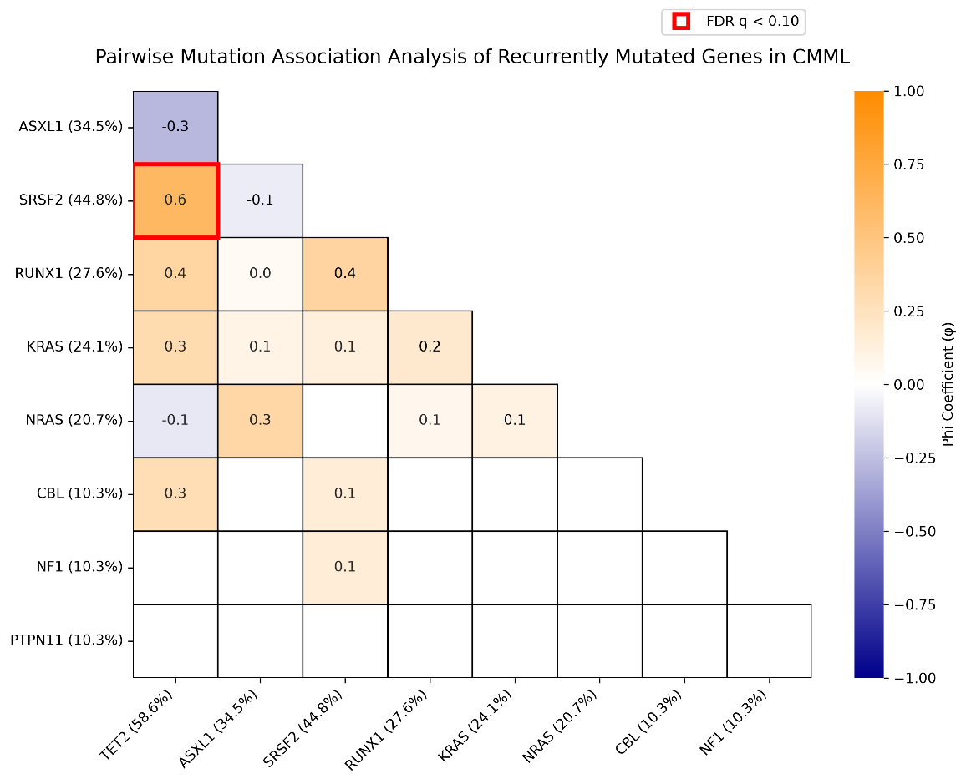

Supplementary Fig. S1. Pairwise mutation association analysis of recurrently mutated genes in CMML. Heatmap showing pairwise associations among recurrently mutated genes in CMML using the Phi coefficient (φ). Positive values indicate co-occurrence and negative values indicate mutual exclusivity. Gene mutation frequencies are shown in parentheses along the axes. The color scale represents the magnitude and direction of association, ranging from mutual exclusivity (blue) to co-occurrence (orange). The red border indicates mutation pairs that met the predefined false discovery rate threshold for statistical significance (FDR q < 0.10).

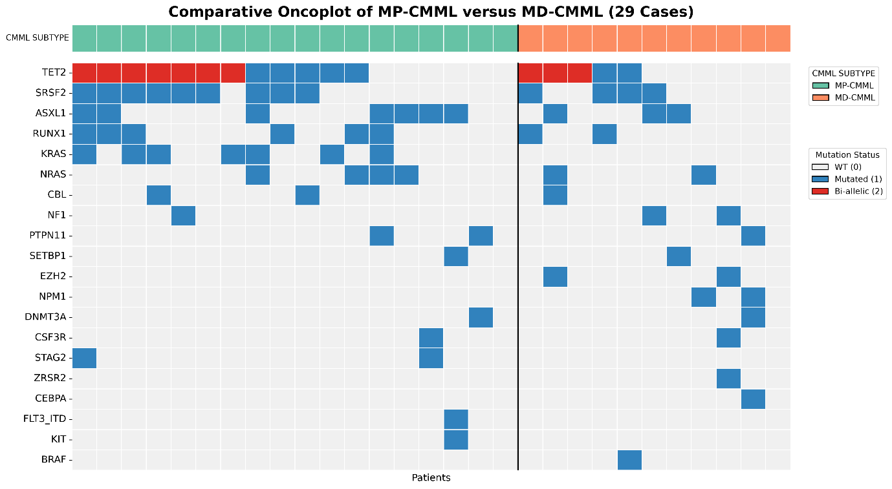Supplementary Fig. S2. Comparative oncoplot of recurrent molecular alterations in MP-CMML versus MD-CMML. Each column represents one patient, and each row represents a recurrently mutated gene. Cases are grouped according to leukocyte count-based CMML subtype, with the vertical black line separating MP-CMML and MD-CMML. The top annotation track indicates CMML subtype, while the lower tracks show recurrent gene mutations detected by targeted next-generation sequencing. TET2 alterations are annotated single-hit or putative bi-allelic/multi-hit. 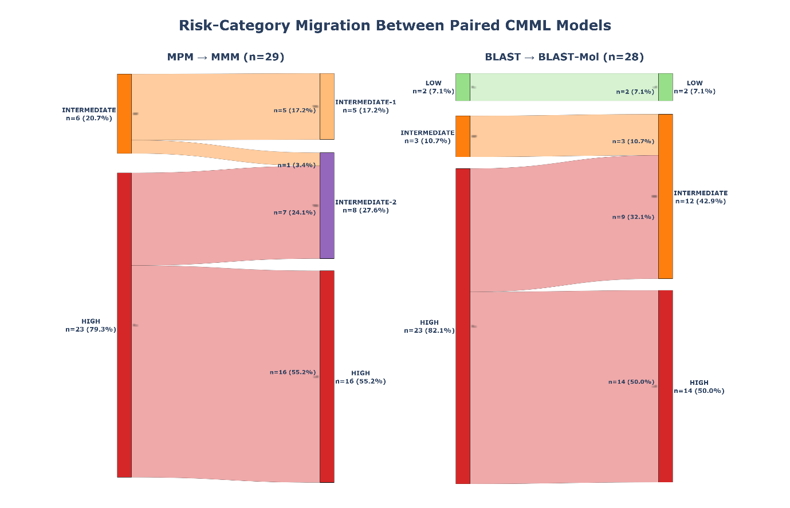Supplementary Fig. S3. Risk-category migration between paired CMML prognostic models.
Alluvial plots showing baseline risk-class redistribution from MPM to MMM (left) and from BLAST to BLAST-Mol (right). Each flow represents the number of patients migrating between risk categories, with percentages calculated among evaluable cases for each paired comparison.

