Supporting Information

Defined extracellular matrices uncover gravity-dependent switching in adhesion-migration behavior

Giulia Silvani^{1*}, Caitlin Williams¹, Nicolas Warburton², Kanwar A. Singh², Riddhesh B. Doshi², Yuzhu Liu², Martina Stenzel^{2,3}, Kate Poole⁴, Kristopher A. Kilian^{1,2,3*}

¹ School of Materials Science and Engineering, UNSW Sydney, Australia
² School of Chemistry, UNSW Sydney, Australia
³ Australian Centre for Nanomedicine (ACN), UNSW Sydney, Australia
⁴ School of Biomedical Sciences, UNSW Sydney, Australia
* Corresponding Authors: g.silvani@unsw.edu.au; k.kilian@unsw.edu.au

Supplementary Material fro this mauscript include the following:

Figs. S1 to S3

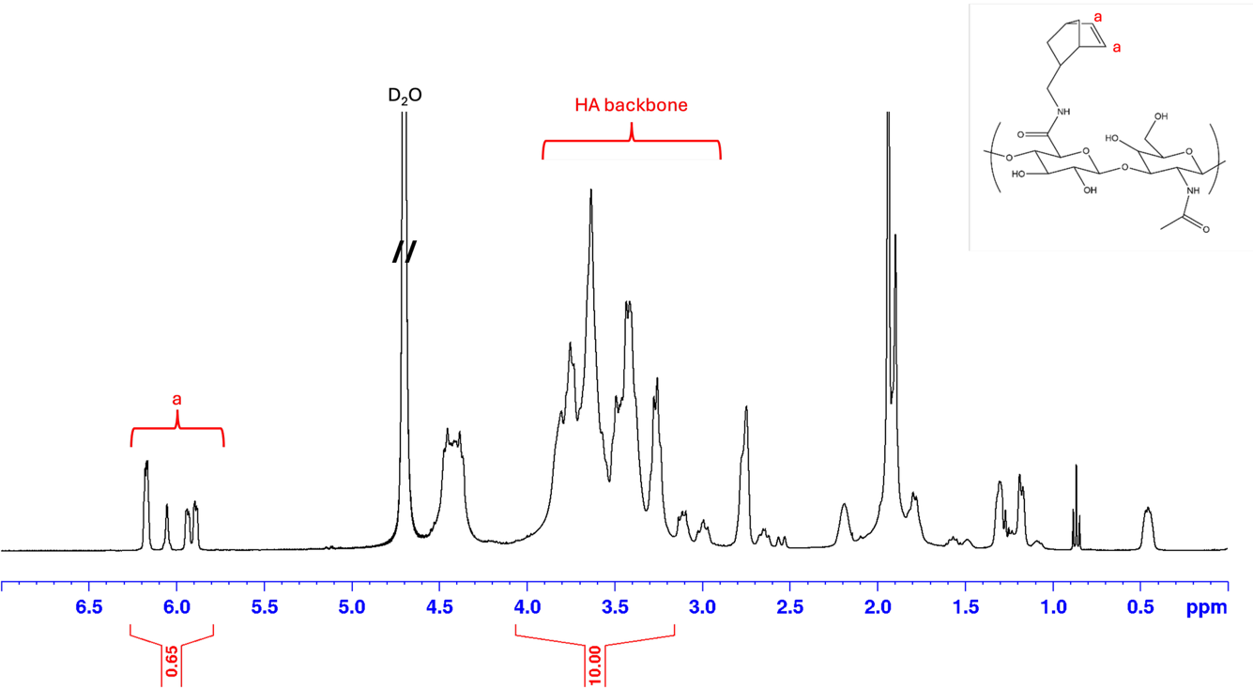

Fig. S1. Structural confirmation of norbornene-functionalized hyaluronic acid (NorHA) by ¹H NMR spectroscopy. Representative ¹H NMR spectrum of the modified polymer showing the characteristic resonances associated with norbornene functional groups alongside the native proton signals of the hyaluronic acid backbone. The appearance of distinct olefinic signals in the downfield region confirms successful incorporation of the norbornene moieties, while the broad multiplet region corresponds to protons from the polysaccharide backbone. The schematic structure of the modified repeat unit is shown for reference, illustrating the chemical modification of hyaluronic acid with norbornene groups.

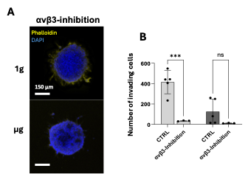

Fig. S2. αvβ3-integrin Inhibition does not restore glioblastoma invasion under simulated microgravity. (A) Representative fluorescence images of U87 spheroids cultured in adhesive, degradable NorHA matrices under normal gravity (1g) or simulated microgravity (µg) following αvβ3-integrin inhibition. F-actin is shown by phalloidin staining (yellow) and nuclei by DAPI (blue). Scale bar, 150 µm. (B) Quantification of invading cells under control and αvβ3-inhibited conditions. αvβ3 inhibition reduced invasion under 1g but did not significantly alter dissemination under simulated microgravity. Data are presented as mean ± SEM from at least 3 independent experiments.

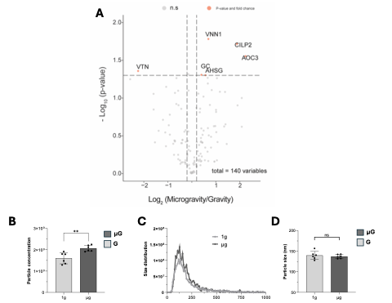

Fig. S3. Proteomic profiling reveals microgravity-associated changes in vesicle-related proteins. (A) Volcano plot showing differential protein abundance in conditioned media collected from GBM spheroids cultured under simulated microgravity compared with normal gravity conditions. The x-axis represents the log₂ fold change (microgravity/gravity), and the y-axis shows the –log₁₀(p-value). Dashed lines indicate statistical and fold-change thresholds used to identify differentially expressed proteins. Proteins significantly upregulated under simulated microgravity are highlighted in orange. (B) Quantification of extracellular vesicles (EVs) from spheroids cultured under simulated microgravity compared with normal gravity controls. (C) Size distribution of EVs showing no difference between the two groups. (D) Quantification of EVs size from spheroids cultured under simulated microgravity and normal gravity. Data are presented as mean ± S.D. from 6 independent experiments

