Solar-to-hydrogen peroxide conversion of photocatalytic carbon dots with anthraquinone: Unveiling the dual role of surface functionalities
Minsu Gu,^{1†} Do-Yeon Lee, ^{2†} Jinhong Mun,³ Dongseok Kim,¹ Hae-in Cho,² Geunsik Lee,³ Byeong-Su Kim,¹* and Hyoung-il Kim²*

¹Department of Chemistry and ¹Department of Civil & Environmental Engineering,
Yonsei University, 50 Yonsei-ro, Seoul 03722, Republic of Korea
³Department of Chemistry, Ulsan National Institute of Science and Technology (UNIST), 50 UNIST-gil, Ulsan 44919, Republic of Korea

†These authors contributed equally to this work.

E-mail: bskim19@yonsei.ac.kr (B.-S.K.); hi.kim@yonsei.ac.kr (H.-i.K.)

Table 1. Photocatalytic H₂O₂ formation yields by oxygen reduction reaction with carbon-based metal-free photocatalysts.
 | Catalyst | Light source | H₂O₂ yield  ( μmol g⁻¹ h⁻¹ ) | AQY (%) | AQY Wavelength (nm) | Ref.
1 | Carbon dots with Anthraquinone  (CD-AQ) | AM 1.5  (100 mW cm⁻²) | 2512 | 26.4 | 340 | This work
2 | Carbon dot (CD) | AM 1.5  (100 mW cm⁻²) | 333 | 2.82 | 340 | This work
3 | g-C₃N₄ | Xe lamp  ( λ > 420 nm ),  (light intensity at 420–500 nm: 26.9 W m^{–2}) | 125 | 23.0 | 330 | S1
4 | g-C₃N₄ / AQ-COOH | AM 1.5  (100 mW cm⁻²) | 361 | 19.5 | 380 | S2
5 | DCN-15A  (Holey defective g-C₃N₄) | AM 1.5  (λ > 420 nm) | 96.8 | 11.0 | 420 | S3
6 | OCN | Xe lamp  ( λ > 420 nm ),  35.2 mW cm⁻² | 2920 | 10.2 | 420 | S4
7 | g‐C₃N₄ / PDI‐BN_{0.2}‐rGO_{0.05} | Xe lamp  ( λ > 420 nm ),  (light intensity at 420–500 nm: 43.3 W m^{–2}) | 30.8 | 7.3 | 420 | S5
8 | g-C₃N₄ / PDI / rGO_{0.05} | Xe lamp  ( λ > 420 nm ),  (light intensity at 420–500 nm: 43.3 W m^{–2}) | 24.2 | 6.1 | 420 | S6
9 | R370-CN  (Reduced g-C₃N₄ prepared at 370 ℃) | Xe lamp  ( λ > 420 nm ) | 170.0 | 4.3 | 420 | S7
10 | PCNBA_{0.2}  (Polymetric carbon nitride prepared by using barbituric acid and melem as precursors) | Xe lamp  ( λ > 420 nm ),  (light intensity at 400–500 nm: 30.3 W m^{–2}) | 39.7 | 4.0 | 420 | S8
11 | PI_{5.0}-NCN  (Assembling perylene imides on g-C₃N₄ nanosheets) | Xe lamp  ( λ > 420 nm ),  560 mW cm⁻² | 1200.0 | 3.2 | > 420 | S9
12 | PEI / C₃N₄  (Polyethylenimine onto carbonitride) | AM 1.5  (100 mW cm⁻²) | 208.1 | 2.1 | 420 | S10

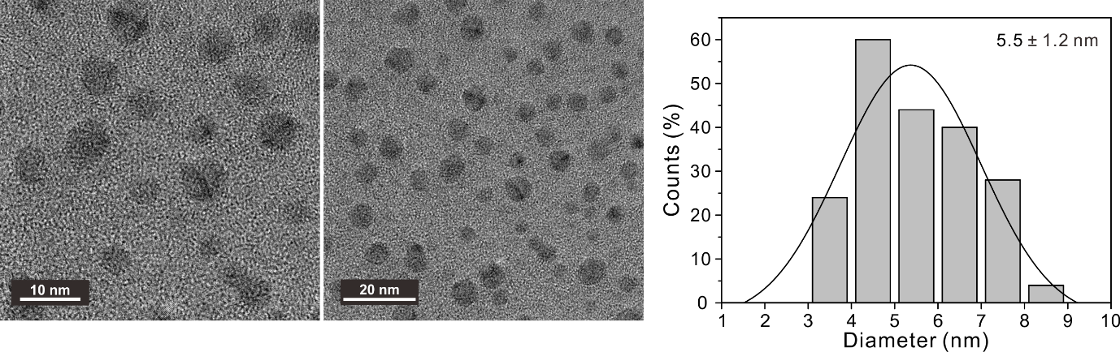
Fig. S1 TEM images of bare CDs with a corresponding size distribution histogram counted 100 samples.

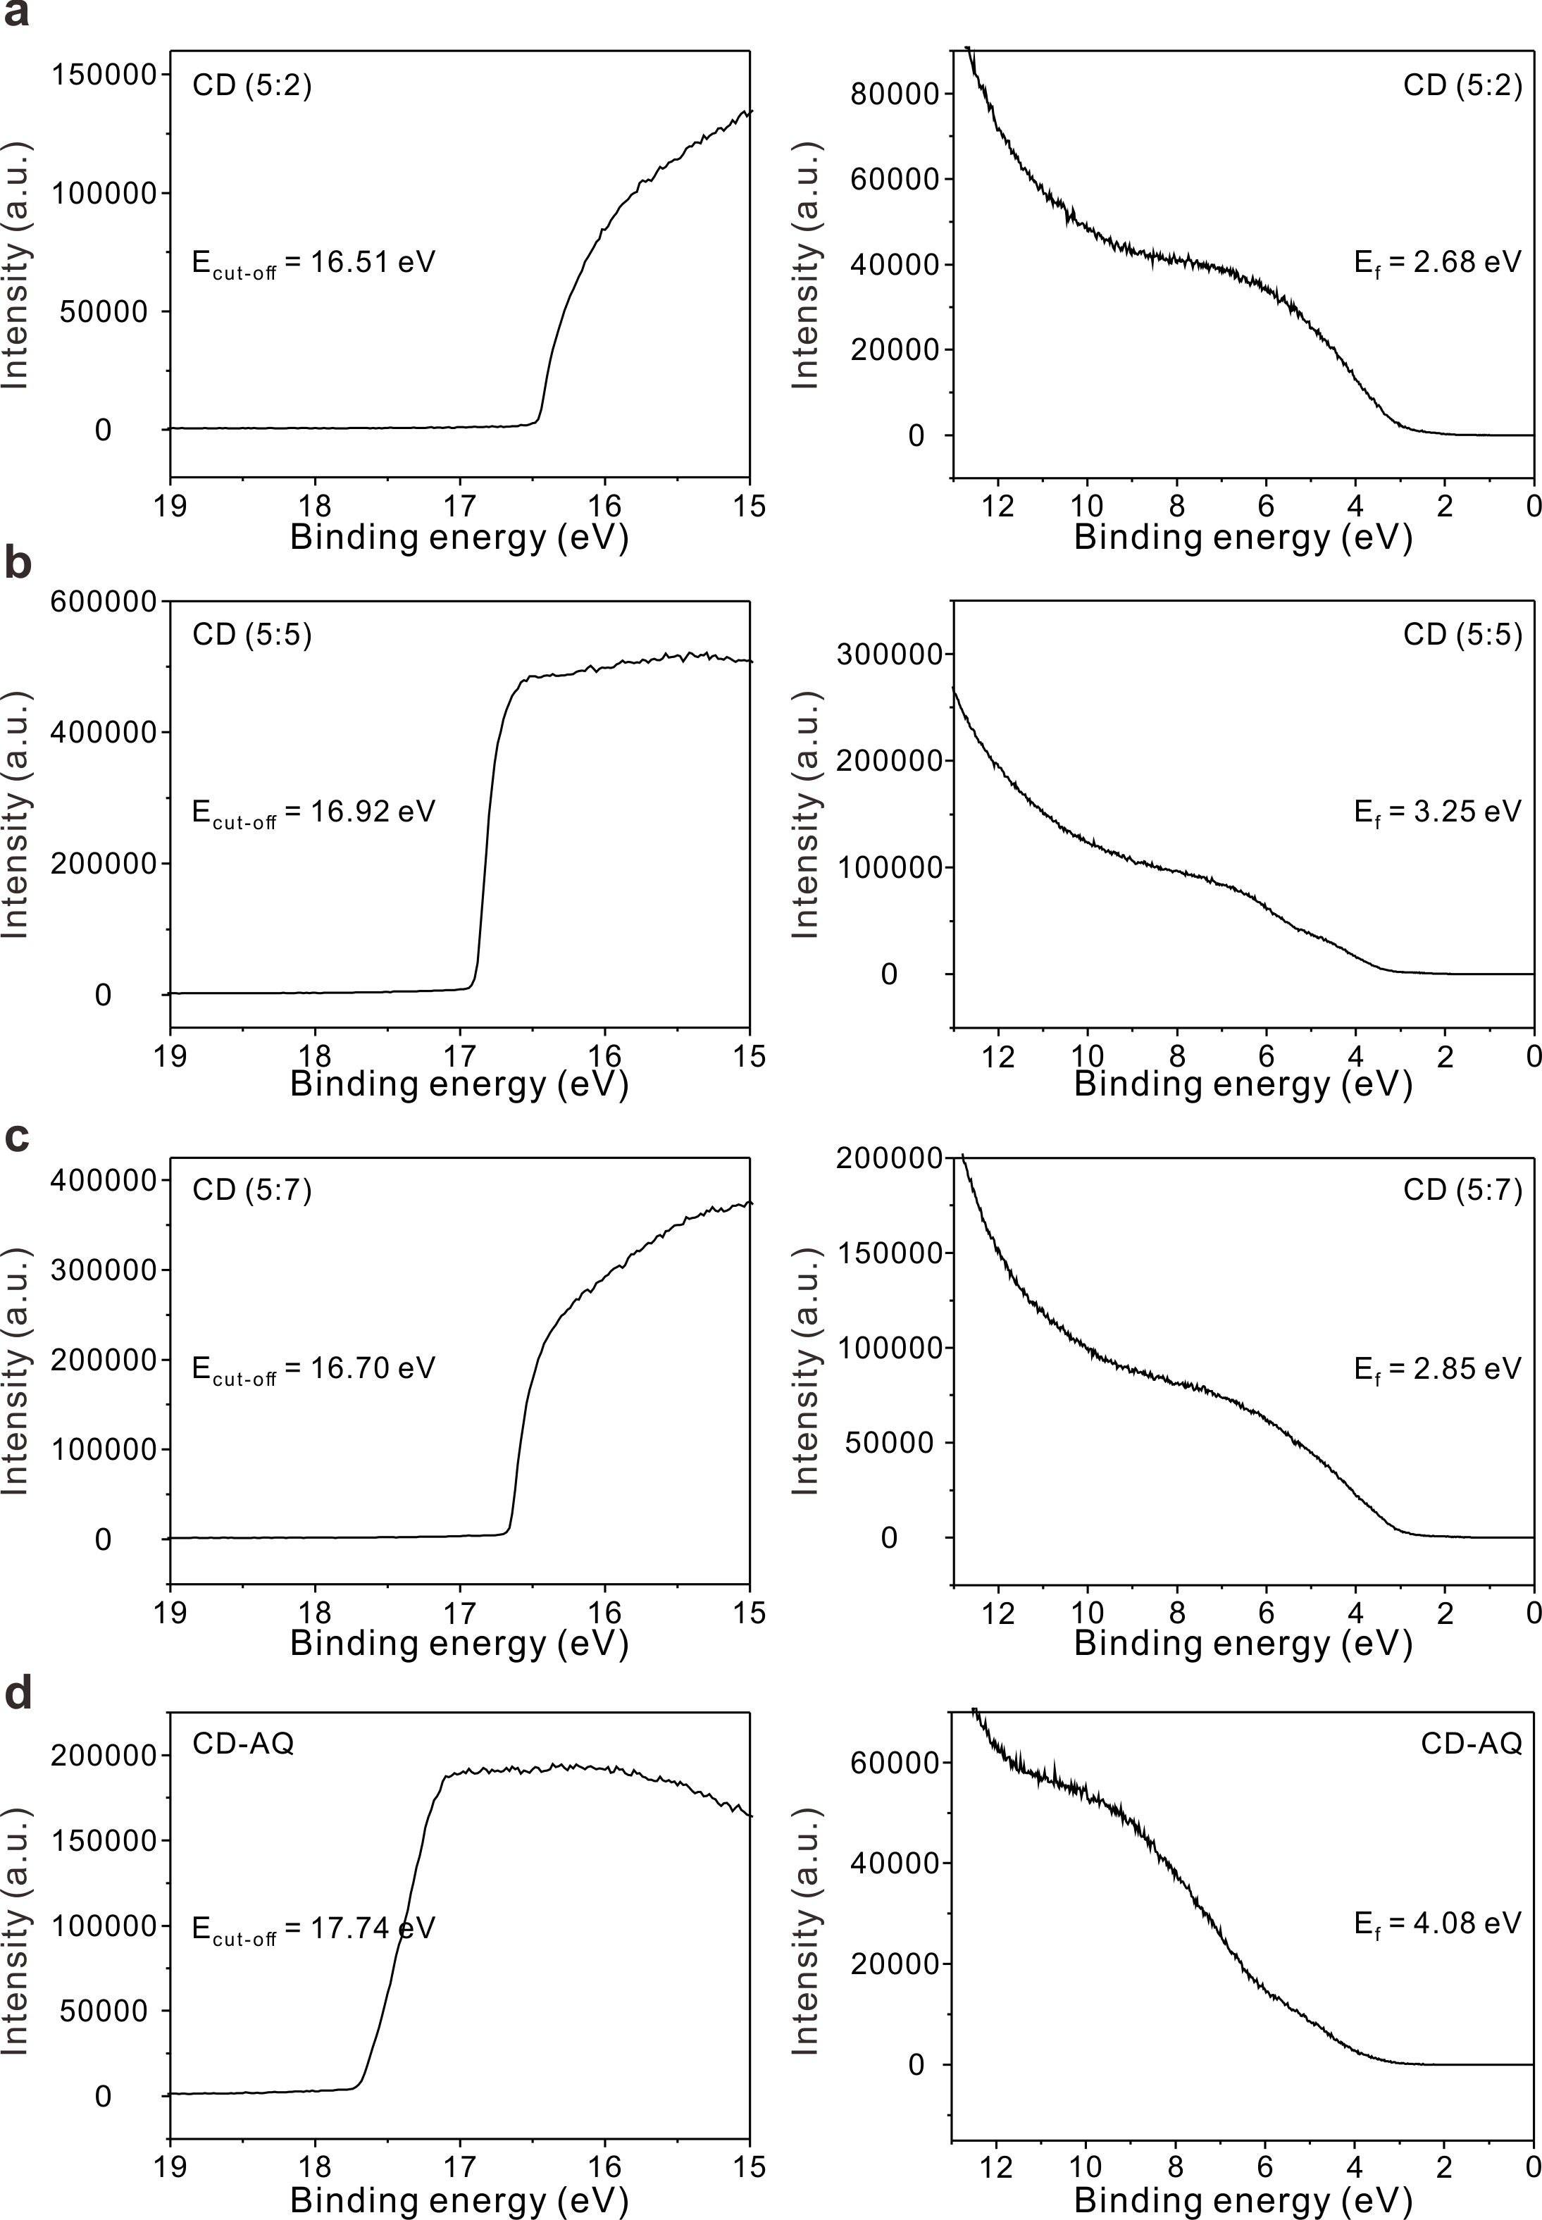
Fig. S2 High-resolution UPS spectra of (a–c) CDs with varying the molar ratio of (a) 5:2, (b) 5:5, (c) 5:7, and (d) CD-AQ.

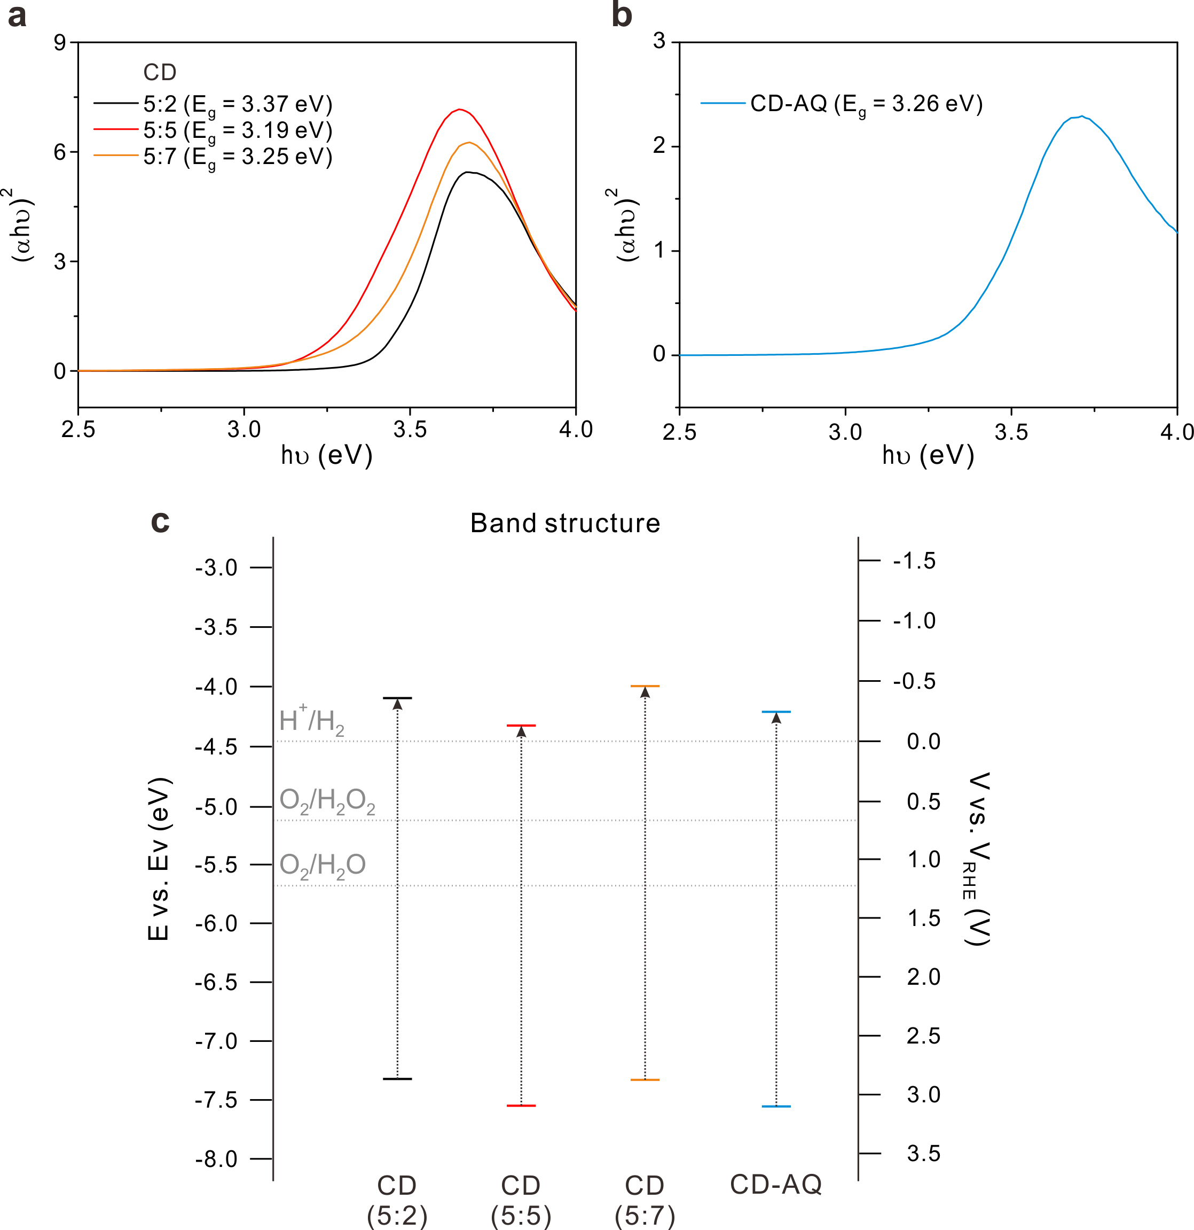
Fig. S3 (a-c) Tauc’s plots of (a) various CDs prepared in molar ratio of CA and EDA precursors and (b) CD-AQ to estimate their corresponding band gap energy (E_{g}). (c) Energy diagram of all CDs and CD-AQ.

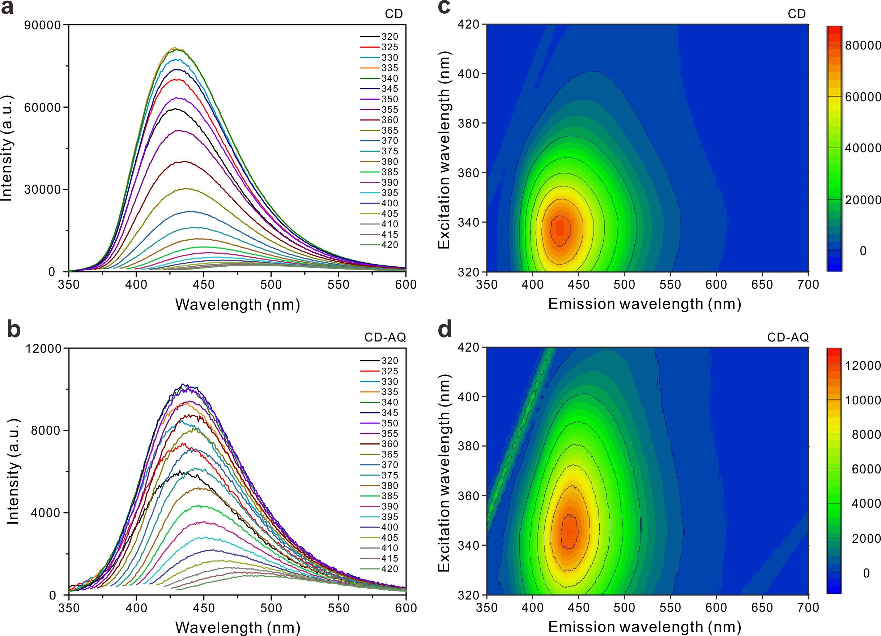
Fig. S4 (a-b) PL spectra as a function of excitation wavelength of (a) bare CD and (b) CD-AQ. (c-d) Excitation/emission contour plots of (c) bare CD and (d) CD-AQ.

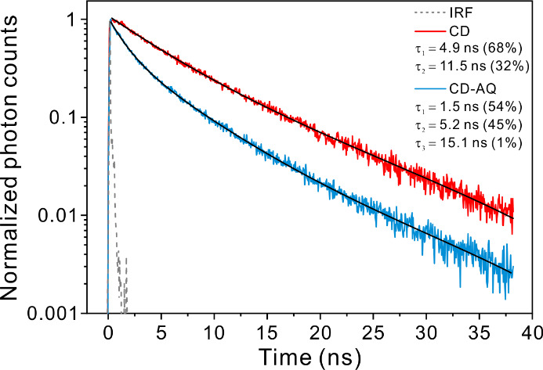
Fig. S5 PL decay profile from ensemble time-correlated single photon counting (TCSPC) measurements for CD and CD-AQ (λ_{ex} = 360 nm and λ_{em} = 450 nm).

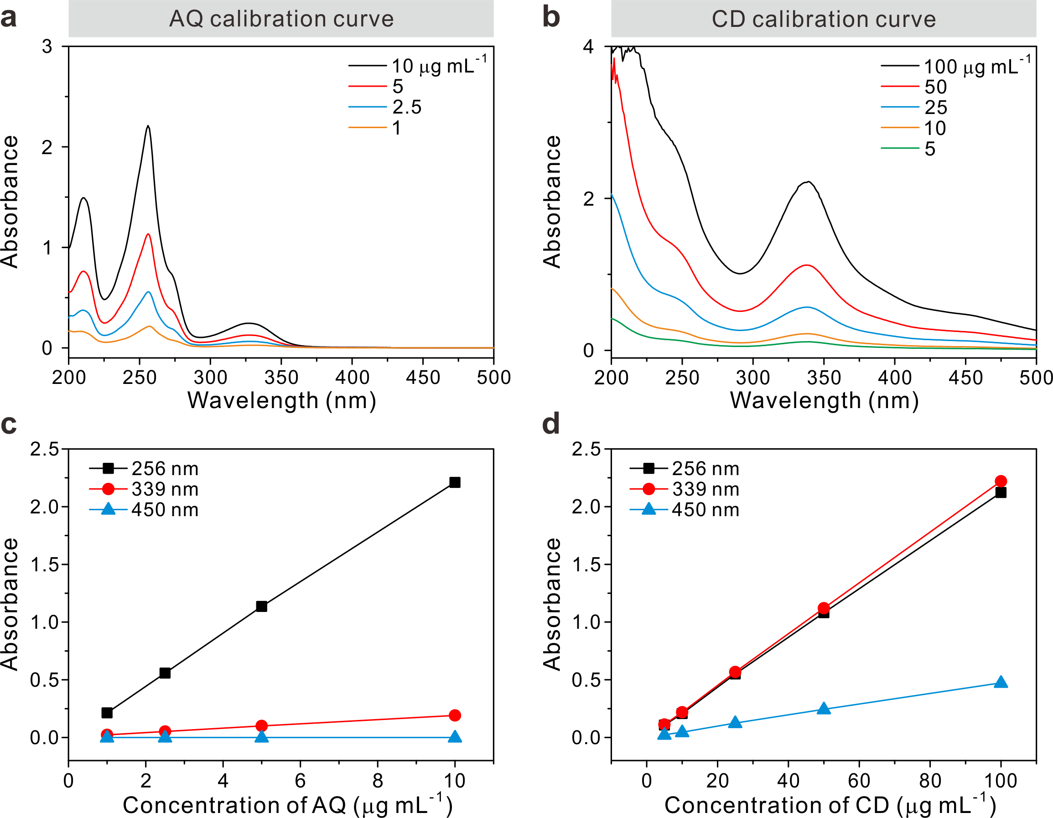
Fig. S6 (a-b) Calibration curves of (a) AQ and (b) CD using UV/vis spectra. (c-d) The corresponding absorbance maxima of (c) AQ and (d) CD at 256, 339, and 450 nm.

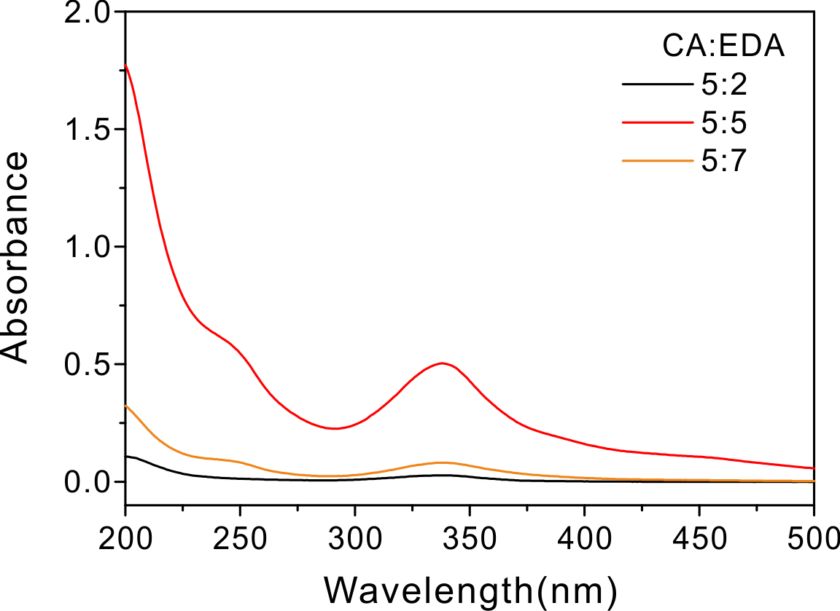
Fig. S7 UV/vis spectra of various CDs prepared in different ratios of CA and EDA precursors. The concentration of all CDs is fixed to 0.032 mg L⁻¹.

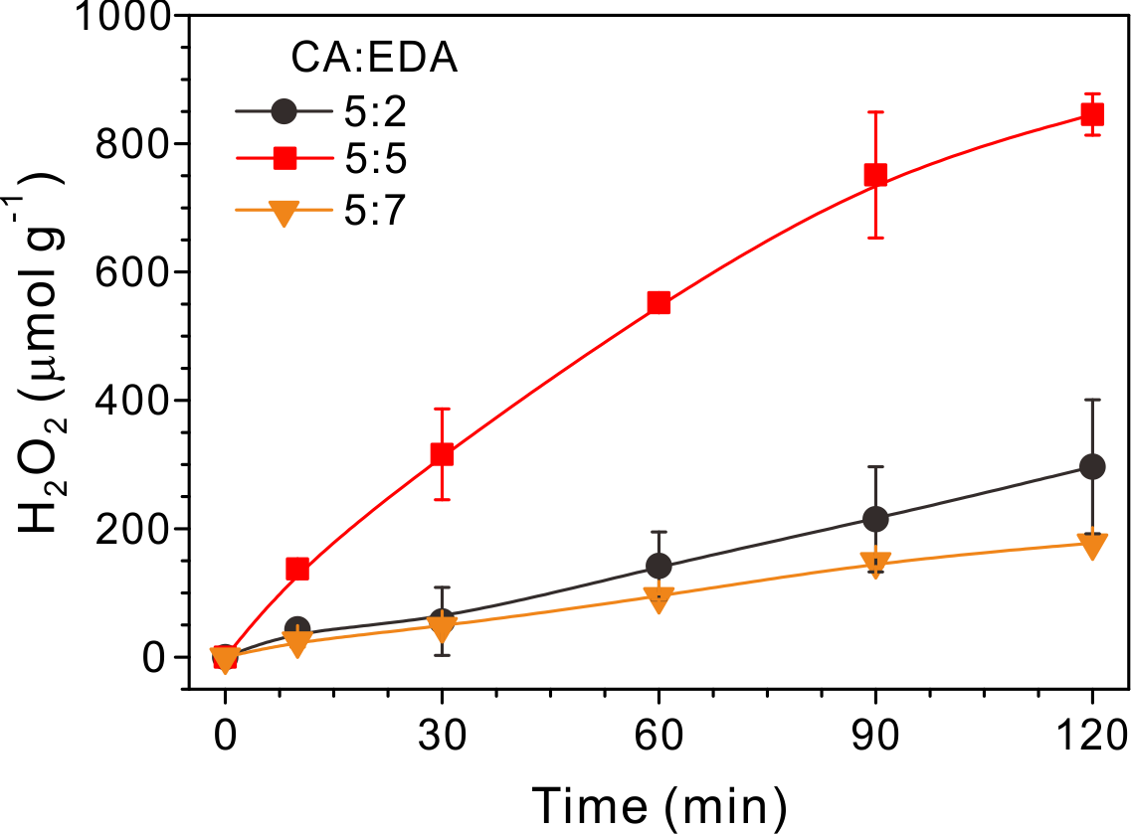
Fig. S8 Time-dependent profiles of H₂O₂ production on various CDs prepared in different ratios of CA and EDA precursors.

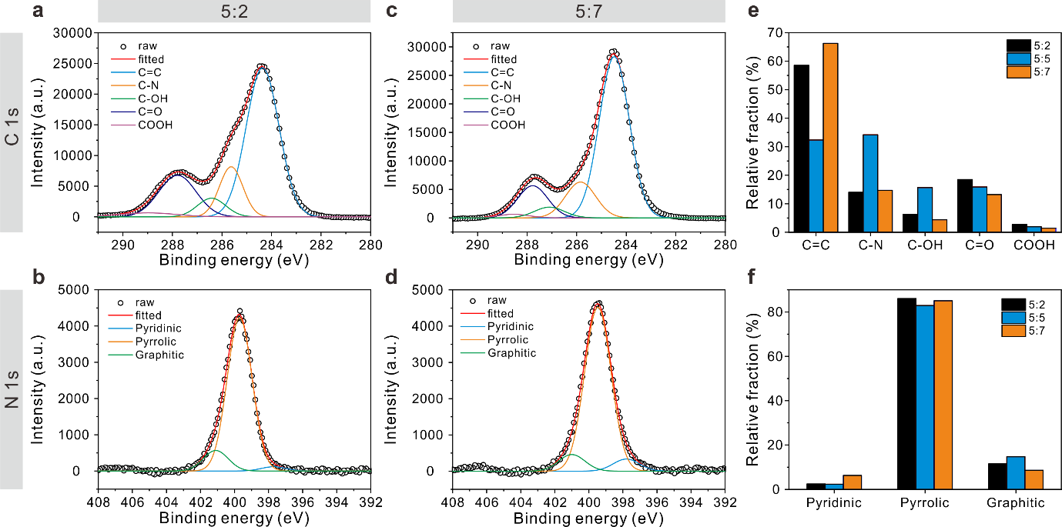
Fig. S9 Deconvoluted high-resolution XPS spectra of (a, c) C 1s and (b, d) N 1s for 5:2 and 5:7 CDs prepared in different molar ratios of CA and EDA precursors. The relative fraction in the chemical compositions of (e) C 1s and (f) N 1s for varying CDs (5:2, 5:5, and 5:7 of CA:EDA).

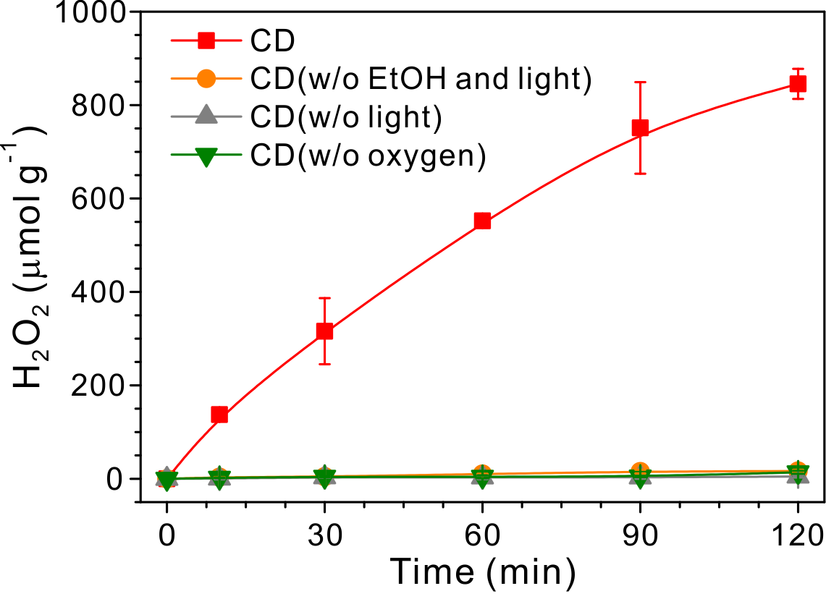
Fig. S10 Time-dependent profiles of H₂O₂ production by CD under various reaction conditions. Each experimental condition was under (red) O₂-saturated with 10 vol% of ethanol with light irradiation, (orange) O₂-saturated without ethanol and light irradiation, (gray) O₂-saturated with 10 vol% of ethanol without light irradiation, and (green) Ar-saturated with 10 vol% of ethanol with light irradiation.

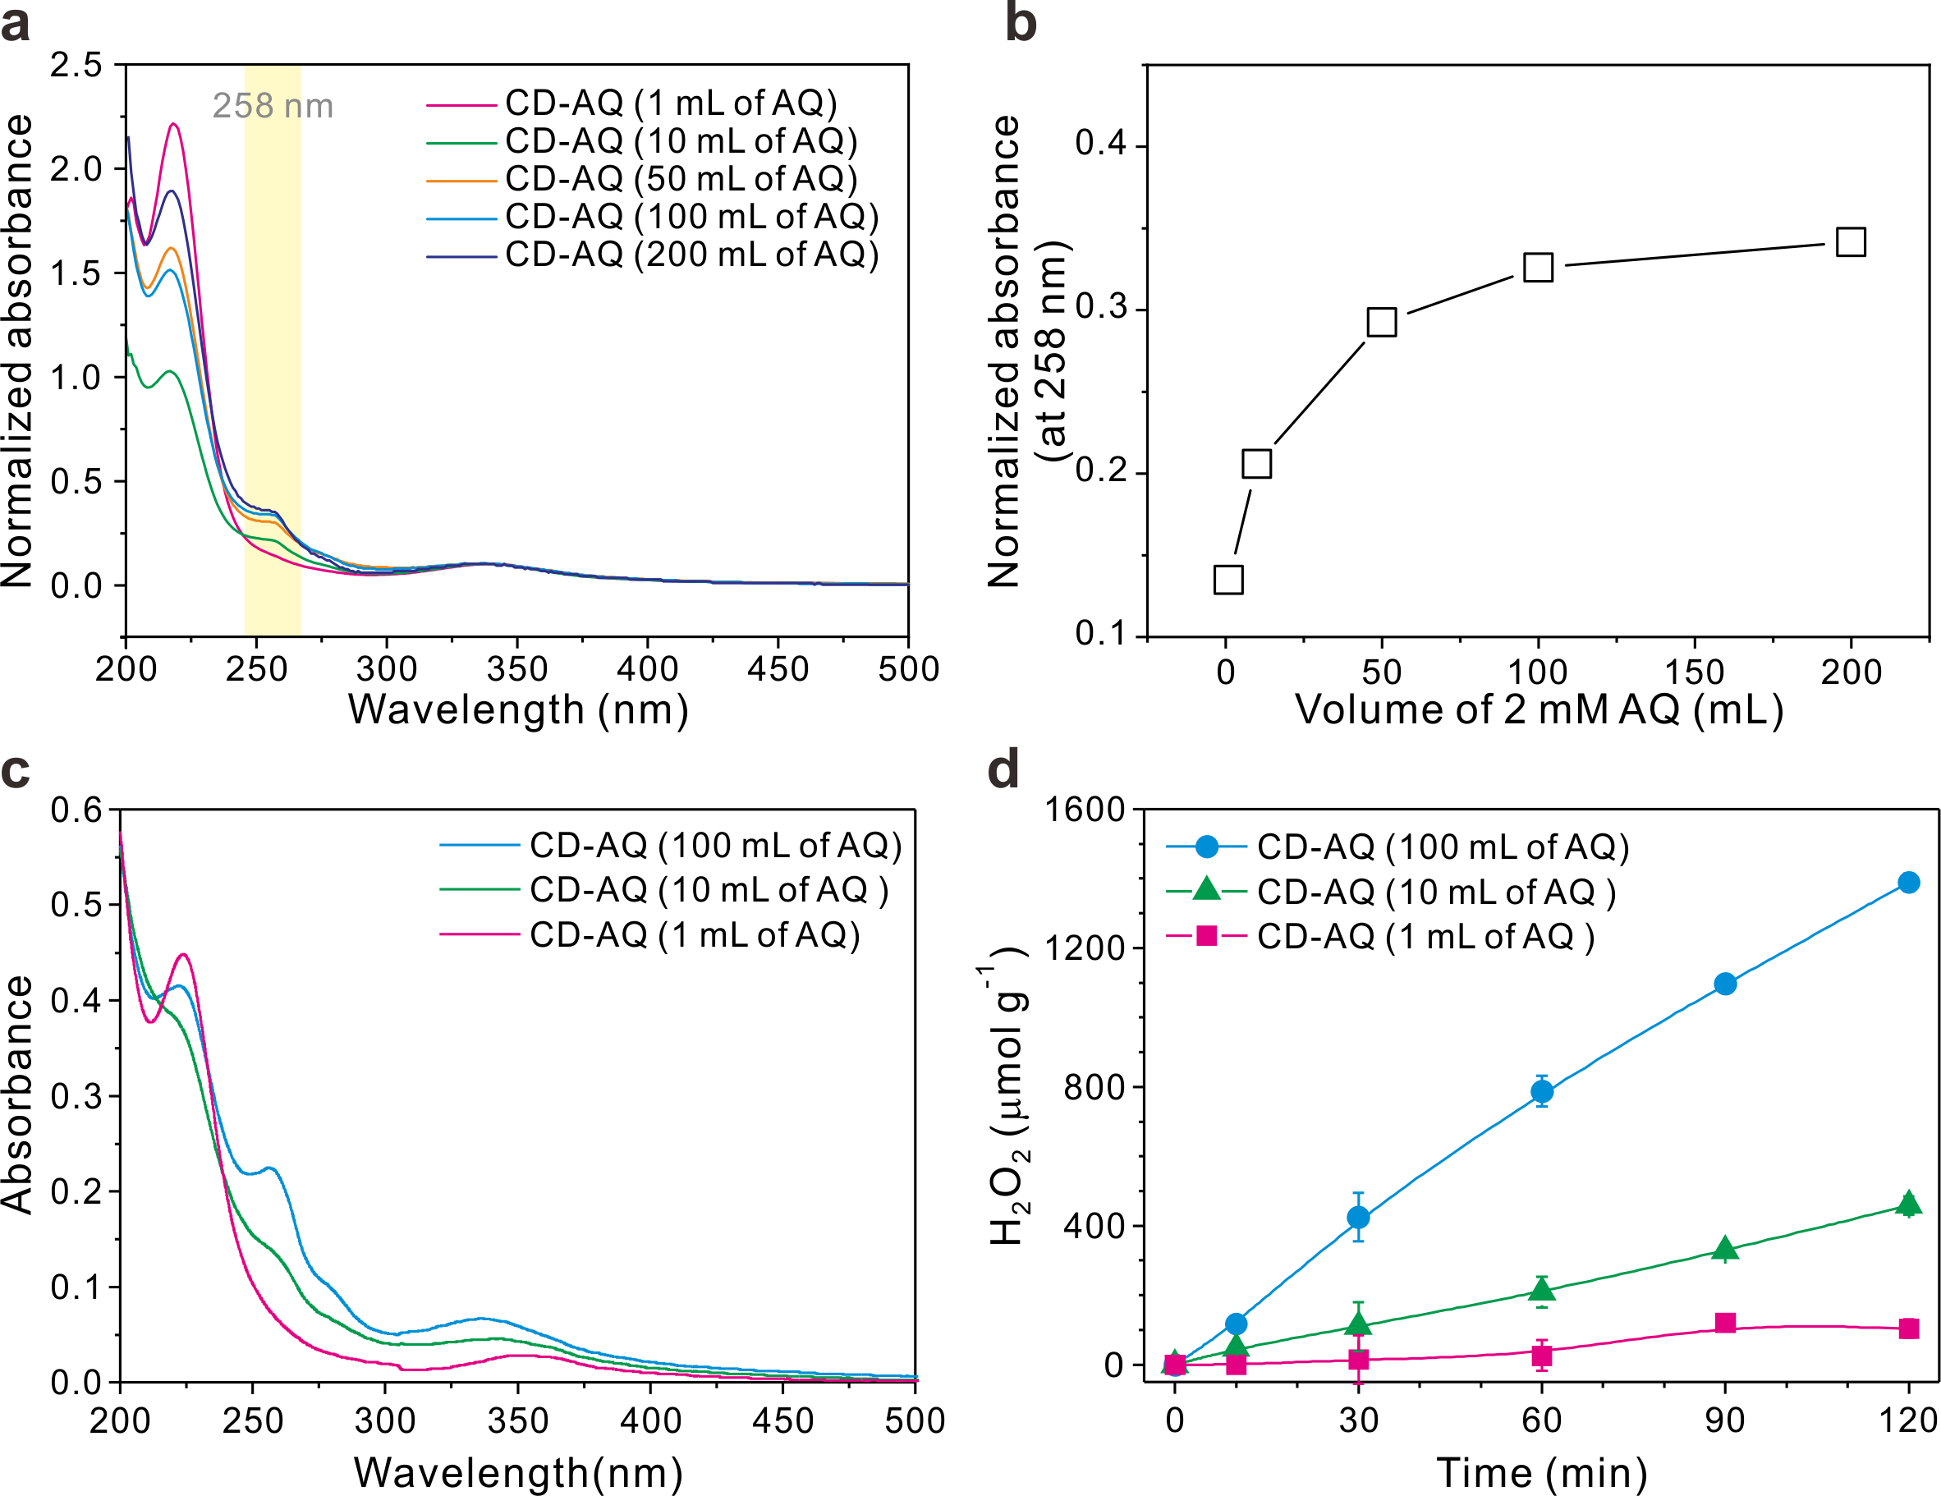
Fig. S11 (a) Normalized UV/vis spectra and (b) corresponding normalized absorbance at 258 nm of various CD-AQ nanohybrids prepared in different amounts of 2 mM AQ solution. (c) UV/vis spectra at a concentration of 12.7 mg L⁻¹ and (d) time-dependent H₂O₂ production of various CD-AQ nanohybrids prepared in different amounts of AQ. A concentration solution of AQ (2 mM) in varying volume was used to functionalize the CD surface under otherwise identical conditions. Excess free AQ molecules were removed through an extensive dialysis process. The experimental conditions were as follows: [catalyst] = 0.07 g L⁻¹, pHi = 6, 100 mW cm⁻² (AM 1.5), [EtOH]₀ = 10 vol% (as an electron donor), and O₂-saturated.

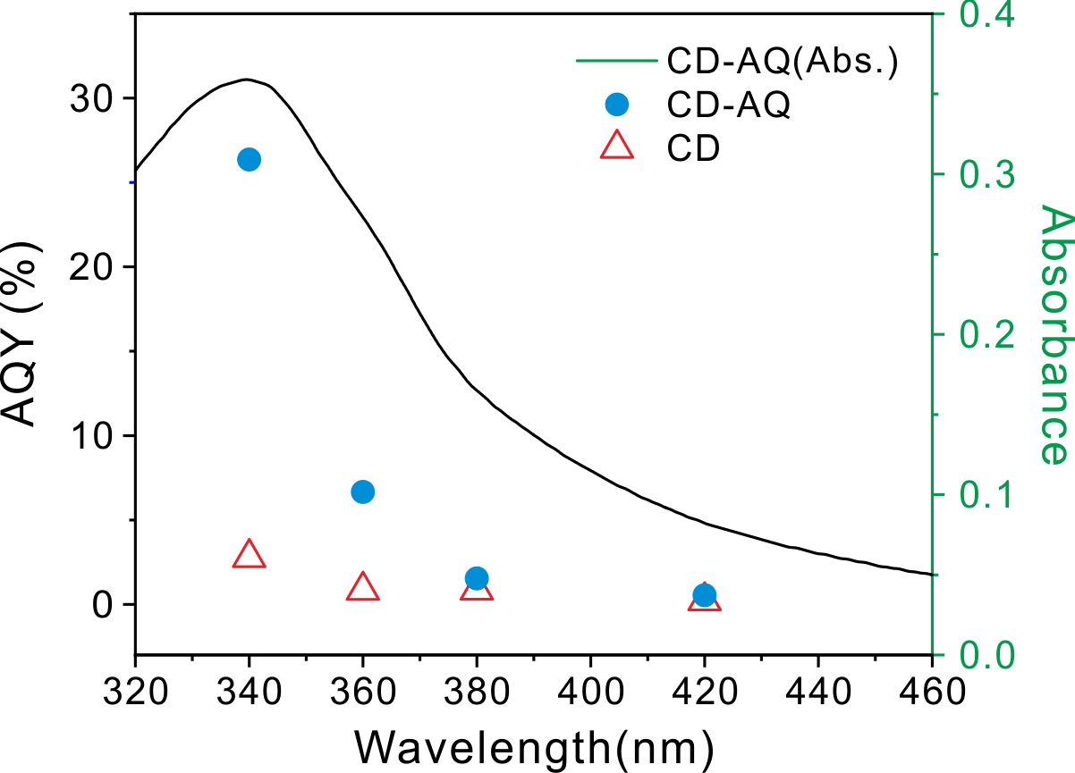
Fig. S12 Absorption spectrum (black) and apparent quantum yield (AQY, blue) of the photocatalytic H₂O₂ production as a function of wavelength on CD and CD-AQ. The experimental conditions were as follows: [catalyst] = 0.176 g L⁻¹, [EtOH]₀ = 10 vol%, and O₂-saturated.

AQY was obtained by illuminating the suspension of CD and CD-AQ while collecting the H₂O₂ produced in the presence of ethanol electron donor with monochromated light (λ = 340, 360, 380, and 420 nm).
$$AQY \left(\%\right)=\frac{[H_{2}O_{2} formed]×2}{[photon number entered into the reactor]}×100$$

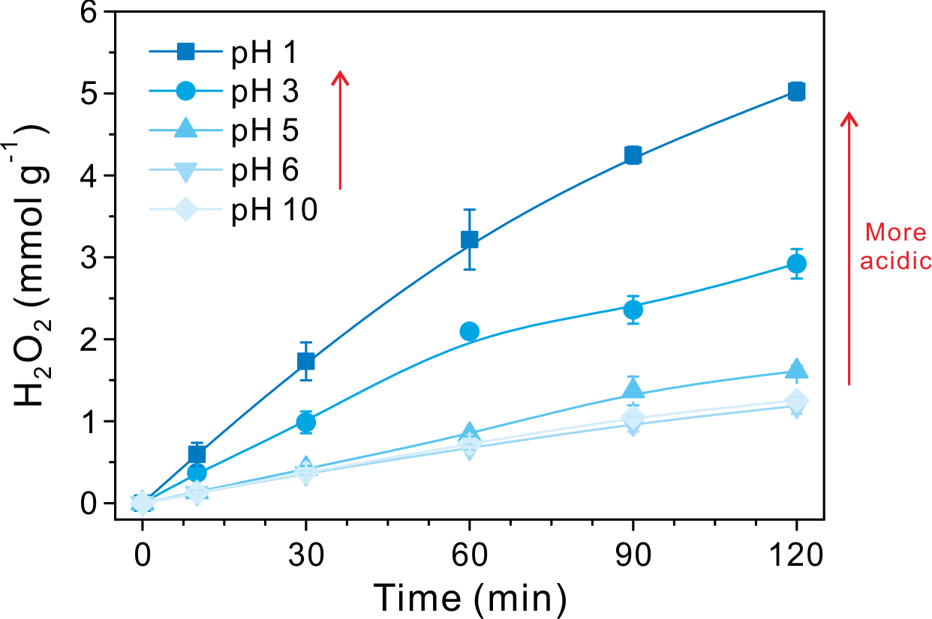
Fig. S13 Time-dependent profiles of H₂O₂ production by CD-AQ at various pH conditions.

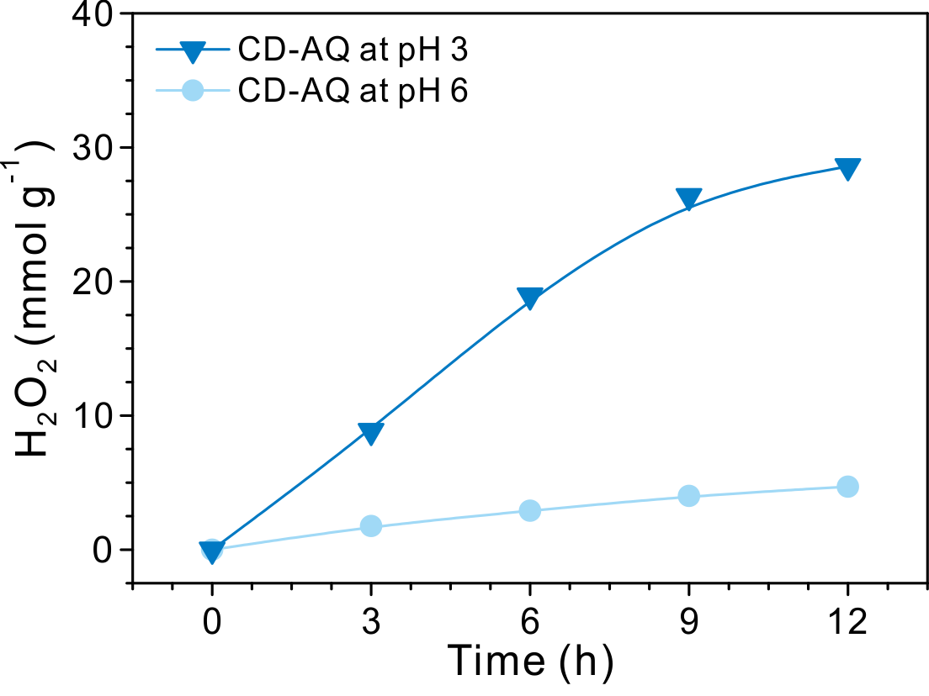
Fig. S14 Long-term performance in the production of H₂O₂ by CD-AQ under pH 3 and 6 for 12 h reaction. The experimental conditions were as follows: [catalyst] = 0.3 g L⁻¹, [EtOH]₀ = 20 vol%, 100 mW cm⁻² (AM 1.5), and temperature = 4 °C.

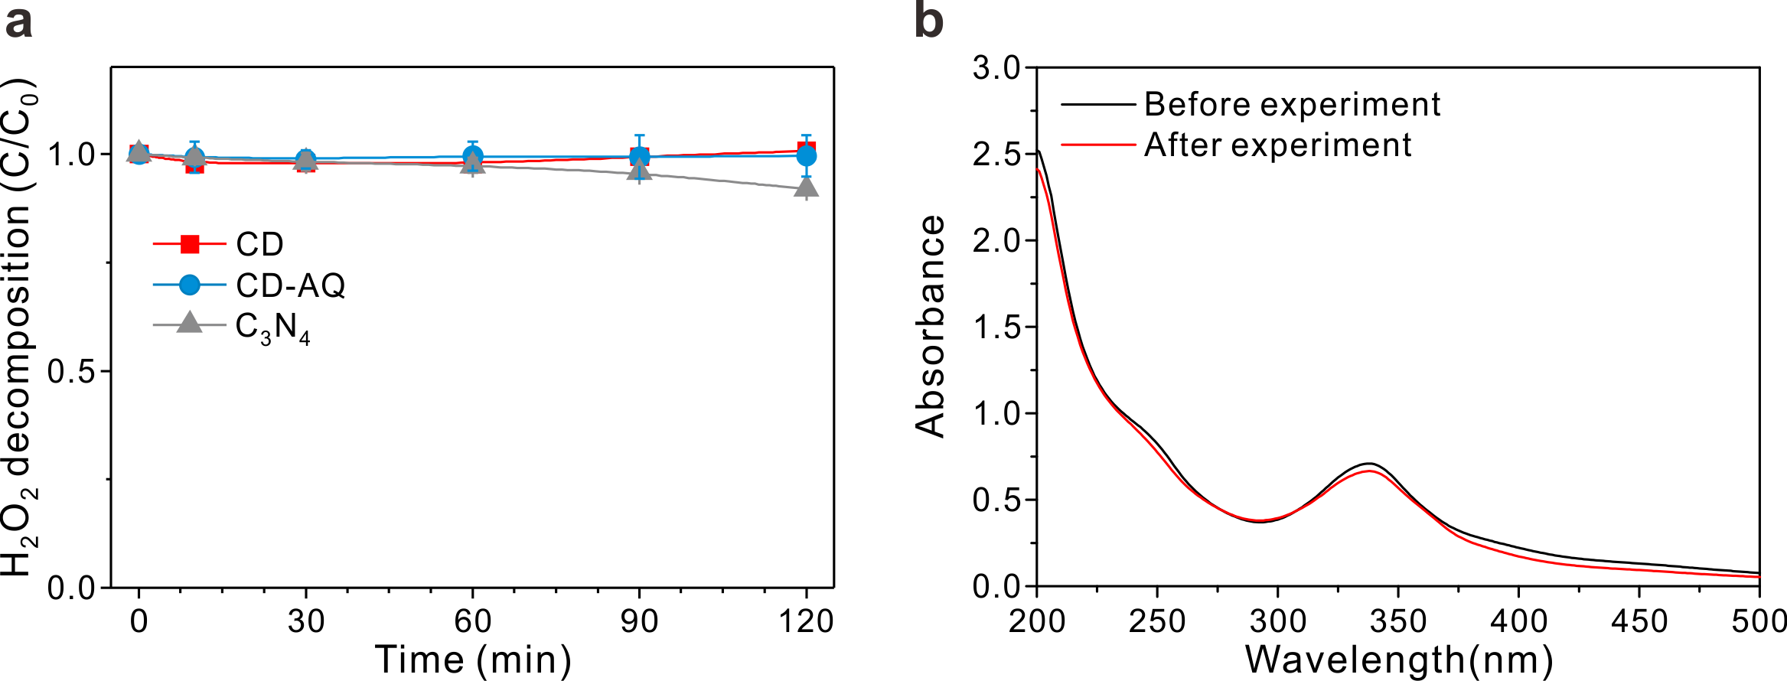
Fig. S15 (a) Photocatalytic H₂O₂ decomposition by CD, CD-AQ, and C₃N₄ at an initial concentration of 1.0 mM H₂O₂. (b) UV/vis spectra of CD with 10 vol% ethanol before and after light irradiation for 2 h.

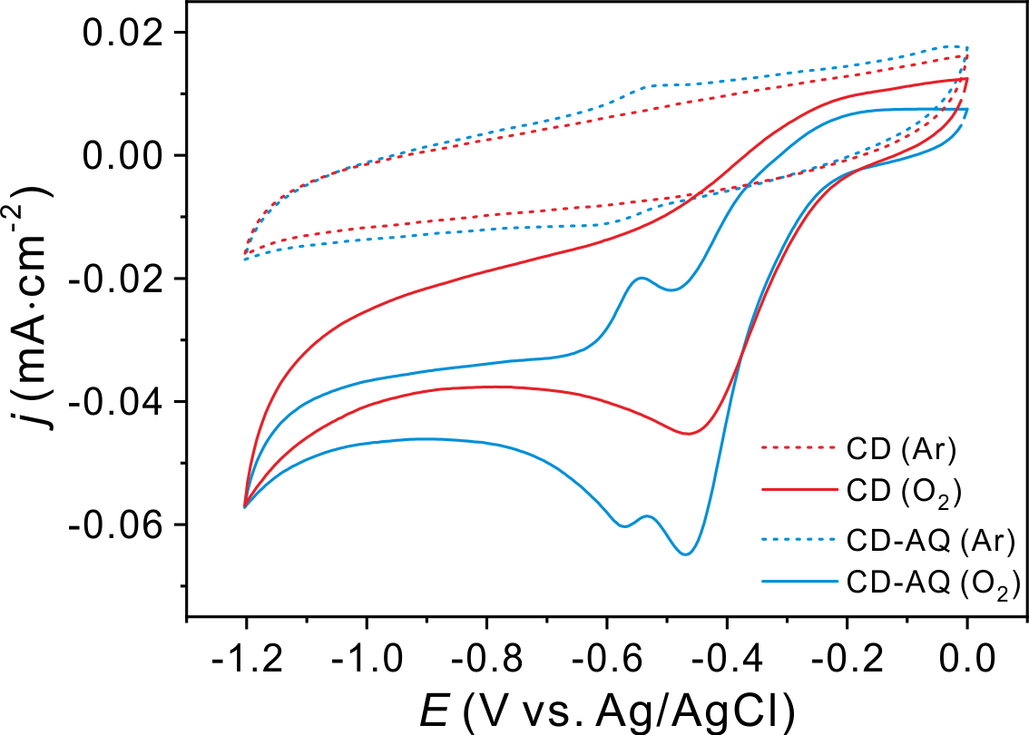
Fig. S16 Cyclic voltammetry of CD and CD-AQ. Inset shows a magnified CV of CD. All measurements were performed in an Ar- or O₂-saturated 0.10 M KOH solution at a scan rate of 10 mV s⁻¹.

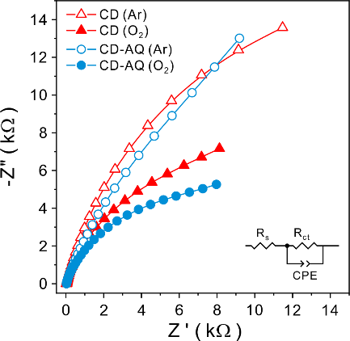
Fig. S17 Nyquist plots of impedance on CD and CD-AQ in an Ar or O₂-saturated dark condition. Inset represents an equivalent circuit. Experimental condition: 1.0 M NaHCO₃ electrolyte was used at pH 7.8 and potential was applied at -0.35 V (vs. Ag/AgCl) in frequency range from 0.1 mHz to 0.5 Hz.

Table 2. Summary of electrochemical impedance values of CD and CD-AQ.
 | R_{s} (Ω) | R_{ct} (kΩ) | Q
 | R_{s} (Ω) | R_{ct} (kΩ) | Y₀  (μMho*s^N) | N
CD (Ar) | 34.316 | 38.345 | 16.7 | 0.852
CD (O₂) | 33.294 | 15.629 | 18.4 | 0.845
CD-AQ (Ar) | 31.205 | 37.245 | 17.7 | 0.812
CD-AQ (O₂) | 31.962 | 11.824 | 16.7 | 0.812
where R_{s} is solution resistance, R_{ct} is charge transfer resistance, Y₀ is base admittance and N is frequency exponent.

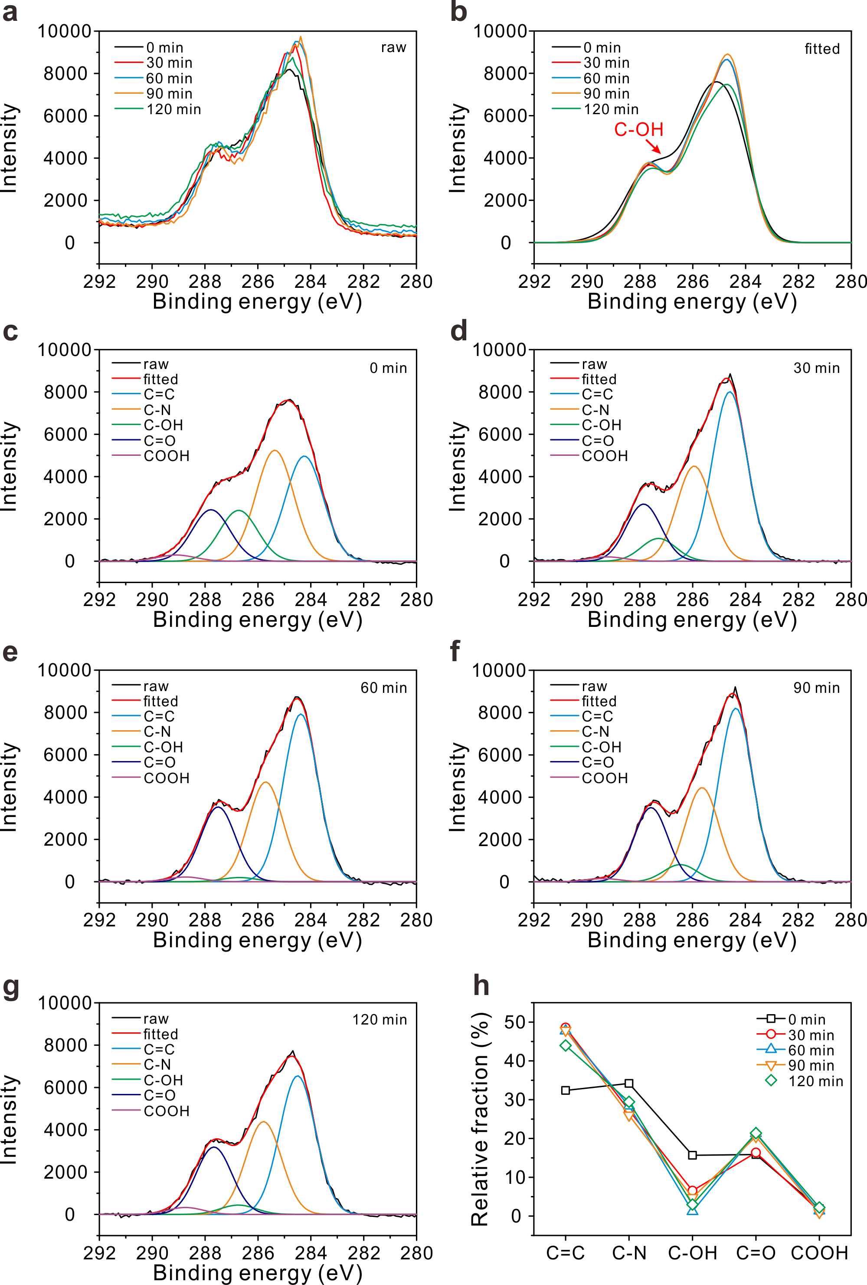
Fig. S18. (a) High-resolution XPS spectra and (b) fitted spectra of the C 1s peak of CD during the progress of the reaction. (c-g) Deconvoluted high-resolution XPS spectra of the C 1s peak of CD at (c) 0 min, (d) 30 min, (e) 60 min, (f) 90 min, and (g) 120 min with the sample used in Fig. 3d. (h) The changes in the chemical compositions of CD during the progress of the photochemical reactions.
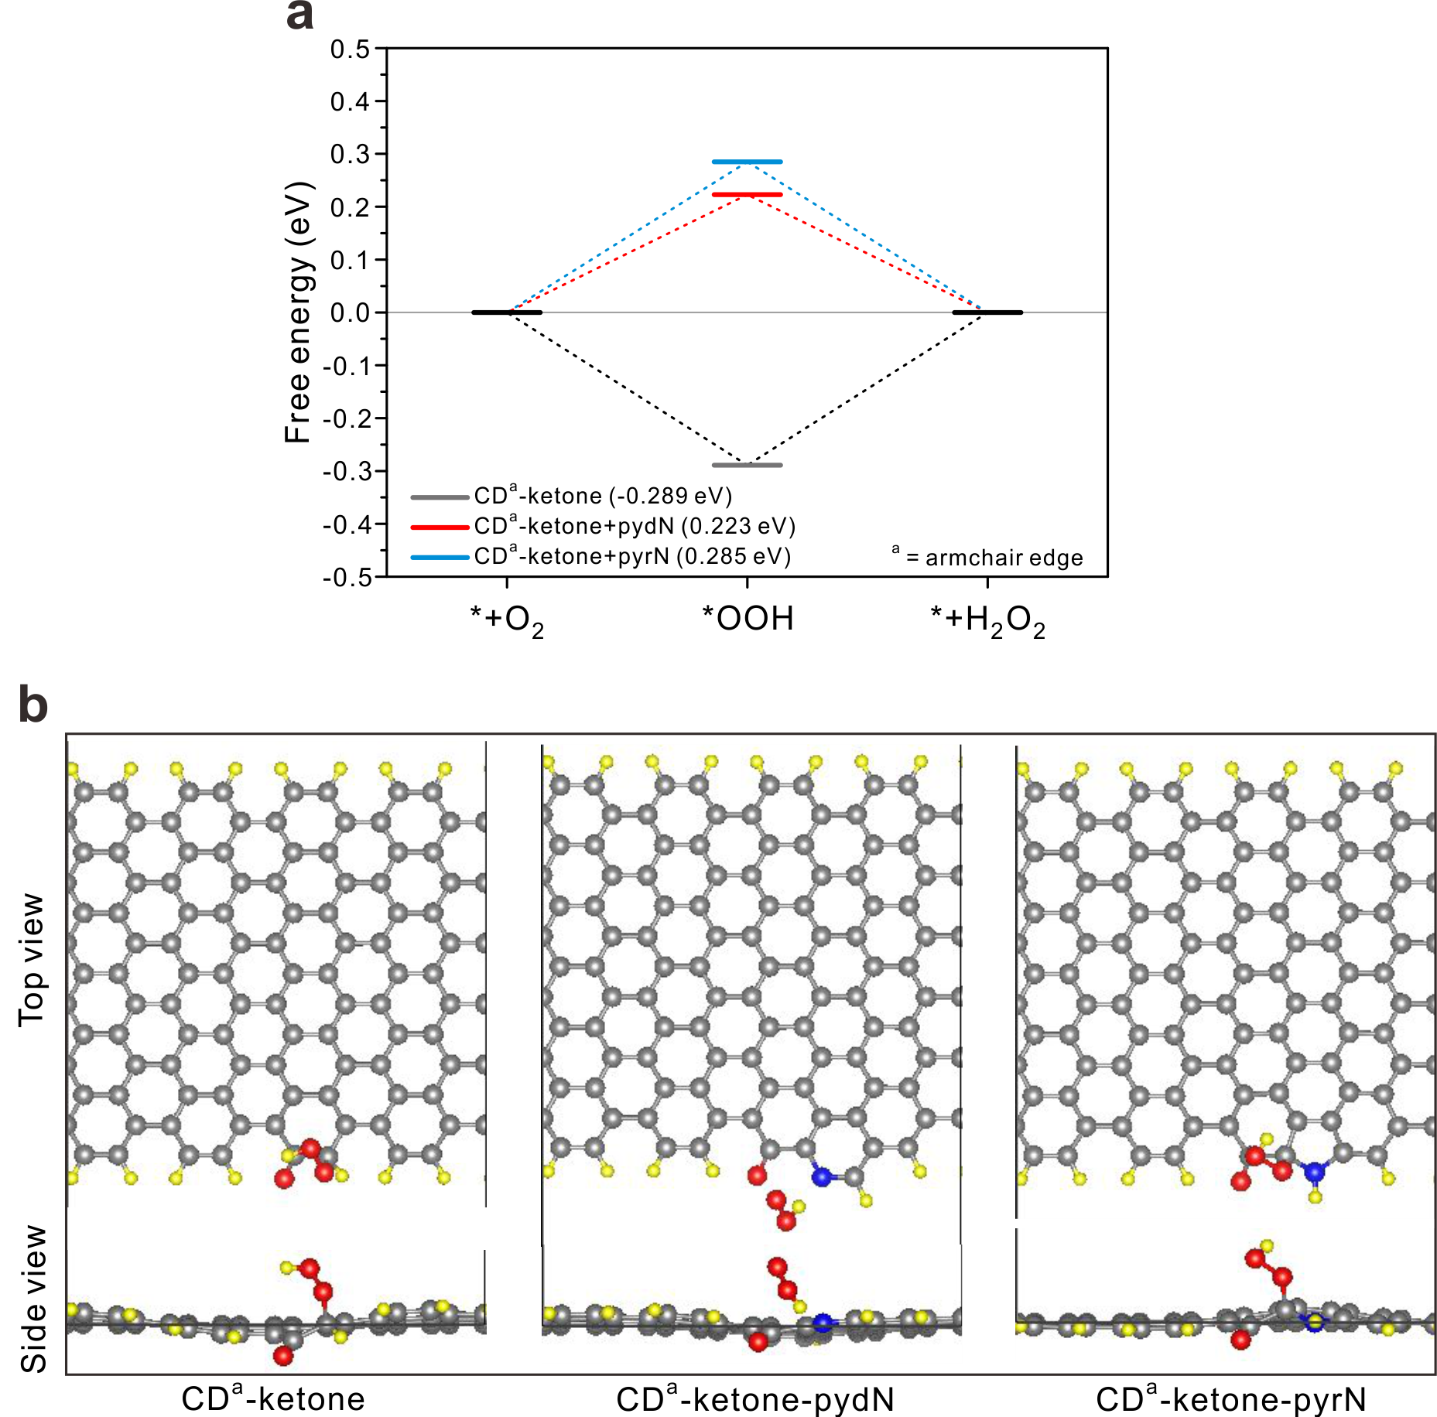
Fig. S19 (a) Free-energy diagram for two-electron ORR and (b) the atomic structures of the examined oxygen (ketone) and nitrogen (pyridinic-N (pydN) and pyrrolic-N (pyrN)) functional groups (carbon (gray), oxygen (red), nitrogen (blue), and hydrogen (yellow)) of CDª-ketone, CDª-ketone-pydN, and CDª-ketone-pyrN. a denotes the armchair edges of CD.

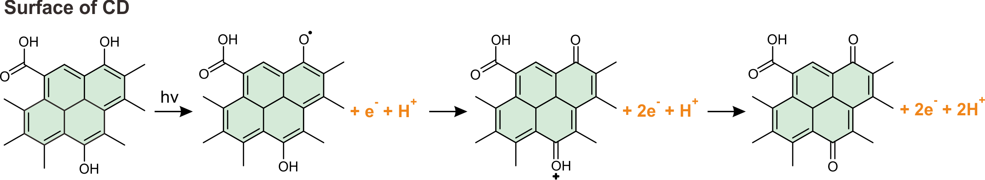
Fig. S20 Proposed chemical mechanism involving the surface oxygen functional groups of carbon dots (CDs) as electron and proton donors upon photoexcitation.

Reference
S1. Shiraishi, Y. et al. Highly selective production of hydrogen peroxide on graphitic carbon nitride (g-C₃N₄) photocatalyst activated by visible light. ACS Catal. 4, 774-780 (2014).
S2. Kim, H.-i., Choi, Y., Hu, S., Choi, W. & Kim, J.-H. Photocatalytic hydrogen peroxide production by anthraquinone-augmented polymeric carbon nitride. Appl. Catal. B-Environ. 229, 121-129 (2018).
S3. Shi, L. et al. Photoassisted construction of holey defective g-C₃N₄ photocatalysts for efficient visible-light-driven H₂O₂ production. Small 14, 1703142 (2018).
S4. Wei, Z. et al. Efficient visible-light-driven selective oxygen reduction to hydrogen peroxide by oxygen-enriched graphitic carbon nitride polymers. Energy Environ. Sci. 11, 2581-2589 (2018).
S5. Kofuji, Y. et al. Hydrogen peroxide production on a carbon nitride–boron nitride-reduced graphene oxide hybrid photocatalyst under visible light. ChemCatChem 10, 2070-2077 (2018).
S6. Kofuji, Y. et al. Carbon nitride–aromatic diimide–graphene nanohybrids: Metal-free photocatalysts for solar-to-hydrogen peroxide energy conversion with 0.2% efficiency. J. Am. Chem. Soc. 138, 10019-10025 (2016).
S7. Zhu, Z., Pan, H., Murugananthan, M., Gong, J. & Zhang, Y. Visible light-driven photocatalytically active g-C₃N₄ material for enhanced generation of H₂O₂. Appl. Catal. B-Environ. 232, 19-25 (2018).
S8. Teng, Z. et al. Bandgap engineering of polymetric carbon nitride copolymerized by 2,5,8-triamino-tri-s-triazine (melem) and barbituric acid for efficient nonsacrificial photocatalytic H₂O₂ production. Appl. Catal. B-Environ. 271, 118917 (2020).
S9. Yang, L. et al. Two-channel photocatalytic production of H₂O₂ over g-C₃N₄ nanosheets modified with perylene imides. J. Catal. 352, 274-281 (2017).
S10. Zeng, X. et al. Simultaneously tuning charge separation and oxygen reduction pathway on graphitic carbon nitride by polyethylenimine for boosted photocatalytic hydrogen peroxide production. ACS Catal. 10, 3697-3706 (2020).

