Supplementary information

Bypassing reductive dimerization of bottleneck PFAS intermediates via asymmetric advanced oxidation for absolute defluorination
Yanei Xueª, Wenjun Sun^{a,#}, Ted Maoª, Guoqing Jiang^{b}, Bing Zhang^{b}, Wenxin Shi^{b}, Madjid Mohseni^{c}

ª School of Environment
Tsinghua University
Beijing, 100084, China
E-mail: wsun@tsinghua.edu.cn

^{b} College of Environment and Ecology
Chongqing University
Chongqing, 400044, China

^{c} Department of Chemical and Biological Engineering
University of British Columbia
2360 East Mall, Vancouver
BC Canada V6T 1Z3

Content
Text 1 Detailed Information on Materials and Methods 3
Text 2 Data-Augmented and Literature-Informed Training Workflow 4
Text 3 Molecular structures of the 90 predicted PFAS 5
Table 1 The structure of PFAS and BDE (bond dissociation energy) of C–C bonds in PFAS molecule 8
PFOA 8
HFPO-DA 9
6:2 FTS 10
PFOS 11
Table 2 The performance of baseline models trained directly on the original 13 experimental samples 12
Figure 1 Time distributions of decay rate and the lnk_{G} of 13 PFASs under VUV system. 12
Figure 2 Time distributions of defluorination rate and the lnk_{F} of 13 PFASs under VUV system. 13
Figure 3 Identified representative transfer products (TPs) of 4 different PFAS under hydroxyl radical(HO•) quenching conditions in VUV irradiation system. 15
PFOS 15
PFOA 22
6:2FTS 27
HFPO-DA 32
Figure 3 Generative Variational Autoencoder (VAE) training performance and latent space distribution of experimental PFAS samples. 34
Figure 4 Heatmap of predicted reactivity metrics and quantum chemical descriptors across the expanded PFAS congener library. 35
Figure 5 Schematic diagram of the physical VUV system setup and cross-sectional view of the VUV reactor 37

Text 1 Detailed Information on Materials and Methods
The four PFCAs (PFPrA, PFHxA, PFOA, PFNA, PFHxA-An, PFHxA-Na ≥96%) and two PFECA (HFPO-DA and HFPO-TA, ≥96%) and 6:2 FTS (≥96%) were purchased from Macklin Reagent and ANPEL-TRACE Stard Technical Services Co., Ltd. (Shanghai, China). Three PFISA (LiTFSI, PFBS and PFOS) (≥96%), 4-Chlorobenzoic acid (pCBA, ≥99.0%) were obtained from Macklin Reagent Co., Ltd. Individual PFAS were dissolved in deionized water (produced by a Milli-Q system) as 10 mM stock solutions. All stock solutions were stored on benchtop at room temperature (20°C).

Text 2 Data-Augmented and Literature-Informed Training Workflow
The dataset comprised 13 experimental samples, 45 existing numerical descriptors, and 91 target PFAS congeners to be predicted. Ten random seeds were fixed a priori. In each iteration, 10 experimental samples were allocated for training, while the remaining 3 were strictly reserved as an independent test set. The VAE was exposed exclusively to the 10 training samples to generate 100 augmented samples, which were used solely during model training; test-set evaluation was consistently restricted to the 3 real samples. Model selection and hyperparameter optimization were conducted using an internal 5-fold cross-validation scheme.

Text 3 Molecular structures of the 90 predicted PFAS
TFA （CF3CO2H）
PFBA （CF3(CF2)2CO2H）
PFPeA （CF3(CF2)3CO2H）
PFHpA （CF3(CF2)5CO2H）
PFDA （CF3(CF2)8CO2H）
PFUnDA （CF3(CF2)9CO2H）
PFDoDA （CF3(CF2)10CO2H）
PFTrDA （CF3(CF2)11CO2H）
PFTeDA （CF3(CF2)12CO2H）
PFPeDA （CF3(CF2)13CO2H）
PFHxDA （CF3(CF2)14CO2H）
PFOcDA （CF3(CF2)16CO2H）
PFMS （CF3SO3H）
PFEtS （CF3CF2SO3H）
PFPrS （CF3(CF2)2SO3H）
PFPeS （CF3(CF2)4SO3H）
PFHpS （CF3(CF2)6SO3H）
PFNS （CF3(CF2)8SO3H）
PFDS （CF3(CF2)9SO3H）
PFUnDS （CF3(CF2)10SO3H）
PFDoS （CF3(CF2)11SO3H）
4:2 FTS （CF3(CF2)3(CH2)2SO3H）
8:2 FTS （CF3(CF2)7(CH2)2SO3H）
10:2 FTS （CF3(CF2)9(CH2)2SO3H）
12:2 FTS （CF3(CF2)11(CH2)2SO3H）
4:2 FTCA （CF3(CF2)3CH2CO2H）
6:2 FTCA （CF3(CF2)5CH2CO2H）
8:2 FTCA （CF3(CF2)7CH2CO2H）
10:2 FTCA （CF3(CF2)9CH2CO2H）
3:3 FTCA （CF3(CF2)2(CH2)2CO2H）
5:3 FTCA （CF3(CF2)4(CH2)2CO2H）
6:3 FTCA （CF3(CF2)5(CH2)2CO2H）
7:3 FTCA （CF3(CF2)6(CH2)2CO2H）
4:2 FTUCA （CF3(CF2)2CF=CHCO2H）
6:2 FTUCA （CF3(CF2)4CF=CHCO2H）
8:2 FTUCA （CF3(CF2)6CF=CHCO2H）
10:2 FTUCA （CF3(CF2)8CF=CHCO2H）
12:2 FTUCA （CF3(CF2)10CF=CHCO2H）
FBSA （CF3(CF2)3SO2NH2）
FPeSA （CF3(CF2)4SO2NH2）
FHxSA （CF3(CF2)5SO2NH2）
FHpSA （CF3(CF2)6SO2NH2）
FOSA （CF3(CF2)7SO2NH2）
FDSA （CF3(CF2)9SO2NH2）
NMeFBSA （CF3(CF2)3SO2NHCH3）
NEtFBSA （CF3(CF2)3SO2NHC2H5）
NMeFHxSA （CF3(CF2)5SO2NHCH3）
NEtFHxSA （CF3(CF2)5SO2NHC2H5）
NMeFOSA （CF3(CF2)7SO2NHCH3）
NEtFOSA （CF3(CF2)7SO2NHC2H5）
NMeFOSE （CF3(CF2)7SO2N(CH3)CH2CH2OH）
NEtFOSE （CF3(CF2)7SO2N(C2H5)CH2CH2OH）
NMeFBSE （CF3(CF2)3SO2N(CH3)CH2CH2OH）
NEtFBSE （CF3(CF2)3SO2N(C2H5)CH2CH2OH）
NMeFHxSE （CF3(CF2)5SO2N(CH3)CH2CH2OH）
NEtFHxSE （CF3(CF2)5SO2N(C2H5)CH2CH2OH）
NMeFOSAA （CF3(CF2)7SO2N(CH3)CH2CO2H）
NEtFOSAA （CF3(CF2)7SO2N(C2H5)CH2CO2H）
NMeFBSAA （CF3(CF2)3SO2N(CH3)CH2CO2H）
NEtFBSAA （CF3(CF2)3SO2N(C2H5)CH2CO2H）
NMeFHxSAA （CF3(CF2)5SO2N(CH3)CH2CO2H）
4:2 monoPAP （CF3(CF2)3(CH2)2OPO3H2）
6:2 monoPAP （CF3(CF2)5(CH2)2OPO3H2）
8:2 monoPAP （CF3(CF2)7(CH2)2OPO3H2）
10:2 monoPAP （CF3(CF2)9(CH2)2OPO3H2）
12:2 monoPAP （CF3(CF2)11(CH2)2OPO3H2）
4:2 diPAP （(CF3(CF2)3(CH2)2O)2PO2H）
6:2 diPAP （(CF3(CF2)5(CH2)2O)2PO2H）
8:2 diPAP （(CF3(CF2)7(CH2)2O)2PO2H）
10:2 diPAP （(CF3(CF2)9(CH2)2O)2PO2H）
12:2 diPAP （(CF3(CF2)11(CH2)2O)2PO2H）
HFPO-TrA （CF3(CF2)2OCFCF3CF2OCFCF3CO2H）
HFPO-TeA （CF3(CF2)2OCFCF3CF2OCFCF3CF2OCFCF3CO2H）
ADONA （CF3O(CF2)3OCHFCF2CO2H）
PFMOAA （CF3OCF2CO2H）
PFMOPrA （CF3O(CF2)2CO2H）
PFMBA （CF3O(CF2)3CO2H）
PFMPA （CF3OCF(CF3)CF2CO2H）
6:2 Cl-PFESA （ClCF2(CF2)5OCF2CF2SO3H）
8:2 Cl-PFESA （ClCF2(CF2)7OCF2CF2SO3H）
6:2 H-PFESA （HCF2(CF2)5OCF2CF2SO3H）
2:2 PFESA （CF3CF2OCF2CF2SO3H）
4:2 PFESA （CF3(CF2)3OCF2CF2SO3H）
6:2 PFESA （CF3(CF2)5OCF2CF2SO3H）
ωH-PFPrA （HCF2CF2CO2H）
ωH-PFBA （HCF2(CF2)2CO2H）
ωH-PFHxA （HCF2(CF2)4CO2H）
ωH-PFOA （HCF2(CF2)6CO2H）
ωCl-PFBA （ClCF2(CF2)2CO2H）
ωCl-PFHxA （ClCF2(CF2)4CO2H）
ωCl-PFOA （ClCF2(CF2)6CO2H）

Table 1 The structure of PFAS and BDE (bond dissociation energy) of C–C bonds in PFAS molecule

PFOA
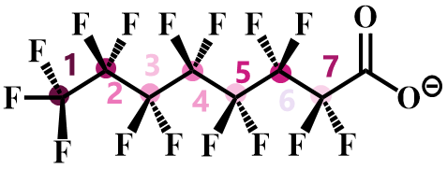

Bond | BDE(kcal/mol) | Bond(left to right) | BDE(kcal/mol)
C–C 1 | 90.95004438 | C−F | 120.7730846
C–C 2 | 86.87938701 | C−F | 113.1601333
C–C 3 | 86.01342321 | C−F | 111.06927
C–C 4 | 86.1759483 | C−F | 111.3503945
C–C 5 | 86.85303159 | C−F | 110.6933915
C–C 6 | 81.54115944 | C−F | 111.9195461
C–C 7 | 87.8200245 | C−F | 106.6767

HFPO-DA
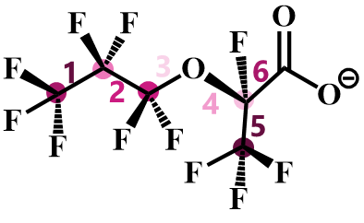
Bond | BDE(kcal/mol) | Bond(left to right) | BDE(kcal/mol)
C–C 1 | 90.29804382 | C−F | 121.3761218
C–C 2 | 84.889112 | C−F | 111.5706505
C–C 3 | 77.32740227 | C−F | 115.025093
C–C 4 | 78.53810945 | C−F | 102.9430155
C–C 5 | 88.90237690 | C−F | 123.2699469
C–C 6 | 85.035892

6:2 FTS
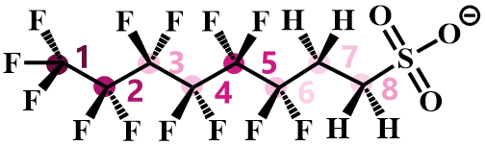
Bond | BDE(kcal/mol) | Bond(left to right) | BDE(kcal/mol)
C–C 1 | 90.50427831 | C−F | 120.43608612
C–C 2 | 87.38421904 | C−F | 115.20951743
C–C 3 | 83.01447206 | C−F | 107.59247012
C–C 4 | 86.19985103 | C−F | 106.32857229
C–C 5 | 86.893632 | C−F | 112.754209
C–C 6 | 68.43205318 | C−F | 104.32188723
C–C 7 | 71.724016 | C−H | 55.690352186
C–S 8 | 70.24509445 | C−H | 57.903461

PFOS
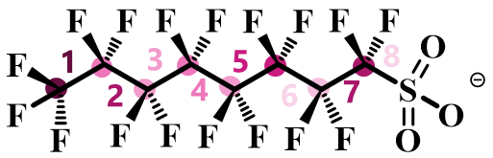
Bond | BDE(kcal/mol) | Bond(left to right) | BDE(kcal/mol)
C–C 1 | 89.13465795 | C−F | 120.763672
C–C 2 | 85.08470841 | C−F | 110.6419357
C–C 3 | 84.26016027 | C−F | 109.3455
C–C 4 | 84.56073756 | C−F | 110.6400532
C–C 5 | 84.94665621 | C−F | 109.4383715
C–C 6 | 84.64419639 | C−F | 111.1690441
C–C 7 | 87.67130463 | C−F | 109.2865141
C–S 8 | 64.73455911 | C−F | 112.2063181

Table 2 The performance of baseline models trained directly on the original 13 experimental samples

Target | Best model | R² | RMSE | MAE | Spearman
Lowest BDE | SVR | 0.152 | 11.49 | 5.793 | 0.707
ΔG‡ | SVR | -0.1519 | 2.216 | 1.521 | 0.1333
ΔG | Ridge | 0.1691 | 2.103 | 1.627 | 0.5934
λ | Ridge | -0.2668 | 6.927 | 5.151 | 0.1209
k_{F} | SVR | 0.1928 | 0.3934 | 0.2737 | 0.4725
k_{G} | RandomForest | 0.1301 | 0.3008 | 0.1698 | 0.5352

Figure 1 Time distributions of decay rate and the lnk_{G} of 13 PFASs under VUV system.
When C_{PFAS}=10 mg L⁻¹, the pH values of the samples were all at their initial values, and no buffering was performed.
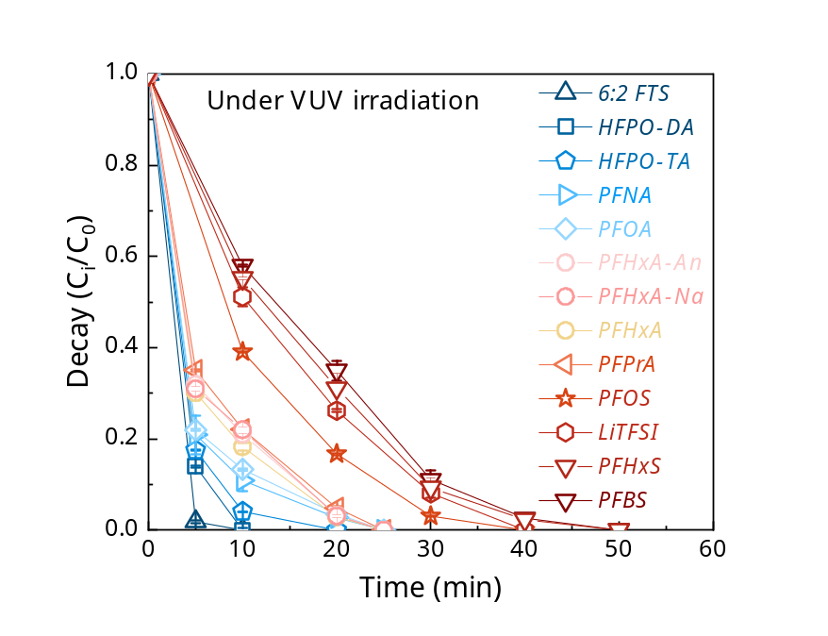
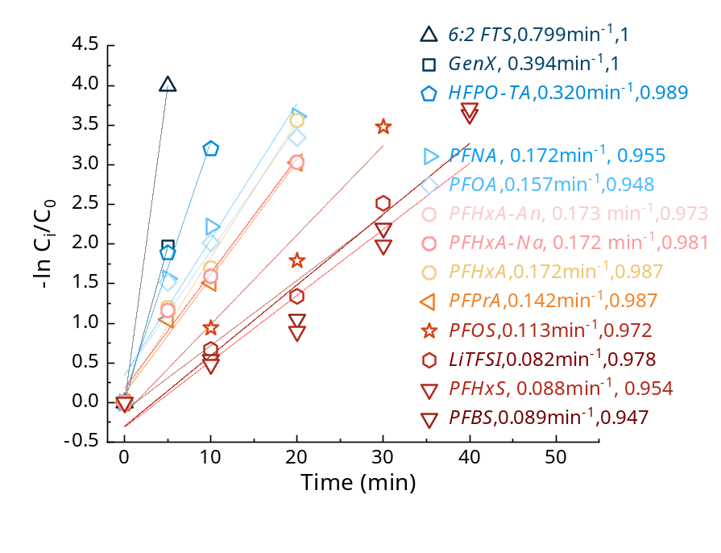

Figure 2 Time distributions of defluorination rate and the lnk_{F} of 13 PFASs under VUV system.
When C_{PFAS}=10 mg L⁻¹, the pH values of the samples were all at their initial values, and no buffering was performed.
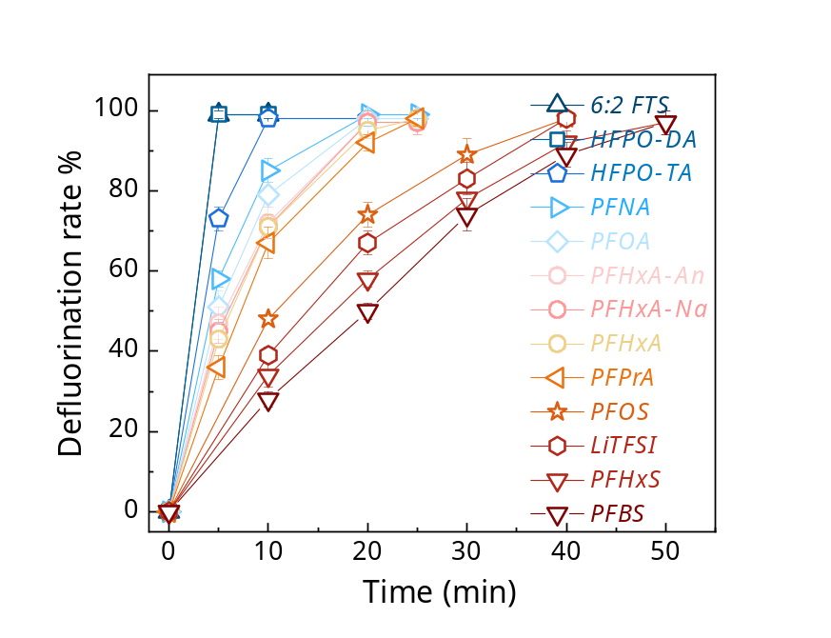
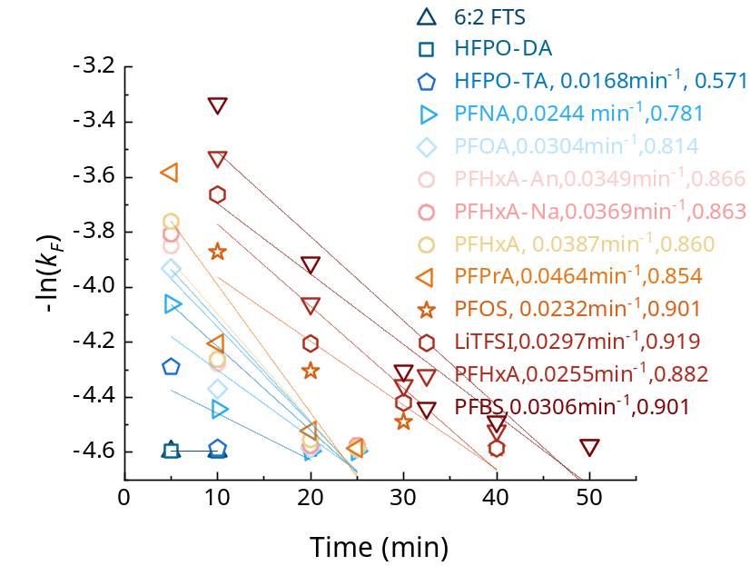

Figure 3 Identified representative transfer products (TPs) of 4 different PFAS under hydroxyl radical(HO•) quenching conditions in VUV irradiation system.

PFOS
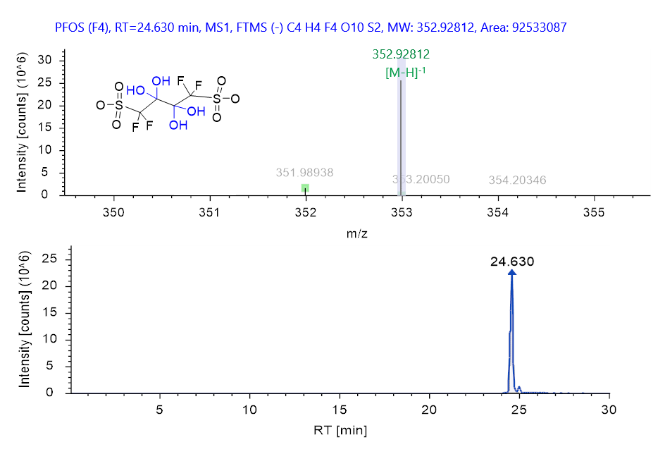
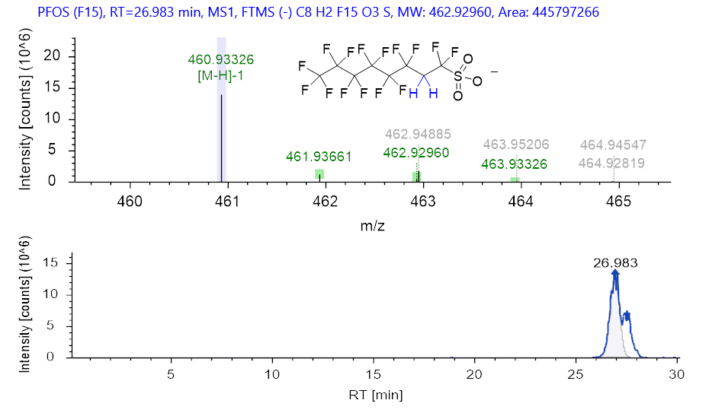

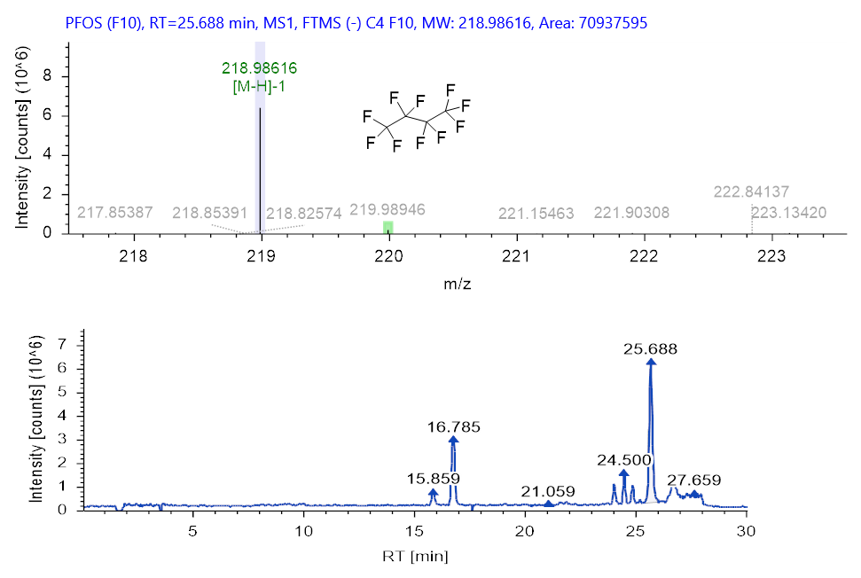

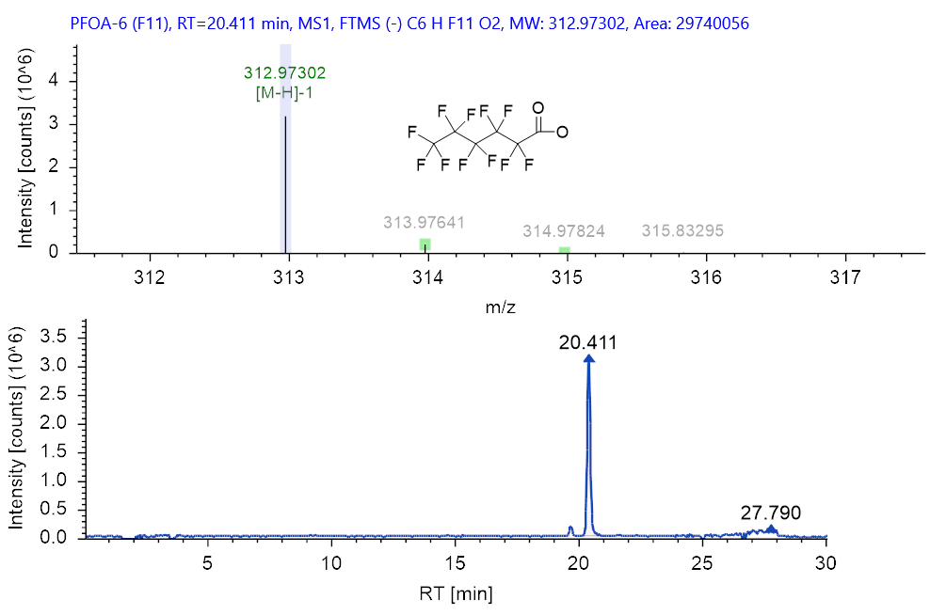

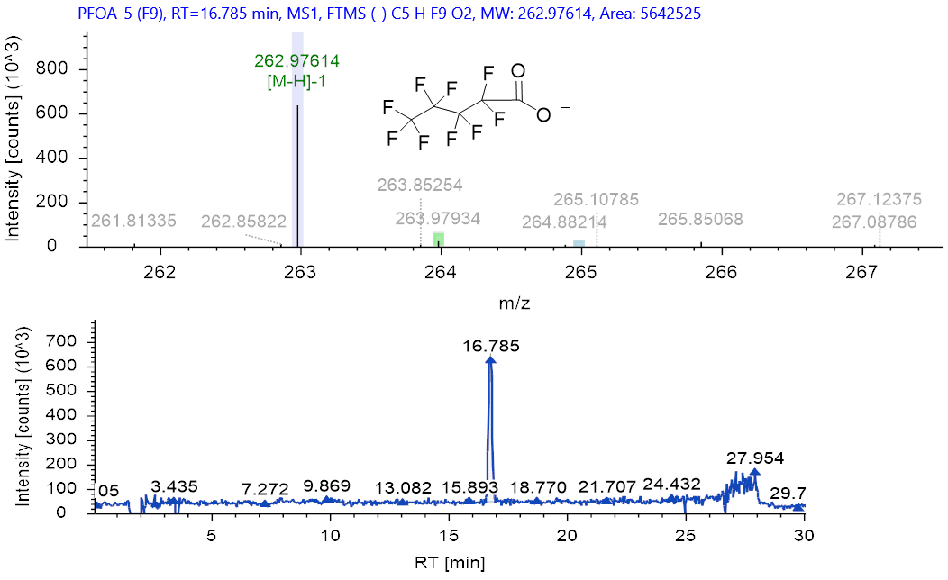

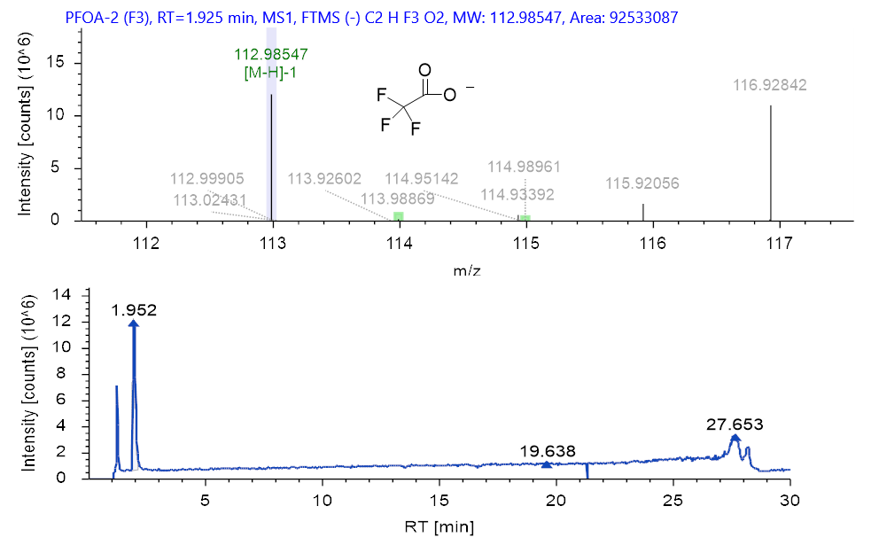

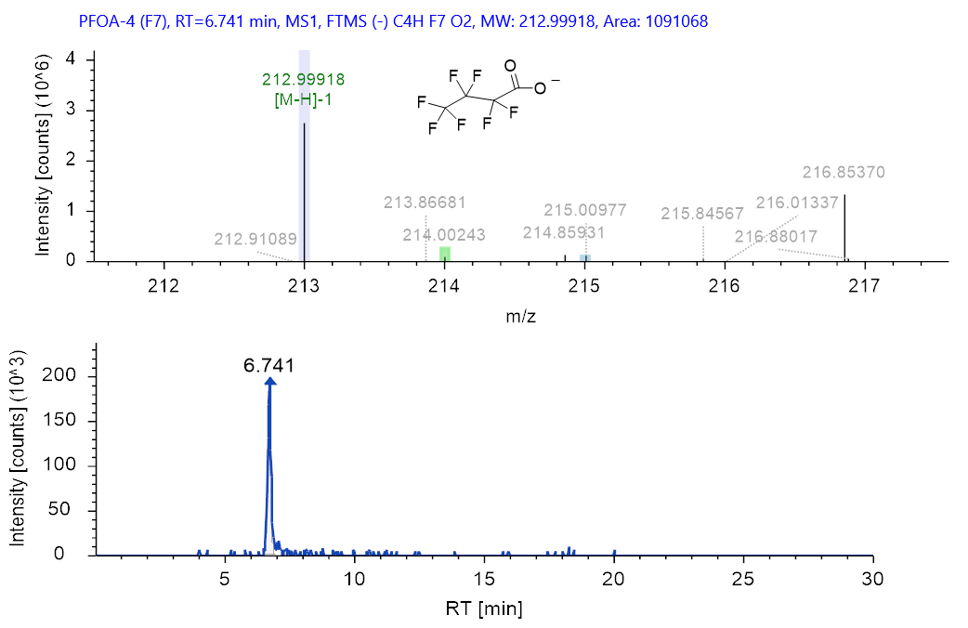

PFOA
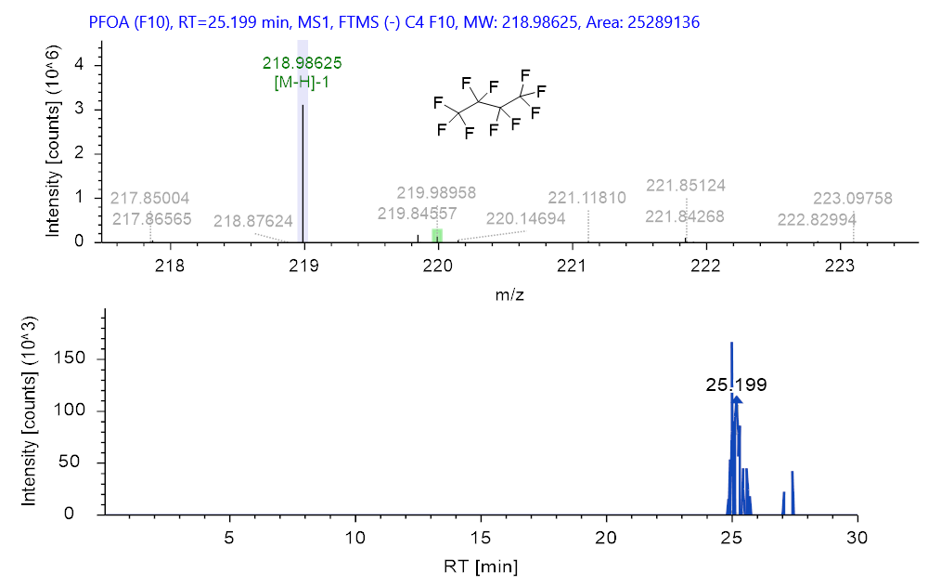

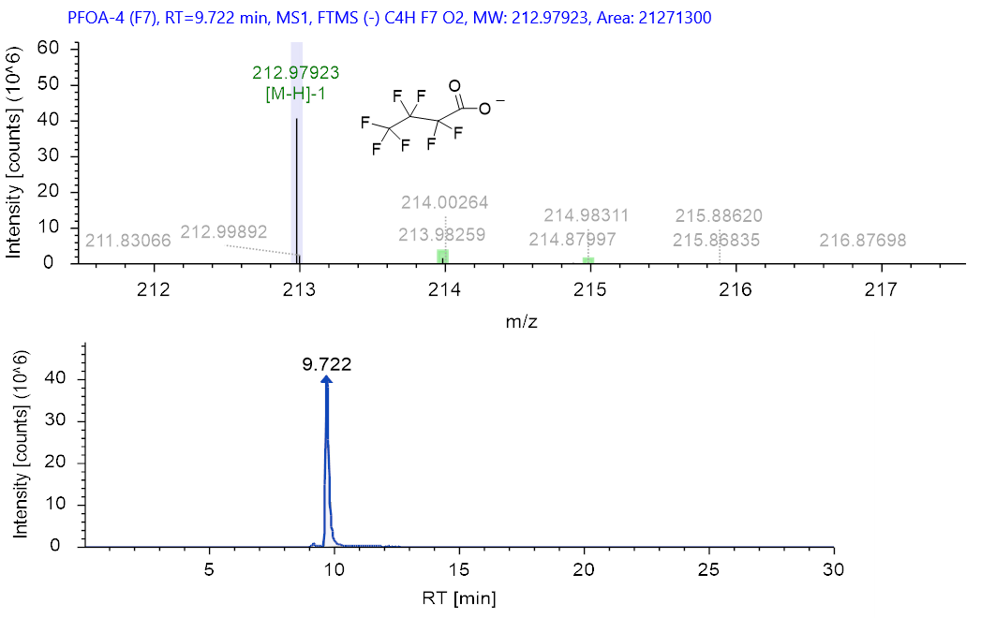

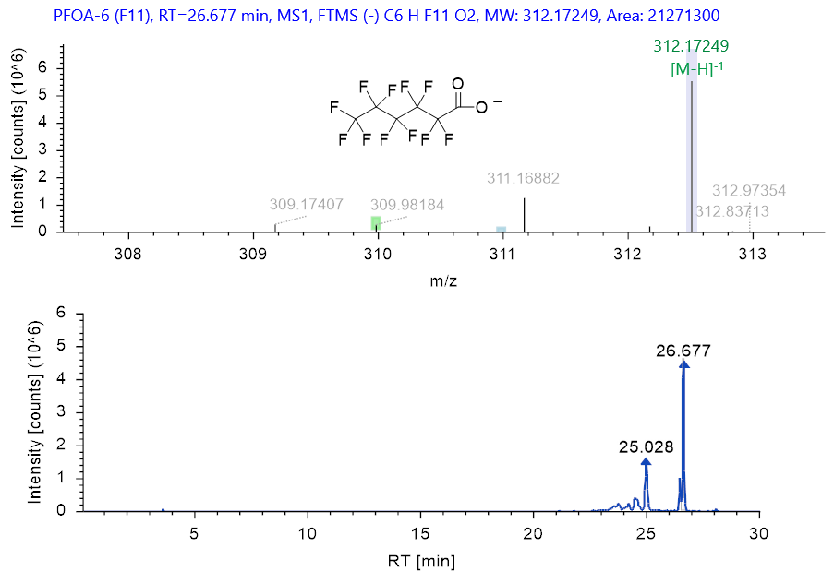

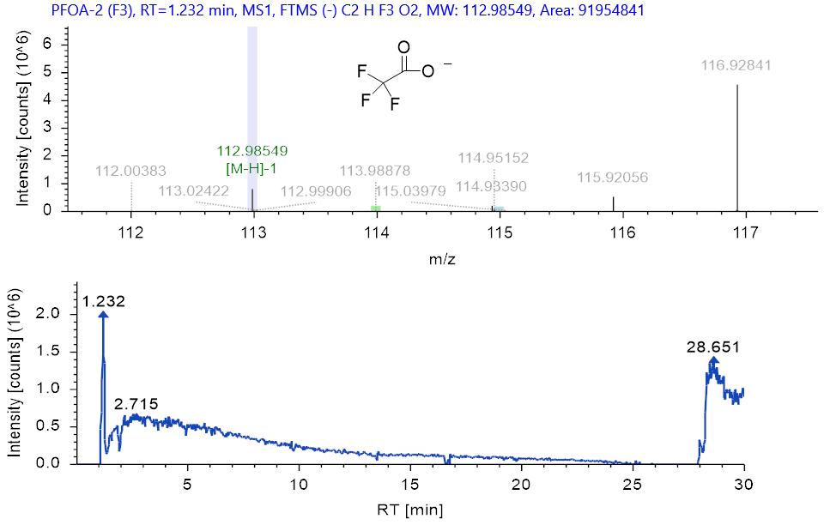

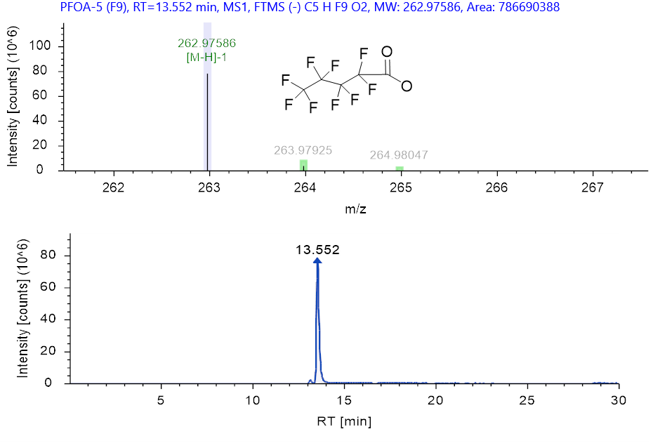

6:2FTS
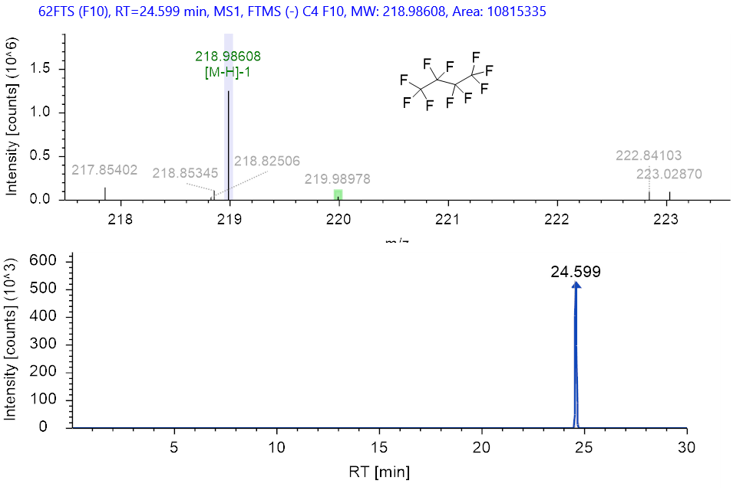

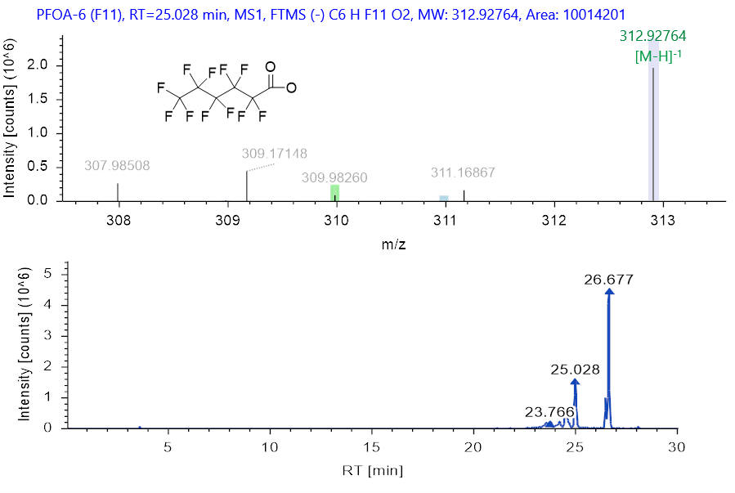

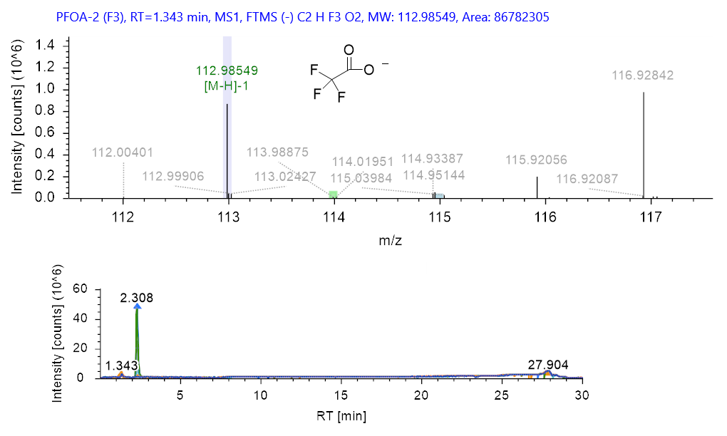

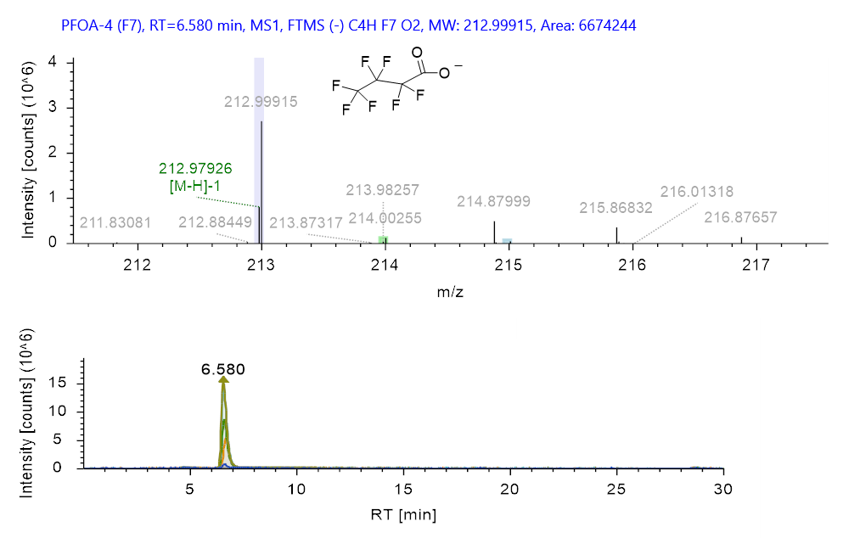

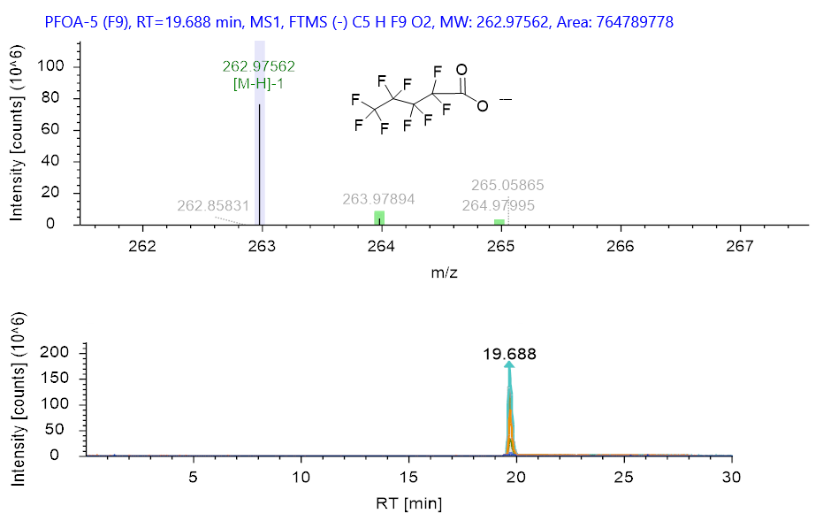

HFPO-DA
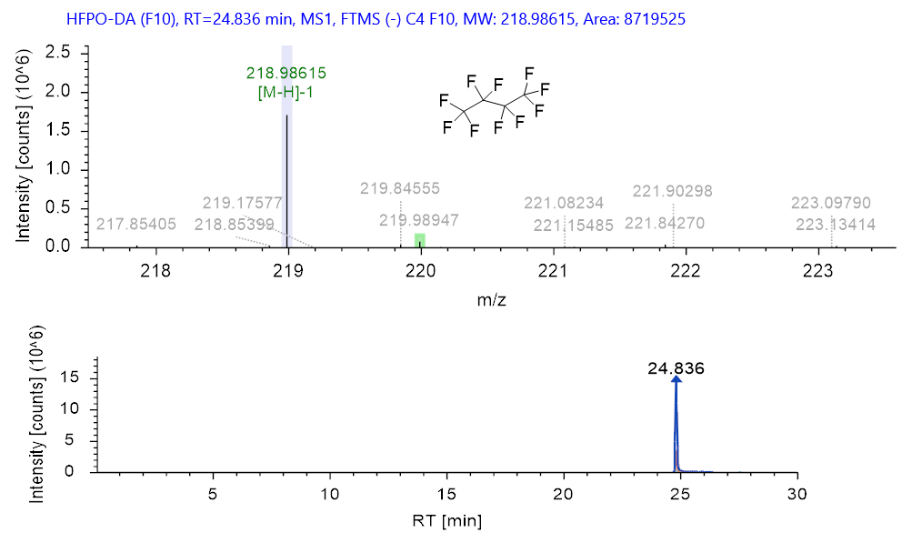

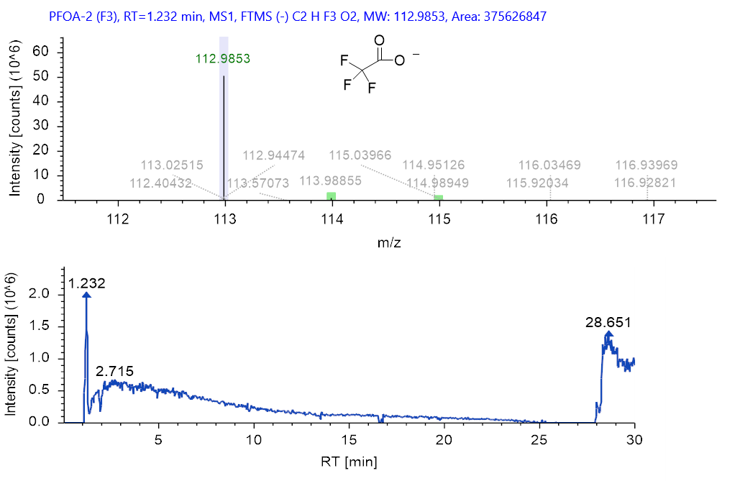

Figure 4 Generative Variational Autoencoder (VAE) training performance and latent space distribution of experimental PFAS samples.
a. Loss curve of the VAE model as a function of training epochs, showing rapid convergence and stability after ~150 epochs. (b) Two-dimensional projection of 13 experimental PFAS congeners mapped within the continuous latent space (Latent 1 vs. Latent 2), demonstrating distinct structural clustering and low-dimensional representation without feature distortion.
a.
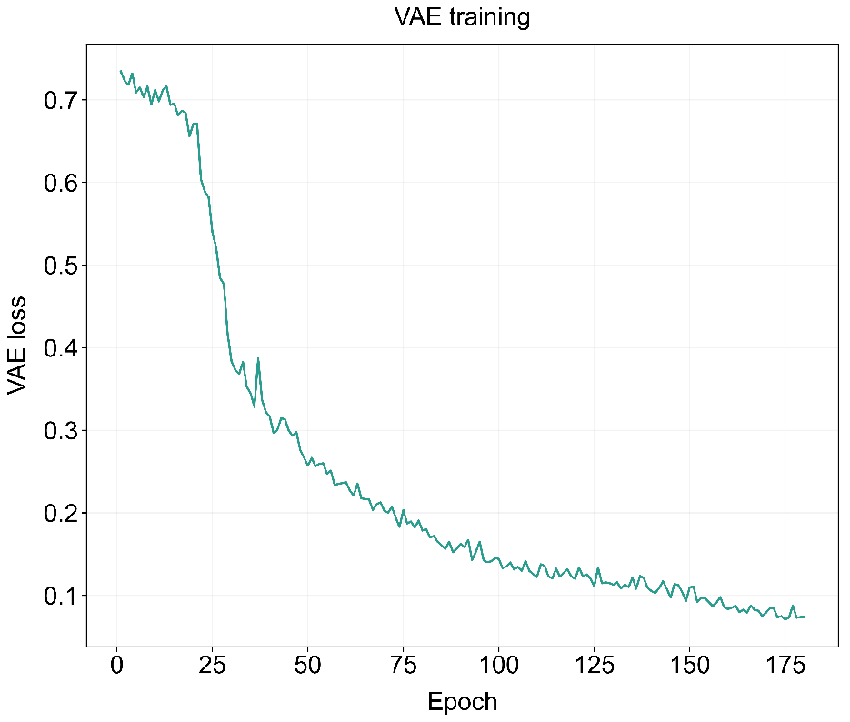
b.
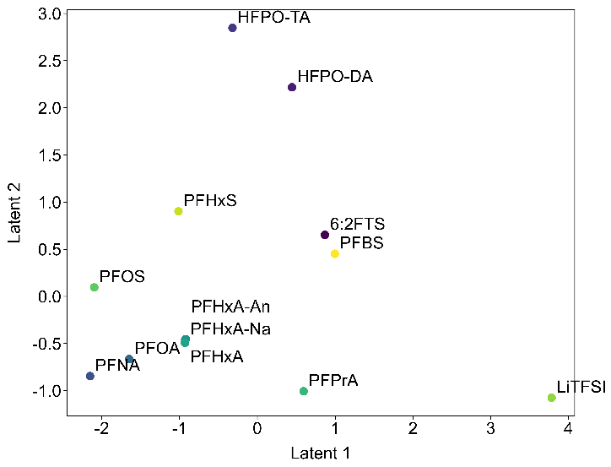

Figure 5 Heatmap of predicted reactivity metrics and quantum chemical descriptors across the expanded PFAS congener library.
Predicted target features include degradation rate (k_{G}), defluorination rate (k_{F}), weakest bond dissociation energy (BDE), reorganization energy (λ), activation free energy (ΔG‡), and reaction free energy (ΔG). Values are presented as normalized Z-scores across more than 90 expanded PFAS candidates generated by the VAE-ANN framework.

The predicted energy heatmap highlights pronounced functional-group-dependent reactivity, where phosphate ester derivatives (monoPAPs/diPAPs) exhibit accelerated k_{G}, k_{F} and lower ΔG, whereas fluorotelomer carboxylic acids (FTUCAs/FTCAs) present elevated activation energy barriers (Δ G‡). This functional variation directly supports the model's SHAP analysis (Fig. 4d), confirming that variations in local charge distribution and electrostatic potential across diverse functional heads play a crucial role, alongside chain length, in modulating the molecular softness (S) and determining the requisite oxidative/reductive commitment (ŋ_{G/F}). Also, the heatmap reveals strong class-dependent kinetic and thermodynamic clustering, where short-chain compounds (e.g., FTUCAs) display higher ΔG‡ and larger bond dissociation energies (BDE) compared to long-chain derivatives like monoPAPs and diPAPs. This shift toward higher kinetic bottlenecks in shorter perfluorinated architectures directly mirrors the demand for an intensified oxidative flux to overcome high HOMO–LUMO gaps (E_{GAP}). These quantum-chemical distributions corroborate the elevated ŋ_{G/F} required for short-chain homologues to navigate reductive kinetic barriers during degradation.

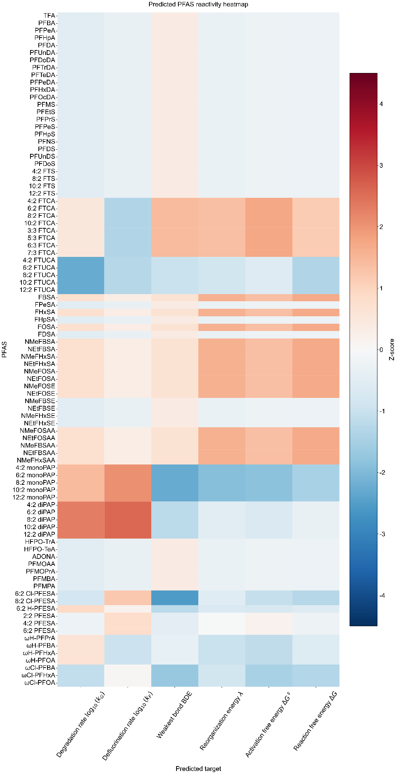

Figure 6 Schematic diagram of the physical VUV system setup and cross-sectional view of the VUV reactor
