Supplementary Materials

Full-length uncropped Western blot image for recombinant FLAG-tagged Hsp70
To confirm transgene expression in the central nervous system, Western blot analysis was performed on spinal cord lysates from S‑FUS(1‑359) transgenic mice treated with rAAV‑Hsp70. The full‑length, uncropped imahe is shown in Supplementary Figure S1. The membrane was probed with anti‑FLAG antibody (GB15938, Servicebio) to detect recombinant Hsp70‑3xFLAG (expected molecular weight ~75 kDa) and with anti‑GAPDH antibody (MAB374, Sigma Aldrich) as a loading control (~36 kDa). FLAG‑specific signal was detected exclusively in rAAV‑Hsp70‑treated animals, whereas no signal was observed in vehicle‑treated controls. The original, uncropped Western blot image is provided for transparency.
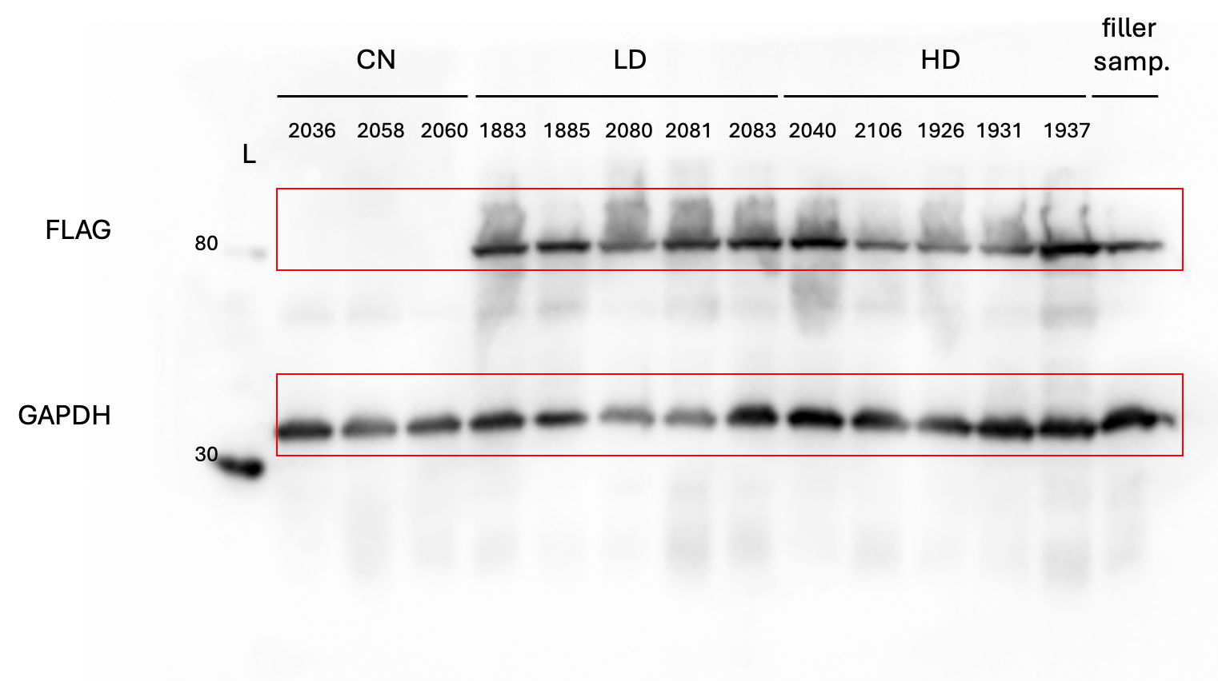
Supplementary Figure S1. Full‑length, uncropped Western blot for recombinant FLAG‑tagged Hsp70.

Western blot analysis of spinal cord lysates from transgenic S‑FUS(1‑359) mice. M - protein ladder (molecular weight markers), the 80 kDa and 30 kDa bands are indicated. Samples: CN - vehicle‑treated transgenic control; LD - low‑dose rAAV‑Hsp70 (5×10¹⁰ gc/mouse); HD - high‑dose rAAV‑Hsp70 (5×10¹¹ gc/mouse). Red boxes indicate the cropped areas shown in the main text of the manuscript (Fig. 2E).

Functional tests
Administration of rAAV-Hsp70 at either dose did not affect motor performance or general well-being in wild-type mice, confirming the absence of overt toxicity or functional impairment.

Supplementary Figure S2. Functional tests in wild‑type mice after retro‑orbital administration of rAAV‑Hsp70. Wild‑type CD‑1 mice received a single retro‑orbital injection of vehicle (PBS, n=6), low‑dose rAAV‑Hsp70 (5×10¹⁰ gc/mouse, n=5), or high‑dose rAAV‑Hsp70 (5×10¹¹ gc/mouse, n=5). Functional assessments were performed weekly for 15 weeks.
A. Inverted grid test. All animals in all groups consistently achieved the maximum hanging time of 60 seconds at every time point. Mixed‑effects model (REML) revealed no significant effect of group (p > 0.9999), time (p > 0.9999), or group × time interaction (p > 0.9999). B. Forelimb grip strength test. A progressive decline in grip strength over time was observed in all groups (effect of time: p = 0.0001). However, there was no significant effect of group (p = 0.3696) nor group × time interaction (p = 0.736). Post‑hoc comparisons (Fisher’s LSD) showed no significant differences between treatment groups and vehicle control at any time point, with a single exception at week 14 (vehicle vs. high‑dose, p = 0.0258) which was not dose‑dependent and not replicated at adjacent weeks. Thus, rAAV‑Hsp70 administration did not affect motor performance in wild‑type mice.

