Western blots included in Verdone et al.

Figure 2B anti-GR:

Colorimetric:

Chemiluminescence:
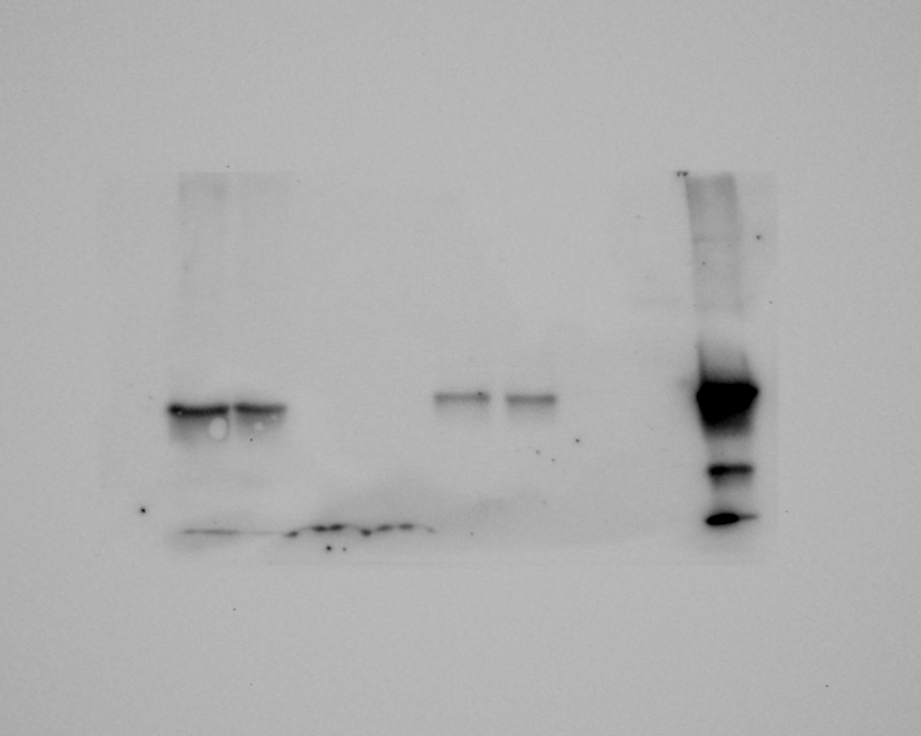

Lanes:
- Ladder
- Cortex GR mouse 1
- Cortex GR mouse 2
- Cortex GFP mouse 1
- Cortex GFP mouse 2
- Spinal Cord mouse 1
- Spinal Cord mouse 2
- Spinal Cord mouse 1
- Spinal Cord mouse 2
- HEK Cell lysate transfected with GR50-GFP

Figure 2B anti-GFP

Colorimetric:
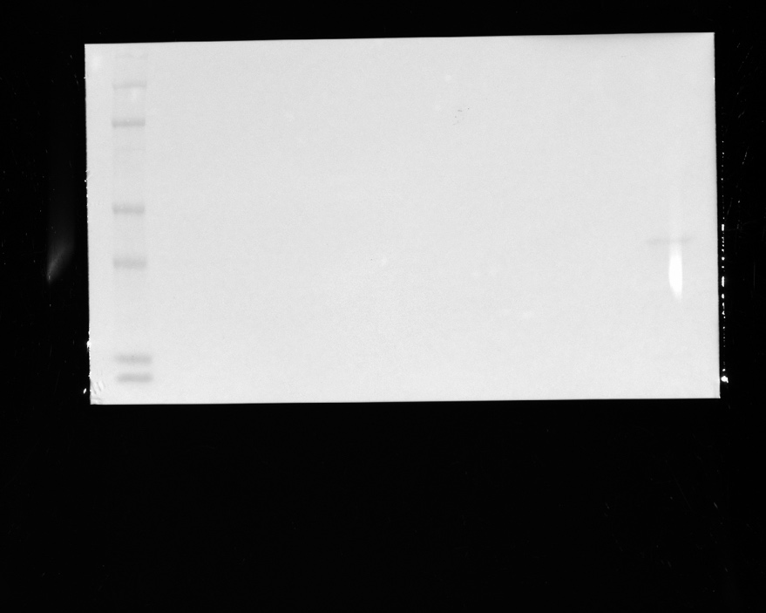

Chemiluminescence:
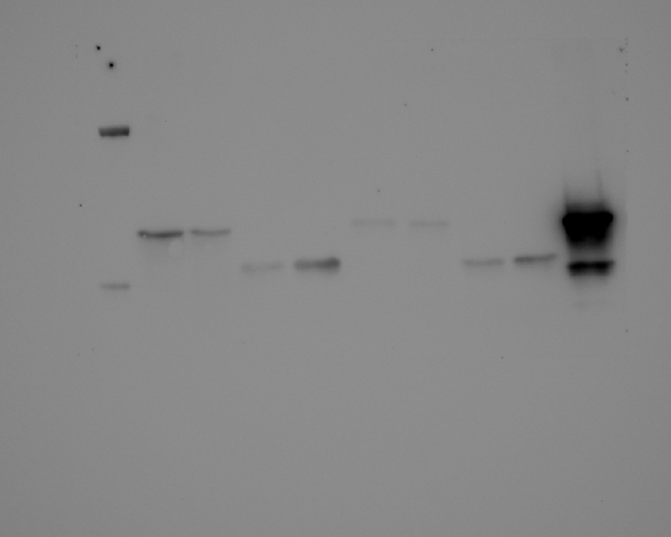

Lanes:
- Ladder
- Cortex GR mouse 1
- Cortex GR mouse 2
- Cortex GFP mouse 1
- Cortex GFP mouse 2
- Spinal Cord mouse 1
- Spinal Cord mouse 2
- Spinal Cord mouse 1
- Spinal Cord mouse 2
- HEK Cell lysate transfected with GR50-GFP

Supplemental Figure 2A: GR50 mouse; anti-GR

Chemiluminescence:

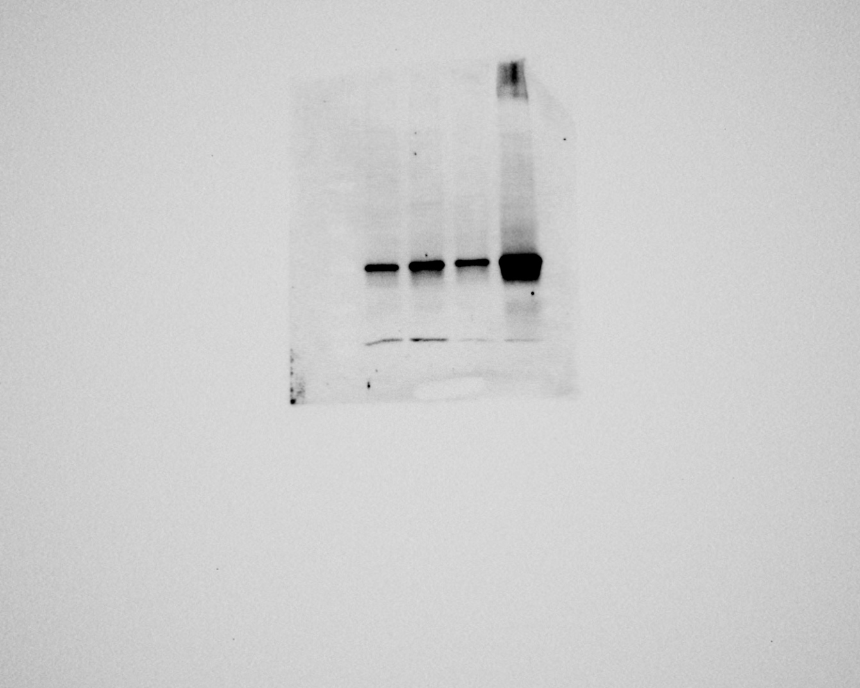

Lanes:
- Ladder
- GR mouse cortex
- GR mouse cerebellum
- GR mouse spinal cord
- GR mouse liver

Supplemental Figure 2A: GR50 mouse; anti-GFP

Chemiluminescence:

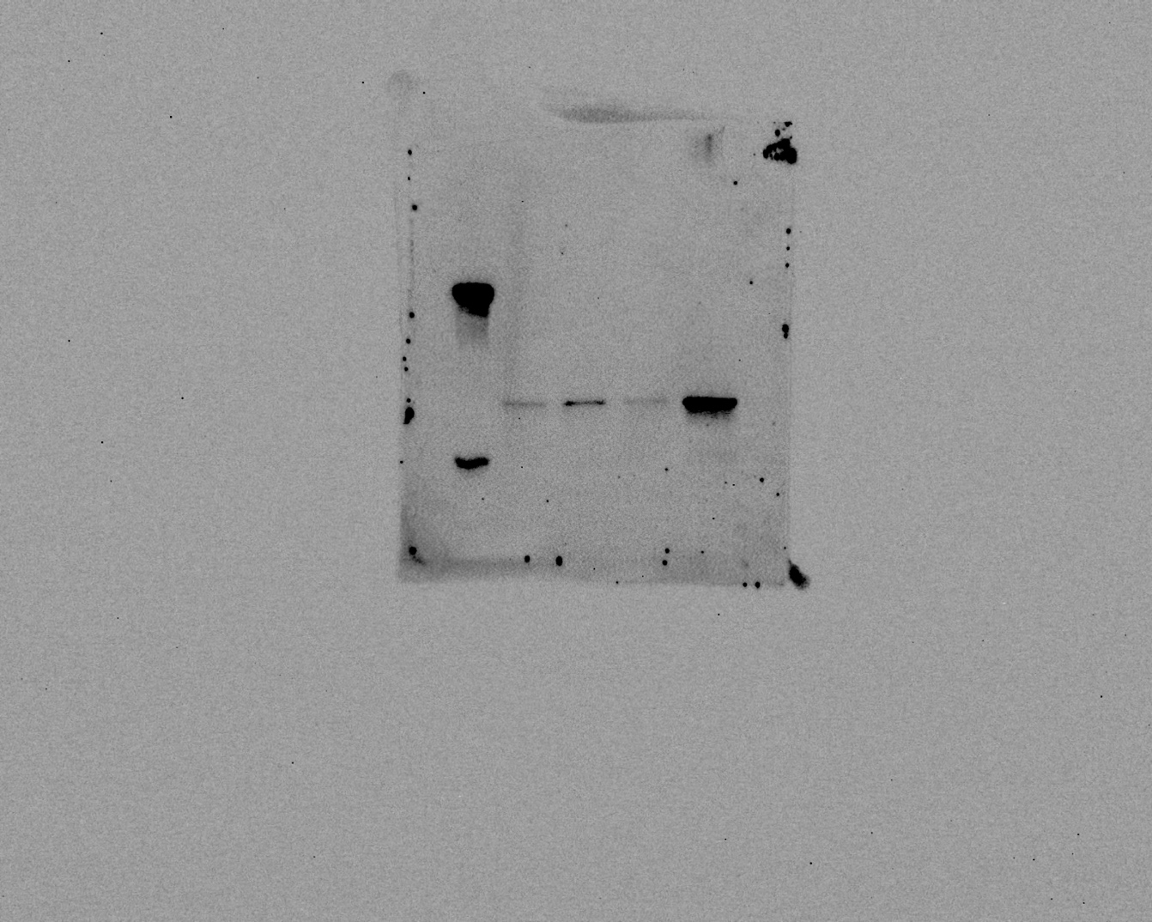

Lanes:
- Ladder
- GR mouse cortex
- GR mouse cerebellum
- GR mouse spinal cord
- GR mouse liver
Supplemental Figure 2A: GR50 mouse; anti-beta tubulin

Chemiluminescence:

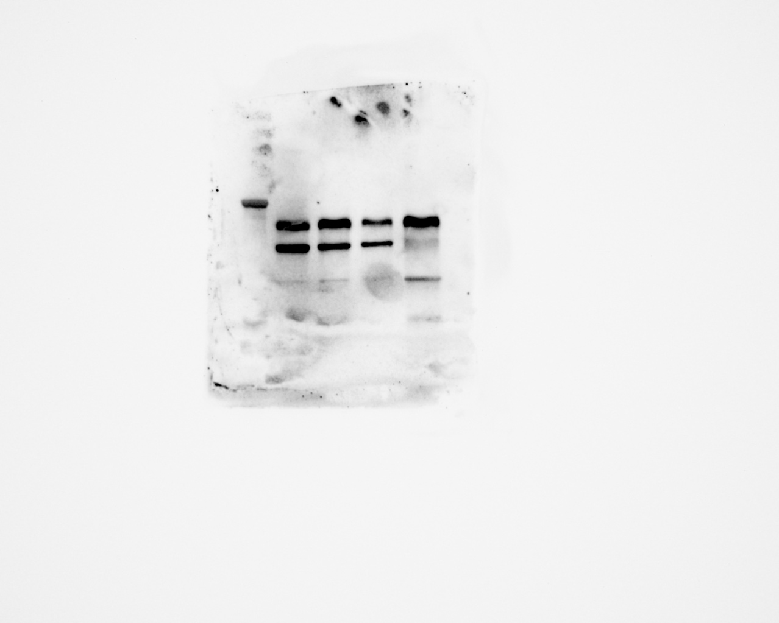

Lanes:
- Ladder
- GR mouse cortex
- GR mouse cerebellum
- GR mouse spinal cord
- GR mouse liver

Supplemental Figure 2D: GFP mouse; anti-GFP

Chemiluminescence:

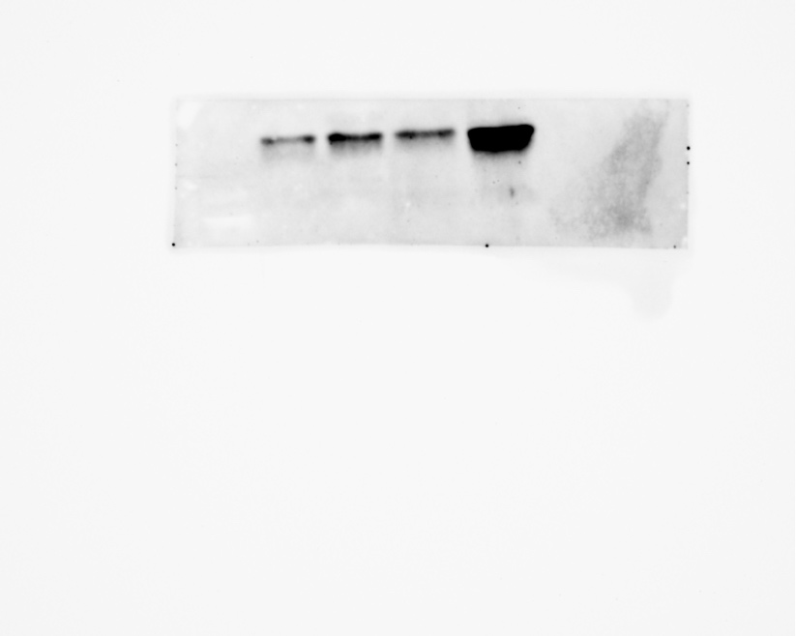

Lanes:
- Ladder
- GFP mouse cortex
- GFP mouse cerebellum
- GFP mouse spinal cord
- GFP mouse liver
Supplemental Figure 2D: GFP mouse; anti-beta tubulin

Chemiluminescence:

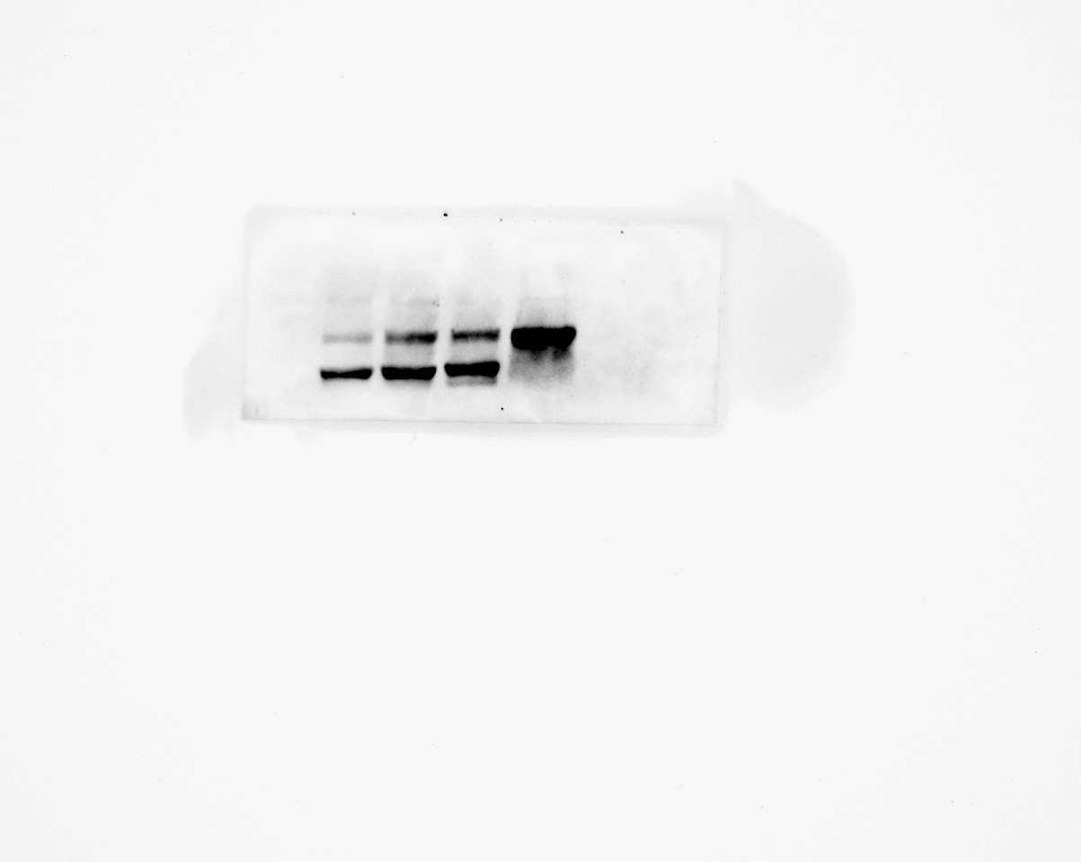

Lanes:
- Ladder
- GFP mouse cortex
- GFP mouse cerebellum
- GFP mouse spinal cord
- GFP mouse liver

