A Scalable, All-Weather Energy-Managing Textile Synergizing Active Energy Harvesting and Passive Cooling

Yan Wang^{1†}, Zheshan Wang^{1†}, Wangkai Jiang^{1,2†*}, Tingting Li¹, Guochao Sun³, Xinlong Lan¹, Honglei Cai¹, Zhuowen Xie¹, Junhao Wu¹, Zhiwei Nan¹, Hui Wang¹, Jun Zhang¹, Jintu Fan², Shuo Shi^{2*}, Jianchen Hu^{1*}, Ke-Qin Zhang^{1*}

Yan Wang, Zheshan Wang, Wangkai Jiang, Tingting Li, Xinlong Lan, Zhuowen Xie, Honglei Cai, Junhao Wu, Zhiwei Nan, Hui Wang, Jun Zhang, Jianchen Hu, Ke-Qin Zhang
National Engineering Laboratory for Modern Silk, College of Textile and Clothing Engineering, Soochow University, Suzhou 215123, P. R. China.

Wangkai Jiang, Jintu Fan, Shuo Shi
School of Fashion and Textiles, The Hong Kong Polytechnic University, Kowloon, Hong Kong 999077, P. R. China.

Guochao Sun
i-lab, Suzhou Institute of Nano-Tech and Nano-Bionics, Chinese Academy of Sciences, Suzhou 215123, P. R. China.

†These authors contributed equally to this work.

- mails: wangkai.jiang@polyu.edu.hk (Wangkai Jiang); shuo.shi@polyu.edu.hk (Shuo Shi); hujianchen@suda.edu.cn (Jianchen Hu); kqzhang@suda.edu.cn (Ke-Qin Zhang)

Supplementary Note 1: Materials
The commercial production of conductive silvered nylon yarn (70 D) was provided by Qingdao Tianyin Textile Technology Co., LTD. Polyester (PET) roving strip (5 g/10 m) was purchased from Jiangyin Yingze Yarn Industry Co., LTD. Commercial PET sewing thread (20 N/2) was from Seung Joon Jewelry. Poly(vinylidene fluoride-co-hexafluoropropylene) (PVDF-HFP) was derived from French Arkema (Kynar Flex 2801). Acetone came from Jiangsu Qiangsheng Functional Chemical Co., LTD. ePTFE hydrophobic nanofiber film was from Guangzhou Juyou Material Trading Co., LTD. Conductive silver paste was purchased from Shenzhen De Liou Technology Development Co., LTD. Deionized (DI) water was prepared in the laboratory. None of the chemicals was further purified.
Supplementary Note 2: Methods
Preparation of the (PVDF-HFP)-acetone-water precursor coating solution: Arkema's PVDF-HFP (Kynar Flex 2801) was initially dissolved in acetone, followed by addition of water to create the precursor solution, respectively with a mass ratio of 1:32:1 (PVDF-HFP:acetone:water) and a mass ratio of 1:8:1 (PVDF-HFP:acetone:water).
Preparation of yarn based TENG: The functional polyethylene terephthalate/silver-coated nylon (PSN) yarn with a coaxial structure, composed of PET staple fiber and the conductive yarn (silver-coated nylon), was manufactured using a friction spinning machine (HFX-02, Suzhou Huafie Textile Technology Co., Ltd.). In this process, the conductive yarn (silver-coated nylon) functioned as the core component, with PET roving strips forming the functional surface layer. The PET roving strips were broken and combed by the friction spinning machine, and then evenly wrapped around the conductive yarn surface to produce the PSN yarn. The prepared yarn was subsequently heated in a vacuum drying oven at 150 ℃ for 1 h to finalize its shape. The prepared (PVDF-HFP)-acetone-water precursor coating solution with the mass ratio of 1:32:1 (PVDF-HFP:acetone:water) was applied to the surface of PSN yarn and dried in an oven at 60 ℃ to obtain the polyvinylidene fluoride-hexafluoropropylene/polyethylene terephthalate/silver-coated nylon yarn (PPSN) yarn¹.
Fabrication of fabric-based TENG: The PPSN functional yarn was woven on a knitting machine to produce a functional fabric of an appropriate size. The commercial PET yarn and PPSN functional yarn were alternately used on the knitting machine to create a rib-structured fabric base¹.
Explanation of COMSOL simulation of the triboelectric charging process of the sliding raindrop: The simulation results are shown in Figure 2e (iv), which shows six different locations in the process of a droplet (The droplet is represented by a small half-oval shape) sliding from the left to the right of a surface. It can be clearly seen that the surface potential of the droplet is constantly changing with sliding.
Outdoor thermal measurement: The outdoor test site was located in Suzhou, China (31°16'21.86"N, 120°43'35.52"E). Referring to previous work, we developed a controlled testing system to minimize electrical and convective heat transfer to samples under strong solar irradiation^{2, 3, 4, 5}. The setup of the outdoor thermal measurement is shown in Figure S14. The 9 cm × 9 cm sample was cut and placed in the hot chamber made of insulated polystyrene foam (size 17 cm × 11 cm × 9 cm). The hot box was covered with a transparent low-density polyethylene (PE) film to control heat convection as showed in Figure S14(b). The entire foam (except for the sample area) was covered with aluminum foil and silver-coated mylar to avoid the absorption of solar radiation. Sample temperature was monitored in real time using an adhesive temperature sensor affixed to a 50-μm copper plate substrate, with continuous recording via data logger (SH-16, Intermeter; uncertainty: ±0.1 °C). For comparison, a temperature detector was installed outside the box to monitor the real-time environmental temperature. An outdoor solar radiometer (CEL-NP2000-Sun180) was used to record solar radiation outside the box simultaneously, while relative humidity and wind speed near the hot box (31°16'21.86"N, 120°43'35.52"E) were measured by weather stations and anemometers.
Temperatures for devices both with and without the PE cover were measured. Figure S15(a) showed the data measured in the case of PE coverage to reduce convective heat loss/gain. To better simulate the real conditions, Figure S15(b-c) presented measurements taken on the surface of the foam without the PE film. In addition, to verify the effectiveness of EM-textile radiative cooling, the temperatures under the edge of the sample were also measured.
Definitions of solar reflectance and thermal emittance: The average reflectance (͞ρ_{solar}) of the ultraviolet to near infrared light (0.25-2.5 μm) was obtained by Eq. S1^{2, 6, 7, 8}.
ρ_{solar} =$\frac{\int_{\text{0}\text{.}\text{25 }\text{μ}\text{m}}^{\text{2.5} \text{μ}\text{m}}{{\text{I}}_{\text{solar}}\text{(λ)}{\text{R}}_{\text{solar}}\text{(λ)}\text{dλ}}}{\int_{\text{0}\text{.25 }\text{μ}\text{m}}^{\text{2.5} \text{μ}\text{m}}{{\text{I}}_{\text{solar}}\text{(λ)}\text{dλ}}}$ (S1)
where λ is the wavelength, I_{solar} (λ) is the normalized ASTM G173 Global solar intensity spectrum, and R_{solar} (λ) is surface spectral reflectance of samples.
The average infrared thermal emittance (͞ε_{ASTW}) in the atmospheric transmittance window (ASTW, 8-13 μm) is defined as^{2, 6, 7, 8}:
ε_{ASTW} =$\frac{\int_{\text{8} \text{μ}\text{m}}^{\text{13} \text{μ}\text{m}}{{\text{I}}_{\text{BB}}\text{(}\text{T, }\text{λ)}ε_{\text{ASTW}}\text{(λ)}\text{dλ}}}{\int_{\text{8} \text{μ}\text{m}}^{\text{13} \text{μ}\text{m}}{{\text{I}}_{\text{BB}}\text{(}\text{T, }\text{λ)}\text{d}\text{λ}}}$ (S2)
where I_{BB} (T, λ) is the blackbody radiation intensity at a temperature of T calculated by Planck’s law^{2, 6, 7, 8}:
I_{BB} (T, λ)=$\frac{2hc^{2}}{λ^{5}}\frac{1}{e^{\frac{hc}{λ{Tk}_{B}}}-1}$ (S3)
where h is the Planck constant, c is the speed of light in vacuum, k_{B} is the Boltzmann constant. In the present work, the temperature T is set as 298 K.
Supplementary Note 3: Scattering Efficiency Calculation
To investigate the optical mechanisms behind the ePTFE nanofiber membranes and PVDF-HFP coating, finite elements simulations were carried out using COMSOL Multiphysics software. Two dimensional (2D) models were used for finite elements simulations refer to https://www.comsol.com/blogs/electromagnetic-scattering-in-2d-axisymmetric-models. Perfect match layer (PML) boundary was used on the outside layer of 2D models. Mesh size of model was controlled by software. The scattering cross section was defined by surface integral of poynting vector. The scattering efficiency among the wavelength range of 0.2-2.5 µm with different nanofiber diameter and aperture distribution was calculated by parametric sweep.
Supplementary Note 4: Theoretical Thermal Calculation of Thermal Emitter
We used a traditional simple model to analyze the energy balance of the thermal emitter, with several parts to the radiation: the emitted thermal radiation from the thermal emitter (P_{rad}), the absorbed thermal radiation from the atmosphere (P_{atm}), the heat transfer by thermal conduction and thermal convention (P_{cond+conv}) and the absorbed thermal radiation from sunlight (P_{solar}). The energy balance equation is as follows^{2, 6, 7, 8}:
P_{cooling}(T, T_{amb})=P_{rad}(T)−P_{atm}(T_{amb})− P_{solar}−P_{cond+conv} (S4)
where T is the surface temperature of the EM-textiles and T_{amb} is the ambient temperature. P_{rad}(T) is the thermal power radiated by the EM-textiles, P_{atm}(T_{amb}) is the absorbed atmospheric thermal radiation at T_{amb}. P_{solar} is the incident solar irradiation absorbed by the EM-textiles, and P_{cond+conv} is the power lost due to convection and conduction. The net cooling power defined in Eq. (S4) can reach a high value by increasing the radiative power of the EM-textiles and reducing either the solar absorption or parasitic heat gain. These parameters can be calculated by the following equations:
P_{rad}(T)=$\text{ A}\int{\text{d}}\text{Ωcosθ}\int_{\text{0}}^{ \text{∞}}{\text{dλ}}{\text{I}}_{\text{BB}}\text{ (T, }\text{λ)ε}\text{(λ, θ)}$ (S5)
P_{atm}(T_{amb})=$\text{ A}\int{\text{d}}\text{Ωcosθ}\int_{\text{0}}^{ \text{∞}}{\text{dλ}}{\text{I}}_{\text{BB}}\text{ (}{\text{T}}_{\text{amb}}\text{, }\text{λ)ε}\text{(λ, θ)}{\text{ε}}_{\text{atm}}\text{(λ, θ)}$ (S6)
P_{solar}=$\text{ A}\int_{\text{0}}^{ \text{∞}}{\text{dλ}}\text{ε(}\text{λ, }θ_{solar}\text{)}{\text{I}}_{\text{AM1.5}}\text{(λ)}$ (S7)
P_{cond+conv}=Ah_{c}(T_{amb}-T) (S8)
where A is the surface area of the EM-textiles. $\int{\text{d}}\text{Ω}$=$\text{2π}\int_{\text{0}}^{ \text{π/2}}{\text{dθ}\text{sin}\text{θ}}$ is the angular integral over a hemisphere. The variable θ denotes the zenith angle, which is the angle between the direction of radiation and the surface normal. $\text{ε(λ, θ)}$ is the directional emissivity of the surface at wavelength λ. ${\text{ε}}_{\text{atm}}\text{(λ, }\text{θ)}$=1-τ(λ)^{1/cosθ} is the angle-dependent emissivity of the atmosphere; τ(λ) is the atmospheric transmittance in the zenith direction. P_{rad}(T) and P_{atm}(T_{amb}) are determined by both the spectral data of the EM-textiles and the emissivity spectrum of the atmosphere according to MODTRAN of Mid-Latitude Summer Atmosphere Model². In Eq. (S7), the solar irradiance is represented by the AM1.5 spectrum (${\text{I}}_{\text{AM1.5}}\text{(λ)}$). The EM-textiles can reflect ~97.6% of solar irradiance, thus, the 2.4% absorption of the solar irradiance will reduce the P_{cooling}. In Eq. (S8), h_{c} is a combined nonradiative heat coefficient that captures the collective effect of conductive and convective heating. The value of h_{c} is determined by: h_{c}=2.8+3v_{a}, where v_{a} is the speed of the wind in m/s. The value of v_{a} is obtained from weather data at the time of
the experiment. Using these equations, the net cooling powers is calculated, as shown in Figure 4d and Figure 4e.
Supplementary Note 5: Energy Saving Performance Simulation
To evaluate the energy-saving cooling effect of the EM-textile, a building energy saving simulation was conducted using EnergyPlus version 9.5. A typical 4-story mid-rise apartment building was used as the prototype, with a floor dimension of 46 m (152 ft., L) × 17 m (55.5 ft., W) × 3 m (10 ft., H), which was developed by the Pacific Northwest National Laboratory of the U.S. Department of Energy⁹. The model represents residential buildings in the United States and is widely recognized by the building energy sector as a benchmark model¹⁰. The model adheres to applicable building codes and energy efficiency standards, incorporates typical operational and occupancy schedules, and defines standard lighting/miscellaneous loads and HVAC systems¹¹. The energy-saving performance of the building is determined by measuring the numerical differences between two types of test specimens: a conventional roof and a roof made of EM-textile materials. In the simulation, the specimens are utilized as the roof panels. The optical properties of conventional roof and the roof covered by EM-textile materials are detailed in Table S1. Typical locations across various climate zones worldwide were selected in the simulation.

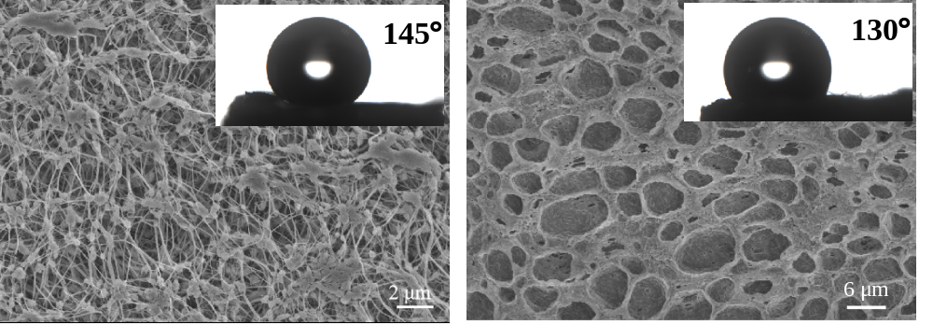
Figure S1 SEM images of the surface morphologies of (a) ePTFE and (b) PVDF-HFP (insets: the respective surface contact angles).

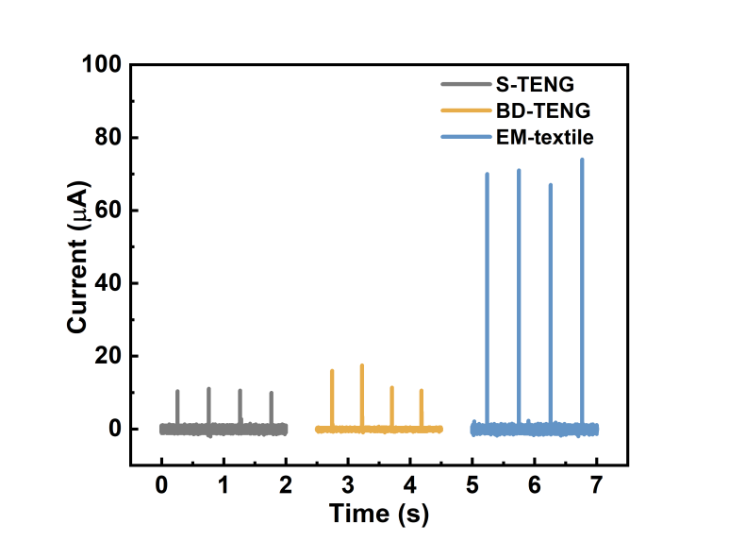
Figure S2 Short-circuit current comparison between EM-textile and S-TENG and BD-TENG.

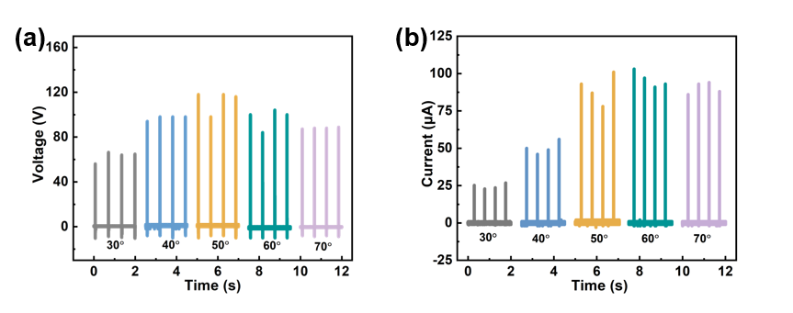
Figure S3 (a) Open circuit voltage and (b) short-circuit current of EM-textile at different inclination angles.

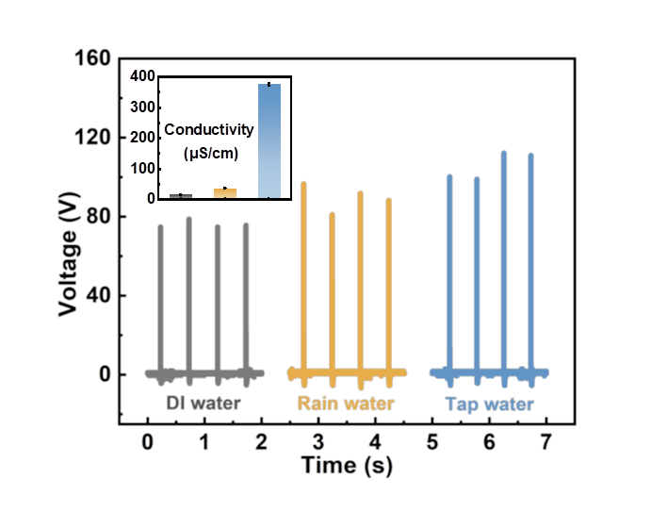
Figure S4 Output voltage of the EM-textile using different kinds of water, containing DI water, rain water and tap water, including conductivities of different kinds of water.

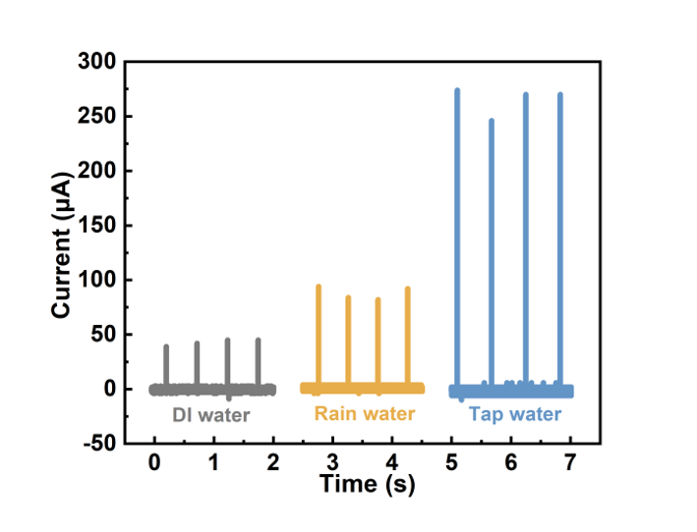
Figure S5 Short-circuit currents of different types of water including DI water, rain water and tap water.

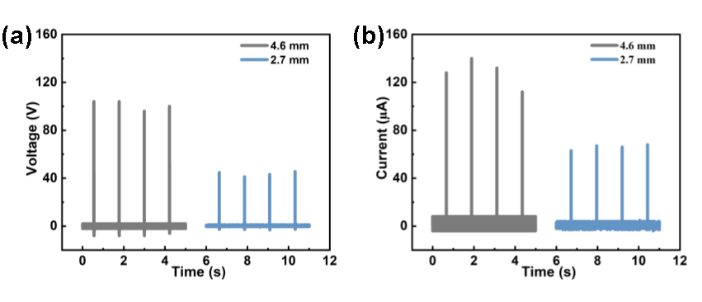
Figure S6 (a) Open-circuit voltage and (b) short-circuit current generated by the droplets with diameters of 4.6 mm and 2.7 mm, respectively.

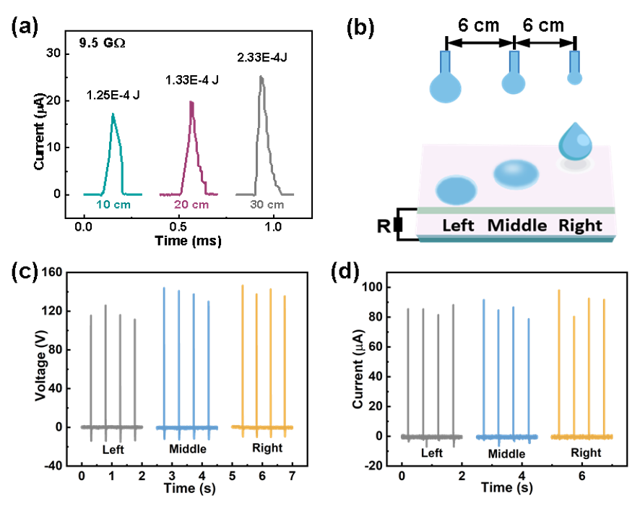
Figure S7 (a) Individual droplet output energy at different drop heights under 9.5 GΩ external resistance in the inset. (b) Schematic illustration of several droplets dropping on one EM-textile surface. (c) Open circuit voltage and (d) short-circuit current signals of the EM-textile for the three droplets.

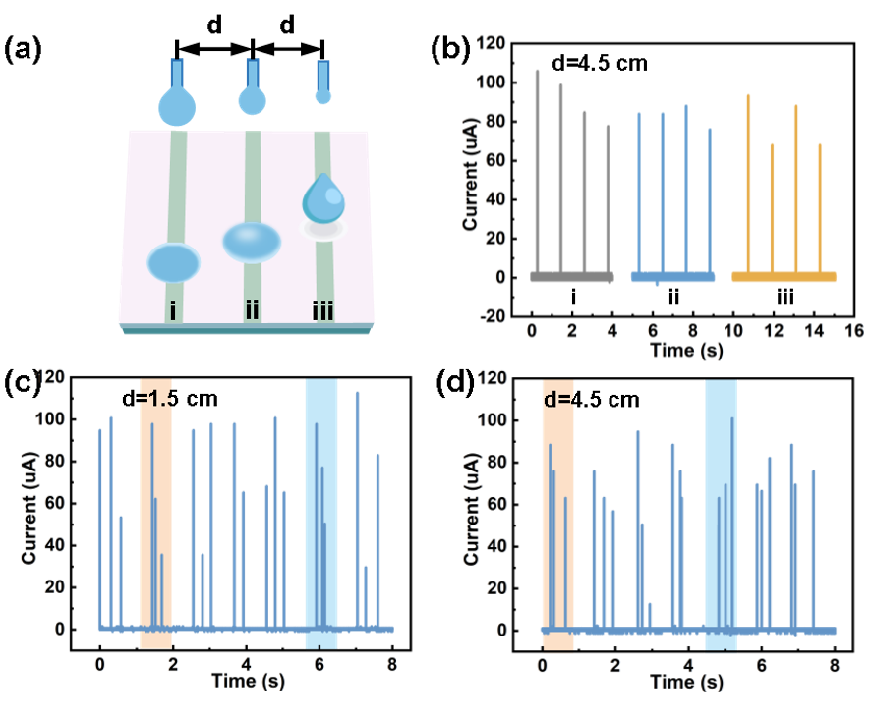
Figure S8 (a) Schematic illustration of several droplets dropping on three identical Ag electrodes (i, ii and iii). (b) Short-circuit current signals simultaneously recorded from Ag electrodes i, ii, and iii with a spacing of 4.5 cm. (c) The common short-circuit current signals of the three Ag electrodes with spacings of 1.5 cm and d) 4.5 cm over a period of 8 seconds.

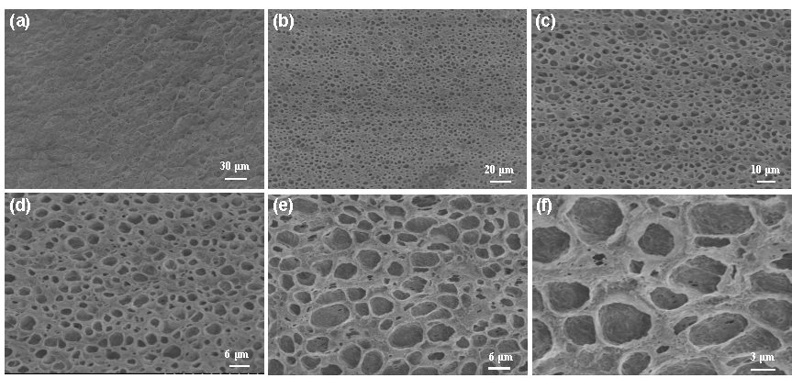
Figure S9 SEM micrographs of PVDF-HFP at six different magnifications.

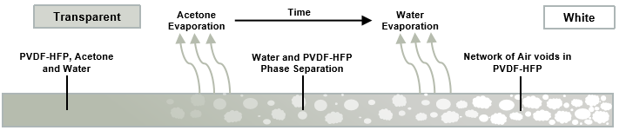
Figure S10 The formation and schematic of the phase inversion process of PVDF-HFP, showing the formation of a hierarchically porous polymer coating from a solution of acetone (solvent), water (nonsolvent), and PVDF-HFP (polymer).

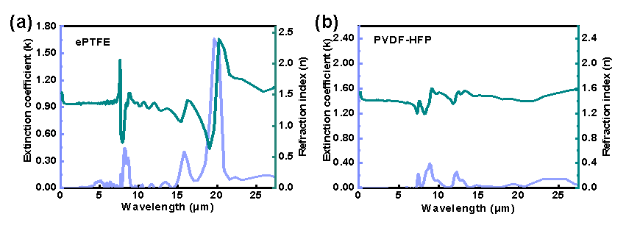
Figure S11 Extinction coefficient and refractive index of (a) ePTFE and (b) PVDF-HFP.

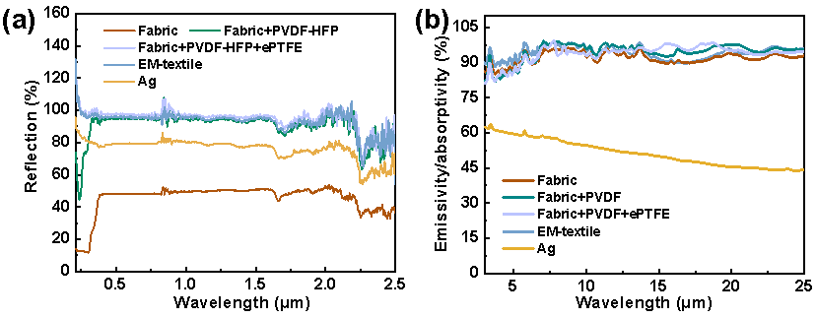
Figure S12 Reflectivity and emissivity of different samples.

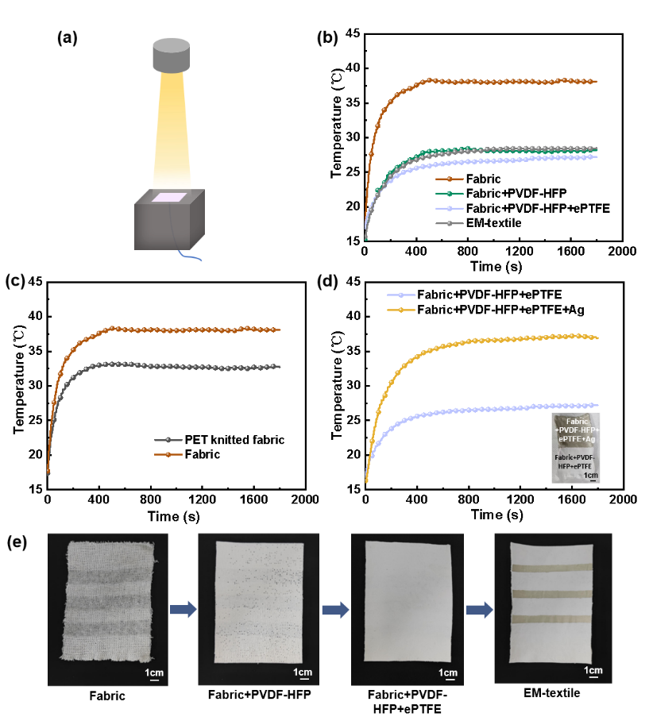
Figure S13 Laboratory simulation test. (a) Schematic diagram of the test; (b)-(d) Reflectance of samples in different stages; (e) Photos of different samples in different stages.

To verify the radiative cooling performance of the EM-textile, we conducted indoor cooling measurements using a custom open environment chamber equipped with an AM 1.5 filter and a Xeon lamp. Under 1-sun illumination, as shown in Figure S13, the sample (Fabric) reached a significantly high temperature (~38 °C) after 504 s of solar exposure, which was approximately 12.5 °C higher than the sample (Fabric+PVDF-HFP+ePTFE) and 11 °C higher than the sample (Fabric+PVDF-HFP+ePTFE+Ag). This highlights the effectiveness of the porous composite material in enhancing the passive cooling performance of the EM-textile.

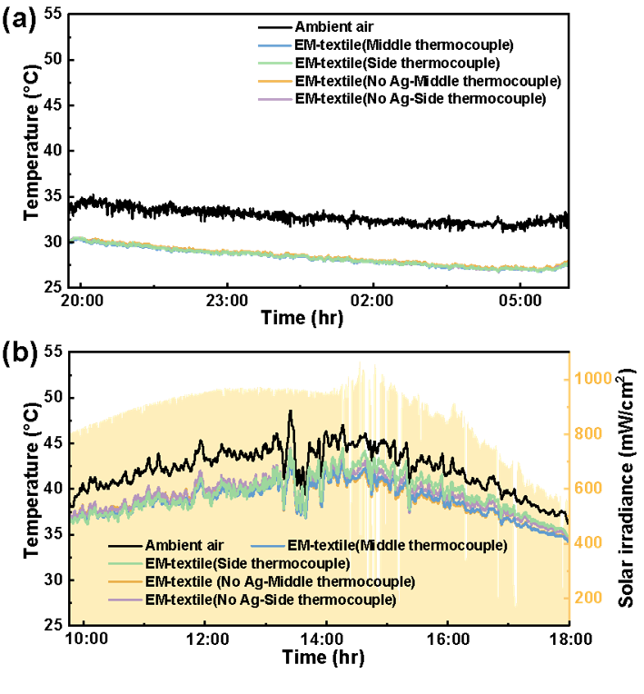
Figure S14 Continuous temperature measurement of the subambient cooling performance test in Suzhou, China (31° 16′ 21.86″ N, 120° 43′ 35.52″ E, 29th and 30th of July, 2024), in the night and (b) during the daytime.

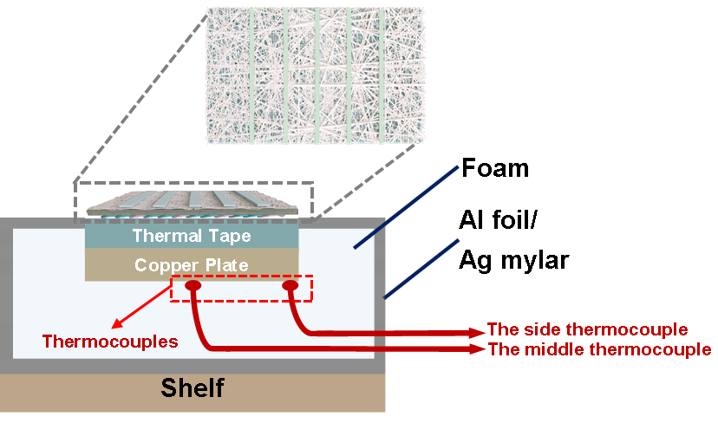
Figure S15 The schematic illustration of EM-textile for the outdoor thermal measurement in thermal insulating foam box.

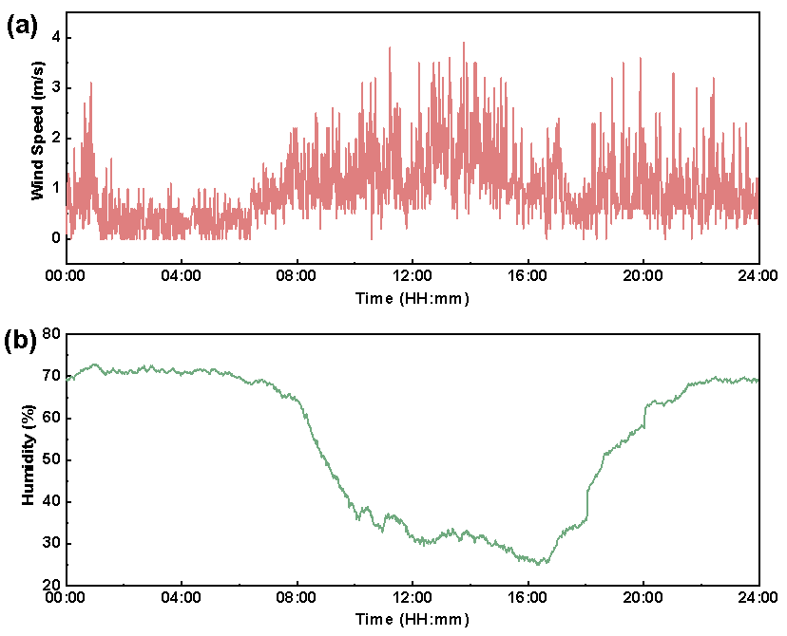
Figure S16 The ambient condition during the outdoor cooling performance measurement. (a) Relative variation of wind speed and (b) relative humidity variation for the one-day cycle of the outdoor cooling performance measurement in Suzhou, China.

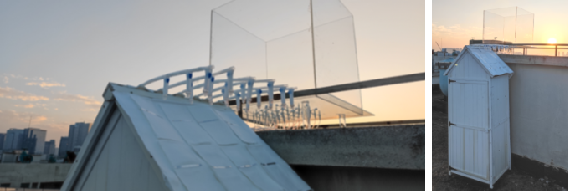
Figure S17 Schematic illustration of the EM-textile.

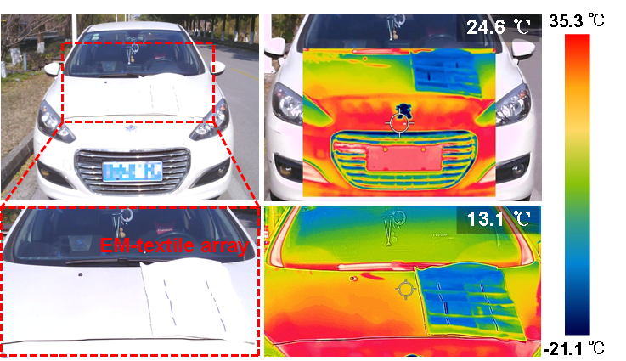
Figure S18 Photo and thermal imaging display of the car surface with and without EM-textile coverage.

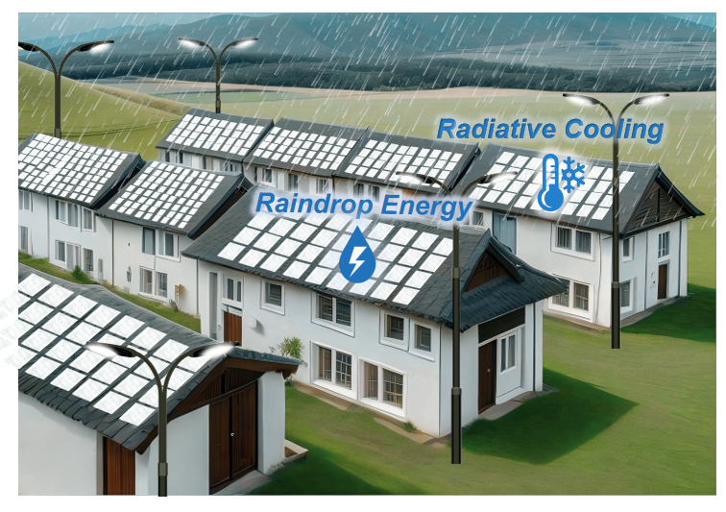
Figure S19 Conceptual schematic diagram of the EM-textile applied as a building envelope.

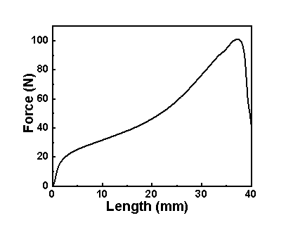
Figure S20 Stretchable properties of EM-textile.

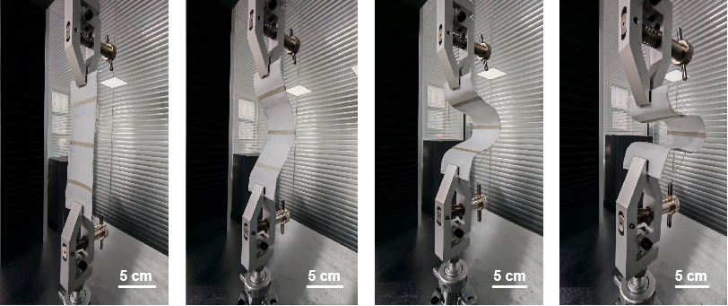
Figure S21 The bending resistance of EM-textile.

Table S1. Optical properties of conventional roof and the roof covered by EM-textile materials used in the EnergyPlus simulation.
Properties | EM-textile-covered roof | The conventional roof
Thermal Absorptance (2.5~16 µm) | 0.950 | 0.910
Solar Absorptance | 0.040 | 0.240
Visible Absorptance | 0.040 | 0.220

Supplementary references
1. Y. Wang, Z. Wang, L. Sun, et al., "Scale manufacturing of braided coaxial triboelectric yarns for flexible wearable smart electronics for energy harvesting, motion sensing and human-computer interaction," Chemical Engineering Journal 520 (2025): 165881.
2. T. Wang, Y. Wu, L. Shi, et al., "A structural polymer for highly efficient all-day passive radiative cooling," Nature Communications 12 (2021): 365.
3. P. C. Yao, Z. P. Chen, T. J. Liu, et al., "Spider-silk-inspired nanocomposite polymers for durable daytime radiative cooling," Advanced Materials 34 (2022): 2208236.
4. D. Li, X. Liu, W. Li, et al., "Scalable and hierarchically designed polymer film as a selective thermal emitter for high-performance all-day radiative cooling," Nature Nanotechnology 16 (2021): 153.
5. R. H. Wu, C. X. Sui, T. H. Chen, et al., "Spectrally engineered textile for radiative cooling against urban heat islands," Science 384 (2024): 1203-1212.
6. B. Zhu, W. Li, Q. Zhang, et al., "Subambient daytime radiative cooling textile based on nanoprocessed silk," Nature Nanotechnology 16 (2021): 1342-U1336.
7. J. N. Song, W. L. Zhang, Z. N. Sun, et al., "Durable radiative cooling against environmental aging," Nature Communications 13 (2022): 4805.
8. S. H. Fan, and W. Li, "Photonics and thermodynamics concepts in radiative cooling," Nature Photonics 16 (2022): 182-190.
9. S. Goel, R. Athalye, and W. Wang, et al., "Enhancements to ASHRAE standard 90.1 prototype building models," Tech. Rep. PNNL-23269 (Pacific Northwest National Laboratory, 2014). Figshare https://api.semanticscholar.org/CorpusID:111908017 (2014).
10. M. Deru, K. Field, and D. Studer, et al., "U.S. department of energy commercial reference building models of the national building stock," Tech. Rep. NREL/TP-5500-46861 (National Renewable Energy Laboratory, 2011). Figshare https://doi.org/10.2172/1009264 (2011).
11. American Society of Heating, Refrigerating and air-conditioning engineers (ASHRAE), ASHRAE 90.1(I-P): Standard 90.1-2016 (I-P edition)-energy standard for buildings except low-rise residential buildings. Figshare https://www.ashrae.org/technical-resources/ashrae-standards-and-guidelines (2016).

