Supplemental Material
Five supplemental figures, one picture and five tables are included in below.

Supplementary Figures
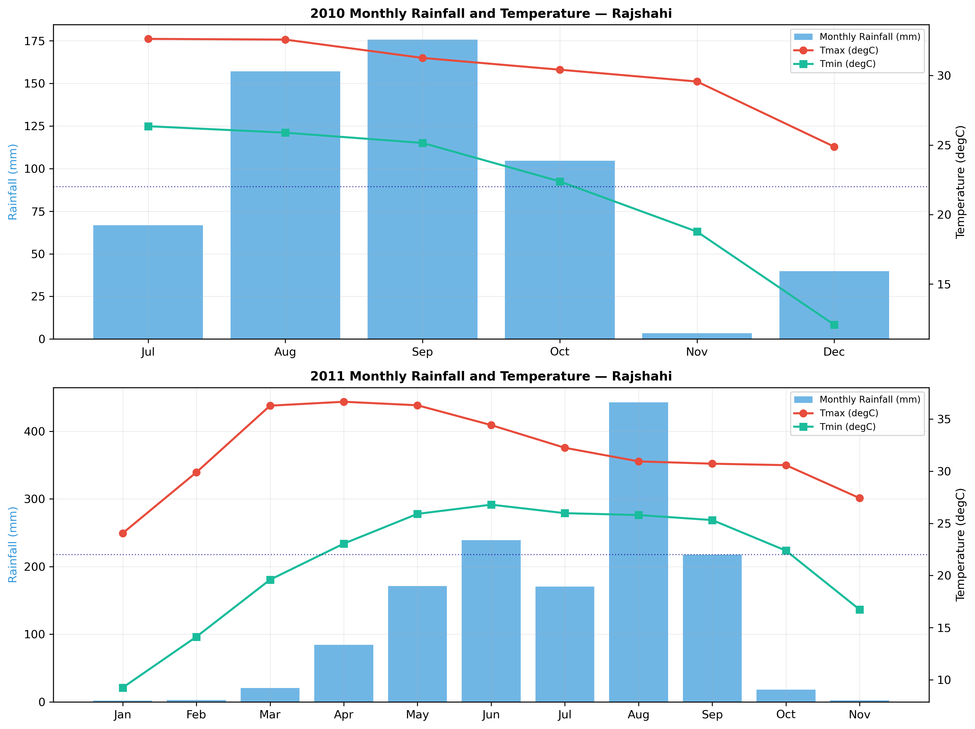
Figure S1 Monthly rainfall (mm) and mean maximum/minimum air temperature (°C) at BRRI Regional Station, Rajshahi during the 2010 (left) and 2011 (right) wet seasons (July-November). Data from NASA POWER Release 8 [21]. Shaded bars = monthly rainfall; solid line = mean maximum temperature; dashed line = mean minimum temperature. Vertical dashed lines indicate approximate anthesis periods for T1 (25-DAS, green), T2 (35-DAS, orange), and T3 (45-DAS, red) transplanting treatments. Note the severe reduction in October rainfall in 2011 compared with 2010, representing the terminal drought that coincided with reproductive stages in late-transplanted treatments.
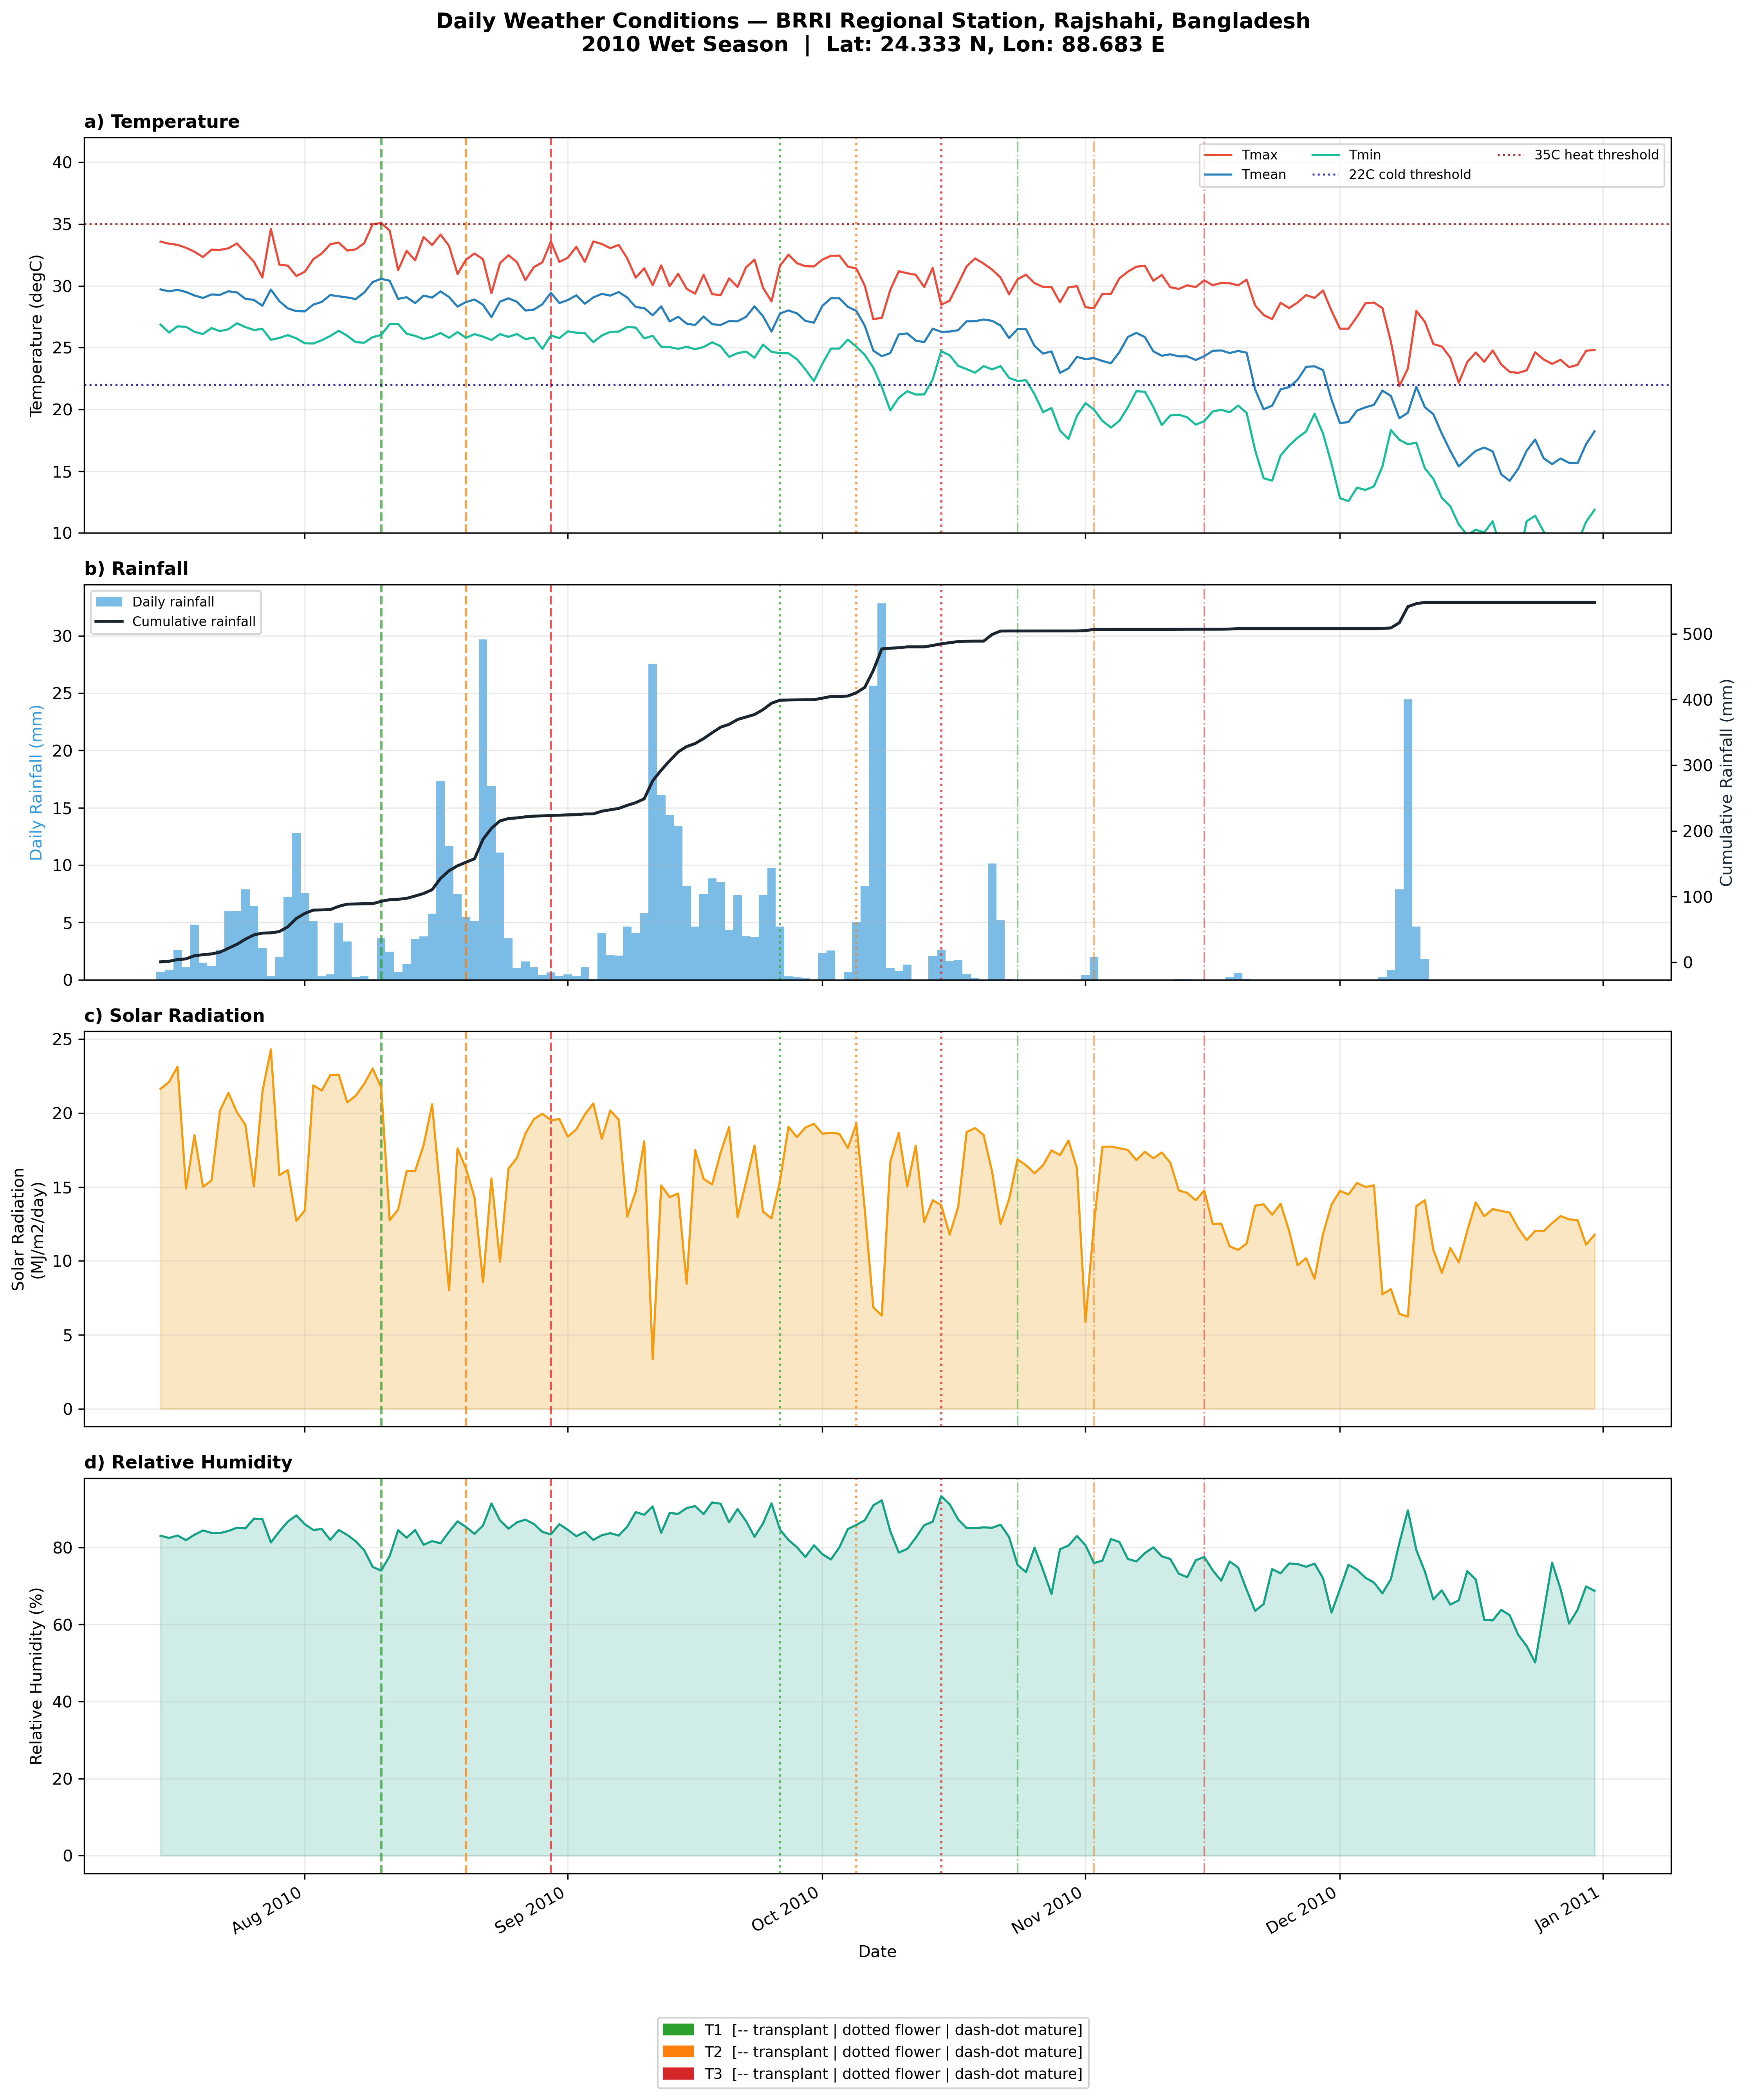
Figure S2 Daily weather conditions at BRRI Rajshahi during the 2010 wet season (15 July-30 November). (a) Daily maximum (red) and minimum (blue) air temperature (°C); horizontal dashed lines indicate the 35°C heat stress threshold and 22°C cold-induced sterility threshold. (b) Daily rainfall (bars, mm) and cumulative rainfall (line, mm). (c) Daily all-sky surface solar radiation (MJ m-2 day-1). (d) Relative humidity at 2 m (%). Vertical shaded zones indicate the approximate flowering windows for T1 (green), T2 (orange), and T3 (red) transplanting treatments. Data source: NASA POWER Release 8 [21].
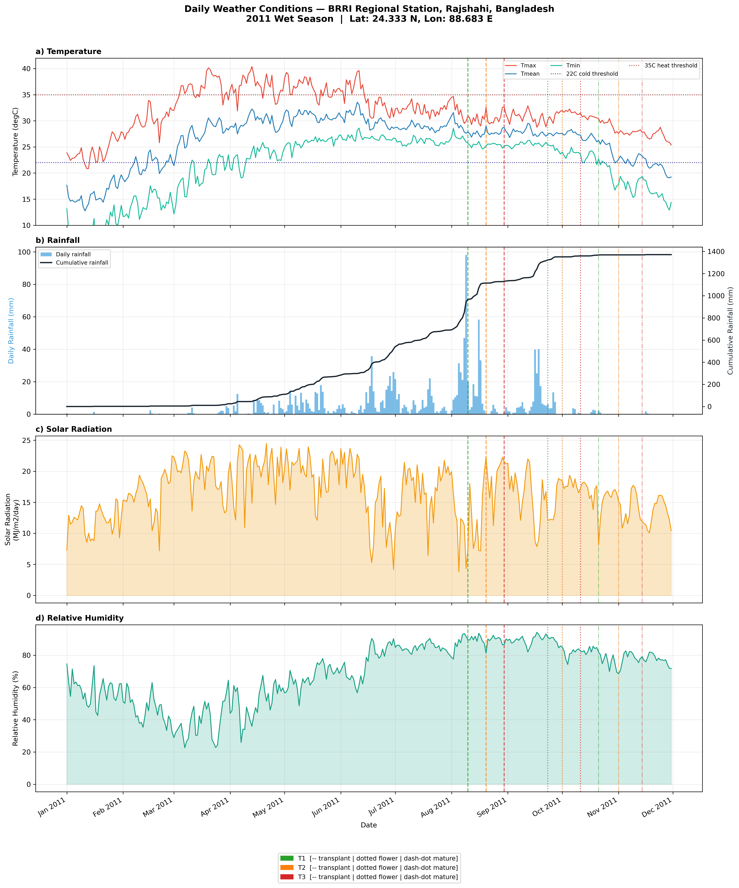
Figure S3 Daily weather conditions at BRRI Rajshahi during the 2011 wet season (15 July-30 November). Panel arrangement identical to Fig. S2. Note: (i) maximum temperatures exceeding 35°C during June-July 2011 coinciding with early vegetative growth; (ii) minimum temperatures dropping below 22°C on multiple nights during late-September T3 anthesis; (iii) the 18-day consecutive dry spell (September 15-October 2, 2011) marked by pink shading in panel (b), directly overlapping the flowering period for T2 and early grain filling for T1 treatments. Data source: NASA POWER Release 8 [21].
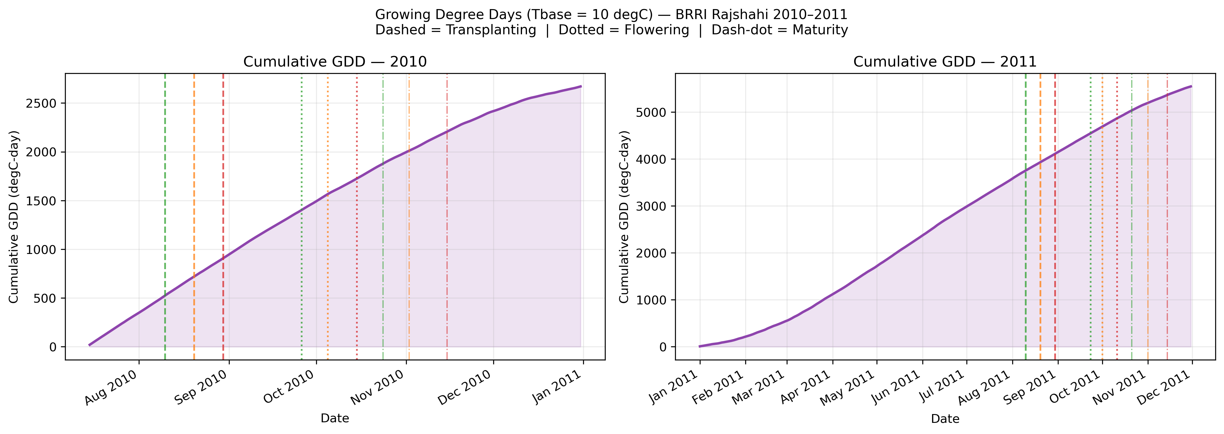
Figure S4 Cumulative growing degree days (GDD, base temperature 10°C) from transplanting to physiological maturity for three transplanting treatments (T1, T2, T3) in 2010 (left panel) and 2011 (right panel) at BRRI Rajshahi. GDD calculated as [(T_max + T_min)/2] - 10; negative daily values set to zero. Total cumulative GDD ranged 2630-2710°C·day in 2010 versus 5210-5380°C·day in 2011. Data source: NASA POWER Release 8 [21].
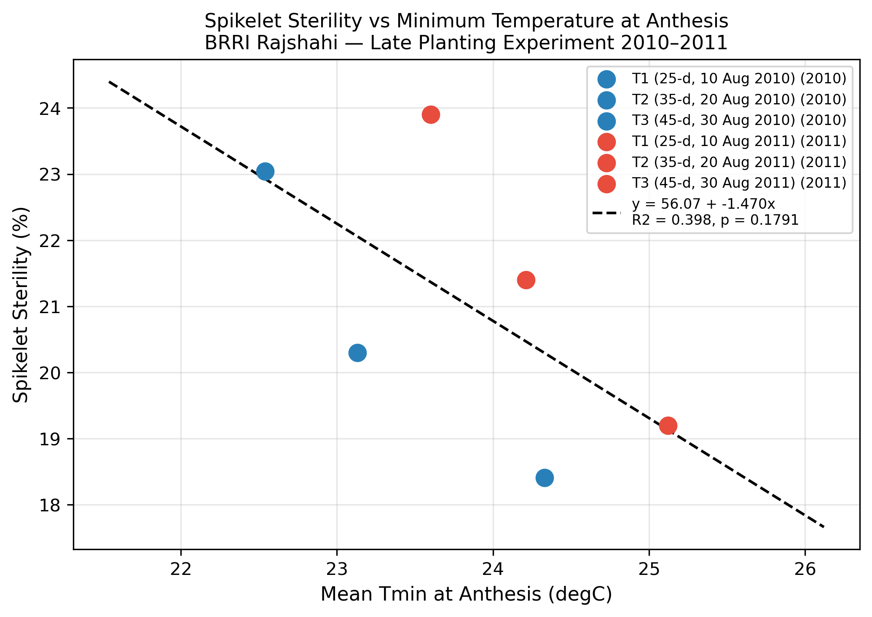
Figure S5 Relationship between mean minimum temperature during the 14-day anthesis window (°C) and spikelet sterility (%) for six rice genotypes across three transplanting treatments and two years (n = 36 observations). Fitted linear regression: Sterility (%) = 56.07 - 1.470 x Tmin; R2 = 0.398, p = 0.179. Blue filled circles = 2010 observations; red open circles = 2011 observations. IR83377-B-B-93-3 and IRRI123 in 2011 T3 conditions fell below the regression line, indicating better-than-expected spikelet fertility maintenance.

Effect of late transplanting on the performances of rice genotypes in drought-prone rainfed environments
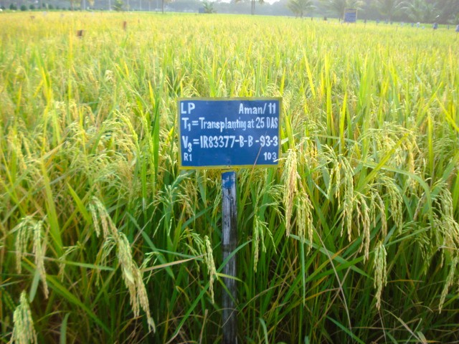 | 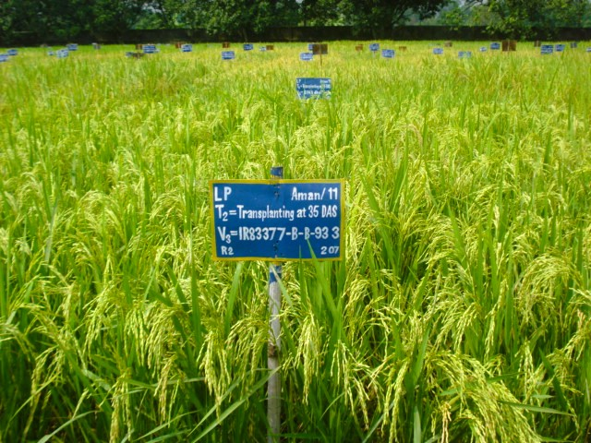 | 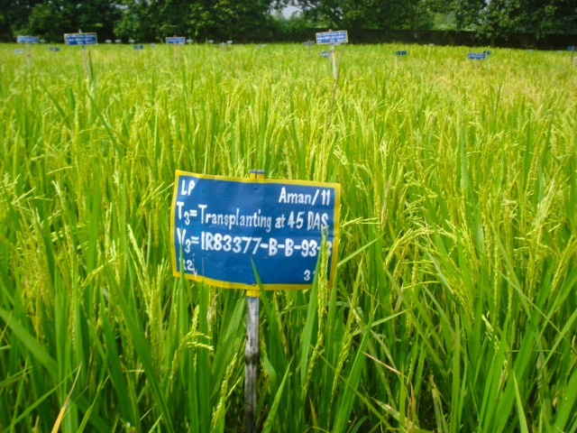
IR83377-B-B-93-3 transplanted 25-d old seedling age | IR83377-B-B-93-3 transplanted 35-d old seedling, 10-d late | IR83377-B-B-93-3 transplanted 45-d old seedlings, 20-d late
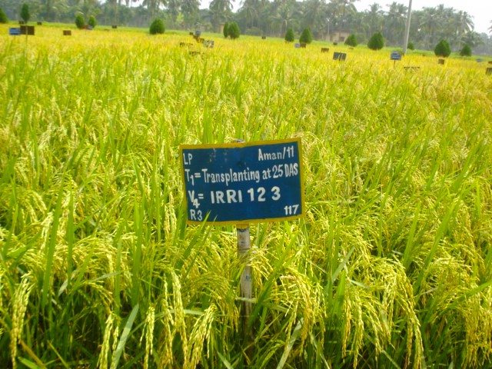 | 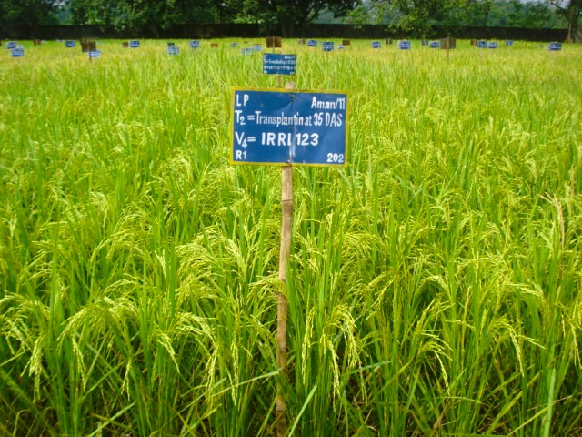 | 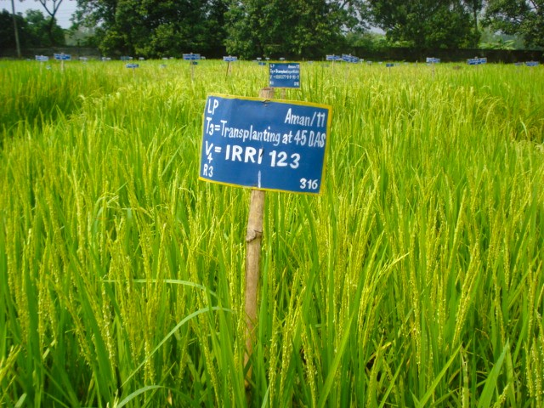
IRRI123 transplanted 25-d old seedling age | IRRI123 transplanted 35-d old seedling, 10-d late | IRRI123 transplanted 45-d old seedlings, 20-d late
PICTURE S1 Better performing two rice genotypes IR83377-B-B-93-3 and IRRI123 showing better yield even in the late plantings. Seeding of all the treatments on same date, but transplanting dates were different means transplanted in three dates, optimum seedling age, 10-day late and 20-day late with 25, 35 and 45-day old seedlings. Moreover, Irrespective of genotypes, days to flowering and maturity were increased by 6 to 12 days as a consequence of delayed transplanting by 10 to 20-days.

Supplementary Tables
TABLE S1 Complete stress tolerance indices (SSI, STI, GMP, TOL) for all six rice genotypes under both T2 (10-day delay) and T3 (20-day delay) stress levels in 2010 and 2011 wet seasons at BRRI Rajshahi.
Genotype | Year | Stress | Yp (t ha⁻¹) | Ys (t ha⁻¹) | SSI | STI | GMP (t ha⁻¹) | TOL (t ha⁻¹)
BRRI dhan56 | 2010 | T2 (10-d) | 4.916 | 4.616 | 0.549 | 0.938 | 4.763 | 0.300
BRRI dhan57 | 2010 | T2 (10-d) | 4.284 | 3.310 | 2.049 | 0.586 | 3.766 | 0.975
IR83377-B-B-93-3 | 2010 | T2 (10-d) | 5.446 | 5.059 | 0.639 | 1.139 | 5.249 | 0.386
IRRI123 | 2010 | T2 (10-d) | 5.112 | 4.877 | 0.414 | 1.031 | 4.993 | 0.235
IR83381-B-B-6-1 | 2010 | T2 (10-d) | 4.648 | 4.014 | 1.229 | 0.772 | 4.320 | 0.635
Binadhan-7 | 2010 | T2 (10-d) | 5.100 | 4.353 | 1.318 | 0.918 | 4.712 | 0.746
BRRI dhan56 | 2010 | T3 (20-d) | 4.916 | 3.646 | 0.924 | 0.741 | 4.234 | 1.270
BRRI dhan57 | 2010 | T3 (20-d) | 4.284 | 2.515 | 1.477 | 0.446 | 3.283 | 1.769
IR83377-B-B-93-3 | 2010 | T3 (20-d) | 5.446 | 4.522 | 0.607 | 1.018 | 4.962 | 0.924
IRRI123 | 2010 | T3 (20-d) | 5.112 | 4.631 | 0.337 | 0.979 | 4.866 | 0.481
IR83381-B-B-6-1 | 2010 | T3 (20-d) | 4.648 | 3.030 | 1.245 | 0.582 | 3.753 | 1.618
Binadhan-7 | 2010 | T3 (20-d) | 5.100 | 2.914 | 1.533 | 0.614 | 3.855 | 2.186
BRRI dhan56 | 2011 | T2 (10-d) | 4.810 | 4.550 | 0.484 | 0.949 | 4.678 | 0.260
BRRI dhan57 | 2011 | T2 (10-d) | 4.210 | 3.040 | 2.487 | 0.555 | 3.577 | 1.170
IR83377-B-B-93-3 | 2011 | T2 (10-d) | 5.240 | 5.000 | 0.410 | 1.136 | 5.119 | 0.240
IRRI123 | 2011 | T2 (10-d) | 5.160 | 4.920 | 0.416 | 1.101 | 5.039 | 0.240
IR83381-B-B-6-1 | 2011 | T2 (10-d) | 4.540 | 3.900 | 1.261 | 0.768 | 4.208 | 0.640
Binadhan-7 | 2011 | T2 (10-d) | 4.850 | 4.180 | 1.236 | 0.879 | 4.503 | 0.670
BRRI dhan56 | 2011 | T3 (20-d) | 4.810 | 3.610 | 0.895 | 0.753 | 4.167 | 1.200
BRRI dhan57 | 2011 | T3 (20-d) | 4.210 | 2.410 | 1.534 | 0.440 | 3.185 | 1.800
IR83377-B-B-93-3 | 2011 | T3 (20-d) | 5.240 | 4.510 | 0.500 | 1.025 | 4.861 | 0.730
IRRI123 | 2011 | T3 (20-d) | 5.160 | 4.570 | 0.410 | 1.023 | 4.856 | 0.590
IR83381-B-B-6-1 | 2011 | T3 (20-d) | 4.540 | 2.960 | 1.249 | 0.583 | 3.666 | 1.580
Binadhan-7 | 2011 | T3 (20-d) | 4.850 | 2.720 | 1.576 | 0.572 | 3.632 | 2.130
SSI = Stress Susceptibility Index (Fischer and Maurer, 1978): SSI < 1.0 = stress-tolerant. STI = Stress Tolerance Index (Fernandez, 1992): STI > 1.0 = high combined performance. GMP = Geometric Mean Productivity. TOL = absolute yield loss (Rosielle and Hamblin, 1981). Yp = optimum yield (T1); Ys = yield under stress treatment.

TABLE S2 Linear regression parameters for grain yield response to transplanting delay (0, 10, 20 days) for six rice genotypes at BRRI Rajshahi in 2010 and 2011 wet seasons.
Genotype | Year | Intercept (t ha⁻¹) | Slope (t ha⁻¹ day⁻¹) | R² | p-value | % Loss T2 | % Loss T3
BRRI dhan56 | 2010 | 5.027 | -0.0635 | 0.915 | 0.188 | 12.6 | 25.3
BRRI dhan56 | 2011 | 4.923 | -0.0600 | 0.903 | 0.201 | 12.2 | 24.4
BRRI dhan57 | 2010 | 4.254 | -0.0885 | 0.997 | 0.037 | 20.8 | 41.6
BRRI dhan57 | 2011 | 4.120 | -0.0900 | 0.971 | 0.109 | 21.8 | 43.7
IR83377-B-B-93-3 | 2010 | 5.471 | -0.0462 | 0.991 | 0.060 | 8.4 | 16.9
IR83377-B-B-93-3 | 2011 | 5.282 | -0.0365 | 0.962 | 0.124 | 6.9 | 13.8
IRRI123 | 2010 | 5.114 | -0.0241 | 1.000 | 0.009 | 4.7 | 9.4
IRRI123 | 2011 | 5.178 | -0.0295 | 0.989 | 0.068 | 5.7 | 11.4
IR83381-B-B-6-1 | 2010 | 4.707 | -0.0809 | 0.985 | 0.079 | 17.2 | 34.4
IR83381-B-B-6-1 | 2011 | 4.590 | -0.0790 | 0.988 | 0.070 | 17.2 | 34.4
Binadhan-7 | 2010 | 5.215 | -0.1093 | 0.968 | 0.115 | 21.0 | 41.9
Binadhan-7 | 2011 | 4.982 | -0.1065 | 0.956 | 0.134 | 21.4 | 42.8
Intercept = predicted yield at 0 days delay (t ha-1). Slope = daily yield loss rate (t ha-1 day-1). R2 = coefficient of determination. p = F-test p-value for slope. % Loss at T2/T3 = percentage reduction from regression vs T1.

TABLE S3 Principal component analysis loadings for 18 agronomic traits across 36 observations (6 genotypes x 3 treatments x 2 years) at BRRI Rajshahi in 2010-2011.
Trait | PC1 (68.4%) | PC2 (16.1%) | PC3 (10.0%) | PC4 (3.5%) | PC5 (1.5%) | PC6 | Communality
GY | 0.280 | 0.066 | -0.028 | 0.133 | -0.080 | 0.021 | 0.083
SY | 0.264 | -0.002 | -0.091 | 0.389 | -0.082 | 0.018 | 0.070
TDM | 0.278 | 0.042 | -0.050 | 0.226 | -0.081 | 0.011 | 0.079
HI | 0.271 | 0.122 | 0.042 | -0.075 | -0.056 | 0.043 | 0.088
PPM | 0.240 | -0.220 | -0.283 | -0.090 | -0.051 | 0.022 | 0.106
TGW | 0.156 | 0.418 | -0.034 | 0.569 | -0.126 | 0.051 | 0.199
STER | -0.274 | -0.058 | -0.093 | 0.303 | -0.079 | 0.031 | 0.079
FERT | 0.274 | 0.058 | 0.093 | -0.303 | 0.079 | 0.031 | 0.079
PANL | 0.251 | 0.191 | -0.095 | -0.089 | 0.559 | 0.074 | 0.099
GPP | 0.239 | 0.142 | 0.329 | -0.248 | -0.215 | 0.047 | 0.077
TSP | 0.194 | 0.180 | 0.454 | -0.185 | -0.401 | 0.050 | 0.070
DTF | -0.048 | 0.499 | -0.352 | -0.204 | -0.004 | 0.082 | 0.252
DTM | -0.036 | 0.507 | -0.347 | -0.174 | -0.055 | 0.088 | 0.259
PHT | 0.247 | -0.004 | 0.257 | 0.114 | 0.618 | 0.094 | 0.061
TPM | 0.238 | -0.221 | -0.285 | -0.092 | -0.125 | 0.021 | 0.106
TPH | 0.237 | -0.223 | -0.288 | -0.095 | -0.132 | 0.019 | 0.106
PPH | 0.239 | -0.219 | -0.285 | -0.096 | -0.054 | 0.018 | 0.105
GYKPHPD | 0.276 | -0.081 | 0.091 | 0.207 | -0.078 | 0.033 | 0.083
Eigenvector loadings for each trait on each PC. Variance explained shown in parentheses. Analysis performed on standardized data using correlation matrix [24].
TABLE S4 Stage-specific agroclimatic stress summary for each transplanting treatment and year at BRRI Rajshahi, Bangladesh, 2010-2011.
Year | Treatment | Stage | Tmax (°C) | Tmin (°C) | Rain (mm) | CDD max | GDD sum | Heat days | Cold days
2010 | T1 | Vegetative | 32.6 | 25.9 | 203.2 | 7 | 596 | 1 | 0
2010 | T1 | Anthesis | 31.3 | 24.0 | 122.6 | 0 | 230 | 0 | 0
2010 | T1 | Grain fill | 30.4 | 22.4 | 99.7 | 10 | 508 | 0 | 0
2010 | T2 | Vegetative | 32.6 | 25.9 | 222.6 | 6 | 596 | 0 | 0
2010 | T2 | Anthesis | 30.4 | 22.3 | 48.2 | 6 | 185 | 0 | 5
2010 | T2 | Grain fill | 29.6 | 18.8 | 26.6 | 15 | 425 | 0 | 0
2010 | T3 | Vegetative | 32.6 | 25.9 | 179.1 | 9 | 596 | 0 | 0
2010 | T3 | Anthesis | 30.4 | 23.6 | 85.1 | 5 | 210 | 0 | 0
2010 | T3 | Grain fill | 29.6 | 18.8 | 8.0 | 23 | 425 | 0 | 0
2011 | T1 | Vegetative | 30.9 | 25.8 | 211.7 | 9 | 569 | 0 | 0
2011 | T1 | Anthesis | 30.7 | 24.8 | 171.6 | 1 | 235 | 0 | 0
2011 | T1 | Grain fill | 30.6 | 22.4 | 17.0 | 16 | 511 | 0 | 0
2011 | T2 | Vegetative | 30.9 | 25.8 | 127.7 | 10 | 569 | 0 | 0
2011 | T2 | Anthesis | 30.7 | 23.8 | 133.9 | 4 | 210 | 0 | 0
2011 | T2 | Grain fill | 27.4 | 16.7 | 13.7 | 20 | 362 | 0 | 0
2011 | T3 | Vegetative | 30.9 | 25.8 | 223.2 | 4 | 569 | 0 | 0
2011 | T3 | Anthesis | 30.7 | 23.2 | 16.0 | 12 | 200 | 0 | 2
2011 | T3 | Grain fill | 27.4 | 16.7 | 8.3 | 25 | 362 | 0 | 0
Heat days = days with Tmax > 35°C. Cold days = days with Tmin < 22°C during 14-day anthesis window. CDD max = maximum consecutive dry days (daily rain < 1 mm). GDD = cumulative growing degree days (base 10°C). Data: NASA POWER Release 8.

TABLE S5 Monthly agroclimatic summary for BRRI Rajshahi experimental seasons, 2010-2011, from NASA POWER Agroclimatology database [21].
Month | Tmax (°C) | Tmin (°C) | Tmean (°C) | Rain (mm d⁻¹) | Solar rad. (MJ m⁻² d⁻¹) | RH (%) | GDD (°C·d)
2010-Jul | 32.64 | 26.35 | 29.12 | 2.16 | 18.64 | 84.45 | 331.44
2010-Aug | 32.59 | 25.89 | 28.92 | 5.07 | 17.50 | 83.56 | 596.40
2010-Sep | 31.27 | 25.15 | 27.88 | 5.86 | 16.18 | 86.01 | 546.28
2010-Oct | 30.42 | 22.38 | 26.16 | 3.38 | 15.71 | 82.86 | 508.44
2010-Nov | 29.57 | 18.76 | 23.69 | 0.12 | 13.70 | 74.76 | 425.01
2010-Dec | 24.88 | 12.06 | 17.76 | 1.29 | 12.01 | 68.38 | 262.54
2011-Jul | 32.24 | 25.98 | 28.83 | 5.50 | 17.10 | 84.78 | 592.42
2011-Aug | 30.94 | 25.80 | 28.16 | 14.28 | 14.62 | 88.88 | 569.43
2011-Sep | 30.72 | 25.32 | 27.74 | 7.26 | 15.75 | 89.34 | 540.53
2011-Oct | 30.58 | 22.38 | 26.34 | 0.58 | 16.62 | 80.32 | 510.94
2011-Nov | 27.42 | 16.73 | 21.74 | 0.08 | 13.64 | 77.60 | 362.18
Rain = monthly mean daily rainfall (mm day-1). Solar rad. = all-sky surface solar radiation. RH = relative humidity at 2 m. GDD = monthly total growing degree days (base 10°C). Coordinates: 24.333°N, 88.683°E.
Note: Citation numbers in this supplement correspond to the numbered reference list in the main manuscript.

