Pathway decoupling of heat and electricity by a thermal invisible gateway

Jiahao Li ^{1,#}, Fei Sun ^{1,#,*}, Yichao Liu^{1,*}, Yawen Qi¹, Qin Liao¹, and Jianpu Yang¹
¹Key Lab of Advanced Transducers and Intelligent Control System, Ministry of Education and Shanxi Province, College of Physics and Optoelectronics, Taiyuan University of Technology, Taiyuan, 030024 China
# These authors contribute equally to this work
* Corresponding author: sunfei@tyut.edu.cn
liuyichao@tyut.edu.cn

Supplementary Note 1. Numerical Method and Settings
All numerical simulations in this study are performed based on the finite element method using the commercial software COMSOL Multiphysics 5.6 (license number: 9406999; official website: https://www.comsol.com). Both 2D and 3D Solid Heat Transfer and Electric Current modules are employed in conjunction with a stationary solver to accurately simulate the distribution characteristics of the temperature and electric potential fields. Free tetrahedral meshing with automatically generated grids is adopted, balancing computational accuracy and efficiency.
The simulations for Fig. 2(a)–(c) employ a 2D steady-state numerical simulation scheme, focusing on investigating the electrothermal transport behaviors of the thermal invisible gateway structure and comparative structures. The geometric parameters of the simulation model for Fig. 2(a) (structure integrated with the thermal invisible gateway) are consistent with those in the main text: length parameters L₁=0.13 m and L₂=0.06 m, width parameters D₁=0.12 m, D₂=0.04 m and D₄=0.02 m, and ATMSs spacing parameters L₃=0.04 m and D₃=0.01 m. The upper and lower boundaries of the computational domain are set to thermal insulation and electrical insulation conditions to eliminate interference from the external environment on the simulation results. Initially, the temperature field and electric potential field of the entire structure are uniformly distributed, set to T₀=293 K and φ₀=0 V, respectively. To drive the unidirectional transmission of heat flux and electric current from left to right, a constant high temperature T₁=313 K and a constant high potential V₁=1 V are applied to the left boundary, while a constant low temperature T₂=293 K and a constant low potential V₂=0 V are applied to the right boundary. Material parameters are strictly set in accordance with the experimental conditions in the main text: the thermal conductivity and electrical conductivity of the copper substrate are 400 W/(m·K) and 5.96×10⁷ S/m (consistent with the intrinsic properties of copper); the thermal conductivity and electrical conductivity of the air region are 0.026 W/(m·K) (consistent with the air thermal conductivity parameter in the main text) and 1 S/m, respectively. The active thermal metasurfaces (ATMSs) realizing the thermal invisible gateway function are simulated as four line heat sources. Based on the theoretically derived Equations (1)–(3) in the main text, their power density parameters are set as follows: the power densities of the two line heat sources on the high-temperature side of the bridge interface are both Q=+1600 W/m, and those on the low-temperature side are both Q=-1600 W/m. Notably, simulation verification results show that each ATMS unit represented by a line heat source can be further subdivided into multiple discrete units, and consistent thermal regulation effects can be achieved as long as the total input or absorbed power remains unchanged. For systematic comparison and analysis, 2D steady-state temperature field and electric potential field simulations are also conducted for two other structures under identical boundary conditions and material parameters: an intact copper bridge structure without a thermal invisible gateway (corresponding to Fig. 2(b), with geometric parameters L₁=0.13 m, D₁=0.12 m, L₂=0.06 m, D₂=0.04 m) and a structure with the bridge interface completely separated by air (corresponding to Fig. 2(c), with geometric parameters L₁=0.13 m, D₁=0.12 m, L₂=0.06 m).
The simulations presented in Fig. 3(c) (thermal performance verification) and Fig. 3(d) (electrical performance verification) are performed using full three-dimensional (3D) models. In comparison to the two-dimensional (2D) simulation framework adopted earlier in this work, the 3D models preserve the majority of structural parameters (L₁, L₂, L₃, D₁, D₂, D₃, D₄). The key distinctions lie in the inclusion of a thickness dimension, as well as adjustments to the heat source configurations and electrical component layouts tailored to the actual sample structure and experimental setup, thereby enhancing the agreement between numerical predictions and experimental results. For the 3D thermal simulation of Fig. 3(c), the thickness of the entire structure is set to 0.001 m (consistent with the sample thickness H=0.001 m in the main text). The temperatures of the high-temperature heat source and low-temperature cold source are consistent with those adopted in the experiment, which are 305.8 K and 293.8 K, respectively. Instead of the line heat sources used in the 2D simulation, cuboid heat sources attached to the surface of the dumbbell-shaped copper substrate are adopted, with dimensions of 0.0098 m (length) × 0.0098 m (width) × 0.0026 m (thickness). The constant thermal power density of the cuboid heat sources near the constant high-temperature source is set to 3844551 W/m³, and that near the constant low-temperature source is set to -3844551 W/m³, ensuring consistent energy compensation effects with the 2D simulation. For the 3D electrical simulation of Fig. 3(d), the structure thickness is also set to 0.001 m, and additional components matching the experimental electrical measurement circuit are added: a cylinder with a radius of 0.0005 m and a length of 0.1 m (with the same electrical conductivity as the copper substrate, used as a wire) and a cube with a side length of 0.01 m (electrical conductivity set to 100 S/m, used as a 1 Ω resistor). A constant low potential is applied to the left surface of the cube to drive current transmission, which is fully consistent with the circuit connection method of the experimental setup.

(1) Electrical isolation between the ATMSs and the copper substrate
Each ATMS adopts a ceramic-insulated package, with the semiconductor thermoelectric elements, electrodes, and electrical circuit confined inside the package. The external ceramic layer electrically isolates the ATMS from the copper substrate while allowing heat to be transferred through thermal conduction. Therefore, the ATMS-copper interface has no electrical current path. In particular, $I_{\text{interface}}=0$, and the corresponding interfacial Peltier heat,
$$Q_{P}=ΠI_{interface},$$
is therefore absent. From the perspective of the copper-substrate thermal model, each ATMS can consequently be represented by a prescribed heat source or heat sink with experimentally calibrated thermal power.
(2) Negligible intrinsic thermoelectric effect of the copper substrate
Copper is a highly electrically conductive metal with a small room-temperature Seebeck coefficient. Literature values for bulk copper give $S_{Cu}≈1.83μVK^{-1}$. In the present experiment, the temperature difference between the two ends of the copper substrate is maintained at approximately
$$ΔT=32.8-20.8=12.0K.$$
The maximum Seebeck voltage associated with the copper substrate is therefore
$$V_{Seebeck}=S_{Cu}ΔT≈1.83×12≈21.96μV.$$
Thus, the thermoelectric voltage generated in the copper substrate is only approximately $22μV$, which is negligible compared with the 1 V external voltage used in the electrical measurement. The remaining thermoelectric contribution to the temperature field is mainly associated with Joule heating in the copper path,
$$P_{J}=I_{Cu}^{2}R_{Cu}.$$
This contribution is evaluated from the electrical transport of the continuous copper path and is much smaller than the thermal power supplied or removed by the ATMSs under the experimental operating conditions. Therefore, it does not produce an observable perturbation to the dominant temperature field. Previous thermoelectric finite-element studies have likewise identified Joule heating, Peltier heating, and Seebeck-induced transport as separate contributions that must be considered when thermoelectric components are electrically coupled; in the present configuration, the absence of an electrical connection between the ATMSs and copper substrate eliminates the corresponding interfacial Peltier coupling .
(3) Numerical implementation
Based on the above physical considerations, heat transfer and electrical transport in the copper substrate are solved independently. The thermal field is obtained from the steady-state heat-conduction equation
$$∇⋅\left(k∇T\right)+Q_{ATMS}=0,$$
where $Q_{ATMS}$ represents the prescribed heat flux corresponding to the experimentally calibrated heating/cooling power of each ATMS. The electrical field is calculated separately from
$$∇⋅\left(σ∇V\right)=0.$$
No thermoelectric coupling term is introduced between these two equations because the ATMSs are electrically isolated from the copper substrate and the intrinsic thermoelectric contribution of the copper path is negligible under the experimental conditions.
(4) Deviation between theoretical and experimentally optimized ATMS currents
The initial ATMS currents listed in Table S1 were obtained from the theoretical estimation under the idealized nonlinear current-thermal-power relation. The final currents were subsequently optimized through repeated thermal measurements and fine adjustment. The relative deviation is defined as
$$δ_{I}=\frac{∣I_{initial}-I_{optimized}∣}{I_{initial}}×100\%.$$
The resulting deviations are $47.83\%$, $49.78\%$, $7.44\%$, and $6.70\%$ for ATMSs ①–④, respectively. These values should not be regarded as measurement errors. Instead, they quantify the deviation between the idealized theoretical operating points and the experimentally optimized operating points. The deviation can arise from the nonlinear current-power characteristics of the ATMSs, thermal-contact resistance, assembly tolerances, and differences between the idealized numerical boundary conditions and the actual experimental configuration.
The experimentally optimized currents were therefore used for the final experimental demonstration, while the numerical model uses the corresponding experimentally calibrated thermal powers as the thermal boundary conditions.

Supplementary Note 2. Sample preparation and Pre-experiment preparation
2.1 Sample preparation:
Step 1: A dumbbell-shaped copper substrate as shown in Fig. 1(b) of the main text is fabricated via laser cutting technology, with core dimensional parameters strictly following the design requirements: D₂=0.04 m, L₂=0.06 m, D₃=0.01 m, L₁=0.15 m, D₁=0.12 m, L₃=0.04 m, and thickness H=0.001 m. During the cutting process, equipment parameters are controlled to ensure the substrate edges are smooth and burr-free, with the dimensional error strictly limited to ±0.001 m to meet the experimental precision requirements.
Step 2: In a constant-temperature laboratory (ambient temperature stably maintained at 23 °C), a thin layer of black paint is uniformly sprayed on the infrared thermal imager observation side of the copper substrate. The purpose is to improve the contrast and clarity of infrared imaging, reducing interference from surface reflections and stray light on temperature measurements. The black paint is required to fully cover the observation surface with a uniform thickness; after spraying, the substrate is left to stand for 2 hours until the paint is completely air-dried, with dust prevention measures taken to avoid dust adhesion or external contamination during this period.
Step 3: One active thermal metasurface (ATMS, Model HT009022, TECooler Technology, dimensions: 9.8 mm×9.8 mm×2.6 mm) is assembled on each of the four square copper plate regions at the bridge interface on the non-observation side of the copper substrate. To eliminate air gaps at the contact interface between the ATMSs and the copper substrate and ensure efficient heat transfer, thermal conductive silicone grease VK887 is uniformly applied to the contact surface, avoiding excessive overflow or local absence during application. Subsequently, the ATMSs are firmly bonded using high-strength tape and solid adhesive, and pressed to fit tightly without residual air bubbles, ensuring full contact between the ATMSs and the copper substrate surface with no relative displacement during the experiment.
Step 4: On the surface of the copper substrate where the ATMSs are attached, except for the bridge interface and the areas covered by the ATMSs, an expanded polystyrene (EPS) foam board with a thickness of 2.6 mm and a thermal conductivity of 0.05 W/(m·K) is laid. The foam board is double-fixed to the copper substrate surface using solid glue and tape (see Fig. S1 for the specific assembly structure). This EPS foam board serves dual functions: first, providing thermal insulation protection for non-test areas of the copper substrate to reduce heat loss from non-target regions and concentrate the thermal field on the test area; second, offering stable mechanical support for the copper substrate to prevent deformation or displacement during the experiment. The complete sample preparation process can be found in Supplementary Movie 1.
Step 5: The copper substrate is placed face-down (with the ATMSs-attached side facing downward) on a heat-dissipating copper plate. Thermal conductive silicone grease VK887 is also uniformly applied to the contact interface between the ATMSs and the heat-dissipating copper plate to ensure good thermal contact. The temperature of the heat-dissipating copper plate is stably maintained at 23 °C via an environmental temperature control system (consistent with the experimental ambient temperature). Acting as a thermal buffer layer, the heat-dissipating copper plate can real-time absorb or transfer heat from the bottom surface of the ATMSs, effectively avoiding excessive temperature differences between the upper and lower surfaces of the ATMSs, thereby ensuring the operational stability and performance consistency of the ATMSs throughout the experiment.

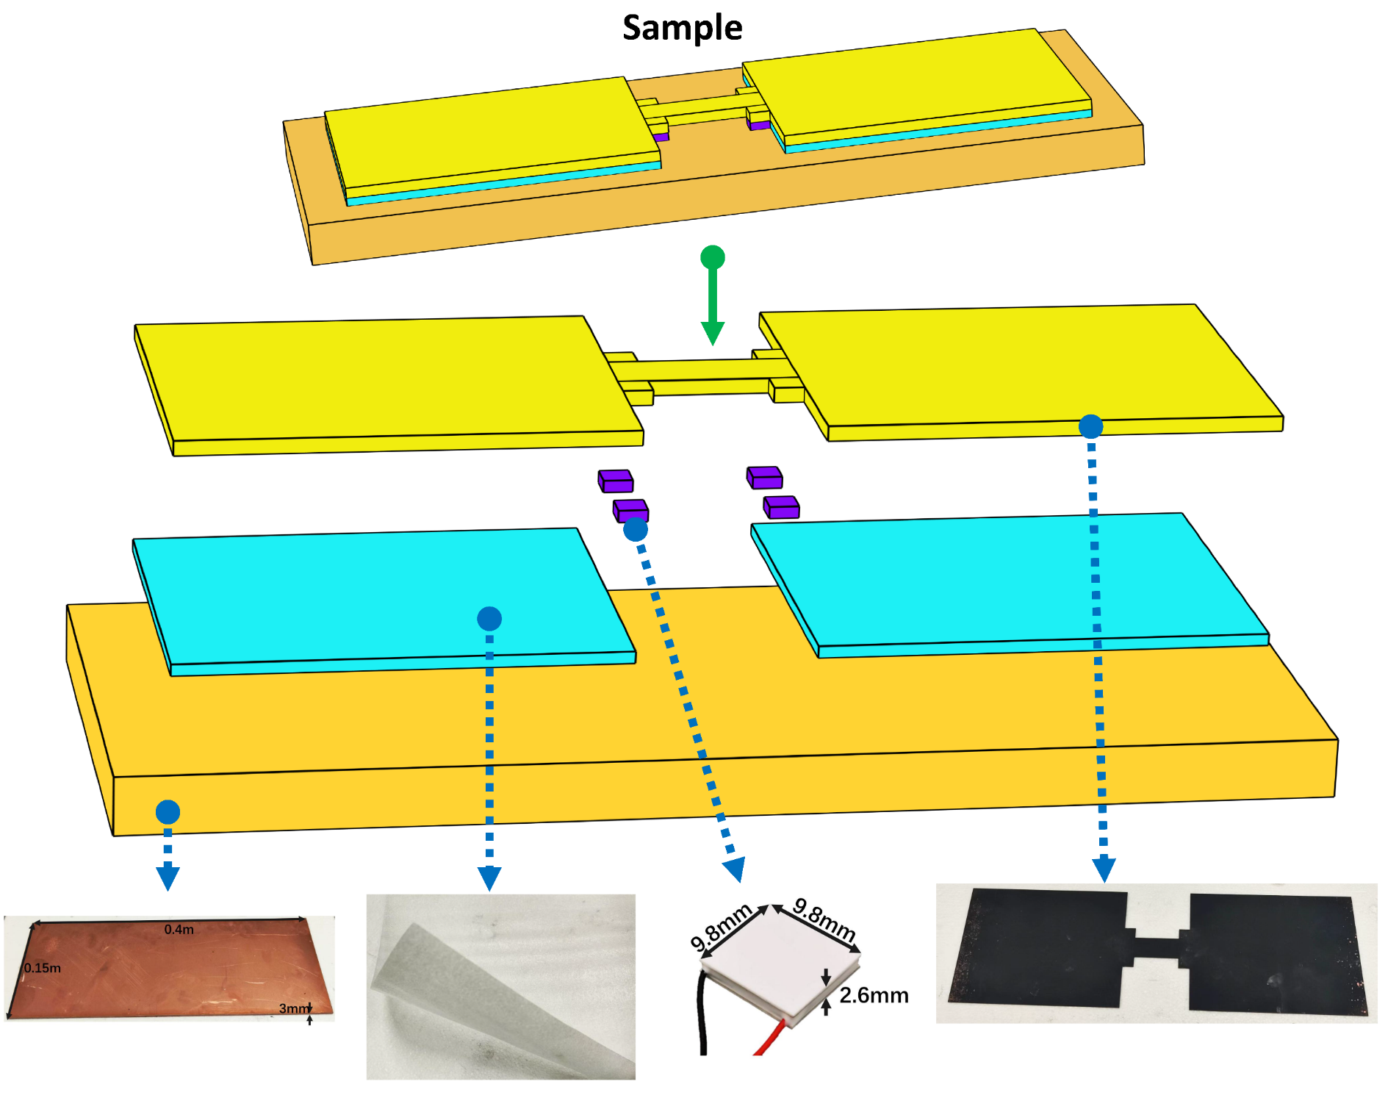
Fig. S1. Assembly of the Experimental Sample

2.2 Pre-experiment preparation:
- A heating plate is closely attached to one side of the test copper substrate and firmly secured. It is connected to an independent adjustable DC power supply via alligator clip wires to ensure the subsequent establishment of a stable high-temperature source.
- A cooling device (refrigerator) is closely attached to the other side of the test copper substrate (opposite to the heating plate) and fixed, then connected to another independent power supply to guarantee a constant temperature difference across the two sides of the copper substrate.
- The four active thermal metasurfaces (ATMSs) are respectively connected to two multi-channel adjustable DC power supplies via alligator clip wires (each power supply is equipped with 3 independent output channels). This setup enables independent power supply and precise current regulation for each ATMS, meeting the power output requirements of different ATMSs in the experiment.
- The entire experimental setup is placed in a closed laboratory, where the indoor ambient temperature is stably maintained at 23 °C by an air conditioning system—consistent with the controlled temperature of the heat-dissipating copper plate. This minimizes interference from air convection on thermal field measurements, ensuring the stability of the experimental environment and the reliability of data.

Supplementary Note 3. Details of Experimental Measurements
The experimental measurement process has the following steps:
- Place the prepared sample and related components in position. Mount the infrared camera (Model FOTRIC 288) on a tripod, then adjust the tripod height and camera orientation to ensure the detection region on the sample is fully covered by the camera’s field of view with clear focusing. Turn on the infrared camera to initialize the measurement system.
- Connect the heating plate and cooling device (refrigerator) to independent DC constant current power supplies respectively. Monitor the temperature in real time via the infrared camera, and adjust the power supply output to stabilize the temperature of the high-temperature side of the test copper substrate at approximately 32.8 °C and the low-temperature side at 20.8 °C, ensuring a constant temperature difference of 12 K between the two sides (consistent with the simulation settings).
- Connect the four active thermal metasurfaces (ATMSs) to independent DC constant current power supplies respectively. Calculate the initial theoretical current values using the theoretical estimation formulas in the main text under the nonlinear approximation condition, and adjust the output current of each power supply to the initial values listed in Table S1. Subsequently, monitor the temperature distribution of the detection region via the infrared camera and wait for the system to reach thermal steady state (i.e., the temperature distribution no longer changes with time, typically approximately 35 seconds after power-on).
- Once thermal steady state is achieved, save the temperature distribution data collected by the infrared camera. Then turn off all power supplies and allow the entire test system to cool naturally to the ambient temperature (23 °C).
- Analyze the collected temperature data and compare it with the simulation results. Reactivate the power supplies and fine-tune the currents of the four ATMSs according to the comparison differences. After eight rounds of measurement and slight correction, the optimized current values for each ATMS are finally determined as listed in Table S1, which enable the system to exhibit a temperature distribution consistent with the simulation results. The discrepancy between the initial theoretical current values and the experimentally optimized ones arises from the nonlinear relationship between the power and current of the ATMSs, as well as inevitable manufacturing tolerances during sample preparation.
- Apply the optimized currents to each ATMS and wait for the system to reach thermal steady state again. The final temperature distribution captured by the infrared camera is shown in Fig. 3(c), and the relevant experimental process can be referenced in Supplementary Movie 2.
- After completing the thermal experiment, remove the heating plate and cooling device from the test copper substrate while keeping the positions and power supply connections of the four ATMSs unchanged. Use three alligator clip wires to connect the test copper substrate, sliding rheostat, and power supply in series to form a circuit. It is important to note that due to the extremely high electrical conductivity of the structure (nearly equivalent to that of the metallic copper substrate), the negative terminal of the constant voltage source must first be connected to a sliding rheostat (maintained at a fixed resistance of 1 Ω during the experiment) before being connected to the low-potential end of the copper substrate, so as to prevent short circuits that could damage the power supply.
- After assembling all electrical components correctly, set the power supply to constant voltage mode, adjust the output voltage to 1 V, and turn it on; the copper plate quickly reaches electrical equilibrium. Perform potential measurements using a high-precision digital multimeter (Model UNT): fix one probe at the high-potential end of the test copper substrate, and sequentially contact the other probe with each preset measurement point to read the voltage difference between the point and the high-potential end, thereby calculating the actual potential of each measurement point. Record the actual potential of all measurement points in an Excel spreadsheet, then import the data into COMSOL Multiphysics software for post-processing to obtain the electric potential distribution as shown in Fig. 3(d).

After each thermal steady-state measurement, the measured temperature distribution was compared with the corresponding numerical result, and the currents of the four ATMSs were slightly adjusted according to the observed deviation. After eight rounds of measurement and optimization, the final current values listed in Table S1 were obtained. The differences between the theoretical initial currents and the experimentally optimized currents are not treated as measurement errors, but rather as deviations between the idealized theoretical operating points and the actual experimental operating conditions. These deviations mainly originate from the nonlinear current–thermal-power characteristics of the ATMSs, thermal-contact resistance between the ATMSs and the copper substrate, unavoidable assembly and dimensional tolerances, and deviations between the idealized numerical boundary conditions and the actual experimental configuration.
Table S1. Electric current values of the ATMS in the experiment for the remote heating effect
Number | Initial current value, I_{initial}[A] | Modified current value, I_{optimized}[A] | Absolute deviation, |ΔI|[A] | Relative deviation,$δ_{I}$[%]
 | 4.000 | 2.087 | 1.913 | 47.83
 | 4.000 | 2.009 | 1.991 | 49.78
 | 4.555 | 4.216 | 0.339 | 7.44
 | 4.555 | 4.250 | 0.305 | 6.70
The relative deviation is calculated as $δ_{I}=∣I_{\text{initial}}-I_{\text{optimized}}∣/I_{\text{initial}}×100\%$. These deviations represent differences between theoretical initial estimates and experimentally optimized operating points and should not be interpreted as measurement uncertainties.

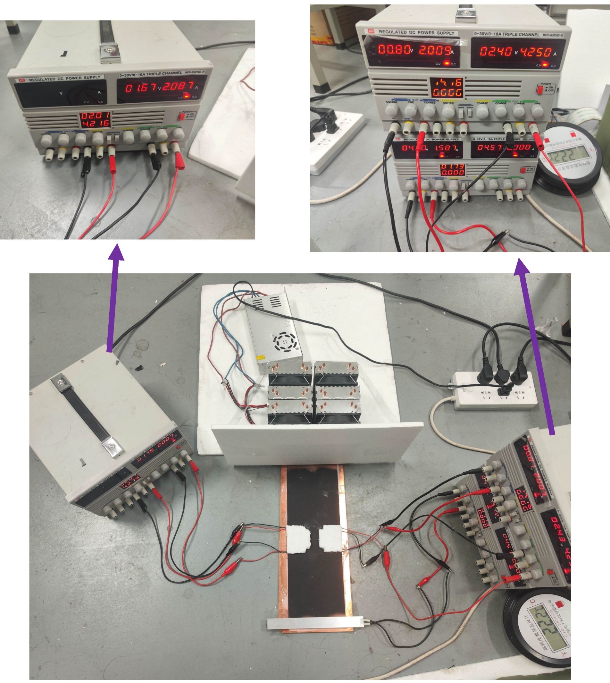
Fig. S2. Experimental setup in operation

All experimental components and materials required for this study are listed below (see Figure S3 for visual reference):
- Four active thermal metasurfaces (ATMSs) with dimensions of 9.8 mm × 9.8 mm × 2.6 mm (Model: TEcooler HT009022; product page: http://www.tecooler.com/products/tec.ht.html), used to realize active heat flux compensation and thermal insulation.
- Infrared thermal imager (Model: FOTRIC 288; product page: https://www.fotric.cn/products/21) equipped with a tripod, employed to capture real-time temperature field distributions on the sample surface.
- Thermally conductive silicone grease (Model: VK887) with a thermal conductivity of 6.0 W/(m·K), applied to eliminate air gaps at contact interfaces and optimize thermal contact between the ATMSs, copper substrate, and heat-dissipating plate.
- Black paint, uniformly sprayed on the infrared observation side of the copper substrate to enhance imaging contrast and reduce stray light interference during temperature measurements.
- Dumbbell-shaped copper substrate with core geometric parameters: D₂ = 0.04 m, L₂ = 0.06 m, D₃ = 0.01 m, L₁ = 0.15 m, D₁ = 0.12 m, L₃ = 0.04 m, and thickness H = 0.001 m, fabricated via precision laser cutting to ensure dimensional accuracy within ±0.001 m.
- Ten crocodile clip wires, used for reliable electrical connections between power supplies, the copper substrate, ATMSs, and other electrical components.
- Heat-dissipating copper plate with dimensions of 400 mm × 150 mm × 3 mm, serving as a thermal buffer layer to stabilize the operating temperature of the ATMSs by absorbing or transferring excess heat.
- Expanded polystyrene (EPS) foam board with a thickness of 2.6 mm and a thermal conductivity of 0.05 W/(m·K), providing thermal insulation for non-test regions of the copper substrate and mechanical support for the sample.
- Two multi-channel adjustable DC power supplies (Model: MCH K3010D), each equipped with three independent output channels to enable independent power supply and precise current regulation for each ATMS.
- Ceramic PTC constant-temperature heating plate (cast aluminum, rapid heating accessory), used to establish a stable high-temperature source on one side of the copper substrate during thermal performance tests.
- High-precision digital multimeter (Model: UNT), employed to measure potential differences across the copper substrate with high accuracy during electrical characterization.
- Sliding rheostat, maintained at a fixed resistance of 1 Ω during electrical experiments to prevent short circuits and protect the power supply from damage due to the high conductivity of the copper substrate.
- Refrigeration device (refrigerator), used to establish a stable low-temperature source on the opposite side of the copper substrate, ensuring a constant temperature difference across the sample during thermal tests.

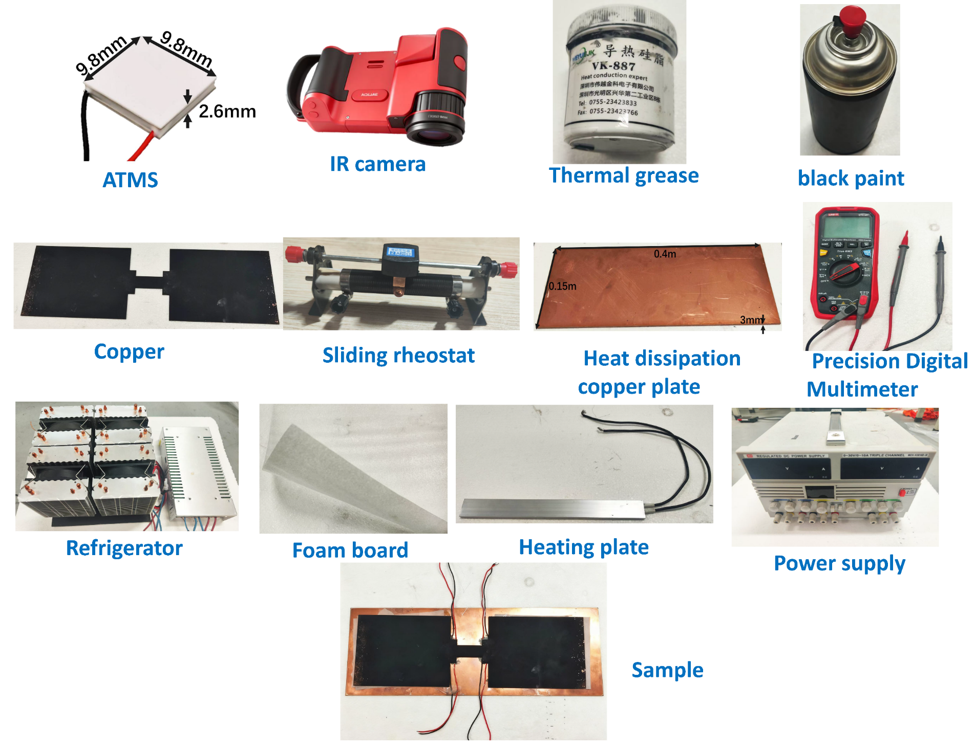
Fig. S3. Photographs of core components and the sample for the experimental setup

Uncertainty analysis of the effective thermal conductivity
The effective thermal conductivity $K_{\text{eff}}$ is indirectly determined from the infrared temperature field by using a well-characterized copper section as a thermal-resistance reference. As described in the main text, the heat flow through the low-temperature-side copper section is first obtained from the local Fourier law,
$$Q=K_{1}S_{2}\frac{T_{m2}-T_{m3}}{ΔX}, (S1)$$
where $K_{1}$ is the intrinsic thermal conductivity of the copper substrate, $S_{2}$ is the cross-sectional area of the reference copper section, $T_{m2}$ and $T_{m3}$ are the average temperatures of the two selected infrared measurement regions, and $ΔX$ is the distance between these two regions. The effective thermal conductivity of the entire gateway is then defined as
$$K_{\text{eff}}=\frac{QL}{\left(T_{m1}-T_{m3}\right)S_{2}}, L=2L_{1}+L_{2}. (S2)$$
Combining Eqs. (S1) and (S2), the cross-sectional area $S_{2}$ cancels, giving
$$K_{\text{eff}}=\frac{K_{1}\left(2L_{1}+L_{2}\right)\left(T_{m2}-T_{m3}\right)}{ΔX\left(T_{m1}-T_{m3}\right)}. (S3)$$
which is identical to Eq. (5) in the main text. This form is also advantageous for uncertainty analysis because the cross-sectional-area uncertainty does not enter the final expression.

First-order differential uncertainty propagation
Let
$$A=2L_{1}+L_{2}, ΔT_{23}=T_{m2}-T_{m3}, ΔT_{13}=T_{m1}-T_{m3}.$$
Equation (Sx+2) can then be written in the compact form
$$K_{\text{eff}}=K_{1}\frac{AΔT_{23}}{ΔXΔT_{13}}. (S4)$$
Taking the total differential of Eq. (S4) gives
(S5）
The corresponding sensitivity coefficients are
$$\frac{∂K_{\text{eff}}}{∂K_{1}}=\frac{K_{\text{eff}}}{K_{1}}, \\ \frac{∂K_{\text{eff}}}{∂A}=\frac{K_{\text{eff}}}{A}, \\ \frac{∂K_{\text{eff}}}{∂ΔX}=-\frac{K_{\text{eff}}}{ΔX}, \\ \frac{∂K_{\text{eff}}}{∂T_{m1}}=-\frac{K_{\text{eff}}}{ΔT_{13}}, \\ \frac{∂K_{\text{eff}}}{∂T_{m2}}=\frac{K_{\text{eff}}}{ΔT_{23}}, \\ \frac{∂K_{\text{eff}}}{∂T_{m3}}=K_{\text{eff}}\left(\frac{1}{ΔT_{13}}-\frac{1}{ΔT_{23}}\right). (S6)$$
For statistically independent input quantities, the combined standard uncertainty is therefore
$$u^{2}\left(K_{\text{eff}}\right)=\sum_{i}{{\left(\frac{∂K_{\text{eff}}}{∂x_{i}}\right)}^{2}}u^{2}\left(x_{i}\right) (S7)$$
where $x_{i}$ denotes each independent input quantity. In relative form,
$${\left[\frac{u\left(K_{\text{eff}}\right)}{K_{\text{eff}}}\right]}^{2}={\left[\frac{u\left(K_{1}\right)}{K_{1}}\right]}^{2}+{\left[\frac{u\left(A\right)}{A}\right]}^{2}+{\left[\frac{u\left(ΔX\right)}{ΔX}\right]}^{2}+{\left[\frac{u\left(ΔT_{23}\right)}{ΔT_{23}}\right]}^{2}+{\left[\frac{u\left(ΔT_{13}\right)}{ΔT_{13}}\right]}^{2} (S8)$$
with
$${ u}^{2}\left(A\right)=4u^{2}\left(L_{1}\right)+u^{2}\left(L_{2}\right), (S9)$$
assuming $L_{1}$ and $L_{2}$ are independently measured.

Treatment of the correlated temperature measurements
Because $T_{m1},T_{m2},$ and $T_{m3}$ are extracted from the same infrared frame, the temperature uncertainties may contain common-mode components. The most rigorous treatment is therefore to propagate the uncertainties directly from the three measured temperatures rather than treating $ΔT_{23}$ and $ΔT_{13}$ as completely independent quantities.
Using the covariance matrix of the three temperature measurements, the temperature-related contribution is
$$u_{T}^{2}\left(K_{\text{eff}}\right)=\sum_{i,j=1}^{3}{\frac{∂K_{\text{eff}}}{∂T_{mi}}}\frac{∂K_{\text{eff}}}{∂T_{mj}}\text{Cov}\left(T_{mi} , T_{mj}\right). (S10)$$
Accordingly,
$$u^{2}\left(K_{\text{eff}}\right)={\left(\frac{∂K_{\text{eff}}}{∂K_{1}}u\left(K_{1}\right)\right)}^{2}+{\left(\frac{∂K_{\text{eff}}}{∂A}u\left(A\right)\right)}^{2}+{\left(\frac{∂K_{\text{eff}}}{∂ΔX}u\left(ΔX\right)\right)}^{2}+u_{T}^{2}\left(K_{\text{eff}}\right). (S11)$$
This treatment is particularly relevant because a common-mode temperature offset affects the three regions similarly and is therefore strongly suppressed in the temperature differences. Consequently, the uncertainty relevant to the inversion is not the absolute temperature accuracy alone, but primarily the uncertainty and spatial non-uniformity of the differential temperature measurements.

Table S2. Uncertainty budget for the experimentally extracted effective thermal conductivity.
Input quantity | Symbol | Nominal value | Uncertainty | Sensitivity coefficient | Contribution to u(κ_{eff})/κ_{eff}
Copper thermal conductivity | κ₁ | 400 W/(m·K) | u(κ₁) | 1/κ₁ | u(κ₁)/κ₁
Gateway length | A=2L₁+L₂ | 0.36 m | u(A) | 1/A | u(A)/A
Temperature-region separation | ΔX | 0.12 m | u(ΔX) | −1/ΔX | u(ΔX)/ΔX
Temperature T_{m1} | T_{m1} | 32.8 °C | u(T_{m1}) | −1/ΔT₁₃ | see Eq. (S10)
Temperature T_{m2} | T_{m2} | measured value | u(T_{m2}) | 1/ΔT₂₃ | see Eq. (S10)
Temperature T_{m3} | T_{m3} | measured value | u(T_{m3}) | 1/ΔT₁₃−1/ΔT₂₃ | see Eq. (S10)

Supplementary Note 4. Comparison of Effective Thermal Conductivity, Electrical Conductivity and Implementation Conditions with Previous Studies

Ref. | Effective thermal conductivity [W/(m·K)] | Effective electrical conductivity [S/m] | Implementation method and required conditions
This work | 0 | 2.8×10⁷ | Active, achievable at room or high temperatures
10 | 0.23–0.34 | 10000 | Single-crystal SnSe, measured along the b-axis of its room-temperature orthorhombic unit cell in a helium atmosphere over a temperature range of 300–973 K
11 | 0.72 | 8.0×10⁵ | Single-crystal vanadium dioxide (VO₂) nanobeams, with heat and charge transport along the nanobeam length at 240–340 K under single-crystalline, free-standing conditions (to eliminate extrinsic domain and strain interference)
12 | 0.24 | 1×10⁵ | n-type SnSe crystals, measured along the out-of-plane direction over a temperature range of 300–800 K
13 | 0.9 | 3.57×10⁶ | Nanoscale nickel particles prepared by thermal decomposition, at 300 K with a grain size of 23.1±0.3 nm (Sample Ni1)
14 | 0.010–0.032 | 420 | C/SiCON nonwovens with "sea-island" nanostructures, at room temperature
15 | 0.027 | 225 | Graphene nanosheet/carbon aerogel (GNS/CA) composites, at room temperature
16 | 1.65 | 1.5×10⁵ | Hole-doped single-crystal SnSe, over a temperature range of 300–773 K (along the b crystallographic direction)
17 | 1.2 | 30000 | n-type single-crystal SnSe, measured along the out-of-plane direction (a-axis) over a temperature range of 300–773 K
18 | 2.2 | 1.66×10⁵ | p-type ZrCoBi-based half-Heusler compounds, over a temperature range of 300–973 K
19 | 1.2 | 1.0×10⁵ | Cu₀.₀₁Bi₂Te₂.₇Se₀.₃-based thermoelectric materials, over a temperature range of 5–525 K

Ref. 10 reports a SnSe single crystal material, which achieves an effective thermal conductivity of only 0.23–0.34 W/(m·K) when measured along the b-axis direction of the room-temperature orthorhombic unit cell in a helium atmosphere at a high temperature range of 300–973 K, but the corresponding electrical conductivity is only 10⁴ S/m; Ref. 11 uses single-crystal vanadium dioxide (VO₂) nanobeam materials, which, after eliminating extrinsic domains and strain interference through single-crystal, unsupported structures in the temperature range of 240–340 K, achieves an effective thermal conductivity of 0.72 W/(m·K) and an electrical conductivity of 8.0×10⁵ S/m, but its performance is highly dependent on the directional transmission characteristics of the nanobeams; Ref. 12 uses n-type tin selenide (SnSe) crystals, which achieves an effective thermal conductivity of 0.24 W/(m·K) and an electrical conductivity of 1×10⁵ S/m when measured along the out-of-plane direction of the crystal at a temperature range of 300–800 K, still limited by crystal orientation and temperature window; Ref. 13 uses nanoscale nickel particles prepared by thermal decomposition, which only achieves an effective thermal conductivity of 0.9 W/(m·K) and an electrical conductivity of 3.57×10⁶ S/m at 300 K with a grain size of 23.1±0.3 nm (sample Ni1), and the performance is highly sensitive to nanostructure size; Ref. 14 and Ref. 15 use "island-type" nanostructured C/SiCON non-woven fabrics and graphene nanosheets/carbon aerogel (GNS/CAs) materials, respectively, which achieve low thermal conductivities of 0.010–0.032 W/(m·K) and 0.027 W/(m·K) at room temperature, but the electrical conductivities are only 420 S/m and 225 S/m, far below the metal-level conductivity requirements; Ref. 16 and Ref. 17 use hole-doped and n-type SnSe single crystal materials, which achieve effective thermal conductivities of 1.65 W/(m·K) and 1.2 W/(m·K) at a high temperature range of 300–773 K along specific crystallographic directions, with electrical conductivities of only 1.5×10⁵ S/m and 3×10⁴ S/m, respectively; Ref. 18 uses p-type ZrCoBi-based half-Heusler compounds, which achieves an effective thermal conductivity of 2.2 W/(m·K) and an electrical conductivity of 1.66×10⁵ S/m at high temperatures of 300–973 K; Ref. 19 uses Cu₀.₀₁Bi₂Te₂.₇Se₀.₃-based thermoelectric materials, which achieves an effective thermal conductivity of 1.2 W/(m·K) and an electrical conductivity of 1×10⁵ S/m at a temperature range of 5–525 K. In summary, although existing materials can achieve a certain degree of low thermal conductivity and moderate electrical conductivity under specific conditions, they are always limited by the intrinsic physical property coupling of materials: either the electrical conductivity is difficult to exceed the order of 10⁶ S/m, or the thermal conductivity is still much higher than the air-level level (<0.01 W/(m·K)). Moreover, their implementation conditions mostly rely on high-temperature atmospheres, specific crystal orientations, nanostructure sizes, or narrow temperature windows, making it difficult to directly adapt to practical engineering scenarios.

Movie 1: Assembly of the Experimental Sample

Movie 2: Thermal and Electrical Experimental Process

